Supplemental Digital Content 4: Time Series of Connectivity States for Individual Participants
Figure 1
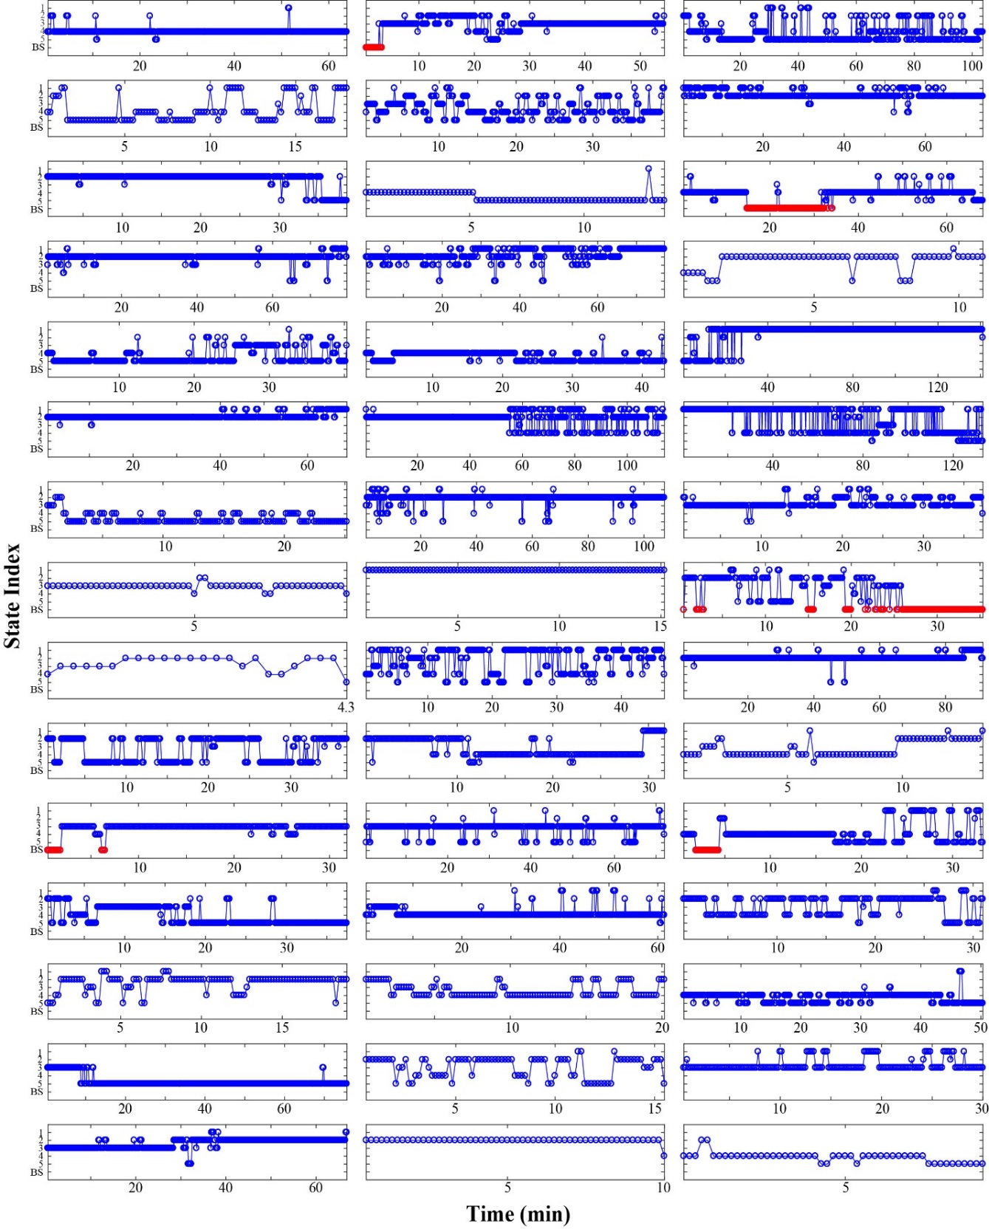
Individual time courses of connectivity states from cluster analysis. The frequency-resolved frontal-parietal and prefrontal-frontal connectivity patterns were concatenated across participants and then subjected to principal component analysis (PCA) and k-means clustering, from which each time window was assigned into one of the five connectivity states (blue circles), and for the time windows with burst suppression, we classified them into an additional state as ‘BS’ (burst suppression, red circles). For most of the participants, the connectivity pattern is not static – transitions occur among connectivity states.

Figure 2
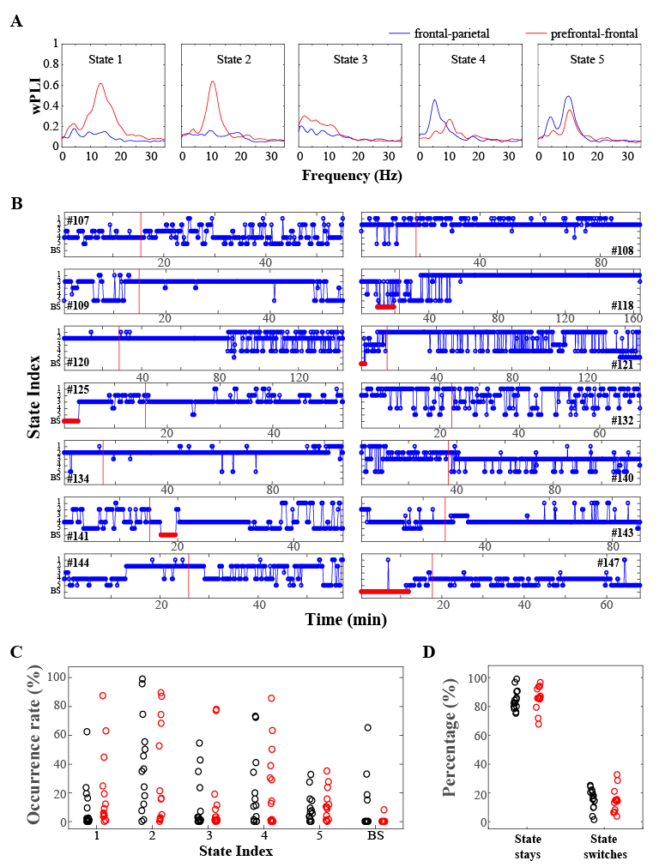
(A) To examine the data both with and without surgical stimulation, the dynamic connectivity and cluster analysis was performed on an aggregated dataset, including the data used in the main analysis (the anesthetic maintenance phase from 30 s after skin incision to the last MAC of 0.7 towards the end of surgery, 45 participants) together with the data during an additional period without surgical stimulation (time period from 3 min after intubation to the last data available immediately prior to skin incision). With time duration of >15 min, data were available in 14 of 45 participants. With these additional data analyses, the clusters showed similar – but not identical – connectivity patterns as compared to those in the main analysis (manuscript fig. 5A). (B) Individual connectivity state time courses are displayed for the 14 participants with data from “non-stimulation” periods (i.e., data from the time between intubation and skin incision). Even without surgical stimulation, cortical connectivity transitioned among multiple states (the start of surgery is indicated using the red vertical line). (C) State occurrence rate and (D) state persistencies were also compared across the 14 participants. The black circles indicated the pre-surgical data, and the red circles indicated the surgery period. There was no significant difference in the occurrence rate for all the connectivity states (P>0.1, Wilcoxon signed rank test). Regardless of surgical stimulation, cortical connectivity was likely to remain in the same state, with probabilities of 84.5±7.2% (pre-surgery) and 85.3±8.1% (surgery), which was significantly higher than that of switching to a different state of 15.5±7.2% (pre-surgery) and 14.7±8.1 % (surgery) (P<0.001). There was no significant difference between pre-surgery and surgery periods (P=0.81). Taken together, surgical stimulation alone does not appear to account for the observed dynamic connectivity changes.

