SUPPLEMENTAL DIGITAL CONTENT 1

Blood purification and mortality in sepsis and septic shock:
a systematic review and meta-analysis of randomized trials

AUTHORS
Alessandro Putzu, Raoul Schorer, Juan Carlos Lopez-Delgado, Tiziano Cassina, Giovanni Landoni.

SUMMARY
Table S1 - PRISMA 2009 Checklist 3
Table S2 - Search strategies 5
eMethods 1 - Changes from the initial protocol. 7
Table S3 - Major Exclusions 8
Table S4 - Further characteristics of the included trials (1). 9
Table S5 - Further characteristics of the included trials (2). 14
Table S6 - Further characteristics of the included trials (3). 14
Figure S1 - Risk of bias summary: review authors' judgements about each risk of bias item for each included study. 16
Figure S2 - Risk of bias graph: review authors' judgments about each risk of bias item presented as percentages across all included studies. 17
Table S7 - Certainty of the body of evidence assessment using the grading of recommendations assessment, development and evaluation (GRADE) framework. 18
Figure S3 – Hemoperfusion and mortality. Forest plot for the relative risk of mortality at longest follow-up available with hemoperfusion with different devices. 20
Figure S4 – Funnel plot for mortality with hemoperfusion techniques. 21
Table S8 – Sensitivity analyses for hemoperfusion. 21
Figure S5 – Trial sequential analysis for mortality at longest follow-up available with hemoperfusion (any device). 22
Figure S6 – Hemoperfusion (any device) and mortality. Subgroup analysis according to geographical area. 23
Figure S7 – Hemoperfusion (any device) and mortality. Subgroup analysis according to year of publication. 24
eResults 1 – Hemoperfusion (any device) and mortality. Meta-regression for APACHE 2 score, SOFA score, control group mortality, and age. 25
Figure S8 – Hemoperfusion (any device) and mortality. Forest plot for the relative risk of mortality at longest follow up available according to disease severity. 26
Figure S9 - Hemoperfusion and 30-days mortality (secondary endpoint). Forest plot for the relative risk of 28/30-days mortality. 27
Figure S10 – Polymyxin B-immobilized fiber column hemoperfusion and mortality. Subgroup analysis according to risk of bias assessment. 28
Figure S11 – Polymyxin B-immobilized fiber column hemoperfusion and mortality. Subgroup analysis according to geographical area. 28
Figure S12 – Polymyxin B-immobilized fiber column hemoperfusion and mortality. Subgroup analysis excluding trials from Nakamura group. 29
Figure S13 – Polymyxin B-immobilized fiber column hemoperfusion and mortality. Subgroup analysis according to year of publication. 29
Figure S14 – Trial sequential analysis for mortality at longest follow-up available with hemofiltration. 30
Figure S15 – Hemofiltration and mortality. Subgroup analysis according to geographical area. 31
Figure S16 – Hemofiltration and mortality. Subgroup analysis according to year of publication. 31
Figure S17 – Hemofiltration and mortality. Forest plot for the relative risk of mortality at longest follow up available according to disease severity. 32
Figure S18 - Hemofiltration, combined hemofiltration and hemoperfusion, and plasmapheresis. Forest plot for the relative risk of 28/30-days mortality (secondary endpoint). 32
Table S9 – Sensitivity analyses for hemofiltration, combined hemofiltration and hemoperfusion, and plasmapheresis. 33
eResults 2 – Hemofiltration and mortality. Meta-regression for APACHE 2 score, SOFA score, control group mortality, and age. 34

Table S1 - PRISMA 2009 Checklist
Section/topic | # | Checklist item | Reported on page #
TITLE
Title | 1 | Identify the report as a systematic review, meta-analysis, or both. | 1
ABSTRACT
Structured summary | 2 | Provide a structured summary including, as applicable: background; objectives; data sources; study eligibility criteria, participants, and interventions; study appraisal and synthesis methods; results; limitations; conclusions and implications of key findings; systematic review registration number. | 1
INTRODUCTION
Rationale | 3 | Describe the rationale for the review in the context of what is already known. | 1,2
Objectives | 4 | Provide an explicit statement of questions being addressed with reference to participants, interventions, comparisons, outcomes, and study design (PICOS). | 1,2
METHODS
Protocol and registration | 5 | Indicate if a review protocol exists, if and where it can be accessed (e.g., Web address), and, if available, provide registration information including registration number. | 2
Eligibility criteria | 6 | Specify study characteristics (e.g., PICOS, length of follow-up) and report characteristics (e.g., years considered, language, publication status) used as criteria for eligibility, giving rationale. | 2
Information sources | 7 | Describe all information sources (e.g., databases with dates of coverage, contact with study authors to identify additional studies) in the search and date last searched. | 2
Search | 8 | Present full electronic search strategy for at least one database, including any limits used, such that it could be repeated. | _{2, Supplemental}
Study selection | 9 | State the process for selecting studies (i.e., screening, eligibility, included in systematic review, and, if applicable, included in the meta-analysis). | 2
Data collection process | 10 | Describe method of data extraction from reports (e.g., piloted forms, independently, in duplicate) and any processes for obtaining and confirming data from investigators. | 2
Data items | 11 | List and define all variables for which data were sought (e.g., PICOS, funding sources) and any assumptions and simplifications made. | 2
Risk of bias in individual studies | 12 | Describe methods used for assessing risk of bias of individual studies (including specification of whether this was done at the study or outcome level), and how this information is to be used in any data synthesis. | 2,3
Summary measures | 13 | State the principal summary measures (e.g., risk ratio, difference in means). | 3
Synthesis of results | 14 | Describe the methods of handling data and combining results of studies, if done, including measures of consistency (e.g., I²) for each meta-analysis. | 3
Risk of bias across studies | 15 | Specify any assessment of risk of bias that may affect the cumulative evidence (e.g., publication bias, selective reporting within studies). | 3
Additional analyses | 16 | Describe methods of additional analyses (e.g., sensitivity or subgroup analyses, meta-regression), if done, indicating which were pre-specified. | 3
RESULTS
Study selection | 17 | Give numbers of studies screened, assessed for eligibility, and included in the review, with reasons for exclusions at each stage, ideally with a flow diagram. | _{3, Figure 1}
Study characteristics | 18 | For each study, present characteristics for which data were extracted (e.g., study size, PICOS, follow-up period) and provide the citations. | _{3, Table, Supplemental}
Risk of bias within studies | 19 | Present data on risk of bias of each study and, if available, any outcome level assessment (see item 12). | _{3, Supplemental}
Results of individual studies | 20 | For all outcomes considered (benefits or harms), present, for each study: (a) simple summary data for each intervention group (b) effect estimates and confidence intervals, ideally with a forest plot. | _{3-6, Supplemental}
Synthesis of results | 21 | Present results of each meta-analysis done, including confidence intervals and measures of consistency. | _{3-6, Suppl.}
Risk of bias across studies | 22 | Present results of any assessment of risk of bias across studies (see Item 15). | _{3-6, Suppl.}
Additional analysis | 23 | Give results of additional analyses, if done (e.g., sensitivity or subgroup analyses, meta-regression [see Item 16]). | _{3-6, Suppl.}
DISCUSSION
Summary of evidence | 24 | Summarize the main findings including the strength of evidence for each main outcome; consider their relevance to key groups (e.g., healthcare providers, users, and policy makers). | 6-9
Limitations | 25 | Discuss limitations at study and outcome level (e.g., risk of bias), and at review-level (e.g., incomplete retrieval of identified research, reporting bias). | 9
Conclusions | 26 | Provide a general interpretation of the results in the context of other evidence, and implications for future research. | 9,10
FUNDING
Funding | 27 | Describe sources of funding for the systematic review and other support (e.g., supply of data); role of funders for the systematic review. | 10
From: Moher D, Liberati A, Tetzlaff J, Altman DG, The PRISMA Group (2009). Preferred Reporting Items for Systematic Reviews and Meta-Analyses: The PRISMA Statement. PLoS Med 6(7): e1000097. doi:10.1371/journal.pmed1000097
For more information, visit: www.prisma-statement.org.

Table S2 - Search strategies
PubMed | (“blood purification”[tiab] OR “renal replacement”[tiab] OR RRT[tiab] OR dialysis[tiab] hemodialysis[tiab] OR haemodialysis[tiab] OR hemoperfusion[tiab] OR haemoperfusion[tiab] OR “plasma exchange”[tiab] OR adsorption[tiab] OR hemoadsorption[tiab] OR haemoadsorption[tiab] OR filtration[tiab] OR hemofiltration[tiab] OR haemofiltration[tiab] OR CVVH[tiab] OR hemodiafiltration[tiab] OR haemodiafiltration[tiab] OR polymyxin[tiab] OR cytosorb[tiab] OR alteco[tiab] OR adsorba[tiab] OR “plasma filter”[tiab] OR CVVHDF[tiab] OR HVHF[tiab]) AND (sepsis[tiab] OR septic[tiab] OR infect*[tiab] OR ARDS[tiab] OR “acute respiratory distress”[tiab] OR pneumonia[tiab] OR shock[tiab] OR exacerbation[tiab]) AND (“randomized controlled trial”[tiab] OR “controlled trial”[tiab] OR “randomized controlled trials”[tiab] OR blind*[tiab] OR “clinical trial”[tiab] OR “clinical trials”[tiab] OR “randomized trial”[tiab] OR random*[tiab] OR “case control”[tiab] OR randomised[tiab])
Embase | (“blood purification”:ab,ti OR “renal replacement”:ab,ti OR RRT:ab,ti OR dialysis:ab,ti hemodialysis:ab,ti OR haemodialysis:ab,ti OR hemoperfusion:ab,ti OR haemoperfusion:ab,ti OR “plasma exchange”:ab,ti OR adsorption:ab,ti OR hemoadsorption:ab,ti OR haemoadsorption:ab,ti OR filtration:ab,ti OR hemofiltration:ab,ti OR haemofiltration:ab,ti OR CVVH:ab,ti OR hemodiafiltration:ab,ti OR haemodiafiltration:ab,ti OR polymyxin:ab,ti OR cytosorb:ab,ti OR alteco:ab,ti OR adsorba:ab,ti OR “plasma filter”:ab,ti OR CVVHDF:ab,ti OR HVHF:ab,ti) AND (sepsis:ab,ti OR septic:ab,ti OR ARDS:ab,ti OR “acute respiratory distress”:ab,ti OR pneumonia:ab,ti OR infect*:ab,ti OR shock:ab,ti OR exacerbation:ab,ti) AND (“randomized controlled trial”:ab,ti OR “controlled trial”:ab,ti OR “randomized controlled trials”:ab,ti OR blind*:ab,ti OR “clinical trial”:ab,ti OR “clinical trials”:ab,ti OR “randomized trial”:ab,ti OR random*:ab,ti OR “case control”:ab,ti OR randomised:ab,ti)
Cochrane Library | #1 "blood purification"  #2 "renal replacement"  #3 RRT  #4 dialysis  #5 hemodialysis  #6 haemodialysis  #7 hemoperfusion  #8 haemoperfusion  #9 hemofiltration  #10 haemofiltration  #11 "plasma exchange"  #12 adsorption  #13 hemoadsorption  #14 haemoadsorption  #15 CVVH  #16 hemodiafiltration  #17 haemodiafiltration  #18 polymyxin  #19 cytosorb  #20 alteco  #21 adsorba  #22 "plasma filter"  #23 CVVHDF  #24 HVHF  #25 sepsis  #26 septic  #27 infect*  #28 ARDS  #29 "acute respiratory distress"  #30 pneumonia  #31 shock  #32 exacerbation  #33 "randomized controlled trial"  #34 "controlled trial"  #35 "randomized controlled trials"  #36 blind*  #37 "clinical trial"  #38 "clinical trials"  #39 "randomized trial"  #40 random*  #41 "case control"  #42 randomised  #43 (#1 or #2 or #3 or #4 or #5 or #6 or #7 or #8 or #9 or #10 or #11 or #12 or #13 or #14 or #15 or #16 or #17 or #18 or #19 or #20 or #21 or #22 or #23 or #24) and (#25 or #26 or #27 or #28 or #29 or #30 or #31 or #32) and (#33 or #34 or #35 or #36 or #37 or #38 or #39 or #40 or #41 or #42)

eMethods 1 - Changes from the initial protocol.

Primary analysis and subgroup analyses
- Protocol: The primary analysis planned to include all eligible trials, with subgroup analyses according to blood purification techniques and to specific device
- Amendment: As deemed most appropriate during the review process, the primary analysis was stratified to blood purification techniques and subgroup analyses according to specific device were carried out. To explore the sources of heterogeneity, we performed some subgroup analyses: a) low risk of bias vs. unclear/high risk of bias trials [requested during review process]; b) Trials from Nakamura group vs. other trials [requested during review process]; c) recent trails published after 2010 vs. older trials [requested during review process]; d) trials performed in Asia vs. trials not performed in Asia [authors driven, according to Zhou F et al., Crit Care Med 2013;41(9):2209–20].

Disease severity assessment
- Protocol: The analysis planned to include a meta-regression on APACHE II score and SOFA score and a subgroup analyses on trials enrolling a septic shock population vs. sepsis/mixed population.
- Amendment: We performed the meta-regression according to SOFA and APACHE II score as planned, but the subgroup analysis according to disease severity definition was not performed, due to very high heterogeneity in disease definitions. We performed further sub-analyses according to the findings of a previous meta-analysis [Chang T et al., Crit Care Med 2017;45(8):e858–64]: a) a random-effects meta-regression on control group mortality; b) subgroup analyses according to conventional therapy group mortality: low-risk group (mortality rate < 30%), intermediate-risk group (30-60%), and high-risk group (> 60%).

Table S3 - Major Exclusions

First author | Year | Journal | Reason for exclusion
Coudroy | 2017 | Shock | Overlapping population
Cui | 2015 | Chin Med J | Paediatric population
Hu | 2014 | Chin Crit Car Med | Lack of outcomes of interest
Hui | 2017 | Int J Clin Exp Med | Lack of outcomes of interest
Long | 2013 | Crit Care Resusc | Paediatric population
Martin | 2010 | Contrib Nephrol | Lack of outcomes of interest
Morgera | 2003 | Nephrol Dial Transplant | Lack of outcomes of interest
Morgera | 2003 | Nephron Clin Pract | Lack of outcomes of interest
Nakamura | 2004 | ASAIO Journal | Lack of outcomes of interest
Nakamura | 2000 | Nephron | Overlapping population
Nguyen | 2008 | Crit Care Med | Paediatric population
Öveges | 2018 | Crit Care (abstract) | Overlapping population
Pavlovic | 2014 | Swiss Med Wkly (abstract) | Lack of outcomes of interest
Peng | 2010 | Cytokine | Lack of outcomes of interest
Wang | 2017 | Journal of Hainan Medical University | Lack of outcomes of interest
Yuan | 2014 | Chin J Contemp Pediatr | Paediatric population
Zhang | 2010 | Cytokine | Lack of outcomes of interest

Table S4 - Further characteristics of the included trials (1).
Trial | Journal | Number of centres | Further inclusion criteria | Major exclusion criteria | Disease definition
Busund 2002 | Intensive Care Med | 1 | 17-70 years old. | More than 12 h in other center; terminal  cancer; terminal cardiac failure; ESRD; potentially lethal injuries. | [1]
Cantaluppi 2008 | Intensive Care Med | 2 | Positive culture for Gram-negative bacteria; randomization performed within 24 h of matching study criteria; three of the systemic inflammatory response system and presence of one organ dysfunction. | Two or more failing organs; HIV infection; organ transplantation during the year before study entry; severe thrombocytopenia (<30 G/L); granulocytopenia (<500 cells/mm3); acute physiology and chronic health evaluation (APACHE) II score >30. | [4]
Chung 2017 | Crit Care | 7 | Development of septic shock with acute kidney injury at least 2 days after burn. | ESRD. | [2]
Cole 2002 | Crit Care Med | 1 | An identified source of sepsis with the administration of appropriate antibiotics and following surgical intervention (if required). | ESRD; malignancy; AIDS; life expectancy < 6 months; possible withdrawal of therapy. | [3]
Cruz 2009 | JAMA | 10 | Intra-abdominal cavity infection requiring emergency abdominal surgery. | Organ transplantation < 1 year; terminally ill patients; uncontrolled hemorrhage within the last 24 hours; leukocyte count of <500/µL; platelet count of <30 000/µL. | [4]
Dellinger 2018 | JAMA | 50 | High endotoxin activity (Endotoxin Activity Assay ≥0.60); evidence of at least 1 new onset organ dysfunction; vasopressor requirement; fluid resuscitation of a minimum of 30mL/kg administered within 24 hours of eligibility. | ESRD on dialysis; inability to achieve or maintain a minimum mean arterial pressure of ≥ 65mmHg; major trauma within 36 hours of screening; acute myocardial infarction (AMI) within the past 4 weeks; cardiopulmonary resuscitation without immediate return to communicative state; severe granulocytopenia; severe thrombocytopenia (<30 G/L); HIV infection in association with a last known or suspected CD4 count of <50/mm3. | See study protocol
Guo 2017 | Int J Artif Organs | 1 | 18-80 years old. | Severe acute head injury; terminal stage; autoimmune disease; malignant tumors; AIDS; acute stroke, ACS; recent viral hepatitis; hormone or immunosuppressive therapy within 3 months; unexpected termination of blood purification treatment. | [5]
Han 2011 | Chin Crit Car Med | 1 | - | Age >80years; standard; severe chronic heart, liver, or kidney diseases; receiving immunosuppressive therapy. | [4]
Hassan 2013 | Excli J. | 1 | 19-74 years old. | More than 2 inotropes; history of cardio-pulmonary resuscitation; prolonged ventilation; poor premorbid status; termination of blood purification within 24 h. | [1]
Hawchar 2018 | J Crit Care | 1 | Patients on mechanical ventilation, noradrenaline >10mg/min, procalcitonin >3ng/mL, and no need for renal replacement therapy. | Acute or chronic renal insufficiency requiring renal replacement therapy; operation in connection with the septic condition of the patient; end-stage cardiomyopathy; hemato-oncological diseases; admission after cardiac arrest; immune-compromised patients due to HIV positivity and active AIDS or organ transplantation or on chronic steroid treatment; thrombocytopenia (<20 G/L); coagulopathies contraindicating extracorporeal therapies. | NR
Huang 2010 | Ther Apher Dial | 1 | 18-85 years old. | More than 3 organ failures. | [1]
Huang 2013 | Ther Apher Dial | 1 | NR | NR | [1]
Jing 2015 | Eur Rev Med Pharmacol Sci | 1 | NR | Terminal cancer; terminal disease; incomplete protocol; incomplete follow-up. | NR
Livigni 2014 | BMJ | 18 | Blood purification need to be started within 6h from the occurrence of hypotension refractory to fluid resuscitation. | Cardiopulmonary resuscitation; coma due to an organic cerebral disease; metastatic cancer; contraindication to blood purification; estimated life expectancy < 14 days. | [4]
Meng 2016 | Biomed Res Int | 1 | Disease occurrence < 48 h. | Absence of fluid resuscitation; unstable hemodynamic condition; pneumonia; ACS; uncontrolled tachyarrhythmia; death within 48 h after the implementation of the Pulse Indicator Continue Cardiac Output (PiCCO) system; pre-existing acute kidney injury. | [6]
Nakamura 1999 | Inflamm. res. | 2 | 20-81 years old. | NR | NR
Nakamura 2002(a) | ASAIO J. | NR | ICU admission within 60 minutes of major trauma with organ failure. | History of hypertension or endocrine disease (including diabetes); malignancy; glomerulonephritis; kidney or urinary tract injury; acute renal failure. | [1]
Nakamura 2002(b) | ASAIO Journal | NR | NR | ACS ≤ 12 months; history of angina on minimal exertion. | [3]
Nakamura 2003(a) | Nephron Clin Pract | NR | NR | Treatment with steroids, immunosuppressive agents or nonsteroidal antinflammatory agents. | [1]
Nakamura 2003(b) | J Hosp Infect | 2 | NR | Treatment with steroids, immunosuppressive agents, or nonsteroidal antinflammatory agents. | [1]
Nemoto 2001 | Blood Purif | NR | NR | Organ transplant; hemorrhagic or cardiogenic shock; expected survival < 3 months; chronic vegetative state. | [1]
Payen 2009 | Crit Care Med | 12 | One or more sepsis-induced organ failures within the 24 hours before inclusion and a Simplified Acute Physiology II  score between 35 and 63 points. | Moribund state; chronic renal failure; immunosuppressive therapy. | [4]
Payen 2015 | Intensive Care Med | 18 | Patients underwent emergency surgery assessing peritonitis; septic shock occurring within 8 hours after surgery and persisting at least 2 hours after surgery. | Life expectancy < 48 h; aplasia related to chemotherapy or malignancy; non-surgically treated abdominal sepsis; absence of intra-abdominal organ perforation; trauma-induced gastro-intestinal perforation; appendicle peritonitis; cirrhosis Child C; prolonged cardiac arrest within 72 h before surgery; contraindication to the use of heparin; advanced stage of cancer. | [4]
Peng 2005 | Burns | 1 | Burn on total body surface area ≥ 50 %. | Severe trauma; severe pre-existing disease. | [3]
Peng 2010 | Int J Artif Organs | 1 | NR | Immunomodulation therapy within 1 month; prior CVVH treatment. | [1]
Quenot 2015 | Intensive Care Med | 3 | 18-85 years old; body weight < 120 kg; no heparin contraindication; platelets count > 50 ×10⁹/L; neutrophils count > 0.5 ×10⁹/L; administration of epinephrine and/or  norepinephrine (namely above 0.27 ug kg-1 min-1) after adequate fluid resuscitation for more than 120 min but less than 24 h. | Need for catecholamines > 24 h; blood purification duration < 48 h; cardiac arrest without recovery of cardiac and neurological functions; limited autonomy in daily life; cancer or hematological malignancy; immunosuppressive therapy; steroid therapy (excluding hydrocortisone); immunocompromized by immunological disease. | [3]
Reeves 1999 | Crit Care Med | 6 | NR | Positive HIV serology; recent (< 48 h) cardiac surgery. | [1]
Reinhart 2004 | Crit Care Med | 31 | Identified focus of infection; APACHE II Score between 20 and 35 points. | Acute uncontrollable blood loss; severe pre-existing liver disease; withhold life-sustaining treatment; cranial trauma and/or severe risk of intracranial bleeding; signs of increased intracranial pressure; breastfeeding; known bleeding disorders; immunocompromized status; ACS within 7 days; cardiogenic shock; second- or third-degree burns > 10% body surface area. | [3]
Sander 1997 | Intensive Care Med | 1 | 18-80 years old. | Sepsis during the preceding 6 weeks; chronic renal failure or dialysis; systemic anticoagulation contraindication; immunosuppression; immunodeficiency; death within 24 h. | [1]
Schädler 2017 | PLOS one | 10 | 18-80 years old; ARDS/ALI diagnosis ≤ 3 days; intubation ≤ 3 days; identified source of sepsis; under antibiotics for at least 24 hours; fixed home address. | Neuromuscular disease that impairs the ability to ventilate spontaneously; increased intracranial pressure; hemoglobin SS or SC; hypercapnia; severe chronic respiratory disease; body mass index ≥40 kg/m2; burns > 30% body surface area; bone marrow transplant; lung transplant; end stage hepatic liver failure; mean arterial pressure ≤ 60 mmHg not responsive to vasopressors; active malignancy; AIDS; ACS; decompensated heart failure; end-stage renal failure or need of dialysis; immunosuppressive agents, excluding corticosteroids; platelets ≤ 20,000/mm3; possible limited compliance with the study procedure (e.g.; life-threatening cardiac arrhythmia, some psychiatric or social conditions) | [3]
Shum 2014 | Indian J Crit Care Med. | 1 | 18-85 years old; vasopressor support (noradrenaline 0.2 µg/kg/min or equivalent); on hydrocortisone 200-300 mg IV/day or equivalent. | Terminally ill patients with life expectancy ≤3 months; severe thrombocytopenia (<50,000/mm3); uncontrolled active bleeding. | [4]
Srisawat 2018 | Crit Care | 5 | - | White blood cell count less than 500/mm3; platelet count < 30 G/L; uncontrolled coagulopathy; organ transplantation. | [4]
Suzuki 2002 | Ther Apher | NR |  | NR | [7]
Vincent 2005 | Shock | 6 | Surgical patients with sepsis presumed to be caused by gram-negative infection, arising from the  abdominal cavity, and still present after surgery. Treatment could be started within 24 h of diagnosis of severe sepsis (or within 48 h for emergent surgery); at least one organ dysfunction; detectable endotoxin level. | Life expectancy < 30 days; HIV infection; uncontrolled hemorrhage; organ transplantation < 1 year; platelet count < 30,000 cells/mm3; neutrophils count <500 cells/mm3; APACHE II score >30; SOFA score 12; >4 organ failures by Goris score; end-stage chronic obstructive airways disease; persistent vegetative state; renal failure requiring hemodialysis; advanced and complicated chronic liver disease. | [3]
Wang 2009 | Chin Crit Car Med | 1 | - | NR | NR
Xu 2014 | Burns & Trauma | 1 | NR | NR | NR
Zheng 2017 | Experimental and therapeutic medicine | 1 | NR | Life-threatening water electrolyte or acid-base balance disorder; ESRD receiving dialysis; immunosuppressive therapy; HIV infection. | [1]
NR, not reported; ACS, acute coronary syndrome; AIDS, acquired immunodeficiency syndrome; ARDS, acute respiratory distress syndrome; ALI, acute lung injury; HIV, human immunodeficiency virus; ESRD, end-stage renal disease.

1. Bone RC, Balk RA, Cerra FB, et al. Definitions for sepsis and organ failure and guidelines for the use of innovative therapies in sepsis. Chest 1992; 101:1644–1655
2. Greenhalgh DG, Saffle JR, Holmes JH, et al. American Burn Association consensus conference to define sepsis and infection in burns. J Burn Care Res. 2007;28(6):776–90.
3. American College of Chest Physicians/Society of Critical Care Medicine Consensus Conference Committee. Definitions for sepsis and organ failure and guidelines for the use of innovative therapies in sepsis. Crit Care Med 1992; 20:864–874
4. Levy MM, Fink MP, Marshall JC, et al; International Sepsis Definitions Conference. Crit Care Med. 2003;31(4):1250-1256.
5. Singer M, Deutschman CS, Seymour CW, et al. The Third International Consensus Definitions for Sepsis and Septic Shock (Sepsis-3). JAMA. 2016;315(8):801-810
6. Dellinger RP, Levy MM, Rhodes A, et al., “Surviving sepsis campaign: international guidelines for management of severe
sepsis and septic shock: 2012,” Critical Care Medicine 2013; 41(2): 580–637.
7. Muckart D, Bhagwanjee S. American College of Chest Physicians/Society of Critical Care Medicine Consensus Conference definitions of the systemic inflammatory response syndrome and allied disorders in relation to critically injured patients. Crit Care Med 1997;25:1789–95.

Table S5 - Further characteristics of the included trials (2).

Trial | Recruitment start | Recruitment termination | Presumed device-related adverse events | Longest follow-up for mortality | Others follow-up available | Risk of potential conflict of interests in funding sources | Risk of potential authors’ conflict of interests
Busund 2002 | 1994 | 1997 | 6 hypotension and 1 fresh frozen plasma allergy. | 28-days | NR | Unclear | Unclear
Cantaluppi 2008 | 2006 | 2007 | NR | 28-days | NR | Low | Unclear
Chung 2017 | 2012 | 2016 | 2 electrolytic abnormality. | Hospital | 28-days | Low | Low
Cole 2002 | NR | NR | NR | Unclear | NR | Low | Unclear
Cruz 2009 | 2004 | 2007 | 4 clotting, 1 hypotension, 2 tachycardia. | 28-days | 28-days | Low | Low
Dellinger 2018 | 2010 | 2016 | 2 serious adverse events related to the dialysis catheter. 11 adverse events in the polymyxin B hemoperfusion group and 5 in the sham group. Circuit clotting occurred in 8% of the participants. | 1-year | 28-days | High | High
Guo 2017 | 2015 | 2016 | NR | 28-days | NR | Low | Low
Han 2011 | 2008 | 2009 | NR | 28-days | NR | Low | Low
Hassan 2013 | 2011 | 2012 | NR | 30-days | NR | Unclear | Unclear
Hawchar 2018 | 2015 | 2017 | None | 2-days | NR | Low | High
Huang 2010 | NR | NR | 1 fever. | 28-days | Hospital and ICU | Unclear | Unclear
Huang 2013 | NR | NR | NR | 28-days | ICU | Unclear | Unclear
Jing 2015 | 2011 | 2014 | NR | 28-days | NR | Low | Low
Livigni 2014 | 2007 | 2010 | NR | 90-days | Hospital | Low | Low
Meng 2016 | 2014 | 2016 | NR | 28-days | NR | Low | Low
Nakamura 1999 | 1996 | 1998 | NR | 30-days | NR | Unclear | Unclear
Nakamura 2002(a) | NR | NR | Decrease in the platelet count. | Unclear | NR | Unclear | Unclear
Nakamura 2002(b) | NR | NR | NR | Unclear | NR | Unclear | Unclear
Nakamura 2003(a) | NR | NR | NR | 60-days | NR | Unclear | Unclear

Nakamura 2003(b) | NR | NR | 1 erythema with unsure association. | 60-days | NR | Unclear | Unclear
Nemoto 2001 | NR | NR | No adverse events. | 28-days | NR | Unclear | Unclear
Payen 2009 | 1997 | 1999 | No adverse events. | 28-days | 14-days | High | High
Payen 2015 | 2010 | 2013 | 92 adverse events in blood purification group and 82 in control group (respectively 6 and 3 severe events). Decrease in platelet count. | 90-days | 28-days | High | Low
Peng 2005 | 2001 | 2001 | NR | Unclear | NR | Unclear | Unclear
Peng 2010 | 2009 | 2010 | NR | 28-days | 3-days | Low | Low
Quenot 2015 | 2009 | 2012 | 1 undefined adverse event. | 90-days | 28-days | Unclear | Low
Reeves 1999 | 1992 | 1994 | NR | 14-days | NR | Unclear | Unclear
Reinhart 2004 | NR | NR | 67.2% of the patients in blood purification group and 72.4% of the patients in control group had adverse events. Lower platelet count in blood purification group | 28-days | 4- and 7-days | Unclear | Unclear
Sander 1997 | NR | NR | NR | Unclear | NR | Unclear | Unclear
Schädler 2017 | 2008 | 2011 | 8 adverse events (5 serious). | 60-days | 28-days | High | High
Shum 2014 | 2010 | 2012 | 1 thrombocytopenia. | 28-days | NR | Low | Low
Srisawat 2018 | 2014 | 2017 | None | 28-days | 3- and 7-days | High | Low
Suzuki 2002 | NR | NR | No adverse events. | 28-days | NR | Unclear | Unclear
Vincent 2005 | NR | NR | 1 fever. | 28-days | NR | Unclear | Unclear
Wang 2009 | 2006 | 2008 | NR | 7-days | NR | Low | Low
Xu 2014 | 2003 | 2012 | No adverse events. | Unclear | NR | Low | Low
Zheng 2017 | 2015 | 2015 | NR | 30-days | NR | Unclear | Unclear
NR, not reported.

Table S6 - Further characteristics of the included trials (3).
Trial | Mean APACHE II score |  | Mean SOFA score |  | Mean age (years) |  | Percentage of males
 | Blood purification | Control | Blood purification | Control | Blood purification | Control | Blood purification | Control
Busund 2002 | NR | NR | NR | NR | 41 | 48 | 63% | 50%
Cantaluppi 2008 | 21.2 | 20.4 | 11 | 9 | 61 | 59 | 75% | 75%
Chung 2017 | 32 | 28 | NR | NR | 47 | 50 | 74% | 79%
Cole 2002 | 21.8 | 22.2 | NR | NR | 65.5 | 68 | 58% | 58%
Cruz 2009 | 21 | 20 | 11 | 9 | 61 | 67 | 71% | 60%
Dellinger 2018 | 29.4 | 28.1 | NR | NR | 61 | 59 | 63% | 59%
Guo 2017 | 27.82 | 25.06 | NR | NR | 53.5 | 57.1 | 73% | 64%
Han 2011 | NR | NR | NR | NR | 47 | 51 | 74% | 64%
Hassan 2013 | 23.27 | 20.58 | 12.18 | 11.33 | 60.45 | 62.83 | 73% | 67%
Hawchar 2018 | 26 | 30 | 13.6 | 12.8 | 60 | 71 | 70% | 60%
Huang 2010 | 28.5 | 29.1 | 8.1 | 8.3 | 75.2 | 74.4 | 54% | 55%
Huang 2013 | 26.1 | 27.3 | 8.2 | 8.3 | 64.5 | 66.4 | 52% | 43%
Jing 2015 | NR | NR | NR | NR | 55.8 | 53.6 | 55% | 57%
Livigni 2014 | NR | NR | 9 | 9 | 63.6 | 64.9 | 62% | 70%
Meng 2016 | 19.7 | 21.1 | 7.1 | 6.8 | 62.8 | 58.6 | 57% | 61%
Nakamura 1999 | 24.8 | NR | NR | NR | 54.4 | 52.9 | 60% | 60%
Nakamura 2002(a) | 28.5 | 27.5 | NR | NR | 41 | 39 | 67% | 67%
Nakamura 2002(b) | NR | NR | NR | NR | 56 | 53 | 57% | 57%
Nakamura 2003(a) | 27.6 | 27 | NR | NR | 64.4 | 63 | 60% | 60%
Nakamura 2003(b) | 23.8 | 22 | NR | NR | 58.5 | 54.4 | 67% | 60%
Nakamura 2004 | 28.4 | 28 | NR | NR | 60.4 | 59.4 | 60% | 60%
Nemoto 2001 | 22 | 23 | NR | NR | 61 | 63 | 61% | 61%
Payen 2009 | NR | NR | NR | NR | 57.6 | 58.6 | 73% | 69%
Payen 2015 | NR | NR | 10 | 10 | 71.5 | 72 | 61% | 55%
Peng 2005 | NR | NR | NR | NR | 34.3 | 32 | 100% | 90%
Peng 2010 | 18.6 | NR | 9.4 | NR | 55.3 | 51.5 | 55% | 64%
Quenot 2015 | NR | NR | 13 | 11 | 64.5 | 67 | 76% | 65%
Reeves 1999 | 24.22 | 26.15 | NR | NR | 51.78 | 64.69 | 78% | 54%
Reinhart 2004 | 28 | 28 | 12.3 | 11.3 | 60.3 | 62 | 63% | 62%
Sander 1997 | 15.3 | 13.9 | NR | NR | 58 | 52 | 85% | 92%
Schädler 2017 | 24.6 | 23.8 | NR | NR | 66 | 65 | 74% | 70%
Shum 2014 | NR | NR | 13 | 14.5 | 75 | 73.5 | NR | NR
Srisawat 2018 | NR | NR | 13.8 | 13.3 | 70 | 67 | 79% | 57%
Suzuki 2002 | 25 | 25 | NR | NR | 65 | 64 | 75% | 71%
Vincent 2005 | 16.7 | 18.7 | 10 | 10.2 | 52.7 | 62.3 | 76% | 50%
Wang 2009 | NR | NR | 17.6 | 18.8 | 57 | 56 | 54% | 56%
Xu 2014 | NR | NR | NR | NR | 31.1 | 31.4 | 82% | 91%
Zheng 2017 | NR | NR | NR | NR | 59.1/61.5/57.70 | 56.6 | 60-60-50% | 40%
NR, not reported.

Figure S1 - Risk of bias summary: review authors' judgements about each risk of bias item for each included study.
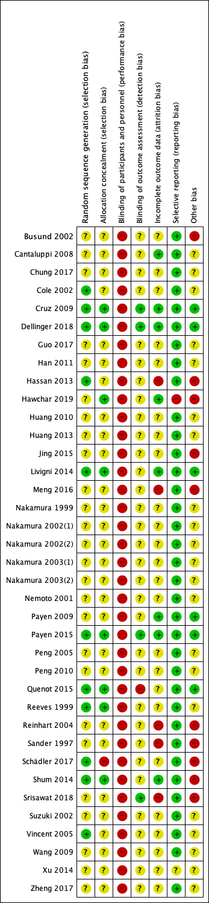

Figure S2 - Risk of bias graph: review authors' judgments about each risk of bias item presented as percentages across all included studies.

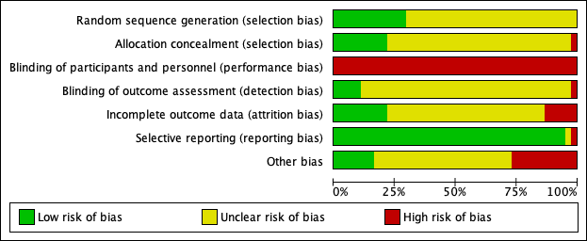

Table S7 - Certainty of the body of evidence assessment using the grading of recommendations assessment, development and evaluation (GRADE) framework.
Certainty assessment |  |  |  |  |  |  | № of patients |  | Effect |  | Certainty | Importance
№ of studies | Study design | Risk of bias | Inconsistency | Indirectness | Imprecision | Other considerations | HP | conventional therapy | Relative  (95% CI) | Absolute  (95% CI)
Hemoperfusion - Mortality at longest follow-up available
20 | randomised trials | serious ª | serious ^{b} | serious ^{c} | serious ^{d} | publication bias strongly suspected | 316/789 (40.1%) | 341/759 (44.9%) | RR 0.88  (0.78 to 0.98) | 54 fewer per 1 000  (from 99 fewer to 9 fewer) | ⨁◯◯◯  VERY LOW | CRITICAL
Hemoperfusion with polymyxin B - Mortality at longest follow-up available
13 | randomised trials | serious ª | serious ^{b} | not serious | serious ^{d} | publication bias strongly suspected | 253/599 (42.2%) | 272/564 (48.2%) | RR 0.87  (0.77 to 0.98) | 63 fewer per 1 000  (from 111 fewer to 10 fewer) | ⨁◯◯◯  VERY LOW | CRITICAL
Hemoperfusion with polymyxin B - low risk of bias trials - Mortality at longest follow-up available
3 | randomised trials | not serious | not serious | not serious | serious ^{d} | none | 164/376 (43.6%) | 141/369 (38.2%) | RR 1.14  (0.96 to 1.36) | 53 more per 1 000  (from 15 fewer to 138 more) | ⨁⨁⨁◯  MODERATE | CRITICAL
Hemoperfusion with polymyxin B - recent trials published after 2010 - Mortality at longest follow-up available
3 | randomised trials | serious | not serious | not serious | serious | none | 167/371 (45.0%) | 136/369 (36.9%) | RR 1.23  (1.04 to 1.46) | 85 more per 1 000  (from 15 more to 170 more) | ⨁⨁◯◯  LOW | CRITICAL
Hemoperfusion without polymyxin B - Mortality at longest follow-up available
7 | randomised trials | serious ª | serious ^{b} | serious ^{c} | serious ^{d} | none | 63/190 (33.2%) | 69/195 (35.4%) | RR 0.91  (0.70 to 1.19) | 32 fewer per 1 000  (from 106 fewer to 67 more) | ⨁◯◯◯  VERY LOW | CRITICAL

Hemofiltration - Mortality at longest follow-up available
13 | randomised trials | serious | not serious | serious | serious | none | 93/307 (30.3%) | 115/289 (39.8%) | RR 0.79  (0.63 to 1.00) | 84 fewer per 1’000  (from 147 fewer to 0 fewer) | ⨁◯◯◯  VERY LOW | CRITICAL
Combined hemofiltration and hemoperfusion - Mortality at longest follow-up available
4 | randomised trials | serious | not serious | serious | very serious | none | 51/122 (41.8%) | 66/125 (52.8%) | RR 0.63  (0.63 to 1.13) | 195 fewer per 1’000  (from 195 fewer to 69 more) | ⨁◯◯◯  VERY LOW | CRITICAL
Plasmapheresis - Mortality at longest follow-up available
2 | randomised trials | serious | not serious | serious | very serious | none | 21/63 (33.3%) | 34/65 (52.3%) | RR 0.63  (0.42 to 0.96) | 194 fewer per 1’000  (from 303 fewer to 21 fewer) | ⨁◯◯◯  VERY LOW | CRITICAL
CI: Confidence interval; RR: Risk ratio

Figure S3 – Hemoperfusion and mortality. Forest plot for the relative risk of mortality at longest follow-up available with hemoperfusion with different devices.

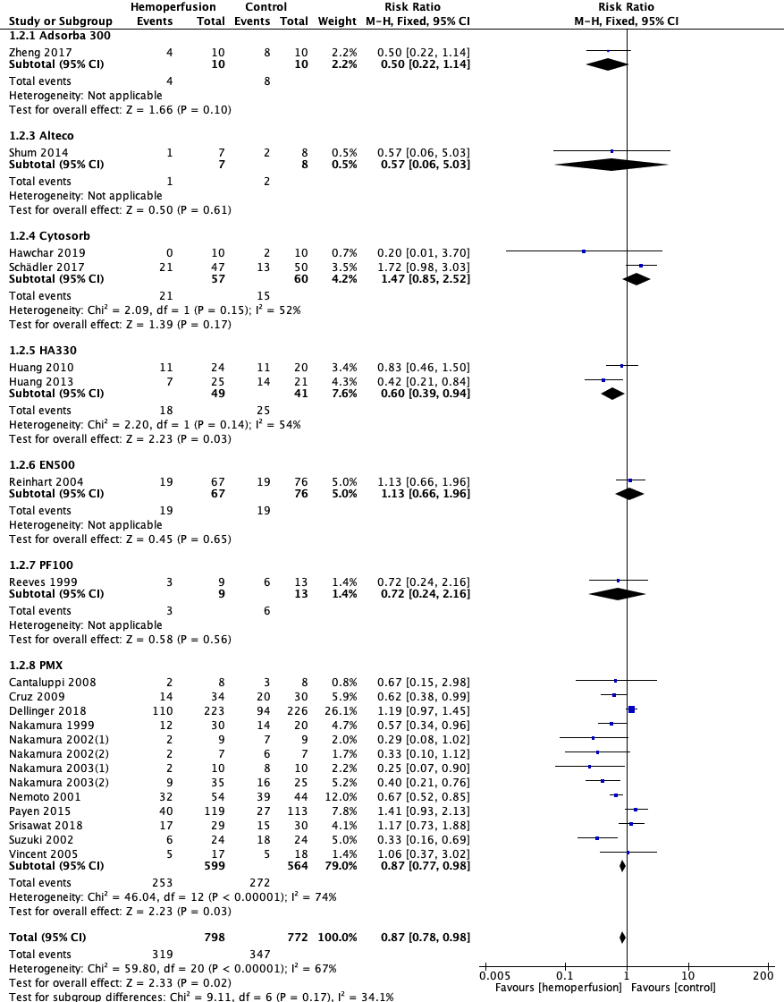

Figure S4 – Funnel plot for mortality with hemoperfusion techniques.

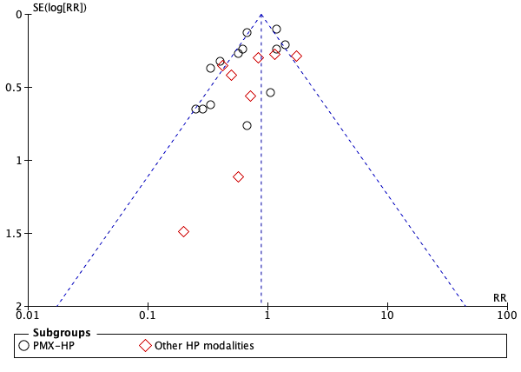

Table S8 – Sensitivity analyses for hemoperfusion.

Type of analysis | Effect estimate | p value
Primary analysis (fixed-effects model) | RR = 0.87 [95% CI, 0.77, 0.98] | 0.02
Random-effects model | RR = 0.72 [95% CI, 0.57, 0.91] | 0.006
Odds Ratio | OR = 0.79 [95% CI, 0.64, 0.96] | 0.02
Risk Difference | RD = -0.06 [95% CI, -0.10, -0.01] | 0.01
CI, confidence interval; RR, relative risk; OR, odds ratio; RD, risk difference.

Figure S5 – Trial sequential analysis for mortality at longest follow-up available with hemoperfusion (any device).

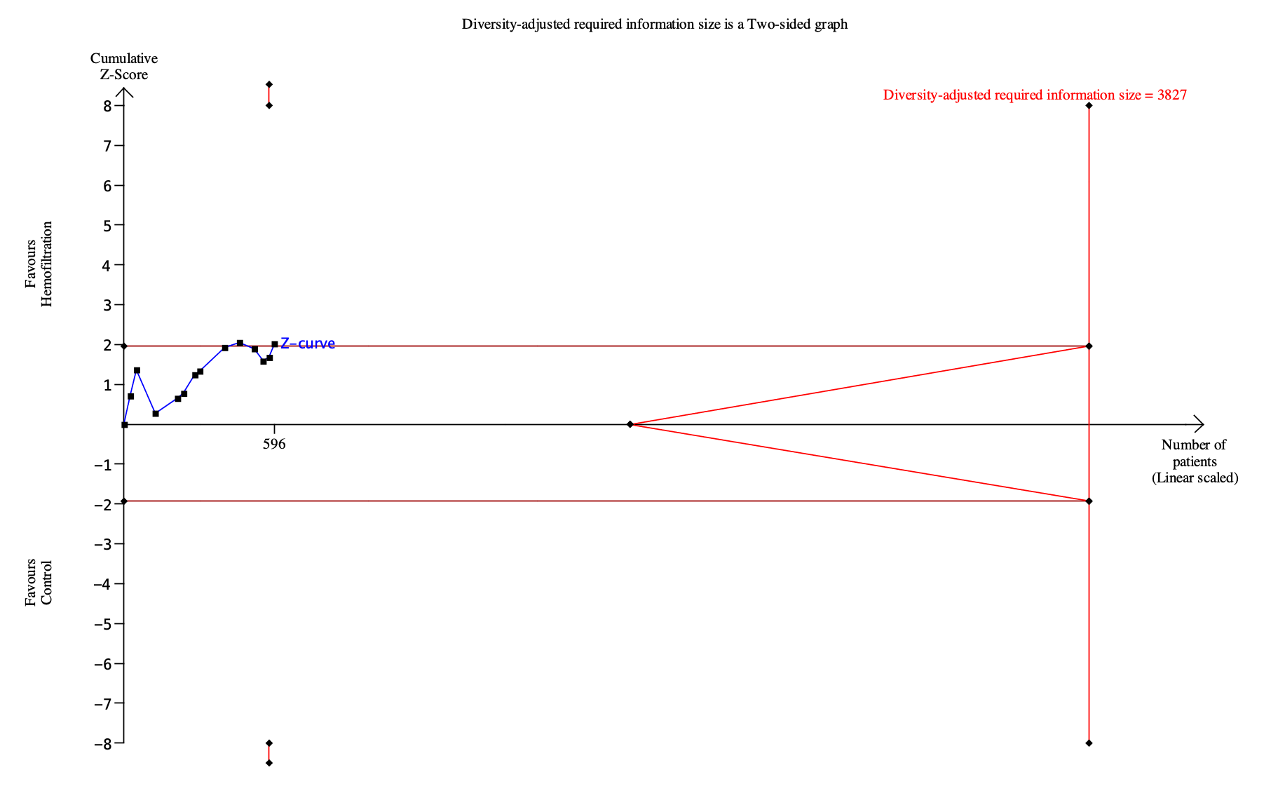

Figure S6 – Hemoperfusion (any device) and mortality. Subgroup analysis according to geographical area.
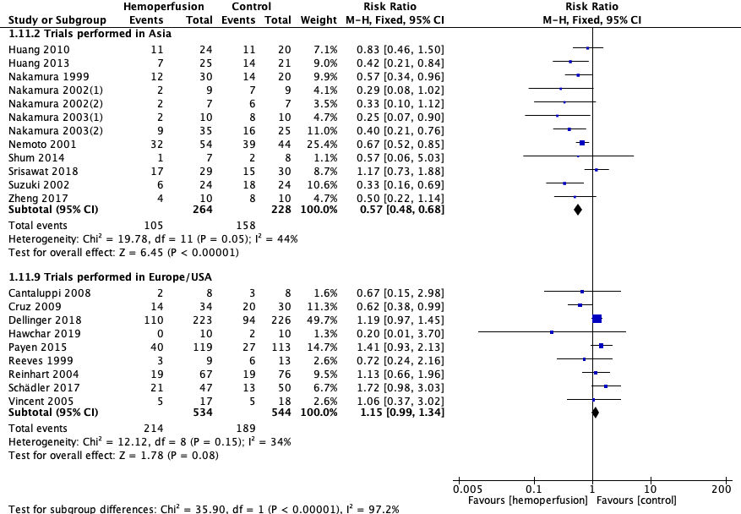

Figure S7 – Hemoperfusion (any device) and mortality. Subgroup analysis according to year of publication.

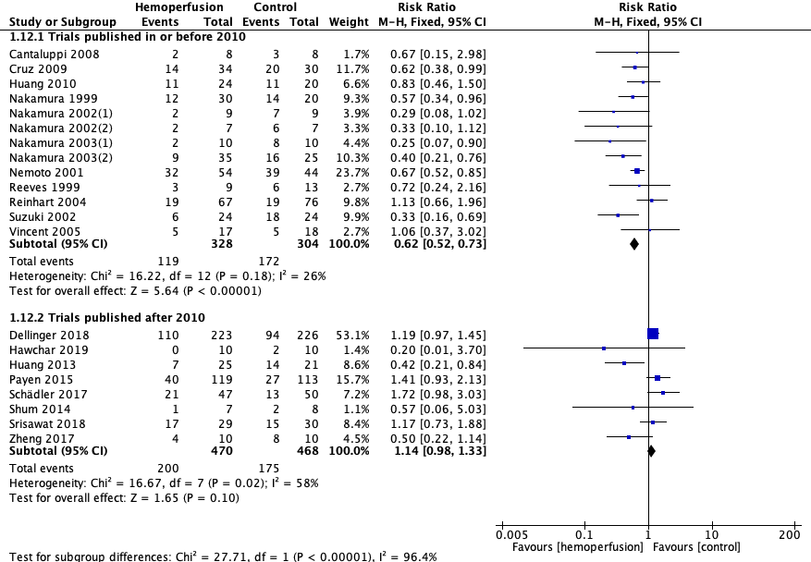

eResults 1 – Hemoperfusion (any device) and mortality. Meta-regression for APACHE 2 score, SOFA score, control group mortality, and age.
Baseline APACHE II and SOFA scores were reported in 70% and 50% of the trials, without any correlation with mortality in the meta-regression. A post-hoc meta-regression found a relationship between effect estimate and control group mortality (p<0.001).

Random-effects meta-regression for APACHE 2 score and mortality (p = 0.859).

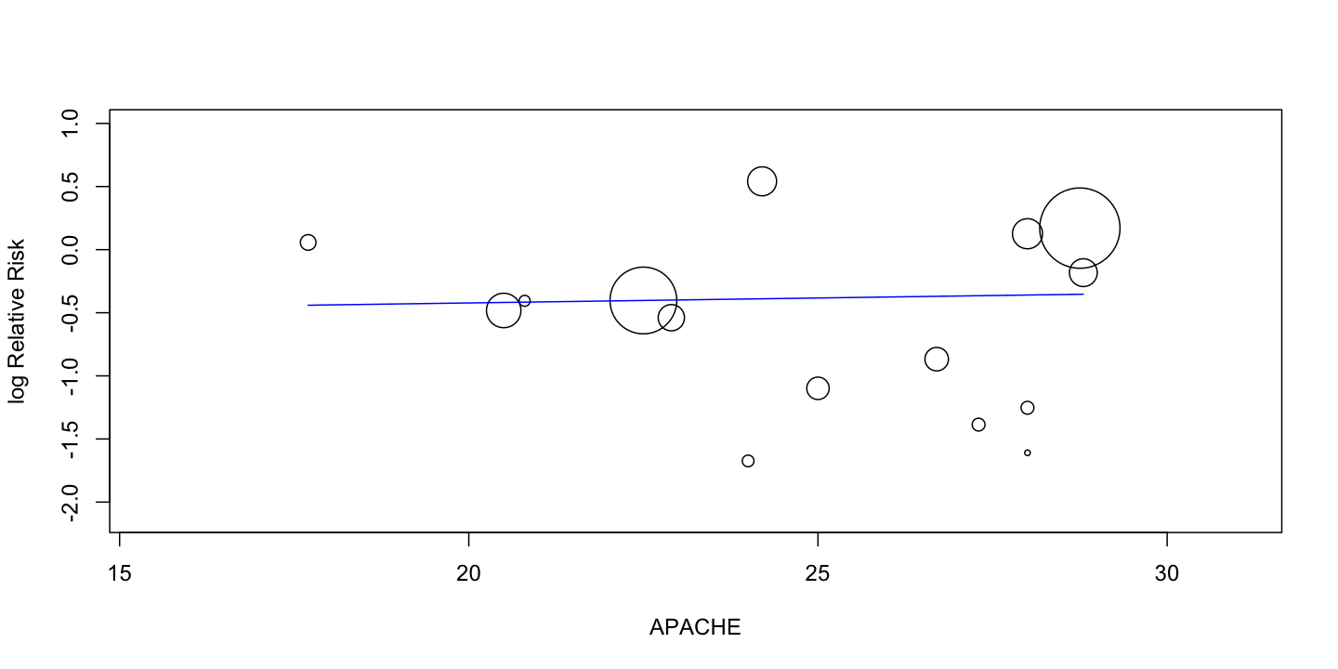
Random-effects meta-regression for SOFA score and mortality (p = 0.180).
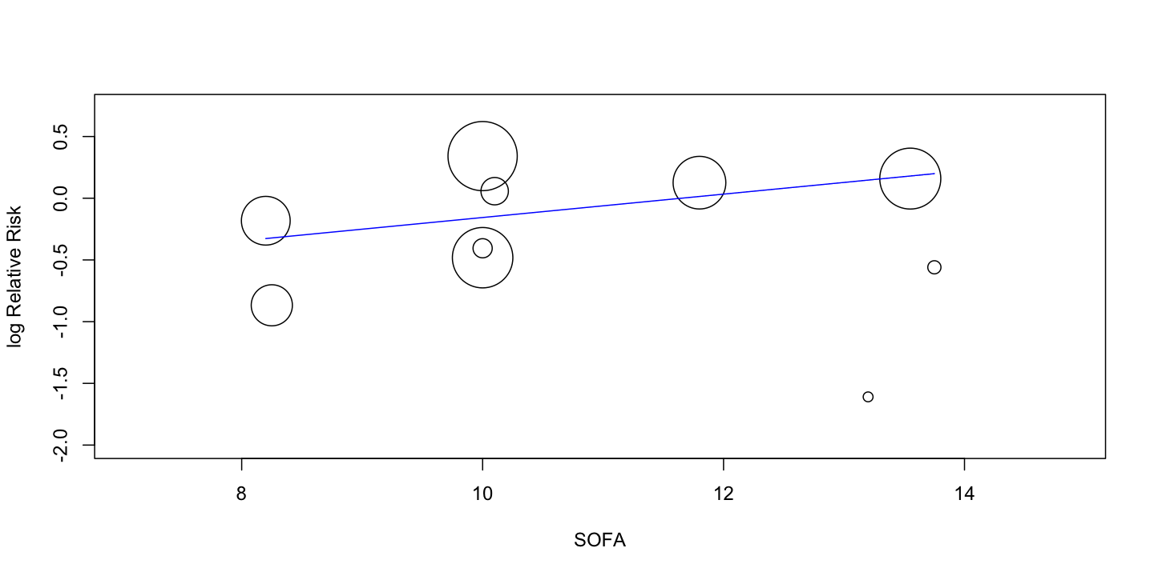

Random-effects meta-regression for conventional therapy mortality (control group mortality) (p<0.001).
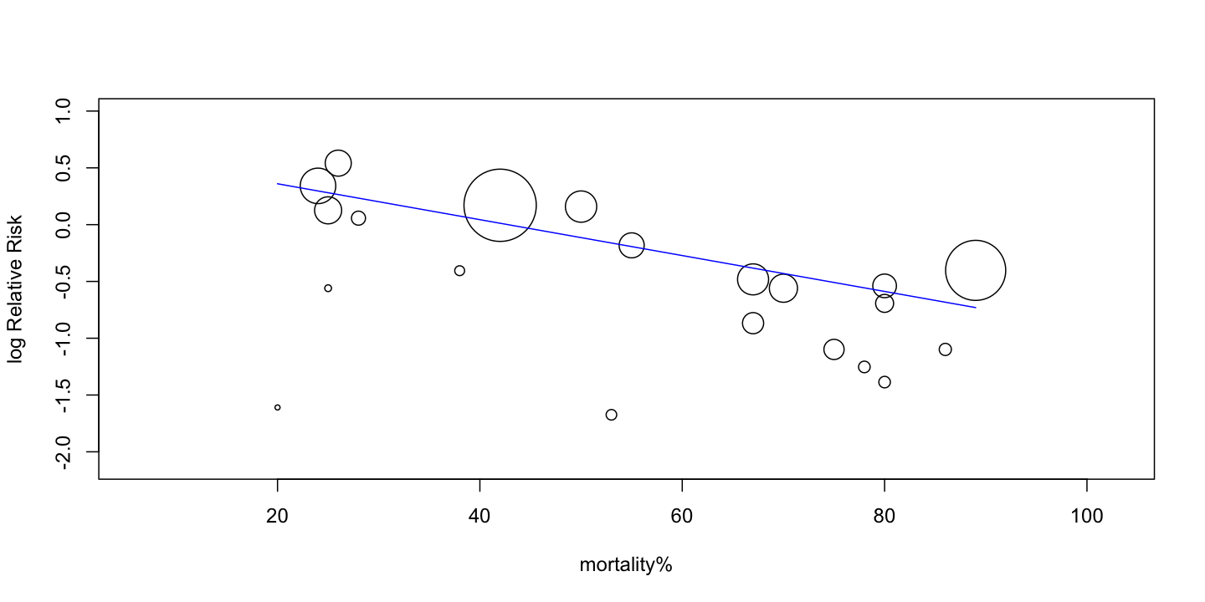

Random-effects meta-regression for age (p = 0.029). The results changed significantly (p = 0.08) when excluding the trial Nakamura 2002(a) (18 patients, mean age = 40), the only trial with mean age lower than 53.
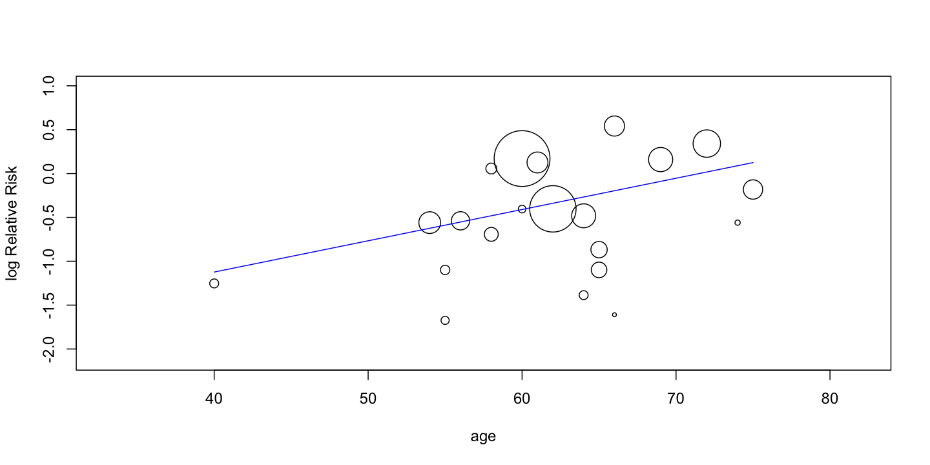

Figure S8 – Hemoperfusion (any device) and mortality. Forest plot for the relative risk of mortality at longest follow up available according to disease severity.
A significant mortality risk reduction was observed in the trials with control group mortality higher than 60% (RR = 0.49 [95% CI, 0.41 to 0.59], p<0.001); 90% of the trials in the high-risk group were trials conducted in Asia and presented a high risk of bias, limiting the validity of this aggregate sub-analysis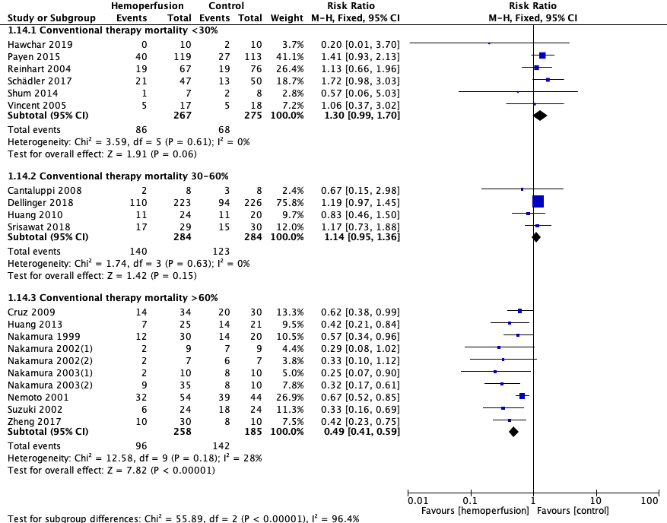

Figure S9 - Hemoperfusion and 30-days mortality (secondary endpoint). Forest plot for the relative risk of 28/30-days mortality.

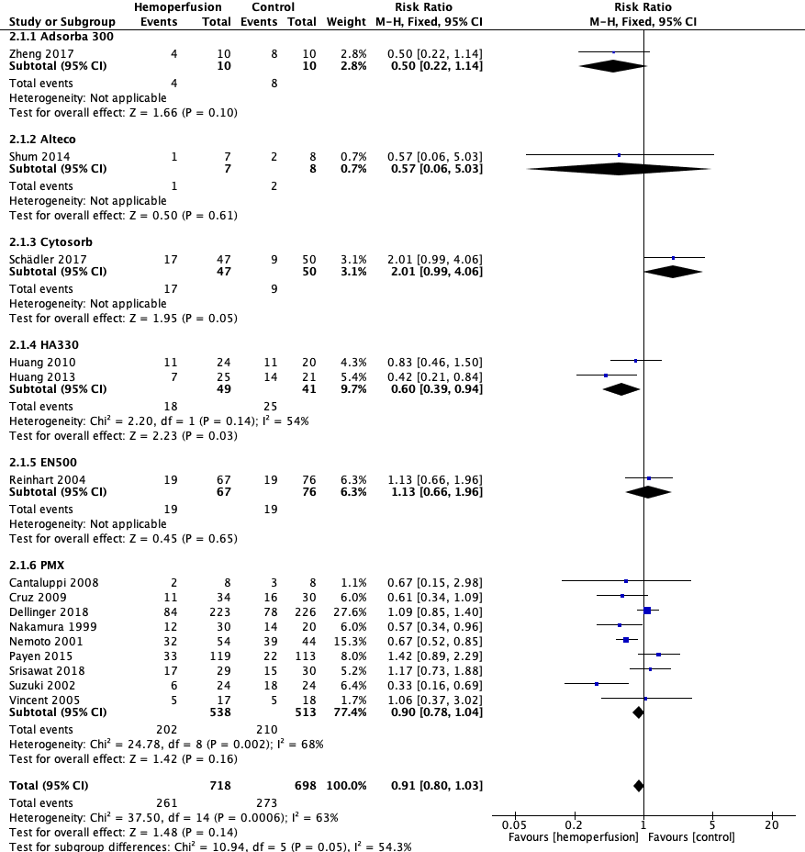

Figure S10 – Polymyxin B-immobilized fiber column hemoperfusion and mortality. Subgroup analysis according to risk of bias assessment.

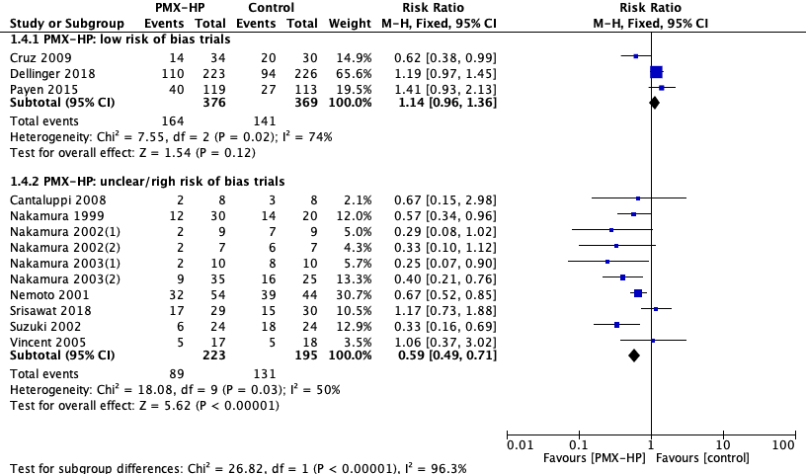

Figure S11 – Polymyxin B-immobilized fiber column hemoperfusion and mortality. Subgroup analysis according to geographical area.
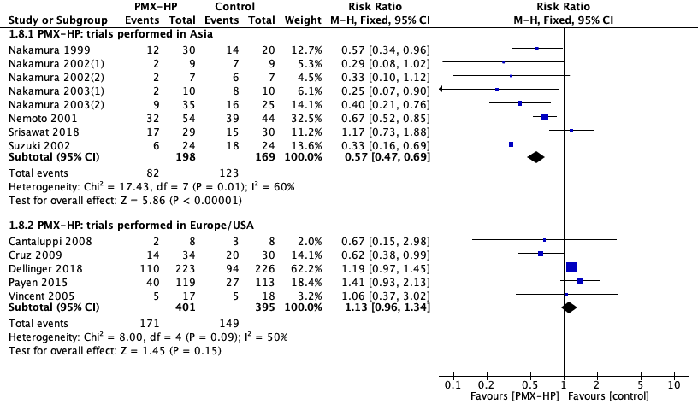

Figure S12 – Polymyxin B-immobilized fiber column hemoperfusion and mortality. Subgroup analysis excluding trials from Nakamura group.
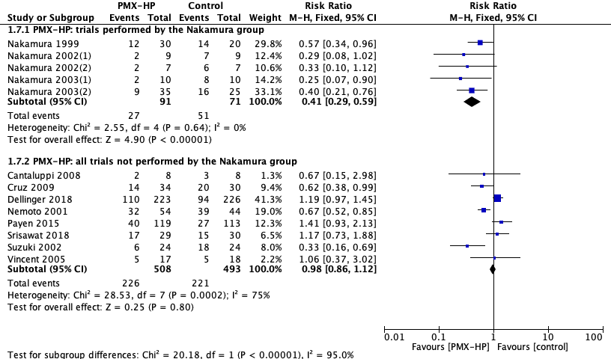

Figure S13 – Polymyxin B-immobilized fiber column hemoperfusion and mortality. Subgroup analysis according to year of publication.
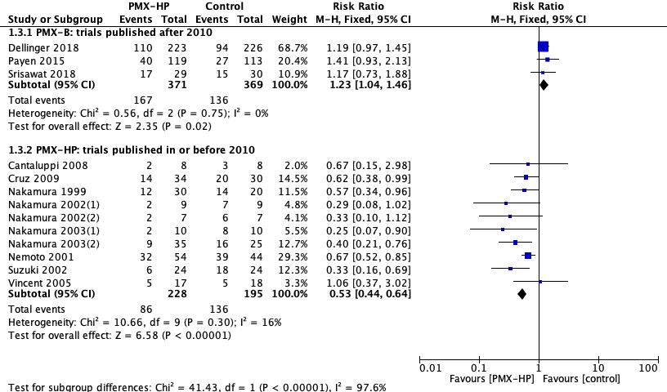

Figure S14 – Trial sequential analysis for mortality at longest follow-up available with hemofiltration.

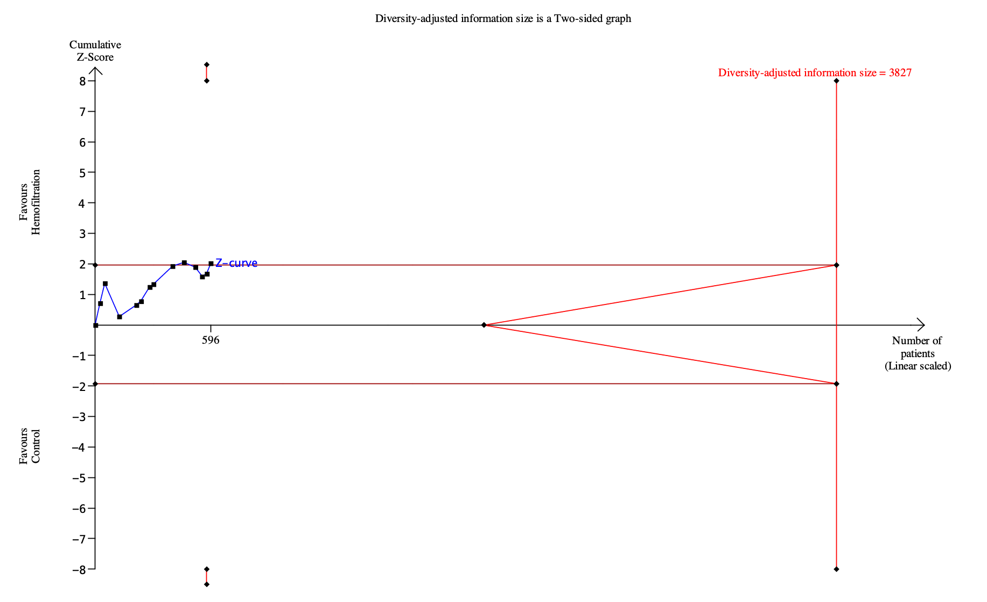

Figure S15 – Hemofiltration and mortality. Subgroup analysis according to geographical area.

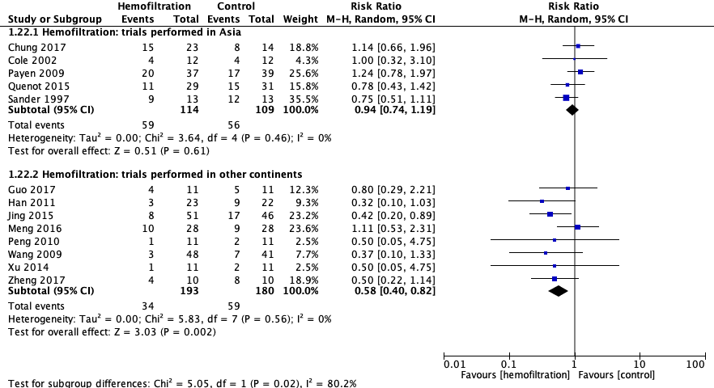

Figure S16 – Hemofiltration and mortality. Subgroup analysis according to year of publication.

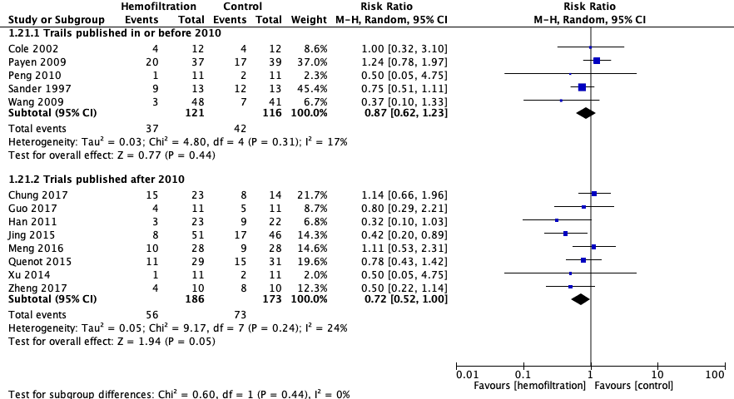

Figure S17 – Hemofiltration and mortality. Forest plot for the relative risk of mortality at longest follow up available according to disease severity.

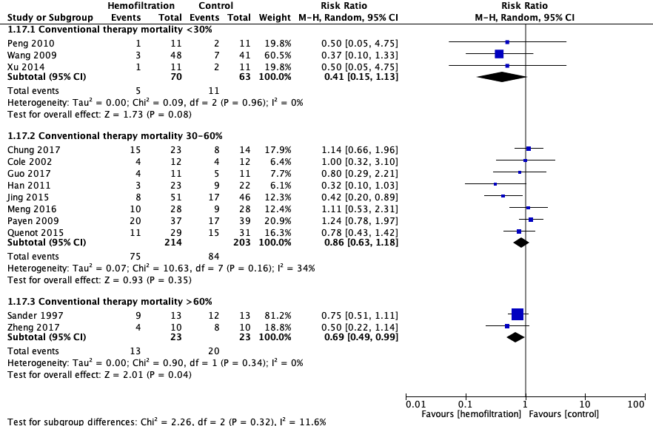

Figure S18 - Hemofiltration, combined hemofiltration and hemoperfusion, and plasmapheresis. Forest plot for the relative risk of 28/30-days mortality (secondary endpoint).
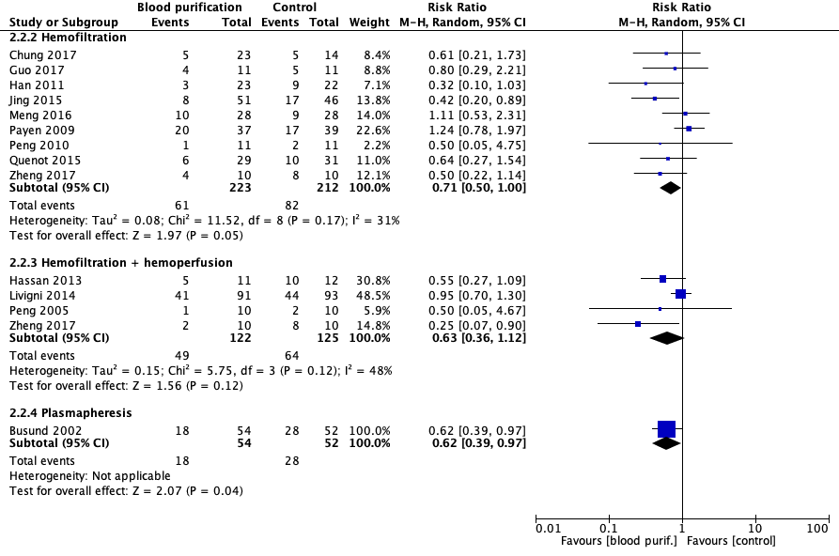

Table S9 – Sensitivity analyses for hemofiltration, combined hemofiltration and hemoperfusion, and plasmapheresis.

Type of analysis | Effect estimate | p value
HEMOFILTRATION
Primary analysis (random-effects model) | RR = 0.79 [95% CI, 0.63, 1.00] | 0.05
Fixed-effects model | RR = 0.76 [95% CI, 0.62, 0.94] | 0.01
Odds Ratio | OR = 0.61 [95% CI, 0.40, 0.94] | 0.02
Risk Difference | RD = -0.11 [95% CI, -0.18, -0.04] | 0.003
COMBINED HEMOFILTRATION AND HEMOPERFUSION
Primary analysis (random-effects model) | RR = 0.63 [95% CI, 0.36, 1.13] | 0.12
Fixed-effects model | RR = 0.79 [95% CI, 0.61, 1.04] | 0.09
Odds Ratio | OR = 0.32 [95% CI, 0.08, 1.23] | 0.10
Risk Difference | RD = -0.25 [95% CI, -0.51, 0.02] | 0.07
PLASMAPHERESIS
Primary analysis (random-effects model) | RR = 0.79 [95% CI, 0.63, 1.00] | 0.03
Fixed-effects model | RR = 0.63 [95% CI, 0.42, 0.96] | 0.03
Odds Ratio | OR = 0.45 [95% CI, 0.22, 0.92] | 0.03
Risk Difference | RD = -0.19 [95% CI, -0.36, -0.02] | 0.03
CI, confidence interval; RR, relative risk; OR, odds ration; RD, risk difference.

eResults 2 – Hemofiltration and mortality. Meta-regression for APACHE 2 score, SOFA score, control group mortality, and age.
Random-effects meta-regression for APACHE 2 score and mortality (p = 0.250).
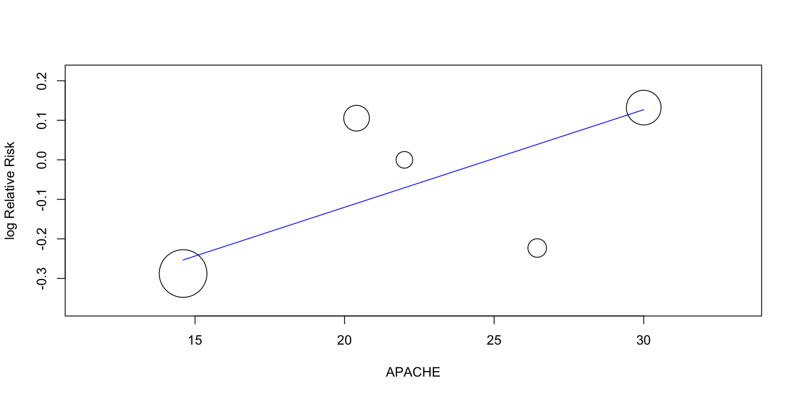

Random-effects meta-regression for SOFA score and mortality (p = 0.148).
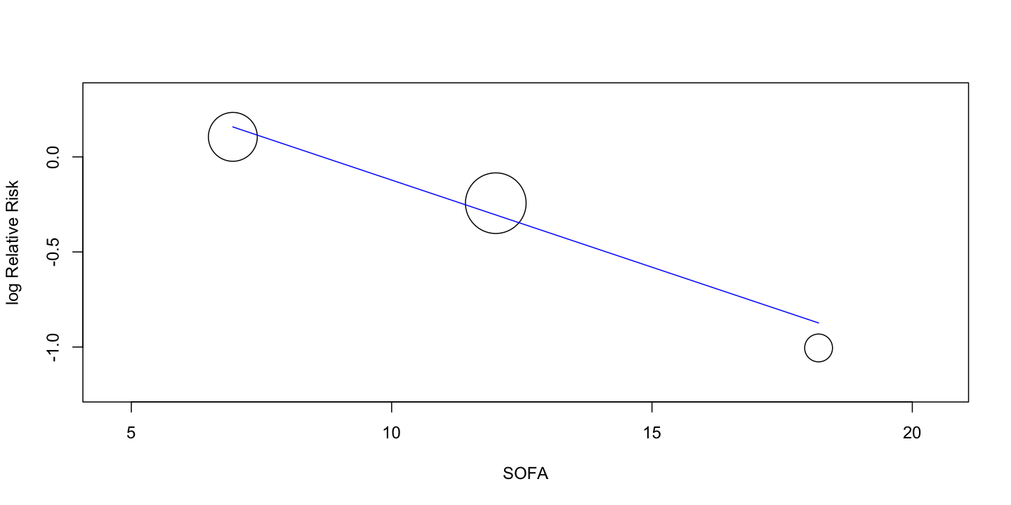

Random-effects meta-regression for conventional therapy mortality (control group mortality) (p = 0.949).
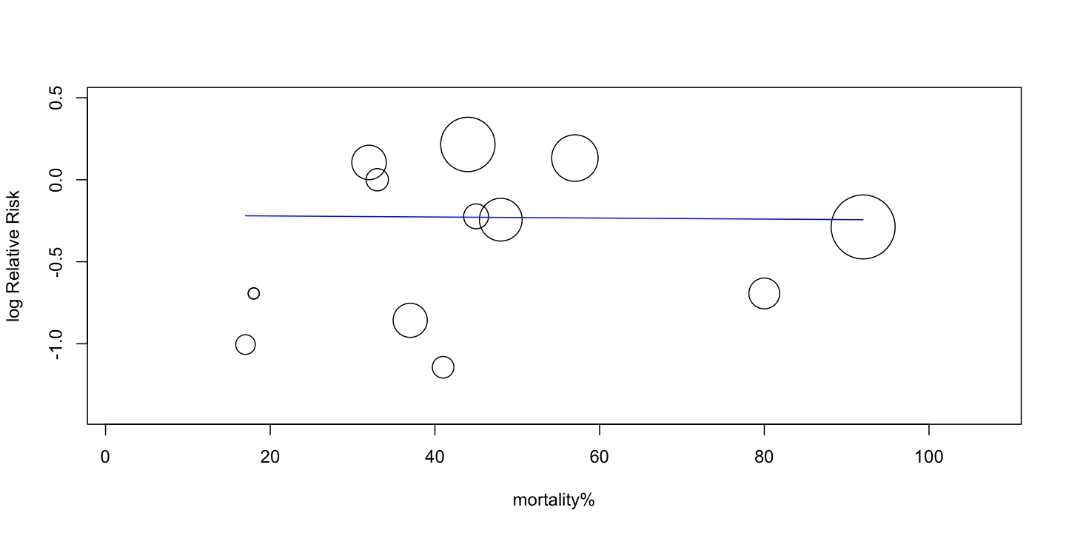

Random-effects meta-regression for age (p = 0.591).

