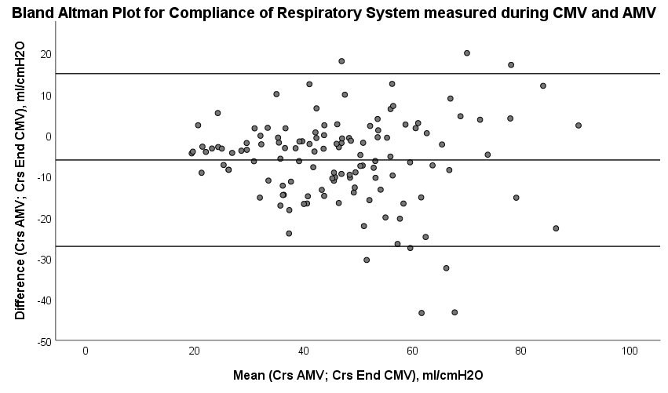
Figure E2: Bland and Altman plot showing the differences between C_{RS} (ml/cmH₂O) measured during Controlled and Assisted Mechanical Ventilation (CMV and AMV).

