Individualized positive end-expiratory pressure and regional gas exchange in porcine lung injury

Muders T, Luepschen H, Meier T, Reske A, Zinserling J, Kreyer S, Pikkemaat R, Maripuu E, Leonhardt S, Hedenstierna G, Putensen C, and Wrigge H

**Supplemental Digital Content 1 - Assessment of tidal recruitment using Electrical Impedance Tomography (EIT)**

Regional ventilation delay inhomogeneity (RVDI) was measured using electrical impedance tomography (EIT) as recently described 1 to estimate the amount of tidal recruitment.

EIT images were recorded during one low flow breath (slow inflation) with a tidal volume of 12 ml/kg BW. An EIT system (EIT evaluation KIT II, Dräger Medical GmbH, Lübeck, Germany) was used. The EIT device produces image vectors Δz(tk) with 912 elements (or pixels) each at discrete points in time tk. In order to obtain the best temporal resolution, we set the maximal frame rate to 40 images per second so that. These image vectors show the impedance change at time tk related to a reference impedance measurement previously recorded (usually the reference is the average impedance distribution calculated over the preceding breath cycles). Images are reconstructed applying a modified Newton-Raphson algorithm 2. In addition, the EIT device calculates functional EIT image vectors f(tk) based on the standard deviation over the preceding breath cycles 1.

After temporal low-pass filtering with a corner frequency of fc = 50 min-1 to suppress cardiac-related impedance changes, the functional EIT image vector f at the beginning of the slow inflation was used to determine the region of interest (ROI, i.e. the lung region) by setting a threshold to 15% of the maximum value of f. Therefore, we calculated new image vectors Δz*(tk) with NL<912 elements containing only the NL elements of the lung ROI (using the mask derived from thresholding f). For simplicity, we will denominate Δz*(tk) as Δz(tk) from now on. We then discarded all image vectors taken outside the low flow breath retaining N vectors Δz(tk) with k = 1…N wherein k = 1 designates the beginning and k = N the end of the low flow breath. t1 = tmin and tN = tmax were derived from the minimum and maximum of the global impedance change ΔZ(tk) which is given by the sum over all pixels in the lung ROI 1. Afterwards, each pixel time curve Δzi(tk) was normalized to its respective impedance values at times tmin and tmax.

Regional-Ventilation-Delay time (ΔtRVD) 1 was determined between the start of inspiration defined as first increase of the global ∆Z(t) curve and the time when the respective regional curve ∆Zi(t) reaches a threshold of 40 % of the maximal local impedance change (figure 1) 1. To address the fact that ΔtRVD depends on inflation time, it was normalized by dividing by inflation time (Δtmax-min):

RVD = ΔtRVD / Δtmax-min

Thus, Regional-Ventilation-Delay describes the delay given in [%] of inflation time until the respective regional impedance change exceeds a certain threshold (figure 1) 1.

RVDs were obtained for any single EIT-pixel. A color-coded map was plotted to visualize the pixels’ Regional-Ventilation-Delay Indices. To quantify Regional-Ventilation-Delay Inhomogeneity (RVDI) the standard deviation over all single pixel RVDs was calculated (figure 1, right panel) RVDI was shown to be well correlated to intratidal recruitment (r was 0.88 for inter-individual linear correlation and 0.69 to 0.99 for intra-individual linear correlation of RVDI and tidal recruitment) 1.

Figure 1 of the main document shows calculation of regional ventilation delay inhomogeneity (RVDI) as a schematic description. The left panel shows the functional image (ventilation map) recorded by EIT during a slow inflation maneuver. The medium panel shows normalized regional impedance/time curves of three exemplary pixels during slow inflation breath of 12 ml/kg BW. All curves are normalized to the beginning (tmin) and end (tmax) of the slow inflation maneuver (blue: right ventral pixel, red: right dorsal pixel, yellow: left dorsal pixel). Ventilation delay time (ΔtRVD) of every pixel was determined between the start of inspiration (tmin) and the time when the respective regional impedance-time curve reaches a threshold of 40% of the maximal local impedance change. In this example it takes 57% of the complete maneuver time (tmax-tmin) for the impedance of the left dorsal region to reach 40% of its maximum value on the ordinate whereas it only takes 36% in the right ventral region. The right panel displays the RVD-map to visualize all RVD-indices. Regional-ventilation-delay-inhomogeneity (RVDI) can by expressed by calculating the standard deviation of all single pixel values 1.

In the present study EIT was used to titrate PEEP aiming at minimizing RVDI, assuming that RVDI is able to detect PEEP-related changes in tidal recruitment. Since our method to quantify RVDI was previously validated in a model of lung injury that was characterized by large recruitability (central venous oleic acid injection and intra-abdominal hypertension (IAH) of 20 cm H2O), it is not clear if RVDI is able to detect an 'optimal' PEEP in lungs less responsive to recruitment. Figure S1 shows a comparison of courses of RVDI during PEEP titration in highly recruitable lungs (closed circles; present study) and in healthy lungs with no/low recruitability (open circles; unpublished data). These data suggest that RVDI-measurements will provide low values even at lower or lowest PEEP levels when less or no tidal recruitment is present. Hence, RVDI-based PEEP titration might be helpful even in non-recruitable lungs to avoid increased PEEP levels that do not further prevent tidal recruitment.

## *Figure S1*

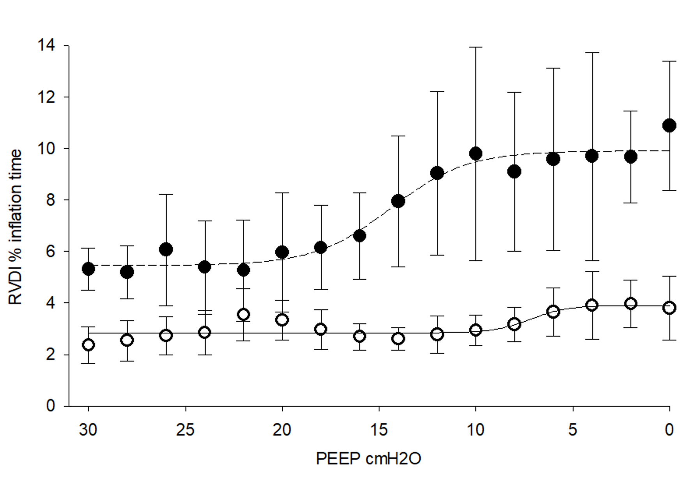

Courses of regional ventilation delay inhomogeneity (RVDI) during PEEP titration. Closed circles: 14 lung injured pigs. Open circles: nine healthy pigs (unpublished).

EIT-based estimation of tidal recruitment (RVDI-measurements) during PEEP-titration from the current study (IAP of 15 cmH2O) was compared to data from our previous CT-validation study (data from 1, IAP of 20 cmH2O) (figure S1). This analysis suggests that IAP influences tidal recruitment on lower PEEP levels (below 10 cm H2O). Using higher IAP might have aggravated our findings on tidal recruitment. However, PEEP selection would probably not have been influenced.

1. Muders T, Luepschen H, Zinserling J, Greschus S, Fimmers R, Guenther U, Buchwald M, Grigutsch D, Leonhardt S, Putensen C, Wrigge H: Tidal recruitment assessed by electrical impedance tomography and computed tomography in a porcine model of lung injury*. Crit Care Med 2012; 40:903–11

2. Frerichs I, Amato MBP, Kaam AH van, Tingay DG, Zhao Z, Grychtol B, Bodenstein M, Gagnon H, Böhm SH, Teschner E, Stenqvist O, Mauri T, Torsani V, Camporota L, Schibler A, Wolf GK, Gommers D, Leonhardt S, Adler A: Chest electrical impedance tomography examination, data analysis, terminology, clinical use and recommendations: consensus statement of the TRanslational EIT developmeNt stuDy group. Thorax 2016: thoraxjnl-2016-208357 doi:10.1136/thoraxjnl-2016-208357