Individualized positive end-expiratory pressure and regional gas exchange in porcine lung injury

Muders T, Luepschen H, Meier T, Reske A, Zinserling J, Kreyer S, Pikkemaat R, Maripuu E, Leonhardt S, Hedenstierna G, Putensen C, and Wrigge H

Supplemental Digital Content 12 - Results from densitometric CT analyses
Comparable degrees of lung tissue aeration were found with both maximal-oxygenation-PEEP and minimal-tidal-recruitment-PEEP settings. In contrast, table-PEEP led to significant decrease in lung aeration (repeated measures ANOVA, P<0.05 for factors HU-distribution, PEEP, and their interaction, respectively figure S4).

Figure S4
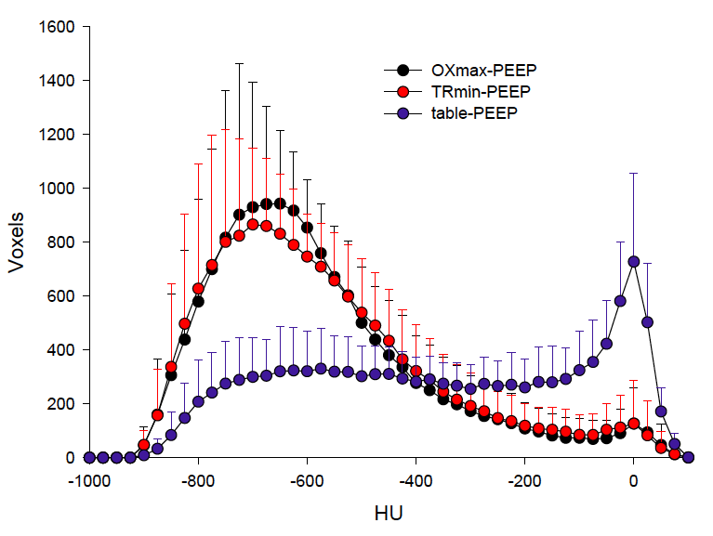
Densitometric analysis of the lung during ongoing ventilation with table-PEEP ,maximal-oxygenation-PEEP (OXmax-PEEP) and minimal-tidal-recruitment-PEEP (TRmin-PEEP), respectively; obtained from transmission scans during SPECT; Gas content increases from the right (0 HU, no gas, to the left (-1000 HU, 100% gas); given as mean and SD in voxel per Hounsfield units; repeated measures ANOVA, P<0.05 for factors HU-distribution, PEEP, and their interaction, respectively.
Total lung volume was reduced with table-PEEP when compared to maximal-oxygenation-PEEP and minimal-tidal-recruitment-PEEP settings (figure S5). Reduced lung volume during table-PEEP was associated with a reduction in normally aerated lung tissue (figure S5) but an increase in non-aerated lung tissue volume (figure S5). Total gas content was lower with table-PEEP when compared to both maximal-oxygenation-PEEP and minimal-tidal-recruitment-PEEP settings (figure S5).

Figure S5
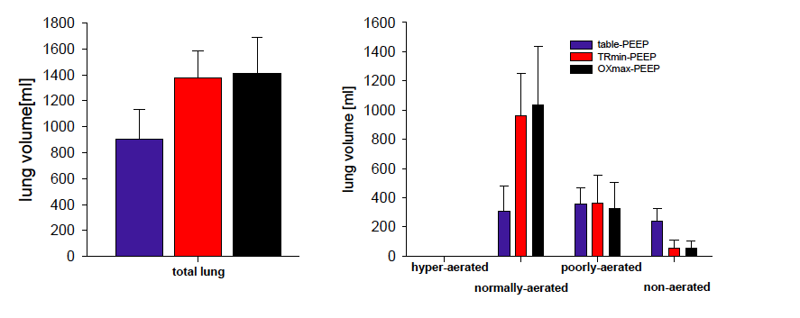
left: total lung volume obtained from transmission CT scans during SPECT, repeated measures ANOVA, P<0.05; right: distribution of total lung volume to differentially aerated lung tissue compartments given as mean and SD in ml; repeated measures ANOVA, P<0.05 for factors aeration distribution, PEEP, and their interaction, respectively

Total lung mass did not differ between PEEP modes (figure S6). However, non-aerated lung tissue mainly contributed to total lung mass during table-PEEP settings (figure S6), whereas lung mass essentially consisted of normally aerated lung tissue (figure S6) with both maximal-oxygenation-PEEP and minimal-tidal-recruitment-PEEP settings.

Figure S6
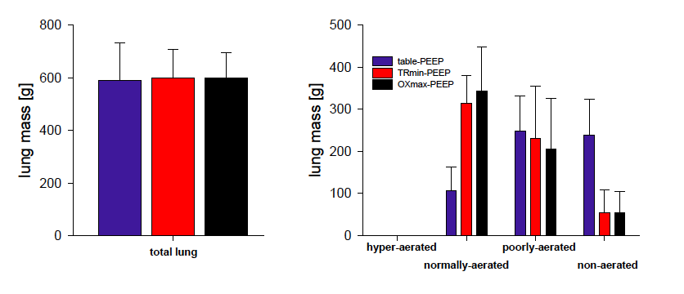
left: total lung mass obtained from transmission scans during SPECT, repeated measures ANOVA, n.s.; right: distribution of total lung mass to differentially aerated lung tissue compartments given as mean and SD in g; repeated measures ANOVA, P<0.05 for factors aeration distribution, PEEP, and their interaction, respectively

