Supplementary Digital Content 3
Group Sensor Level Power Analysis. Pre-processed data (as described in the methods) were used in the source level were used to evaluate sensor level changes as follows. Group sensor level power calculations were statistically assessed at each frequency band first, within gases and across the baselines and step-wise gas concentrations and second, across gases and within the baselines and equivalent MAC-awake gas concentrations. The statistical method utilized here was a Non-Parametric Group Statistics approach proposed by Nichols and Holmes,^{1,2} which has been subsequently used by countless research groups, particularly pertaining to BOLD-fMRI statistical analysis as well as more recently in magnetoencephalography statistical analysis (e.g. ^{3,4}).
For the across gas comparison, a two-sample t-statistic calculation was performed within each frequency band and subject, all valid trials within a sensor at each of the Nitrous Oxide (N₂O) gas pre- and post- baselines and equivalent 0.25, 0.50, 0.75 MAC-awake concentrations levels were contrasted to all valid trials within a sensor for Xenon (Xe) gas. Loss of responsiveness under Xe anaesthesia was not included in this analysis as the corresponding gas concentration of 1.30 MAC-awake does not apply to N₂O. The resulting student’s t-statistic maps of the sensor power for all sensors were tested against the null hypothesis that the distribution of a given condition in N₂O isn’t significantly different to the same condition for Xe. In order to correct for multiple comparisons across the magnetoencephalography and electroencephalography sensors, a null distribution was computed using 5000 permutations of the t-statistic sign at each sensor and across participants.⁵ Calculation of one-sample t-tests was performed across individuals. Maximum statistics with significance set at p=0.050 were performed under the omnibus null hypothesis that if changes at each permutation were not significant at the sensors with the highest and lowest t-statistic values then none of the remaining sensors should have significant changes. This method allowed for the correction of multiple comparisons problem across sensors. Finally, in order to correct for the multiple comparisons performed across conditions, Bonferroni-Holm corrections were used, resulting in a t-statistic threshold with significance set at p=0.004 for the multiple conditions comparison across gases (p=0.025 to allow for two tailed comparison of increases and decreases in power; p=0.025/6 for the six condition comparisons).
Significant differences (p=0.004) in sensor level magnetoencephalography and electroencephalography for equivalent N₂O to Xe concentrations are shown in Supp. Figure 3A and summarized in Supp. Table 3A. Importantly, this contrast revealed no significant differences in the pre-antiemetic baselines and post-antiemetic baseline across the two agents suggesting that the two recording sessions were sufficiently similar in all participants and both modalities. In addition, this comparison again pointed to agent as well as modality specific alterations. Differences across the two dissociative agents were observed in all frequencies for electroencephalography sensor absolute power while the magnetoencephalography only yielded differences in the delta, theta, alpha and beta bands. The contrast revealed bandwidth and modality invariant decreases for N₂O relative to Xe and bandwidth and modality specific occipital increases in magnetoencephalography delta, theta and alpha bands.
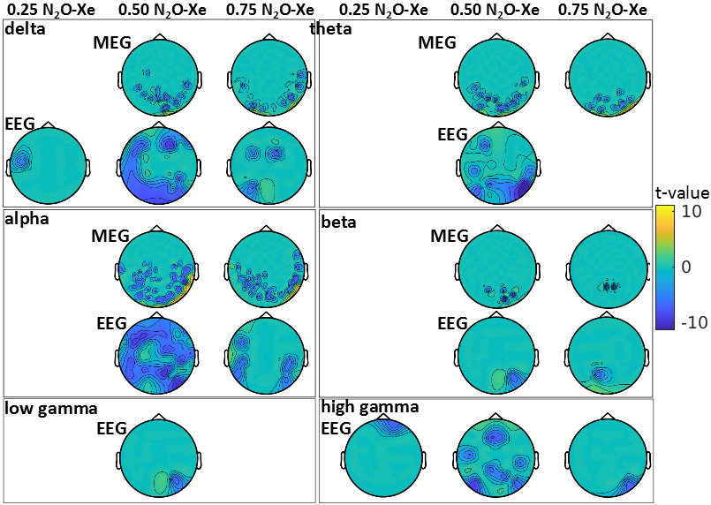
Supp. Figure 3A. Group sensor level differences in power across equivalent increasing Xenon and Nitrous Oxide administered doses. Maximum statistic and Bonferroni corrected t-statistic topomaps with significant changes (p=0.004) for 0.25, 0.50, 0.75 MAC-awake Nitrous Oxide (N₂O) relative to Xenon (Xe) for the 306 magnetoencephalography channels (MEG) and 64 electroencephalography channels (EEG). Absolute maximum significance for MEG and EEG (t-value = 11.24). [delta (1-4 Hz), theta (4-8 Hz), alpha (8-13 Hz), beta (13-30 Hz), low gamma (30-49 Hz), high gamma (51-99 Hz)].
 | 0.25 MAC-awake N₂O-Xe |  | 0.50 MAC-awake N₂O-Xe |  | 0.75 MAC-awake N₂O-Xe
 | MEG | EEG | MEG | EEG | MEG | EEG
Delta |  |  | decreased posterior power | widespread decreased power | decreased posterior power  increased  posterior power | decreased  anterior, posterior power  increased  left frontal/central power
Theta |  |  | decreased posterior power  increased  occipital power | widespread decreased  power | decreased posterior power  increased  occipital power
Alpha |  |  | decreased posterior power  increased  right parietal/occipital power | widespread decreased  power | decreased posterior power  increased  right parietal/occipital power | decreased parietal, frontal power
Beta |  |  | decreased posterior power |  | decreased posterior power
Low Gamma |  |  |  | decreased posterior/parietal power
High Gamma |  | decreased anterior/frontal power |  | widespread decreased  anterior/posterior power |  | decreased posterior power
Supp. Table 3A. Summary of significant alterations in power across equivalent increasing Xenon and Nitrous Oxide administered doses. Maximum statistic and Bonferroni corrected t-statistic significant (p=0.004) increases (in red ink) and decreases (in blue ink) for 0.25, 0.50, 0.75 MAC-awake Nitrous Oxide (N₂O) relative to Xenon (Xe) for the 306 magnetoencephalography channels (MEG) and 64 electroencephalography channels (EEG). [delta (1-4 Hz), theta (4-8 Hz), alpha (8-13 Hz), beta (13-30 Hz), low gamma (30-49 Hz), high gamma (51-99 Hz)].

Group Source Level Power Analysis. Significant maximum statistics (p=0.025) corrected t-statistic maps of the power changes of N₂O relative to Xe across subjects that demonstrate trends in the data at increasing equivalent gas concentrations of 0.25, 0.50, 0.75 MAC-awake in magnetoencephalography and electroencephalography datasets are shown in Supp. Figure 3B.
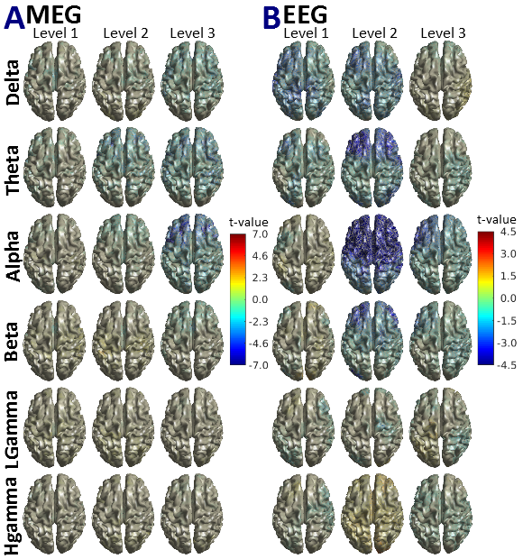
Supp. Figure 3B. Group level source power t-statistic maps contrasting equivalent doses of Xenon and Nitrous Oxide. The t-values for magnetoencephalographic (MEG - A) and electroencephalographic (EEG - B) point to subtle yet significant (p=0.05) changes in low frequency delta, theta and alpha when comparing the 0.25 (Level 1), 0.50 (Level 2) and 0.75 (Level 3) equi MAC-awake concentrations of Xenon (Xe) and Nitrous Oxide (N₂O) administered (N₂O relative to Xe comparison). No significant differences appear across the two gases in high frequency beta and gamma activity. The difference in scale between A and B should be noted. [delta (1-4 Hz), theta (4-8 Hz), alpha (8-13 Hz), beta (13-30 Hz), Lgamma: low gamma (30-49 Hz), Hgamma: high gamma (51-99 Hz)].
Highly significant (p=0.004) power changes across the two gases in increasing gas levels contrasted to the post-antiemetic baseline reveal region specific changes in each frequency band investigate. Supp. Table 3 gives a full account of all significantly altered regions for N₂O relative to Xe.
Supp. Table 3B. Magnetoencephalographic and Electroencephalographic sources most significantly altered in equivalent gas concentrations of Xenon and Nitrous Oxide. Significantly (p=0.004) changed regions of interest by contrasting equivalent inhaled concentrations of the two gases in magnetoencephalography and electroencephalography data. Voxel coordinates are in Automated Anatomical Labeling (AAL) Atlas atlas coordinate system along with associated labels⁶. [delta (1-4 Hz), theta (4-8 Hz), alpha (8-13 Hz), beta (13-30 Hz), Lgamma: low gamma (30-49 Hz), Hgamma: high gamma (51-99 Hz)].
Measurement | Frequency Band | MAC-awake Level |  | Region of Interest | Voxel Coordinate | t-value | p-value
MEG | alpha |  | 0.75 | Frontal_Mid_R | 24 30 30 | -6.97 | 0.0017
 |  |  | 0.75 | Frontal_Inf_Oper_L | -48 6 18 | -6.86 | 0.0020
 |  |  | 0.75 | Frontal_Inf_Tri_L | -36 42 0 | -6.64 | 0.0032
 |  |  | 0.75 | Frontal_Mid_L | -24 30 30 | -6.42 | 0.0038
EEG | alpha |  | 0.50 | Frontal_Mid_R | 42 -6 54 | -6.22 | 0.0013
 |  |  | 0.50 | Frontal_Sup_Medial_L | -6 42 54 | -6.15 | 0.0016
 |  |  | 0.50 | Frontal_Mid_L | -24 30 54 | -6.14 | 0.0016
 |  |  | 0.50 | Supp_Motor_Area_L | -6 6 72 | -6.11 | 0.0018
 |  |  | 0.50 | Precentral_R | 42 -12 60 | -6.07 | 0.0022
 |  |  | 0.50 | Precentral_L | -24 -12 72 | -6.06 | 0.0024
 |  |  | 0.50 | Frontal_Sup_L | -18 42 48 | -5.98 | 0.0026
 |  |  | 0.50 | Cingulum_Mid_L | -6 12 42 | -5.84 | 0.0026
 |  |  | 0.50 | Frontal_Inf_Oper_L | -48 12 18 | -5.80 | 0.0026
 |  |  | 0.50 | Cingulum_Ant_L | -6 18 30 | -5.72 | 0.0028
 |  |  | 0.50 | Cingulum_Mid_R | 6 18 42 | -5.71 | 0.0028
 |  |  | 0.50 | Frontal_Sup_Medial_R | 6 24 42 | -5.69 | 0.0028
 |  |  | 0.50 | Supp_Motor_Area_R | 6 18 48 | -5.64 | 0.0028
 |  |  | 0.50 | Frontal_Sup_R | 18 30 60 | -5.63 | 0.0030
 |  |  | 0.50 | Frontal_Inf_Tri_L | -48 18 24 | -5.62 | 0.0030
 |  |  | 0.50 | Insula_L | -36 12 12 | -5.56 | 0.0030
 |  |  | 0.50 | Cingulum_Ant_R | 6 18 24 | -5.27 | 0.0056
 |  |  | 0.50 | Caudate_L | -18 6 24 | -5.21 | 0.0058
 |  |  | 0.50 | Rolandic_Oper_L | -42 0 18 | -5.18 | 0.0058
 |  |  | 0.50 | Frontal_Inf_Orb_L | -36 24 -6 | -5.14 | 0.0058
 |  |  | 0.50 | Paracentral_Lobule_L | -18 -12 66 | -5.00 | 0.0066
 |  |  | 0.50 | Putamen_L | -24 12 12 | -4.96 | 0.0072
 |  |  | 0.50 | Temporal_Pole_Mid_R | 42 18 -36 | -4.96 | 0.0072
 |  |  | 0.50 | Frontal_Inf_Oper_R | 30 12 30 | -4.95 | 0.0072
 |  |  | 0.50 | Temporal_Pole_Sup_R | 42 18 -30 | -4.89 | 0.0080
 |  |  | 0.50 | Postcentral_L | -60 -6 30 | -4.88 | 0.0082
 |  |  | 0.50 | Caudate_R | 18 6 24 | -4.88 | 0.0080
 |  |  | 0.50 | Postcentral_R | 48 -6 30 | -4.83 | 0.0084
 |  |  | 0.50 | Temporal_Pole_Sup_L | -30 18 -30 | -4.83 | 0.0084
 |  |  | 0.50 | Insula_R | 42 18 -12 | -4.81 | 0.0084
 |  |  | 0.50 | Frontal_Inf_Tri_R | 36 24 12 | -4.78 | 0.0086
 |  |  | 0.50 | Frontal_Inf_Orb_R | 42 24 -18 | -4.78 | 0.0086
 |  |  | 0.50 | Temporal_Pole_Mid_L | -36 18 -36 | -4.71 | 0.0088
 |  |  | 0.50 | Temporal_Sup_R | 60 0 -6 | -4.66 | 0.0092
 |  |  | 0.50 | Temporal_Inf_L | -42 6 -42 | -4.65 | 0.0094
 |  |  | 0.50 | Rolandic_Oper_R | 42 6 12 | -4.64 | 0.0094
 |  |  | 0.50 | Putamen_R | 30 18 0 | -4.63 | 0.0094
 |  |  | 0.50 | Frontal_Mid_Orb_L | -24 30 -18 | -4.62 | 0.0100
 |  |  | 0.50 | Olfactory_L | -18 12 -18 | -4.62 | 0.0098
 |  |  | 0.50 | ParaHippocampal_R | 24 12 -30 | -4.58 | 0.0108
 |  |  | 0.50 | Temporal_Inf_R | 36 6 -42 | -4.48 | 0.0122
 |  |  | 0.50 | Rectus_L | -12 18 -12 | -4.47 | 0.0122
 |  |  | 0.50 | Fusiform_R | 24 6 -42 | -4.47 | 0.0122
 |  |  | 0.50 | Fusiform_L | -30 0 -36 | -4.44 | 0.0132
 |  |  | 0.50 | ParaHippocampal_L | -18 6 -24 | -4.42 | 0.0142
 |  |  | 0.50 | Temporal_Mid_L | -36 6 -30 | -4.42 | 0.0140
 |  |  | 0.50 | Frontal_Sup_Orb_L | -12 18 -18 | -4.41 | 0.0142
 |  |  | 0.50 | Amygdala_L | -24 0 -12 | -4.40 | 0.0142
 |  |  | 0.50 | Olfactory_R | 24 12 -18 | -4.39 | 0.0148
 |  |  | 0.50 | Temporal_Mid_R | 48 6 -30 | -4.39 | 0.0148
 |  |  | 0.50 | Heschl_R | 42 -24 12 | -4.38 | 0.0150
 |  |  | 0.50 | Amygdala_R | 24 6 -18 | -4.36 | 0.0154
 |  |  | 0.50 | Pallidum_L | -18 6 0 | -4.36 | 0.0152
 |  |  | 0.50 | Frontal_Mid_Orb_R | 42 48 -6 | -4.35 | 0.0156
 |  |  | 0.50 | Temporal_Sup_L | -48 6 -6 | -4.31 | 0.0158
 |  |  | 0.50 | Pallidum_R | 24 0 0 | -4.27 | 0.0164
 |  |  | 0.50 | Frontal_Sup_Orb_R | 24 30 -24 | -4.23 | 0.0178
 |  |  | 0.50 | Thalamus_R | 12 -12 18 | -4.21 | 0.0178
 |  |  | 0.50 | SupraMarginal_R | 60 -42 24 | -4.14 | 0.0188
 |  |  | 0.50 | Paracentral_Lobule_R | 6 -42 78 | -4.14 | 0.0188
 |  |  | 0.50 | Rectus_R | 18 18 -18 | -4.13 | 0.0190
 |  |  | 0.50 | Hippocampus_R | 18 6 30 | -4.10 | 0.0192
 |  |  | 0.50 | Thalamus_L | -6 -12 18 | -4.05 | 0.0198
 |  |  | 0.50 | Hippocampus_L | -18 -6 -12 | -4.03 | 0.0204
 |  |  | 0.50 | Parietal_Sup_R | 18 -48 72 | -4.03 | 0.0206
 |  |  | 0.50 | Parietal_Sup_L | -24 -54 72 | -4.01 | 0.0206
 |  |  | 0.50 | Frontal_Med_Orb_L | -12 36 -12 | -3.93 | 0.0226
 |  |  | 0.75 | Frontal_Mid_L | -42 48 18 | -3.71 | 0.0141
 |  |  | 0.75 | Frontal_Inf_Tri_L | -54 24 12 | -3.45 | 0.0230
 | theta |  | 0.50 | Frontal_Inf_Tri_L | -48 36 24 | -4.66 | 0.0111
 |  |  | 0.50 | Frontal_Inf_Tri_R | 54 30 24 | -4.37 | 0.0156
 |  |  | 0.50 | Frontal_Mid_L | -48 30 30 | -4.36 | 0.0156
 |  |  | 0.50 | Frontal_Mid_R | 36 24 54 | -4.11 | 0.0208
 | beta |  | 0.50 | Frontal_Mid_R | 42 48 24 | -4.61 | 0.0139
 |  |  | 0.50 | Frontal_Inf_Tri_R | 48 36 24 | -4.41 | 0.0184
 |  |  | 0.50 | Occipital_Mid_L | -36 -90 6 | -4.37 | 0.0192
 | delta |  | 0.50 | Precentral_R | 60 -6 42 | -3.95 | 0.0231

References
1. Nichols TE, Holmes AP: Nonparametric Permutation Tests for Functional Neuroimaging: A Primer with examples. Hum Brain Mapp 2001; 15:1–25
2. Nichols TE, Holmes AP: Nonparametric Permutation Tests for Functional Neuroimaging. 2003
3. Muthukumaraswamy SD, Shaw AD, Jackson LE, Hall J, Moran R, Saxena N: Evidence that Subanesthetic Doses of Ketamine Cause Sustained Disruptions of NMDA and AMPA-Mediated Frontoparietal Connectivity in Humans. J Neurosci 2015; 35:11694–706
4. Hillebrand A, Tewarie P, Dellen E van, Yu M, Carbo EWS, Douw L, Gouw AA, Straaten ECW van, Stam CJ: Direction of information flow in large-scale resting-state networks is frequency-dependent. Pnas 2016; 113:3867–72
5. Pantazis D, Nichols TE, Baillet S, Leahy RM: A comparison of random field theory and permutation methods for the statistical analysis of MEG data. Neuroimage 2005; 25:383–94
6. Tzourio-Mazoyer N, Landeau B, Papathanassiou D, Crivello F, Etard O, Delcroix N, Mazoyer B, Joliot M: Automated anatomical labeling of activations in SPM using a macroscopic anatomical parcellation of the MNI MRI single-subject brain. Neuroimage 2002; 15:273–89

