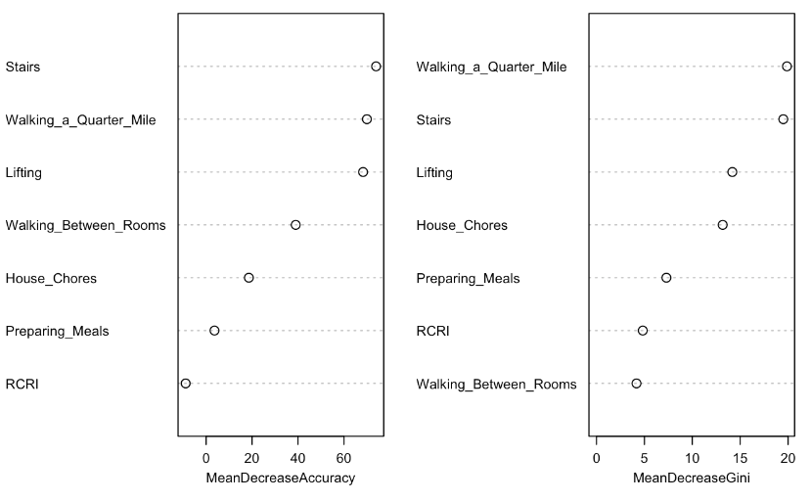
B
A
Figure 2: Results of random forest analyses illustrating the importance of each physical function question in the classification and regression tree analysis: Stair climbing and Walking 2-3 blocks are the most important questions for predicting the presence of a 2-minute bout of moderate-vigorous physical activity. A) Indicates the mean decrease in accuracy of the tree as the result of removing a physical functioning question. B) The Gini coefficient is a measurement of the likelihood of an incorrect classification of the outcome. Physical function questions that decrease the mean Gini coefficient improve the prediction of that outcome. In each figure the greater the decrease in accuracy and the greater the mean decrease in Gini impurity is associated with increased variable importance to the final classification and regression tree analysis.
RCRI=Revised Cardiac Risk Index

