Appendix E: Risk of Bias Summary

Figure E.1. Risk of bias graph: review authors’ judgements about each risk of bias item presented as percentages across all included studies.

Figure E.2. Ketamine Studies

Figure E.3. Pregabalin Studies
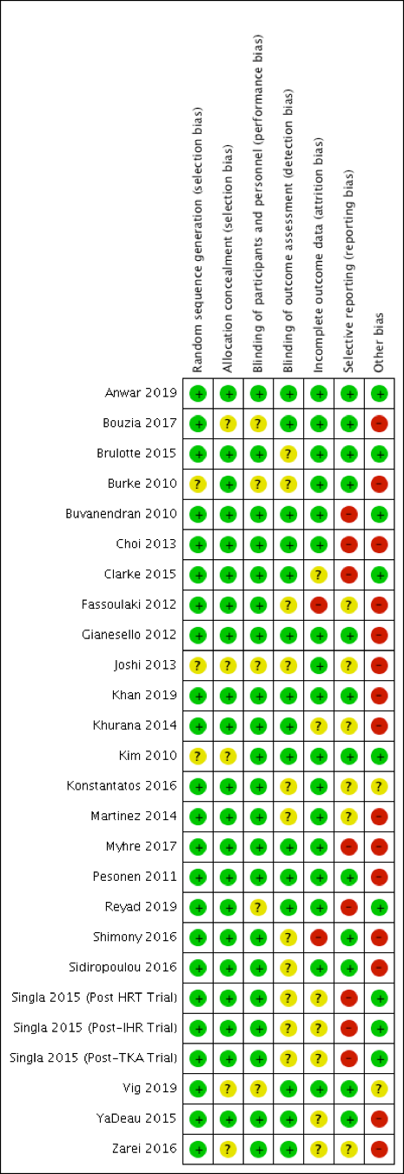

Figure E.4. Gabapentin Studies
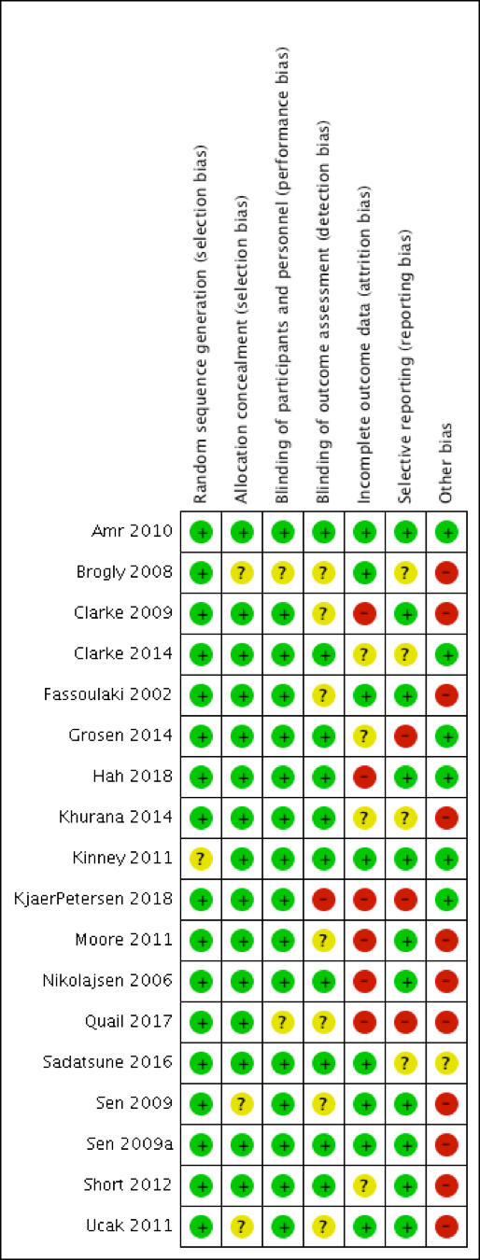

Figure E.5. Lidocaine Studies
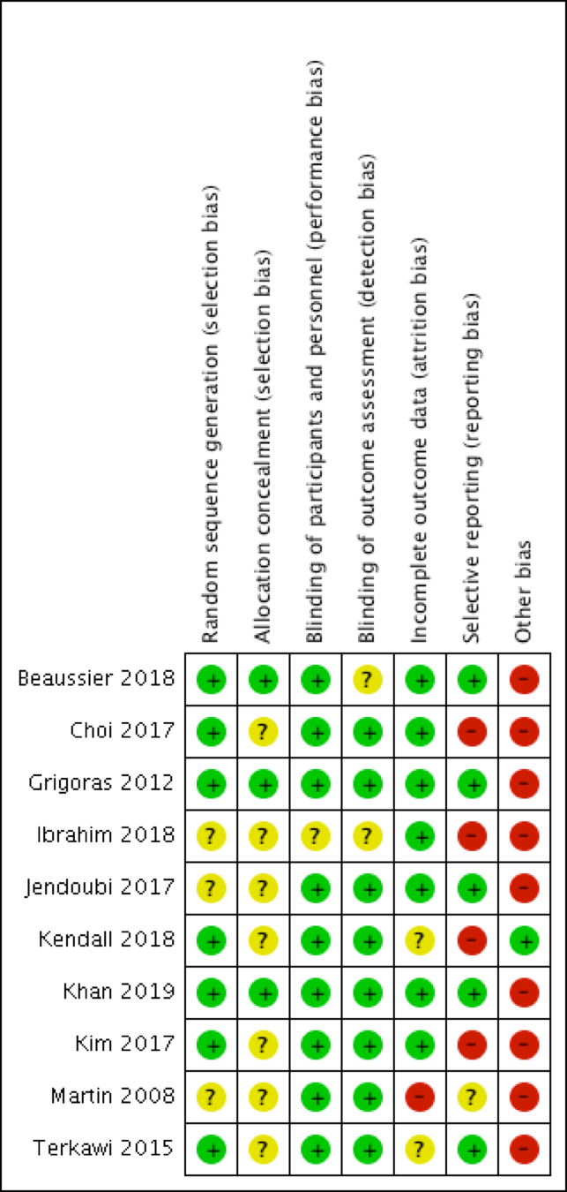

Figure E.6. NSAID Studies
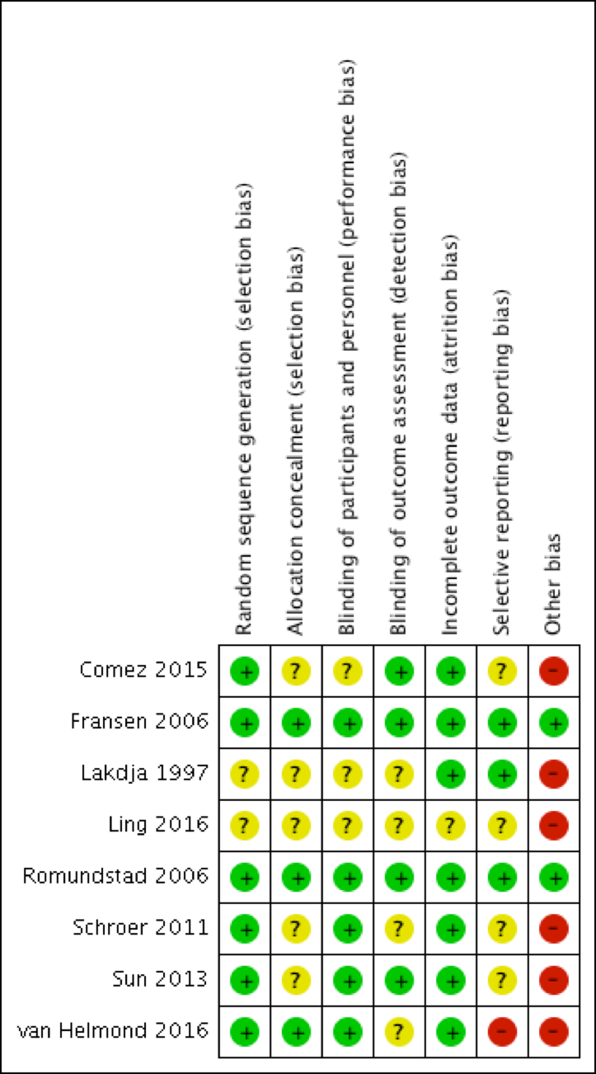

Figure E.7. Corticosteroid Studies
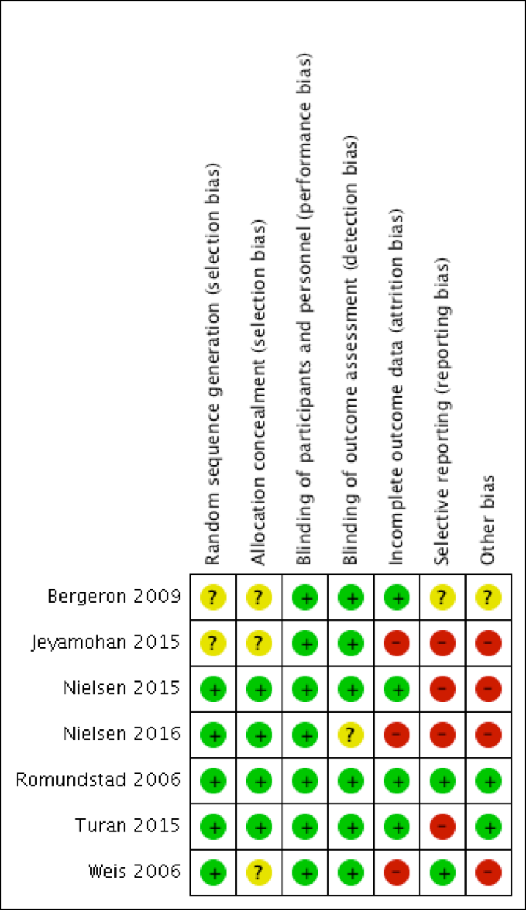

Figure E.8. Other Drug Studies
