Supplemental Digital Content Figure 1
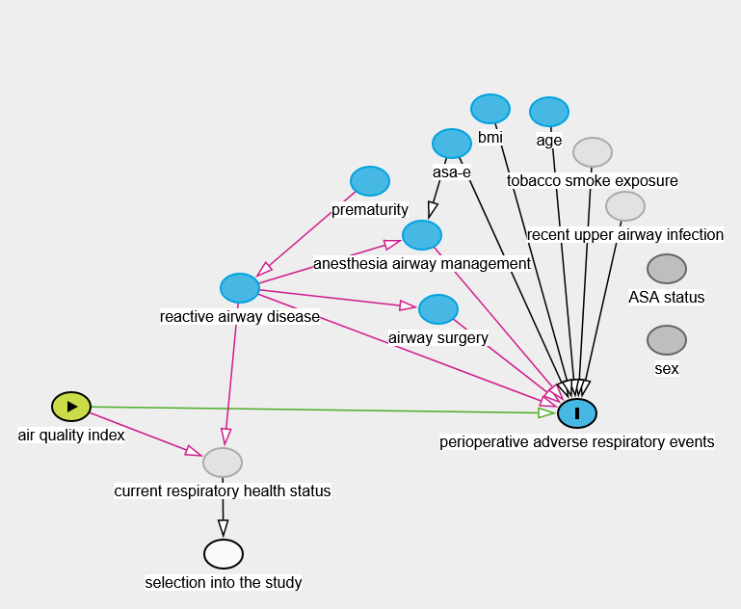
A

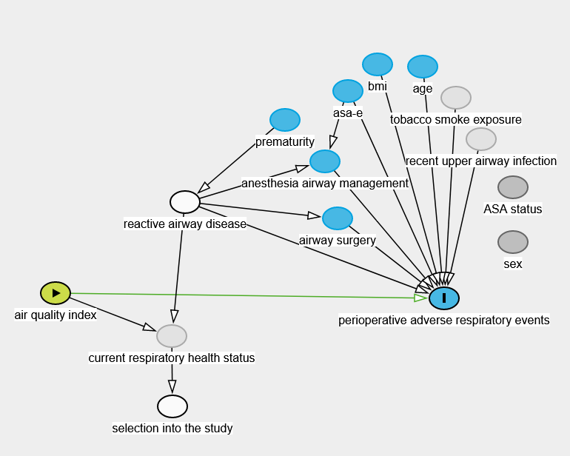
B
Figure 1: Directed Acyclic Graph. The directed acyclic graph displays the underlying assumptions of the causal relationship between variables in our model. Exposure variable AQI (air quality index), outcome variable: perioperative adverse respiratory events.
The green arrow indicates the causal pathway between exposure and outcome (aka the study hypothesis), the red arrows indicate confounding pathways.
Panel A: unadjusted model; Panel B: adjusted model (adjusted for hx/reactive airway disease).
The interactive graph can be accessed under: http://dagitty.net/dags.html?id=_z3mG5#
Legend:
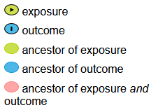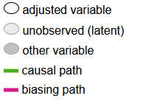
Johannes Textor, Benito van der Zander, Mark K. Gilthorpe, Maciej Liskiewicz, George T.H. Ellison.
Robust causal inference using directed acyclic graphs: the R package 'dagitty'.
International Journal of Epidemiology 45(6):1887-1894, 2016

