Supplemental Figures

Supplemental Figure 1. Carbohydrate-containing clear liquids: summary risk of bias appraisal for randomized controlled trials including patient-reported outcomes in adults.
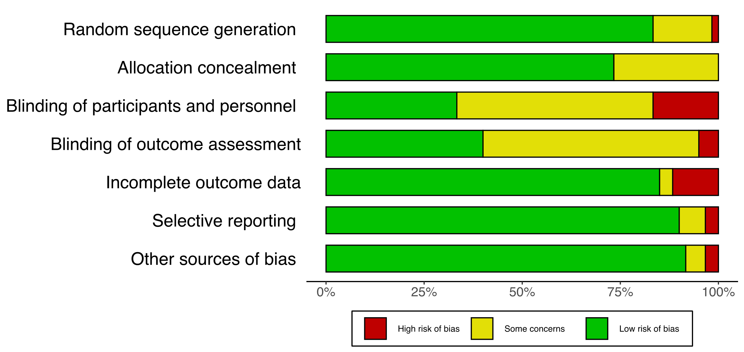

Supplemental Figure 2. Carbohydrate-containing clear liquids individual trial risk of bias appraisals for patient-reported outcomes in adults.
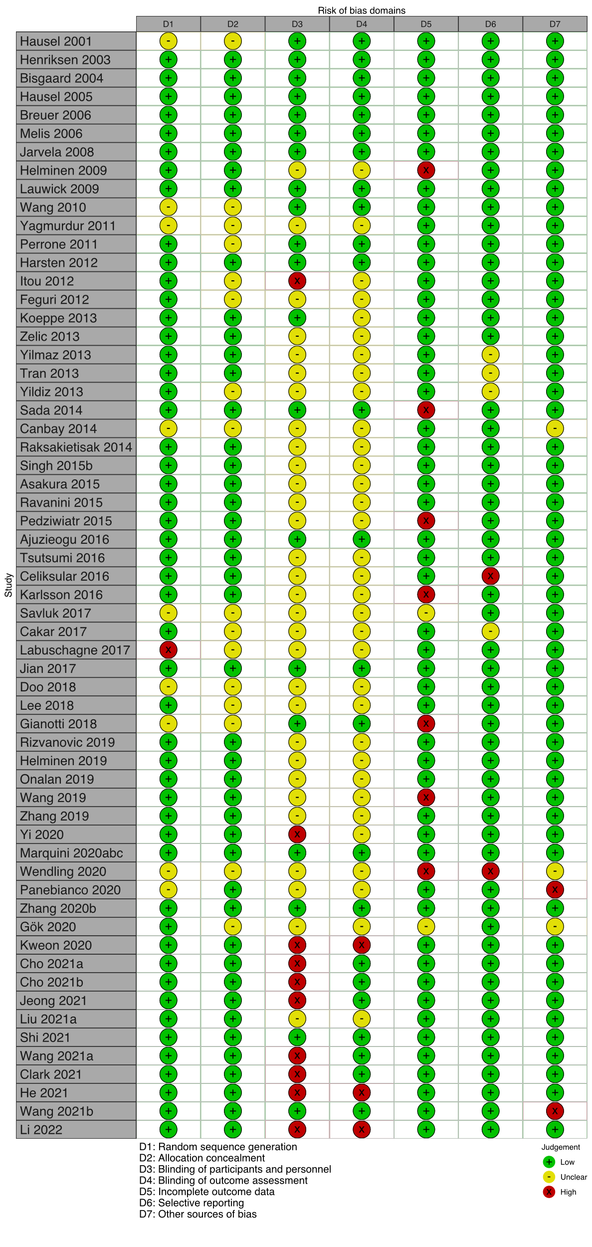

Supplemental Figure 3. Carbohydrate-containing clear liquids summary risk of bias – clinical outcomes from randomized controlled trials in adults.
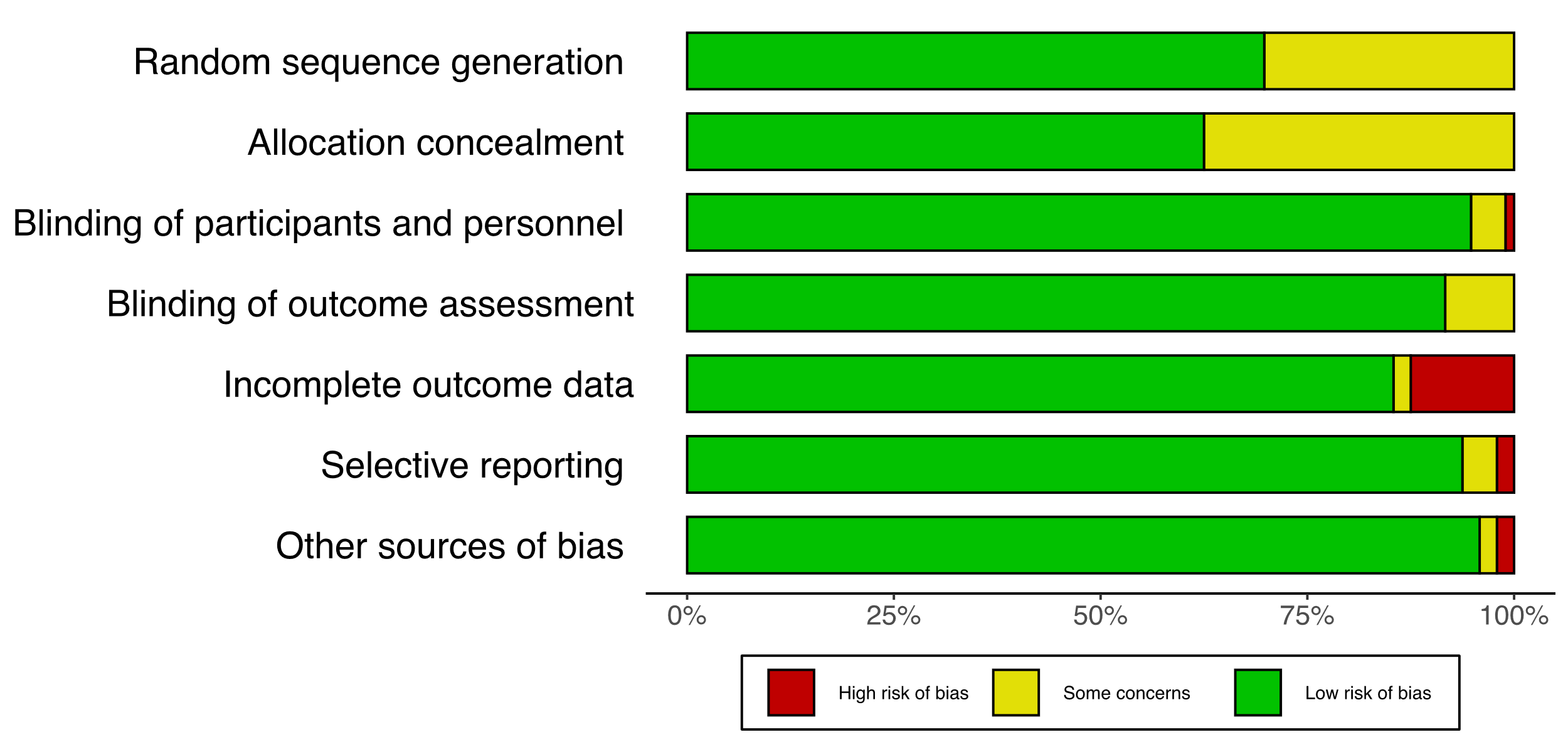

Supplemental Figure 4. Carbohydrate-containing clear liquids individual trial risk of bias appraisals for clinical outcomes in adults.
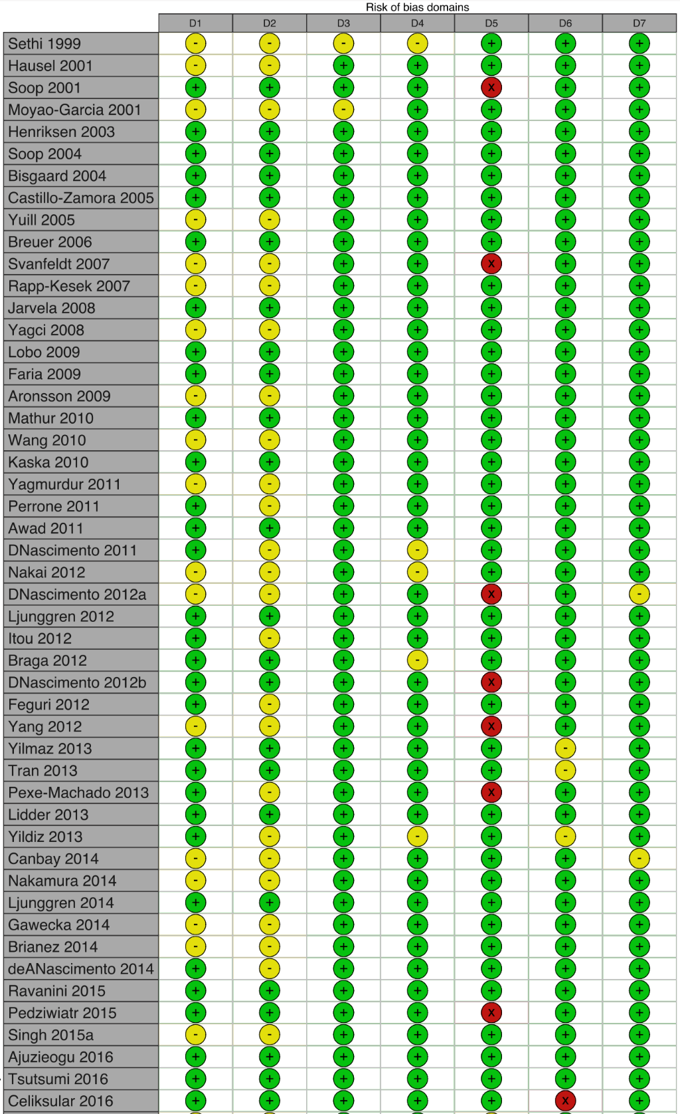

Supplemental Figure 4 (continued). Carbohydrate-containing clear liquids individual trial risk of bias appraisals for clinical outcomes in adults.

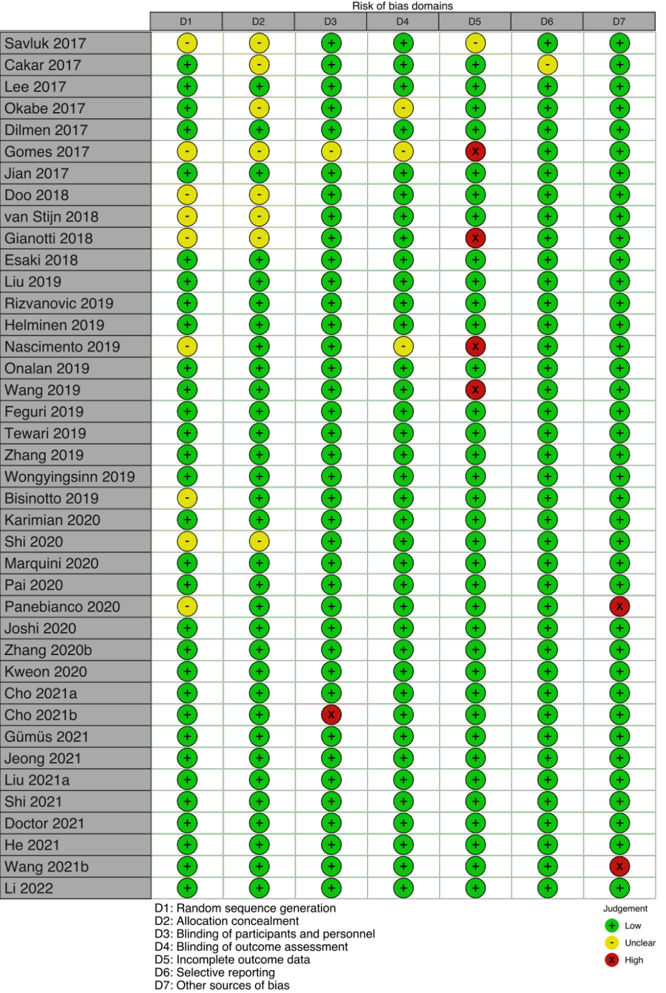

Supplemental Figure 5. Protein-containing clear liquids summary risk of bias – patient-reported outcomes from randomized controlled trials in adults.
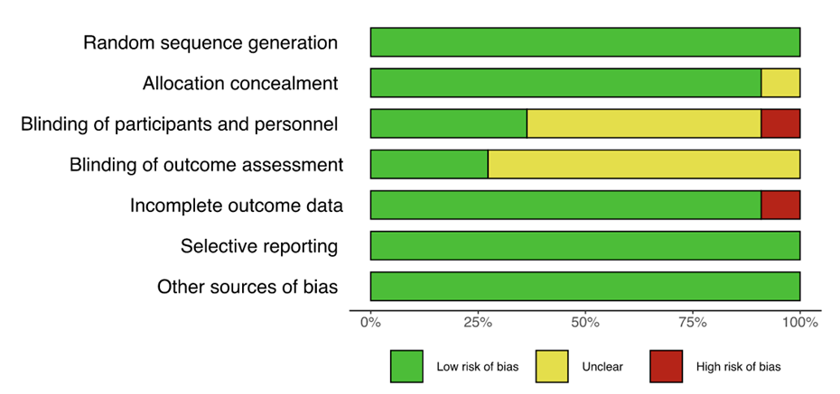

Supplemental Figure 6. Protein-containing clear liquids: individual trial risk of bias appraisals for patient-reported outcomes in adults.
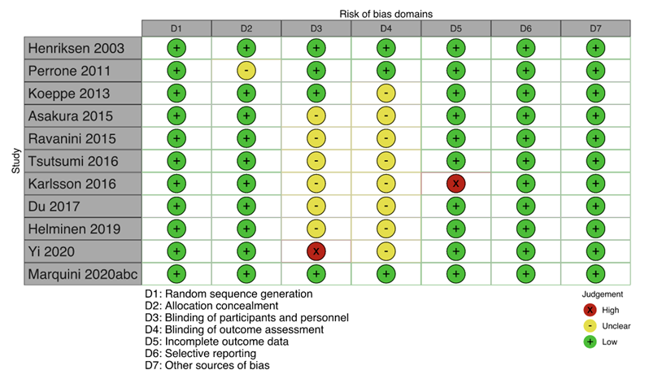

Supplemental Figure 7. Protein-containing clear liquids summary risk of bias – clinical outcomes from randomized controlled trials in adults.
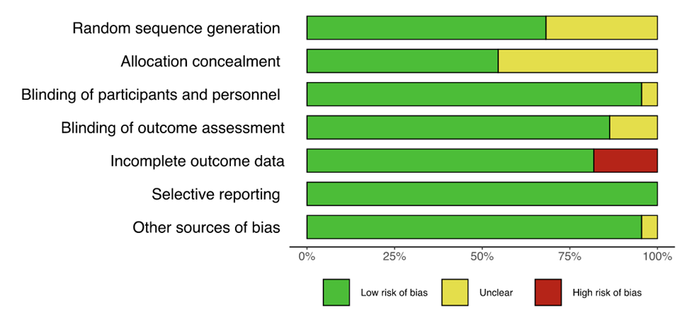

Supplemental Figure 8. Protein-containing clear liquids individual trial risk of bias appraisals for clinical outcomes in adults.
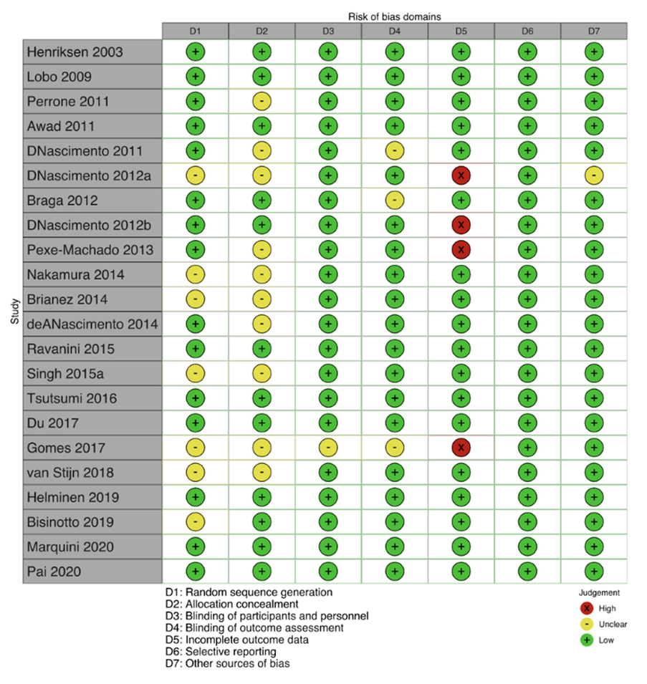

Supplemental Figure 9. Chewing gum summary risk of bias from randomized controlled trials - patient-reported outcomes.
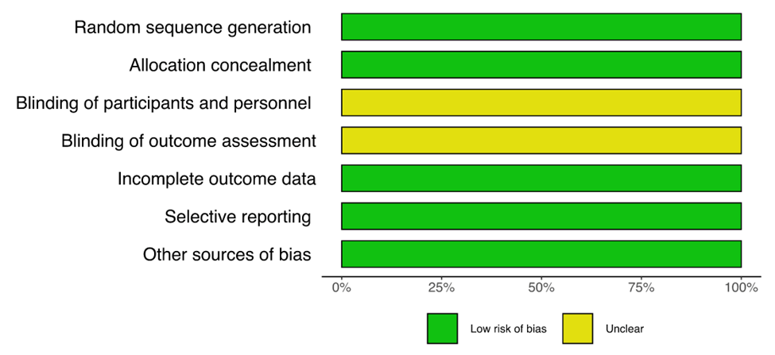

Supplemental Figure 10. Chewing gum individual trial risk of bias appraisals for patient-reported outcomes.
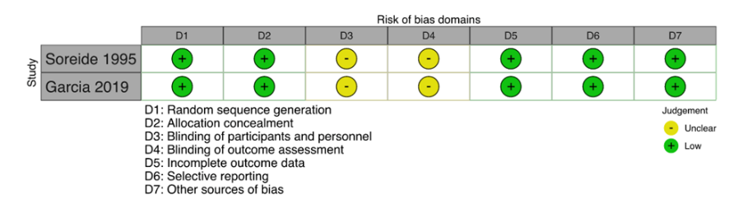

Supplemental Figure 11. Chewing gum summary risk of bias from randomized controlled trials - clinical outcomes.
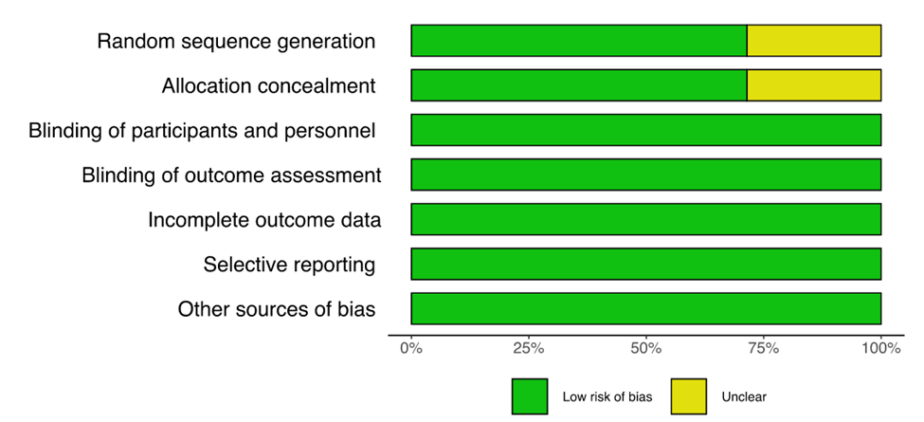

Supplemental Figure 12. Chewing gum individual trial risk of bias appraisals for clinical outcomes.
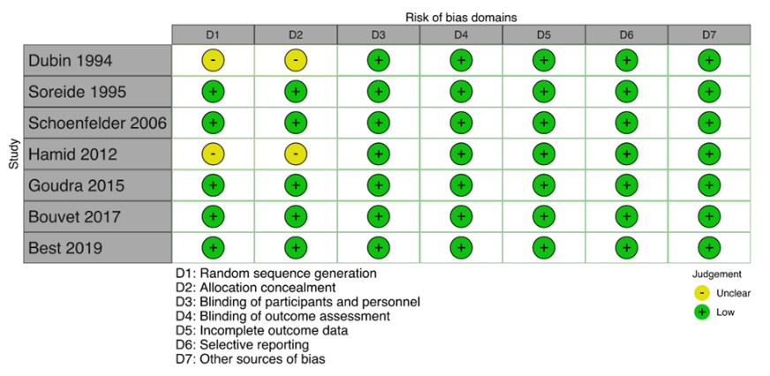

Supplemental Figure 13. Average risk of bias contributions in network structure across comparisons using CINeMA for residual gastric volume network meta-analysis. Red indicates high risk of bias, yellow uncertain, and green low. Numbers indicate studies for each direct comparison.
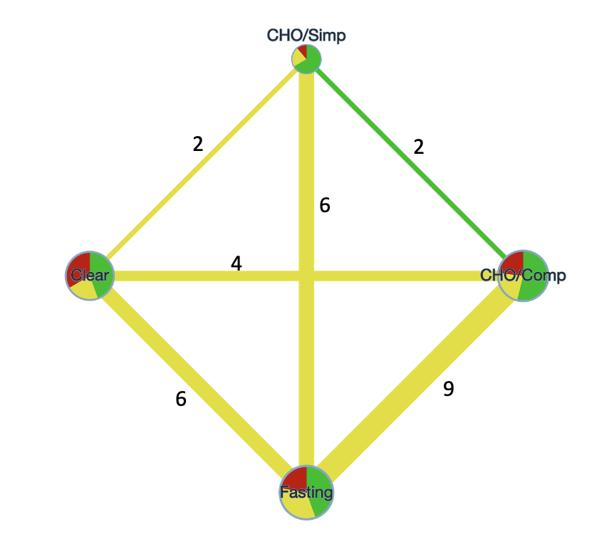
CHO: carbohydrate; Simp: simple; Comp: complex.

Supplemental Figure 14. Average risk of bias contributions in network structure across comparisons using CINeMA for patient-reported hunger network meta-analysis. Red indicates high risk of bias, yellow uncertain, and green low. Numbers indicate studies for each direct comparison.
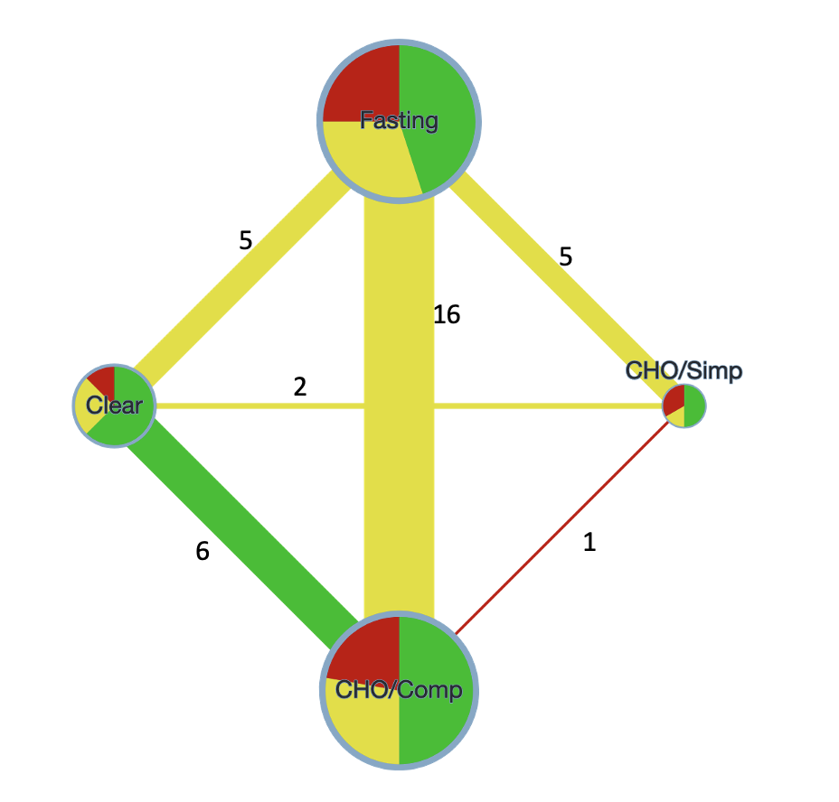
CHO: carbohydrate; Simp: simple; Comp: complex.

Supplemental Figure 15. Pooled preoperative hunger (incidence proportion) from randomized controlled trials comparing carbohydrate-containing clear liquids with fasting in adult surgical patients.
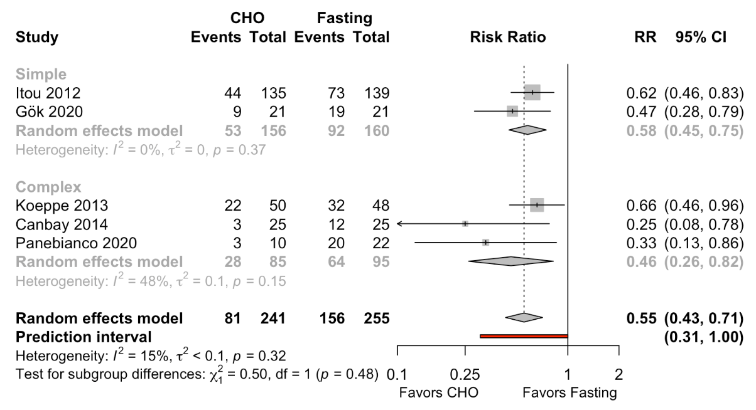
CHO: carbohydrate; RR: risk ratio
Hartung-Knapp adjustment not applied owing to variability in study size. Too few studies to effectively examine small-study effects (funnel plot suggested asymmetry)

Supplemental Figure 16. Pooled preoperative hunger (patient-rated) from randomized controlled trials comparing carbohydrate-containing clear liquids with fasting in adult surgical patients.
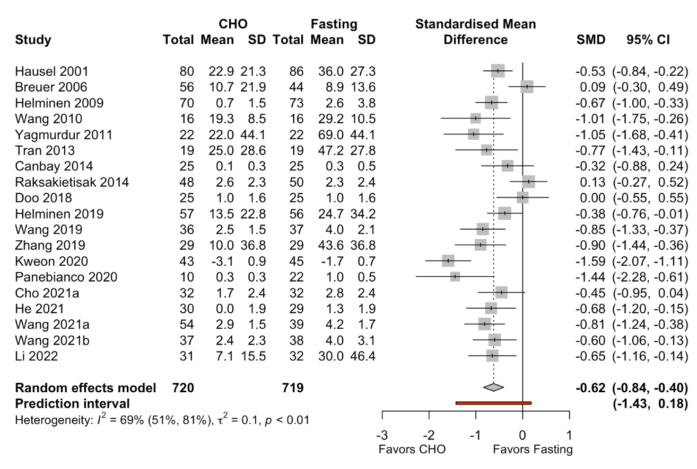
CHO: carbohydrate; SMD: standarised mean difference.
Melis 2006 reported only nonsignificant results and could not be included. Variances for Yagmurdur 2011 and Zhang 2019 were estimated using P-values. For other studies, if means and variances were not reported when practicable they were estimated from the median, interquartile range, and range (Wan 2014, Shi 2020). For He 2021 mean and standard deviation imputed using between arm p-value, median, and interquartile range. Implausibly large effect sizes were obtained for Rizvanovic 2019 (effectively no hunger in CHO arm, but incorrect confidence intervals reported) and Wendling 2020 (reported a difference score over 1 hour). Both also contributed substantially to heterogeneity. They were judged to be outliers and excluded from the main result—retaining both resulted in an SMD -0.99 (95% CI, -1.65 to -0.34), I² = 88% (95% CI, 83% to 91%). Converting result to a 100-point VAS scale with a variance estimated as a weighted average of study arms reporting a 100-point result, yielded a mean difference of -16.7 (95% CI, -22.5 to -10.9). Presence of small-study effects not suggested Pustejovsky’s test of asymmetry, P = 0.27.

Supplemental Figure 17. Pooled residual gastric volume from randomized controlled trials comparing carbohydrate-containing clear liquids (excluding protein-containing) with fasting in adult surgical patients.
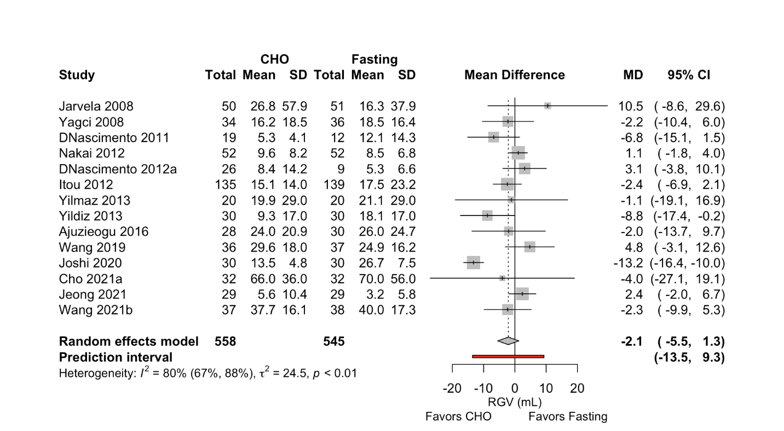
CHO: carbohydrate; MD: mean difference; RGV: residual gastric volume
Mean differences estimated from means, standard deviations, medians, interquartile and overall ranges. Owing to skewed
distributions of residual gastric volume, conducted sensitivity analysis on a log scale with consistent results.

Supplemental Figure 18. Network plot of comparators for studies reporting hunger. Numbers indicate studies for each direct comparison.

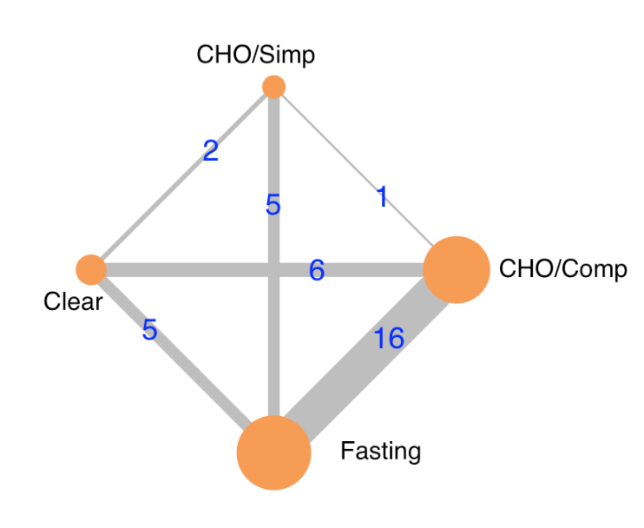
CHO: carbohydrate; Simp: simple; Comp: complex.

Supplemental Figure 19. Forest plot of estimated mean differences in residual gastric volume compared with complex and simple carbohydrate-containing clear liquids.
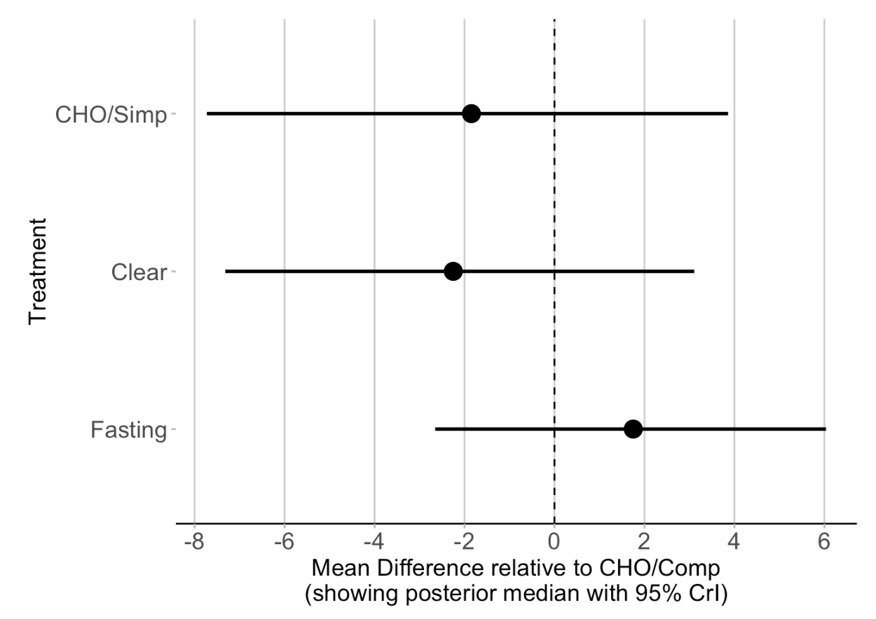
CHO: carbohydrate; Simp: simple; Comp: complex; CrI: credible interval.

Supplemental Figure 20. Network plot of comparators for studies reporting residual gastric volume. Numbers indicate studies for each direct comparison.

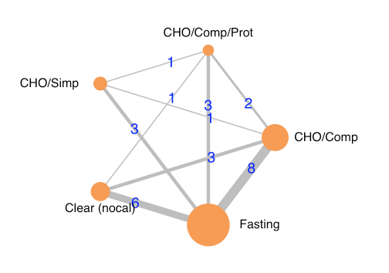
CHO: carbohydrate; Simp: simple; Comp: complex.

Supplemental Figure 21. Pooled mean difference for residual gastric volume in randomized controlled trials of adult surgical patients – gum chewing versus fasting.
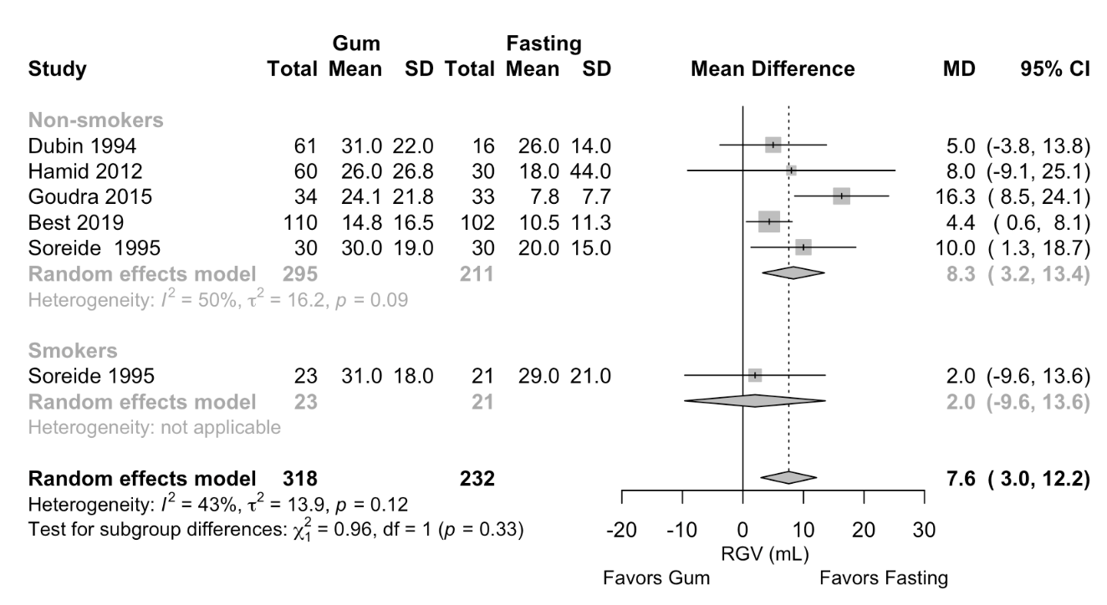
MD: mean difference; RGV: residual gastric volume.
Gum arms combined for Dubin 1994 and Hamid 2012. Goudra 2015 estimates assume a 70 kg patient for pooling.

