Figure E2

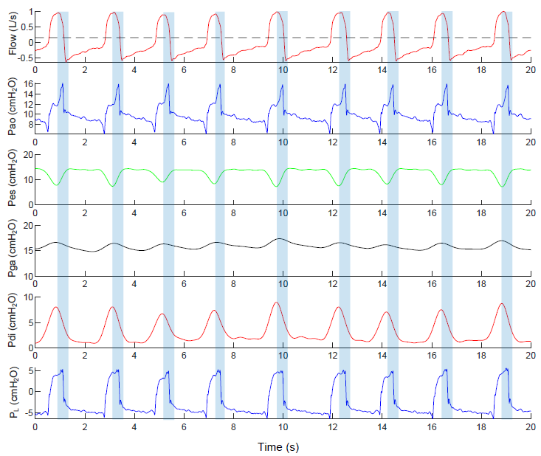
Figure legend: Example of a tracings from a patient with delayed cycling. Linegraphs showing flow, airway opening pressure (Pao), esophageal pressure (Pes), gastric pressure (Pga), transdiaphragmatic pressure (Pdi), and transpulmonary pressure (PL) over time. Shaded areas are the time where the diaphragm is starting to relax (Pdi is decreasing to baseline). All of the breaths show that the ventilator is still providing inspiratory flow during most of the time where the patient’s diaphragm is relaxing, causing a sharp rise in airway pressure (3-5 cmH₂O) while transpulmonary pressure barely changes (<1 cmH₂O).

