Figure E4
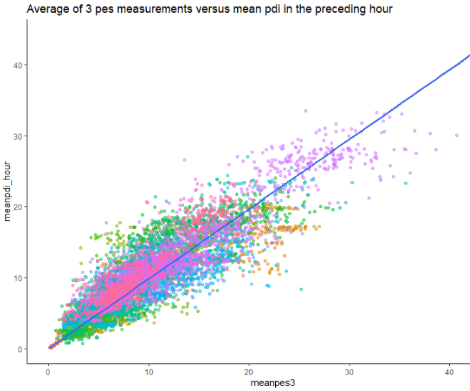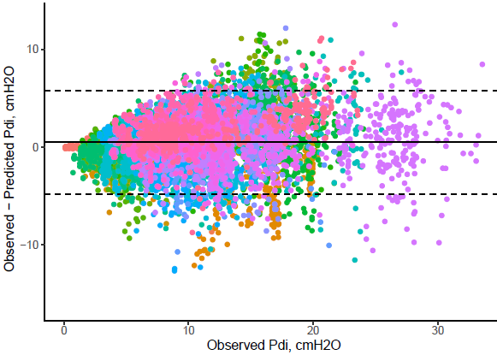
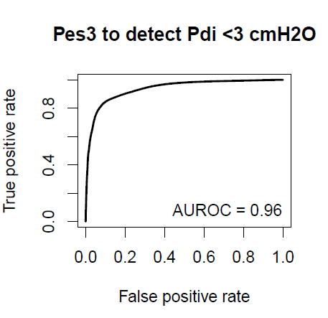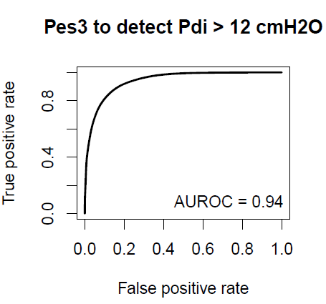
Figure legend: Performance of averaging Pes-measurements to assess diaphragm effort in the preceding hour. Top left: Correlation between the average of 3 consecutive esophageal pressure (ΔPes, in cmH₂O) measurements and the average transdiaphragmatic pressure (ΔPdi, in cmH₂O) in the preceding hour. Explained variance (r²) was 0.84. Top right: Bland-Altman plot showing the bias and 95% limits of agreement between observed ΔPdi and predicted ΔPdi based on the average of 3 consecutive ΔPes-measurements. Bottom: Receiver-operator characteristic curves of using the average of 3 ΔPes-measurements to identify subjects with low ΔPdi (<3 cmH₂O) and high ΔPdi (>12 cmH₂O) in the preceding hour.

