Figure E5
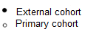
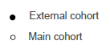
f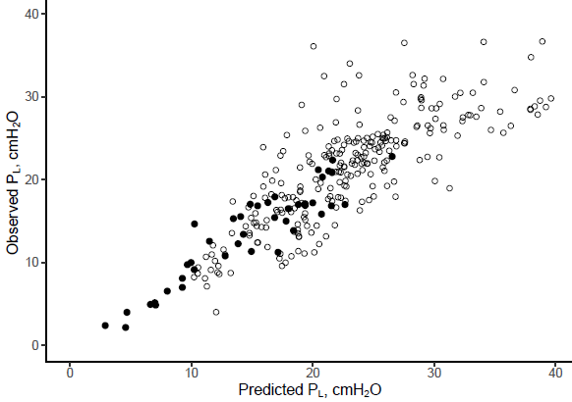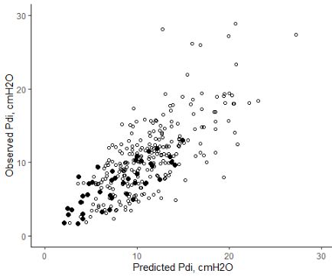
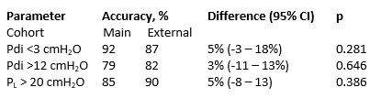
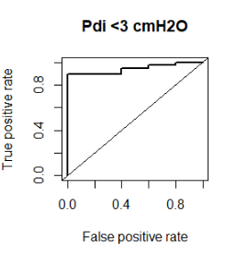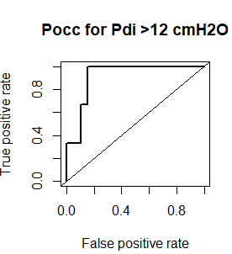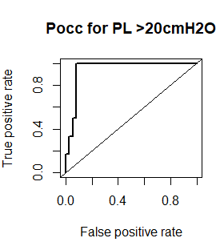
AUC = 0.94
AUC = 0.94
AUC = 0.91
Figure legend: Scatter plot showing the relationship between predicted and observed transdiaphragmatic (ΔPdi) and transpulmonary (ΔP_{L}) pressures based on the occluded inspiration pressure (Pocc) in the external cohort (solid dots, n = 43) and primary cohort (open dots, n = 282). Bottom graphs show areas under receiver-operator curves of using Pocc to detect potentially injurious diaphragm effort and lung stress using the cut-offs derived in the main cohort on the data in the external cohort.

