Figure E7
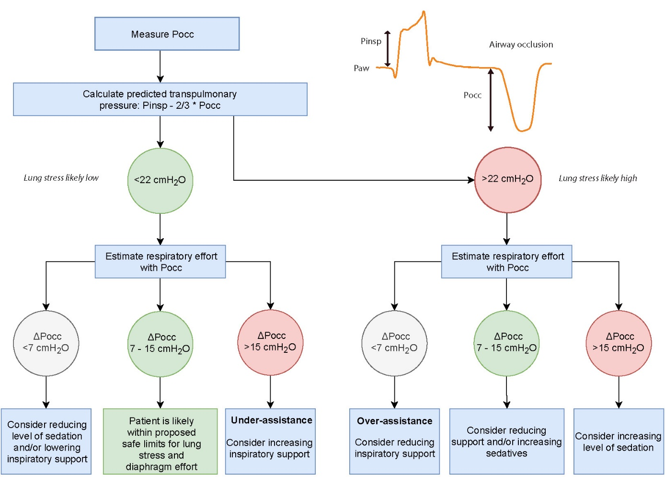
Figure legend: Proposed monitoring protocol based on the occluded inspiratory airway pressure (Pocc). The protocol requires measuring Pocc once by applying an airway occlusion maneuver to estimate both lung stress and diaphragm effort. Pinsp is the inspiratory pressure set on the ventilator without including the rise in pressure that can sometimes be observed during the latter part of inspiration. First, transpulmonary pressure (P_{L}) is estimated with the formula Pinsp – 2/3 * Pocc. Note that Pocc is a negative number if patient breathing effort is present. Patients with a predicted P_{L} <22 cmH₂O have a purported safe P_{L} (<20cmH₂O) in 86% of the cases. Next, Pocc without conversion is used to assess whether patients like have transdiaphragmatic pressure in the purported safe range (3-12 cmH₂O). Patient with a Pocc between – 7 and - 15 cmH2O have purported safe Pdi in 89% of the cases. The protocol can be repeated hourly, or when patient breathing effort has likely changed such as after changing ventilator settings.

