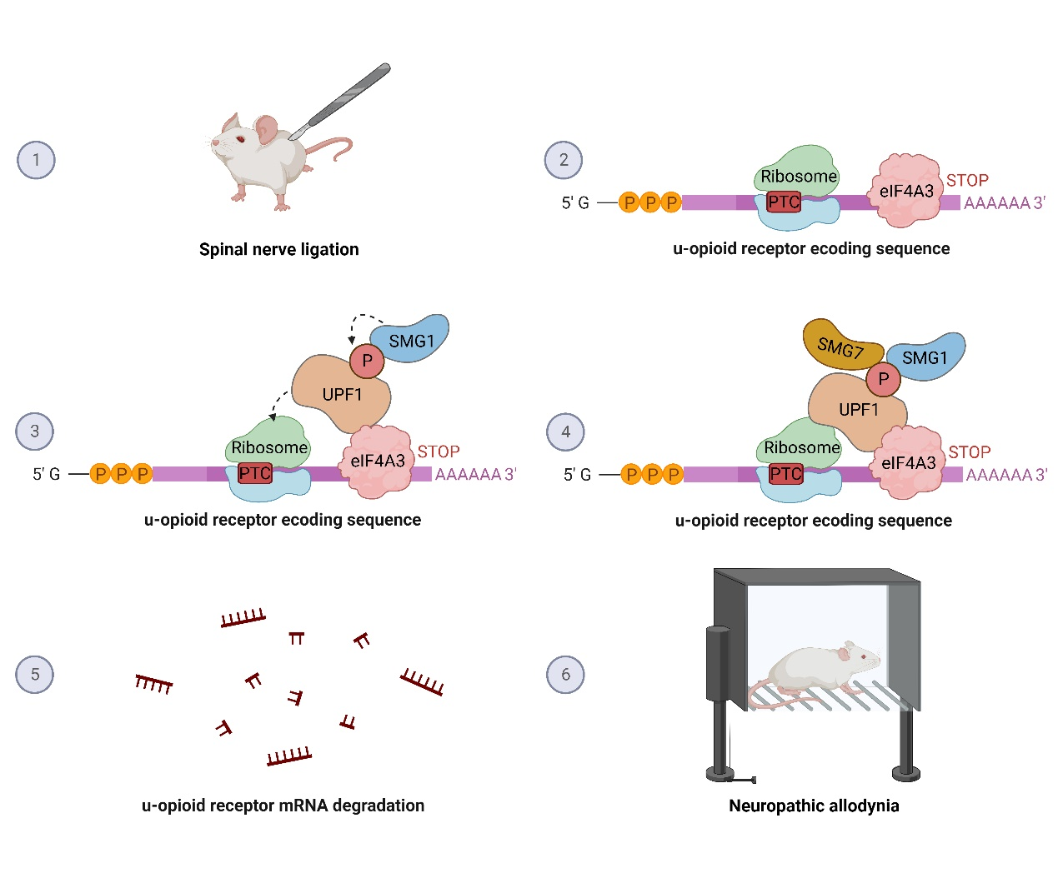
Supplementary figure 1: Spinal pUPF1-dependent mechanism in nociception
elF4A3 leads to increasing phosphorylation of upstream frameshift 1 (UPF1) by SMG1 and interaction of phosphorylated UPF1 with SMG7, subsequently triggering the decay of the u-opioid receptor mRNA during spinal plasticity in SNL-induced neuropathic allodynia-like development in rat. Created with BioRender.com

