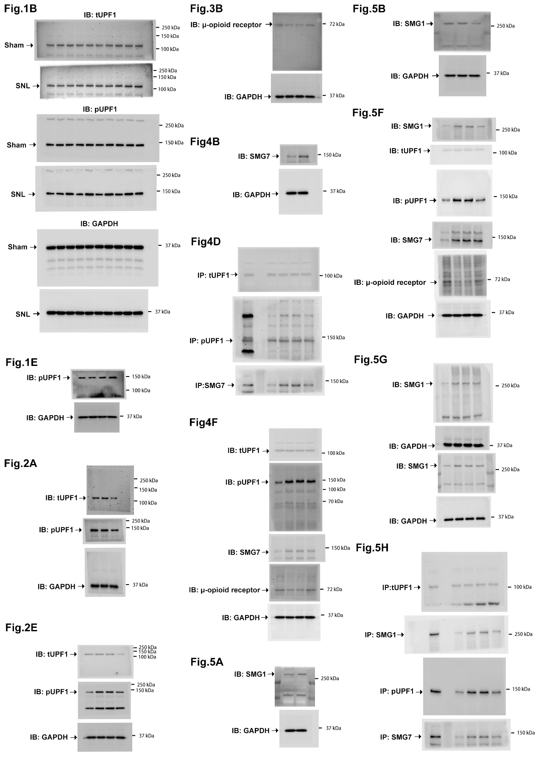

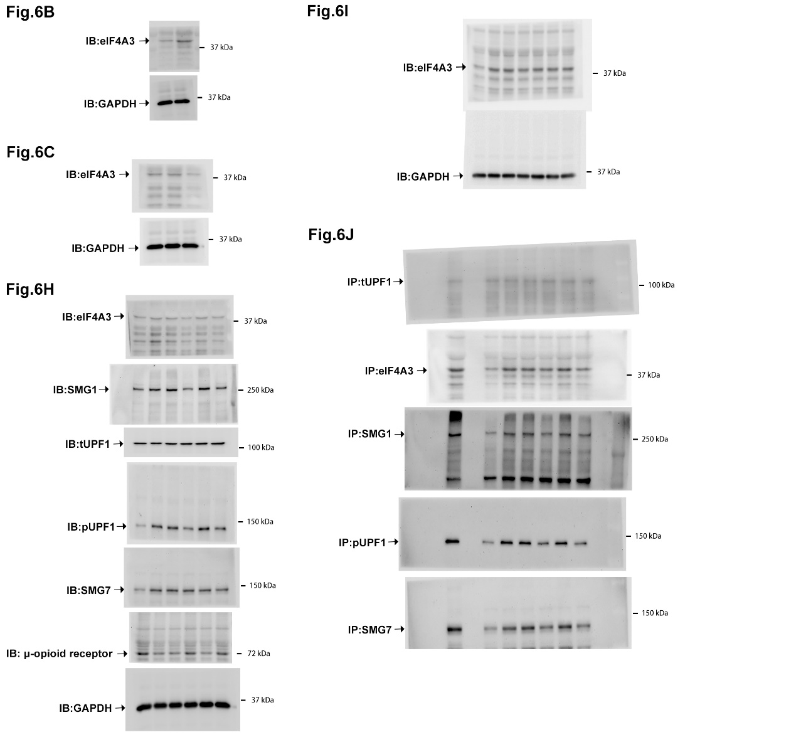

Supplementary file 1: Full-length Western blot images

Full-length blot image for figure 1B – 6J.

