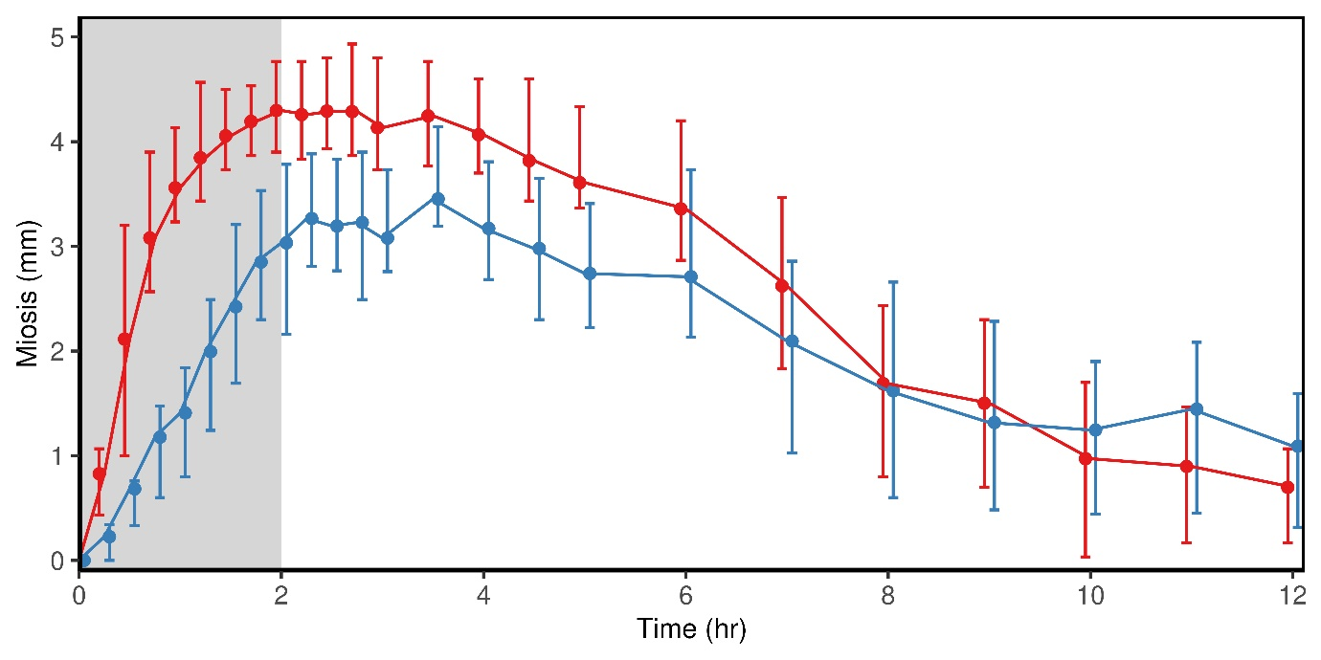

Supplemental Figure 2: Morphine and hydromorphone effects on pupil diameter. Miosis of subjects receiving 0.2 mg/kg morphine (n=44, blue) and 0.05 mg/kg hydromorphone (n=45, red). Results are the marginal mean and 25-75% quantiles (whiskers). Opioids were administered as a 2 h infusion (gray).

