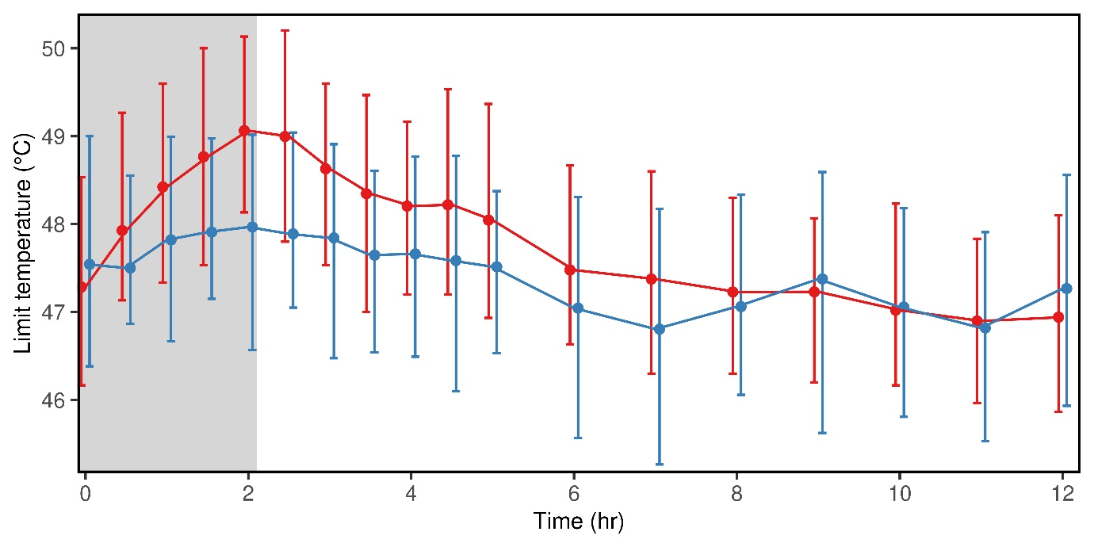

Supplemental Figure 3: Morphine and hydromorphone analgesia. Shown is the maximally tolerated temperature (“method of limits”, mean of three measurements) for subjects receiving 0.2 mg/kg morphine (n=44, blue) and 0.05 mg/kg hydromorphone (n=45, red) as a 2 h infusion (gray). Results are the marginal mean and the 25% and 75% quantiles (whiskers).

