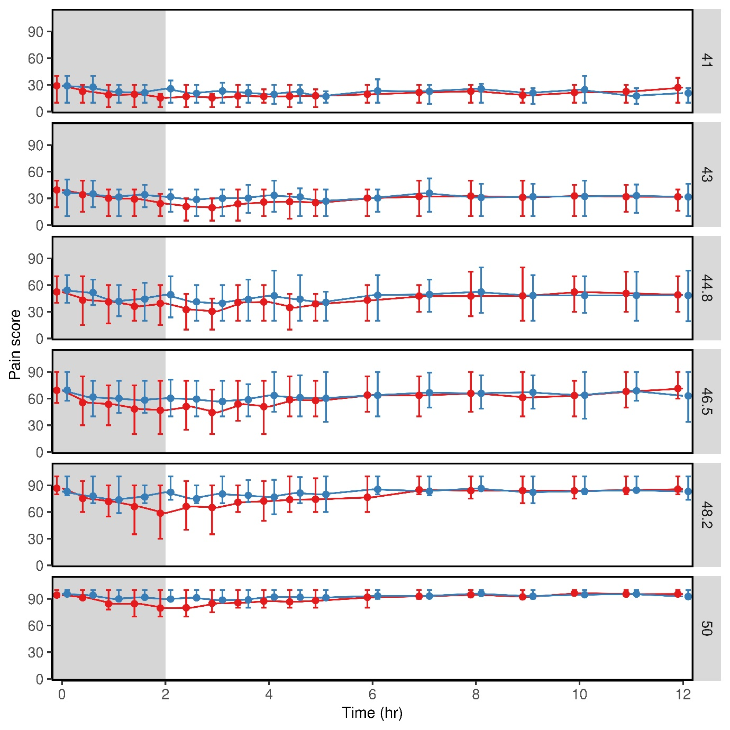

Supplemental Figure 4: Morphine 0.2 mg/kg (n=44, blue) vs. hydromorphone 0.05 mg/kg (n=45, red) analgesia. Shown are self-reported VAS scores (0-100) over time at six specific discrete temperatures (“ramp and hold” method). Results are the marginal mean and the 25% and 75% quantiles.

