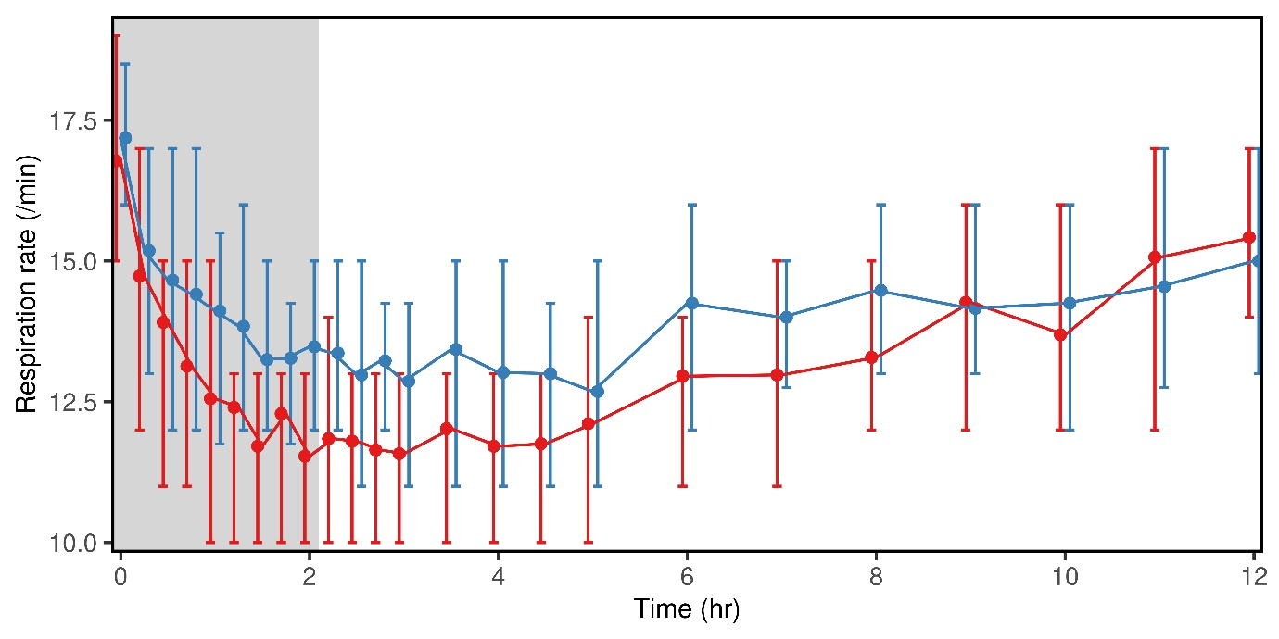

Supplemental Figure 6: Ventilatory effects of opioids. Shown is the respiratory rate in subjects receiving both 0.2 mg/kg morphine (n=44, blue) and 0.05 mg/kg hydromorphone (n=45, red) as a 2 h infusion (gray). Results are the marginal mean and the 25% and 75% quantiles.

