SDC 6, Figure 3. Histologic injury of the alveolar parenchyma in abrupt increase of RR ventilated for 1 h (Control-2 group).

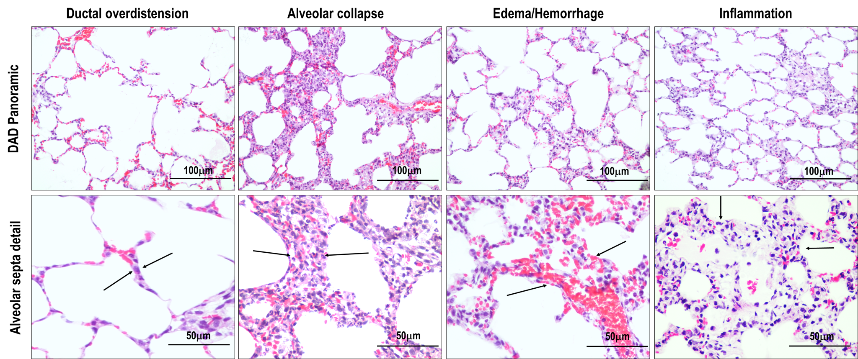

Top panel: modifications of alveolar parenchyma histoarchitecture along the sequential steps of histologic injury. Hematoxylin-eosin staining, visualized at ×200 magnification (scale bar = 100 µm). Bottom panel: ×400 magnification of the alveolar septa contained in square areas, showing details of the alveolar septal histologic injury characterized by increased diameter of alveolar ducts (arrows), pile-up of the alveolar septa (arrows), change in capillary permeability promoting interstitial edema and hemorrhage, and interstitial accumulation of inflammatory cells (arrows) (scale bar = 50 µm).

