SDC 7, Figure 4. E-cadherin immunostaining according to histologic injury in abrupt increase of RR ventilated for 1 h (Control-2 group).

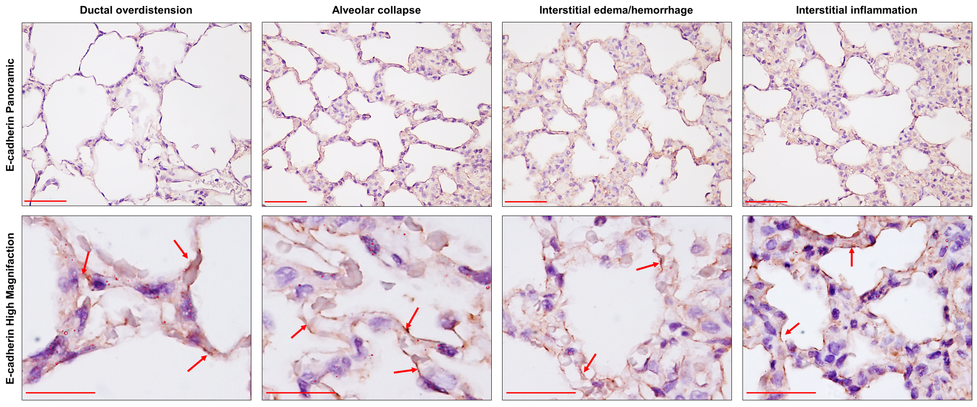

Top panel: diffuse distribution of E-cadherin expression along the alveolar septa modified by ductal overdistention, alveolar collapse, interstitial edema and hemorrhage, and interstitial inflammation, visualized at ×400 magnification (scale bar = 100 µm). Bottom panel: ×1000 magnification of the alveolar septa contained in square areas, showing details of the histologic injury characterized by extensive fragmentation of E-cadherin along the cytoplasm of alveolar epithelial cells in all stages of DAD (arrows). Note that the loss of E-cadherin integrity is maximal in the interstitial edema and hemorrhage stage of the DAD histologic injury (arrows) (scale bar = 20 µm).

