SDC 8, Figure 5. Cumulative power during different ventilatory strategies.
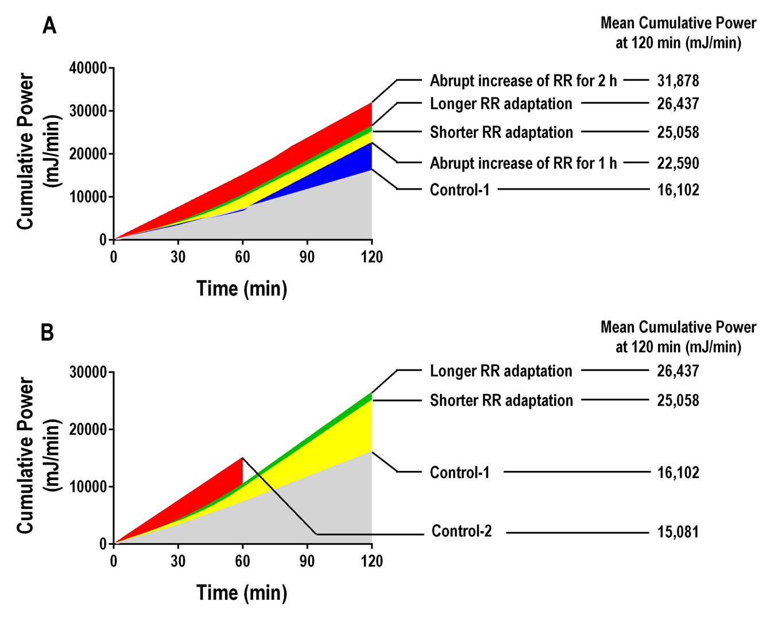

Legend. A) Cumulative power exposure in the 2-h groups. The numbers reflect the mean cumulative power measured at minute 120th. B) Cumulative power exposure in the 2-h groups (Control-1, longer and shorter adaptation groups), and in Control-2 group was submitted to abrupt increase of RR (from 70 bpm up to 130 bpm) and ventilated for 1 h. The numbers reflect the mean cumulative power measured at minute 120th in the 2-h groups, and the mean cumulative power measured at minute 60th in the 1-h group.

