SDC 10, Figure 6. Early effects of abrupt increase in respiratory rate (from 70 to 130 bpm) on respiratory system dynamic compliance (Cdyn,_{RS}).

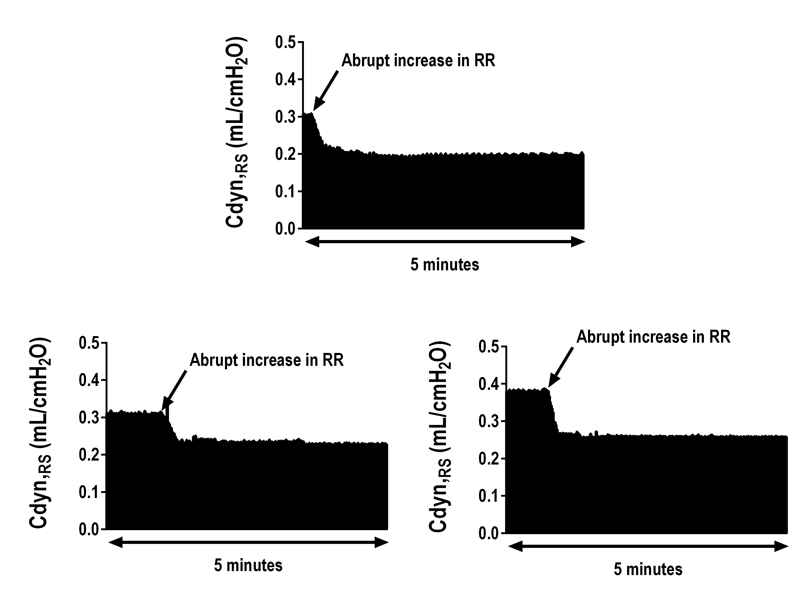
Three representative tracings from 3 different rats. Respiratory system dynamic compliance (Cdyn,_{RS}) during the abrupt increase in RR from 70 to 130 bpm. Just after the increase in RR, the Cdyn,_{RS} is seen to decrease. This likely represents narrowing of the inspiratory time, which may promote ventilation of fast alveolar units.

