SDC 1, Figure 1. Experimental configuration

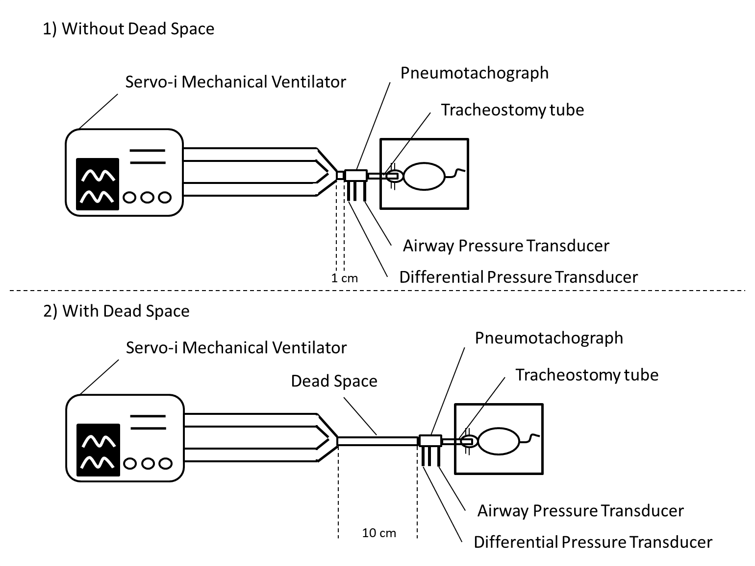

To keep PaCO₂ within a range from 30 to 45 mmHg, circuit dead space (polyethylene tubing) between the ventilatory circuit and pneumotachograph was added. Thus, the distance between the tracheal tube and pneumotachograph was constant, which minimizes the compressible volume at high RR.

