SUPPLEMENTARY MATERIALS
Table S1 List of experiments and acceptance criteria per assay
Assay | Within-run precision | Intermediate / within-lab precision | Reproducibility | Method comparison vs reference | Reagent lot-to-lot variability
PT Rec | CV ≤3.0% | CV ≤5.0% | Lot-to-lot: CV ≤20.0%  Site-to-site: CV ≤20.0%  Total: CV ≤25.0% | Correlation (Pearson): ≥0.900 Intercept: not applicable  Slope (Deming): 1.00±0.10  Bias at INR=1: ≤0.15 | Correlation (Pearson): ≥0.975 Intercept: not applicable  Slope (Passing–Bablok): 1.00±0.10
Fibrinogen | 60–400 mg/dl: CV ≤4.0%  400–600 mg/dl: CV ≤6.0%  >600 mg/dl: CV ≤10.0% | 60–400 mg/dl: CV ≤5.0%  400-600 mg/dl: CV ≤8.0%  >600 mg/dl: CV ≤15.0% | Lot-to-lot:  60–400 mg/dl: CV ≤20.0% 400–600 mg/dl: CV ≤20.0%  >600 mg/dl: CV ≤20.0%  Site-to-site:  60–400 mg/dl: CV ≤20.0% 400–600 mg/dl: CV ≤20.0%  >600 mg/dl: CV ≤20.0%  Total:  60–400 mg/dl: CV ≤25.0% 400–600 mg/dl: CV ≤25.0%  >600 mg/dl: CV ≤25.0% | Correlation (Pearson): ≥0.900  Intercept ±25.0 mg/dl  Slope (Deming): 1.00±0.10 | Correlation (Pearson): ≥0.975 Intercept: ±20.0 mg/dl  Slope (Passing–Bablok): 1.00±0.10
PT-derived Fibrinogen | CV ≤5.0% | CV ≤7.0% | Lot-to-lot: CV ≤20.0%  Site-to-site: CV ≤20.0%  Total: CV ≤25.0% | Samples: normal samples (clotting time <12 seconds)  Correlation (Pearson): ≥0.850 Intercept: not applicable  Slope (Passing–Bablok): 1.00±0.15  Bias: ±20 mg/dl at 200 mg/dl | Correlation (Pearson): ≥0.900 Intercept: not applicable  Slope (Passing–Bablok): 1.00±0.10  Bias: ±20 mg/dl at 200 mg/dl
Thrombin Time | Normal sample  CV ≤4.0% Pathological sample  CV ≤6.0% | Normal sample  CV ≤5.0%  Pathological sample CV ≤8.0% | Lot-to-lot: CV ≤20.0%  Site-to-site: CV ≤20.0%  Total: CV ≤25.0% | Samples: samples shall cover a range of 14 - max. 120 sec; ≥30% of samples ≤24 sec  30%–50% of samples 25–55 seconds  ≥10% of samples >55 seconds  Correlation (Pearson): not applicable  Intercept: not applicable (uncalibrated test)  Slope (Deming): test and report | Correlation (Pearson): not applicable  Intercept: not applicable  Slope (Passing–Bablok): not applicable
Antithrombin | ≤80.0%: SD ≤2.4% (absolute) >80.0%: CV ≤3.0% | ≤80.0%: SD ≤4.0% (absolute)  >80.0%: CV ≤5.0% | Lot-to-lot: CV ≤20.0%  Site-to-site: CV ≤20.0%  Total: CV ≤25.0% | Correlation (Pearson): ≥0.900  Intercept: not specified  Slope (Deming): 1.00±0.10  Absolute bias at 50% activity ≤10% (absolute) | Correlation (Pearson): ≥0.975  Intercept: not specified  Slope (Passing–Bablok): 1.000±0.050  Absolute bias at 50% AT activity: ≤10% (absolute)
D-dimer | <0.56 μg FEU/ml: SD ≤0.02 μg FEU/ml  0.56–1.7 μg FEU/ml: CV ≤3.5%  >1.7 μg FEU/ml: CV ≤3% | <0.56 μg FEU/ml: SD ≤0.034 μg FEU/ml 0.56-1.7 μg FEU/ml: CV ≤6% >1.7 μg FEU/ml: CV ≤4% | Lot-to-lot: CV ≤20.0%  Site-to-site: CV ≤20.0%  Total: CV ≤25.0% | Correlation (Pearson): ≥0.950 Intercept: ≤ ±0.20 μg FEU/ml  Slope (Deming): 1.000±0.100 | Correlation (Pearson): ≥0.975 Intercept: ≤0.1 μg FEU/ml  Slope (Passing–Bablok): 1.000±0.100
aPTT | CV ≤4.0% | CV ≤5.0% | Lot-to-lot: CV ≤20.0%  Site-to-site: CV ≤20.0%  Total: CV ≤25.0% | Correlation (Pearson): ≥0.85  Intercept: not applicable (uncalibrated test)  Slope (Deming): 0.65–1.35 | Correlation (Pearson): ≥0.975 Intercept: not applicable (uncalibrated test)  Slope (Deming): 1.00±0.10
aPTT Screen | CV ≤4.0% | CV ≤5.0% | Lot-to-lot: CV ≤20.0%  Site-to-site: CV ≤20.0%  Total: CV ≤25.0% | Correlation (Pearson): ≥0.85  Intercept: not applicable (uncalibrated test)  Slope (Deming): 0.65–1.35 | Correlation (Pearson): ≥0.975 Intercept: not applicable (uncalibrated test)  Slope (Deming): 1.00±0.10
aPTT Lupus | CV ≤4.0% | CV ≤5.0% | Lot-to-lot: CV ≤20.0%  Site-to-site: CV ≤20.0%  Total: CV ≤25.0% | Comparison method/instrument: Actin FSL or equivalent competitor reagent/system  Correlation (Pearson): ≥0.85  Intercept: not applicable (uncalibrated test)  Slope (Deming): 0.65–1.35 | Correlation (Pearson): ≥0.975 Intercept: not applicable (uncalibrated test)  Slope (Deming): 1.00 ± 0.10
PT Owren | CV ≤3.0% | CV ≤5.0% | Lot-to-lot: CV ≤20.0%  Site-to-site: CV ≤20.0%  Total: CV ≤25.0% | Correlation (Pearson): ≥0.90 Intercept: not applicable  Slope (Deming): 1.00±0.10 Bias at INR=1: ≤0.15 | Correlation (Pearson): ≥0.95 Intercept: not applicable  Slope (Passing–Bablok): 1.00±0.10  Bias at INR=1: ≤0.10
aPTT, activated partial thromboplastin time; AT, antithrombin time; CV, coefficient of variation; FEU, fibrinogen-equivalent units; INR, international normalized ratio; PT, prothrombin time ; Rec, recombinant human thromboplastin reagent; SD, standard deviation.

Table S2 Scenarios and outcomes for the routine simulation download
Scenario | Purpose | Special conditions
A1 | Determine time required for all sample measurements to be performed on t 711. | None – default process and rack configuration used.
A2 | Determine time required for all sample measurements to be performed on t 711. | QC status time out (every application).  QC status time out on bottle change.
A3 | Determine time required for all sample measurements to be performed on t 711/t 511. | Optimization of rack release times.
B | Determine time required for all sample measurements to be performed on t 711. | Same as A2/A3, except PT Owren is used instead of PT Rec.
C | Determine time required for all sample measurements to be performed on t 711/t 511 if HIL is on. | Same as A3, except automatic HIL testing is turned on.
D | Perform provocations and report on machine reporting/effects. | At least five provocations.
E | Determine walkaway time. | t 511: load as many racks as possible at a single time (no planned connection to a pre-analytical instrument).  t 711: load as many racks with samples as possible and keep re-supplied via sample loader unit. Run instrument until it is forced to go into “Error”, “Pause” or “Standby” state, due to any auxiliary running out or a waste container filling up.
HIL, haemolysis, icterus, lipaemia; PT, prothrombin time; QC, quality control; Rec, recombinant human thromboplastin reagent.
Table S3 List of the domains and features included in the practicability and usability questionnaire†
Domain | Feature
- General | Space requirements for analyzer
 | Noise level
 | Appeal of industrial design of the instrument
 | System weight (470 kg)
 | System dimensions (L x W x H: 175 cm x 104 cm x 140 cm)
 | Location of power switch
 | Throughput
 | Time to first result
 | Elapsed time until analyzer is in standby after power on
 | Easiness to get trained on the system for novice customers
 | Usability of system fluid and liquid waste
 | Convenience of loading/unloading liquid waste container
 | Convenience of loading/unloading solid waste container
 | Handling of the sample/calibrator rack
 | Access to all relevant system parts for manual handling
 | Safety of the user ensured enough
 | Time required to start up the instrument
 | Usability of input devices (e.g., keyboard, touchscreen, mouse)
 | Completeness and comprehensibility of operator manual
 | Auditability (loudness) of acoustic alarm
 | Reliability and robustness of the system
- General Aspects of Software | Ease of use of the software
 | Navigation in menus
 | Presentation of information on the screen
 | Ability to locate the requested functions in the software
 | Behavior of the system in case of operational errors
 | Clearness of alarm and error messages
 | Availability of login and logoff function
 | Result presentation
 | Usability of graphical results presentation
 | Usability of the user interface workflows
 | Display and tracking of rack status in the software
 | Size of buttons and table rows
 | Readability in terms of font size
 | Completeness of information displayed in results menu
 | Ease to print results
 | Responsiveness of the software in general
 | Ability to locate the requested functions in the software
 | Organization of windows/screens
 | Clearness of abbreviations and symbols
 | Ability to configure the system to fit laboratory demands
- Processing of Samples | Continuous loading of samples
 | Removal of samples
 | Handling of sample racks
 | Clearness of sample status
 | Fault tolerance of damaged/misaligned barcodes
 | Handling of barcode read error samples
 | Possibility to use different tube types
 | Time from sample loading to result
 | Time to stop/abort a run
 | Handling of STAT samples
 | Walk-away time
 | Manual requesting of samples
 | Ease of adding tests manually to existing samples
 | Number of racks that can be loaded at one time
- Test Reagents | Bottle size in cassette (number of tests)
 | Cassette size (number of tests)
 | Cassette size (storage)
 | Usability of reagent loading
 | Display of reagent information on the screen
 | Notification of missing reagent
 | Notification of low reagent
 | Time required for reagent preparation
 | Convenience of storing reagents in on-board fridge
 | Convenience of automatic reconstitution of reagents
- Calibration | Ease of calibration procedure
 | Time consumption for calibration
 | Recommended calibration frequency
 | Number of calibrators required
 | Ease of requesting calibrations
 | Presentation of calibration results
 | Quality and completeness of calibration reports
 | Completeness and clearness of result flags for calibration results
 | Notification of missing calibrators
 | Notification of calibration failures
- Quality Control | Ease to perform a QC
 | Usability of control rack
 | Presentation of QC results
 | Quality and completeness of QC reports
 | Completeness and clearness of result flags for control results
 | Notification of control failures
- Maintenance | Access to all relevant system parts for maintenance
 | Tracking of maintenance actions in software
 | Frequency of maintenance actions
 | Time required for daily maintenance
 | Time required for weekly maintenance
 | Complexity and efforts for maintenance actions
 | Material required for maintenance
†Operators were asked to rate analyzers according to each feature from 1 to 10 (best: 10, worst: 1) and to prioritize each feature (A=very important; B=important; C=not important; D=not relevant)
QC, quality control; STAT, short turn around testing
Table S4 System throughput in routine simulation download experiment for each scenario tested on the cobas t 711 and cobas t 511 analyzers
 | Scenario A1 | Scenario A2 | Scenario A3 | Scenario  B | Scenario  C | Scenario  D | Scenario  E
Site 1 (cobas t 711)
Workload, n samples (n results) | 458 (690) | 527 (880) | 527 (880) | 458 (882) | 527 (1408) | 527 (870) | 666 (1181)
Samples, n results/h | 113 | 141 | 163 | 75 | 84 | 165 | 138
Measured average throughput, n results/h | 170 | 235 | 271 | 125 | 225 | 273 | 245
Calculated maximum throughput, n results/h | 252 | 231 | 304 | 126 | 237 | 289 | 291
Median sample processing time, min | 12.02 | 11.04 | 15.17 | 34.57 | 31.47 | 14.01 | 31.47
Site 2 (cobas t 711)
Workload, n samples (n results) | 243 (441) | – | 252 (465) | 252 (463) | 252 (715) | 252 (464) | –
Samples, n results/h | 90 | – | 105 | 51 | 46 | 46 | –
Measured average throughput, n results/h | 163 | – | 195 | 94 | 130 | 84 | –
Calculated maximum throughput, n results/h | 342 | – | 198 | 125 | 212 | 224 | –
Median sample processing time, min | 28.31 | – | 20.22 | 30.39 | 28.44 | 14.42 | –
Site 3 (cobas t 711)
Workload, n samples (n results) | 249 (531) | 254 (545) | 254 (379) | 254 (633) | – | – | –
Samples, n results/h | 104 | 91 | 149 | 79 | – | – | –
Measured average throughput, n results/h | 223 | 195 | 223 | 197 | – | – | –
Calculated maximum throughput, n results/h | 366 | 396 | 364 | 249 | – | – | –
Median sample processing time, min | 12.49 | 19.27 | 16.33 | 37.32 | – | – | –
Site 3 (cobas t 511)
Workload, n samples (n results) | – | – | 254 (379) | – | 254 (789) | – | 93 (152)
Samples, n results/h | – | – | 80 | – | 50 | – | 81
Measured average throughput, n results/h | – | – | 119 | – | 148 | – | 133
Calculated maximum throughput, n results/hour | – | – | 168 | – | 175 | – | 189
Median sample processing time, min | – | – | 22.26 | – | 04.23 | – | 40.50

Fig. S1 Routine simulation series correlation graphs – site 1 (cobas t 711)

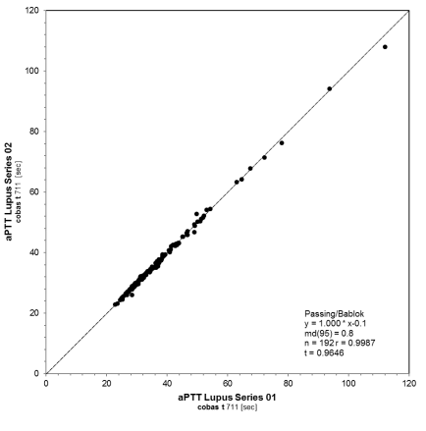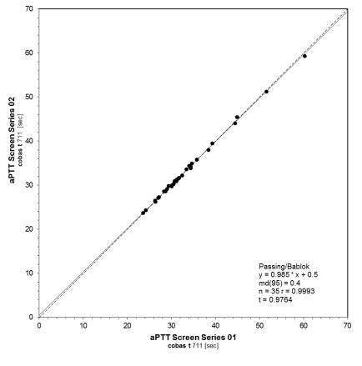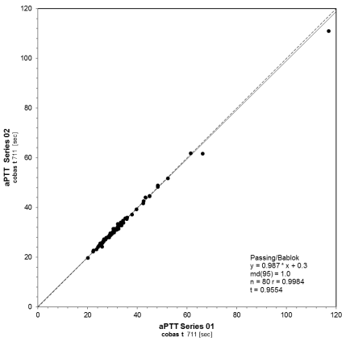
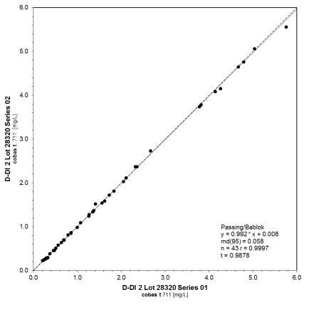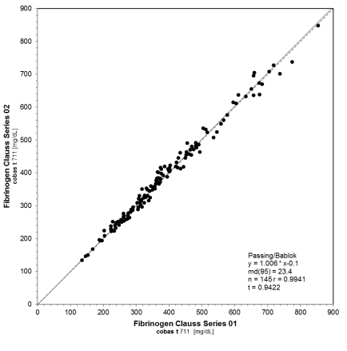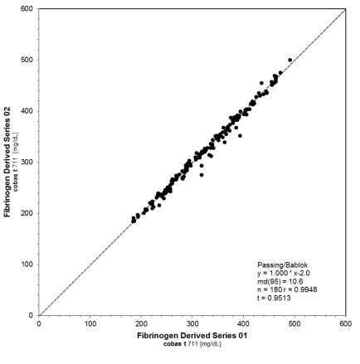
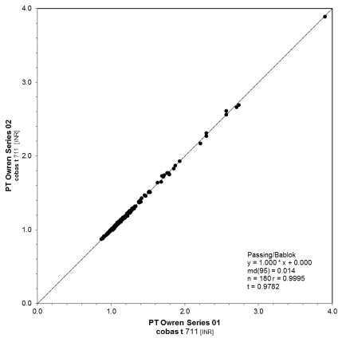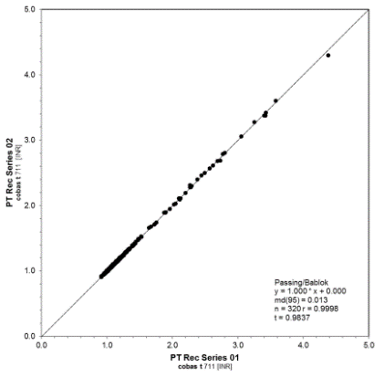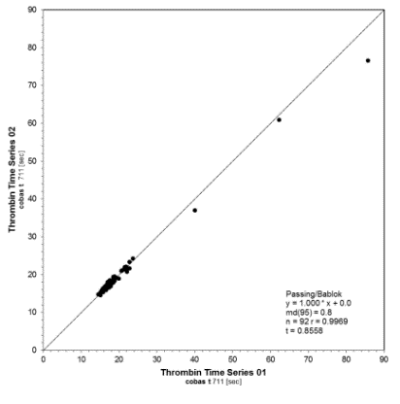
aPTT, activated partial thromboplastin time; D-DI, D-dimer; INR, international normalized ratio; PT, prothrombin time; Rec, recombinant human thromboplastin reagent.
Fig. S2 Routine simulation series correlation graphs – site 2 (cobas t 711)

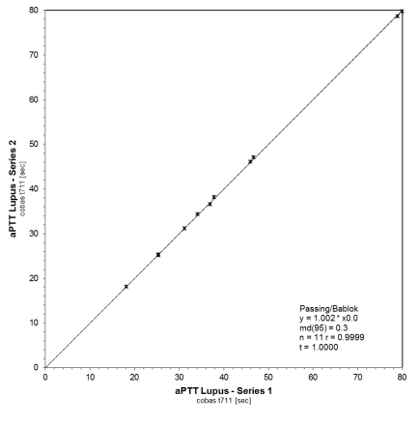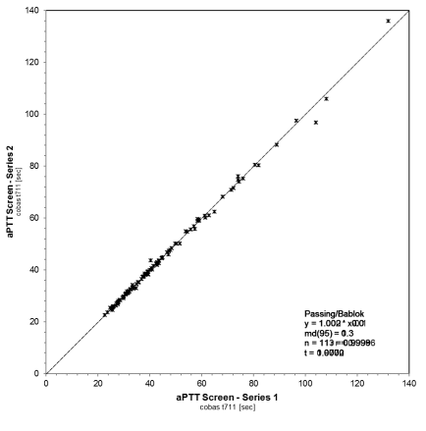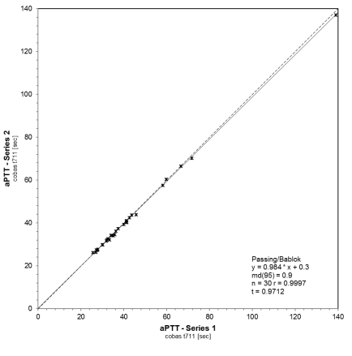

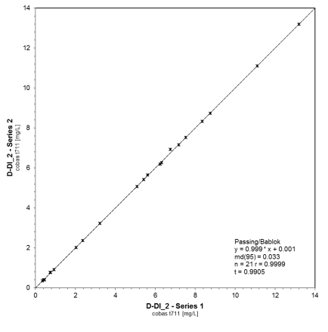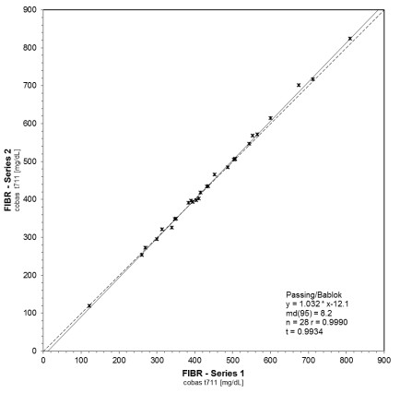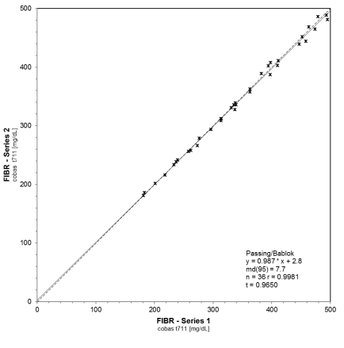
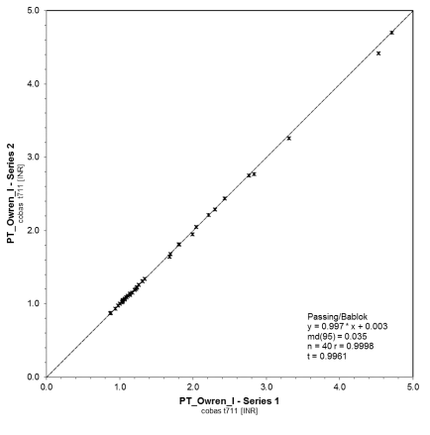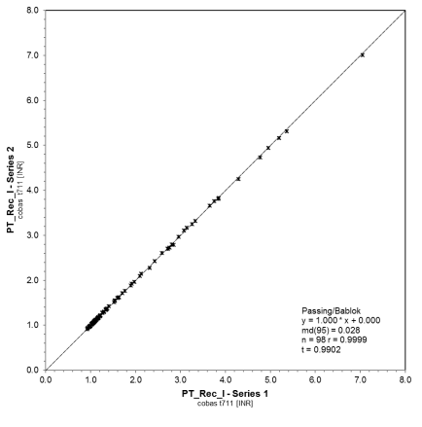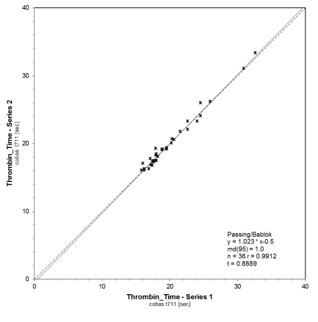
aPTT, activated partial thromboplastin time; D-DI, D-dimer; FIBR, Fibrinogen; INR, international normalized ratio; PT, prothrombin time; Rec, recombinant human thromboplastin reagent.
Fig. S3 Routine simulation series correlation graphs – site 3 (cobas t 711)
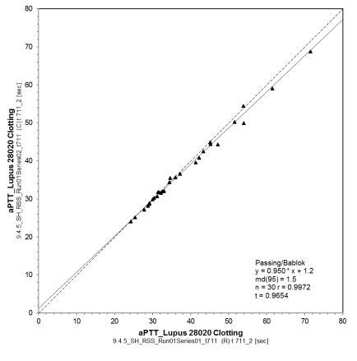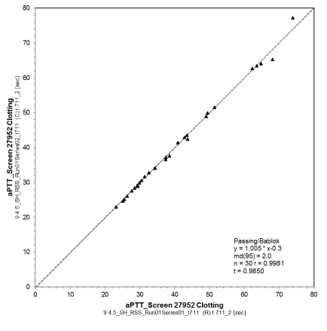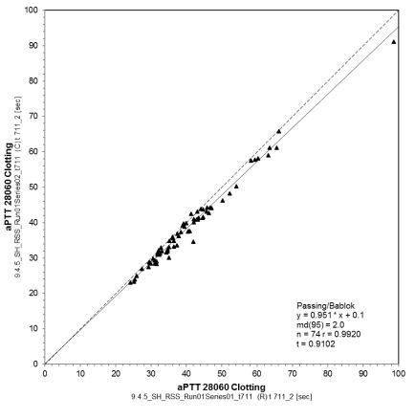
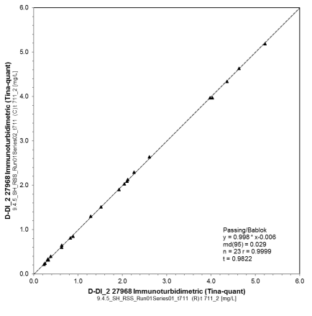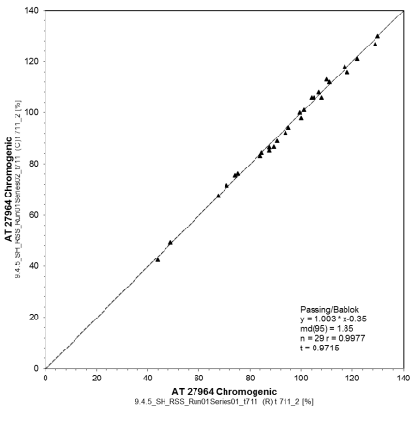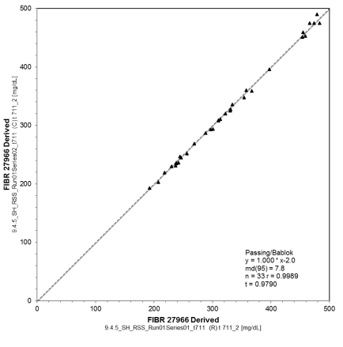
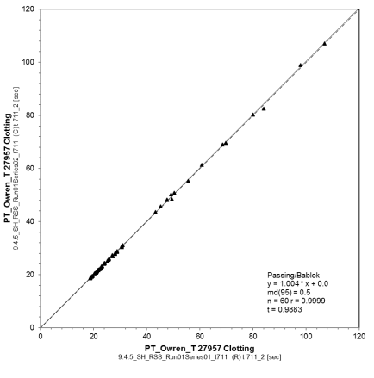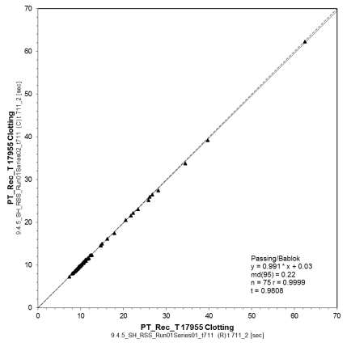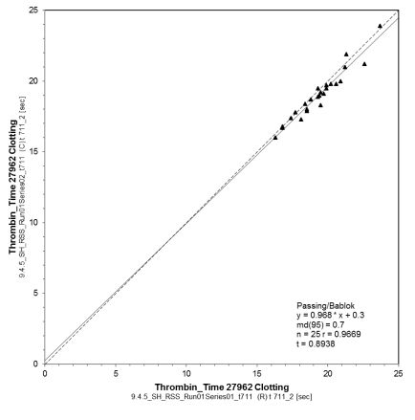
aPTT, activated partial thromboplastin time; AT, Antithrombin Time; D-DI, D-dimer; FIBR, Fibrinogen; PT, prothrombin time; Rec, recombinant human thromboplastin reagent.
Fig. S4 Routine simulation series correlation graphs – site 3 (cobas t 511)
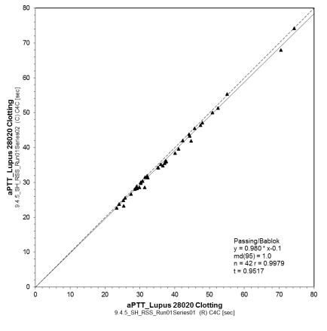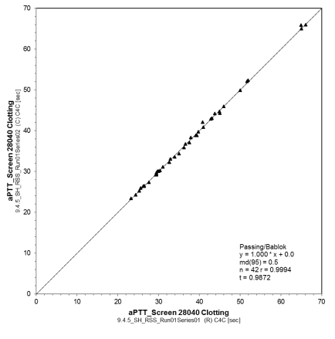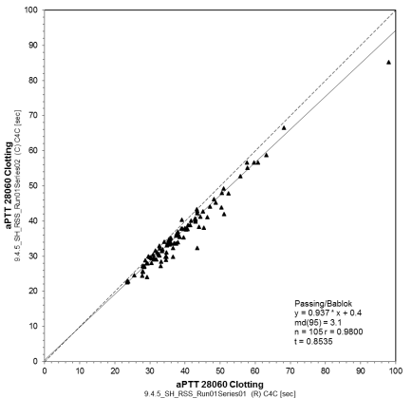
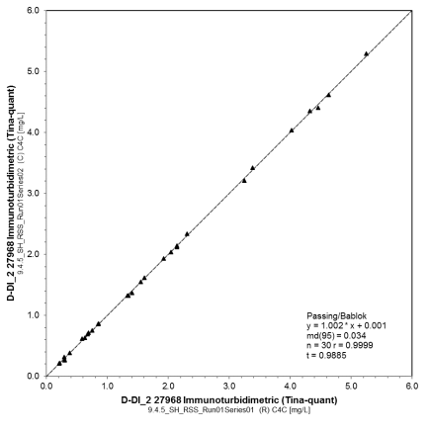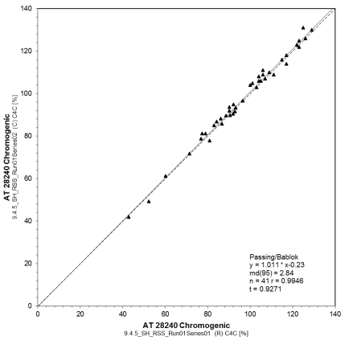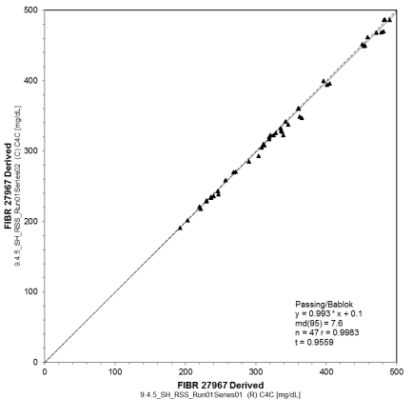
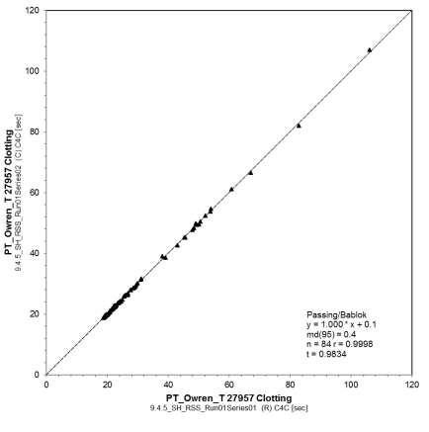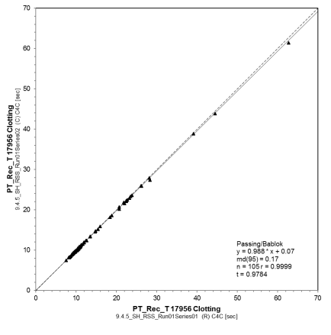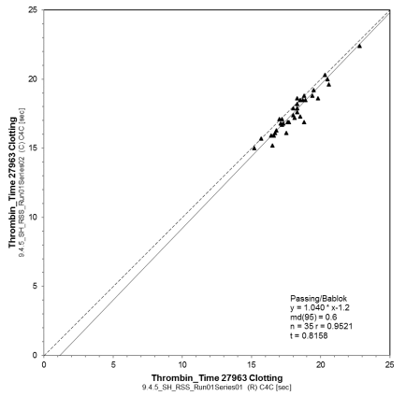
aPTT, activated partial thromboplastin time; AT, Antithrombin Time; D-DI, D-dimer; FIBR, Fibrinogen; PT, prothrombin time; Rec, recombinant human thromboplastin reagent.

