Supplementary material for Simulation of hip preservation surgery

Simulation of cam resection

First, hip range of motion (flexion and internal rotation in 90° of flexion) was simulated without treatment using the CT-based 3D models of untreated severe SCFE patients. This was performed with the previously described software for impingement simulation. This is similar to previous studies that used this software (Tannast et al, LCPD, Steppacher DDH 2015 and Lerch 2019 AJSM). Then the femoral 3D models were used to simulate osteochondroplasty of the femoral head-neck junction (cam resection). This method was described previously by Ecker et al (Ecker et al, Journal of Arthroplasty, 2012) and was validated on sawbone femora and 5 cadaver hips. For the current study, cam resection was performed as described by Ecker et al, the software was used to plan and perform repeated computerassisted osteochondroplasty procedures (cam resection) using a virtual burr (surgical reaming device, similar to the electric pen drive of Synthes AG, Switzerland). The virtual sphere of the burr (red sphere in supplemental Figure 1) was used to simulate stepwise the cam resection. The green and red area in Figure represents the extent and depth of the cam resection on the proximal femur (Figure 2). The difference between virtual preoperative and posterior femoral models are visualized with the red transparent volume (Figure 3). Postoperative 3D models were created and compared with the preoperative models.
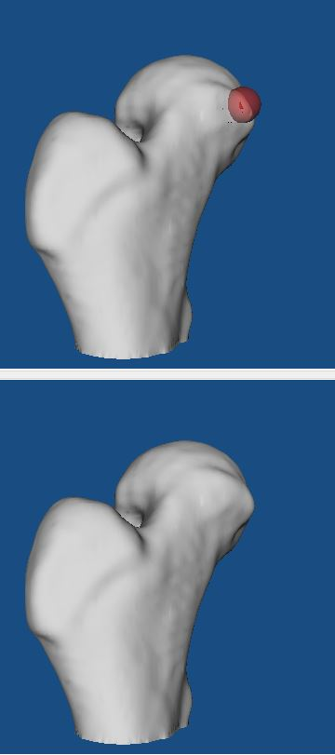
Figure 1 the red sphere of the burr (above) and the original proximal femur (below).
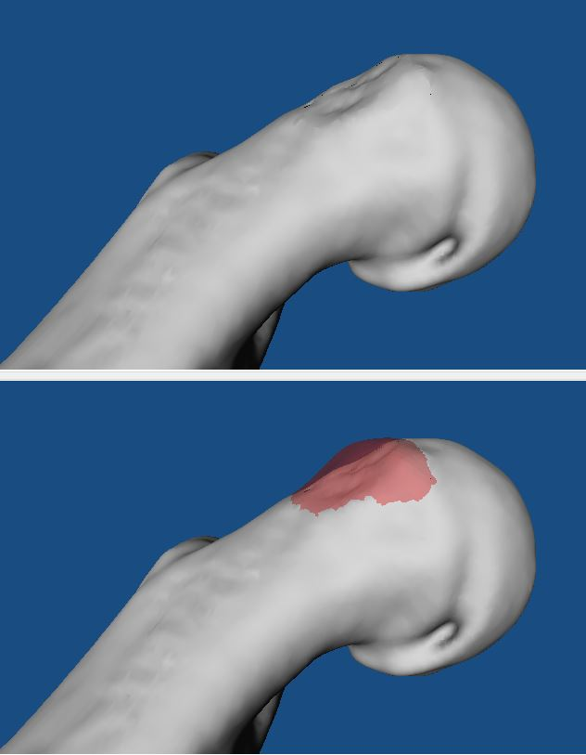

Figure 2A original proximal femur (top) and with red transparent volume after virtual cam resection (below) of a patient with severe SCFE is shown.
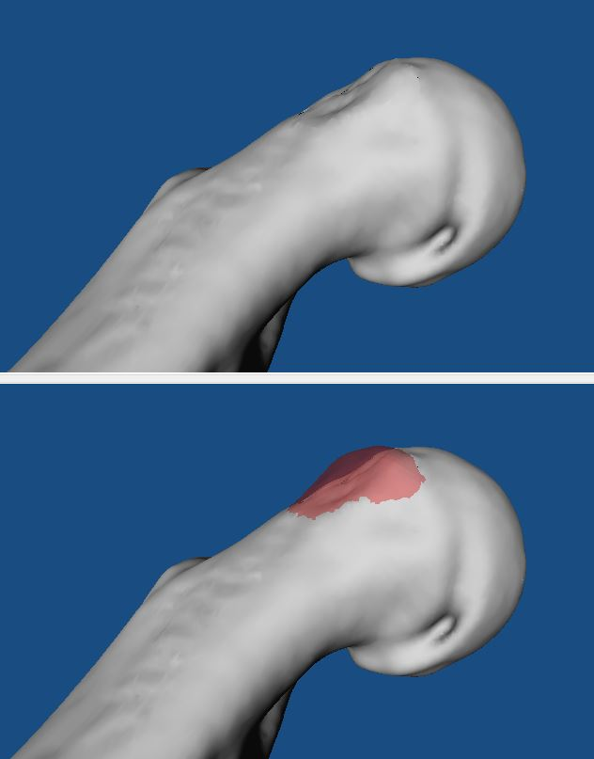
Figure 2B original proximal femur (top) and with red transparent volume after virtual cam resection (below) of the same patient with severe SCFE shown in Figure 2A.

Figure 3A original proximal femur (below) and after virtual cam resection (top) of another patient with severe SCFE.

Figure 3B original proximal femur (below) and after virtual cam resection (top) of the same patient with severe SCFE shown in Figure 3A.
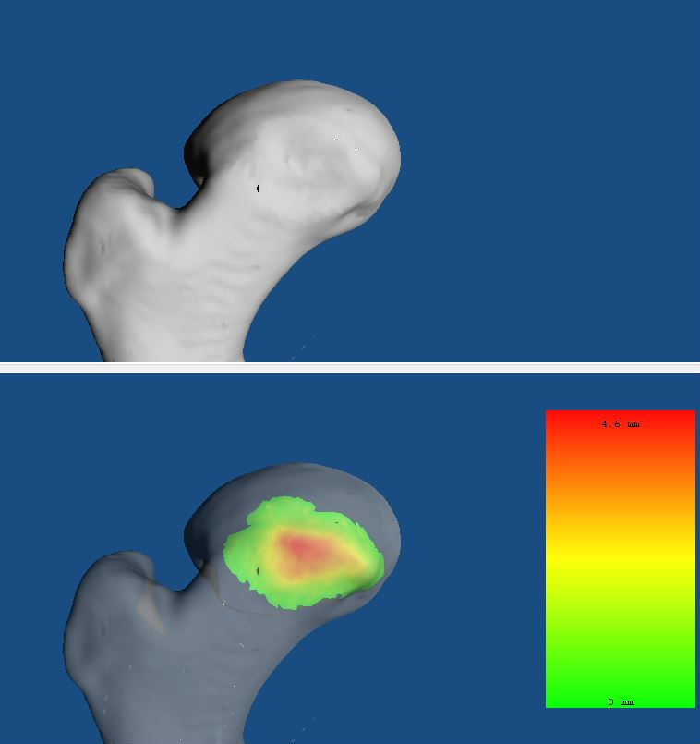
Figure 4 showing the green and red area of the cam resection to visualize width and depth of the cam resection of another patient with severe SCFE.

Supplementary material for simulation of femoral osteotomy
Second, simulation of derotation-osteotomy (10°, 20° and 30°correction) and later flexion-derotation-osteotomy (10° and 20°correction) was performed. For this purpose, specific software was used. The software allows to perform open or closed wedge osteotomy as well as derotation osteotomy, detailed description and figures are provided thereafter. For simulation of derotation-osteotomy, a virtual intertrochanteric derotation osteotomy was performed using this software (Figure 5). The landmarks and the reference system are exactly the same as for the equidistant method. After performing the virtual osteotomy perpendicular to the femoral shaft axis, the distal femur is rotated inwards (medial, in direction of the contralateral limb) in order to increase femoral version stepwise (Figure 5). The difference between the three steps (10°, 20° and 30°correction) are visualized in supplemental Figure 6. Three virtual femoral osteotomies were created for each patient (one model for 10°, one model for 20° and one model for 30° of correction). Then the postoperative 3D models were compared with the preoperative 3D models.
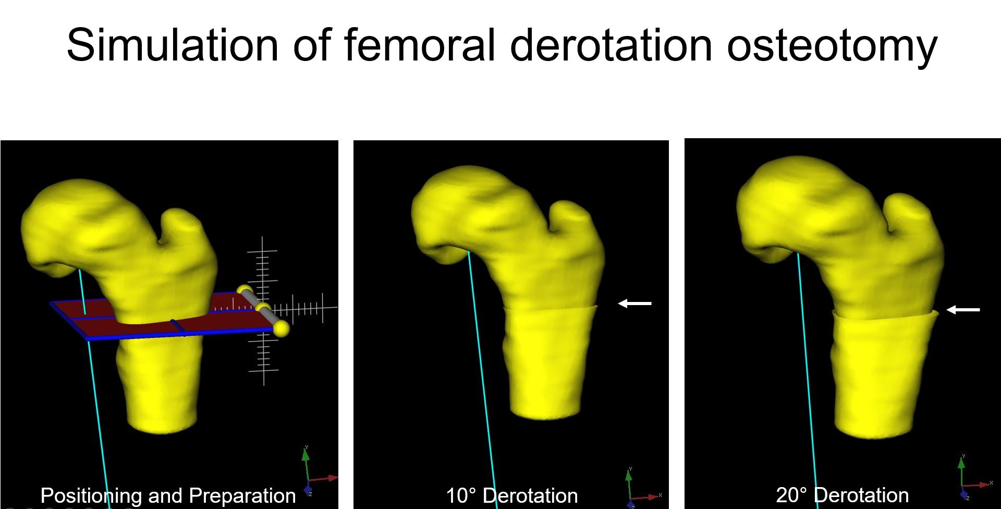
Figure 5 showing the positioning and preparation (left) of the intertrochanteric femoral derotation osteotomy (white arrow, right image) to increase femoral version.

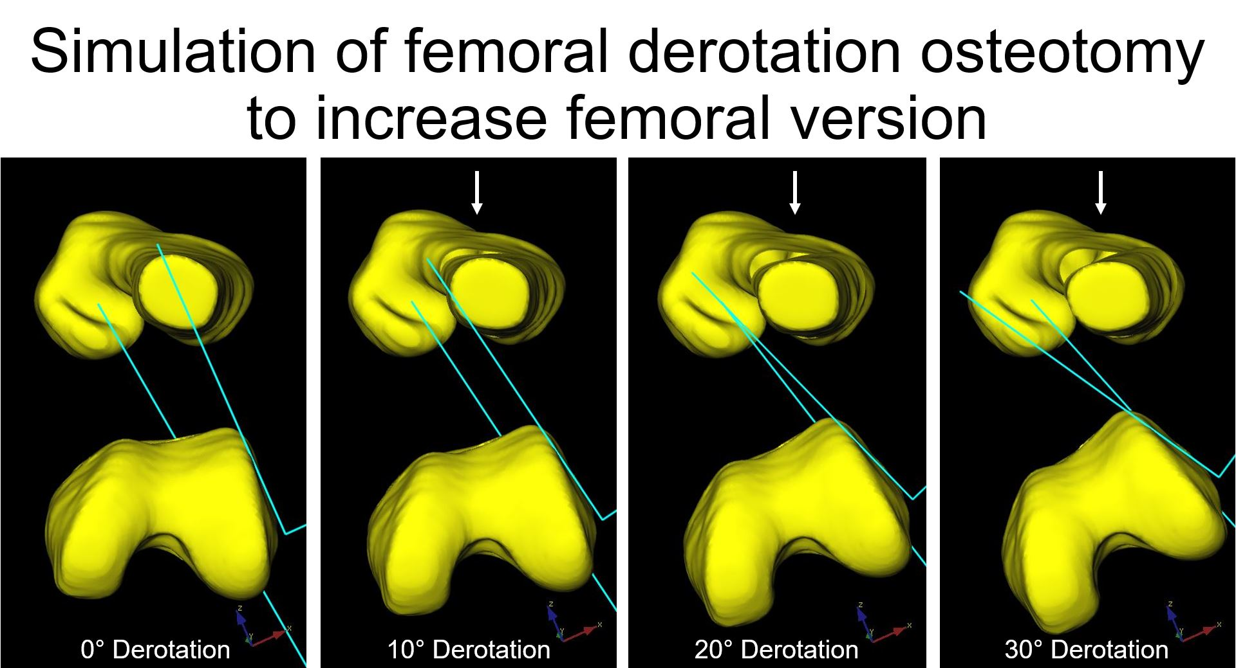
Figure 6. showing stepwise simulation of 10°, 20° and 30°correction of femoral derotation osteotomy to increase femoral version.

Third, the three above-mentioned virtual femoral osteotomies were used to simulate flexion-derotation-osteotomy(10° and 20°correction). Using the virtual femoral osteotomy model with 10° of correction, 10° of flexion correction was added in the same software. This resulted in a femoral model with a flexion-derotation-osteotomy (10° correction of flexion and 10° correction of derotation). Tilting of the distal femoral fragment was performed in anterior direction (proximal femoral fragment was tilted posteriorly, shown in schematic Figure 3 of the manuscript). Similar virtual femoral osteotomy was performed for combined 20° correction of flexion and 20° correction of derotation.

