LIST OF SUPPLEMENTAL DIGITAL CONTENT
Supplemental Digital Content 1. Table that reports main study eligibility criteria. docx
Supplemental Digital Content 2. Figure that reports the CONSORT flow diagram. docx
Supplemental Digital Content 3. Table that reports components of the primary composite endpoint at 5 years for activL vs. Control artificial discs (complete case imputation analysis). docx
Supplemental Digital Content 4. Figure that reports back pain severity Visual Analogue Scale score through 5 years post-treatment for activL vs. Control artificial discs (complete case imputation analysis). docx
Supplemental Digital Content 5. Figure that reports Oswestry Disability Index scores through 5 years post-treatment for activL vs. Control artificial discs (complete case imputation analysis). docx
Supplemental Digital Content 6. Table that reports radiographic findings: 5-year endpoint for activL vs. Control artificial discs (complete case imputation analysis). docx
Supplemental Digital Content 7. Table that reports correlation of total disc replacement flexion-extension rotation with pain and function scores at 5 years (complete case imputation analysis). docx
Supplemental Digital Content 8. Table that reports narcotic usage through 5 years for activL vs. Control artificial discs (complete case imputation analysis). docx
ONLINE SUPPLEMENT
Supplemental Digital Content 1. Main study eligibility criteria
Key Inclusion Criteria
- Skeletally mature adults aged 18 to 60 years
- Radiographic evidence of lumbar DDD, based on identification of any of the following characteristics by MRI scan:
  - instability (≥3mm translation or ≥5° angulation)
  - osteophyte formation of facet joints or vertebral endplates
  - decreased disc height (>2mm compared to the adjacent level)
  - scarring/thickening of ligamentum flavum, annulus fibrosis, or facet joint capsule
  - herniated nucleus pulposus
  - facet joint degeneration
  - vacuum phenomenon
- Single-level symptomatic disease at L4/L5 or L5/S1
- Minimum of 6 months of unsuccessful conservative treatment
- Minimum Oswestry Disability Index score of 40/100
- Minimum VAS back pain score of 40/100 mm
- Surgical candidate for an anterior approach to the lumbar spine
Key Exclusion Criteria
- Previous surgery at any lumbar level, other than IDET, percutaneous nucleoplasty, microdiscectomy, hemilaminectomy, or laminotomy
- Chronic radiculopathy, defined as unremitting pain with a predominance of leg pain symptoms greater than back pain symptoms extending over a period of at least 1 year
- Anatomically unsuitable for TDR based on preoperative radiographic assessment
- Index level disc height < 3 mm
- Myelopathy
- Previous compression or burst fracture at index level
- Sequestered herniated nucleus pulposus with migration
- Mid-sagittal stenosis <8mm (by MRI)
- Spondylolysis.
- Lumbar scoliosis (>11 degrees sagittal plane deformity)
- Spinal tumor
- Active systemic infection or infection at the site of surgery
- Facet ankylosis or severe facet degeneration
- Continuing steroid use or prior use for more than 2 months
- Pregnancy or planning to become pregnant within the next 2 years
- Morbid obesity (BMI >35)
- Osteoporosis, osteopenia, or metabolic bone disease
- History of rheumatoid arthritis, lupus, or other autoimmune disorder
- Ankylosing spondylitis
- Abdominal pathology that would preclude the abdominal surgical approach
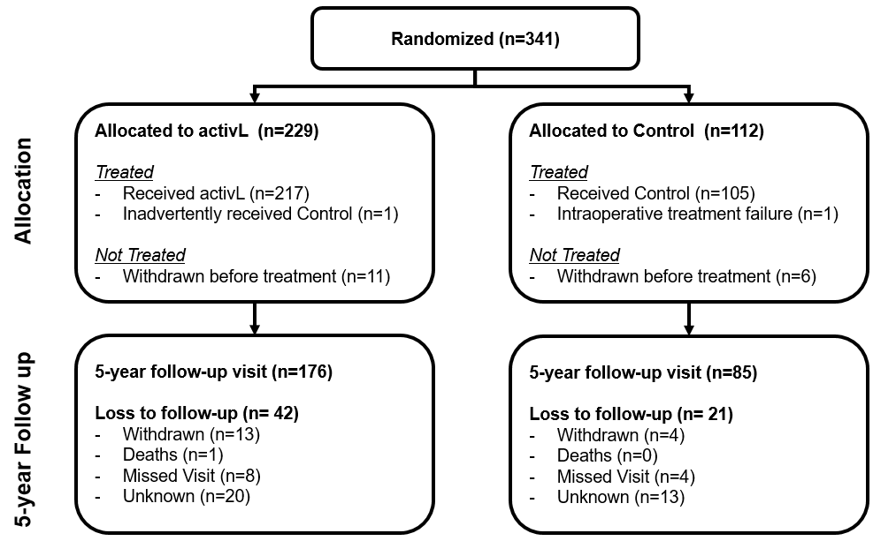

Supplemental Digital Content 2. CONSORT flow diagram.

Supplemental Digital Content 3. Components of the primary composite endpoint at 5 years for activL vs. Control artificial discs (complete case imputation analysis).
Type of analysis | activL | Control | P-value*
ODI successª | 83% (117/141) | 85.9% (61/71) | 0.69
Neurological success^{b} | 95.1% (135/142) | 90.1% (64/71) | 0.24
Radiographic success^{c} | 59.9% (82/137) | 54.3% (38/70) | 0.46
Device success^{d} | 92.7% (140/151) | 92% (69/75) | 1.0
Freedom from device-related serious AE^{e} | 71.7% (114/159) | 69.1% (56/81) | 0.76
ªImprovement ≥15 points in Oswestry Disability Index from baseline.
^{b}Maintenance or improvement in neurological status compared with baseline.
^{c}Maintenance or improvement in range of motion at index level.
^{d}Freedom from device failure requiring revision, reoperation, removal, or supplemental fixation.
^{e}Adverse event attributable to the device that was fatal, was life-threatening, required prolonged hospitalization, resulted in permanent anatomic or physiological impairment, caused a malignant tumor, or resulted in distress, congenital anomaly, or death of a fetus.
*Fisher’s Exact Test was used to compare sample proportions between groups.

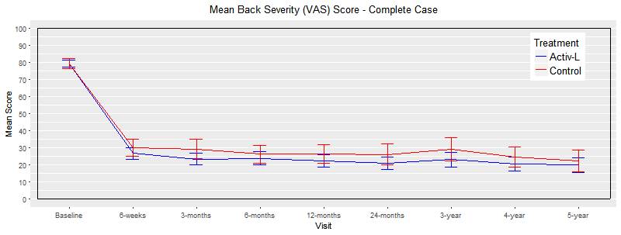
Supplemental Digital Content 4. Back pain severity Visual Analogue Scale score through 5 years post-treatment for activL vs. Control artificial discs. Complete case imputation was used for missing patient data. Values are mean ± 95% confidence interval.

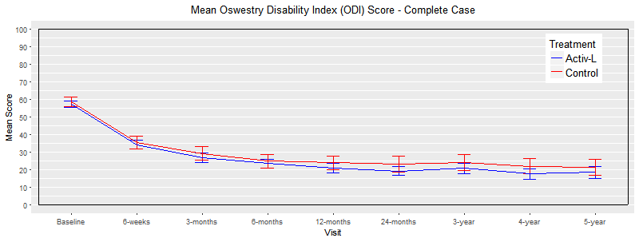
Supplemental Digital Content 5. Oswestry Disability Index scores through 5 years post-treatment for activL vs. Control artificial discs. Complete case imputation was used for missing patient data. Values are mean ± 95% confidence interval.

Supplemental Digital Content 6. Radiographic findings: 5-year endpoint for activL vs. Control artificial discs (complete case imputation analysis).
Type of analysis | activL  n=218 | Control  n=106 | ProDisc-L  n=65 | P-value*  activL vs. Control | P-value*  activL vs. ProDisc-L
Disc height (mm) | 13.7 ± 1.6 | 13.7 ± 1.7 | 12.9 ± 1.4 | 0.95 | 0.0006
Disc angle (degrees) | 21.5 ± 4.4 | 20.2 ± 4.7 | 19.4 ± 5 | 0.048 | 0.016
Flexion-extension rotation (degrees) | 6.2 ± 4.7 | 4.7 ± 4.1 | 4 ± 4 | 0.021 | 0.0036
Flexion-extension translation (mm) | 0.8 ± 0.9 | 0.7 ± 0.8 | 0.7 ± 0.8 | 0.13 | 0.24
*Two-sample t-test was used to compare if sample means were statistically different between groups.

Supplemental Digital Content 7. Correlation of total disc replacement flexion-extension rotation with pain and function scores at 5 years (complete case imputation analysis).
Pain and Function Variable | Motion (Flexion/Extension - Rotation)
 | r | p-value*
Pain (Back Pain VAS) | -0.17 | 0.014
Pain (Leg Pain VAS) | -0.092 | 0.19
Function (ODI) | -0.18 | 0.0075
*Two-sample t test.

Supplemental Digital Content 8. Narcotic usage through 5 years for activL vs. Control artificial discs (complete case imputation analysis).
 | Baseline |  | 12-months |  | 24 months |  | 36 months |  | 48 months |  | 60 months
 | activL  n/N  % | Control  n/N  % | activL  n/N  % | Control  n/N  % | activL  n/N  % | Control  n/N  % | activL  n/N  % | Control  n/N  % | activL  n/N  % | Control  n/N  % | activL  n/N  % | Control  n/N  %
% patients with narcotic use | 141/218  (64.7) | 65/106  (61.3) | 55/202  (27.2) | 37/96  (38.5) | 58/189  (30.7) | 29/87  (33.3) | 30/208  (14.4) | 15/99  (15.2) | 7/201  (3.5) | 7/97  (7.2) | 2/182  (1.1) | 2/93  (2.2)
p-value* (compared to baseline) |  |  | 0 | 0.0002 | 0 | 0.0002 | 0 | 0 | 0 | 0 | 0 | 0
p-value**  (between groups) | 0.62 |  | 0.06 |  | 0.68 |  | 0.86 |  | 0.24 |  | 0.61
*Two-sample proportion test was used to compare to baseline.
**Fisher’s Exact Test was used to compare sample proportions between groups.

