Supplemental Figure 1. General medical service use for scoliosis - Number of patients (WM: Western medicine; KM: Korean medicine)
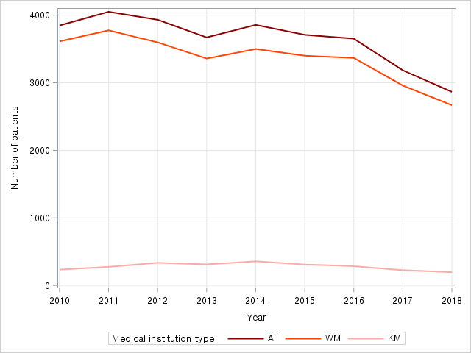
The number of patients was calculated based on patients with primary diagnosis of scoliosis who received treatments included in NHI covered items.

Supplemental Figure 2. General medical service use for scoliosis - Annual expense per patient (WM: Western medicine; KM: Korean medicine)
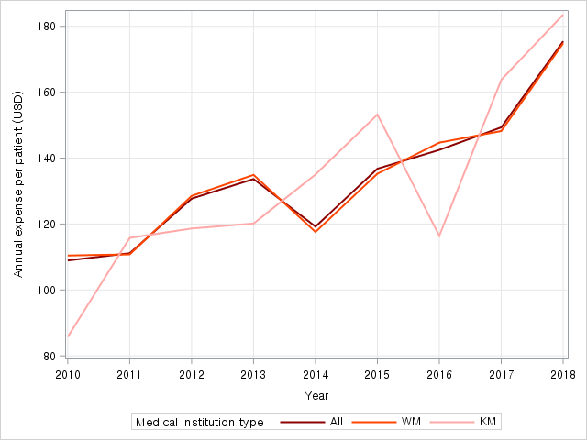
Annual expense per patient was calculated by dividing the total expense for applicable year by the number of patients for that year (Annual expense per patient = total expense for applicable year / the number of patients for that year); Annual expense per patient was calculated based on patients with primary diagnosis of scoliosis who received treatments included in NHI covered items; In cases where patients included in this study received both treatments covered and not covered by NHI, only data related to treatments covered by NHI were calculated.

Supplemental Figure 3. General medical service use for scoliosis - Total expense (WM: Western medicine; KM: Korean medicine)
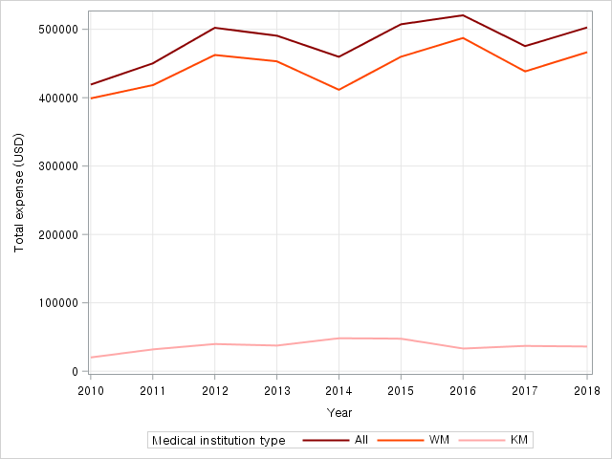
Total expense was calculated based on patients with primary diagnosis of scoliosis who received treatments included in NHI covered items; In cases where patients included in this study received both treatments covered and not covered by NHI, only data related to treatments covered by NHI were calculated.
Supplemental Figure 4. General medical service use for scoliosis - Number of cases (WM: Western medicine; KM: Korean medicine)
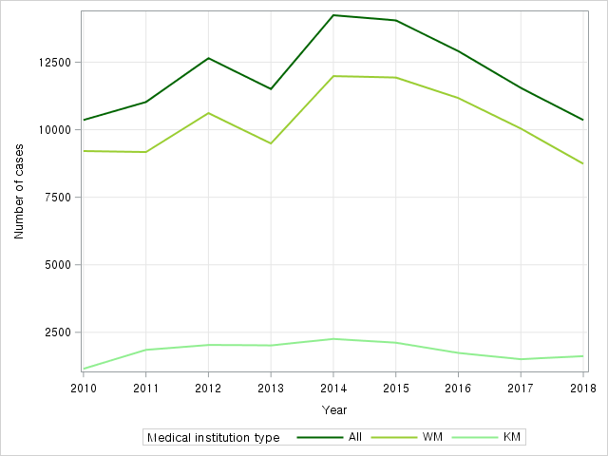
The number of cases was calculated based on patients with primary diagnosis of scoliosis who received treatments included in NHI covered items; In cases where patients included in this study received both treatments covered and not covered by NHI, only data related to treatments covered by NHI were calculated.

Supplemental Figure 5. General medical service use for scoliosis - Average visit per patient (WM: Western medicine; KM: Korean medicine)
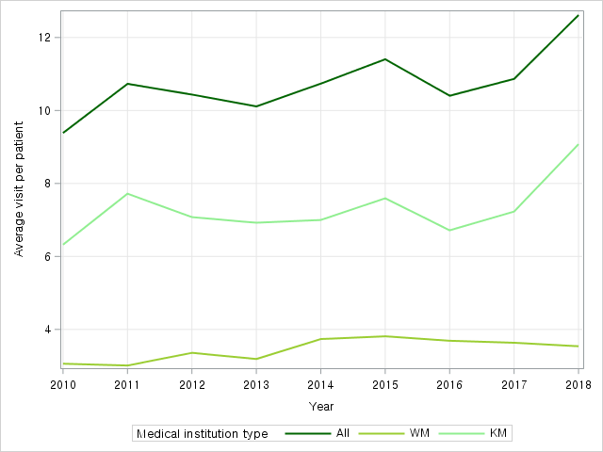
Average visit per patient was calculated by dividing the number of total cases for applicable year by the number of patients for that year (Average visit per patient = Number of total cases for applicable year / the number of patients for that year); Average visit per patient was calculated based on patients with primary diagnosis of scoliosis who received treatments included in NHI covered items; In cases where patients included in this study received both treatments covered and not covered by NHI, only data related to treatments covered by NHI were calculated.

Supplemental Table 1. ATC code by category of drugs for scoliosis
Category | ATC code
Anti-inflammatory analgesics (NSAIDs) | M01A
Antipyretic analgesics (Acetaminophen) | N02A, N02B
Gastrointestinal drugs | A03A, A03B, A03F, A16A
Antacids | A02A, A02B, A02X
Other central nervous system drugs | N01A, N01B, N03A, N05A, N05B, N05C, N06A, N07AX02
Skeletal muscle relaxers | M03A, M03B
Adrenal hormone | H02A
Other cardiovascular drugs | B01A, C01C, C04A, C05C, C08C
Enzymes | M09AB
Other | A01A, A04A, A05A, A05B, A06A, A07B, A10A, A11B, A11E, A12A, B02BA01, B03A, B05XA07, C03A, C03C, G04C, J01C, J01D, J01X, M01A, M05B, M09AX, R01B, R03C, R05C, R05D, R05F, R06A
Blood products | A12B, B02A, B02B, B05A, B05B, B05X, V07A
Autonomic nervous system drugs | A03AB02, N07A
Oxygen | V03A
Narcotics | N01AH, N02A
ATC: Anatomical Therapeutic Chemical; The ATC codes were coded based on the WHO Guidelines for the anatomic/therapeutic/chemical (ATC) classification and defined daily dose (DDD) assignment 2020 23rd edition;

Supplemental Table 2. General medical service use for scoliosis - patients in South Korea
Year | Type of visit | Number of patients | Total cases | Total expense | Per-patient expense | Per-case expense | Total care | Avg days in care per patient | Total visit | Avg visits per patient
2010 | Total | 3,848 | 10,360 | 419,209 | 108.94 | 40.46 | 12,891 | 9.87 | 12,193 | 9.38
 | WM | 3,613 | 9,209 | 399,054 | 110.45 | 43.33 | 11,468 | 3.24 | 10,825 | 3.06
 | KM | 235 | 1,151 | 20,155 | 85.77 | 17.51 | 1,423 | 6.63 | 1,368 | 6.32
2011 | Total | 4,051 | 11,026 | 450,199 | 111.13 | 40.83 | 14,736 | 11.41 | 12,942 | 10.73
 | WM | 3,776 | 9,174 | 418,354 | 110.79 | 45.6 | 12,735 | 3.48 | 10,961 | 3.01
 | KM | 275 | 1,852 | 31,845 | 115.8 | 17.2 | 2,001 | 7.93 | 1,981 | 7.72
2012 | Total | 3,933 | 12,648 | 502,243 | 127.7 | 39.71 | 15,220 | 10.97 | 13,909 | 10.44
 | WM | 3,598 | 10,615 | 462,495 | 128.54 | 43.57 | 12,989 | 3.71 | 11,738 | 3.36
 | KM | 335 | 2,033 | 39,748 | 118.65 | 19.55 | 2,231 | 7.26 | 2,171 | 7.08
2013 | Total | 3,671 | 11,507 | 490,639 | 133.65 | 42.64 | 14,280 | 10.79 | 12,361 | 10.11
 | WM | 3,359 | 9,492 | 453,151 | 134.91 | 47.74 | 12,195 | 3.75 | 10,314 | 3.19
 | KM | 312 | 2,015 | 37,488 | 120.15 | 18.6 | 2,085 | 7.04 | 2,047 | 6.92
2014 | Total | 3,857 | 14,240 | 459,789 | 119.21 | 32.29 | 17,202 | 11.77 | 14,910 | 10.74
 | WM | 3,500 | 11,984 | 411,581 | 117.59 | 34.34 | 14,770 | 4.37 | 12,579 | 3.74
 | KM | 357 | 2,256 | 48,209 | 135.04 | 21.37 | 2,432 | 7.4 | 2,331 | 7
2015 | Total | 3,710 | 14,048 | 507,451 | 136.78 | 36.12 | 16,799 | 12.25 | 14,880 | 11.4
 | WM | 3,400 | 11,932 | 459,958 | 135.28 | 38.55 | 14,505 | 4.36 | 12,650 | 3.81
 | KM | 310 | 2,116 | 47,493 | 153.2 | 22.44 | 2,294 | 7.9 | 2,230 | 7.59
2016 | Total | 3,653 | 12,908 | 520,518 | 142.49 | 40.33 | 15,172 | 11.09 | 13,902 | 10.4
 | WM | 3,368 | 11,172 | 487,335 | 144.7 | 43.62 | 13,336 | 4.04 | 12,153 | 3.69
 | KM | 285 | 1,736 | 33,183 | 116.43 | 19.11 | 1,836 | 7.05 | 1,749 | 6.72
2017 | Total | 3,184 | 11,547 | 475,455 | 149.33 | 41.18 | 13,093 | 11.38 | 12,039 | 10.87
 | WM | 2,958 | 10,041 | 438,444 | 148.22 | 43.67 | 11,500 | 3.98 | 10,483 | 3.64
 | KM | 226 | 1,506 | 37,011 | 163.77 | 24.58 | 1,593 | 7.39 | 1,556 | 7.23
2018 | Total | 2,865 | 10,359 | 502,724 | 175.47 | 48.53 | 12,334 | 13.72 | 10,859 | 12.62
 | WM | 2,668 | 8,739 | 466,565 | 174.87 | 53.39 | 10,598 | 4.05 | 9,239 | 3.54
 | KM | 197 | 1,620 | 36,159 | 183.55 | 22.32 | 1,736 | 9.66 | 1,620 | 9.08
WM: Western medicine; KM: Korean medicine; All cost-related results presented in this study were converted to the 2018 level based on healthcare and medical service price index adjusted for healthcare inflation rate and KRW:USD exchange rate (see Supplemental Table 3).

Supplemental Table 3. Annual average KRW-USD exchange rate and price level of health expense
Year | KRW/USD | Healthcare & medical service price index
2010 | 1156.00 | 0.9345
2011 | 1107.99 | 0.9510
2012 | 1126.76 | 0.9597
2013 | 1095.04 | 0.9631
2014 | 1053.12 | 0.9699
2015 | 1131.52 | 0.9820
2016 | 1160.41 | 0.9918
2017 | 1130.48 | 1.0005
2018 | 1100.58 | 1.0000
All cost-related results presented in this study were converted to the 2018 level based on healthcare and medical service price index adjusted for healthcare inflation rate and KRW:USD exchange rate; This information is available on the following site: Korean Statistical Information Service (http://kosis.kr).

