Supplemenetal Digital Content 4
Evidence Summary
Sepsis
Forest Plots – Annane D, Bellissant E, Bollaert PE, Briegel J, Keh D, Kupfer Y. Corticosteroids for treating sepsis. Cochrane Database of
Systematic Reviews 2015, Issue 12. Art. No.: CD002243. DOI: 10.1002/14651858.CD002243.pub3.
Evidence Profile – corticosteroids in sepsis
Quality assessment |  |  |  |  |  |  | № of patients |  | Effect |  | Quality | Importance
№ of studies | Study design | Risk of bias | Inconsistency | Indirectness | Imprecision | Other considerations | corticosteroids | placebo | Relative  (95% CI) | Absolute  (95% CI)
28-day mortality - all comers with sepsis
27 | randomised trials | not serious | serious ª | not serious | serious ^{b} | none | 474/1618 (29.3%) | 495/1558 (31.8%) | RR 0.87  (0.76 to 1.00) | 41 fewer per 1,000  (from 0 fewer to 76 fewer) | ⨁⨁◯◯  LOW | CRITICAL
28-day mortality - sepsis without shock
6 | randomised trials | not serious | not serious | not serious | serious ^{c} | none | 140/414 (33.8%) | 126/412 (30.6%) | RR 1.11  (0.91 to 1.34) | 34 more per 1,000  (from 28 fewer to 104 more) | ⨁⨁⨁◯  MODERATE | CRITICAL
28-day mortality - septic shock
12 | randomised trials | not serious | serious ^{d} | not serious | serious ^{b} | none | 291/741 (39.3%) | 302/703 (43.0%) | RR 0.88  (0.78 to 0.99) | 52 fewer per 1,000  (from 4 fewer to 95 fewer) | ⨁⨁◯◯  LOW | CRITICAL
28 day mortality - low dose/long course steroids
22 | randomised trials | not serious | not serious | not serious | not serious | none | 322/1148 (28.0%) | 359/1118 (32.1%) | RR 0.87  (0.78 to 0.97) | 42 fewer per 1,000  (from 10 fewer to 71 fewer) | ⨁⨁⨁⨁  HIGH | CRITICAL
28 day mortality - high dose/short course corticosteroids
5 | randomised trials | not serious | serious ^{d} | not serious | serious ^{c} | none | 152/470 (32.3%) | 136/440 (30.9%) | RR 0.96  (0.80 to 1.16) | 12 fewer per 1,000  (from 49 more to 62 fewer) | ⨁⨁◯◯  LOW | CRITICAL
Shock reversal (assessed with: at day 7)
12 | randomised trials | not serious | not serious | not serious | not serious | none | 532/806 (66.0%) | 395/755 (52.3%) | RR 1.31  (1.14 to 1.51) | 162 more per 1,000  (from 73 more to 267 more) | ⨁⨁⨁⨁  HIGH | CRITICAL
Superinfection
19 | randomised trials | not serious | not serious | not serious | not serious | none | 219/1307 (16.8%) | 203/1260 (16.1%) | RR 1.02  (0.87 to 1.20) | 3 more per 1,000  (from 21 fewer to 32 more) | ⨁⨁⨁⨁  HIGH | CRITICAL
Hyperglycemia
13 | randomised trials | not serious | not serious | serious ^{e} | not serious | none | 460/1066 (43.2%) | 353/1015 (34.8%) | RR 1.11  (0.91 to 1.34) | 38 more per 1,000  (from 31 fewer to 118 more) | ⨁⨁⨁◯  MODERATE | CRITICAL

CI: Confidence interval; RR: Risk ratio
a. 1 of 2 largest studies showed no survival benefit.
b. at upper limit of CI (1.0) would make different clinical decision than lower end
c. wide confidence intervals do not exclude benefit
d. high Isquared of 60%
e. Likely varying degrees of severity, less severe may not be as important.

ARDS
Forest Plots
Mortality
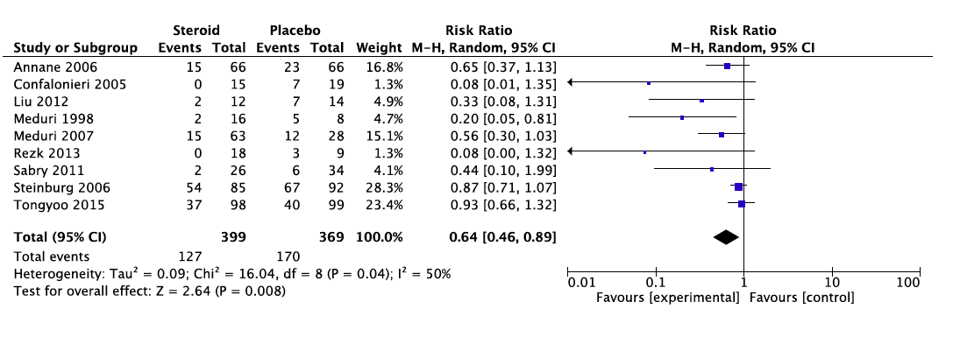
Ventilator free days at day 28
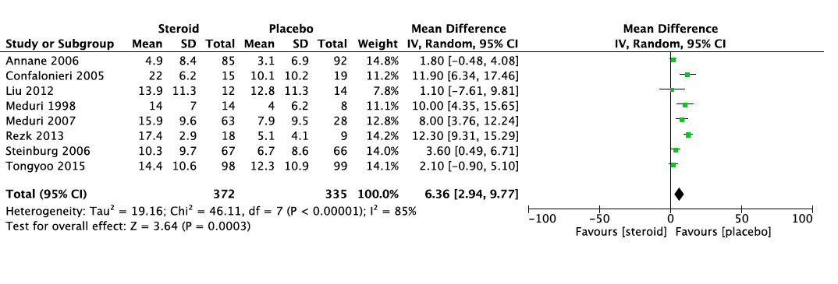
Nosocomial Infections
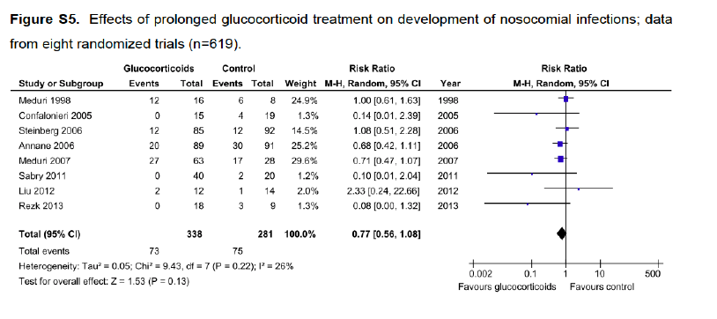
Evidence Profile for corticosteroids in ARDS
Quality assessment |  |  |  |  |  |  | № of patients |  | Effect |  | Quality | Importance
№ of studies | Study design | Risk of bias | Inconsistency | Indirectness | Imprecision | Other considerations | corticosteroids within 14d of ARDS onset | placebo | Relative  (95% CI) | Absolute  (95% CI)
Hospital Mortality (assessed with: days)
4 ¹ | randomised trials | not serious ² | not serious ³ | not serious | serious ⁴ | none | 86/240 (35.8%) | 108/220 (49.1%) | RR 0.76  (0.59 to 0.98) | 118 fewer per 1000  (from 10 fewer to 201 fewer) | ⨁⨁⨁◯  MODERATE | CRITICAL
Ventilator Free Days at Day 28
7 | randomised trials | serious ⁵ | not serious ³ | not serious | not serious | none | 274 | 236 | - | MD 7.06 days higher  (3.19 higher to 10.93 higher) | ⨁⨁⨁◯  MODERATE | CRITICAL
Nosocomial Infection
8 | randomised trials | serious ⁵ | not serious | serious ⁶ | serious ⁷ | none | 73/338 (21.6%) | 75/281 (26.7%) | RR 0.77  (0.56 to 1.08) | 61 fewer per 1000  (from 21 more to 117 fewer) | ⨁◯◯◯  VERY LOW | IMPORTANT
Weakness (assessed with: looking for mention of neuromyopathy in chart)
1 | randomised trials | serious ⁸ | not serious | serious ⁹ | serious ¹⁰ | none | 21/88 (23.9%) | 20/91 (22.0%) | RR 1.09  (0.63 to 1.86) | 20 more per 1000  (from 81 fewer to 189 more) | ⨁◯◯◯  VERY LOW | IMPORTANT
CI: Confidence interval; RR: Risk ratio; MD: Mean difference
- Only included 4 trials which had over 60 patients due to concerns regarding ROB.
- Studies with higher ROB excluded. Only included studies with lower ROB.
- High Isquared value. Although we did not lower for inconsistency as all included trials suggest benefit with overlapping confidence intervals. Instead, there was a varying degree of magnitude of benefit.
- Small number events and confidence interval that approaches no effect.
- Some of the included trials allowed blinded crossover (although the majority was from placebo to steroid which would decrease effect size). Two trials stopped early for benefit.
- Variable reporting and capturing of nosocomial infection among studies.
- Wide confidence intervals do not exclude harm.
- This was collected retrospectively for half of enrolled patients and prospectively for other half - as it was suggested mid-trial by DMSB.
- Not clear whether writing of neuromyopathy in the patient's chart is at all correlated with actual functional impairment. No objective measurement of weakness.
- Confidence intervals do not exclude harm or benefit.

Trauma

Forest Plots
Mortality
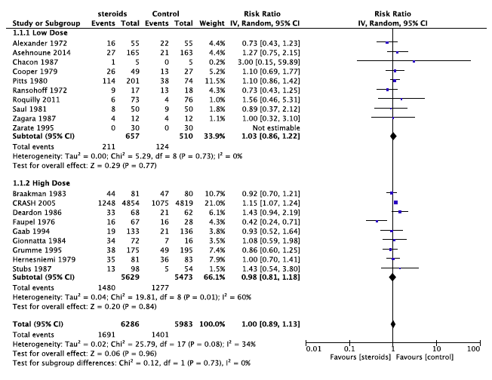
GI Bleeding
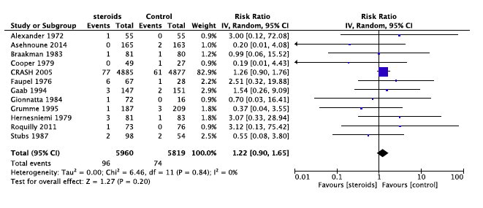
Any Infection
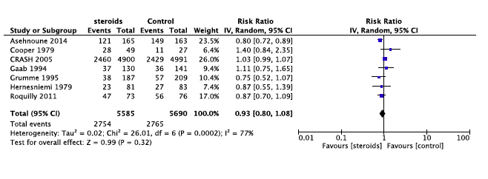

Evidence Profile for Corticosteroids in Trauma
Quality assessment |  |  |  |  |  |  | № of patients |  | Effect |  | Quality | Importance
№ of studies | Study design | Risk of bias | Inconsistency | Indirectness | Imprecision | Other considerations | corticosteroids | placebo | Relative  (95% CI) | Absolute  (95% CI)
Mortality (assessed with: duration of followup)
19 | randomised trials | not serious ¹ | not serious | not serious ² | serious ³ | none | 1691/6286 (26.9%) | 1401/5983 (23.4%) | RR 1.00  (0.89 to 1.13) | 0 fewer per 1,000  (from 26 fewer to 30 more) | ⨁⨁⨁◯  MODERATE | CRITICAL
Any New Infection
7 | randomised trials | not serious ¹ | serious ⁴ | serious ⁵ | serious ³ | none | 2754/5585 (49.3%) | 2765/5690 (48.6%) | RR 0.93  (0.80 to 1.08) | 34 fewer per 1,000  (from 39 more to 97 fewer) | ⨁◯◯◯  VERY LOW | IMPORTANT
GI Bleeding
12 | randomised trials | not serious ¹ | not serious | serious ⁶ | serious ⁷ | none | 96/5960 (1.6%) | 74/5819 (1.3%) | RR 1.22  (0.90 to 1.65) | 3 more per 1,000  (from 1 fewer to 8 more) | ⨁⨁◯◯  LOW | IMPORTANT
CI: Confidence interval; RR: Risk ratio
- Although many of the trials are older and lack a clear description of the methods followed, the largest trials which primarily drive the signal were well done with low risk of bias.
- Included studies used various dosing regimes and types of corticosteroids. Also included patients varied in severity of illness. Finally outcome duration varied by study. Despite these factors, the largest studies show a clear signal of no effect of steroids on survival in trauma. As such, we chose not to lower for indirectness.
- Although the numbers are large, the confidence intervals do not exclude harm or benefit. Even slight benefit would be clinically significant to this population.
- Large degree of statistical heterogeneity with Isquared >75%
- Variable definition and severity of infection lead to significant indirectness.
- Variable definition and severity of GI bleeding lead to significant indirectness.
- Wide confidence intervals do not exclude benefit. Also low number of events.

