Supplemental Digital Content 2. TREATMENT QUESTIONS EVIDENCE SUMMARY

Community Acquired Pneumonia
Forest Plot – Siemieniuk R, Meade M, Alonso-Coello P, et al. Corticosteroid therapy for patients hospitalized with community-acquired pneumonia: a systematic review and meta-analysis. Annals Internal Medicine 2016:163(7):519-28.

Evidence Profile for corticosteroids in CAP
Quality assessment |  |  |  |  |  |  | № of patients |  | Effect |  | Quality | Importance
№ of studies | Study design | Risk of bias | Inconsistency | Indirectness | Imprecision | Other considerations | corticosteorids | placebo | Relative  (95% CI) | Absolute  (95% CI)
Mortality (assessed with: In-Hospital)
12 | randomised trials | not serious | not serious | not serious | serious ¹ | none | 52/977 (5.3%) | 79/997 (7.9%) | RR 0.67  (0.45 to 1.01) | 26 fewer per 1000  (from 1 more to 44 fewer) | ⨁⨁⨁◯  MODERATE | CRITICAL
Need for mechanical ventilation
5 | randomised trials | not serious | not serious | not serious | serious ² | none | 17/550 (3.1%) | 29/510 (5.7%) | RR 0.45  (0.26 to 0.79) | 31 fewer per 1000  (from 12 fewer to 42 fewer) | ⨁⨁⨁◯  MODERATE | CRITICAL
Duration of Hospitalization (assessed with: days)
6 | randomised trials | not serious | not serious | not serious | not serious | none |  |  | - | MD 1 day lower  (1.79 lower to 0.21 lower) | ⨁⨁⨁⨁  HIGH | CRITICAL
Hyperglycemia requiring treatment
6 | randomised trials | not serious | not serious | not serious | not serious | none | 88/640 (13.8%) | 50/640 (7.8%) | RR 1.49  (1.01 to 2.19) | 38 more per 1000  (from 1 more to 93 more) | ⨁⨁⨁⨁  HIGH | IMPORTANT
CI: Confidence interval; RR: Risk ratio; MD: Mean difference
- Wide confidence intervals do not exclude harm.
- Small number of events.

Influenza
Forest Plots - Rodrigo C, Leonardi-Bee J,Nguyen-Van-Tam J, LimWS.Corticosteroids as adjunctive therapy in the treatment of influenza.
Cochrane Database of Systematic Reviews 2016, Issue 3. Art. No.: CD010406. DOI: 10.1002/14651858.CD010406.pub2.

Evidence Profile for corticosteroids in Influenza

Quality assessment |  |  |  |  |  |  | № of patients |  | Effect |  | Quality | Importance
№ of studies | Study design | Risk of bias | Inconsistency | Indirectness | Imprecision | Other considerations | corticosteroids | placebo | Relative  (95% CI) | Absolute  (95% CI)
Mortality (assessed with: in-hospital)
4 | observational studies | not serious ¹ | not serious | serious ² | not serious | strong association |  |  | OR 2.82  (1.61 to 4.92) | 3 fewer per 1000  (from 2 fewer to 5 fewer) | ⨁⨁◯◯  LOW | CRITICAL
CI: Confidence interval; OR: Odds ratio
- All 4 trials found to be low risk of bias according to Ottawa-Newcastle scale.
- Variable dosing regimes and duration of therapy. 2 included studies were only done in ICU, 2 were hospital wide - although analysis was adjusted for severity.

Meningitis
Forest Plots
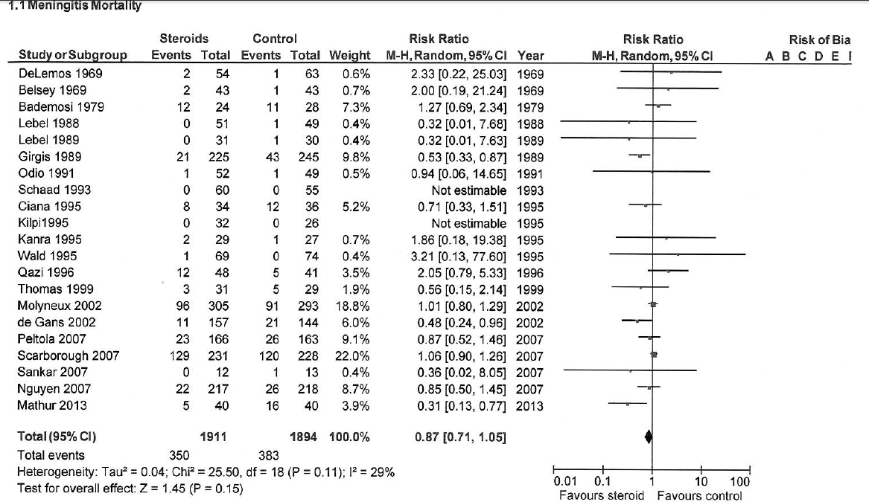
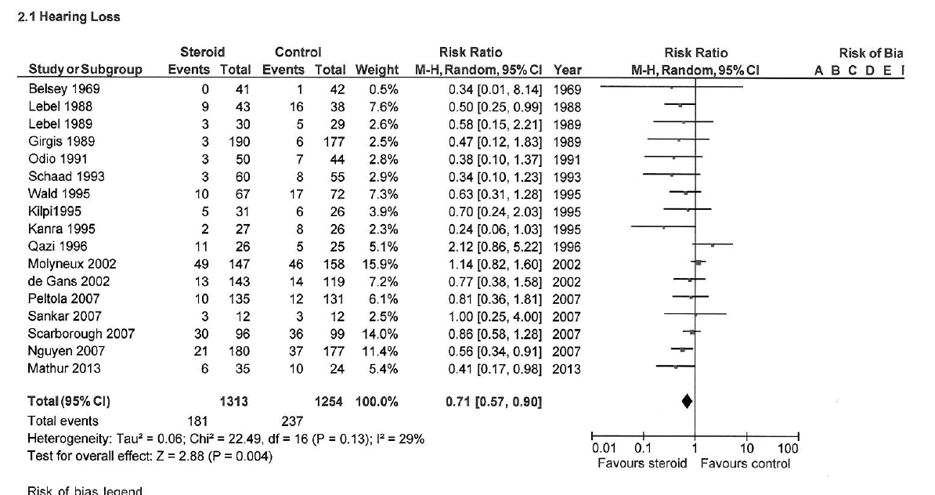

Evidence Profile for corticosteroids in meningitis
Quality assessment |  |  |  |  |  |  | № of patients |  | Effect |  | Quality | Importance
№ of studies | Study design | Risk of bias | Inconsistency | Indirectness | Imprecision | Other considerations | corticosteroids | placebo | Relative  (95% CI) | Absolute  (95% CI)
Mortality
21 | randomised trials | serious ¹ | not serious | not serious | serious ² | none | 350/1911 (18.3%) | 383/1894 (20.2%) | RR 0.87  (0.71 to 1.05) | 26 fewer per 1000  (from 10 more to 59 fewer) | ⨁⨁◯◯  LOW | CRITICAL
Hearing Loss
17 | randomised trials | serious ³ | not serious | not serious | not serious | none | 181/1313 (13.8%) | 237/1254 (18.9%) | RR 0.71  (0.57 to 0.90) | 55 fewer per 1000  (from 19 fewer to 81 fewer) | ⨁⨁⨁◯  MODERATE | CRITICAL
CI: Confidence interval; RR: Risk ratio
- 5/21 studies judged to be of high ROB. Many small single center trials.
- Confidence intervals do not exclude harm.
- 3/17 studies judged to be of high ROB. Many small single center trials included.

Burns
Evidence Profile for corticosteroids in burns with shock
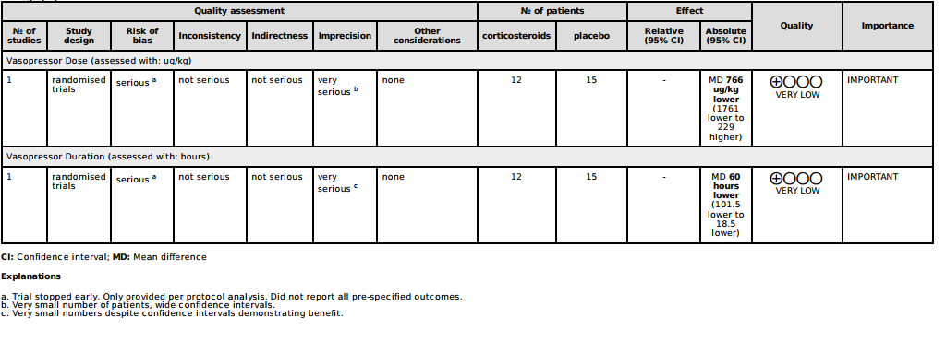

Cardiopulmonary Bypass Surgery
Forest Plots
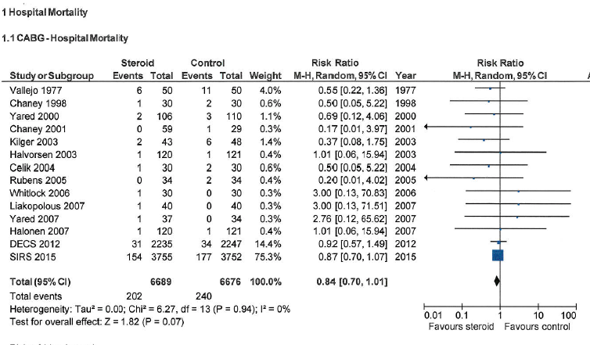
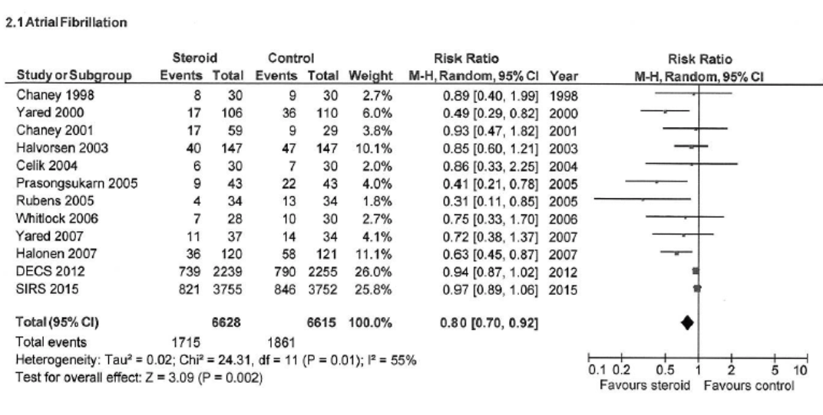

Evidence Profile for corticosteroids in Cardiopulmonary Bypass Surgery
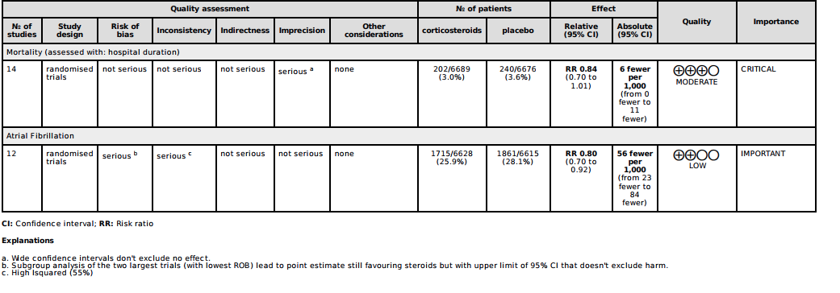

Cardiac Arrest
Forest Plots
Survival Hospital Discharge
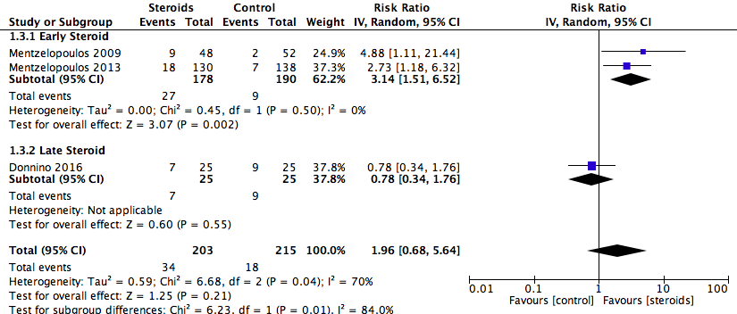
Good Neuro Outcome
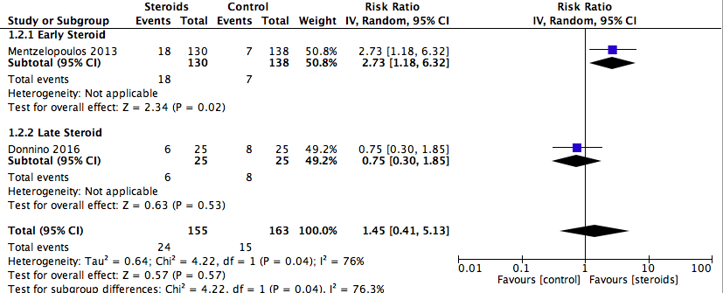

Shock Reversal
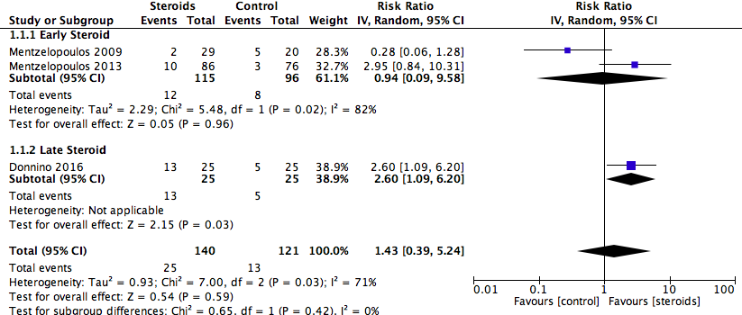
Any Bleeding
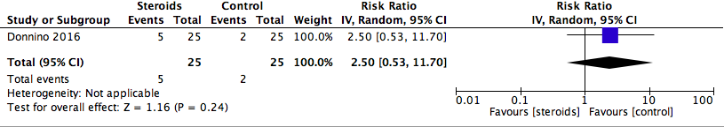

Evidence Profile for corticosteroids in cardiac arrest
