**Adjuvant Treatment -Acetaminophen**

**VAS Pain Score at 24 hours (postoperatively)**



Cattabriga [1], Memis [2]

**Adjuvant Treatment -Acetaminophen**

**Opoid Consumption (Morphine Equivalents)**



Cattabriga [1], Memis [2]

**Adjuvant Treatment – Neuropathic medication**

**Time to Extubation (hours)**



Joshi [3], Pesonen [4]

**Adjuvant Treatment – Neuropathic medication**

**Opioid Consumption in first 24 hours**



Pandey 2002 [5], Pandey 2005 [6]

**Adjuvant Treatment – Neuropathic medication**

**ICU Length of Stay (Days)**



**Procedural Treatment - Opioid vs. No Opioid**

**Pain Score**

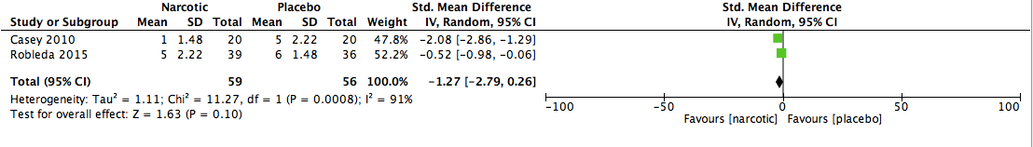

Casey [7], Robleda [8]

**Procedural Treatment – Intravenous Lidocaine**

**VAS Pain Score**

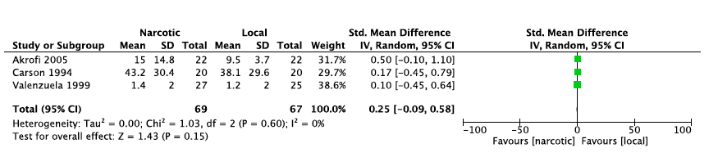

Akrofi [9], Carson [10], Valenzuela [11]

**Non-Pharmacologic – Music Therapy**

**VAS Pain Score**

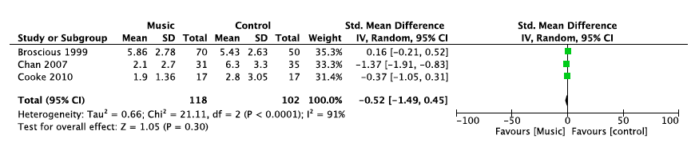

Broscious [12], Chan [13], Cooke [14]

**Non-Pharmacologic – Relaxation Therapy**

**VAS Pain Score post-Chest Tube Removal**



Friesner [15], Houston [16]

References

1. Cattabriga I, Pacini D, Lamazza G, Talarico F, Di Bartolomeo R, Grillone G, Bacchi-Reggiani L: Intravenous paracetamol as adjunctive treatment for postoperative pain after cardiac surgery: a double blind randomized controlled trial. *Eur J Cardiothorac Surg* 2007, 32(3):527-531.

2. Memis D, Inal MT, Kavalci G, Sezer A, Sut N: Intravenous paracetamol reduced the use of opioids, extubation time, and opioid-related adverse effects after major surgery in intensive care unit. *J Crit Care* 2010, 25(3):458-462.

3. Joshi SS, Jagadeesh AM: Efficacy of perioperative pregabalin in acute and chronic post-operative pain after off-pump coronary artery bypass surgery: a randomized, double-blind placebo controlled trial. *Ann Card Anaesth* 2013, 16(3):180-185.

4. Pesonen A, Suojaranta-Ylinen R, Hammarén E, Kontinen VK, Raivio P, Tarkkila P, Rosenberg PH: Pregabalin has an opioid-sparing effect in elderly patients after cardiac surgery: a randomized placebo-controlled trial. *Br J Anaesth* 2011, 106(6):873-881.

5. Pandey CK, Bose N, Garg G, Singh N, Baronia A, Agarwal A, Singh PK, Singh U: Gabapentin for the treatment of pain in guillain-barré syndrome: a double-blinded, placebo-controlled, crossover study. *Anesth Analg* 2002, 95(6):1719-1723, table of contents.

6. Pandey CK, Raza M, Tripathi M, Navkar DV, Kumar A, Singh UK: The comparative evaluation of gabapentin and carbamazepine for pain management in Guillain-Barré syndrome patients in the intensive care unit. *Anesth Analg* 2005, 101(1):220-225, table of contents.

7. Casey E, Lane A, Kuriakose D, McGeary S, Hayes N, Phelan D, Buggy D: Bolus remifentanil for chest drain removal in ICU: a randomized double-blind comparison of three modes of analgesia in post-cardiac surgical patients. *Intensive Care Med* 2010, 36(8):1380-1385.

8. Robleda G, Roche-Campo F, Sendra M-À, Navarro M, Castillo A, Rodríguez-Arias A, Juanes-Borrego E, Gich I, Urrutia G, Nicolás-Arfelis JM *et al*: Fentanyl as pre-emptive treatment of pain associated with turning mechanically ventilated patients: a randomized controlled feasibility study. *Intensive Care Med* 2016, 42(2):183-191.

9. Akrofi M, Miller S, Colfar S, Corry PR, Fabri BM, Pullan MD, Russell GN, Fox MA: A randomized comparison of three methods of analgesia for chest drain removal in postcardiac surgical patients. *Anesth Analg* 2005, 100(1):205-209.

10. Carson M, Barton DM, Morrison CC, Tribble CG: Managing pain during mediastinal chest tube removal. *Heart & lung: the journal of critical care* 1994, 23(6):500-505.

11. Valenzuela RC, Rosen DA: Topical lidocaine-prilocaine cream (EMLA) for thoracostomy tube removal. *Anesthesia & Analgesia* 1999, 88(5):1107-1108.

12. Broscious SK: Music: an intervention for pain during chest tube removal after open heart surgery. *Am J Crit Care* 1999, 8(6):410-415.

13. Chan MF: Effects of music on patients undergoing a C-clamp procedure after percutaneous coronary interventions: a randomized controlled trial. *Heart Lung* 2007, 36(6):431-439.

14. Cooke M, Chaboyer W, Schluter P, Foster M, Harris D, Teakle R: The effect of music on discomfort experienced by intensive care unit patients during turning: a randomized cross-over study. *Int J Nurs Pract* 2010, 16(2):125-131.

15. Friesner SA, Curry DM, Moddeman GR: Comparison of two pain-management strategies during chest tube removal: relaxation exercise with opioids and opioids alone. *Heart Lung* 2006, 35(4):269-276.

16. Houston S, Jesurum J: The quick relaxation technique: effect on pain associated with chest tube removal. *Appl Nurs Res* 1999, 12(4):196-205.