Supplemental Table 14. Description of Methods used for Objective Sedation Assessment Question
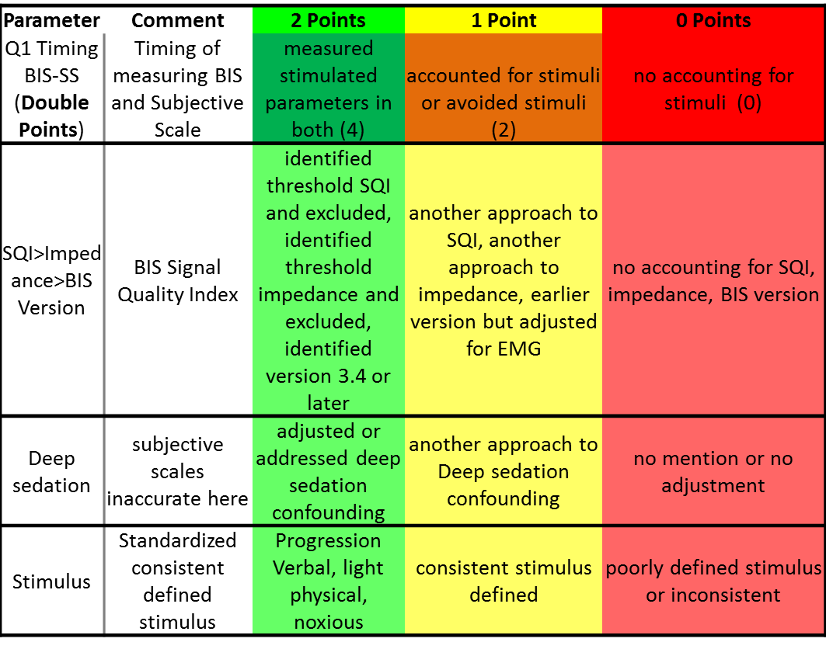
We developed a Quality Assessment tool (below) using four criteria to rate the studies. We allocated 0, 1, or 2 points based on the methodology reported to standardize the stimulus used to assess sedation level: 0 was poor or no description of the stimulus use; 2 was consistent progression from verbal to physical to noxious stimuli; whether deep sedation was accounted for (0 was no accounting for deep sedation and 2 was consistent accounting for deep sedation); and whether EEG signal quality and version of the software were described. Finally, given the critical nature of the timing of stimulus and recording of BIS values (as discussed above), we scored that variable at double value, or 0-2-4 (0 was no accounting for pre- or post-stimulus recording; 4 was measured post-stimulus values for both subjective and objective tools). A semi-quantitative bias rating was created, where low bias represented a score of 4 on the timing issue and a total score ≥4, a high bias rating if a score of zero on the timing issue and a total score <4, and moderate bias for all other scores.

