Supplementary Appendix

D-dimer and Death in Critically Ill Patients with COVID-19

Study of the Treatment and Outcomes in Critically Ill Patients with COVID-19

TABLE OF CONTENTS

STOP-COVID Investigators 3-5
Supplementary Methods 7-8
Supplementary Tables………………………………………………………………………………..…………9-14
Table S1: List of Participating Sites 9
Table S2: Baseline characteristics by D-dimer measurement status ……….….…………..........................................10
Table S3: Logistic regression models for 90-day mortality….……………………………………………….………11
Table S4: Logistic regression models for 28-day mortality for patients measured with the most common assay…………………………………………………………………………………………………………..………12
Table S5: Linear regression models for 28-day mortality for patients measured with the most common assay …….13
Supplementary Figures……………………………………………………………………………………….…14-16

Figure S1: Forest plot of fully adjusted model for 28-day mortality…………………………………………………14
Figure S2: Restricted cubic spline plots of models for mortality in patients measured by the most common assay……………………………………………………………………………………………………………….….15
Figure S3: Mortality risk according to D-dimer category by hypothetical risk status………………………………..16

STOP-COVID INVESTIGATORS

Baylor College of Medicine: Carl P. Walther*, Samaya J. Anumudu

Baylor University Medical Center: Justin Arunthamakun*, Kathleen F. Kopecky, Gregory P. Milligan, Peter A. McCullough, Thuy-Duyen Nguyen

Beth Israel Deaconess Medical Center: Shahzad Shaefi*, Megan L. Krajewski, Sidharth Shankar, Ameeka Pannu, Juan D. Valencia

Boston Medical Center: Sushrut S. Waikar*, Zoe A. Kibbelaar

Cook County Health: Ambarish M. Athavale*, Peter Hart, Shristi Upadhyay, Ishaan Vohra, Ajiboye Oyintayo

Cooper University Health Care: Adam Green*, Jean-Sebastien Rachoin, Christa A. Schorr, Lisa Shea

Duke University Medical Center: Daniel L. Edmonston*, Christopher L. Mosher

Hackensack Meridian Health Mountainside Medical Center: Alexandre M. Shehata*, Zaza Cohen, Valerie Allusson, Gabriela Bambrick-Santoyo, Noor ul aain Bhatti, Bijal Mehta, Aquino Williams

Hackensack Meridian Health Hackensack University Medical Center: Samantha K. Brenner*, Patricia Walters, Ronaldo C. Go, Keith M. Rose

Harvard T.H. Chan School of Public Health: Miguel A. Hernán

Harvard University: Amy M. Zhou, Ethan C. Kim, Rebecca Lisk

Icahn School of Medicine at Mount Sinai: Lili Chan*, Kusum S. Mathews*, Steven G. Coca, Deena R. Altman, Aparna Saha, Howard Soh, Huei Hsun Wen, Sonali Bose, Emily A. Leven, Jing G. Wang, Gohar Mosoyan, Girish N. Nadkarni, Pattharawin Pattharanitima, Emily J. Gallagher

Indiana University School of Medicine/Indiana University Health: Allon N. Friedman*, John Guirguis, Rajat Kapoor, Christopher Meshberger, Katherine J. Kelly

Johns Hopkins Hospital: Chirag R. Parikh*, Brian T. Garibaldi, Celia P. Corona-Villalobos, Yumeng Wen, Steven Menez, Rubab F. Malik, Carmen Elena Cervantes, Samir C. Gautam

Kings County Hospital Center: Mary C. Mallappallil*, Jie Ouyang, Sabu John, Ernie Yap, Yohannes Melaku, Ibrahim Mohamed, Siddhartha Bajracharya, Isha Puri, Mariah Thaxton, Jyotsna Bhattacharya, John Wagner, Leon Boudourakis

Loma Linda University: H. Bryant Nguyen*, Afshin Ahoubim

Mayo Clinic, Arizona: Leslie F. Thomas*, Dheeraj Reddy Sirganagari

Mayo Clinic, Florida: Pramod K. Guru*

Mayo Clinic, Rochester: Kianoush Kashani*, Shahrzad Tehranian

Medical College of Wisconsin: Yan Zhou,* Paul A. Bergl, Jesus Rodriguez, Jatan A. Shah, Mrigank S. Gupta

MedStar Georgetown University Hospital: Princy N. Kumar*, Deepa G. Lazarous, Seble G. Kassaye

Montefiore Medical Center/Albert Einstein College of Medicine: Michal L. Melamed*, Tanya S. Johns, Ryan Mocerino, Kalyan Prudhvi, Denzel Zhu, Rebecca V. Levy, Yorg Azzi, Molly Fisher, Milagros Yunes, Kaltrina Sedaliu, Ladan Golestaneh, Maureen Brogan, Neelja Kumar, Michael Chang, Jyotsana Thakkar

New York-Presbyterian Queens Hospital: Ritesh Raichoudhury*, Akshay Athreya, Mohamed Farag

New York-Presbyterian/Weill Cornell Medical Center: Edward J. Schenck*, Soo Jung Cho, Maria Plataki, Sergio L. Alvarez-Mulett, Luis G. Gomez-Escobar, Di Pan, Stefi Lee, Jamuna Krishnan, William Whalen

New York University Langone Hospital: David Charytan*, Ashley Macina, Sobaata Chaudhry, Benjamin Wu, Frank Modersitzki

Northwestern Memorial Hospital: Northwestern University Feinberg School of Medicine - Anand Srivastava*, Alexander S. Leidner, Carlos Martinez, Jacqueline M. Kruser, Richard G. Wunderink, Alexander J. Hodakowski

Ochsner Medical Center: Juan Carlos Q. Velez*, Eboni G. Price-Haywood, Luis A. Matute-Trochez, Anna E. Hasty, Muner MB. Mohamed

Oregon Health and Science University Hospital: Rupali S. Avasare*, David Zonies*

Partners Healthcare: Brigham and Women’s Hospital, Brigham and Women’s Faulkner Hospital, Massachusetts General Hospital, and Newton Wellesley Hospital - David E. Leaf*, Shruti Gupta*, Meghan E. Sise, Erik T. Newman, Samah Abu Omar, Kapil K. Pokharel, Shreyak Sharma, Harkarandeep Singh, Simon Correa, Tanveer Shaukat, Omer Kamal, Wei Wang, Heather Yang, Jeffery O. Boateng, Meghan Lee, Ian A. Strohbehn, Jiahua Li, Ariel L. Mueller

ProMedica Health System: Roberta E. Redfern,* Nicholas S. Cairl, Gabriel Naimy, Abeer Abu-Saif, Danyell Hall, Laura Bickley

Renown Health: Chris Rowan*, Farah Madhani-Lovely*, Vivian S. Cruz, Kristen M. Hess, Alanna L. Jacobs

Rush University Medical Center: Vasil Peev*, Jochen Reiser, John J. Byun, Andrew Vissing, Esha M. Kapania, Zoe Post, Nilam P. Patel, Joy-Marie Hermes

Rutgers/New Jersey Medical School: Anne K. Sutherland*, Amee Patrawalla, Diana G. Finkel, Barbara A. Danek, Sowminya Arikapudi, Jeffrey M. Paer, Peter Cangialosi, Mark Liotta

Rutgers/Robert Wood Johnson Medical School: Jared Radbel*, Sonika Puri, Jag Sunderram, Matthew T. Scharf, Ayesha Ahmed, Ilya Berim, Jayanth S. Vatson

Stanford Healthcare: Stanford University School of Medicine – Shuchi Anand*, Joseph E. Levitt, Pablo Garcia

Temple University Hospital: Suzanne M. Boyle*, Rui Song

Thomas Jefferson University Hospital: Jingjing Zhang*, Sang Hoon Woo, Xiaoying Deng, Goni Katz-Greenberg, Katharine Senter

Tulane Medical Center: Moh’d A. Sharshir*, Vadym V. Rusnak

United Health Services Hospitals: Muhammad Imran Ali

University of Colorado Anschutz Medical Campus: Anip Bansal*, Amber S. Podoll, Michel Chonchol, Sunita Sharma, Ellen L. Burnham, David J. Douin

University Hospitals Cleveland Medical Center: Arash Rashidi*, Rana Hejal

University of Alabama-Birmingham Hospital: Eric Judd*, Laura Latta, Ashita Tolwani

University of California-Davis Medical Center: Timothy E. Albertson*, Jason Y. Adams

University of California-Los Angeles Medical Center: Ronald Reagan-UCLA Medical Center - Steven Y. Chang*, Rebecca M. Beutler; UCLA Medical Center, Santa Monica – Carl E. Schulze

University of California-San Diego Medical Center: Etienne Macedo*, Harin Rhee

University of California-San Francisco Medical Center: Kathleen D. Liu*, Vasantha K. Jotwani

University of Chicago Medical Center: Jay L. Koyner*

University of Florida Health-Gainesville: Chintan V. Shah*

University of Florida-Health-Jacksonville: Vishal Jaikaransingh*

University of Illinois Hospital and Health Sciences System: Stephanie M. Toth-Manikowski*, Min J. Joo*, James P. Lash

University of Kentucky Medical Center: Javier A. Neyra*, Nourhan Chaaban, Madona Elias, Yahya Ahmad

University Medical Center of Southern Nevada: Rajany Dy*, Alfredo Iardino, Elizabeth H. Au, Jill H. Sharma

University of Miami Health System: Marie Anne Sosa*, Sabrina Taldone, Gabriel Contreras, David De La Zerda, Hayley B. Gershengorn, Bhavarth Shukla, Alessia Fornoni, Tanira Ferreira

University of Michigan: Salim S. Hayek*, Pennelope Blakely, Hanna Berlin, Tariq U. Azam, Husam Shadid, Michael Pan, Patrick O’ Hayer, Chelsea Meloche, Rafey Feroze, Rayan Kaakati, Danny Perry, Abbas Bitar, Elizabeth Anderson, Kishan J. Padalia, John P. Donnelly, Andrew J. Admon

University of North Carolina School of Medicine: Jennifer E. Flythe*, Matthew J. Tugman, Emily H. Chang

University of Oklahoma Health Sciences Center: Brent R. Brown*

University of Pennsylvania Health System: Amanda K. Leonberg-Yoo*, Ryan C. Spiardi, Todd A. Miano, Meaghan S. Roche, Charles R. Vasquez

University of Pittsburgh Medical Center: Amar D. Bansal*, Natalie C. Ernecoff, Sanjana Kapoor, Siddharth Verma, Huiwen Chen

University of Tennessee Health Science Center and Memphis VA Medical Center/Methodist

University Hospital – Csaba P. Kovesdy*, Miklos Z. Molnar*, Ambreen Azhar

University of Texas Southwestern Medical Center and Parkland Health and Hospital System: S. Susan Hedayati*, Mridula V. Nadamuni, Shani Shastri, Duwayne L. Willett

University of Vermont Larner College of Medicine: Samuel A.P. Short

University of Virginia Health System: Amanda D. Renaghan*, Kyle B. Enfield

University of Washington Medical Center: Pavan K. Bhatraju*, A. Bilal Malik

Vanderbilt University Medical Center: Matthew W. Semler

Washington University in St. Louis/Barnes Jewish Hospital: Anitha Vijayan*, Christina Mariyam Joy, Tingting Li, Seth Goldberg, Patricia F. Kao

Wellforce Health System: Lowell General Hospital - Greg L. Schumaker*, Tufts Medical Center - Nitender Goyal*, Anthony J. Faugno, Greg L. Schumaker, Caroline M. Hsu, Asma Tariq, Leah Meyer, Ravi K. Kshirsagar, Daniel E. Weiner, Aju Jose

Westchester Medical Center: Marta Christov*, Jennifer Griffiths, Sanjeev Gupta, Aromma Kapoor, Savneek Chugh

Yale School of Medicine: Perry Wilson,* Tanima Arora, Ugochukwu Ugwuowo

*Site Principal Investigator

Supplemental Methods

Data Collection and Validation
Data were collected using REDCap, a secure, HIPAA-compliant, web-based application. Wherever possible, data were captured using checkboxes rather manual entry to minimize keystroke errors. For data that required keystroke entry (e.g., laboratory values), we implemented validation ranges to flag potential errors in real-time. We also implemented automated data validation rules to flag errors in dates (e.g., if the date of death was entered as being before the date of ICU admission). Finally, all data were manually reviewed, and values that appeared incongruent or out of range were manually validated by confirming the accuracy of the data with the collaborator who entered it.

Sensitivity Analysis of 28-day mortality in patients discharged from the hospital prior to 28 days
In a subset of patients consisting of those who had been admitted to one of six hospitals in Boston, MA, and who had been discharged from the hospital prior to 28 days, we manually reviewed their charts or called them to ascertain their 28-day survival status. Among 50 patients reviewed, all 50 remained alive at 28 days.

Multivariable Modeling of D-dimer’s Association with Mortality
We prespecified the variables below for inclusion in the multivariable models based on clinical knowledge, biologic plausibility, and completeness of data. All patient data were abstracted through manual chart review by study staff. To minimize missingness of laboratory and physiologic data, we selected the worse value on ICU day 1 or 2.

- D-dimer: highest value on ICU day 1 or ICU day 2, normalized by dividing value by assay-specific upper limit of normal (venous thromboembolism) cut-off. Categories: <2 times (x, ref), 2-3.9x, 4-7.9x, and ≥8x upper limit of normal
- Age: 18-39 (ref); 40-49; 50-59; 60-69; 70-79; ≥80 years
- Male sex
- Race: White (ref), Black, Asian, and Other
- Hypertension: per chart review
- Diabetes mellitus: per chart review
- Body mass index: <25; 25-29.9; 30-34.9; 35-39.9; and ≥40 kg/m²
- Coronary artery disease: per chart review; any history of angina, myocardial infarction, or coronary artery bypass graft surgery
- Congestive heart failure: per chart review, heart failure with preserved or reduced ejection fraction
- Chronic obstructive pulmonary disease: per chart review
- Current smoking status: per chart review, does not include vaping or non-tobacco products
- Active malignancy: active malignancy (other than non-melanoma skin cancer) treated in the past year. Defined as cancer of the lung, breast, colorectal, prostate, gastric, pancreatic, melanoma, ovarian, brain, or other
- Days from symptom onset to ICU admission: ≤3 vs. >3
- Lymphocyte count (lowest value on ICU day 1 or day 2): <1000, ≥1000 per mm³, and missing
- Invasive mechanical ventilation on ICU day 1 or day 2
- Shock on ICU day 1 or day 2: defined as the requirement for ≥2 vasopressors

- Renal, liver, and coagulation components of the Sequential Organ Failure Assessment (SOFA) score, highest score on ICU day 1 or day 2:
 | Categories
 | 0ª | 1 | 2^{b}
SOFA Renal | Cr<1.2 and UOP≥500 | Cr 1.2-1.9 and UOP≥500 | Cr ≥2 or UOP<500^{c} or acute RRT or ESRD
SOFA Liver (Bilirubin) | <1.2 | 1.2-1.9 | ≥2
SOFA Coagulation (Platelets) | ≥150 | 100-149 | ≤99

ªMissing data were categorized as 0.
^{b}Renal, liver, and coagulation SOFA scores of 2, 3, or 4 were binned due to low frequency of events in categories “3” and “4”.
^{c}If the UOP was missing, the category was assigned according to the Cr

- Home anticoagulation
- Receipt of therapeutic anticoagulation on ICU day 1 or day 2, defined as the receipt of one of the following:
  - Continuous drips of heparin, argatroban, or bivalirudin
  - Subcutaneous regimens: enoxaparin (Lovenox) 1mg/kg twice per day, enoxaparin (Lovenox) 1.5mg/kg once per day, dalteparin (Fragmin) 150-200 units/kg once per day, dalteparin (Fragmin) 100 units/kg twice per day, fondaparinux (Aristra) at doses of 5mg or more daily
  - Oral anticoagulants: warfarin (Coumadin), apixaban (Eliquis), rivaroxaban (Xarelto), edoxaban, or dabigatran (Pradaxa)
- Receipt of aspirin on ICU day 1 or day 2
- Receipt of steroids on ICU day 1 or day 2

Mortality Risk Stratification
To explore the ability of D-dimer to assist in rapid mortality risk stratification, we fit additional logistic regression models for 28-day mortality to the cohort data. Two models were used to determine the added benefit of D-dimer consideration in risk assessment with varying patient characteristics.

Model covariates were limited to prespecified clinical factors that were deemed to be readily apparent soon after ICU admission. The first model included the following clinical factors, without consideration of D-dimer level: age, sex, diabetes mellitus, hypertension, body mass index, coronary artery disease, congestive heart failure, chronic obstructive pulmonary disease, current smoking status, active malignancy, need for invasive mechanical ventilation with two days following ICU admission, and shock within two days following ICU admission. The second model included each of these clinical factors, as well as the D-dimer category. Covariate definitions matched the primary analysis, as above.

After fitting these models to the cohort data, D-dimer’s ability to risk stratify was explored using two sets of hypothetical patients. In the first set, the characteristics of four patients deemed low-, moderate-, high-, or very high-risk were prespecified based on clinical knowledge. Point estimates for mortality risk were then calculated using each model, yielding five mortality risks for each patient: without D-dimer consideration, and with D-dimer values corresponding to each of the four D-dimer categories.

In a second set of hypothetical patients, the characteristics of 10,000 patients were generated at random. Point estimates for 28-day mortality were then calculated without D-dimer consideration, with a D-dimer level corresponding to the lowest category (<2x ULN), and with a D-dimer level corresponding to the highest category (>8x ULN). The point estimate for mortality with D-dimer corresponding to the lowest category was then subtracted from the point estimate corresponding to the highest category, yielding an absolute difference in mortality risk.
Table S1. List of Participating Sites
Northeast
Beth Israel Deaconess Medical Center
Brigham and Women’s Faulkner Hospital
Brigham and Women's Hospital
Cooper University Health Care
Hackensack Meridian Health Hackensack University Medical Center
Hackensack Mountainside Hospital
Johns Hopkins Hospital
Kings County Hospital Center
Lowell General Hospital
Massachusetts General Hospital
MedStar Georgetown University Hospital
Montefiore Medical Center
Mount Sinai
Newton Wellesley Hospital
New York-Presbyterian Queens Hospital
New York-Presbyterian/Weill Cornell Medical Center
New York University Langone Hospital
Rutgers/New Jersey Medical School
Rutgers/Robert Wood Johnson Medical School
Temple University Hospital
Thomas Jefferson University Hospital
Tufts Medical Center
United Health Services Hospitals
University of Pennsylvania Health System
University of Pittsburgh Medical Center
Westchester Medical Center
Yale University Medical Center
South
Baylor College of Medicine, Houston
Baylor University Medical Center/Baylor Scott White and Health
Duke University Medical Center
Mayo Clinic, Florida
Memphis VA Medical Center
Methodist University Hospital
Ochsner Medical Center
Tulane Medical Center
University of Alabama-Birmingham Hospital
University of Florida Health-Gainesville
University of Florida Health-Jacksonville
University of Miami Health System
University of North Carolina Hospitals
University of Texas Southwestern Medical Center
University of Virginia Health System
Midwest
Barnes-Jewish Hospital
Cook County Health
Mayo Clinic, Rochester
Froedtert Hospital
Indiana University Health Methodist Hospital
Northwestern Memorial Hospital
Promedica Health System
Rush University Medical Center
University Hospitals Cleveland Medical Center
University of Chicago Medical Center
University of Illinois Hospital and Health Sciences System
University of Kentucky Hospital
University of Michigan Hospital
University of Oklahoma Health Sciences Center
West
Loma Linda University Medical Center
Mayo Clinic, Arizona
Oregon Health and Science University Hospital
Renown Health
Stanford Healthcare
University of California-Davis Medical Center
University of California-Los Angeles Medical Center
University of California-San Diego Medical Center
University of California-San Francisco Medical Center
UCHealth University of Colorado
University Medical Center of Southern Nevada
University of Washington Medical Center

Table S2: Baseline characteristics by D-dimer measurement status. Body mass index data was missing in 4.0% of patients, lymphocyte count data was missing in 8.6% of patients, and data for at least one SOFA score component score was missing in 9.9% of patients. All other data are complete. IQR, interquartile range; SOFA; Sequential Organ Failure Assessment.
Characteristic | All Patients  (N=4949) | Measured D-Dimer  (N = 3418) | No D-Dimer  (N = 1531)
Demographics
Age (yr), median (IQR) | 62 (52-71) | 62 (51-71) | 63 (53-71)
Male sex – no. (%) | 3123 (63.1) | 2170 (63.5) | 953 (62.2)
Race – no. (%)
White | 1901 (38.4) | 1315 (38.5) | 586 (37.8)
Black | 1516 (30.6) | 1030 (30.1) | 486 (31.7)
Asian | 290 (5.9) | 190 (5.6) | 100 (6.5)
Other | 1239 (25.0) | 880 (25.7) | 358 (23.4)
Hispanic – no. (%) | 1143 (23.1) | 858 (25.1) | 285 (18.6)
Body mass index – median (IQR) | 30 (26-36) | 30 (27-36) | 30 (26-36)
Pregnant – no. (%) | 39 (0.8) | 34 (1.0) | 5 (0.3)
Coexisting conditions – no. (%)
Diabetes mellitus | 2076 (41.9) | 1444 (42.2) | 631 (41.2)
Hypertension | 3040 (61.4) | 2089 (61.1) | 951 (62.1)
Chronic obstructive pulmonary disease | 427 (8.6) | 272 (8.0) | 155 (10.1)
Current smoker | 256 (5.2) | 160 (4.7) | 160 (4.7)
Coronary artery disease | 666 (13.5) | 436 (12.8) | 142 (4.2)
Congestive heart failure | 503 (10.2) | 332 (9.7) | 171 (11.2)
Active malignancy | 224 (4.5) | 142 (4.2) | 85 (5.4)
<3 days of symptom duration before ICU admission | 1080 (21.8) | 726 (21.2) | 354 (23.1)
Severity of illness within 2 days after ICU admission – no. (%)
Mechanical ventilation | 3363 (67.9) | 2359 (69.0) | 1004 (65.6)
Shock | 817 (16.5) | 609 (17.8) | 208 (13.6)
Lymphocyte count <1000 per mm³ | 2044 (41.3) | 1501 (43.9) | 543 (35.5)
Coagulation component of SOFA score
0 | 3845 (77.7) | 2684 (78.5) | 1160 (75.8)
1 | 803 (16.2) | 533 (15.6) | 270 (17.6)
>2 | 302 (6.1) | 201 (5.9) | 101 (6.6)
Liver component of SOFA score
0 | 4299 (86.8) | 2933 (85.8) | 1365 (89.2)
1 | 449 (9.1) | 330 (9.7) | 119 (7.8)
>2 | 202 (4.1) | 155 (4.5) | 47 (3.1)
Renal component of SOFA score
0 | 2049 (41.4) | 1353 (39.6) | 695 (45.4)
1 | 913 (16.2) | 641 (18.8) | 272 (17.8)
>2 | 1988 (40.2) | 1423 (41.7) | 564 (36.8)
Medications affecting hemostasis – no. (%)
Home anticoagulation | 438 (8.8) | 292 (8.5) | 146 (9.5)
Therapeutic anticoagulation | 1189 (24.0) | 916 (26.8) | 273 (17.8)
Aspirin receipt | 779 (15.7) | 527 (15.4) | 252 (16.5)
Steroid receipt | 1101 (22.2) | 858 (25.1) | 243 (15.9)
28-day mortality – no. (%) | 1785 (36.1) | 1180 (34.5) | 605 (39.5)
Mortality within 2 days after ICU admission – no. (%) | 222 (4.5) | 140 (4.1) | 82 (5.4)
Time to death (days) – median (IQR) | 10 (5-18) | 10 (5-18.5) | 9 (5-17)

Table S3: Logistic regression models for 90-day mortality. Within 90 days following ICU admission, 1353 patients (39.6%) had died, 2029 (59.4%) were discharged alive, and 36 (1.0%) remained hospitalized. Model 1 is unadjusted. Model 2 is adjusted for demographics and comorbidities. Model 3 adds severity of illness measures in the first two days after ICU admission. Model 4 adds medications impacting hemostasis received within 2 days of ICU admission. ULN stands for upper limit of normal, as determined by the assay manufacturer.
 | Odds ratios (95% CI) for 90-day mortality (N = 3418)
Model | D-dimer  <2x ULN  (N = 938) | D-dimer  2-3.9x ULN  (N = 875) | D-dimer  4-7.9x ULN  (N = 582) | D-dimer  >8x ULN  (N = 1023)
1 | 1 (ref) | 1.67 (1.37-2.05) | 2.23 (1.79-2.78) | 3.15 (2.61-8.82)
2 | 1 (ref) | 1.61 (1.30-2.00) | 1.94 (1.53-2.45) | 2.82 (2.29-3.47)
3 | 1 (ref) | 1.42 (1.13-1.78) | 1.47 (1.14-1.88) | 1.83 (1.47-2.30)
4 | 1 (ref) | 1.38 (1.11-1.74) | 1.39 (1.08-1.79) | 1.70 (1.35-2.15)

Table S4: Logistic regression models for 28-day mortality for patients measured with the most common assay. The most common assay among participating sites was the STA Liatest®, both in number of included patients (N = 1111) and number of centers (N = 21). Model 1 is unadjusted. Model 2 is adjusted for demographics and comorbidities. Model 3 adds severity of illness measures in the first two days after ICU admission. Model 4 adds medications impacting hemostasis. ULN stands for upper limit of normal, as determined by the assay manufacturer venous thromboembolism threshold.
Odds ratios (95% CI) for 28-day mortality in patients
measured with the most common assay (N = 1111)
Model | D-dimer  <2x ULN  (N = 227) | D-dimer  2-3.9x ULN  (N = 255) | D-dimer  4-7.9x ULN  (N = 255) | D-dimer  >8x ULN  (N = 374)
1 | 1 (ref) | 1.67 (1.14-2.42) | 1.88 (1.30-2.75) | 3.46 (2.44-4.93)
2 | 1 (ref) | 1.90 (1.26-2.87) | 1.74 (1,16-2.65) | 3.48 (2.37-5.15)
3 | 1 (ref) | 1.65 (1.07-2.55) | 1.11 (0.71-1.75) | 1.87 (1.21-2.88)
4 | 1 (ref) | 1.58 (1.02-2.45) | 1.03 (0.65-1.62) | 1.65 (1.06-2.57)

Table S5: Linear regression models for 28-day mortality for patients measured with the most common assay. The most common assay among participating sites was the STA Liatest®, both in number of included patients (N = 1111) and number of centers (N = 21). For this assay, 1 ULN is equal to 500 ng/mL FEU. Model 1 is unadjusted. Model 2 is adjusted for demographics and comorbidities. Model 3 adds severity of illness measures in the first two days after ICU admission. Model 4 adds medications impacting hemostasis. ULN stands for upper limit of normal, as determined by the assay manufacturer venous thromboembolism threshold.

Model | Odds ratio, per each ULN increase | 95% CI
1 | 1.17 | 1.12-1.23
2 | 1.16 | 1.11-1.22
3 | 1.07 | 1.01-1.13
4 | 1.05 | 0.99-1.11

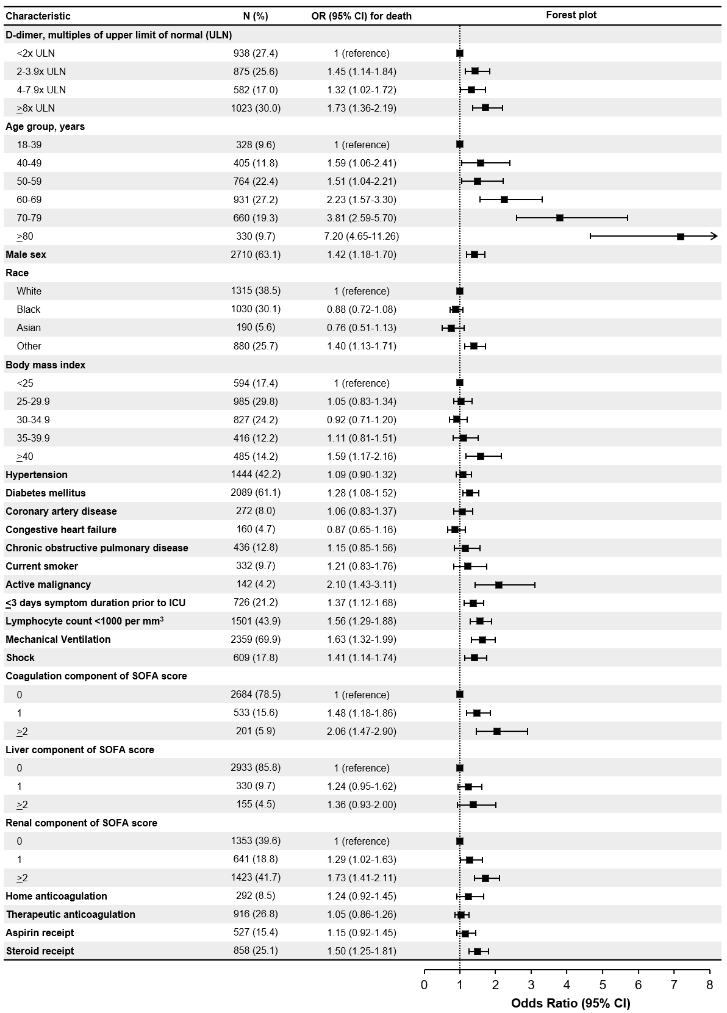
Figure S1: Forest plot of fully adjusted model for 28-day mortality.

Figure S2: Restricted cubic spline plots of models for mortality in patients measured by the most common assay. Lines represent the predicted mortality risk and the shading represents 95% confidence intervals. ULN stands for assay upper limit of normal. The fully adjusted model is adjusted for age, sex, race, body mass index, diabetes, coronary artery disease, chronic obstructive pulmonary disease, current smoking status, active malignancy, mechanical ventilation, shock, lymphocyte count, renal, liver and coagulation, SOFA component scores, therapeutic anticoagulation, home anticoagulation, aspirin, and steroids.

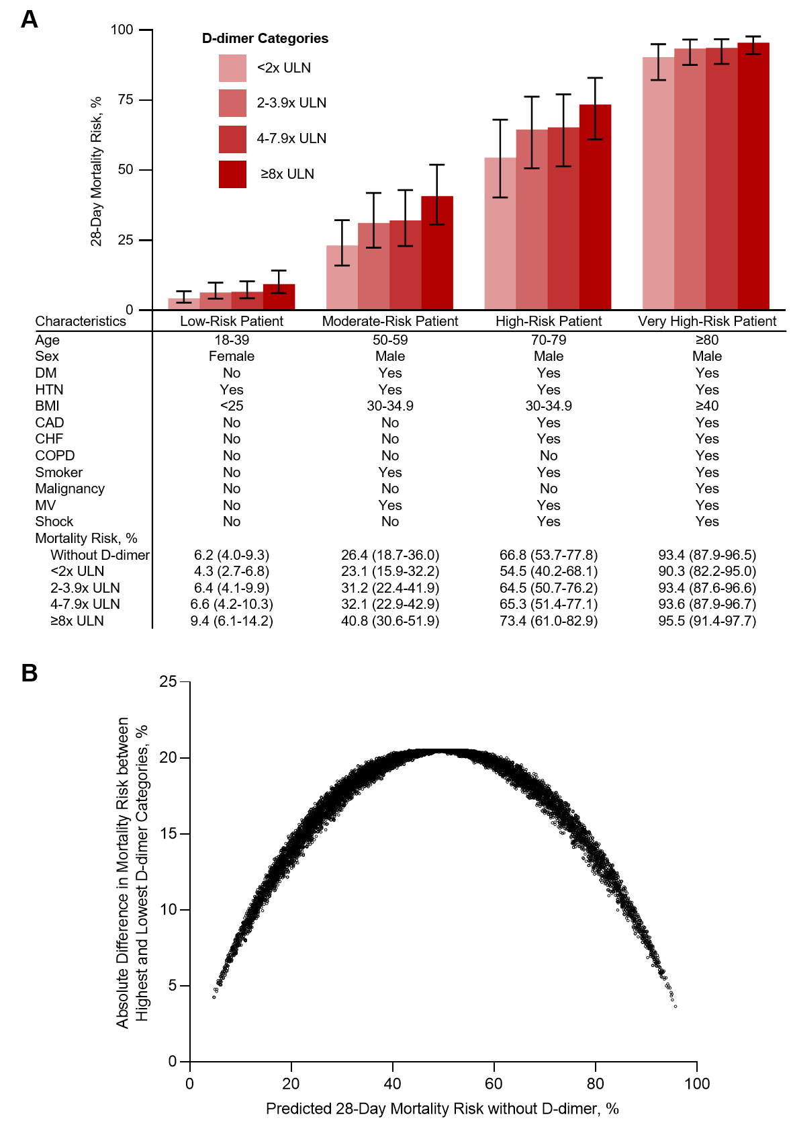
Figure S3: Mortality risk according to D-dimer category by hypothetical risk status. Mortality risk was predicted by a model including the listed covariates. Risk was predicted for 4 patients with pre-specified characteristics (A) and 10,000 patients with randomly generated characteristics (B). Abbreviations: BMI, body mass index; CAD, coronary artery disease; CHF, congestive heart failure; COPD, chronic obstructive pulmonary disease; DM, diabetes mellitus; HTN, hypertension; MV, mechanical ventilation; ULN, upper limit of normal.

