Beneficial Effect of Prone Positioning During Venovenous Extracorporeal Membrane Oxygenation for COVID-19
Akram M Zaaqoq, Adrian G Barnett, Matthew J Griffee , Graeme MacLaren , Jeffrey P. Jacobs , Silver Heinsar , Jacky Y Suen , Gianluigi Li Bassi , John F Fraser, Heidi J Dalton, Giles J Peek
On behalf of the COVID-19 Critical Care Consortium (COVID Critical)

Model diagram
The figure below shows the four states in the multi-state survival model. Patients start in the “ECMO & supine” state on the day they begin ECMO. Patients in the prone position on their first day of ECMO start in the “ECMO & Prone” state. Patients can move from Supine to Prone, and back from Prone to Supine. ECMO = Extracorporeal Membrane Oxygenation
Figure: The four states in the model and the possible movements between states
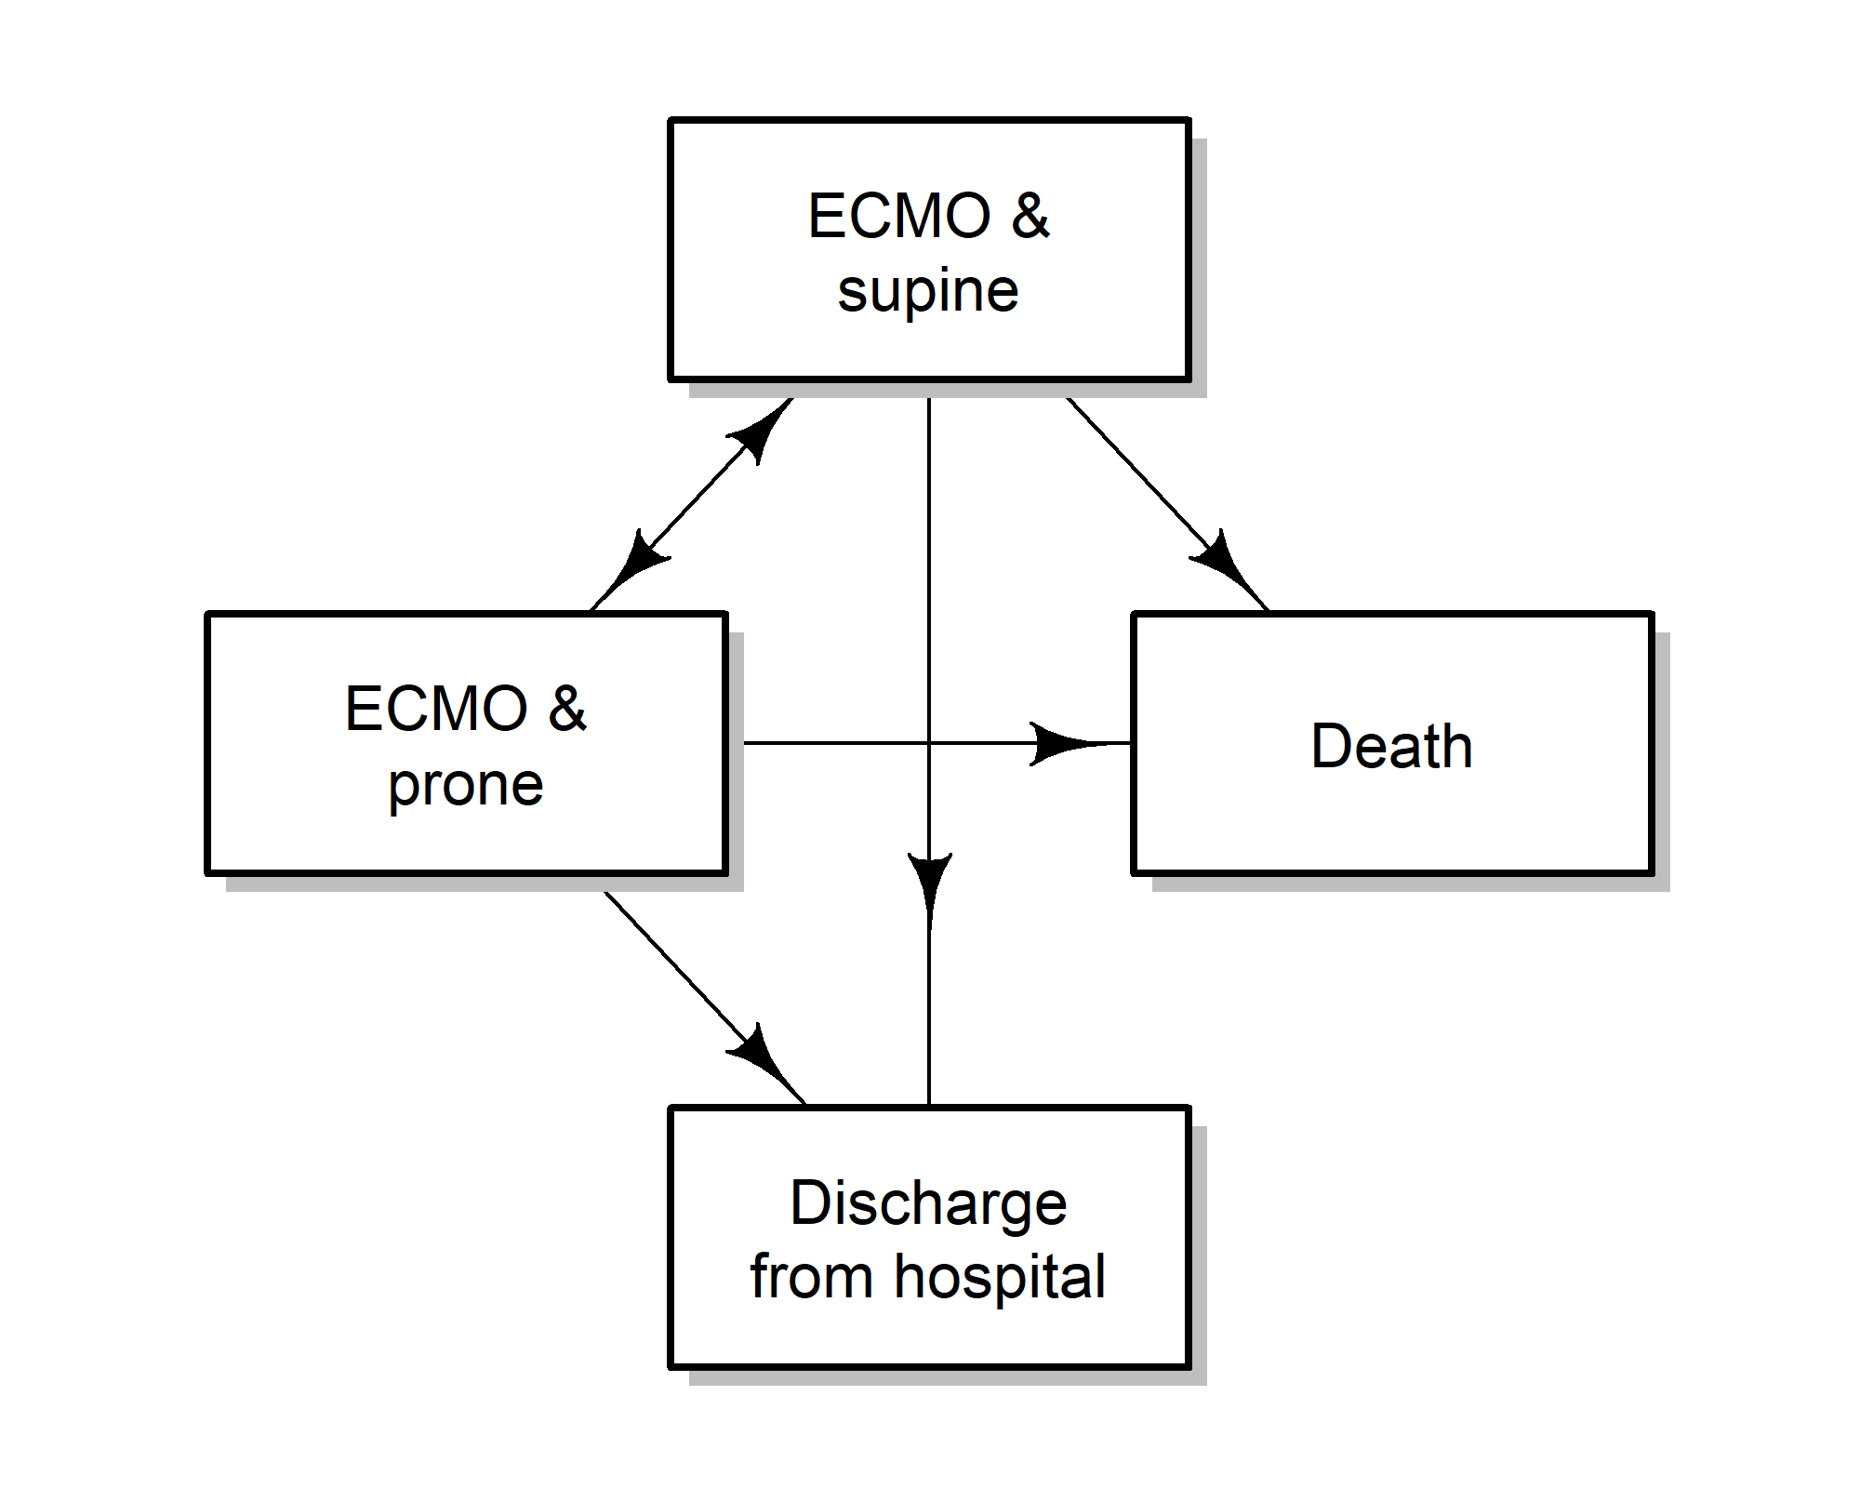

Table of transitions between states
This table shows the transitions (movements) between the four states.

Table: Transition numbers between states. ECMO = Extracorporeal Membrane Oxygenation
 | State moved to
State moved from | Supine | Prone | Discharge | Death | Censored
ECMO & Prone | 59 | 0 | 1 | 7 | 1
ECMO & Supine | 0 | 27 | 94 | 81 | 48

Models of prone
Here we examine whether there are important predictors of whether patients get prone positioning. This is important because prone positioning was not a randomly allocated treatment, hence patients who get prone may have important differences from patients who do not. This could then cause confounding when we examine the effects of prone on death and discharge. Understanding the differences between patients who did and did not receive prone positioning will help us understand the potential biases and will also be use to create weights for a propensity weighted analysis.

Model diagram (for models of prone)
Figure: The three states in the model and the possible movements between states. ECMO = Extracorporeal Membrane Oxygenation

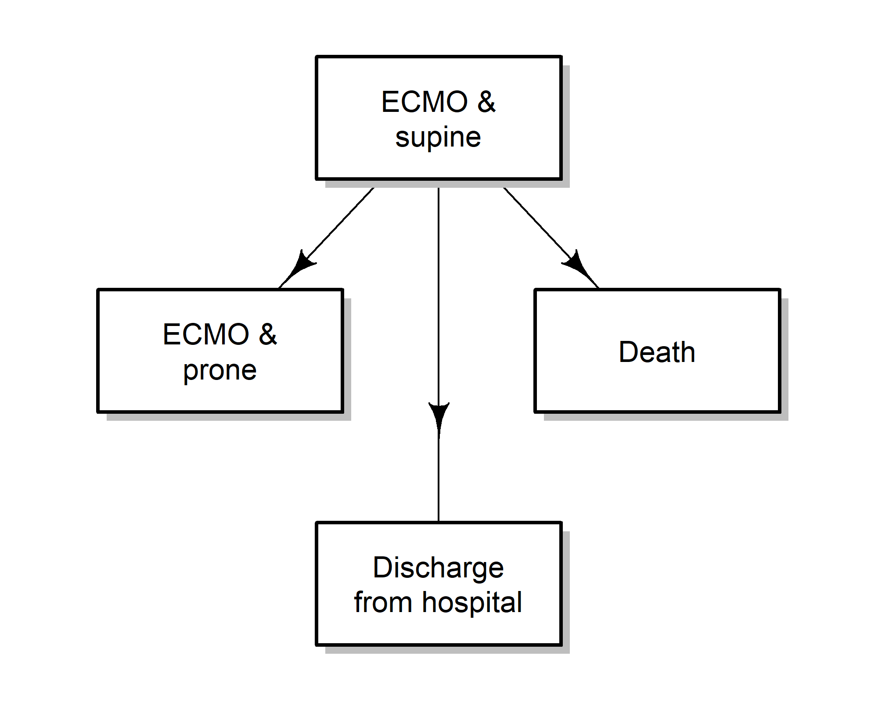

Cumulative risk plot for prone positioning
The plot below shows the times that patients received prone positioning. For this analysis we examine the time to first prone position and do not consider whether a patient was later moved to supine.
Figure: Cumulative probabilities over time of moving to prone, discharge and death states
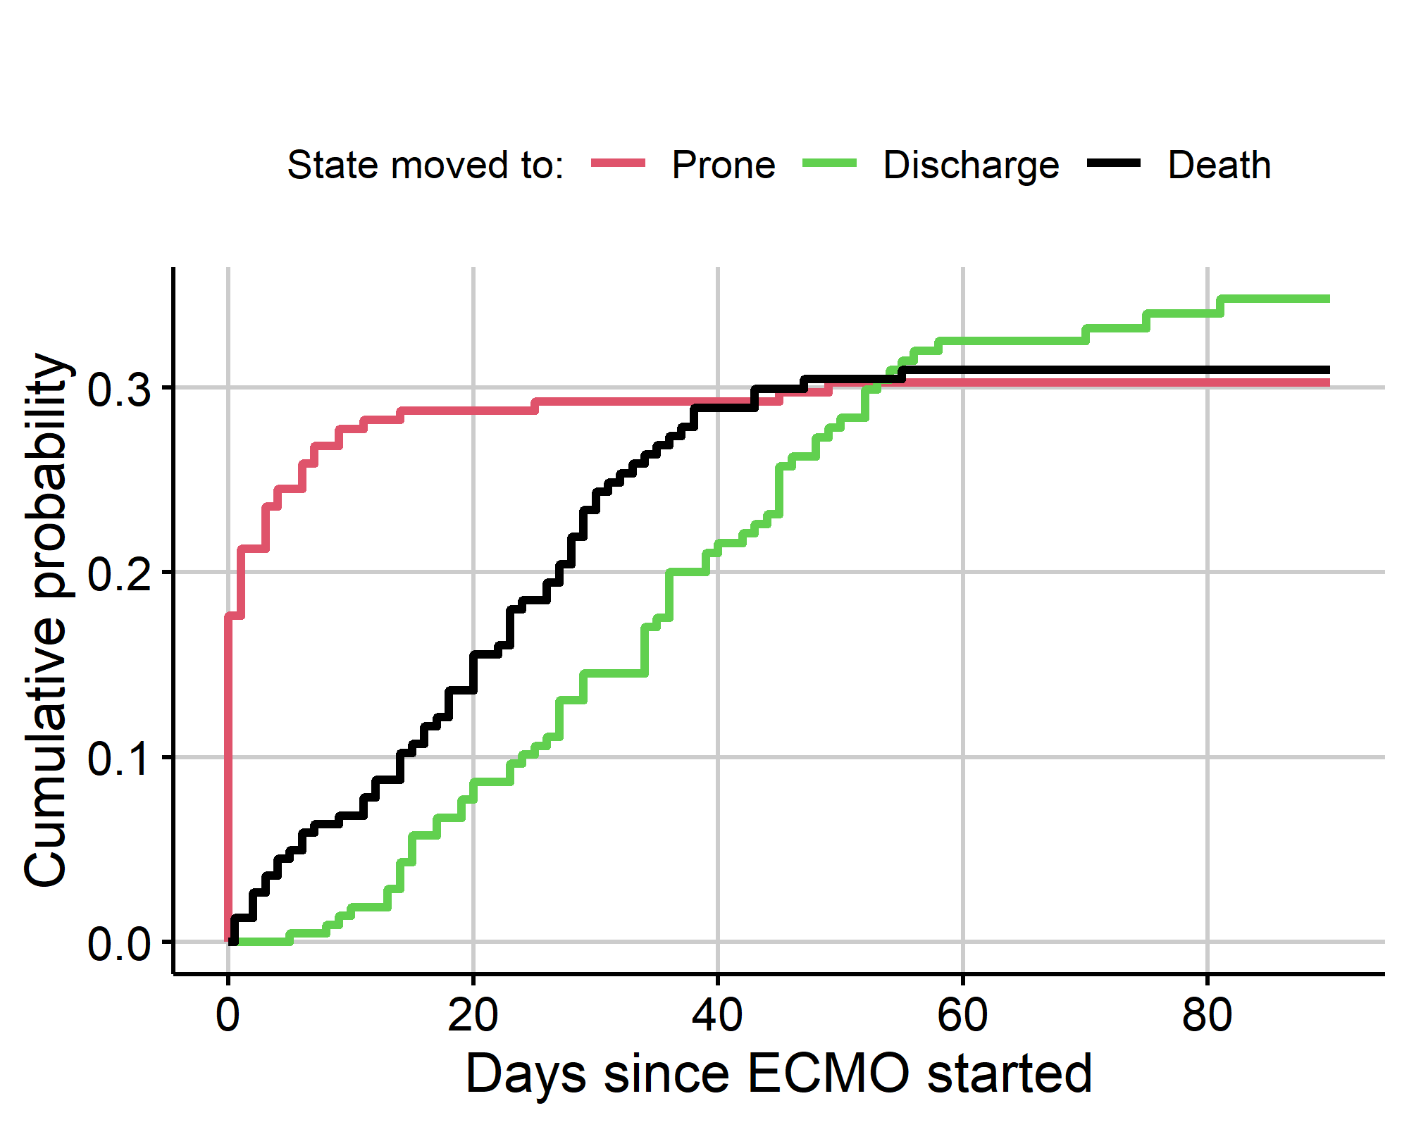
Many patients were already prone on the day ECMO started. Death and discharge were competing risks for experiencing prone position. We need to account for this censoring when examining the predictors of prone.

Survival model for prone positioning
We use a Weibull survival model to examine the time to prone position. This modeled the time to prone position whilst accounting for censoring due to death and discharge, or administrative censoring if the patient was still on ECMO at the end of the study.
The table below is the hazard ratios and 95% credible intervals for the survival model of prone. A hazard ratio of 1 indicates no change in risk, whereas a hazard ratio above 1 indicates increased risk, and a hazard ratio below 1 indicated decreased risk.
Table: Hazard ratios and 95% credible intervals for prone position from the Weibull model
variable | HR | CI
Male | 0.80 | 0.44 to 1.47
Age (+10 years) | 0.68 | 0.50 to 0.90
Calendar time (+30 days) | 1.02 | 0.80 to 1.28
BMI (+5 kg/m2) | 0.74 | 0.58 to 0.92
Prone before ECMO | 0.82 | 0.41 to 1.65
Older patients have a reduced hazard of being put in a prone position (HR = 0.68). Patients with a higher BMI have a reduced hazard of being put in a prone position (HR = 0.74).
There were 32 patients who were administratively censored, meaning they were not yet discharged or dead by the end of the study.

Check Weibull assumption for time to prone
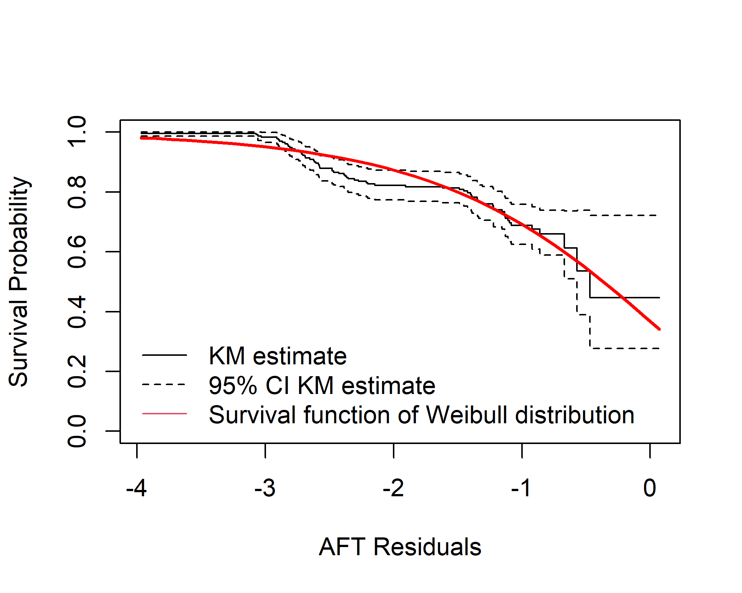

Models of death and discharge
Here we examine the key outcomes of death and discharge. We examine whether prone positioning is associated with death or discharge whilst controlling for potential confounders.
Table: Expected length of stay in days. ECMO = Extracorporeal Membrane Oxygenation
 | State moved to
State moved from | ECMO & supine | ECMO & prone | Discharge | Death
ECMO & supine | 33.9 (30.8, 37.2) | 1.6 (1.0, 2.4) | 25.1 (21.2, 29.1) | 29.3 (24.6, 34.1)
ECMO & prone | 26.6 (22.2, 30.6) | 9.7 (7.1, 13.7) | 23.4 (18.9, 27.4) | 30.3 (23.9, 38.3)
The table shows expected lengths of stay between states, with the current state in the rows on the left and the new state in the columns along the top. The results are up to day 90. These results do not adjust for potential confounders.
The days in parentheses are 95% confidence intervals based on 200 bootstrap replications.
The results use 232 patients.
Figure: Plot of predicted probabilities for the four states
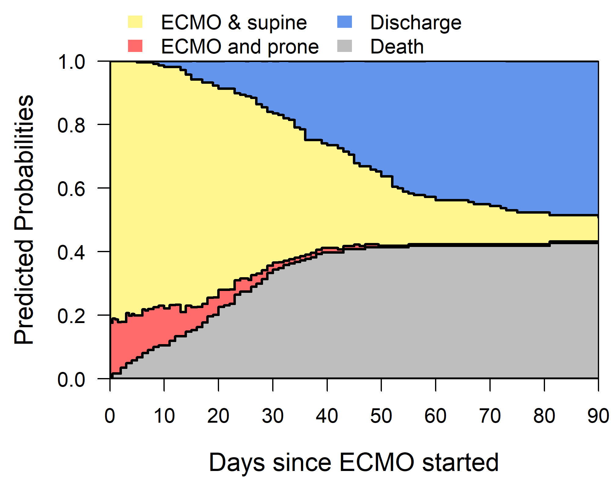
There is relatively little change in patients’ states after day 70.

Cumulative risk plots
Figure: Cumulative probabilities over time for the four states.
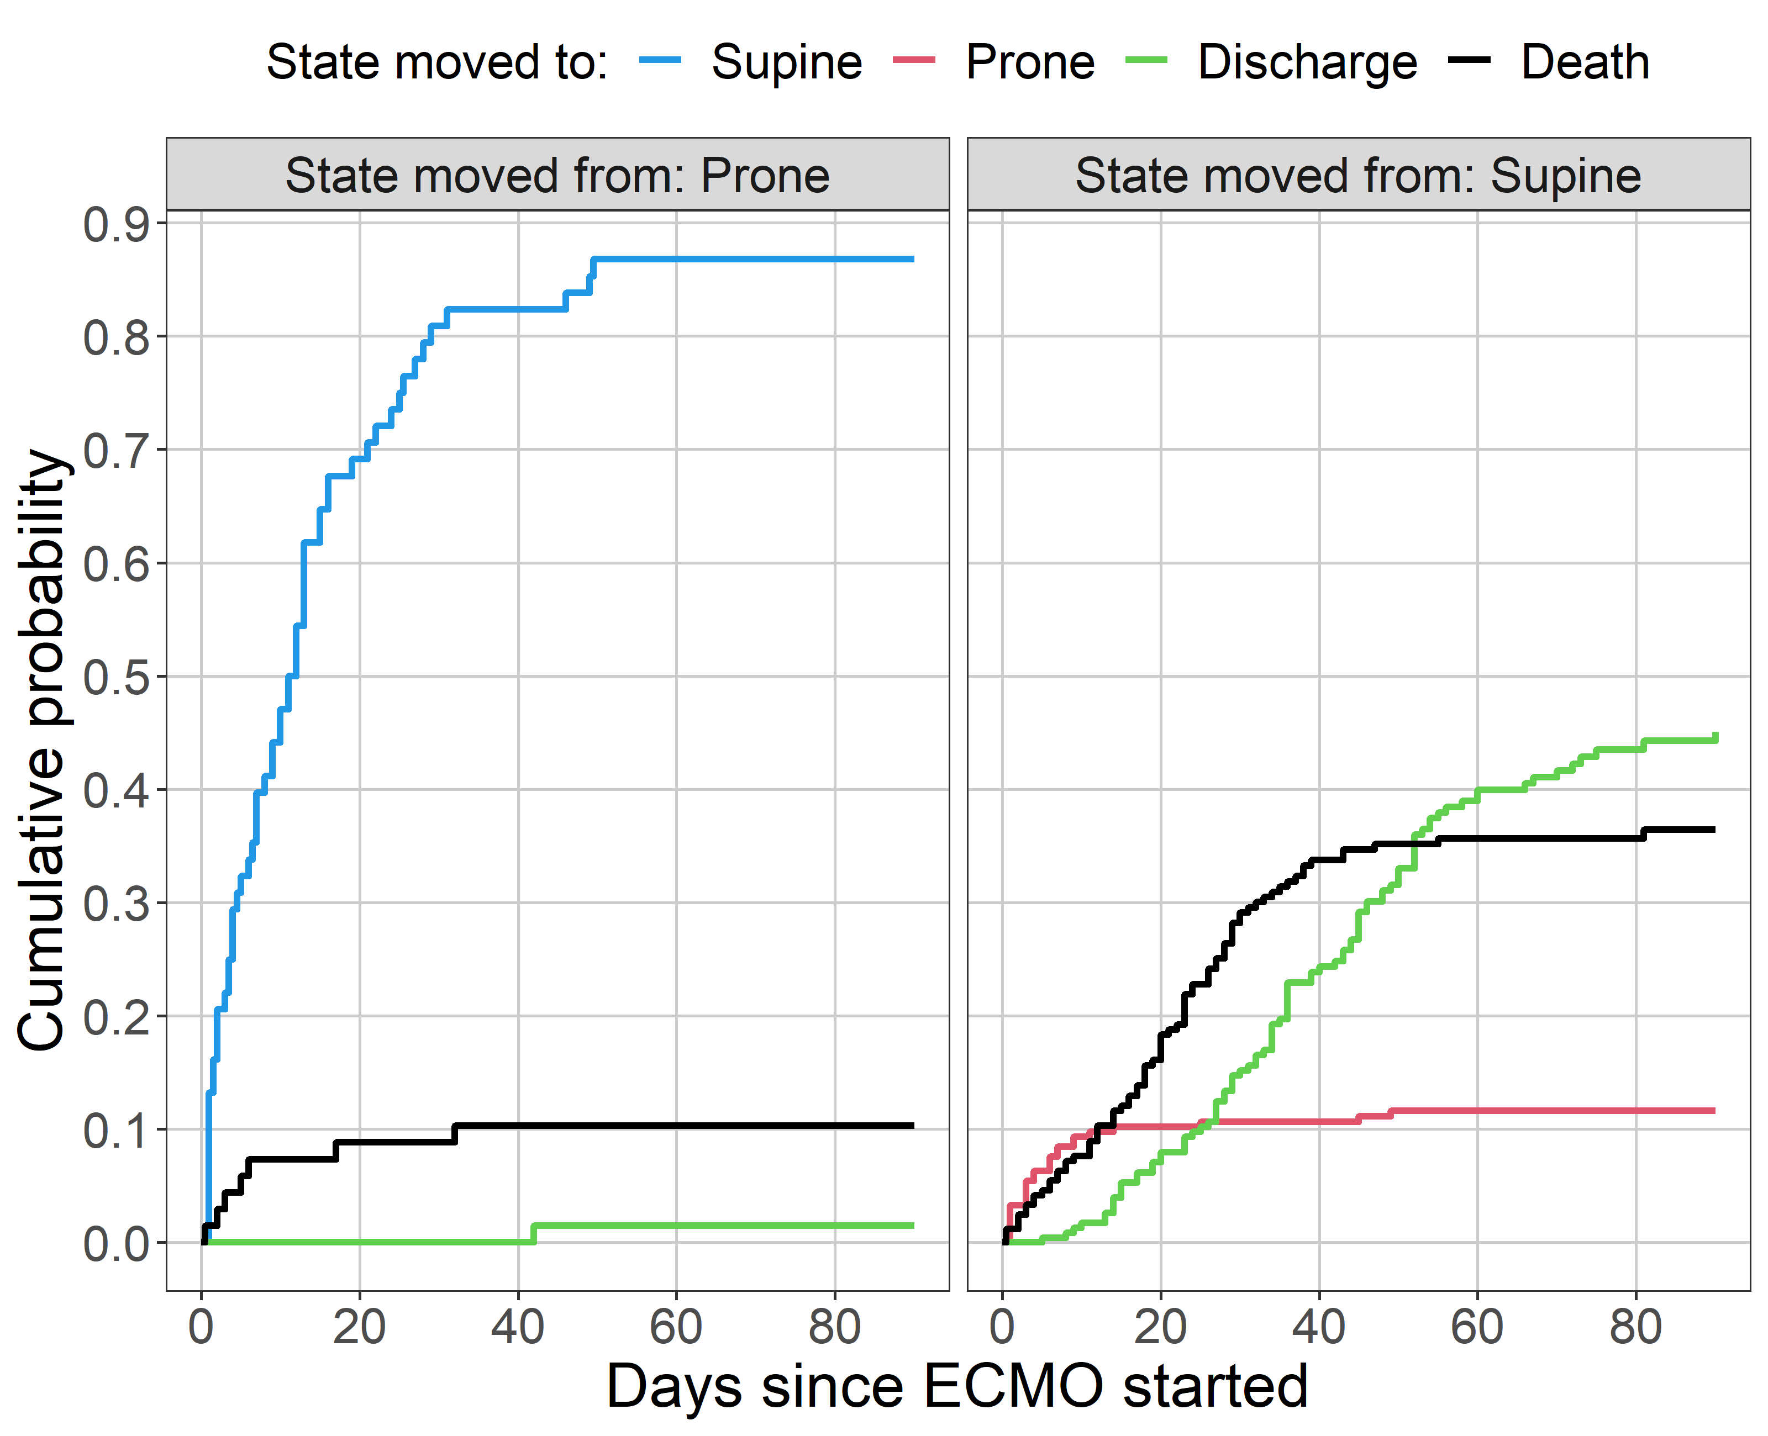
The plots show the cumulative probability over time of moving between states. The left panel shows the probabilities for patients in the “ECMO and prone” state, and the right panel shows the probabilities for patients in the “ECMO and supine” state. There is a steady accumulation of deaths in patients in the supine group (black line in right panel), although this slows after around 40 days. The movement of patients from the supine to the prone group greatly reduces after around 12 days (red line in right panel). Patients in the supine position are more likely to eventually experience discharge than patients in the prone position (green lines).

Survival models
Here we model the survival time and outcome (discharge/death) with the aim of examining prone position whilst adjusting for confounders.

Time to death and discharge
The table below is the hazard ratios (HRs) and 95% credible intervals for the competing risks of death and discharge. A hazard ratio of 1 indicates no change in risk, whereas a hazard ratio above 1 indicates increased risk, and a hazard ratio below 1 indicated decreased risk.
Table: Hazard ratios and 95% credible intervals for death and discharge from the Weibull model
 | Death |  | Discharge
Variable | HR | 95% CI | HR | 95% CI
Male | 1.23 | 0.72 to 2.16 | 1.13 | 0.66 to 1.97
Age (+10 years) | 1.40 | 1.09 to 1.81 | 0.72 | 0.57 to 0.91
Calendar time (+30 days) | 1.21 | 0.99 to 1.46 | 0.59 | 0.42 to 0.80
BMI (+5 kg/m2) | 1.12 | 0.93 to 1.33 | 1.02 | 0.86 to 1.19
Prone position during ECMO | 0.85 | 0.34 to 1.95 | 0.04 | 0.00 to 0.32
Prone before ECMO | 0.97 | 0.54 to 1.75 | 2.15 | 1.11 to 4.38
Prone position somewhat reduces the hazard of death (HR = 0.85).
Older age increases the hazard of death (HR = 1.40). Older age decreases the hazard of discharge (HR = 0.72), which increases the length of time on ECMO. Calendar time has a strong effect on discharge (HR = 0.59), with more days on ECMO (reduced discharge hazard) over calendar time.
There were 48 patients who were administratively censored, meaning they were not yet discharged or dead by the end of the study.

Check Weibull assumption for death and discharge

a) Death
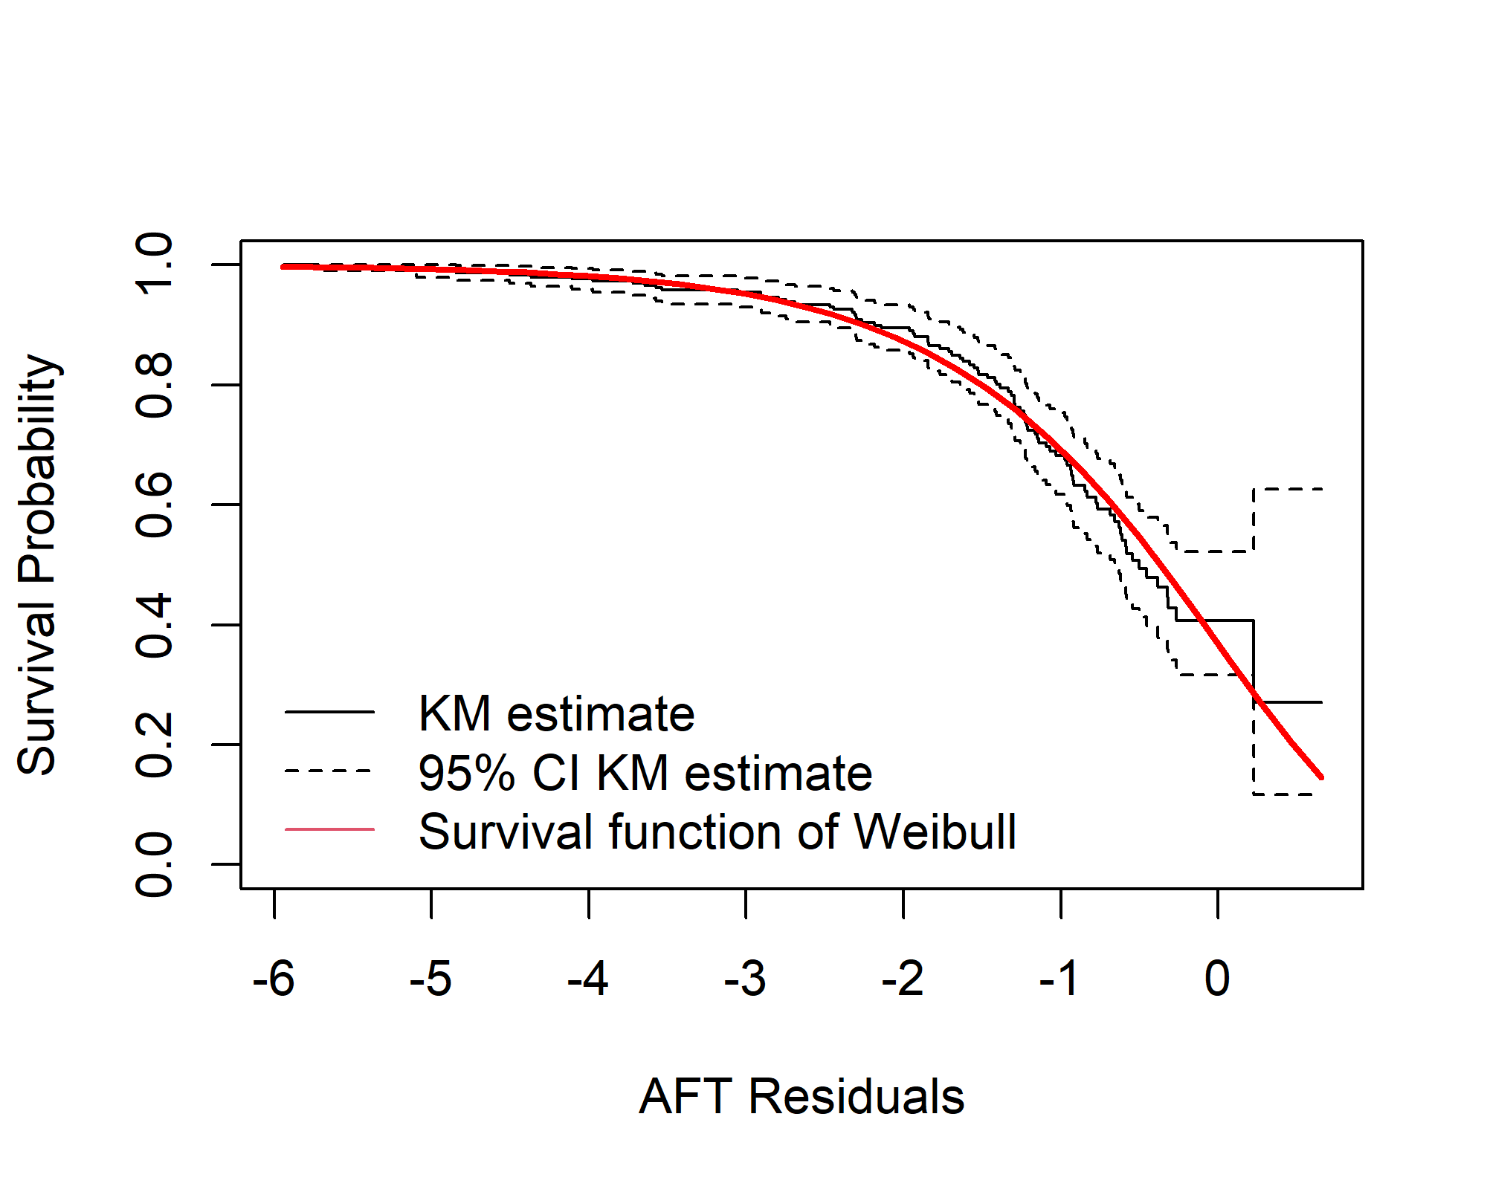

b) Discharge
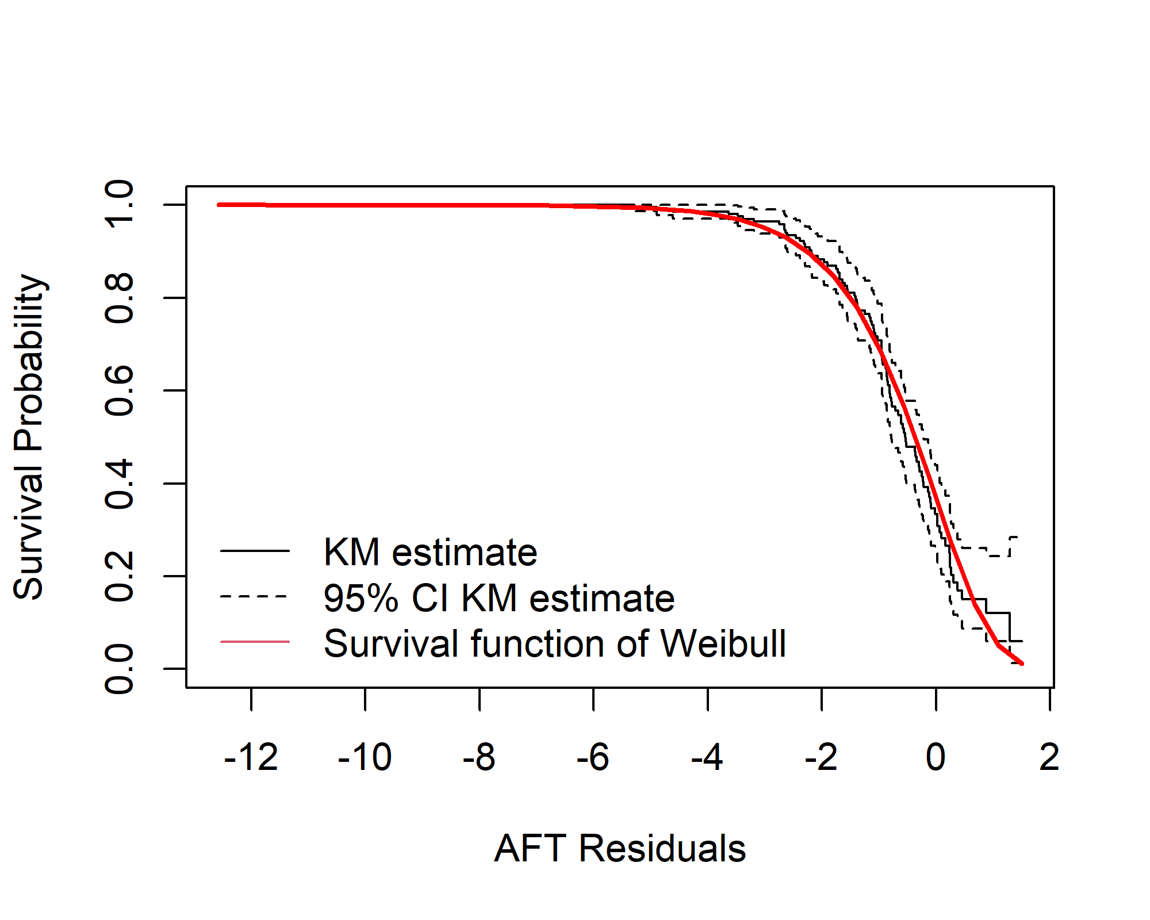

Cumulative survival models
The survival models in this section focus on the patients’ final (or cumulative) outcome of death and discharge, whereas the previous models examined the instantaneous hazard of experiencing death or discharge.
The table below shows the cumulative hazard ratios and 95% confidence intervals for death and discharge.

Table: Hazard ratios and 95% confidence intervals for death and discharge using a cumulative probability regression model
 | Death |  | Discharge
Variable | HR1 | CI1 | HR2 | CI2
Male | 1.19 | 0.77 to 1.86 | 0.73 | 0.48 to 1.12
Age (+10 years) | 1.46 | 1.19 to 1.78 | 0.78 | 0.66 to 0.93
Calendar time (+30 days) | 1.10 | 0.99 to 1.23 | 0.74 | 0.63 to 0.87
BMI (+5 kg/m2) | 1.13 | 0.98 to 1.29 | 0.99 | 0.86 to 1.13
Prone position during ECMO | 0.31 | 0.14 to 0.68 | 0.03 | 0.00 to 0.21
Prone before ECMO | 1.17 | 0.70 to 1.95 | 1.26 | 0.77 to 2.07
Prone position decreases the probability of death and discharge.

Plot of model predictions for cumulative regression

Figure: Plot of predicted cumulative probabilities of death and discharge over time for cumulative regression model for patients in prone and supine position
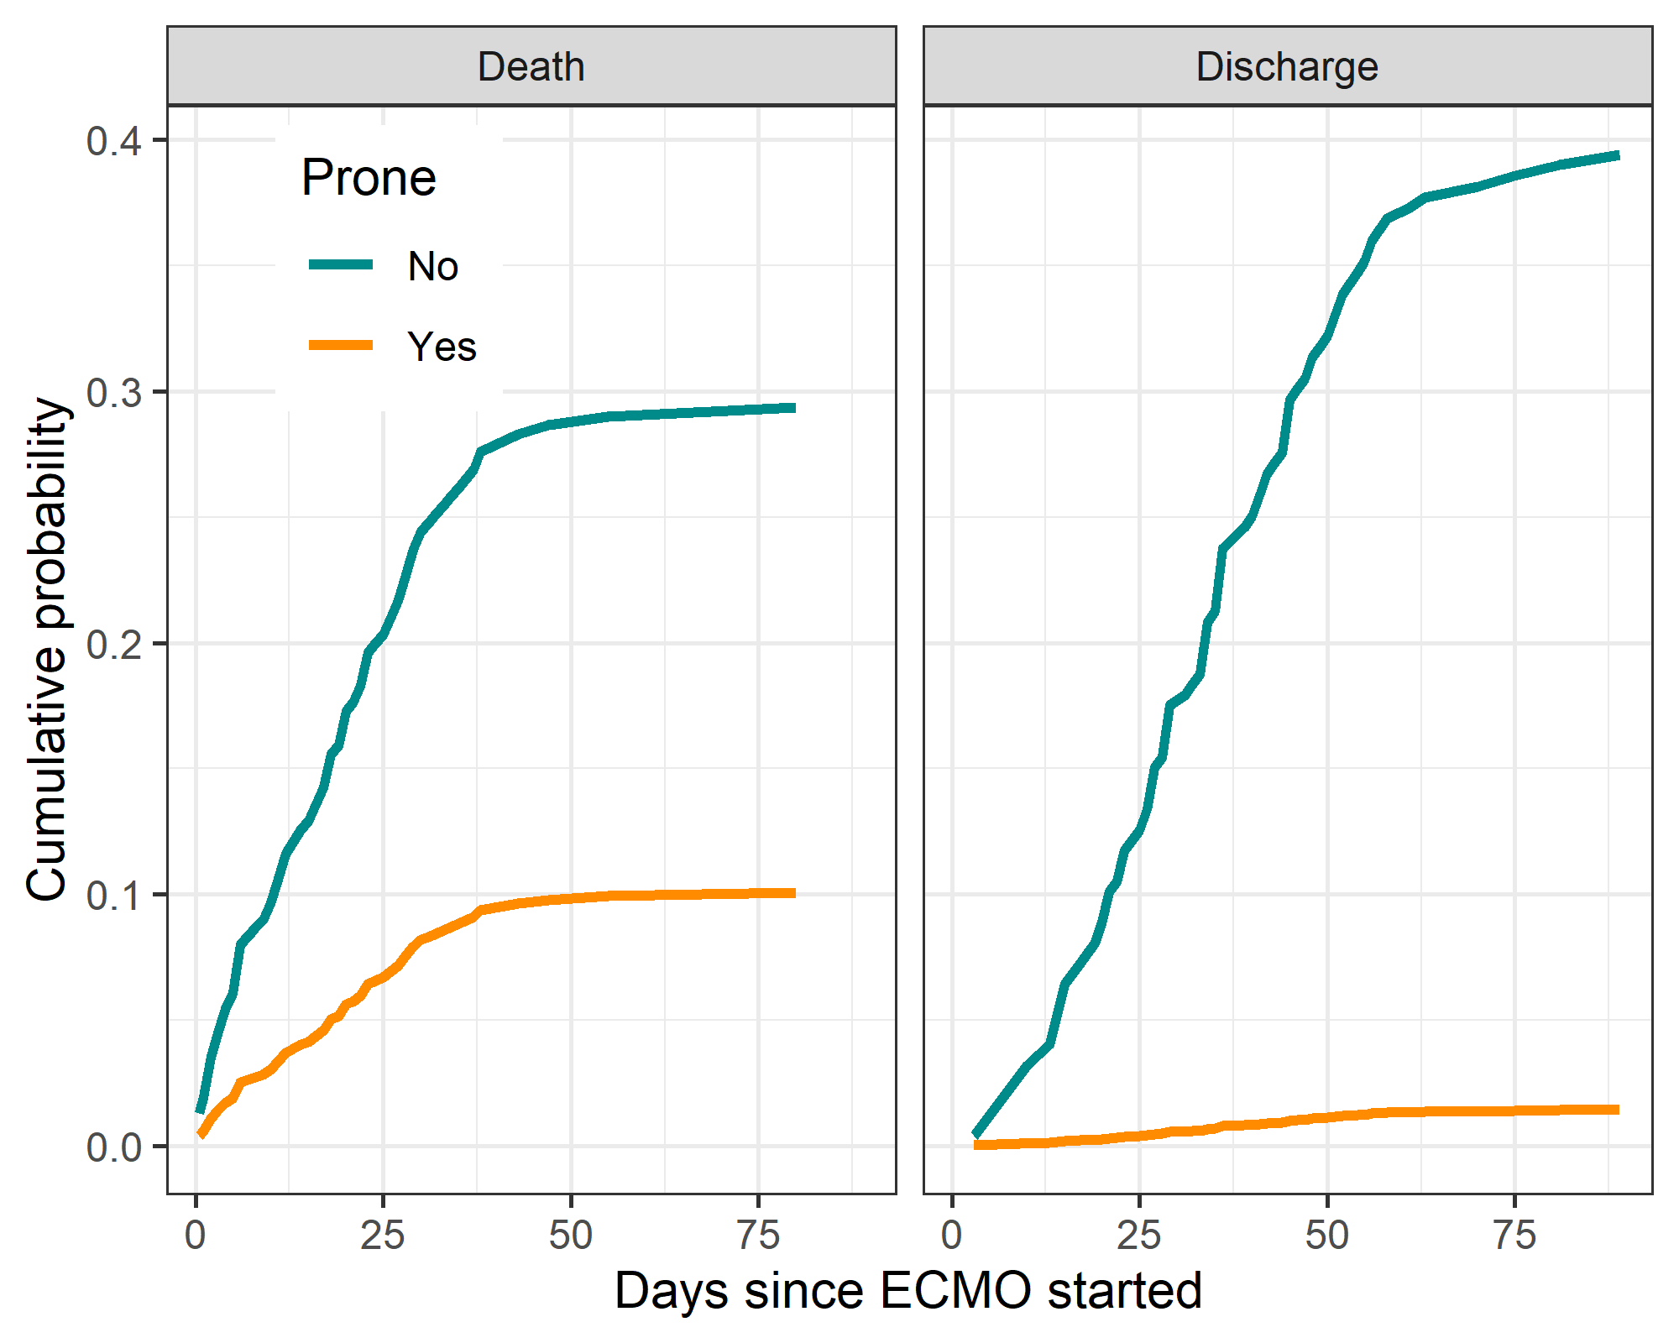
The plots above show the cumulative predicted probabilities of death and discharge for a patient of average age and BMI. By the end of the follow-up time (day 80) there are very large gaps in the predicted probability of both death and discharge for patients in supine and prone position.
Survival models of time on prone
Here we examine the effect of time on prone. We use a survival model that examines each day based the day-to-day changes in position. This allows us to examine how the cumulative number of days in prone impacts the risk of death and discharge.
Plot of model fit
Figure: AIC for the five alternative non-linear models of cumulative prone position.
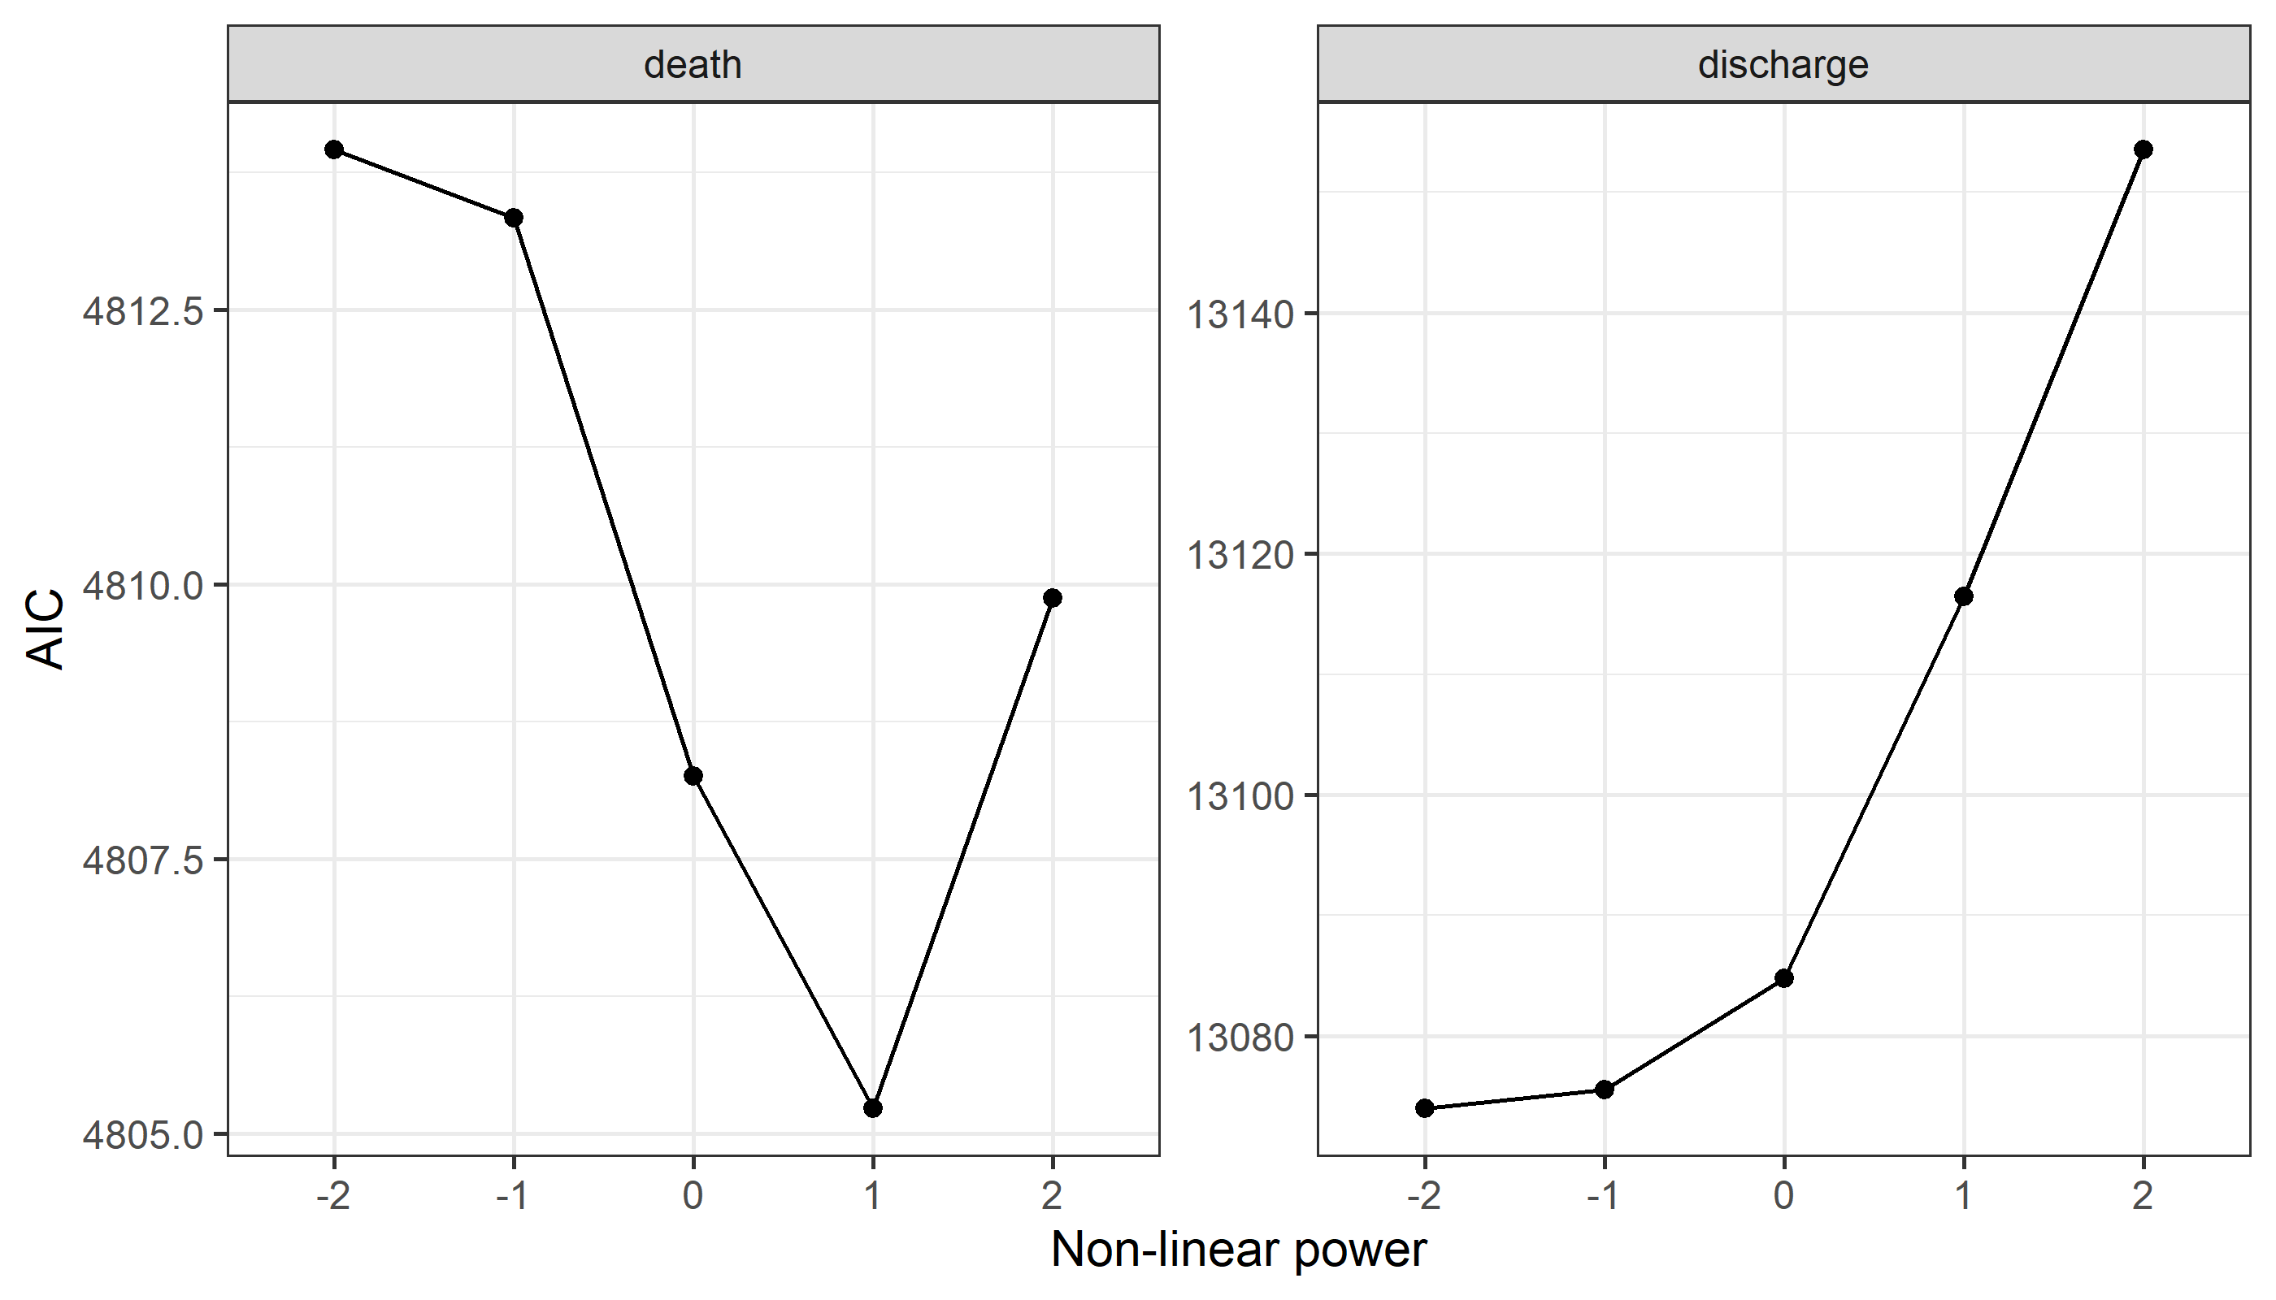
It is plausible that the cumulative effect of prone is non-linear, e.g., sharp change in risk for first few days followed by a slower change in risk. Hence, we fitted several non-linear models and chose the best non-linear shape for the risk using the Akaike Information Criterion (AIC). The plot above shows that the best power for death is 1 and the best power for discharge is -2. We visualize these non-linear changes below using plots of the change in risk.
Table: Hazard ratios and 95% confidence intervals for death and discharge using cumulative prone with the best non-linear fit for cumulative prone.
 | Death |  | Discharge
Variable | HR1 | CI1 | HR2 | CI2
Age (+10 years) | 1.18 | 1.00 to 1.39 | 0.70 | 0.64 to 0.76
Sex = Male | 0.98 | 0.79 to 1.23 | 0.80 | 0.66 to 0.97
BMI (+5 kg/m2) | 1.23 | 1.10 to 1.39 | 0.92 | 0.87 to 0.97
Calendar time (+1 month) | 1.35 | 1.25 to 1.46 | 0.76 | 0.72 to 0.79
Prone before ECMO | 0.85 | 0.65 to 1.11 | 1.40 | 1.14 to 1.72
Cumulative time on prone (non-linear) | 0.95 | 0.92 to 1.00 | 1.36 | 1.28 to 1.46

Plot of model predictions
Figure: Estimated risk of death and discharge by time on prone
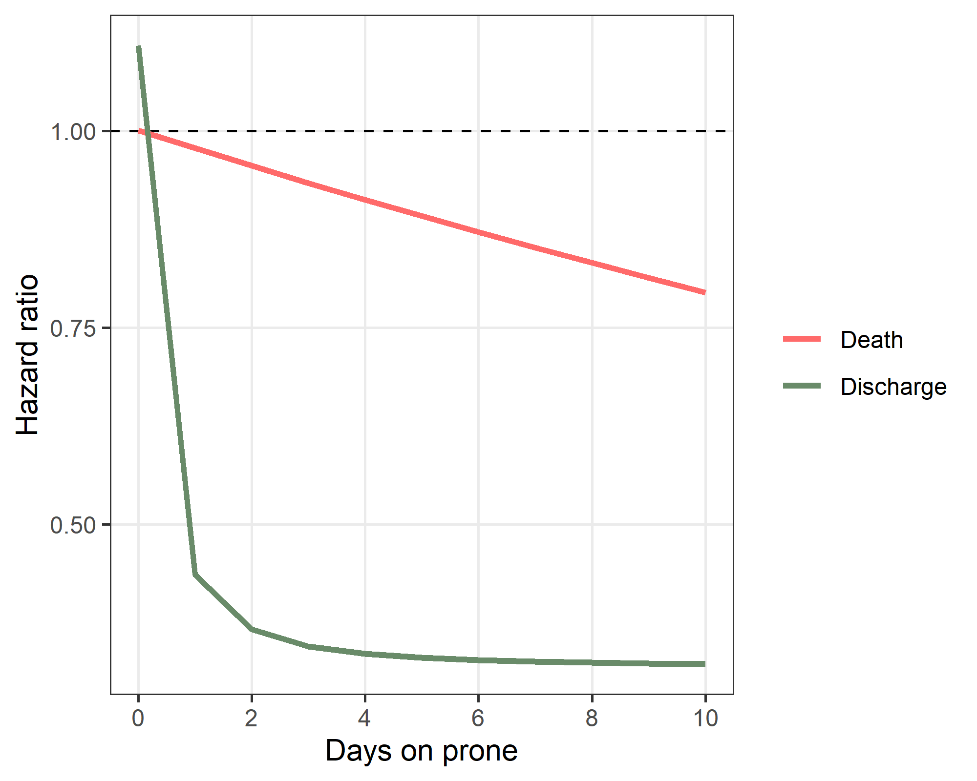
There is a strong change by days on prone on the hazard of discharge. For those with no prone (zero days on prone) the hazard of discharge is above 1, whilst any days on prone greatly reduced the hazard of discharge. For death, the hazard gradually decreases with greater time on prone.

Appendices

Plot of individual patient journeys
This plot shows individual patient journeys from admission to discharge or death. The panels are split by the patient’s final state (death, discharge or censored) and whether they started in a prone or supine position.
Figure: Plots of individual patients over time
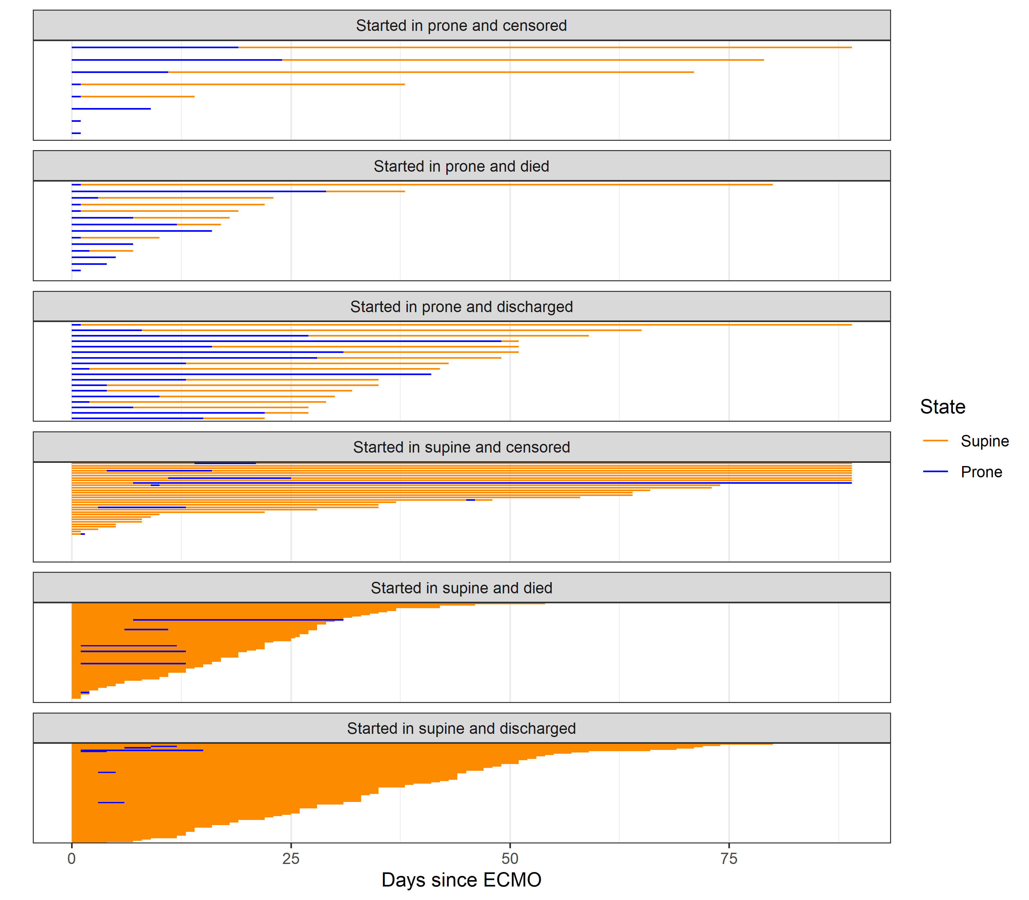

Daily results for patients with a position change
Here we look at daily variables for patients who experience a change from supine to prone. Using within patient change helps control for confounders because patients act as their own control. We examine the two weeks before and after this change. Not all patients have data that covers two weeks before and after the change.
Figure: Individual patients results before and after the change to prone position (grey lines) and the estimated average change from a regression model (red line).
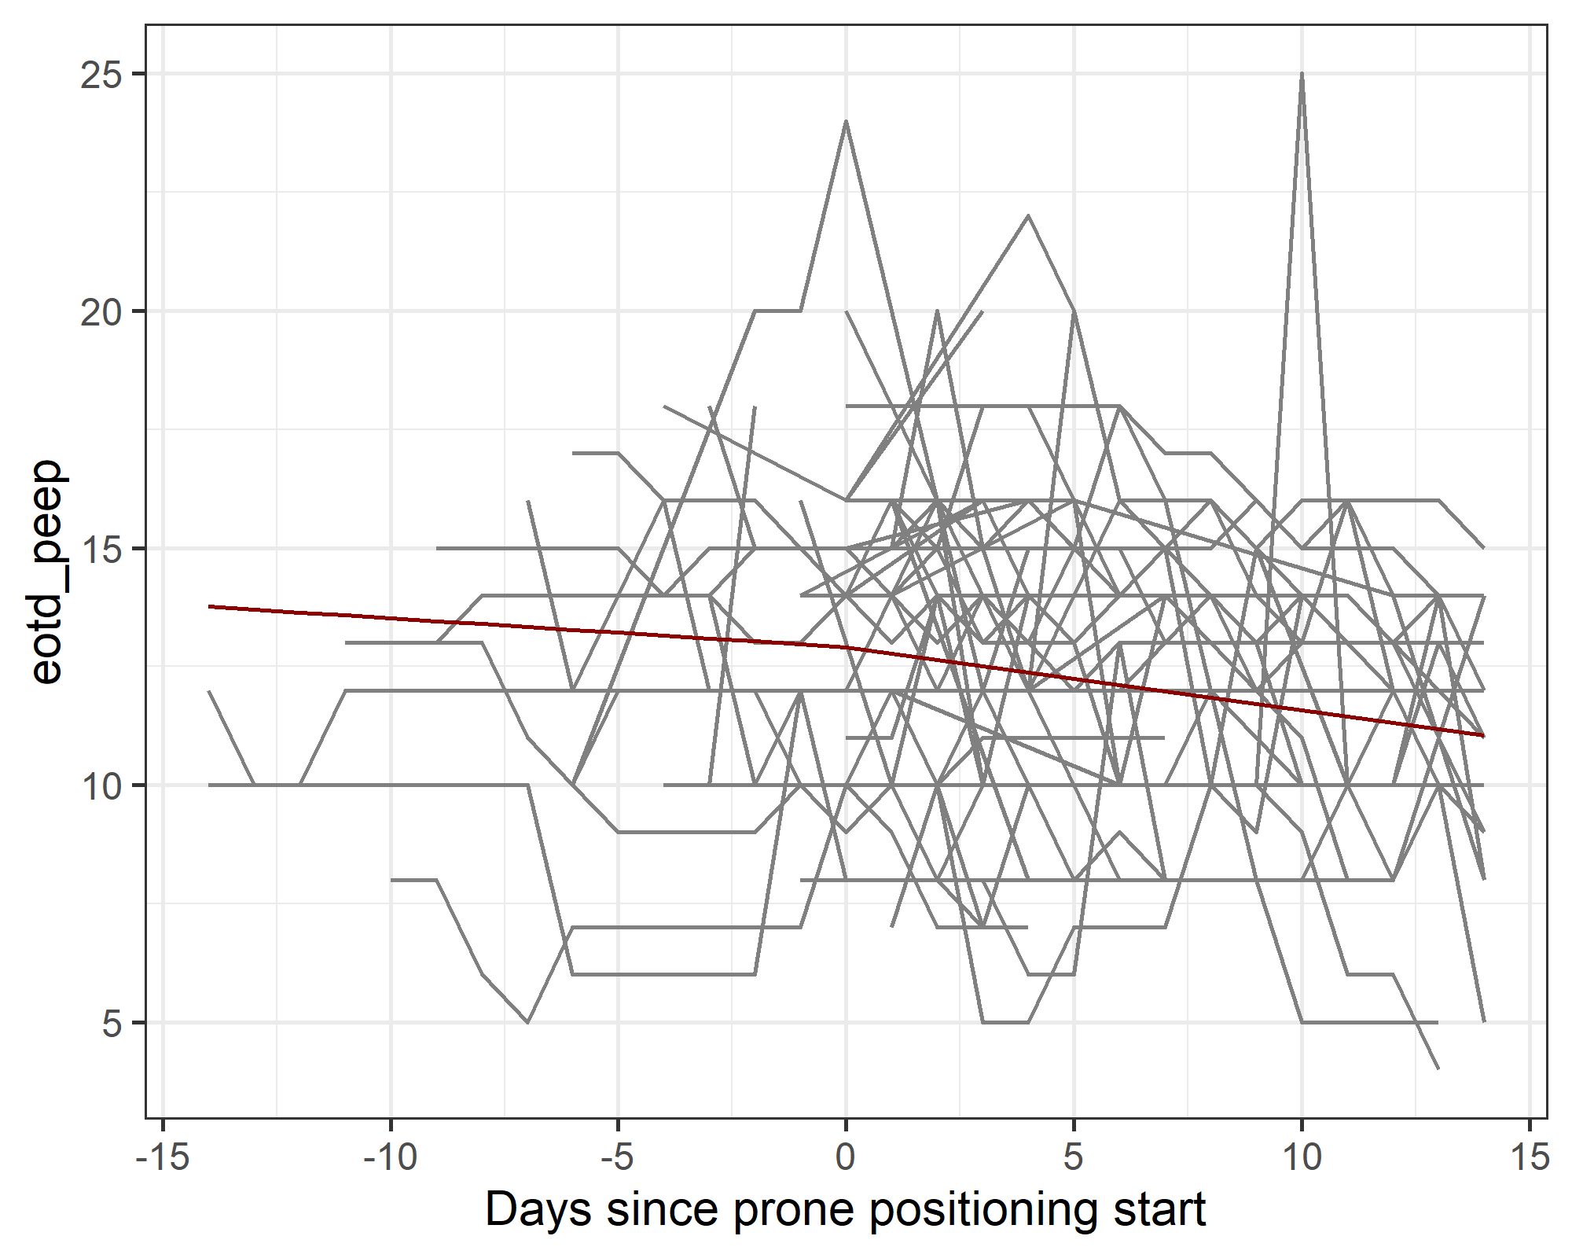
There are 62 patients who move from prone to supine or vice versa, and there are 569 daily observations for these patients.
The plot shows the individual results for patients (grey lines) before and after their move to prone. The red line is the estimated mean change from a regression model that has a change point in the slope over time on the day that patients switched to prone.
For PEEP there was little change after moving to prone position, with a change in the slope per day of -0.07 with a 95% confidence interval from -0.18 to 0.03.

Site effects
Random effects for sites from the survival models.

Site effects (prone position)
Figure: Site effects from the Weibull survival model for prone position
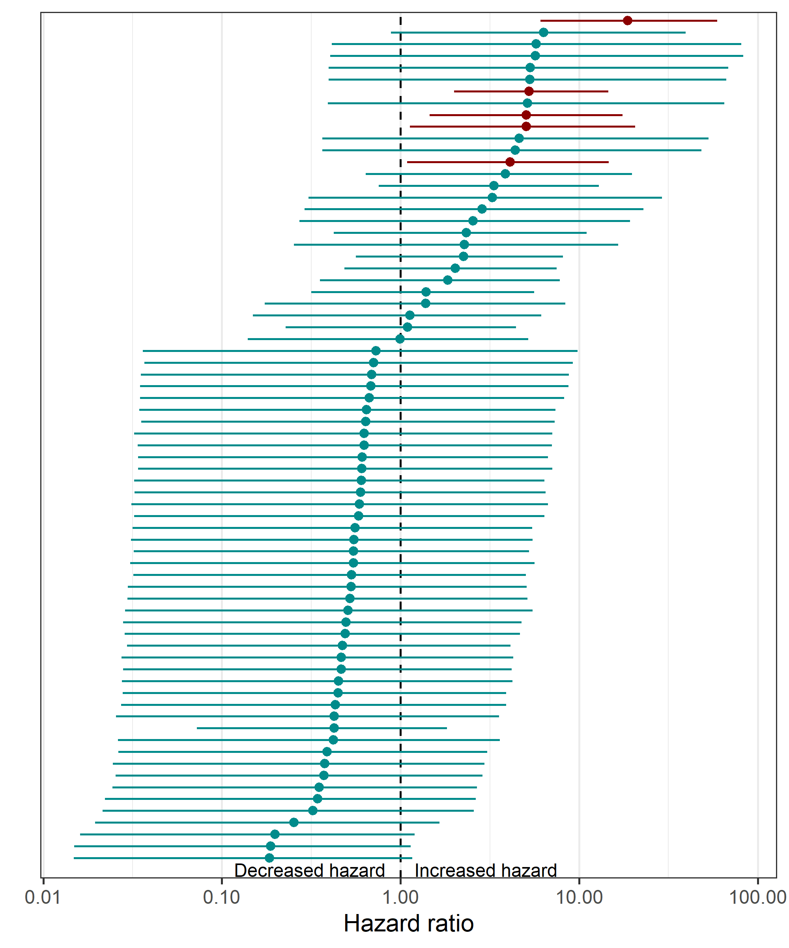
The plot shows the mean hazard ratio per site (circle) and 95% credible interval (horizontal line) for the 72 sites. The dotted vertical line is at a hazard ratio of 1 and indicated no change in hazard. Sites below the line have a decreased hazard of prone position, whilst sites above the line have an increased hazard. Sites with a lower limit above the line have been coloured red. Sites have been ordered using their mean hazard ratio. The wide credible intervals indicate large uncertainty in most sites, and this is because of the small number of patients in most sites. The hazard ratio is on a log scale (base 10).
There are 5 sites that have a relatively large hazard ratio for putting patients in prone position. This could be because prone positioning is an accepted practice at those sites.

Site effects (prone positioning): details on the influential sites
site_num | n | exit | censored | prone
9 | 14 | 18.50 | 2 | 10
30 | 10 | 3.30 | 0 | 9
49 | 8 | 15.75 | 0 | 5
58 | 8 | 15.25 | 0 | 4
67 | 4 | 1.25 | 1 | 3
The table above shows the summary statistics for the five sites that were relative outliers in terms of prone positioning.

Site effects (death and discharge)

Figure: Site effects from the Weibull survival model for death and discharge
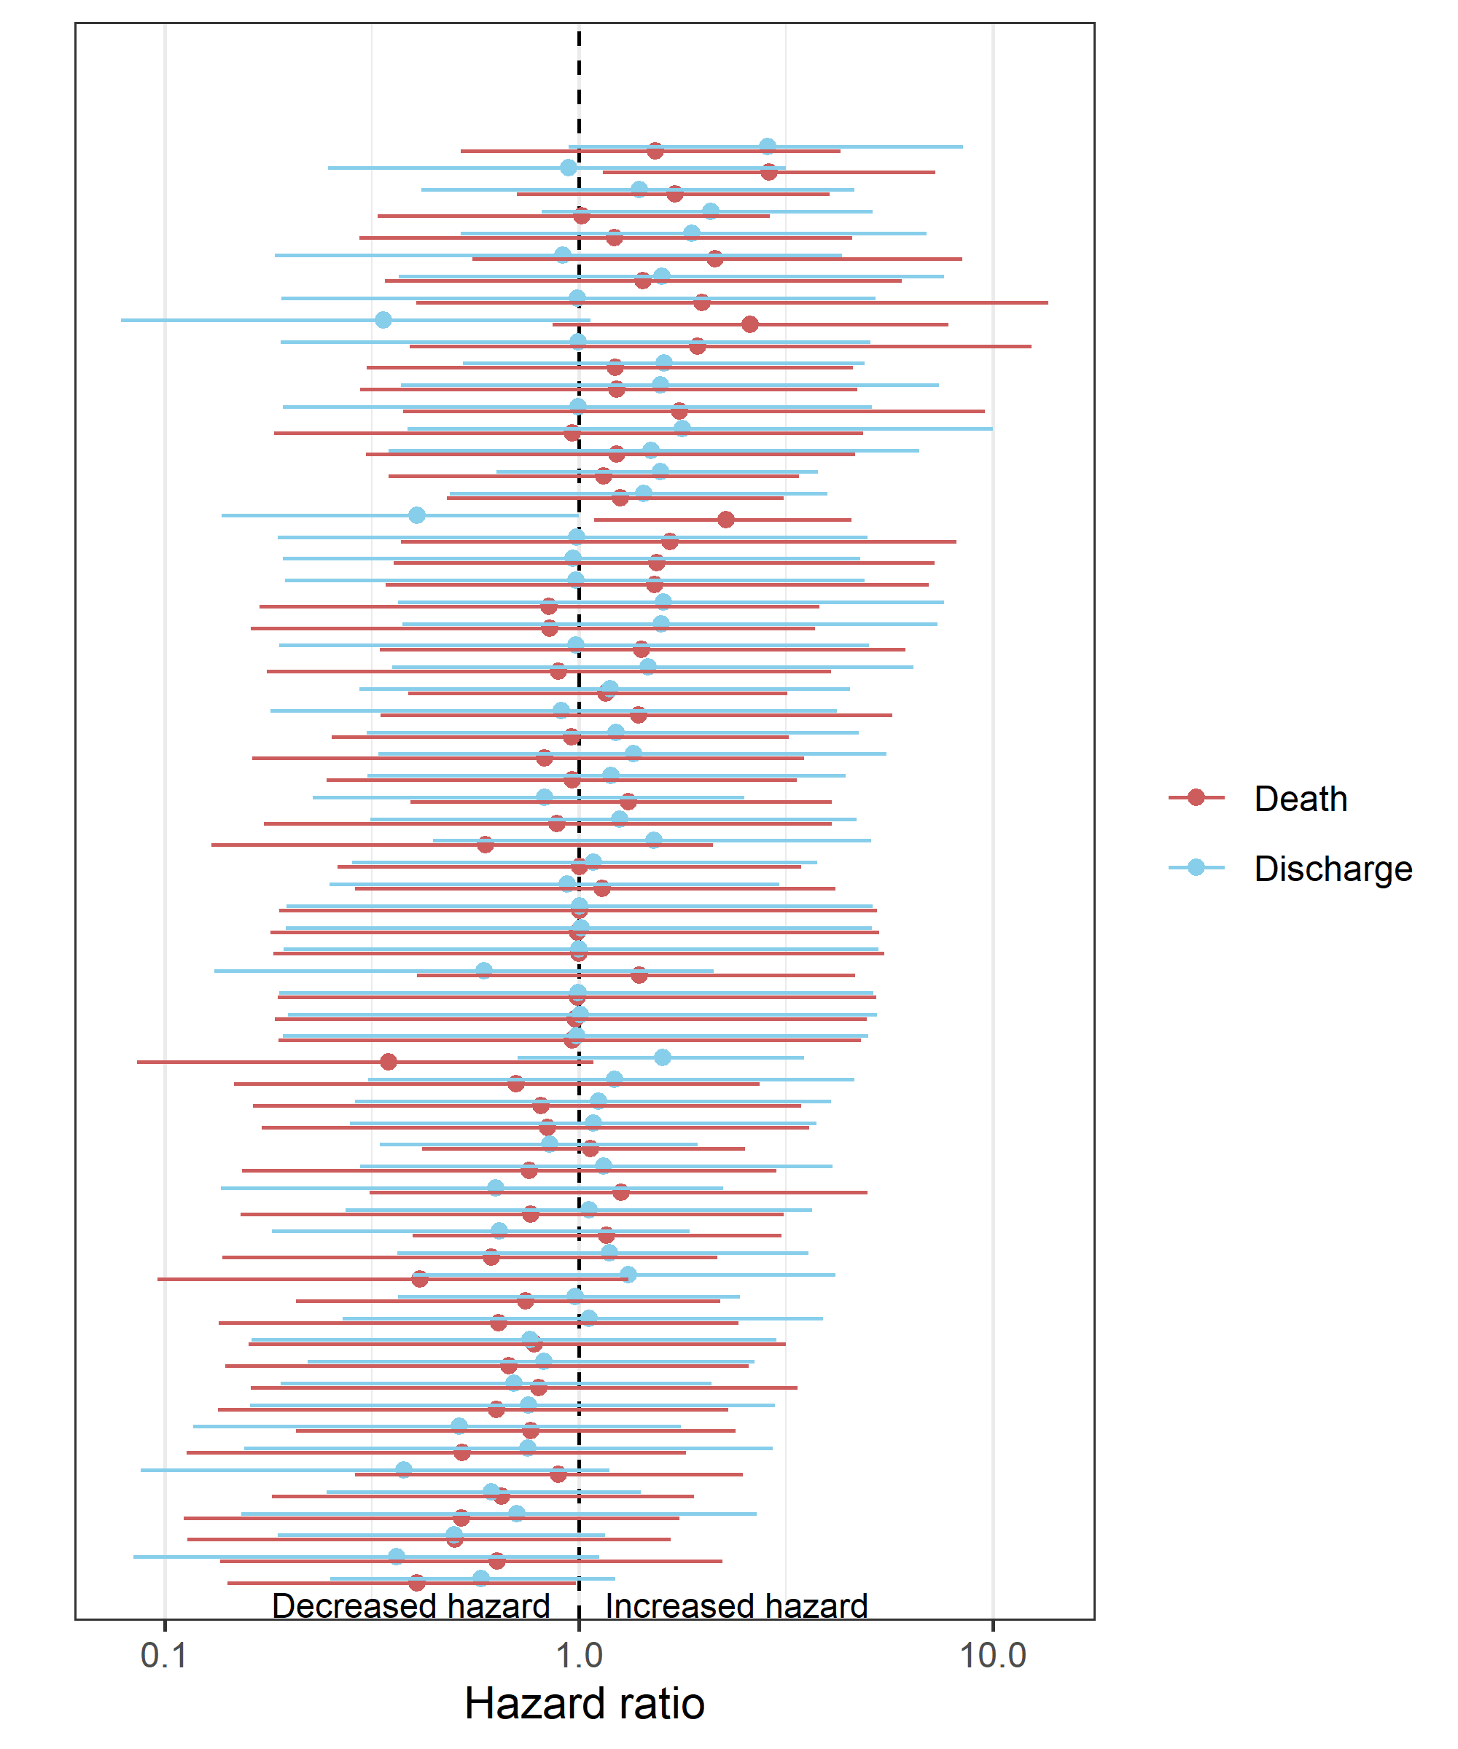
The hazard ratio axis is on log scale (base 10). Each row is a site and there are two estimates per site: one for death and one for discharge.
There was more variability between sites in the hazard of discharge than the hazard of death. This can be seen because the site-specific estimates for death (red dots) are generally closer to 1 than the estimates for discharge (blue dots).

Estimates of the Weibull shape parameter
Here we show the estimates of the Weibull shape parameter from the parametric survival models. The table shows the mean and 95% credible interval.
Table: Means and 95% credible intervals for the Weibull shape parameters
model | mean | CI
Prone | 0.2 | 0.2 to 0.2
Death | 1.0 | 0.9 to 1.2
Discharge | 2.1 | 1.7 to 2.5
A shape parameter under 1 means the event rate decreases over time, whereas a shape parameter over 1 means the event rate increases with time. The shape parameter is well below 1 for the prone model, as most patients experience prone early in their stay. The shape parameter is well above 1 for the discharge model, as few patients are discharged in the first few days after starting ECMO.

Baseline hazards
Plots of the estimated baseline hazard function from the Weibull survival models. Say why this is useful (Royston, P et al, 2013).
Figure: Baseline hazard for survival model of prone position
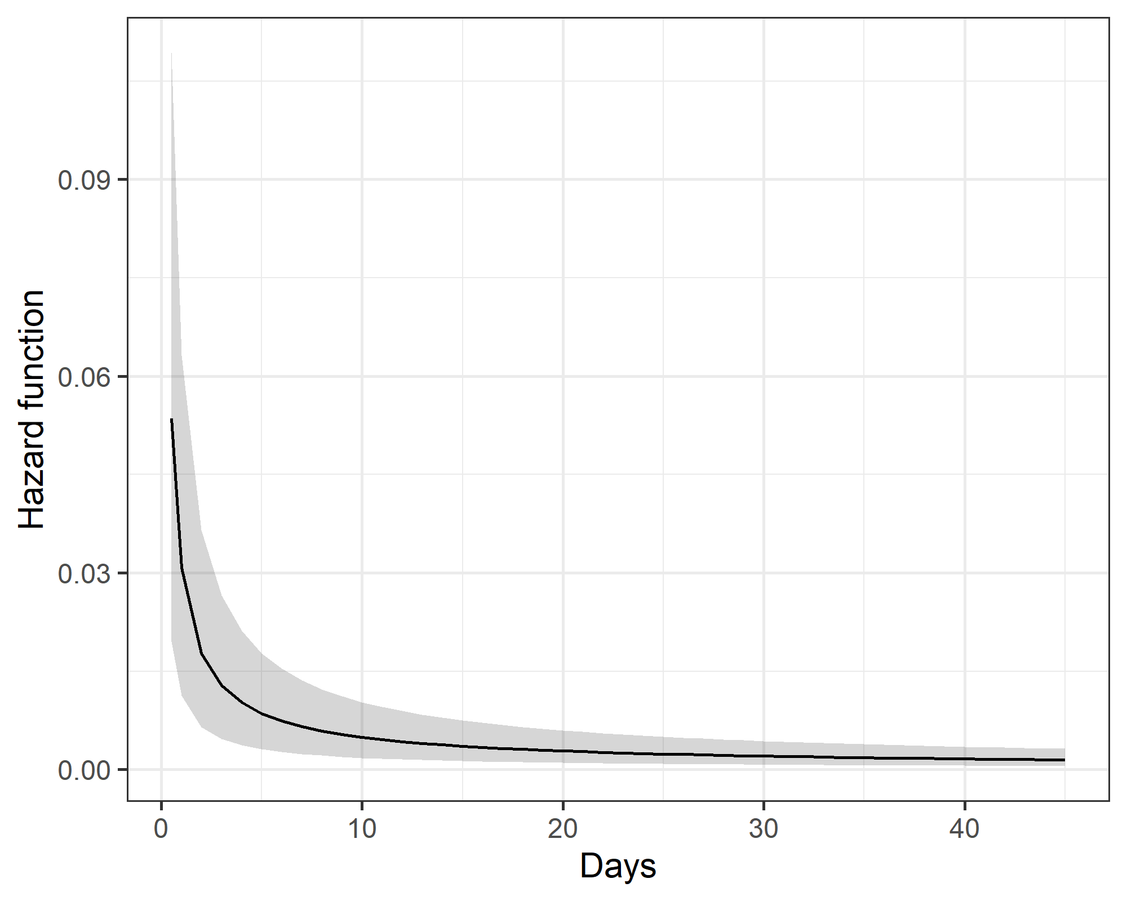
The black line is the mean hazard function and the grey area is the 95% credible interval. The hazard of prone position is highest in the first few days and then sharply declines. This matches the data, as most patients are prone on day zero, or get moved to prone soon after being on ECMO.
Figure: Baseline hazard for survival model of death and discharge
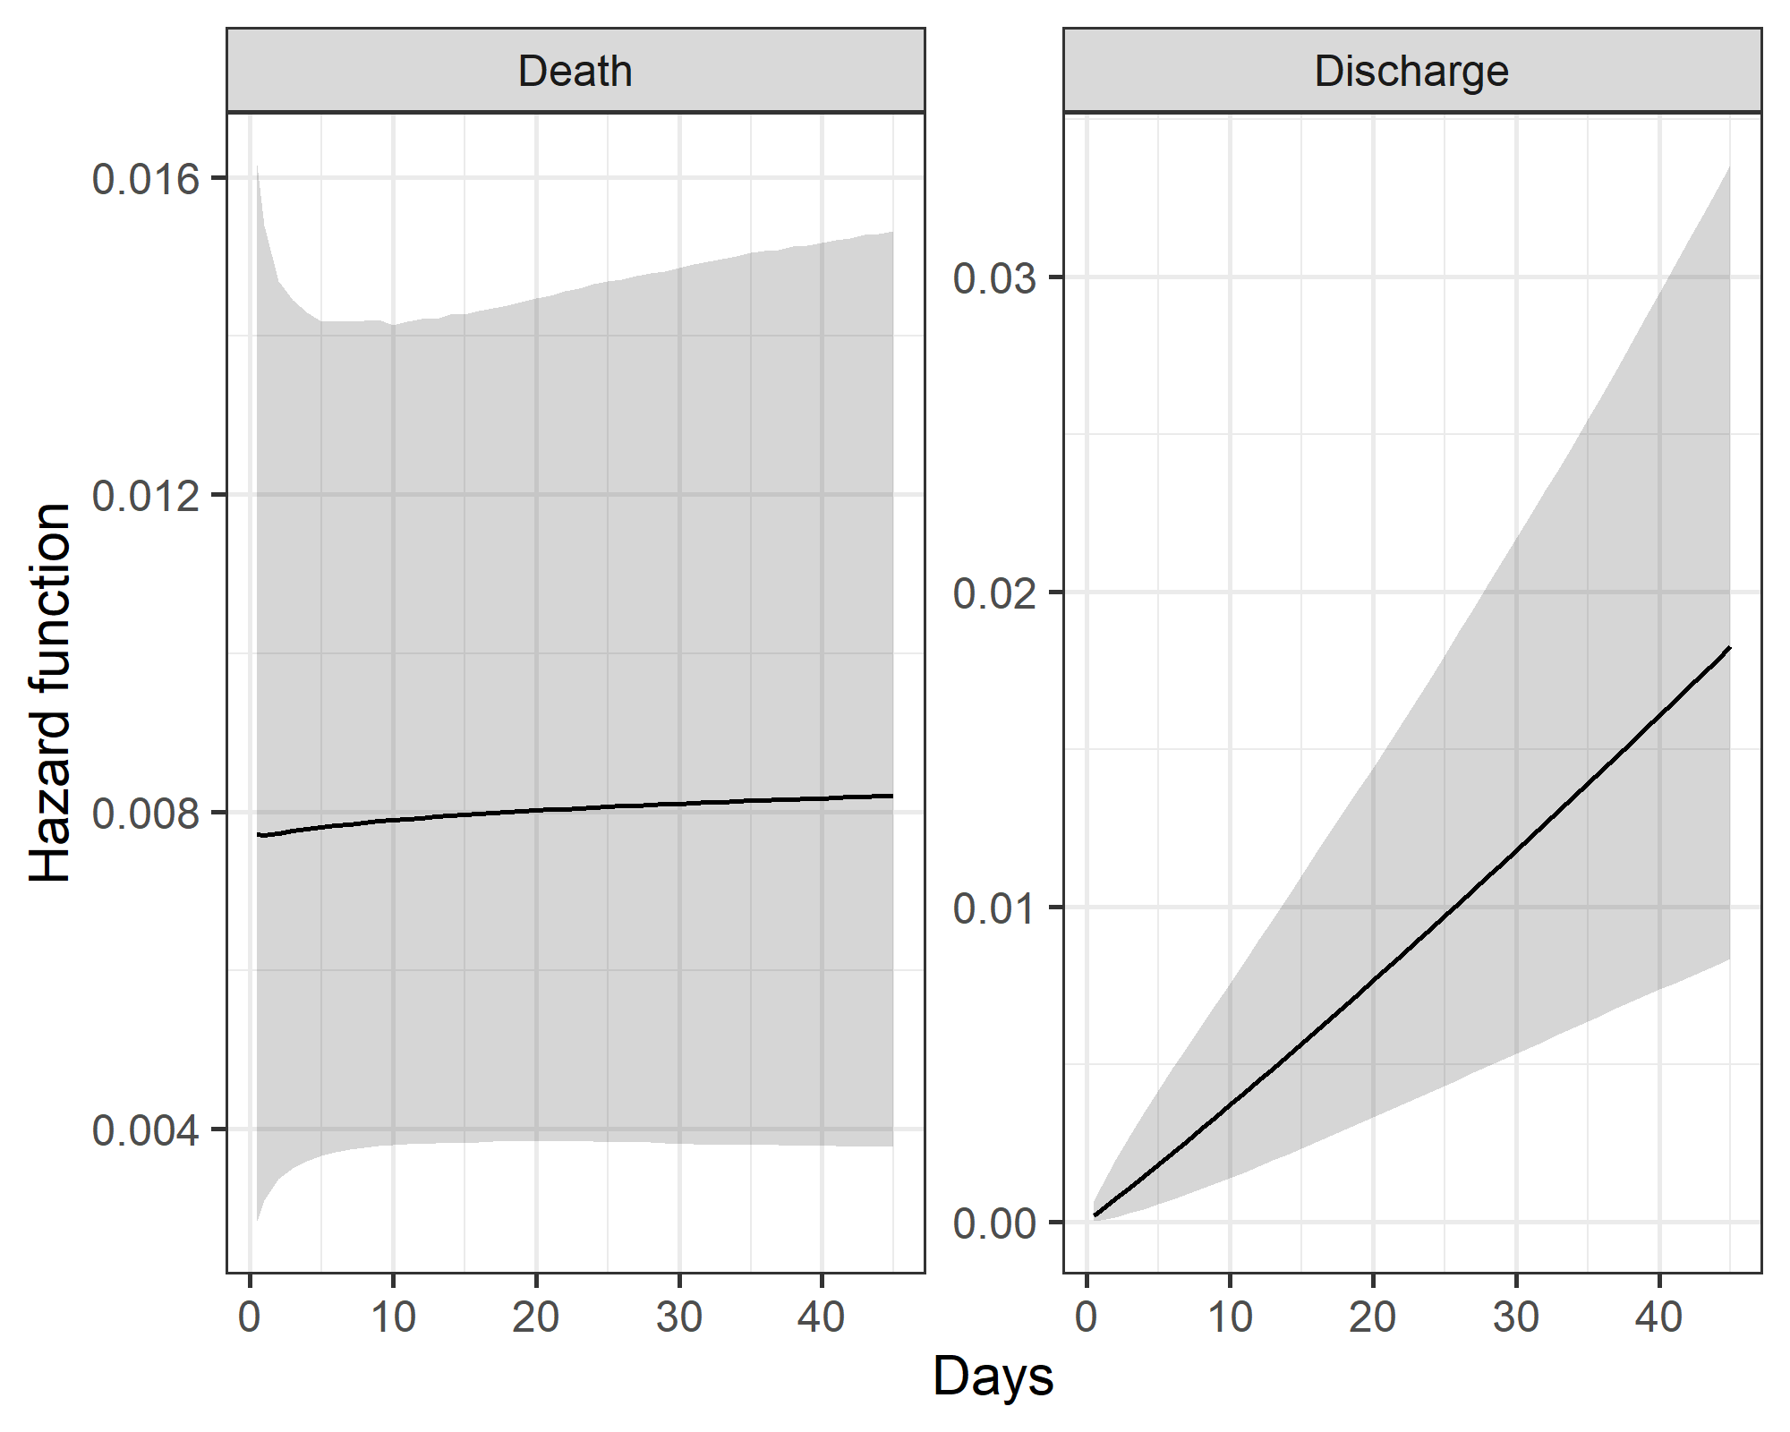
The hazard of discharge increases greatly over time. The hazard of death remains relatively constant.

Alternative Cox survival models
Here we use non-parametric Cox models to confirm the results from the parametric Weibull survival models. These models use the multi-state approach, so patients could move from prone to supine (or vice versa) over time. These models account for correlated results from the same site. We use a simple mean imputation for patients missing BMI.
The table shows the mean hazard ratios (HRs) and 95% confidence intervals for death and discharge.
Table: Hazard ratios and 95% credible intervals for death and discharge from the Cox model
 | Death |  | Discharge
Variable | HR | 95% CI | HR | 95% CI
bmi | 1.16 | 1.03 to 1.32 | 0.88 | 0.56 to 1.36
age | 1.40 | 1.13 to 1.73 | 0.73 | 0.62 to 0.86
sex | 1.39 | 0.92 to 2.09 | 0.73 | 0.61 to 0.88
calendar_time | 1.17 | 1.04 to 1.31 | 1.11 | 0.97 to 1.26
prone | 0.87 | 0.33 to 2.33 | 0.14 | 0.07 to 0.26
prone_before | 1.09 | 0.65 to 1.84 | 1.33 | 0.78 to 2.28
Prone position reduces the hazard of death and discharge.

Censoring times
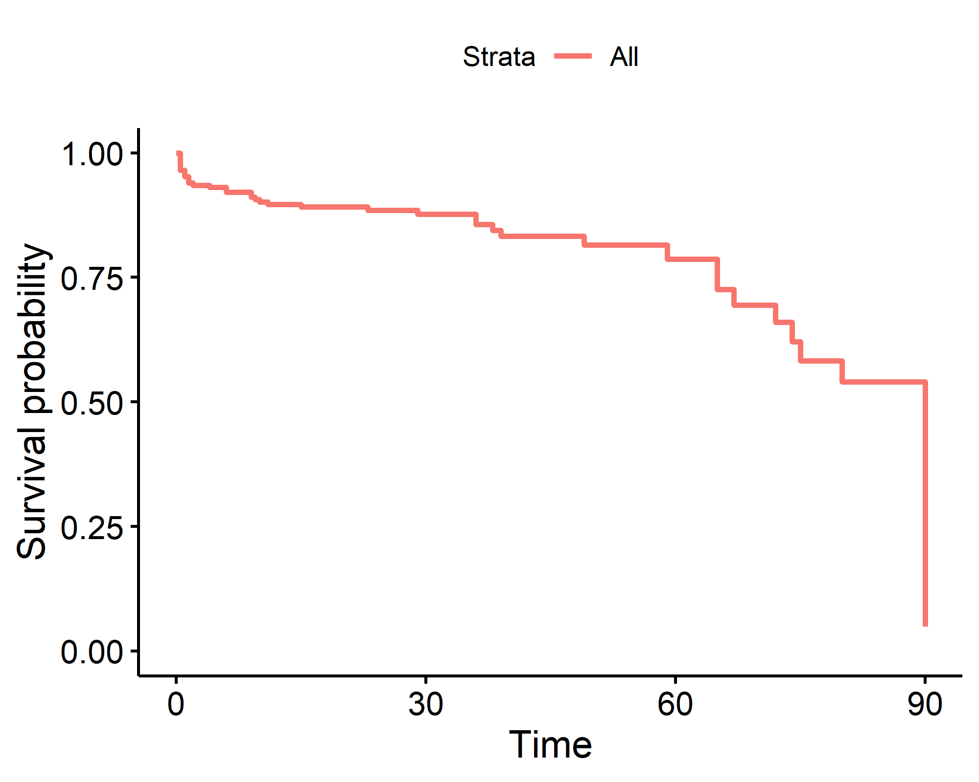
Figure: Kaplan-Meier plot of the censoring times.
The Kaplan-Meier plot above shows the censoring times. Patients could be censored prior to 90 days based on their last date of observation. Patients were censored at 90 days if they were still in hospital. The median day of censoring is 90.

Checking for influential patients
In this section we check whether there were influential patients in the Cox survival analysis. An influential patient is one who has a large effect of the estimates and hence any inference.
The plot below shows the ‘dfbetas’ which are the estimated changes in the regression coefficients after deleting each observation patient in turn. The estimates are on the log-scale and zero means no change. We have separate plots for the discharge and death models.
Figure: Influential observations for the Cox survival model of discharge
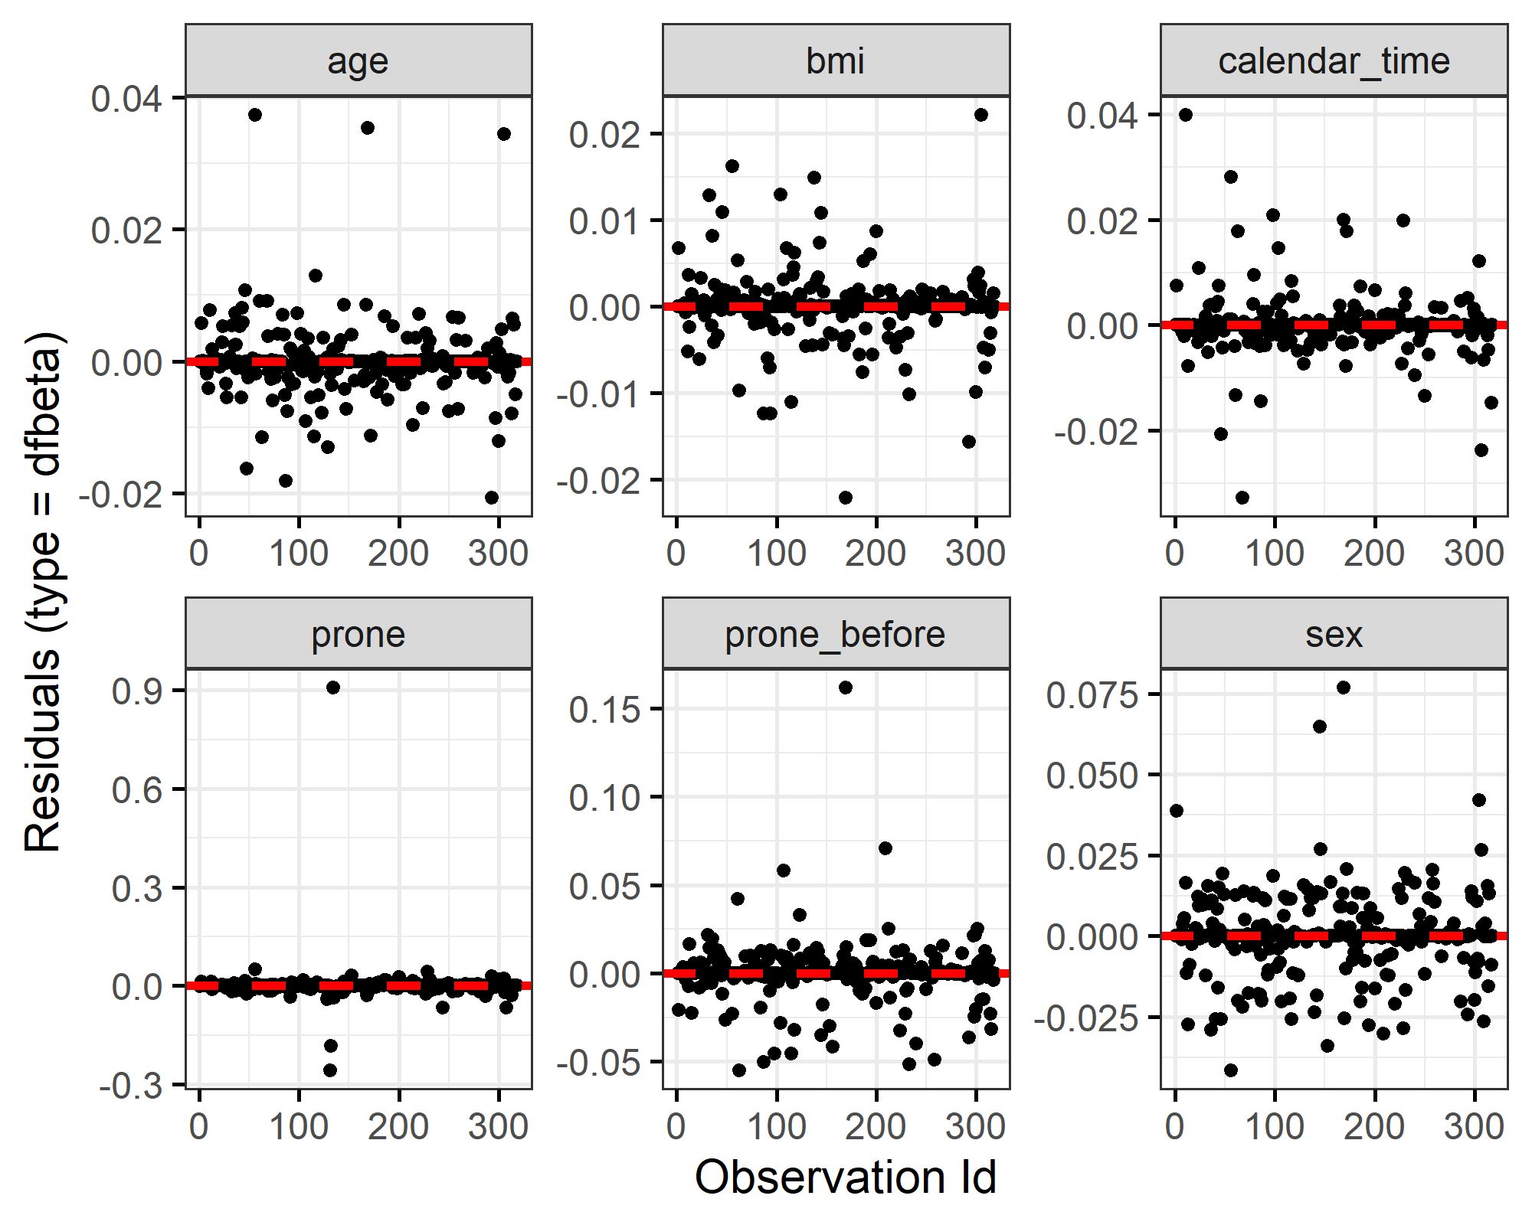
There is one influential patient for prone for the model examining discharge. This is the one patient who was discharged in prone position. Without that patient the hazard of discharge is much greater in
site | sex | age | bmi | prone | days | censored
30 | Male | 54 | 29.4 | Yes | 42 | No
Figure: Influential observations for the Cox survival model of death
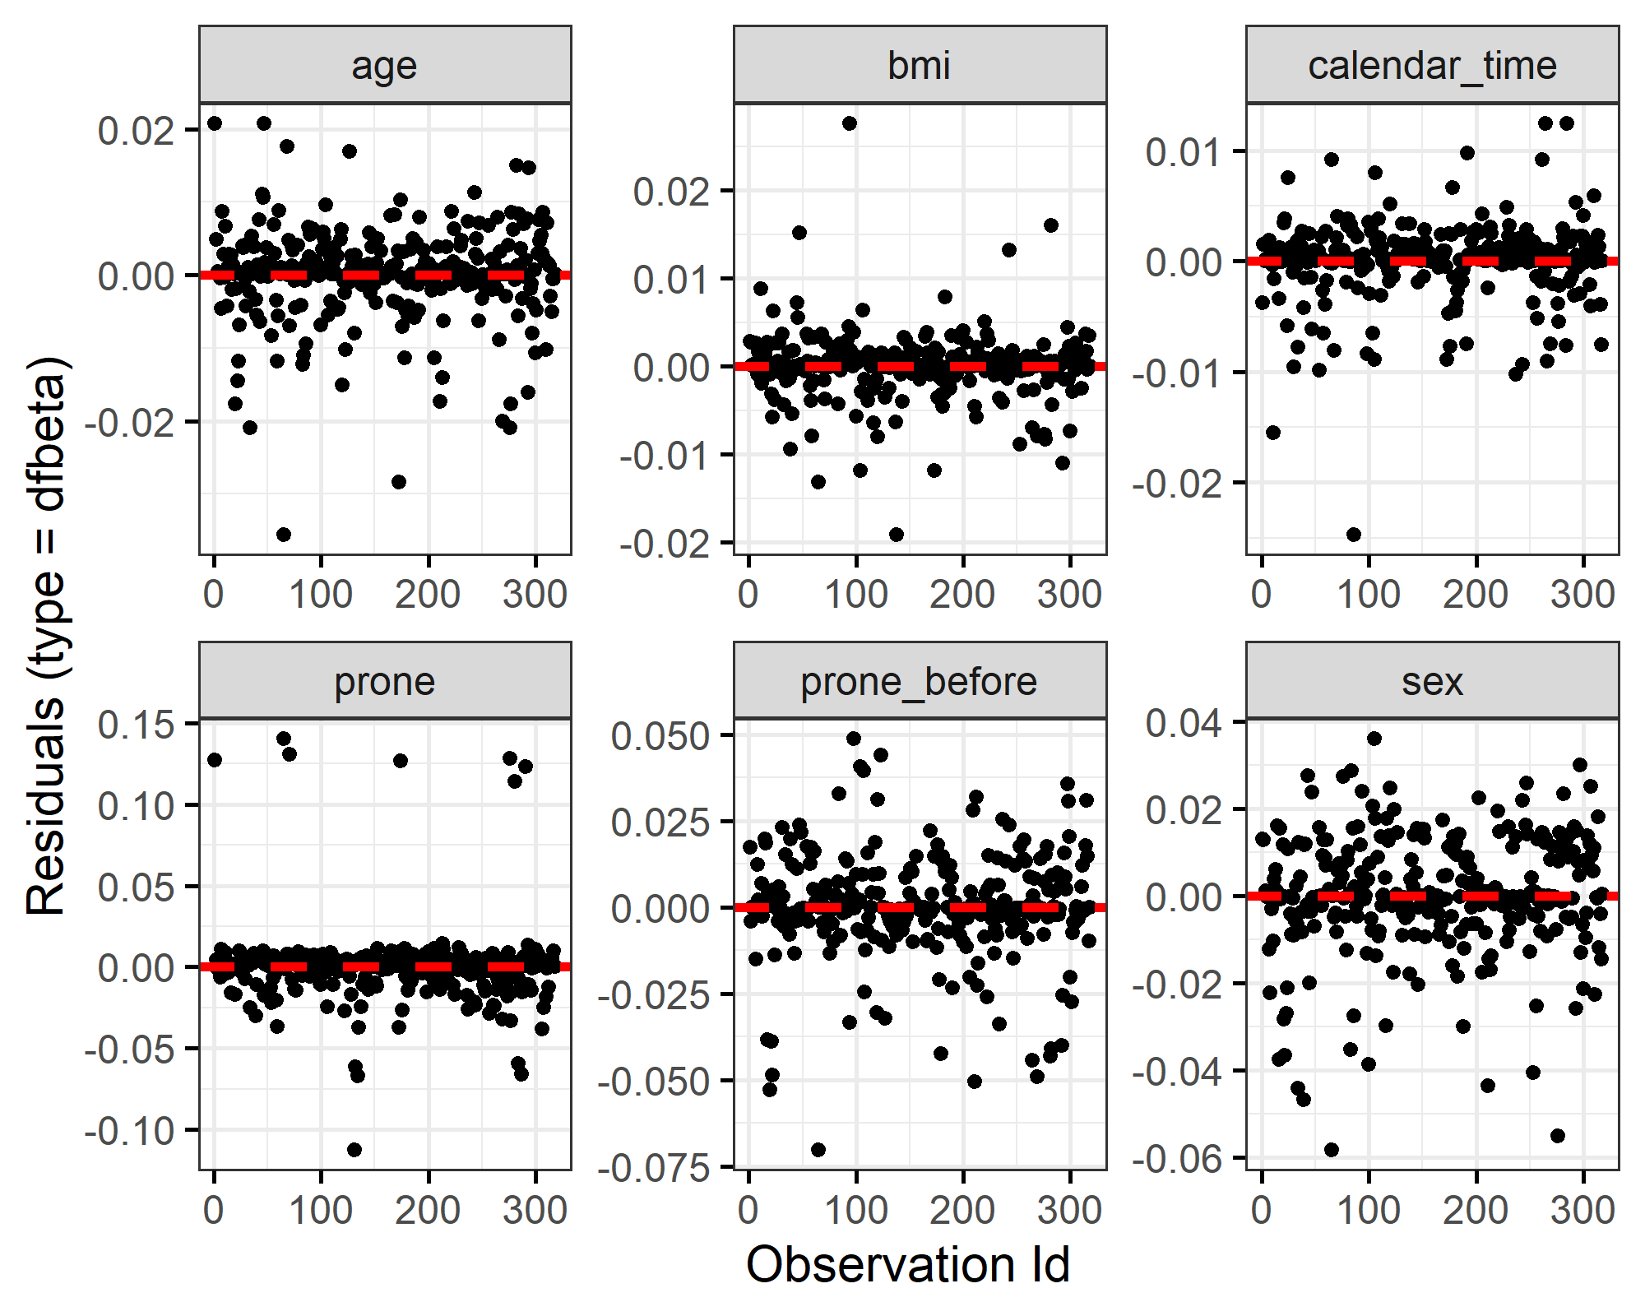
There are some influential patients for prone for the model examining deaths, although the size is relatively small at around 0.1, meaning the estimated reduced risk of death would be larger without these patients. For comparison the estimate for prone with all the data is -0.14.
site | sex | age | bmi | prone | days | censored
36 | Male | 74 | 27.8 | Yes | 5 | No
44 | Female | 28 | 27.5 | Yes | 2 | No
1 | Male | 47 | 28.7 | Yes | 2 | No
30 | Male | 62 | 30.1 | Yes | 83 | Yes
68 | Male | 63 | 30.0 | Yes | 6 | No
59 | Female | 38 | 30.0 | Yes | 1 | No
59 | Male | 53 | 30.4 | Yes | 25 | No
48 | Male | 53 | 30.0 | Yes | 17 | No
These are all patients in the prone position who died in relatively short times (“days” column).

Check of proportional hazards assumption for Cox models
Table: Check of proportional hazards assumption for Cox models
outcome | Variable | Chi-squared | DF | p
Discharge | sex | 1.08 | 1 | 0.29801
 | age | 8.04 | 1 | 0.00457
 | calendar_time | 0.08 | 1 | 0.77453
 | bmi | 0.42 | 1 | 0.51784
 | prone | 0.66 | 1 | 0.41572
 | prone_before | 0.01 | 1 | 0.94204
 | GLOBAL | 12.85 | 6 | 0.04548
Death | bmi | 0.98 | 1 | 0.32267
 | age | 0.84 | 1 | 0.35902
 | sex | 0.88 | 1 | 0.34956
 | calendar_time | 0.73 | 1 | 0.39342
 | prone | 0.81 | 1 | 0.36871
 | prone_before | 0.05 | 1 | 0.82333
 | GLOBAL | 4.97 | 6 | 0.54783
The table above shows no clear concern about the proportional hazards assumption using a Cox model. The only variable with some non-proportional hazards is the effect of age on discharge.

Leave one country out sensitivity analysis
Here we leave one country out in turn and check that the estimates for prone remain similar. The reasoning is to check that the findings for prone are not reliant on one country. We use the Cox survival models.
Figure: Hazard ratios and 95% confidence intervals for death and discharge after leaving out each country
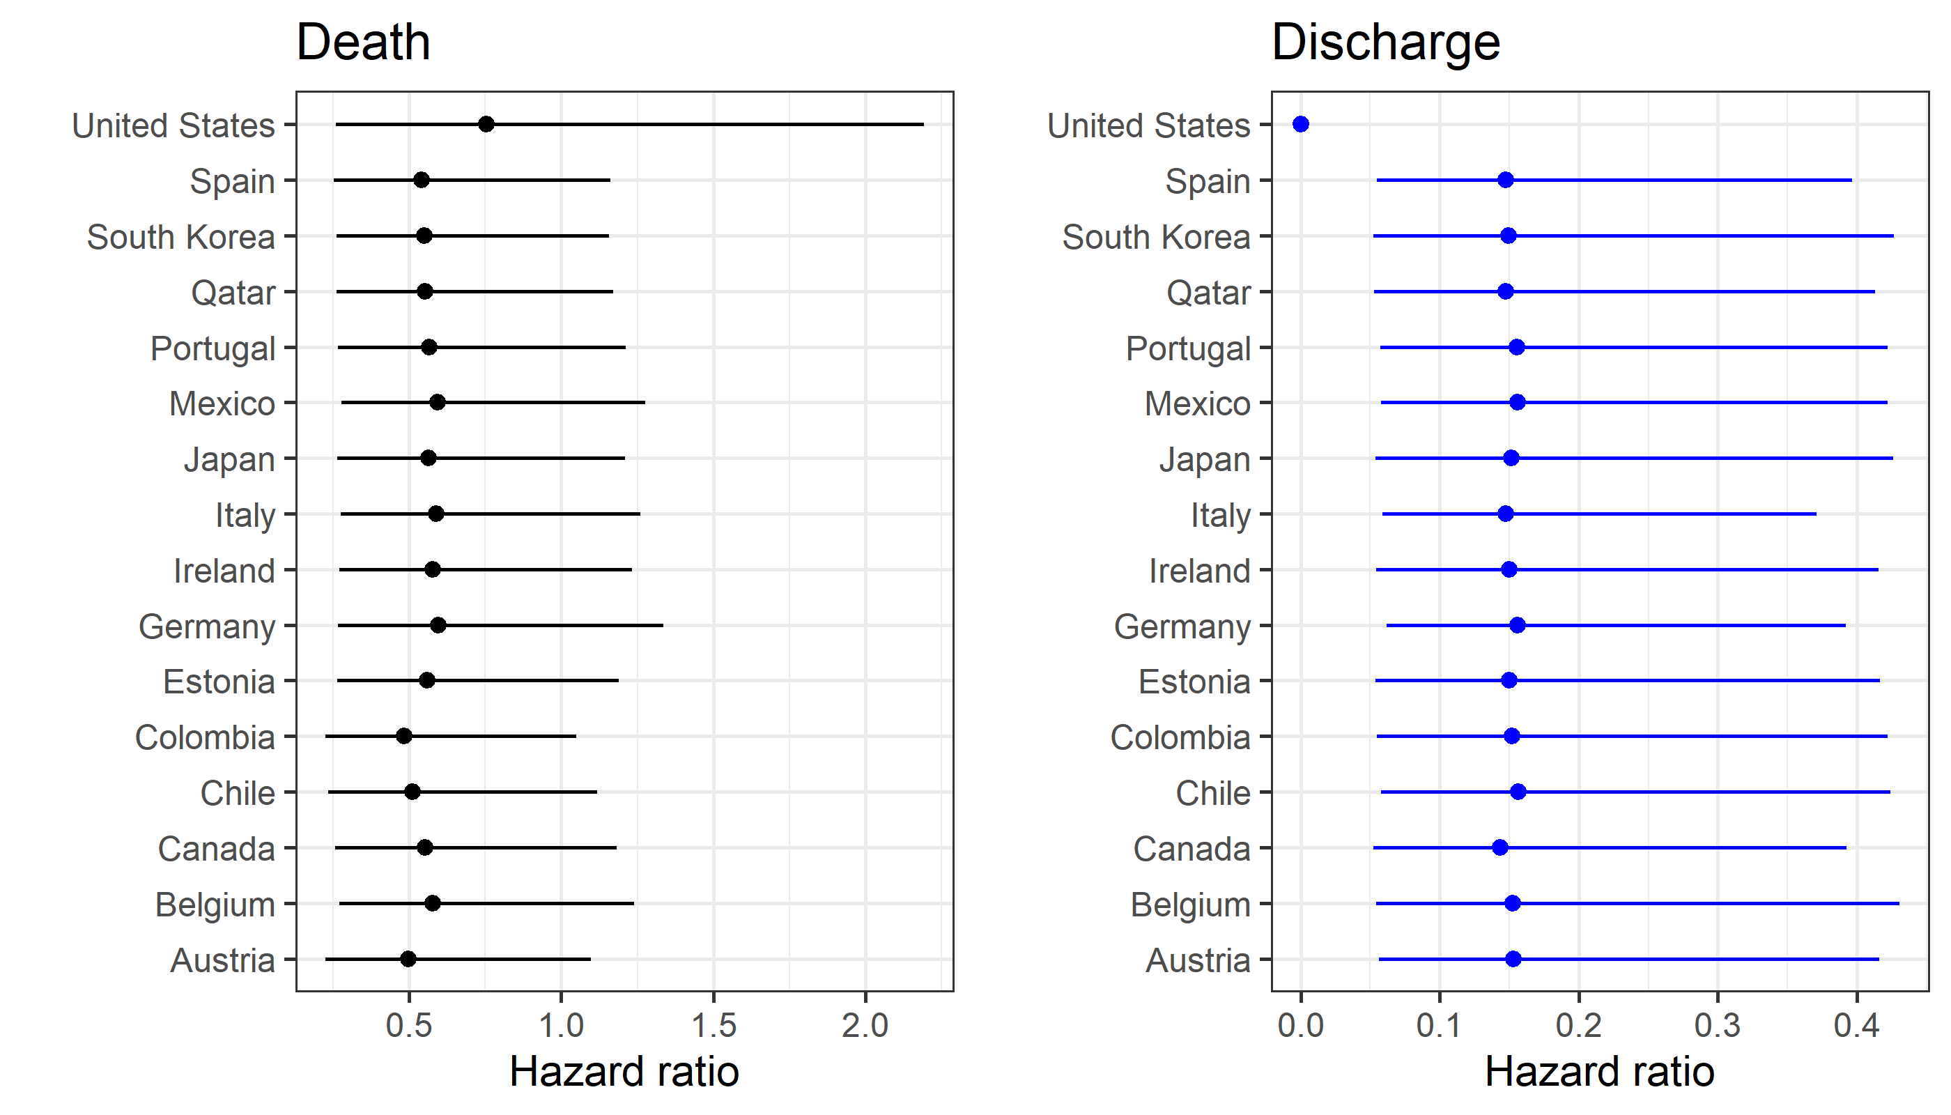
The plot shows the mean hazard ratio (dot) and 95% confidence interval. The estimates change when the USA is left out. This is because the one very influential patient is from the USA.

Convergence of Bayesian models
Here we visually check the convergence of the estimates for the Bayesian survival models. We plot the intercept (int), regression parameters (beta 1 to 5), and Weibull shape parameter (r).
Figure: Markov Chain Monte Carlo estimates for the Weibull survival model of death
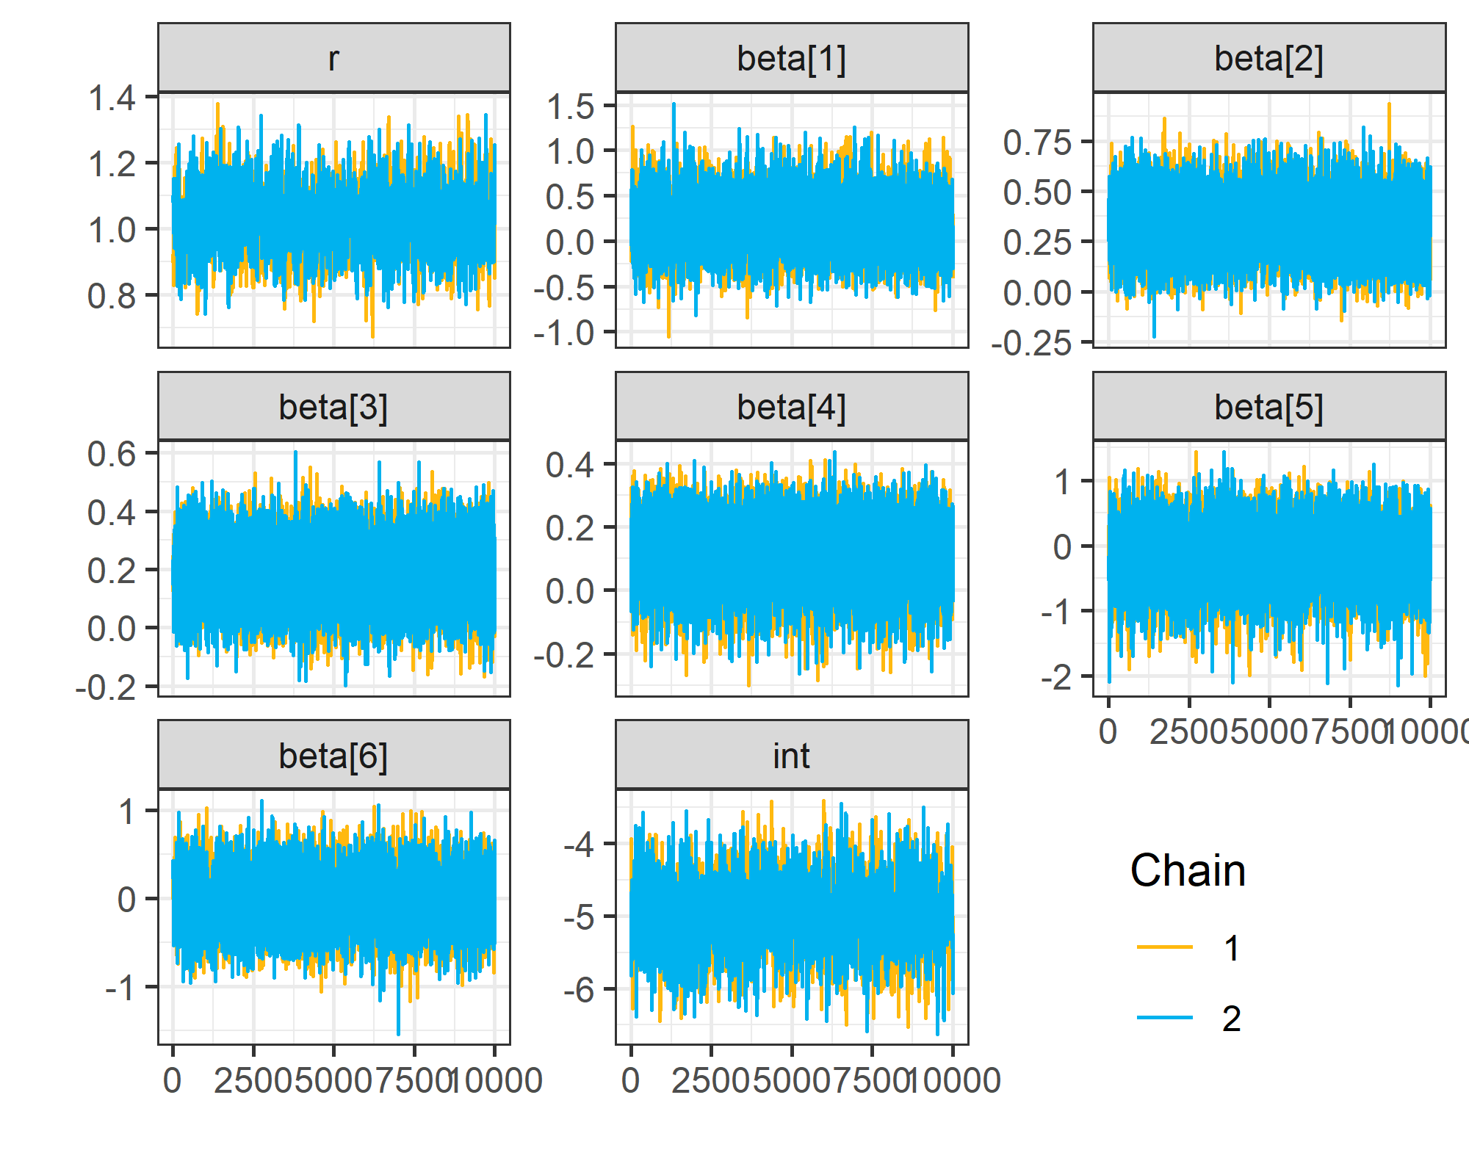
[1] "Figure 5.j: Markov Chain Monte Carlo estimates for the Weibull survival model of discharge"
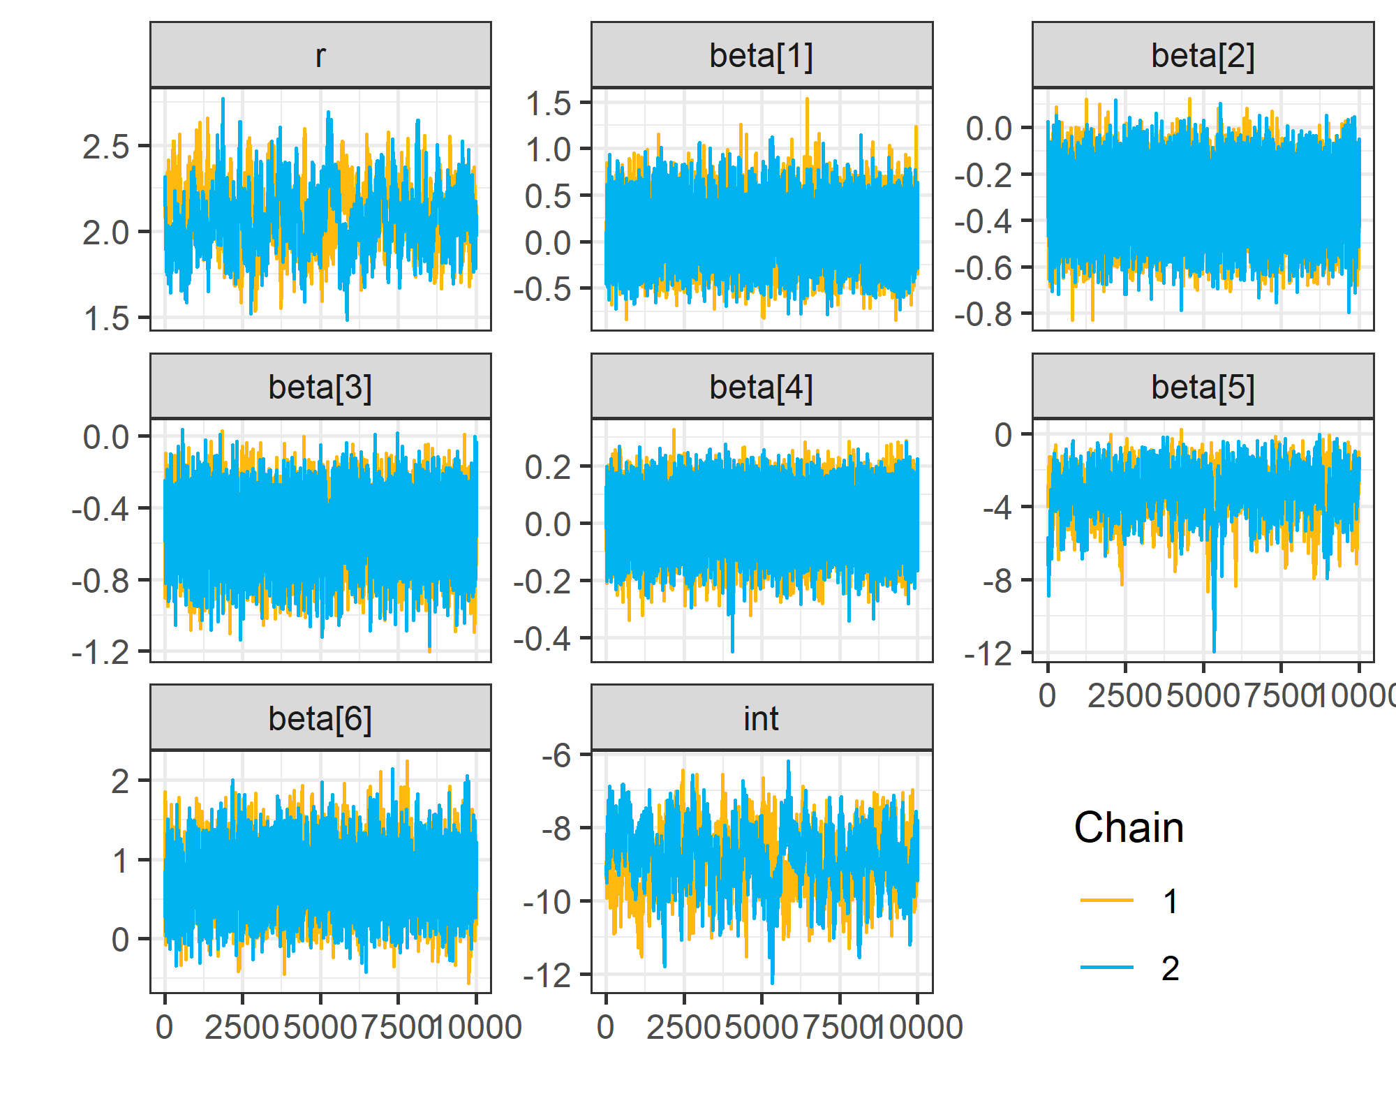

R version and packages used
This information is given for reproducibility purposes.
R version 4.0.3 (2020-10-10)
Platform: x86_64-w64-mingw32/x64 (64-bit)
Running under: Windows 10 x64 (build 18363)
Matrix products: default
locale:
[1] LC_COLLATE=English_Australia.1252 LC_CTYPE=English_Australia.1252 LC_MONETARY=English_Australia.1252 LC_NUMERIC=C LC_TIME=English_Australia.1252
attached base packages:
[1] stats graphics grDevices utils datasets methods base
other attached packages:
[1] gridExtra_2.3 survminer_0.4.8 ggpubr_0.4.0 ggplot2_3.3.2 cmprsk_2.2-10 broom_0.7.3 R2WinBUGS_2.1-21 boot_1.3-25 coda_0.19-3 lme4_1.1-23 Matrix_1.2-18 flextable_0.5.11 stringr_1.4.0 mstate_0.2.12 survival_3.2-7 dplyr_1.0.4 diagram_1.6.4 shape_1.4.5 captioner_2.2.3.9000
loaded via a namespace (and not attached):
[1] nlme_3.1-149 RColorBrewer_1.1-2 tools_4.0.3 backports_1.1.10 R6_2.4.1 mgcv_1.8-33 DBI_1.1.0 colorspace_1.4-1 withr_2.3.0 tidyselect_1.1.0 curl_4.3 compiler_4.0.3 cli_2.0.2 xml2_1.3.2 officer_0.3.14 labeling_0.3 scales_1.1.1 survMisc_0.5.5 systemfonts_0.3.1 digest_0.6.25 foreign_0.8-80 minqa_1.2.4 rmarkdown_2.5 rio_0.5.16 base64enc_0.1-3 pkgconfig_2.0.3 htmltools_0.5.0 rlang_0.4.10 readxl_1.3.1 farver_2.0.3 generics_0.0.2 zoo_1.8-8 zip_2.1.1 car_3.0-10 magrittr_2.0.1 Rcpp_1.0.5 munsell_0.5.0 fansi_0.4.1 abind_1.4-5 gdtools_0.2.2 lifecycle_0.2.0 stringi_1.5.3 yaml_2.2.1 carData_3.0-4 MASS_7.3-53 plyr_1.8.6 grid_4.0.3 blob_1.2.1 forcats_0.5.0 crayon_1.3.4 lattice_0.20-41 haven_2.3.1
[53] splines_4.0.3 hms_0.5.3 knitr_1.30 pillar_1.4.6 uuid_0.1-4 ggsignif_0.6.0 reshape2_1.4.4 glue_1.4.2 evaluate_0.14 data.table_1.13.0 vctrs_0.3.6 nloptr_1.2.2.2 cellranger_1.1.0 gtable_0.3.0 purrr_0.3.4 tidyr_1.1.2 km.ci_0.5-2 assertthat_0.2.1 cpp11_0.2.1 xfun_0.21 openxlsx_4.2.2 xtable_1.8-4 rstatix_0.6.0 tibble_3.0.3 KMsurv_0.1-5 statmod_1.4.34 ellipsis_0.3.1

Additional Reference for the supplement

Royston, P., Altman, D.G. External validation of a Cox prognostic model: principles and methods. BMC Med Res Methodol 13, 33 (2013). https://doi.org/10.1186/1471-2288-13-33

