Early use of Airway Pressure Release Ventilation (APRV) in Acute Respiratory Distress Syndrome.

Protocol Version 1.0 (May 15th, 2017)
Protocol version 2.0 (October 15th, 2018)

-Miguel Á. Ibarra-Estrada. Intensive Care Unit, Hospital Civil Fray Antonio Alcalde. Guadalajara, Jalisco.
-Yessica García Salas. Intensive Care Unit, Hospital Civil Fray Antonio Alcalde. Guadalajara, Jalisco.
-Quetzalcóatl Chávez-Peña. Intensive Care Unit, Hospital Civil Fray Antonio Alcalde. Guadalajara, Jalisco. Centro Universitario de Ciencias de la Salud, Universidad de Guadalajara, Jalisco.
-José A. López-Pulgarín. Intensive Care Unit, Hospital Civil “Fray Antonio Alcalde”. Guadalajara, Jalisco. Centro Universitario de Ciencias de la Salud, Universidad de Guadalajara, Jalisco.
-Julio C. Mijangos-Mendez. Intensive Care Unit, Hospital Civil Fray Antonio Alcalde. Guadalajara, Jalisco.
-Guadalupe Aguirre-Avalos. Intensive Care Unit, Hospital Civil “Fray Antonio Alcalde”. Guadalajara, Jalisco. Centro Universitario de Ciencias de la Salud, Universidad de Guadalajara, Jalisco.

BACKGROUND

Despite advances in ventilatory and non-ventilatory therapies, mortality of acute respiratory distress syndrome is around 40% (1). So far, the best interventions for improving mortality is low tidal volume ventilation (LTV) (2) and prone positioning in selected patients (3). The reasoning of these strategies is the progressive opening of alveolar units, while limiting tidal volumes and potentially damaging high pressures. This lung protective approach is also associated to an increased requirement of analgesic, sedation and neuromuscular blockers, which results in increased risk of adverse effects and morbidity. (4).
Airway pressure release ventilation (APRV), was described more than 30 years ago. It consists of a pressure controlled long inspiratory phase, with intermittent short expiration periods for releasing pressure. (5). It allows spontaneous respiratory efforts, with the potential benefits of recruiting more dependent alveolar units, without the need of higher airway pressure (6). There is clinical evidence in humans suggesting benefits of APRV, for example: oxygenation improvement with lower mean airway pressures, lower dose requirement of sedation, neuromuscular blockers (NMB) and vasopressors, increases in glomerular filtration rate, cardiac output, and shorter length of mechanical ventilation (7, 8, 9, 10, 11). However, most studies are non-controlled, retrospective, and the major pitfall, is that APRV was not compared against the standard LTV ventilation. Until now, the only and largest (n= 63) randomized clinical trial which compared APRV vs LTV, included only trauma patients, and it was underpowered to find significant differences in relevant outcomes.
The aim of this study is to address if the early application of APRV could improve clinical outcomes in patients with ARDS.

OBJECTIVES
Primary Objective
Mechanical ventilation free days [Time Frame: 28 days]

Secondary objectives
The secondary outcomes will be:

- All causes mortality [Time Frame: 28 days]
- ICU length of stay [Time Frame: 28 days]
- Mean airway pressure, peak airway pressure, maximum P high, PEEP/Auto-PEEP, plateau pressure, tidal volume, compliance, respiratory rate, termination of peak expiratory flow rate (%), expiratory time, minute ventilation. [Time Frame: 7 days]
- Oxygen partial pressure (pO2) [Time Frame: 7 days]
- Carbon dioxide partial pressure (pCO2) [Time Frame: 7 days]
- Rate of severe hypercapnia [Time Frame: 7 days]
- Mean arterial pressure [Time Frame: 7 days]
- Maximum dosage of vasopressors requirement [Time Frame: 7 days]
- Richmond Sedation-Agitation Scale [Time Frame: 7 days]
- Average dose of propofol [Time Frame: 7 days]
- Rate of neuromuscular blocker use [Time Frame: 7 days]
- Prone positioning (days, number of sessions and hours/day) [Time Frame: 7 days]
- Rate of recruitment maneuvers [Time Frame: 7 days]
- Tracheostomy rate [Time Frame: 28 days]

METHODS
This is a single-center, parallel, superiority, open label, randomized controlled trial. It will be approved by the Institutional Review Board of Hospital Civil Fray Antonio Alcalde. And informed consent will be obtained from all patients.

Inclusion criteria
- Acute respiratory distress syndrome, according to the Berlin definition of ARDS, with pO₂/FiO₂ <300 (adjusted for altitude), and less than 48 h of endotracheal mechanical ventilation.
Exclusion criteria
- More than 48 h of endotracheal mechanical ventilation.
- Pregnancy
- Less than 18 years-old
- Expected duration of mechanical ventilation less than 48 h
- Preexisting conditions with an expected 3-month mortality exceeding 50%
- Concurrent chemotherapy
- Confirmed intracranial hypertension
- Catastrophic cranial trauma or neuromuscular disorders that are known to prolong mechanical ventilation
- Pneumothorax at enrollment (resolved or not)
- Do-not-resuscitate order
- Refusal of decision makers for participation in the study
- Loss to follow-up

Recruitment
All patients admitted with diagnostic of ARDS to intensive care unit at will be approached to participate by on-site critical care physician.
Height measurement will be obtained for calculation of predicted body weight (PBW) according to the formula:
PBW (kg) males = 50 + 0,91 (height [cm] - 152,4)
PBW (kg) females = 45,5 + 0,91 (height [cm] - 152,4)

All patients must complete a ‘stabilization’ period of at least 12 hours of protective LTV ventilation before randomization, with volume-controlled mode, tidal volume (TV) 6-8 ml/kg PBW, positive end-expiratory pressure (PEEP) >5 cmH₂O and plateau pressure <30 cmH₂O.
In case of absence of exclusion criteria, written informed consent will be obtained from decision makers, and patients will be randomly assigned to APRV or LTV ventilation arm.

Procedures
Evita® V300 (Dräger) ventilator, with built-in APRV mode will be used for mechanical ventilation in both groups,
The oxygenation goals for both arms will be pO₂ 55-80 mmHg and/or capillary saturation 88-95%, with pH 7.30-7.45. Recording of daily mechanical ventilation and oxygenation values for the first 7 days will be performed 4 hours after supine sessions in case of receiving prone positioning therapy. Prone positioning will be a standard of management in all patients with P/F ratio <150, a FiO₂ ≥60% and peep ≥ 5 cm H₂O, according to PROSEVA protocol.

Mechanical Ventilation in LTV arm (Appendix 1)
Titration of PEEP and FiO₂ will be performed as suggested by ARDSnet, in volume controlled ventilation mode (VCV), with preference for the higher PEEP/lower FiO₂ table:

Lower PEEP/higher FiO2
FiO₂ | 0.3 | 0.4 | 0.4 | 0.5 | 0.5 | 0.6 | 0.7 | 0.7 | 0.7 | 0.8 | 0.9 | 0.9 | 0.9 | 1.0
PEEP | 5 | 5 | 8 | 8 | 10 | 10 | 10 | 12 | 14 | 14 | 14 | 16 | 18 | 18-24

Higher PEEP/lower FiO2
FiO₂ | 0.3 | 0.4 | 0.4 | 0.5 | 0.5 | 0.6 | 0.7 | 0.7 | 0.7 | 0.8 | 0.9 | 0.9 | 0.9 | 1.0
PEEP | 5 | 8 | 10 | 12 | 14 | 14 | 16 | 16 | 18 | 20 | 22 | 22 | 22 | 22<

Tidal volume and respiratory rate (RR) will be adjusted to maintain plateau pressure (Pplat) and pH within target limits. The plateau pressure limit will be ≤30 cm H₂O. It must be measured on an inspiratory pause maneuver of 0.5 seconds, without respiratory effort, and will be evaluated after any change in clinical condition or ventilatory adjustment, and at least four times each day. Capillary saturation of oxygen (SpO₂) will be continuously monitored, and arterial blood gas analysis will be taken at least once a day.
If Pplat increases to >30 cm H₂O, TV will be decreased by 1 ml/kg (to a minimum of 4 ml/kg), while increasing RR to maintain previous minute ventilation if necessary (risk of respiratory acidosis worsening). In case of severe respiratory acidosis (pH <7.15) with RR at the maximum allowed limit (35 bpm), TV may be increased in 1ml/kg steps until pH >7.15, while Pplat target limit can be exceeded. If pH persists <7.15 after these adjustments, administration of sodium bicarbonate can be considered.
If oxygenation goals are not reached, active recruitment maneuvers of sustained inflation (40 cmH₂O of positive pressure for 40 seconds) are allowed at the discretion of attending intensivist, and it will be recorded. If hypoxemia persists after all these measures, group cross-over may be considered.
In case of significant asynchrony, TV may be increased in 1ml/kg steps to a maximum of 8 ml/kg, as long as Pplat is <30 cm H₂O. If asynchrony persists after optimization of other ventilatory settings according to the identification of specific asynchrony (flow, inspiratory/expiratory time, trigger), dosage of sedatives can be increased and even NMB can be considered. Otherwise, the use of NMB is not mandatory. An expiratory pause maneuver will be performed daily at the time of recordings to rule-out intrinsic PEEP.

Mechanical Ventilation in APRV arm (Appendix 2)

For APRV, oxygenation goals will be the same at LTV arm.

Initial settings:
-High pressure (P-High): it will be set at the same Pplat measured on an inspiratory pause in previous volume-controlled mode. The maximum Phigh allowed will be 30 cm H₂O
-Low pressure (P-Low): 0 cm H₂O
-Inspiratory time (T-High): 4 to 6 seconds (sec)
-Expiratory time (T-Low): it will be set at 0.4-0.6 sec, but immediately must be adjusted upon analysis of flow-time curve at expiration. The most sensitive variable for titration of Tlow is the termination of peak expiratory flow rate (T-PEFR), which is the maximum percentage of peak flow (%) measured just before initiation of the next inspiration. This T-PEFR should be maintained between 50- 75%. With preference to 75% to avoid derecruitment. (see the image)

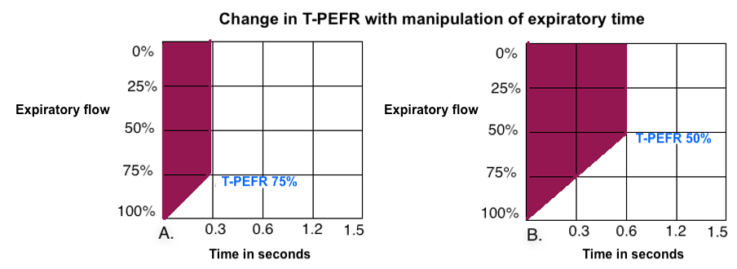

Required T-Low could be fluctuating, as it depends on current respiratory system mechanics, therefore, it must be monitored continuously and the goal is always the T-PEFR at 75%, not a specific number in seconds. A T-PEFR <50% is associated with an excessive air release, loss of alveolar stability and atelectrauma; and >75% leads to an excess in air entrapment with CO₂ retention, risk of overdistention and barotrauma (12). The measurement of T-PEFR will be performed after any change in clinical condition or ventilatory adjustment, and at least four times each day. Although mechanical ventilators have the option of automated setting of T-PEFR, expiratory time must be adjusted manually after analysis of expiratory flow curve.
An expiratory pause maneuver will be performed daily at the time of recordings to measure total-PEEP. This total PEEP and simultaneous measured TV were used for calculation of static compliance.
FiO₂ will be set in the same way as the LTV arm; it could be set at 100% initially, but with immediate lowering to minimal required levels to maintain oxygenation goals.
The percentage of spontaneous minute ventilation will be maintained between 30% and 60% in patients with P/F index >150 and P-High ≤24 cmH₂O. In case of P/F index <150, specially during the first days when P-High is usually higher, this percentage should be at <30%. This measure was adopted due to preliminary data of transpulmonary pressure measurement with esophageal balloon in 8 patients on APRV, where we found that excessive spontaneous efforts, elicit an inspiratory transpulmonary pressure >25 cmH₂O intermittently when Phigh was above 24 cmH₂O.
These settings will be performed always trying to keep the expiratory tidal volume as low as possible.
An arterial blood gas analysis will be mandatory 30 minutes after initiation of APRV, to early detection of hypercapnia, as this mode is associated with acute retention in pCO₂ when experience is limited.
If patients develop acute hypoxemia, defined as pPaO2 <55 mmHg or SpO₂ <88%, the FiO2 must be increased transiently as needed, but with immediate adjustments to optimize recruitment, as follows:
-Decreasing T-Low by 0.1 sec steps until T-PEFR is at maximum allowed 75%. This will increase the end-expiratory lung volume (EELV).
-Optimizing gas exchange surface by increasing mean airway pressure, there are three options in order of preference:
1.- Increase P-High by 1-2 cmH₂O steps every 10-15 min until a maximum of 30 cmH₂O. (This is intended to recruit alveolar units with higher threshold opening pressures)
2.- Increase T-High by 1-2 sec steps. (This is intended to open alveolar units with longer time constant for recruitment)
3.- Increase both P-High and T-High
It must be noted that these measures could be associated with CO₂ retention and even acute hemodynamic instability. Therefore, close monitoring and control ABG analysis is mandatory.
If oxygenation goals are not reached despite these adjustments, active recruitment maneuvers of sustained inflation (40 cmH₂O of positive pressure for 40 seconds) are allowed at the discretion of attending intensivist, and it will be recorded. If hypoxemia persists after all these measures, group cross-over may be considered.
In case of acute hypercapnia, defined as pCO₂ > 55 mmHg and pH <7.30, the following adjustments are suggested:
-If oxygen goals are reached, T-High can be decreased by 1-2 sec steps, as this will lead to increased mandatory RR and minute ventilation. T-Low can be increased by 0.1 sec steps, until a minimum allowed T-PERF is reached at 50% (this will also increase minute ventilation through optimization of time for CO₂ diffusion). It is worth to note, that lowering T-High could lead to de-recruitment of alveolar units with longer time constant, therefore, this is not the preferred adjustment if oxygenation goals are not reached.
-If oxygenation goals are not reached, the preferable method is increasing P-High to a maximum of 30 cmH₂O. This will increase minute ventilation through recruitment and increase of tidal volume.
If hypercapnia persists after all these measures, but pH is >7.15, permissive hypercapnia will be allowed with no upper limit in pCO₂, however, in case of pH <7.15, group cross-over is suggested.

Prone positioning
Prone positioning (PP) will be a standard in all patients with at least 12 hours of protective mechanical ventilation, with TV at 6-8 ml/kg PBW, a FiO2 ≥60% and PEEP ≥5 cmH2O, and with persistent P/F ratio <150. Thus, the decision regarding PP therapy initiation must be established at time of randomization. The length of PP sessions will be at least of 16 h/day.
If a patient was not deemed for PP therapy at randomization, but develops new onset clinical deterioration later, PP will be performed if the same clinical criteria are met in patients randomized to LTV group; and for patients on APRV group, the criteria for initiating PP will be: P/F ratio <150, FiO₂ ≥60% and P-High ≥18 cmH₂O.
The criteria for stopping PP therapy will be the development of complications, i.e.: extubation, displacement of endotracheal tube (ET) to mainstem bronchus, ET obstruction, hemoptysis, SpO₂ <85% or pO₂ <55 mmHg for >5 min despite FiO2 at 100%, bradycardia <30 bpm for >1 minute, mean arterial pressure <60 mmHg for >5 minutes, cardiac arrest.
The stopping criteria due to clinical improvement in patients in the LTV will be: 1) P/F ratio >150 (at least 4 h after last prone session), PEEP ≤10 cmH₂O and FiO2 ≤ 60%. And for the APRV group, PP will be held if three of the following four criteria are met, with A and B being mandatory:
- P/F ratio >150 (at least 4 h after last prone session).
- P-High ≤18 cmH₂O and FiO₂ ≤ 40 %.
- Mean airway pressure ≤16 cmH₂0
- Oxygenation index ≤ 10

Recruitment maneuvers
As previously described, in case of refractory hypoxemia, or derecruitment associated to respiratory circuit disconnection, recruitment maneuvers (RM) will be allowed at on-site intensivist discretion, preferably with sustained inflation method (40 cmH₂O of positive pressure for 40 seconds).

Analgesia and sedation
We will use the CPOT (Critical-Care Pain Observational Tool) to address level of analgesia, with the goal of a score at 0-2 points.
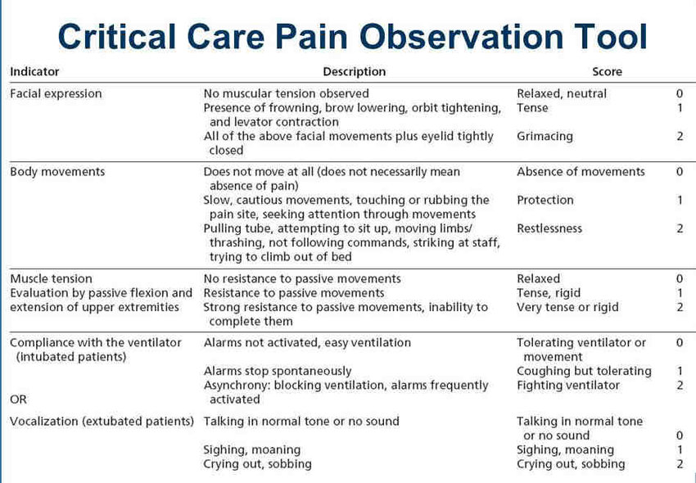

The goal of sedation will be a RASS (Richmond Agitation Sedation Scale) score between -3 and 0.

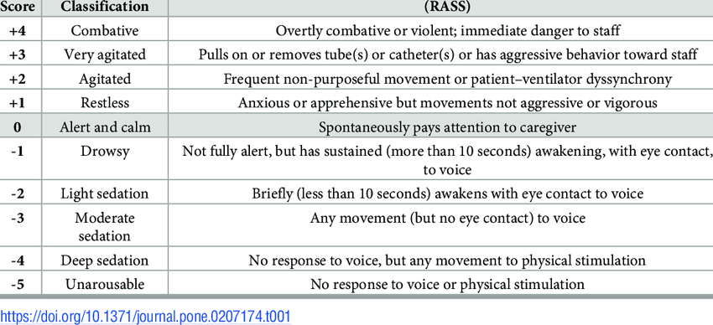

The goals for analgesia and sedation will be the same for both groups, however, these can be adjusted according to clinical criteria (i.e.: excessive respiratory efforts, severe asynchronies, delirium, agitation).

Neuromuscular Blocking

Neuromuscular blocking will not be mandatory, but it will be indicated in case of Pplat >30 cmH₂O, observable excess in spontaneous respiratory efforts, or severe asynchronies that do not correct after ventilatory adjustments. With the aim of not exceeding 48 hours after ICU admission.

Deep Vein thrombosis screening

Screening ultrasound for deep vein thrombosis will be performed in all patients every 3-5 days until death or discharge. Pulmonary CT angiography will be performed in patients with suspected pulmonary embolism according to clinical and POCUS findings.

Mechanical Ventilation Weaning

Patients in LTV arm
Respiratory stabilization will be defined as a maintenance of oxygenation goals without previous increase in ventilatory support in the last 8 hours, and at least 4 h after supine positioning in patients on PP, in which case PEEP may be decreased by 1- 2 cm H₂O steps, and adjusting FiO₂ according to the selected PEEP/FiO₂ table. Attempts to progressive lowering in support will be performed at least every 8 h as long as respiratory stabilization is maintained.
Patients will be considered as ready to wean if the following criteria are met:
- No increase in ventilatory support in the last 12 h
- PEEP requirement ≤8 cmH₂O and FiO₂ ≤40%, while P/F ratio is maintained >150
- No requirement of NMB
- RASS score at between -1 to +1 points
- Observable spontaneous efforts (baseline mandatory RR can be lowered by half for evaluation)
- Mean arterial pressure >65 mmHg, with no vasopressor requirement or with minimal (norepinephrine <0.15 mcg/kg/min or equivalent) or decreasing dose.

If all those criteria are met, we will proceed to a cuff-leak test, considering as adequate a leak >20% measured by built-in software on ventilator. In case of failed test, a short course of IV methylprednisolone will be administered (20 mg every 4 hours for three doses) before spontaneous breathing trial (SBT). If cuff-leak test is successful, a 30-min SBT will be performed with CPAP/PSV mode (PEEP ≤8 cmH₂O, PS 8 cmH₂O). In absence of respiratory failure criteria (RR >30, rapid shallow breathing index >75, SpO₂ <88%, increase in MAP >20% compared to baseline) and presence of adequate level of consciousness, extubation will be done immediately.
In case of SBT failure, prior ventilatory settings will be reassumed and light sedation if necessary, while addressing the cause of failure. (Appendix 3)

Patients in APRV arm
Respiratory stabilization will be defined as a maintenance of oxygenation goals without previous increase in ventilatory support in the last 8 hours, and at least 4 h after supine positioning in patients on PP, in which case the “drop and stretch” approach will be used. This is performed by lowering of P-High at 1-2 cmH2O steps AND increasing T-High by 0.5-1 sec steps simultaneously. It is important to note that these steps would lead to a decrease in mandatory minute ventilation, therefore, the level of sedation must be lighter at this point, so that spontaneous efforts compensate for this change. Attempts of this progressive lowering in support will be performed at least every 8 h as long as respiratory stabilization is maintained.
Patients will be considered as ready to wean if 3 of the following 4 criteria are met, with A and B being mandatory:
- P-High ≤12 cmH2O and FiO2 <40%; T-High ≥10 sec, or inspiratory time accounting for 90% of the complete respiratory cycle.
- P/F ratio ≥150
- Mean airway pressure ≤10 cmH2O
- Oxygenation index ≤5

If these criteria are met, we will proceed to a cuff-leak test, considering as adequate a leak >20% measured by built-in software on ventilator. In case of failed test, a short course of IV methylprednisolone will be administered (20 mg every 4 hours for three doses) before spontaneous breathing trial (SBT). If cuff-leak test is successful, a 30-min SBT will be performed with CPAP/PSV mode (PEEP ≤8 cmH₂O, PS 8 cmH₂O). In absence of respiratory failure criteria (RR >30, rapid shallow breathing index >75, SpO₂ <88%, increase in MAP >20% compared to baseline) and presence of adequate level of consciousness, extubation will be done immediately.
In case of SBT failure, prior ventilatory settings will be reassumed and light sedation if necessary, while addressing the cause of failure. (Appendix 3)

Randomization and data monitoring

Patients will be randomly allocated to either LTV or APRV group at 1:1 ratio. Such randomization will be performed by permuted blocks with length of 4; numbers will be generated by computer and patients will be sequentially numbered. Investigators assistants will recruit patients, will assign allocation groups, and will obtain informed consent from participants.

Blinding

Due to logistic reasons and the nature of the intervention, only investigators and data analysts will be blinded.

Management of data

A steering local committee will monitor the trial, with assessment of inputs to database for consistence and the presence of missing data. Study coordinators will verify accuracy of database inputs. On-site investigators are responsible for adherence to the protocol, and filling paper and electronic case-report forms. All investigators will be blinded regarding patient allocation and outcome measures until database unlock. All personal data will be coded and de- identified, and paper CRF will be stored for at least 5 years into locked cabinets at research center.
This trial is expected to initiate on July 1st , 2017 and completion is estimated in November 30th, 2025. As this study includes only hospitalized patients, lost to follow-up is not expected, however, all analysis will be performed on an intention-to-treat basis in the case of protocol violations or cross-over between groups.
Data monitoring committee will be composed of all investigators, and they will be responsible for data monitoring at the primary level, whereas the local IRB will monitor the overall conduct of the study.

Adverse effects

Although potential adverse effects are expected to be non-serious (acute hypercapnia, asynchronies), all related adverse effects will be documented for each patient, and all investigators will be notified on a weekly basis. In case of subjective perception of any trend suggesting arm in any of the groups, the monitoring committee will discuss a non-prespecified interim analysis and even termination of the study according to the results.

Statistical details

Sample size

With 12 mechanical ventilation free days as mean at our center (SD ± 8), and assuming a difference in 4 days to be clinically relevant, we calculated at least a total of 65 patients per group, for a beta of 0.2, and alpha of 0.5. Therefore, we plan to recruit 130 patients, accounting for losses to follow up. There is no plan for interim analysis.

Analysis
Categorical variables are presented as numbers and percentages, and comparison between groups will be performed with the chi-square test or the Fisher’s exact test as appropriate. Continuous variables are given as means (±SD) or medians (inter-quartile ranges) and will be compared using the Student’s t test or the Mann-Whitney test, according to Shapiro-Wilk test for distribution. For comparison between variables recorded at multiple time points, ANOVA for repeated measures will be used. The comparison between groups for cumulative probability of survival at 28 days will be performed with Kaplan-Meier analysis and log-rank test. All tests will be performed at two-tails and a p value <0.05 will be considered as significant. All statistical analysis and graphics will be performed with GraphPad Prism for MAC OS (GraphPad Software, San Diego, California, USA)

Ethics approval

This study will initiate immediately after the approval from the institutional review board.

Protocol amendments

One of the investigators (GAA) will be responsible for documentation of the protocol amendments, and for process the approval from the IRB.

Conflict of interests

All authors hereby declare that they not have any conflict of interest

Access to data

Only investigators and IRB audit teem will have access to data.

Dissemination policy

Relevant clinical data obtained in this study will be published in peer-review journals of critical/respiratory care, without disclosing any individual patient data. All the investigators will be authors in those final publications. Patient level data, could be shared to abroad investigators on a reasonable request, after data sharing agreement is granted from the local IRB. Sharing of statistical code is not planed.

References:

1.- Lopez Saubidet I, Maskin LP, Rodríguez PO, Bonelli I, Setten M, Valentini R. Mortality in patients with respiratory distress syndrome. Med Intensiva. 2016 Aug-Sep;40(6):356-63.
2.- Guérin C, Reignier J, Richard JC, Beuret P, Gacouin A, Boulain T, et al. Prone positioning in severe acute respiratory distress syndrome. N Engl J Med. 2013 Jun
6;368(23):2159-68.
3.- Acute Respiratory Distress Syndrome Network, Brower RG, Matthay MA, Morris A, Schoenfeld D, Thompson BT, Wheeler A. Ventilation with lower tidal volumes as compared with traditional tidal volumes for acute lung injury and the acute respiratory distress syndrome. N Engl J Med. 2000 May 4;342(18):1301-8.
4.- Albert S, Kubiak BD, Vieau CJ, Roy SK, DiRocco J, Gatto LA, et al. Comparison of “open lung” models with lower tidal volumes in a porcine lung injury model. J Surg Res 2011; 166: e71-81.
5.- Downs JB, Stock MC. Airway pressure release ventilation: a new concept in ventilatory support. Crit Care Med 1987;15:459-461
6.- Sydow M, Burchardi H, Ephraim E, et al. Long-term effects of two different ventilatory modes on oxygenation in acute lung injury. Comparison of airway pressure release ventilation and volume- controlled inverse ratio ventilation. Am J Respir Crit Care Med. 1994 Jun;149(6):1550-6.
7.- Jain SV, Kollish-Singule M, Sadowitz B, Dombert L, Satalin J, Andrews P, et al. The 30-year evolution of airway pressure release ventilation. Intensive Care Medicine Experimental 2016; 4:11.
8.- Davis K Jr, Johnson DJ, Branson RD, Campbell RS, Johannigman JA, Porembka D. Airway pressure release ventilation. Arch Surg 1993; 128:1348-1352
9.- Kaplan LJ, Bailey H, Formosa V. Airway pressure release ventilation increases cardiac performance in patients with acute lung injury/adult respiratory distress syndrome. Crit Care 2001; 5:221-226.
10.- Hering R, Peters D, Zinserling J, Wrigge H, von Spiegel T, Putensen C. Effects of spontaneous breathing during airway pressure release ventilation on renal perfusion and function in patients with acute lung injury. Intensive Care Med 2002; 28:1426-1433.
11.- Li JQ, Li N, Han GJ, Pan CG, Zhang YH, Shi XZ, et al. Clinical Research about airway pressure release ventilation for moderate to severe acute respiratory distress syndrome. Eur Rev Med Pharmacol Sci. 2016; 20(12):2634-2641.
12.- Kollisch-Singule M, Emr B, Smith B, Roy S, Jain S, Satalin J, et al. Mechanical Breath Profile of Airway Pressure Release Ventilation: The Effect on Alveolar Recruitment and Microstrain in Acute Lung Injury. JAMA Surg 2014; 149(11): 1138-45.

Appendix 1. Mechanical Ventilation in LTV arm
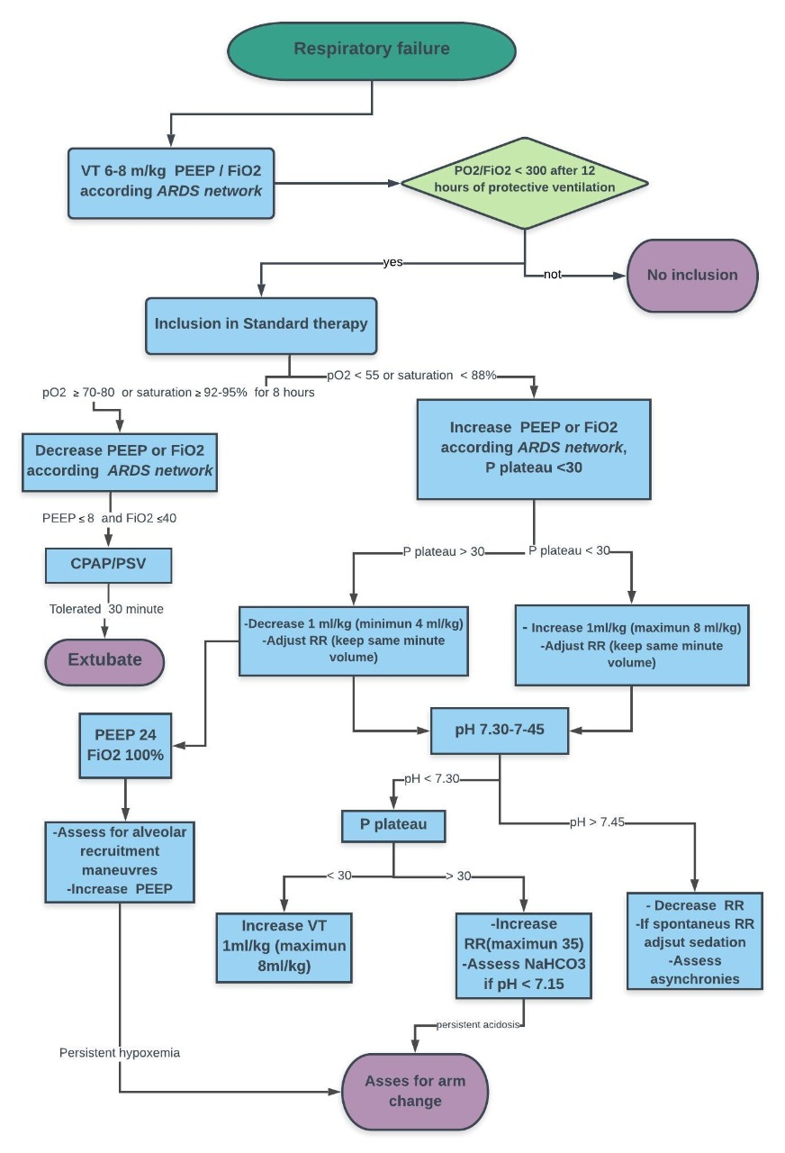

Appendix 2. Mechanical Ventilation in APRV arm

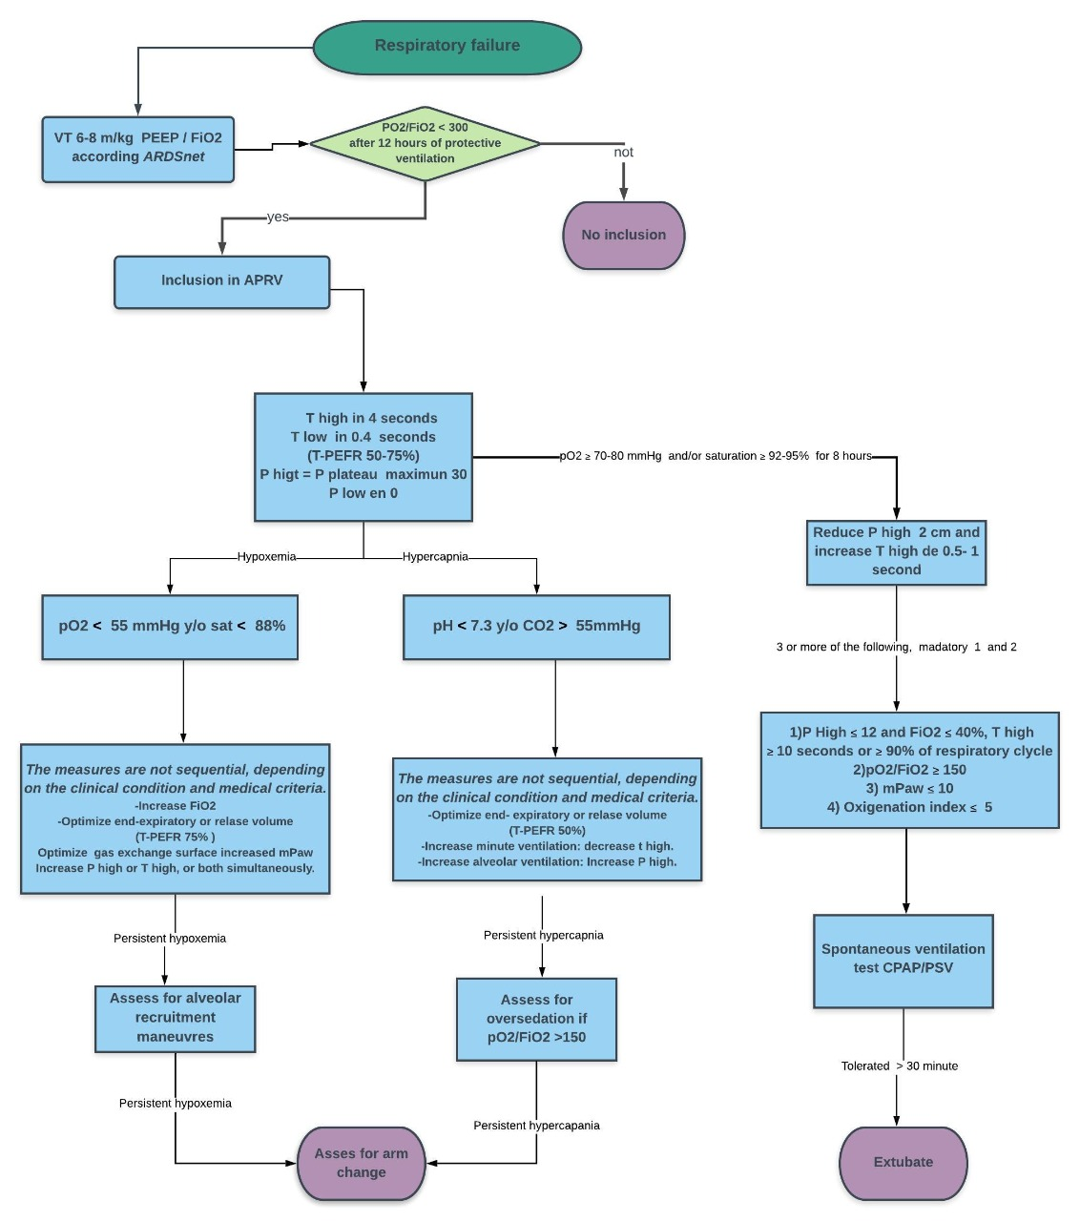

Appendix 3. Weaning of mechanical ventilation for both groups.

