Prone position in COVID-19 and non-COVID-19 acute respiratory distress syndrome: an international multicentre observational comparative study.

Authors
Luigi Camporota^{1,2*}, Barnaby Sanderson^{1*}, Davide Chiumello³, Nicolas Terzi⁴, Laurent Argaud⁵, Thomas Rimmelé⁶, Romain Metuor⁷, Aude Verstraete⁷, Martin Cour⁵, Julien Bohé⁷, Vincent Piriou⁷, Pascal Beuret⁸, Claude Guérin⁵

SUPPLEMENTAL DIGITAL CONTENT

Ethics (IRBO)
Approval for data collection was obtained at each participating institution (Comité d'éthique du CHU de Lyon Number of approval 20-42 – France; Approval n. 10796 – London, and (Comitato Etico Milano Area I; 17263/2020- 2020/ST/095), consent was waived, and data were anonymised before collating into the central database.

Contents
1. Figure E1 Flow chart of patients inclusion in the study 6
2. Relative change in parameters on prone positioning, by COVID-19 status and absolute PaO2/FiO2 response to proning 7
3. Change in PaO₂/FiO₂ ratio from baseline to prone positioning 9
4. Prediction of change in PaO₂/FiO₂ ratio on prone Positioning – OLS Linear Model 10
4.1. Delay from Intubation to Proning 10
4.2. OLS Model 11
4.3. Regression Diagnostics 13

Table E1: Baseline characteristics at the time of intubation, in each etiology cohort.
 | Baseline (Intubation)
Characteristic | Overall,  N = 376 | ARDS,  N = 156 | C-ARDS,  N = 220 | p
Gender, Male | 276 (73%) | 99 (63%) | 177 (80%) | <0.001
Age, yr | 62 [54, 71] | 63 [52, 71] | 62 [56, 70] | 0.5
Predicted Body Weight, kg | 66 [57, 72] | 65 [54, 72] | 69 [60, 73] | 0.006
BMI, kg/m² | 28 [24, 33] | 28 [23, 34] | 28 [25, 32] | 0.2
Admission SOFA | 7 [5, 10] | 9 [7, 12] | 6 [4, 8] | <0.001
Aetiology
COVID-19 | 220 (58.5%) | - | 220 (100%) | -
Pneumonia | 100 (26.6%) | 100 (64.1%) | 0 | -
Aspiration | 11 (2.9%) | 11 (7.1%) | 0 | -
Non-pulmonary sepsis | 45 (12%) | 45 (28.8%) | 0 | -
Respiratory Variables
Respiratory Rate, /min | 22 [18, 25] | 24 [20, 28] | 20 [18, 24.5] | <0.001
Peak Airway Pressure, cmH₂O | 31 [27, 38] | 35 [29, 41] | 30 [26, 35] | <0.001
Plateau Airway Pressure, cmH₂O | 23 [21, 27] | 22.0 [18, 27] | 23 [21, 27] | 0.07
PEEP, cmH₂O | 10 [8, 12] | 10 [7, 12] | 12 [10, 14] | <0.001
Mechanical Power, J/min | 22 [17, 26] | 20 [15, 27] | 23 [19, 25] | 0.04
Tidal Volume, ml | 422 [373, 480] | 400 [352, 450] | 440 [388, 498] | <0.001
Tidal Volume per PBW, ml/kg | 6.4 [6.0, 7.3] | 6.3 [5.9, 7.0] | 6.5 [6.0, 7.5] | 0.1
Driving Pressure, cmH₂O | 13.0 [10.0, 16.0] | 13.0 [10.0, 16.0] | 12.0 [9.0, 14.0] | 0.04
Compliance, ml/cmH₂O | 33 [26, 45] | 32 [24, 39] | 36 [28, 47] | 0.002
FiO₂, % | 75 [60, 90] | 80 [60, 100] | 70 [58, 90] | 0.1
PaO₂, kPa | 10.3 [9.1, 12.3] | 10.2 [8.8, 11.9] | 10.5 [9.3, 12.4] | 0.08
PaCO₂, kPa | 6.0 [5.2, 6.8] | 6.1 [5.3, 7.1] | 5.7 [5.1, 6.8] | 0.01
PaO₂/FiO₂ ratio, kPa | 15 [12, 20] | 14 [11, 18] | 16 [12, 20] | 0.02
Minute Volume, L/min | 9.3 [7.9, 10.5] | 9.5 [8.0, 11.2] | 9.1 [7.9, 10.2] | 0.07
Corrected Minute Volume, L/min | 10.3 [8.3, 12.7] | 11.0 [8.7, 13.5] | 9.7 [8.1, 12.0] | <0.001
Ventilatory Ratio | 1.68 [1.37, 2.09] | 1.91 [1.56, 2.35] | 1.54 [1.25, 2.00] | <0.001
Mechanical Power per PBW, J/min/kg | 0.33 [0.25, 0.42] | 0.34 [0.23, 0.43] | 0.33 [0.29, 0.42] | 0.5
Disease Severity, n | 372 | 152 | 220 | 0.003
Severe | 141 (37.9%) | 68 (44.7%) | 73 (33.2%)
Moderate | 203 (54.6%) | 70 (46.1%) | 133 (60.5%)
Mild | 28 (7.5%) | 14 (9.2%) | 14 (6.3%)
The conversion factor between kPa and mmHg is (1 kPa = 7.500617 mmHg)

Table E2: Baseline organ failure prevalence by etiology cohort and absolute PaO2/FiO2 response to proning

Organ failure prevalence
 | Overall, N = 376 | ARDS, N = 156 | C-ARDS, N = 220 | p-value
Vasopressors | 299 (80%) | 144 (92%) | 155 (70%) | <0.001
Renal Replacement Therapy | 40 (12%) | 25 (16%) | 15 (8.1%) | 0.023
Neuromuscular Blockade | 308 (82%) | 147 (94%) | 161 (73%) | <0.001
Inhaled Nitric Oxide | 15 (4.0%) | 6 (3.8%) | 9 (4.1%) | >0.9
Organ failure prevalence stratified by aetiology and absolute PaO2/FiO2 response to proning
C-ARDS
 | Overall, N = 210 | NON-RESPONDER, N = 50 | RESPONDER, N = 160 | p-value
Vasopressors | 147 (70%) | 40 (80%) | 107 (67%) | 0.077
Renal Replacement Therapy | 15 (8.5%) | 5 (11%) | 10 (7.6%) | 0.5
Neuromuscular Blockade | 151 (72%) | 36 (72%) | 115 (72%) | >0.9
Inhaled Nitric Oxide | 9 (4.3%) | 4 (8.0%) | 5 (3.1%) | 0.2
ARDS
 | Overall, N = 141 | NON-RESPONDER, N = 31 | RESPONDER, N = 110 | p-value
Vasopressors | 130 (92%) | 27 (87%) | 103 (94%) | 0.3
Renal Replacement Therapy | 24 (17%) | 8 (26%) | 16 (15%) | 0.14
Neuromuscular Blockade | 134 (95%) | 31 (100%) | 103 (94%) | 0.3
Inhaled Nitric Oxide | 6 (4.3%) | 1 (3.2%) | 5 (4.5%) | >0.9

Table E3: Baseline characteristics by etiology cohort and absolute PaO2/FiO2 response to proning
 | ARDS, N = 141 |  |  | C-ARDS, N = 213
 | NON-RESPONDER  N = 31 (22%) | RESPONDER  N = 110 (78%) | p | NON-RESPONDER  N = 50 (24%) | RESPONDER  N = 160 (76%) | p
Male | 19 (61%) | 70 (64%) | 0.8 | 41 (82%) | 128 (80%) | 0.8
Age, yr | 65 [56, 69] | 60 [49, 71] | 0.7 | 64 [57, 70] | 62 [54, 70] | 0.5
Predicted Body Weight, kg | 66 [56, 70] | 65 [54, 73] | 0.5 | 64 [57, 70] | 62 [54, 70] | >0.9
BMI | 27 [24, 34] | 29 [24, 34] | 0.8 | 27.8 [25.3, 31.0] | 28.6 [25.2, 32.7] | 0.3
Admission SOFA | 9.0 [5.0, 12.5] | 10.0 [8.0, 12.0] | 0.3 | 6.00 [4.00, 8.00] | 6.00 [4.00, 8.00] | 0.7
Hospital to ICU Admission, days | 0.0 [0.0, 1.5] | 0.0 [0.0, 1.8] | 0.6 | 0.71 [0.00, 3.00] | 1.00 [0.46, 3.00] | 0.2
Intubation to Initial Proning, days | 1.1 [0.7, 3.0] | 1.0 [0.5, 2.0] | 0.3 | 3.1 [0.7, 5.6] | 1.9 [0.7, 5.0] | 0.3
Proning Duration, hours | 16.0 [13.5, 20.0] | 16.0 [14.1, 18.0] | 0.6 | 16.8 [16.0, 18.1] | 16.0 [15.2, 18.0] | 0.2
Heart Rate, /min | 94 [78, 108] | 105 [84, 118] | 0.090 | 96 [81, 116] | 89 [71, 101] | 0.017
Mean BP, mmHg | 75 [68, 78] | 76 [68, 83] | 0.5 | 77 [70, 87] | 76 [70, 85] | 0.7
Respiratory Rate, /min | 28.0 [23.0, 31.5] | 26.0 [24.0, 30.0] | 0.2 | 24 [19, 30] | 22 [18, 26] | 0.039
Peak Airway Pressure, cmH₂O | 36 [32, 46] | 38 [32, 43] | 0.7 | 34 [30, 39] | 31 [27, 36] | 0.034
Plateau Airway Pressure, cmH₂O | 23.5 [20.0, 30.2] | 25.0 [23.0, 29.5] | 0.3 | 24.0 [23.0, 28.0] | 26.0 [22.0, 29.0] | 0.8
PEEP, cmH2O | 10.0 [8.0, 11.0] | 10.0 [8.0, 12.0] | 0.11 | 12.0 [10.0, 13.8] | 12.0 [10.0, 14.0] | 0.4
Mechanical Power, J/min | 25 [18, 29] | 26 [19, 31] | 0.4 | 27 [22, 32] | 24 [19, 29] | 0.084
Tidal Volume, mls | 400 [345, 440] | 400 [350, 443] | 0.7 | 440 [394, 500] | 443 [382, 518] | 0.9
Tidal Volume per PBW, mls/kg | 6.1 [5.9, 6.5] | 6.1 [5.8, 6.7] | 0.9 | 6.5 [6.0, 7.6] | 6.5 [6.0, 7.6] | >0.9
Driving Pressure, cmH₂O | 12.5 [10.0, 21.0] | 14.0 [11.0, 18.8] | >0.9 | 12.0 [10.0, 15.0] | 11.0 [8.0, 15.0] | 0.4
Compliance, mls/cmH₂O | 31 [17, 39] | 30 [22, 36] | 0.9 | 36 [25, 46] | 41 [28, 55] | 0.3
FiO₂, % | 60 [52, 82] | 70 [60, 100] | 0.13 | 70 [60, 85] | 75 [60, 95] | 0.2
PaO₂, kPa | 11.60 [9.73, 12.80] | 9.43 [8.40, 10.51] | <0.001 | 9.94 [8.76, 11.26] | 9.04 [8.27, 10.27] | 0.008
PaCO₂, kPa | 6.20 [5.63, 6.93] | 6.13 [5.34, 7.07] | 0.7 | 6.54 [5.56, 7.46] | 6.36 [5.47, 7.35] | 0.7
PaO₂/FiO₂, kPa | 17 [13, 28] | 14 [10, 17] | <0.001 | 14.5 [10.5, 20.2] | 12.8 [10.7, 15.0] | 0.015
Minute Volume, l/min | 10.56 [8.77, 12.10] | 10.50 [8.54, 11.70] | >0.9 | 10.50 [8.60, 12.70] | 9.78 [8.01, 11.22] | 0.057
Corrected Minute Volume, l/min | 11.7 [10.1, 13.5] | 12.0 [9.5, 14.8] | >0.9 | 13.2 [9.6, 16.6] | 11.2 [8.9, 14.2] | 0.051
Ventilatory Ratio | 2.03 [1.69, 2.51] | 2.05 [1.58, 2.55] | 0.6 | 2.00 [1.43, 2.67] | 1.90 [1.44, 2.29] | 0.068
The conversion factor between kPa and mmHg is (1 kPa = 7.500617 mmHg)

Relative change in parameters on prone positioning, by COVID-19 status and absolute PaO2/FiO2 response to proning
Table E4: Relative change in parameters on prone positioning, stratified by aetiology cohort and absolute PaO2/FiO2 response to proning
 | ARDS, N = 141 |  |  | C-ARDS, N = 213
 | NON-RESPONDER  N = 31 | RESPONDER  N = 110 | p | NON-RESPONDER  N = 50 | RESPONDER  N = 160 | p
ΔHeart Rate, /min | -3 [-14, 6] | -3 [-14, 8] | 0.9 | -2 [-12, 8] | -3 [-12, 7] | 0.7
ΔMean BP, mmHg | -1 [-6, 6] | 2 [-9, 10] | 0.8 | 2 [-8, 9] | 2 [-7, 11] | 0.8
ΔRespiratory Rate, /min | 0.0 [-1.0, 0.0] | 0.0 [-2.0, 2.0] | 0.5 | 0.0 [0.0, 2.0] | 0.0 [-1.0, 2.0] | >0.9
ΔPeak Airway Pressure, cmH2O | -1.0 [-6.5, 1.5] | -1.0 [-5.0, 2.0] | 0.9 | 0.0 [-3.0, 2.0] | 0.0 [-3.0, 3.0] | >0.9
ΔPlateau Airway Pressure, cmH2O | -1.0 [-2.0, 2.0] | -2.0 [-5.0, 0.0] | 0.026 | -0.5 [-2.0, 3.5] | 0.0 [-2.0, 1.0] | 0.6
Δ PEEP, cmH2O | 0.00 [0.00, 0.55] | 0.00 [-2.00, 2.00] | 0.5 | 0.0 [-1.0, 0.0] | 0.0 [-1.2, 0.0] | >0.9
Δ Mechanical Power, J/min | -1.1 [-2.6, 2.3] | -1.7 [-4.6, 1.5] | 0.4 | 0 [-6, 4] | 0 [-4, 3] | >0.9
Δ Tidal Volume, mls | 0 [-18, 7] | 0 [-20, 8] | >0.9 | 0 [-39, 20] | 0 [-24, 22] | 0.4
Δ Tidal Volume per PBW, mls/kg | 0.00 [-0.30, 0.13] | 0.00 [-0.32, 0.13] | >0.9 | 0.00 [-0.53, 0.31] | 0.00 [-0.40, 0.34] | 0.4
Δ Driving Pressure, cmH2O | -1.0 [-3.0, 0.0] | -2.0 [-4.2, 0.0] | 0.2 | 0.0 [-2.0, 2.0] | 0.0 [-2.0, 1.0] | 0.2
Δ Compliance, mls/cmH2O | 2 [-2, 8] | 4 [0, 9] | 0.4 | -1 [-10, 5] | 3 [-3, 10] | 0.024
Δ FiO2, % | 0 [-12, 0] | -30 [-40, -18] | <0.001 | 0 [-10, 5] | -25 [-40, -20] | <0.001
Δ PaO2, kPa | -2.0 [-3.8, -0.6] | 1.6 [0.1, 4.8] | <0.001 | -0.4 [-2.6, 1.0] | 1.6 [0.0, 3.2] | <0.001
Δ PaCO2, kPa | -0.31 [-1.02, 0.23] | -0.39 [-1.27, 0.30] | 0.6 | 0.37 [-0.64, 1.44] | -0.23 [-0.80, 0.52] | 0.026
Δ PaO₂/FiO₂, kPa | -3 [-8, 0] | 12 [7, 21] | <0.001 | 0 [-3, 2] | 10 [6, 18] | <0.001
Δ Minute Volume, l/min | 0.00 [-0.75, 0.20] | 0.00 [-1.01, 0.78] | 0.4 | 0.03 [-0.59, 1.17] | 0.00 [-0.76, 1.15] | >0.9
Δ Corrected Minute Volume, l/min | -1.47 [-2.40, 0.57] | -0.68 [-2.49, 0.71] | 0.7 | 0.4 [-1.1, 2.4] | 0.2 [-1.8, 1.6] | 0.2
ΔVentilatory Ratio | -0.24 [-0.37, 0.09] | -0.13 [-0.38, 0.11] | 0.8 | 0.05 [-0.18, 0.45] | 0.03 [-0.26, 0.24] | 0.3
Outcome
Hospital to ICU Admission, days | 0 [0, 1.5] | 0 [0, 2] | 0.6 | 0.7 [0, 3] | 1 [0.5, 3] | 0.2
ICU Length of Stay, days | 15 [8, 24] | 17 [10, 26] | 0.5 | 22 [12, 41] | 22 [14, 39] | >0.9
Hospital Admit to Proning, days | 3 [2, 10] | 3 [1, 6] | 0.12 | 6 [3.8, 10.5] | 5.0 [2.8, 7.7] | 0.06
Intubation to Proning, days | 1.1 [0.7, 3.0] | 1.0 [0.6, 2.0] | 0.3 | 3.1 [0.7, 5.6] | 1.9 [0.7, 5.0] | 0.3
Duration of Initial Proning Session, hours | 16.0 [13.5, 20.0] | 16.0 [14.1, 18.0] | 0.6 | 16.8 [16.0, 18.1] | 16.0 [15.2, 18.0] | 0.2
Number of Proning Sessions | 2 [1, 3] | 1.5 [1, 3] | 0.5 | 4 [2, 5] | 4 [2, 6] | 0.4
Total Proning Duration, hours | 32 [16, 48] | 22 [16, 44] | 0.6 | 50 [23, 74] | 64 [32, 96] | 0.2
Period of Proning, days | 2.0 [0.7, 5.9] | 1 [0.7, 4.3] | 0.4 | 6 [2, 14] | 4 [1, 9] | 0.1
Predicted Hospital Mortality, % | 58 [33, 81] | 58 [29, 83] | 0.8 | 18 [12, 31] | 20 [12, 31] | 0.9
ICU Mortality | 17 (55%) | 53 (48%) | 0.5 | 27 (54%) | 63 (39%) | 0.07
Δ: change between supine and prone computed for each variable as (supine-prone)/supine
median [IQR], p-values: Mann-Whitney U Test

Change in PaO₂/FiO₂ ratio from baseline to prone positioning

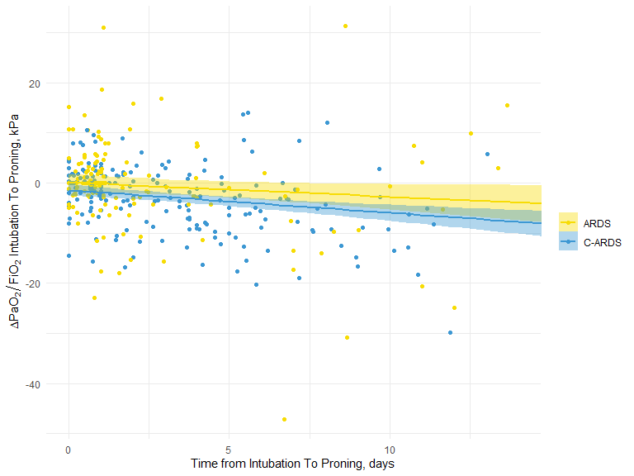
Figure E1 - Change in PaO2/FiO2 ratio from baseline to prone positioning

Prediction of change in PaO₂/FiO₂ ratio on prone Positioning – OLS Linear Model

Delay from Intubation to Proning
Although the delay to proning was negatively associated with the change in PaO₂/FiO₂ ratio on proning, we found this effect was different, but near constant before and after the first 24 hours. Figure 1 below, indicates the negative association when considered over the entire range of delay to proning, with the black trend line. The differing response in the early (<24 hour) period vs the later (>24 hour) can be clearly seen, furthermore over the scale of each period it can be seen that the response is constant within the calculated confidence intervals for each period.
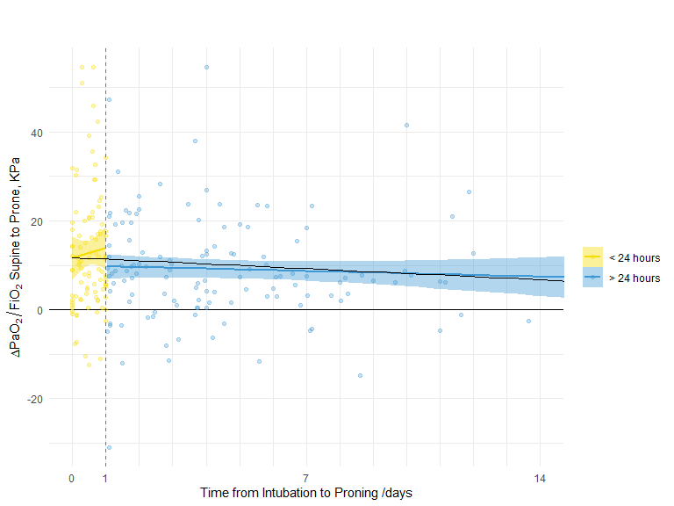
Figure E2 - Change in PaO2/FiO2 ratio upon proning vs Time from Intubation to Proning
Supine PaO₂/FiO₂ was negatively associated with a 0.7kPa (95% CI: -0.9, -0.5) reduction in predicted PaO₂/FiO₂ increase per supine kPa. Proning after 24 hours reduced the predicted PaO₂/FiO₂ increase by -3.0 kPa (95% CI: -5.4, -0.6), and C-ARDS reduced predicted PaO₂/FiO₂ increase by -2.8 kPa (95% CI: -5.3, -0.4) (E-Figure 3).
Therefore, we included delay to proning as a dichotomous indicator variable indicating proning within 24 hours of intubation.

OLS Model
We fitted a linear model (estimated using OLS) to predict the change in PaO₂/FiO₂ ratio on proning with PaO₂/FiO₂ ratio prior to proning, whether proning occurred more than or equal to twenty four hours after intubation, and COVID-19 status.
If:
$$∆PaO_{2}:FiO_{2}= {\frac{{PaO}_{2}}{FiO_{2}}}_{prone}- {\frac{{PaO}_{2}}{FiO_{2}}}_{supine}$$
$${ T}_{prone} = 0 \text{if proned within 24 hours of intubation, 1 otherwise}$$
COVID19$= 0 \text{if ARDS, 1 if C-ARDS}$

Then our regression model was defined as:
$$∆PaO_{2}:FiO_{2}= β_{0}+ β_{1}.{\frac{{PaO}_{2}}{FiO_{2}}}_{supine}+ β_{2}.COVID19+β_{3}.{ T}_{prone} + ε$$

The model explained a significant and moderate proportion of the variance in change in PaO₂/FiO₂ ratio (R² = 0.15, F(3, 344) = 20.06, p < .001, adjusted R² = 0.14). The model’s intercept, corresponding to supine PaO₂/FiO₂ ratio = 0, proned within 24 hours of intubation and aetiology of ARDS (ie non COVID-19), is at 23.92 kPa (95% CI [20.17, 27.68], t(344) = 12.54, p < .001). Within this model:
- The effect of supine PaO₂/FiO₂ ratio is significantly negative (β₁ = -0.70, 95% CI [-0.90, -0.50], t(344) = -6.84, p < .001; Std. beta = -0.35, 95% CI [-0.45, -0.25])
- The effect of COVID [C-ARDS] is significantly negative (β₂ = -2.84, 95% CI [-5.31, -0.37], t(344) = -2.26, p < .05; Std. beta = -0.23, 95% CI [-0.44, -0.03])
- The effect of proning more than or equal to 24 hours after intubation is significantly negative (β₃ = -3.01, 95% CI [-5.44, -0.58], t(344) = -2.44, p < .05; Std. beta = -0.25, 95% CI [-0.45, -0.05])
Standardized parameters were obtained by fitting the model on a standardized version of the dataset.
The multivariable linear regression model described, can be illustrated by examination of the plots in Figure 2, where the model regression lines are plotted for the aetiology indicator variable (A) and delay to proning from intubation indicator variable (B).

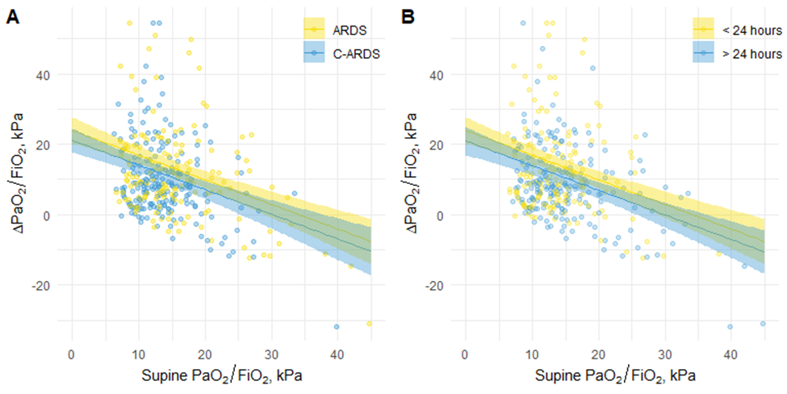
Figure E3 - Multiple linear regression model indicating C-ARDS and delay to intubation indicator variables. The conversion factor between kPa and mmHg is (1 kPa = 7.500617 mmHg)

Regression Diagnostics
We include some OLS linear regression diagnostic plots below in figure 3. From this outliers were noted, which on removal from the model, did not qualitatively effect the findings either of effect size or significance of coefficients and so are retained in the model presented here. Some minor deviation from normal distributed residuals, and non-constant variance in the spread-variance plot were also noted, but accepted for this regression.

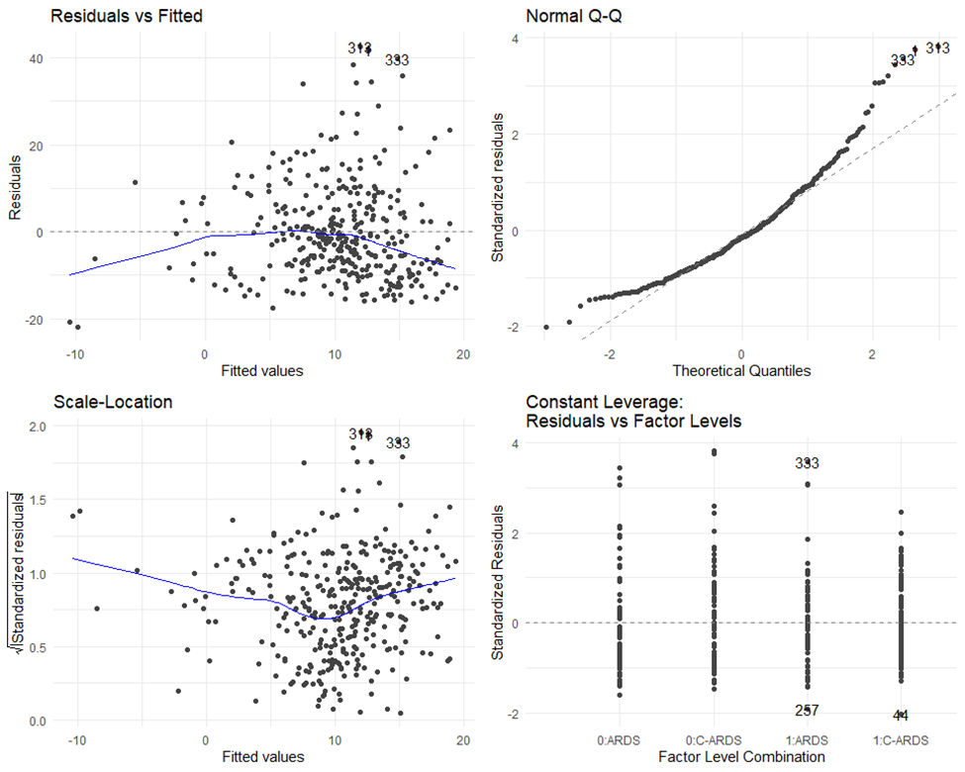
Figure E4: OLS model diagnostics

