International Guidelines for Management of Sepsis and Septic Shock

Surviving Sepsis Campaign: International Guidelines for Management of Sepsis and Septic Shock: 2021

Appendix 2. Infection

Laura Evans1, Andrew Rhodes2, Waleed Alhazzani3, Massimo Antonelli4, Craig M Coopersmith5, Craig French6, Flávia R. Machado7, Lauralyn Mcintyre8, Marlies Ostermann9, Hallie C. Prescott1⁰, Christa Schorr1¹, Steven Simpson1², W Joost Wiersinga1³, Fayez Alshamsi1⁴, Derek C. Angus1⁵, Yaseen Arabi1⁶, Luciano Azevedo1⁷, Richard Beale1⁸, Gregory Beilman1⁹, Emilie Belley-Cote2⁰, Lisa Burry2¹, Maurizio Cecconi2², John Centofanti2³, Angel Coz Yataco2⁴, Jan De Waele2⁵, R. Phillip Dellinger2⁶, Kent Doi2⁷, Bin Du2⁸, Elisa Estenssoro2⁹, Ricard Ferrer3⁰, Charles Gomersall3¹, Carol Hodgson3², Morten Hylander Møller³³, Theodore Iwashyna3⁴, Shevin Jacob3⁵, Ruth Kleinpell3⁶, Michael Klompas3⁷, Younsuck Koh3⁸, Anand Kumar3⁹, Arthur Kwizera4⁰, Suzana Lobo4¹, Henry Masur4², Steven McGloughlin4³, Sangeeta Mehta4⁴, Yatin Mehta4⁵, Mervyn Mer⁴⁶, Mark Nunnally4⁷, Simon Oczkowski4⁸, Tiffany Osborn4⁹, Elizabeth Papathanassoglou5⁰, Anders Perner5¹, Michael Puskarich⁵², Jason Roberts⁵³, William Schweickert5⁴, Maureen Seckel5⁵, Jonathan Sevransky5⁶, Charles L Sprung57, Tobias Welte5⁸, Janice Zimmerman5⁹, Mitchell Levy6⁰.

Affiliations
- Division of Pulmonary, Critical Care and Sleep Medicine, University of Washington, USA
- Adult Critical Care, St George’s University Hospitals NHS Foundation Trust & St George’s University of London, London, UK
- Department of Health Research Methods, Evidence, and Impact, McMaster University, Canada & Department of Medicine, McMaster University, Hamilton, Canada
- Dipartimento di Scienze dell’ Emergenza Anestesiologiche e della Rianimazione, Policlinico Universitario A. Gemelli IRCCS Rome, Italy
- Emory University School of Medicine, USA
- Western Health, Melbourne, Australia
- Federal University of Sao Paulo, Sao Paulo, Brazil
- Ottawa Hospital, Ottawa, ON, Canada
- Guy’s & St Thomas’ Hospital, London, England, UK
- University of Michigan and VA Center for Clinical Management Research, USA
- Cooper Health System, Camden, NJ, USA
- University of Kansas Medical Center, Kansas City, KS, USA
- Division of Infectious Diseases, Amsterdam UMC, University of Amsterdam, Amsterdam
- Department of Internal Medicine, College of Medicine and Health Sciences, United Arab Emirates University, PO Box 17666, Al Ain, United Arab Emirates
- University of Pittsburgh Critical Care Medicine CRISMA Laboratory, Pittsburgh, PA, USA
- Intensive Care Department, Ministry of National Guard Health Affairs, King Saud Bin Abdulaziz University for Health Sciences, King Abdullah International Medical Research Center, Riyadh, Kingdom of Saudi Arabia
- University of Sao Paulo, School of Medicine, Brazil
- Guy’s & St Thomas’ Hospital, London, England, UK
- University of Minnesota
- Population Health Research Institute, Hamilton, Canada
- Mount Sinai Hospital & University of Toronto (Leslie Dan Faculty of Pharmacy), Ontario Canada
- Department of Anesthesia and Intensive care, Humanitas Clinical and Research Center, Rozzano, Milan, Italy.
- Department of Anesthesia, McMaster University, Hamilton, Canada
- Lexington Veterans Affairs Medical Center / University of Kentucky College of Medicine
- Ghent University Hospital, Ghent, Belgium
- Cooper Health System, Camden, NJ, USA
- The University of Tokyo, Japan
- Medical ICU, Peking Union Medical College Hospital, 1 Shuai Fu Yuan, Beijing 100730
- Hospital Interzonal de Agudos San Martin de La Plata, Buenos Aires, Argentina
- Intensive Care Department, Vall d'Hebron University Hospital, Vall d’Hebron Institut de Recerca. Barcelona, Spain.
- Prince of Wales Hospital, Hong Kong, China
- Australian and New Zealand Intensive Care Research Centre, Monash University, Australia
- Copenhagen University Hospital Rigshospitalet, Department of Intensive Care 4131, Copenhagen, Denmark
- University of Michigan Health System, USA
- Liverpool School of Tropical Medicine, UK
- Vanderbilt University Nashville TN, USA
- Department of Medicine, Brigham and Women's Hospital, Boston MA; Department of Population Medicine, Harvard Medical School, and Harvard Pilgrim Health Care Institute, Boston MA, USA
- ASAN Medical Center, University of Ulsan College of Medicine, Seoul, South Korea
- University of Manitoba, Winnipeg, MB, Canada
- Makerere University College of Health Sciences, Uganda
- Intensive Care Division. Faculdade de Medicina de São José do Rio Preto, São Paulo- Brazil
- Critical Care Medicine department, NIH Clinical Center, Bethedsa, MD, USA
- Alfred Health, Australia
- Medanta The Medicity, Gurugram, Haryana, India
- Mount Sinai Hospital, Toronto, ON, Canada
- Charlotte Maxeke Johannesburg Academic Hospital and Faculty of Health Sciences, University of the Witwatersrand, Johannesburg, South Africa
- New York University School of Medicine, New York, NY, USA
- Department of Medicine, McMaster University, Hamilton, Canada
- Washington University School of Medicine, St. Louis, MO, USA
- Faculty of Nursing, University of Alberta, Edmonton AB, Canada
- Rigshospitalet, Copenhagen, Denmark
- University of Minnesota / Hennepin County Medical Center
- University of Queensland, Australia
- University of Pennsylvania, USA
- ChristianaCare, Newark, DE, USA
- Emory University School of Medicine, USA
- Faculty of Medicine, Hebrew University of Jerusalem, Israel and Department of Anesthesiology, Critical Care and Pain Medicine, Hadassah Medical Center, Jerusalem, Israel
- Medizinische Hochschule Hannover and German Center of Lung Research (DZL), Germany
- Houston Methodist Hospital, Houston, TX, USA
- Warren Alpert School of Medicine at Brown University, Providence, Rhode Island & Rhode Island Hospital, Providence, Rhode Island.

Table of Contents
Should clinical evaluation AND procalcitonin vs. clinical evaluation be used in be used to decide when to start antimicrobials in adults with suspected sepsis or septic shock? 4
Evidence profile: Should clinical evaluation AND procalcitonin vs. clinical evaluation be used in be used to decide when to start antimicrobials in adults with suspected sepsis or septic shock? 4
EtD: Summary of Judgments 6
Type of Recommendation 7
Should administration of early (within 1 hour of recognition of septic shock) empirical antimicrobials vs. administration of late (beyond 1 hour of recognition of septic shock) empirical antimicrobials be used in adults with septic shock? 8
Should administration of early (within 1 hour of recognition of sepsis) empirical antimicrobials vs. Administration of late (beyond 1 hour of recognition of sepsis) empirical antimicrobials be used in adults with sepsis? 8
Evidence profile for early antibiotics 8
Forest plot Timing of antibiotics 9
EtD: Summary of Judgements for Early Antibiotics 11
Should shorter duration (as defined by the original trials) of antimicrobial therapy vs. longer duration (as defined by the original trials) of antimicrobial therapy be used in adults with sepsis or septic shock? 13
Evidence profile Duration of Antibiotics 13
Forest plot: Shorter versus longer duration of antimicrobial therapy according to syndrome in RCTs. Short-term mortality. 15
EtD: Summary of Decisions: Duration of Antibiotics Recommendation 16
Type of Recommendation 17
Should daily assessment of de-escalation of antimicrobials vs. fixed duration of antimicrobial therapy (no daily assessment of de-escalation) be used in adults with sepsis or septic shock on antimicrobials? 18
Evidence Profile 18
Forest plot: De-escalation versus no de-escalation in patients with sepsis or septic shock (1 RCT and 12 observational studies). Short-term mortality. 20
EtD. Summary of Decisions 21
Type of Recommendation 22
Should clinical evaluation AND procalcitonin to de-escalate/discontinue antimicrobials vs. clinical evaluation to de-escalate/discontinue antimicrobials be used in adults with sepsis or septic shock on antimicrobials? 23
Evidence profile 23
Forest plot: Use of procalcitonin to decide when to discontinue antimicrobials. RCTs. Short-term mortality 25
EtD. Summary of Judgements 26
Type of Recommendation 27
Should two empirical antimicrobials with gram negative coverage vs. one empirical antimicrobial with gram negative coverage be used in adults with sepsis or septic shock? 28
Should two empirical antimicrobials with different mechanisms of action to provide double-coverage of the most likely pathogen vs. empirical mono-active antimicrobial therapy be used in adults with sepsis or septic shock? 28
Evidence profile 28
EtD: Summary of Judgements 30
Type of recommendation 31
Should empirical antifungal therapy vs. no empirical antifungal therapy be used in adults with sepsis or septic shock at risk of fungal infection? 32
Evidence profile 32
EtD. Summary of Judgments 33
Type of recommendation 34
Should prolonged infusion of beta-lactams (maintenance) vs. bolus infusion of beta-lactams (maintenance) be used in adults with sepsis or septic shock? 35
Evidence profile 35
EtD. Summary of judgements 36
Type of recommendation 37
Should surgical source control within 12 hours vs. surgical source control beyond 12 hours be used in adults with sepsis or septic shock and a source amenable to source control? 38
Evidence profile 38
Forest plot: Early versus late source control in adults with sepsis or septic shock. Observational studies. Short-term mortality 40
EtD. Summary of Judgments 41
Should removal of indwelling catheters and foreign bodies vs. no removal of indwelling catheters and foreign bodies be used in adults with sepsis or septic shock potentially attributable to a catheter or foreign body? 43
Table. Evidence profile 43
Forest plot: Intravascular catheter removal versus watchful waiting in adults with suspected catheter related infection. Short-term mortality. 44
EtD. Summary of Judgments 45

Should clinical evaluation AND procalcitonin vs. clinical evaluation be used in be used to decide when to start antimicrobials in adults with suspected sepsis or septic shock?

Evidence profile: Should clinical evaluation AND procalcitonin vs. clinical evaluation be used in be used to decide when to start antimicrobials in adults with suspected sepsis or septic shock?

Quality assessment |  |  |  |  |  |  | № of patients |  | Effect |  | Quality | Importance
№ of studies | Study design | Risk of bias | Inconsistency | Indirectness | Imprecision | Other considerations | clinical evaluation AND procalcitonin | clinical evaluation | Relative  (95% CI) | Absolute  (95% CI)
Short-term mortality
3 | randomised trials | serious ª | not serious | not serious | serious ^{b} | none | 251/892 (28.1%) | 248/877 (28.3%) | RR 0.99  (0.86 to 1.15) | 3 fewer per 1,000  (from 40 fewer to 42 more) | ⨁⨁◯◯  LOW | CRITICAL
Long-term mortality
0 |  |  |  |  |  |  | 0/0 | 0/0 | not estimable |  | - | CRITICAL
ICU length of stay
3 | randomised trials | serious ª | serious ^{c} | not serious | serious ^{d} | none | 892 | 877 | - | MD 0.19 higher  (0.98 lower to 1.36 higher) | ⨁◯◯◯  VERY LOW | CRITICAL
Hospital length of stay
1 | randomised trials | serious ª | not serious | not serious | very serious ^{d} | none | 30 | 30 | - | MD 7 lower  (26.24 lower to 12.24 higher) | ⨁◯◯◯  VERY LOW | CRITICAL
Re-admission to hospital
0 |  |  |  |  |  |  | 0/0 | 0/0 | not estimable |  | - | CRITICAL
Hospital free days
0 |  |  |  |  |  |  | 0 | 0 | - | 0  (0 to 0 ) | - | CRITICAL
CI: Confidence interval; RR: Risk ratio; MD: Mean difference

Explanations
a. No overall low risk of bias RCTs
b. 95% CI includes both increased and reduced mortality
c. Mean (SD) vales were calculated from median (IQR) values, and the converted results were not consistent between Lam 2018 SR and Peng 2019 SR
d. 95% CI includes both increased and reduced LOS

EtD: Summary of Judgments

 | Judgement
Problem | No | Probably no | Probably yes | Yes |  | Varies | Don't know
Desirable Effects | Trivial | Small | Moderate | Large |  | Varies | Don't know
Undesirable Effects | Large | Moderate | Small | Trivial |  | Varies | Don't know
Quality of evidence | Very low | Low | Moderate | High |  |  | No included studies
Values | Important uncertainty or variability | Possibly important uncertainty or variability | Probably no important uncertainty or variability | No important uncertainty or variability
Balance of effects | Favors the comparison | Probably favors the comparison | Does not favor either the intervention or the comparison | Probably favors the intervention | Favors the intervention | Varies | Don't know
Resources required | Large costs | Moderate costs | Negligible costs and savings | Moderate savings | Large savings | Varies | Don't know
Certainty of evidence of required resources | Very low | Low | Moderate | High |  |  | No included studies
Cost effectiveness | Favors the comparison | Probably favors the comparison | Does not favor either the intervention or the comparison | Probably favors the intervention | Favors the intervention | Varies | No included studies
Equity | Reduced | Probably reduced | Probably no impact | Probably increased | Increased | Varies | Don't know
Acceptability | No | Probably no | Probably yes | Yes |  | Varies | Don't know
Feasibility | No | Probably no | Probably yes | Yes |  | Varies | Don't know

Type of Recommendation

Strong recommendation against the intervention | Conditional recommendation against the intervention | Conditional recommendation for either the intervention or the comparison | Conditional recommendation for the intervention | Strong recommendation for the intervention
○ | ● | ○ | ○ | ○

Should administration of early (within 1 hour of recognition of septic shock) empirical antimicrobials vs. administration of late (beyond 1 hour of recognition of septic shock) empirical antimicrobials be used in adults with septic shock?

Should administration of early (within 1 hour of recognition of sepsis) empirical antimicrobials vs. Administration of late (beyond 1 hour of recognition of sepsis) empirical antimicrobials be used in adults with sepsis?

Evidence profile for early antibiotics
Outcomes | With late antibiotics  (beyond 1 hour) | With early antibiotics (within 1 hour) | Absolute difference | Relative effect  (95% CI)
28-day mortality (%)  1 RCT (n=2672) | 8.2% | 7.9% | 3 fewer per 1.000  (21 fewer to 20 more) | RR 0.96  (0.74 to 1.24)
90-day mortality (%)  1 RCT (n=2672) | 11.8% | 11.5% | 2 fewer per 1,000  (24 fewer to 25 more) | RR 0.98  (0.80 to 1.21)

Forest plot Timing of antibiotics

A) Antibiotics within versus beyond 1 hour in patients with severe sepsis/septic shock in observational studies. Mortality
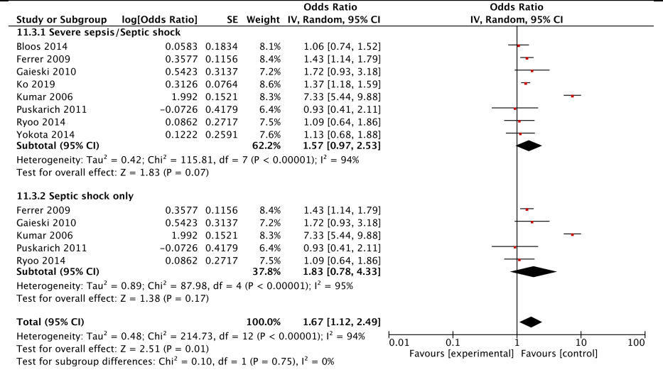

B) Hourly delay in antibiotics in patients with sepsis and septic shock in observational studies. Mortality
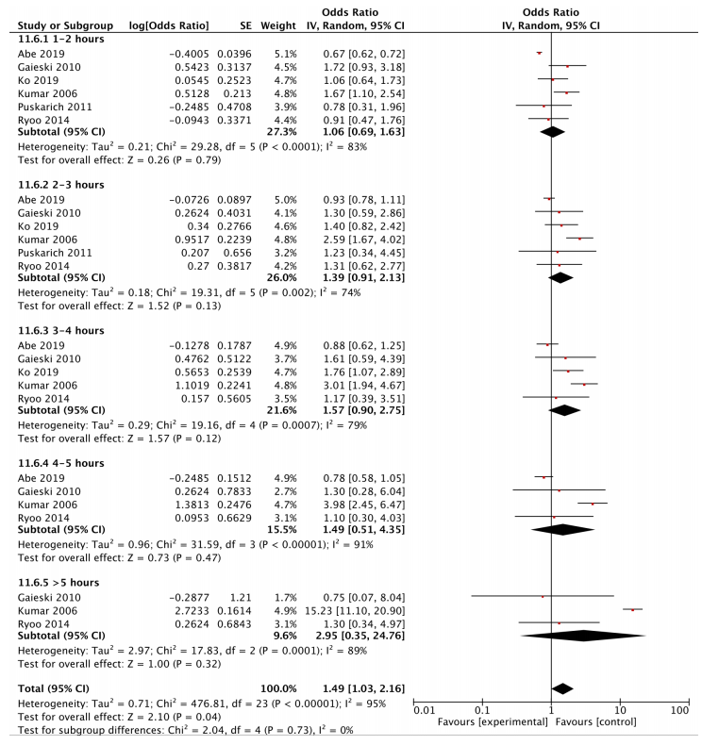

EtD: Summary of Judgements for Early Antibiotics

 | Judgement
Problem | No | Probably no | Probably yes | Yes |  | Varies | Don't know
Desirable effects | Trivial | Small | Moderate | Large |  | Varies | Don't know
Undesirable effects | Large | Moderate | Small | Trivial |  | Varies | Don't know
Quality of evidence | Very low | Low | Moderate | High |  |  | No included studies
Values | Important uncertainty or variability | Possibly important uncertainty or variability | Probably no important uncertainty or variability | No important uncertainty or variability
Balance of effects | Favors the comparison | Probably favors the comparison | Does not favor either the intervention or the comparison | Probably favors the intervention | Favors the intervention | Varies | Don't know
Resources required | Large costs | Moderate costs | Negligible costs and savings | Moderate savings | Large savings | Varies | Don't know
Certainty of evidence of required resources | Very low | Low | Moderate | High |  |  | No included studies
Cost effectiveness | Favors the comparison | Probably favors the comparison | Does not favor either the intervention or the comparison | Probably favors the intervention | Favors the intervention | Varies | No included studies
Equity | Reduced | Probably reduced | Probably no impact | Probably increased | Increased | Varies | Don't know
Acceptability | No | Probably no | Probably yes | Yes |  | Varies | Don't know
Feasibility | No | Probably no | Probably yes | Yes |  | Varies | Don't know

Should shorter duration (as defined by the original trials) of antimicrobial therapy vs. longer duration (as defined by the original trials) of antimicrobial therapy be used in adults with sepsis or septic shock?

Evidence profile Duration of Antibiotics

Quality assessment |  |  |  |  |  |  | № of patients |  | Effect |  | Quality | Importance
№ of studies | Study design | Risk of bias | Inconsistency | Indirectness | Imprecision | Other considerations | shorter duration (as defined by the original trials ) of antimicrobial therapy | longer duration (as defined by the original trials) of antimicrobial therapy | Relative  (95% CI) | Absolute  (95% CI)
Short term mortality
16 | randomised trials | serious ª | not serious | serious ^{b} | serious ^{c} | none | 185/2136 (8.7%) | 181/2100 (8.6%) | RR 1.02  (0.85 to 1.22) | 2 more per 1,000  (from 13 fewer to 19 more) | ⨁◯◯◯  VERY LOW | CRITICAL
Long term mortality (>90 days)
 |  |  |  |  |  |  | 0/0 | 0/0 | not estimable |  | - | CRITICAL
ICU length of stay
3 | randomised trials | serious ª | not serious | serious ^{d} | serious ^{e} | none | 327 | 329 | - | MD 0.17 more  (1.5 fewer to 1.84 more) | ⨁◯◯◯  VERY LOW | CRITICAL
Hospital length of stay
1 | randomised trials | serious ^{f} | not serious | serious ^{d} | very serious ^{e} | none | 14 | 16 | - | MD 1 fewer  (4.11 fewer to 2.11 more) | ⨁◯◯◯  VERY LOW | CRITICAL
Re-admission to hospital
0 |  |  |  |  |  |  | 0/0 | 0/0 | not estimable |  | - | CRITICAL
Hospital free days
0 |  |  |  |  |  |  | 0/0 | 0/0 | not estimable |  | - | CRITICAL
CI: Confidence interval; RR: Risk ratio; MD: Mean difference

Explanations
a. Most RCTs had high risk of bias
b. Indirect population (different infectious conditions; not restricted to sepsis/septic shock)
c. 95% CI includes both reduced and increased mortality
d. Indirect population (pneumonia)
e. 95% CI includes both reduced and increased LOS
f. High risk of bias RCT

Forest plot: Shorter versus longer duration of antimicrobial therapy according to syndrome in RCTs. Short-term mortality.

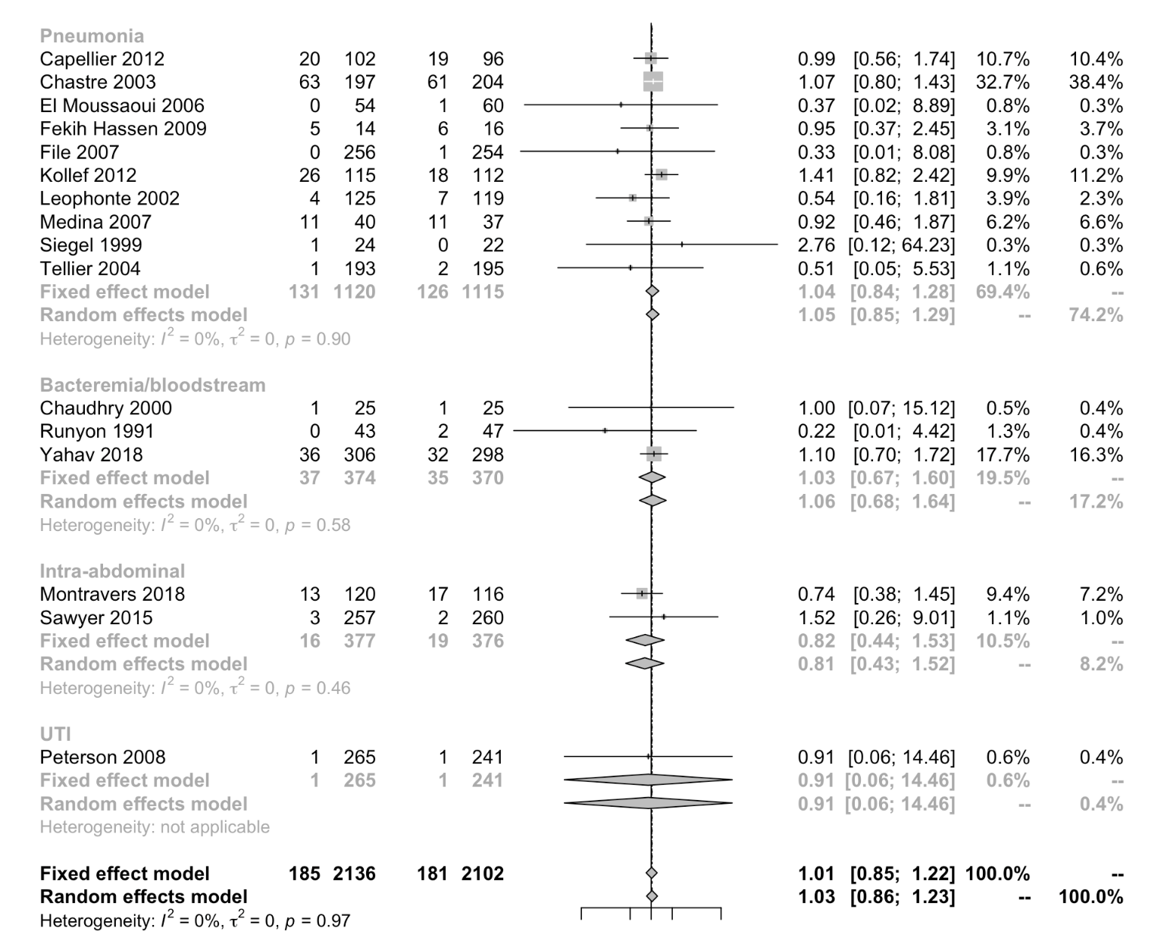

EtD: Summary of Decisions: Duration of Antibiotics Recommendation

 | Judgement
Problem | No | Probably no | Probably yes | Yes |  | Varies | Don't know
Desirable Effects | Trivial | Small | Moderate | Large |  | Varies | Don't know
Undesirable Effects | Large | Moderate | Small | Trivial |  | Varies | Don't know
Certainty of evidence | Very low | Low | Moderate | High |  |  | No included studies
Values | Important uncertainty or variability | Possibly important uncertainty or variability | Probably no important uncertainty or variability | No important uncertainty or variability
Balance of effects | Favors the comparison | Probably favors the comparison | Does not favor either the intervention or the comparison | Probably favors the intervention | Favors the intervention | Varies | Don't know
Resources required | Large costs | Moderate costs | Negligible costs and savings | Moderate savings | Large savings | Varies | Don't know
Certainty of evidence of required resources | Very low | Low | Moderate | High |  |  | No included studies
Cost effectiveness | Favors the comparison | Probably favors the comparison | Does not favor either the intervention or the comparison | Probably favors the intervention | Favors the intervention | Varies | No included studies
Equity | Reduced | Probably reduced | Probably no impact | Probably increased | Increased | Varies | Don't know
Acceptability | No | Probably no | Probably yes | Yes |  | Varies | Don't know
Feasibility | No | Probably no | Probably yes | Yes |  | Varies | Don't know

Type of Recommendation

strong recommendation against the intervention | conditional recommendation against the intervention | conditional recommendation for either the intervention or the comparison | conditional recommendation for the intervention | strong recommendation for the intervention
○ | ○ | ○ | ● | ○

Should daily assessment of de-escalation of antimicrobials vs. fixed duration of antimicrobial therapy (no daily assessment of de-escalation) be used in adults with sepsis or septic shock on antimicrobials?

Evidence Profile

Quality assessment |  |  |  |  |  |  | № of patients |  | Effect |  | Quality | Importance
№ of studies | Study design | Risk of bias | Inconsistency | Indirectness | Imprecision | Other considerations | daily assessment of de-escalation of antimicrobials | fixed duration of antimicrobial therapy (no daily assessment of de-escalation) | Relative  (95% CI) | Absolute  (95% CI)
Short term mortality
13 | observational studies | serious ª | serious ^{b} | not serious | not serious | none | 220/967 (22.8%) | 298/1001 (29.8%) | RR 0.72  (0.57 to 0.91) | 83 fewer per 1,000  (from 128 fewer to 27 fewer) | ⨁◯◯◯  VERY LOW | CRITICAL
Long term mortality (>90 days)
1 | observational studies | serious ª | not serious | not serious | serious ^{c} | none | 31/117 (26.5%) | 30/112 (26.8%) | RR 0.99  (0.64 to 1.52) | 3 fewer per 1,000  (from 96 fewer to 139 more) | ⨁◯◯◯  VERY LOW | CRITICAL
ICU length of stay
6 | observational studies | serious ª | serious ^{b} | not serious | serious ^{d} | none | 424 | 380 | - | MD 2.6 lower  (5.91 lower to 0.72 higher) | ⨁◯◯◯  VERY LOW | CRITICAL
Hospital length of stay
4 | observational studies | serious ª | not serious | not serious | serious ^{e} | none | 248 | 211 | - | MD 5.56 lower  (7.68 lower to 3.44 lower) | ⨁◯◯◯  VERY LOW | CRITICAL
Re-admission to hospital
- | - | - | - | - | - | - | - | - | - | - | - | CRITICAL
Hospital free days
- | - | - | - | - | - | - | - | - | - | - | - | CRITICAL
CI: Confidence interval; RR: Risk ratio; MD: Mean difference

Explanations
a. Most studies had high risk of bias
b. Differential results between data from observational studies and RCT
c. 95% CI includes both increased and reduced mortality
d. 95% CI includes both increased and reduced LOS
e. Wide 95% CI around the effect estimate

Forest plot: De-escalation versus no de-escalation in patients with sepsis or septic shock (1 RCT and 12 observational studies). Short-term mortality.
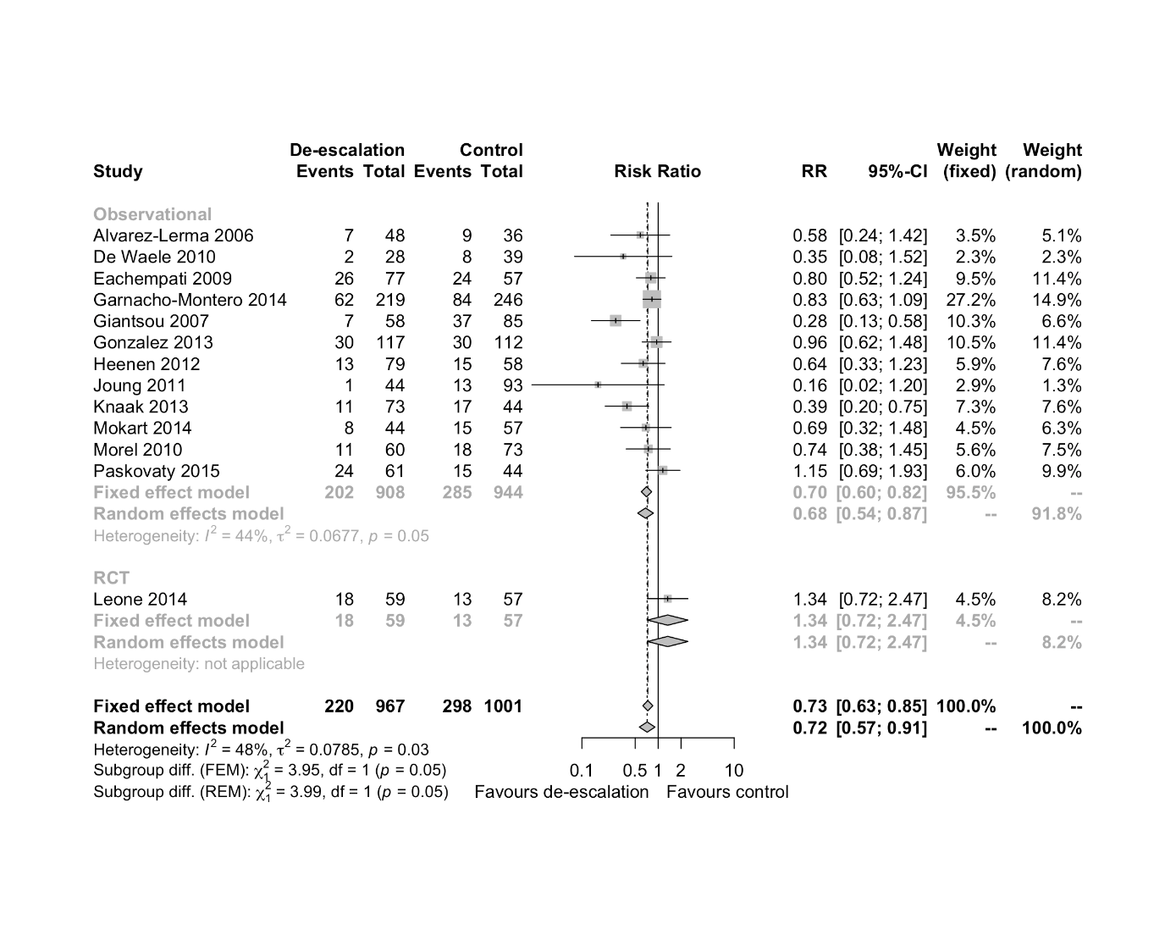

EtD. Summary of Decisions

 | Judgement
Problem | No | Probably no | Probably yes | Yes |  | Varies | Don't know
Desirable Effects | Trivial | Small | Moderate | Large |  | Varies | Don't know
Undesirable Effects | Large | Moderate | Small | Trivial |  | Varies | Don't know
Certainty of evidence | Very low | Low | Moderate | High |  |  | No included studies
Values | Important uncertainty or variability | Possibly important uncertainty or variability | Probably no important uncertainty or variability | No important uncertainty or variability
Balance of effects | Favors the comparison | Probably favors the comparison | Does not favor either the intervention or the comparison | Probably favors the intervention | Favors the intervention | Varies | Don't know
Resources required | Large costs | Moderate costs | Negligible costs and savings | Moderate savings | Large savings | Varies | Don't know
Certainty of evidence of required resources | Very low | Low | Moderate | High |  |  | No included studies
Cost effectiveness | Favors the comparison | Probably favors the comparison | Does not favor either the intervention or the comparison | Probably favors the intervention | Favors the intervention | Varies | No included studies
Equity | Reduced | Probably reduced | Probably no impact | Probably increased | Increased | Varies | Don't know
Acceptability | No | Probably no | Probably yes | Yes |  | Varies | Don't know
Feasibility | No | Probably no | Probably yes | Yes |  | Varies | Don't know

Type of Recommendation

Strong recommendation against the intervention | Conditional recommendation against the intervention | Conditional recommendation for either the intervention or the comparison | Conditional recommendation for the intervention | Strong recommendation for the intervention
○ | ○ | ○ | ● | ○

Should clinical evaluation AND procalcitonin to de-escalate/discontinue antimicrobials vs. clinical evaluation to de-escalate/discontinue antimicrobials be used in adults with sepsis or septic shock on antimicrobials?

Evidence profile

Quality assessment |  |  |  |  |  |  | № of patients |  | Effect |  | Quality | Importance
№ of studies | Study design | Risk of bias | Inconsistency | Indirectness | Imprecision | Other considerations | clinical evaluation AND procalcitonin to de-escalate/discontinue antimicrobials | clinical evaluation to de-escalate/discontinue antimicrobials | Relative  (95% CI) | Absolute  (95% CI)
Short term mortality
14 | randomised trials | serious ª | not serious | not serious | not serious | none | 496/2500 (19.8%) | 552/2500 (22.1%) | RR 0.89  (0.80 to 0.99) | 24 fewer per 1,000  (from 44 fewer to 2 fewer) | ⨁⨁⨁◯  MODERATE | CRITICAL
Long term mortality (>90 days)
0 |  |  |  |  |  |  | 0/0 | 0/0 | not estimable |  | - | CRITICAL
ICU length of stay
13 | randomised trials | serious ª | serious ^{b} | not serious | serious ^{c} | none | 2449 | 2450 | - | MD 0.69 lower  (2.14 lower to 0.77 higher) | ⨁◯◯◯  VERY LOW | CRITICAL
Hospital length of stay
10 | randomised trials | serious ª | serious ^{d} | not serious | serious ^{c} | none | 2237 | 2245 | - | MD 1.19 lower  (3.5 lower to 1.12 higher) | ⨁◯◯◯  VERY LOW | CRITICAL
Re-admission to hospital
- | - | - | - | - | - | - | - | - | - | - | - | CRITICAL
CI: Confidence interval; RR: Risk ratio; MD: Mean difference

Explanations
a. Most trials had high risk of bias
b. I² =87%
c. 95% CI includes both increased and reduced LOS
d. I² =83%

Forest plot: Use of procalcitonin to decide when to discontinue antimicrobials. RCTs. Short-term mortality
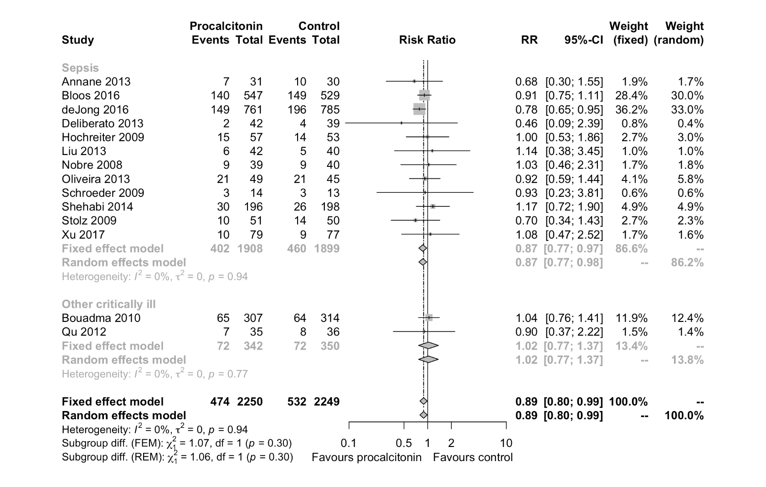

EtD. Summary of Judgements

 | Judgement
Problem | No | Probably no | Probably yes | Yes |  | Varies | Don't know
Desirable effects | Trivial | Small | Moderate | Large |  | Varies | Don't know
Undesirable effects | Large | Moderate | Small | Trivial |  | Varies | Don't know
Quality of evidence | Very low | Low | Moderate | High |  |  | No included studies
Values | Important uncertainty or variability | Possibly important uncertainty or variability | Probably no important uncertainty or variability | No important uncertainty or variability
Balance of effects | Favors the comparison | Probably favors the comparison | Does not favor either the intervention or the comparison | Probably favors the intervention | Favors the intervention | Varies | Don't know
Resources required | Large costs | Moderate costs | Negligible costs and savings | Moderate savings | Large savings | Varies | Don't know
Certainty of evidence of required resources | Very low | Low | Moderate | High |  |  | No included studies
Cost effectiveness | Favors the comparison | Probably favors the comparison | Does not favor either the intervention or the comparison | Probably favors the intervention | Favors the intervention | Varies | No included studies
Equity | Reduced | Probably reduced | Probably no impact | Probably increased | Increased | Varies | Don't know
Acceptability | No | Probably no | Probably yes | Yes |  | Varies | Don't know
Feasibility | No | Probably no | Probably yes | Yes |  | Varies | Don't know

Type of Recommendation

Strong recommendation against the intervention | Conditional recommendation against the intervention | Conditional recommendation for either the intervention or the comparison | Conditional recommendation for the intervention | Strong recommendation for the intervention
○ | ○ | ○ | ● | ○

Should two empirical antimicrobials with gram negative coverage vs. one empirical antimicrobial with gram negative coverage be used in adults with sepsis or septic shock?

Should two empirical antimicrobials with different mechanisms of action to provide double-coverage of the most likely pathogen vs. empirical mono-active antimicrobial therapy be used in adults with sepsis or septic shock?

Evidence profile

Quality assessment |  |  |  |  |  |  |  |  |  |  |  |  |  |  |  |  |  |  |  |  | № of patients |  |  |  |  |  | Effect |  |  |  |  |  | Quality |  |  | Importance
№ of studies |  |  | Study design |  |  | Risk of bias |  | Inconsistency |  |  |  | Indirectness |  |  | Imprecision |  |  | Other considerations |  |  | two empirical antimicrobials with different mechanisms of action to provide double-coverage of the most likely pathogen |  |  | empirical mono-active antimicrobial therapy |  |  | Relative  (95% CI) |  |  | Absolute  (95% CI)
Short term mortality
10 |  |  | randomised trials |  |  | serious ª |  | not serious |  |  |  | not serious |  |  | serious ^{b} |  |  | publication bias strongly suspected ^{c} |  |  | 269/1161 (23.2%) |  |  | 235/1106 (21.2%) |  |  | RR 1.10  (0.94 to 1.28) |  |  | 21 more per 1,000  (from 13 fewer to 59 more) |  |  | ⨁◯◯◯  VERY LOW |  |  | CRITICAL
Long term mortality (>90 days)
- |  |  | - |  |  | - |  | - |  |  |  | - |  |  | - |  |  | - |  |  | - |  |  | - |  |  | - |  |  | - |  |  | - |  |  | CRITICAL
ICU length of stay
3 |  | randomised trials |  |  | serious ª |  |  |  | not serious |  | not serious |  |  | very serious ^{d} |  |  | none |  |  | 279 |  |  | 267 |  |  | - |  |  | MD 0.34 lower  (3.75 lower to 3.08 higher) |  |  | ⨁◯◯◯  VERY LOW |  |  | CRITICAL
Hospital length of stay
1 |  | randomised trials |  |  | serious ª |  |  |  | not serious |  | not serious |  |  | very serious ^{d} |  |  | none |  |  | 71 |  |  | 69 |  |  | - |  |  | MD 1.6 higher  (5.29 lower to 8.49 higher) |  |  | ⨁◯◯◯  VERY LOW |  |  | CRITICAL
Re-admission to hospital
- |  | - |  |  | - |  |  |  | - |  | - |  |  | - |  |  | - |  |  | - |  |  | - |  |  | - |  |  | - |  |  | - |  |  | CRITICAL
Hospital free days
- | - |  |  | - |  |  | - |  |  | - |  |  | - |  |  | - |  |  | - |  |  | - |  |  | - |  |  | - |  |  | - |  |  | CRITICAL
CI: Confidence interval; RR: Risk ratio; MD: Mean difference

Explanations
a. Most trials had high risk of bias
b. 95% CI includes both increased and reduced mortality
c. Risk of small trial bias (publication bias) according to funnel plot
d. 95% CI includes both increased and reduced LOS

EtD: Summary of Judgements

 | Judgement
Problem | No | Probably no | Probably yes | Yes |  | Varies | Don't know
Desirable effects | Trivial | Small | Moderate | Large |  | Varies | Don't know
Undesirable effects | Large | Moderate | Small | Trivial |  | Varies | Don't know
Quality of evidence | Very low | Low | Moderate | High |  |  | No included studies
Values | Important uncertainty or variability | Possibly important uncertainty or variability | Probably no important uncertainty or variability | No important uncertainty or variability
Balance of effects | Favors the comparison | Probably favors the comparison | Does not favor either the intervention or the comparison | Probably favors the intervention | Favors the intervention | Varies | Don't know
Resources required | Large costs | Moderate costs | Negligible costs and savings | Moderate savings | Large savings | Varies | Don't know
Certainty of evidence of required resources | Very low | Low | Moderate | High |  |  | No included studies
Cost effectiveness | Favors the comparison | Probably favors the comparison | Does not favor either the intervention or the comparison | Probably favors the intervention | Favors the intervention | Varies | No included studies
Equity | Reduced | Probably reduced | Probably no impact | Probably increased | Increased | Varies | Don't know
Acceptability | No | Probably no | Probably yes | Yes |  | Varies | Don't know
Feasibility | No | Probably no | Probably yes | Yes |  | Varies | Don't know

Type of recommendation

Strong recommendation against the intervention | Conditional recommendation against the intervention | Conditional recommendation for either the intervention or the comparison | Conditional recommendation for the intervention | Strong recommendation for the intervention
○ | ● | ○ | ○ | ○

Should empirical antifungal therapy vs. no empirical antifungal therapy be used in adults with sepsis or septic shock at risk of fungal infection?

Evidence profile
Quality assessment |  |  |  |  |  |  | № of patients |  | Effect |  | Quality | Importance
№ of studies | Study design | Risk of bias | Inconsistency | Indirectness | Imprecision | Other considerations | empirical antifungal therapy | no empirical antifungal therapy | Relative  (95% CI) | Absolute  (95% CI)
Short term mortality
7 | randomised trials | serious ª | not serious | not serious | serious ^{b} | none | 140/487 (28.7%) | 147/503 (29.2%) | RR 0.94  (0.68 to 1.30) | 18 fewer per 1,000  (from 94 fewer to 88 more) | ⨁⨁◯◯  LOW | CRITICAL
Long Term Mortality (>90 days)
- | - | - | - | - | - | - | - | - | - | - | - | CRITICAL
ICU Length of Stay
- | - | - | - | - | - | - | - | - | - | - | - | CRITICAL
Hospital length of stay
- | - | - | - | - | - | - | - | - | - | - | - | CRITICAL
Re-admission to hospital
- | - | - | - | - | - | - | - | - | - | - | - | CRITICAL
Hospital free days
- | - | - | - | - | - | - | - | - | - | - | - | CRITICAL
CI: Confidence interval; RR: Risk ratio

Explanations
a. Most trials had overall high risk of bias
b. 95% CI includes both increased and reduced mortality

EtD. Summary of Judgments

 | Judgement
Problem | No | Probably no | Probably yes | Yes |  | Varies | Don't know
Desirable Effects | Trivial | Small | Moderate | Large |  | Varies | Don't know
Undesirable Effects | Large | Moderate | Small | Trivial |  | Varies | Don't know
Certainty of evidence | Very low | Low | Moderate | High |  |  | No included studies
Values | Important uncertainty or variability | Possibly important uncertainty or variability | Probably no important uncertainty or variability | No important uncertainty or variability
Balance of effects | Favors the comparison | Probably favors the comparison | Does not favor either the intervention or the comparison | Probably favors the intervention | Favors the intervention | Varies | Don't know
Resources required | Large costs | Moderate costs | Negligible costs and savings | Moderate savings | Large savings | Varies | Don't know
Certainty of evidence of required resources | Very low | Low | Moderate | High |  |  | No included studies
Cost effectiveness | Favors the comparison | Probably favors the comparison | Does not favor either the intervention or the comparison | Probably favors the intervention | Favors the intervention | Varies | No included studies
Equity | Reduced | Probably reduced | Probably no impact | Probably increased | Increased | Varies | Don't know
Acceptability | No | Probably no | Probably yes | Yes |  | Varies | Don't know
Feasibility | No | Probably no | Probably yes | Yes |  | Varies | Don't know

Type of recommendation

Strong recommendation against the intervention | Conditional recommendation against the intervention | Conditional recommendation for either the intervention or the comparison | Conditional recommendation for the intervention | Strong recommendation for the intervention
○ | ○ | ● | ○ | ○

Should prolonged infusion of beta-lactams (maintenance) vs. bolus infusion of beta-lactams (maintenance) be used in adults with sepsis or septic shock?

Evidence profile

Quality assessment |  |  |  |  |  |  | № of patients |  | Effect |  | Quality | Importance
№ of studies | Study design | Risk of bias | Inconsistency | Indirectness | Imprecision | Other considerations | prolonged infusion of beta-lactams (maintenance) | bolus infusion of beta-lactams (maintenance) | Relative  (95% CI) | Absolute  (95% CI)
Short term mortality
17 | randomised trials | serious ª | not serious | not serious | not serious | none | 110/792 (13.9%) | 161/805 (20.0%) | RR 0.70  (0.57 to 0.87) | 60 fewer per 1,000  (from 86 fewer to 26 fewer) | ⨁⨁⨁◯  MODERATE | CRITICAL
Long term mortality (>90 days)
- | - | - | - | - | - | - | - | - | - | - | - | CRITICAL
ICU length of stay
- | - | - | - | - | - | - | - | - | - | - | - | CRITICAL
Hospital length of stay
- | - | - | - | - | - | - | - | - | - | - | - | CRITICAL
Re-admission to hospital
- | - | - | - | - | - | - | - | - | - | - | - | CRITICAL
Hospital free days
- | - | - | - | - | - | - | - | - | - | - | - | CRITICAL
CI: Confidence interval; RR: Risk ratio

Explanations
a. Most trials had high risk of bias

EtD. Summary of judgements

 | Judgement
Problem | No | Probably no | Probably yes | Yes |  | Varies | Don't know
Desirable Effects | Trivial | Small | Moderate | Large |  | Varies | Don't know
Undesirable Effects | Large | Moderate | Small | Trivial |  | Varies | Don't know
Certainty of evidence | Very low | Low | Moderate | High |  |  | No included studies
Values | Important uncertainty or variability | Possibly important uncertainty or variability | Probably no important uncertainty or variability | No important uncertainty or variability
Balance of effects | Favors the comparison | Probably favors the comparison | Does not favor either the intervention or the comparison | Probably favors the intervention | Favors the intervention | Varies | Don't know
Resources required | Large costs | Moderate costs | Negligible costs and savings | Moderate savings | Large savings | Varies | Don't know
Certainty of evidence of required resources | Very low | Low | Moderate | High |  |  | No included studies
Cost effectiveness | Favors the comparison | Probably favors the comparison | Does not favor either the intervention or the comparison | Probably favors the intervention | Favors the intervention | Varies | No included studies
Equity | Reduced | Probably reduced | Probably no impact | Probably increased | Increased | Varies | Don't know
Acceptability | No | Probably no | Probably yes | Yes |  | Varies | Don't know
Feasibility | No | Probably no | Probably yes | Yes |  | Varies | Don't know

Type of recommendation

Strong recommendation against the intervention | Conditional recommendation against the intervention | Conditional recommendation for either the intervention or the comparison | Conditional recommendation for the intervention | Strong recommendation for the intervention
○ | ○ | ○ | ● | ○

Should surgical source control within 12 hours vs. surgical source control beyond 12 hours be used in adults with sepsis or septic shock and a source amenable to source control?

Evidence profile

Certainty assessment |  |  |  |  |  |  | № of patients |  | Effect |  | Certainty | Importance
№ of studies | Study design | Risk of bias | Inconsistency | Indirectness | Imprecision | Other considerations | surgical source control within 12 hours | surgical source control beyond 12 hours | Relative  (95% CI) | Absolute  (95% CI)
Short term mortality
4 | observational studies | not serious | serious ª | not serious | serious ^{b} | none | 808/3062 (26.4%) | 401/1338 (30.0%) | RR 0.86  (0.66 to 1.11) | 42 fewer per 1,000  (from 102 fewer to 33 more) | ⨁◯◯◯  VERY LOW | CRITICAL
Long term mortality (>90 days)
- | - | - | - | - | - | - | - | - | - | - | - | CRITICAL
ICU length of stay
1 | observational studies | not serious | not serious | not serious | serious ^{c} | none | 825 | 265 | - | MD 0.5 lower  (2.62 lower to 1.62 higher) | ⨁◯◯◯  VERY LOW | CRITICAL
Hospital length of stay
1 | observational studies | not serious | not serious | not serious | serious ^{c} | none | 825 | 265 | - | MD 0.3 higher  (3.69 lower to 4.29 higher) | ⨁◯◯◯  VERY LOW | CRITICAL
Re-admission to hospital
- | - | - | - | - | - | - | - | - | - | - | - | CRITICAL
Hospital free days
- | - | - | - | - | - | - | - | - | - | - | - | CRITICAL
CI: Confidence interval; RR: Risk ratio; MD: Mean difference

Explanations
a. Difference between a cut-off of 6 vs. 12 hours
b. 95% CI includes both increased and reduced mortality
c. 95% CI includes both increased and reduced LOS

Forest plot: Early versus late source control in adults with sepsis or septic shock. Observational studies. Short-term mortality

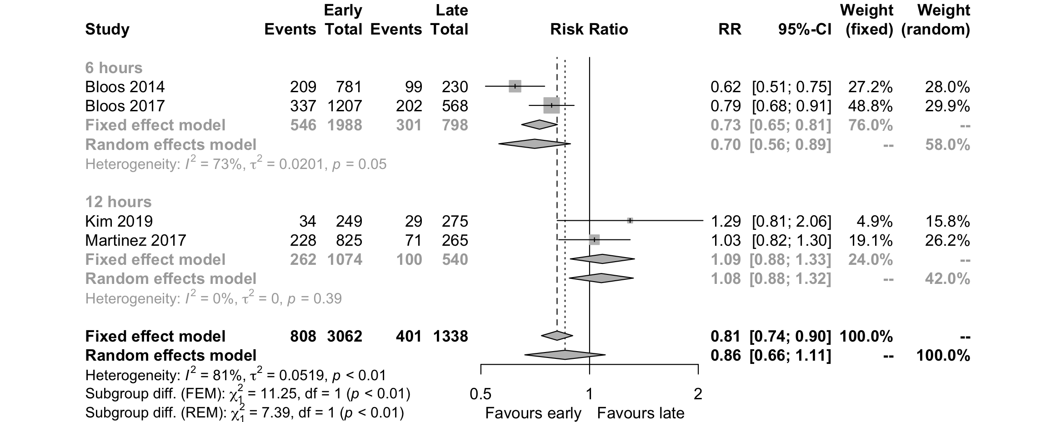

EtD. Summary of Judgments

 | Judgement
Problem | No | Probably no | Probably yes | Yes |  | Varies | Don't know
Desirable Effects | Trivial | Small | Moderate | Large |  | Varies | Don't know
Undesirable Effects | Large | Moderate | Small | Trivial |  | Varies | Don't know
Certainty of evidence | Very low | Low | Moderate | High |  |  | No included studies
Values | Important uncertainty or variability | Possibly important uncertainty or variability | Probably no important uncertainty or variability | No important uncertainty or variability
Balance of effects | Favors the comparison | Probably favors the comparison | Does not favor either the intervention or the comparison | Probably favors the intervention | Favors the intervention | Varies | Don't know
Resources required | Large costs | Moderate costs | Negligible costs and savings | Moderate savings | Large savings | Varies | Don't know
Certainty of evidence of required resources | Very low | Low | Moderate | High |  |  | No included studies
Cost effectiveness | Favors the comparison | Probably favors the comparison | Does not favor either the intervention or the comparison | Probably favors the intervention | Favors the intervention | Varies | No included studies
Equity | Reduced | Probably reduced | Probably no impact | Probably increased | Increased | Varies | Don't know
Acceptability | No | Probably no | Probably yes | Yes |  | Varies | Don't know
Feasibility | No | Probably no | Probably yes | Yes |  | Varies | Don't know

Should removal of indwelling catheters and foreign bodies vs. no removal of indwelling catheters and foreign bodies be used in adults with sepsis or septic shock potentially attributable to a catheter or foreign body?

Table. Evidence profile

Quality assessment |  |  |  |  |  |  | № of patients |  | Effect |  | Quality | Importance
№ of studies | Study design | Risk of bias | Inconsistency | Indirectness | Imprecision | Other considerations | removal of indwelling catheters and foreign bodies | no removal of indwelling catheters and foreign bodies | Relative  (95% CI) | Absolute  (95% CI)
Short term mortality
3 | observational studies | not serious | serious ª | not serious | serious ^{b} | none | 69/294 (23.5%) | 44/220 (20.0%) | RR 0.99  (0.55 to 1.79) | 2 fewer per 1,000  (from 90 fewer to 158 more) | ⨁◯◯◯  VERY LOW | CRITICAL
Long term mortality (>90 days)
- | - | - | - | - | - | - | - | - | - | - | - | CRITICAL
ICU length of stay
- | - | - | - | - | - | - | - | - | - | - | - | CRITICAL
Hospital length of stay
- | - | - | - | - | - | - | - | - | - | - | - | CRITICAL
Re-admission to hospital
- | - | - | - | - | - | - | - | - | - | - | - | CRITICAL
Hospital free days
- | - | - | - | - | - | - | - | - | - | - | - | CRITICAL
CI: Confidence interval; RR: Risk ratio

Explanations
a. I2 64%
b. 95% CI includes both increased and reduced mortality
c. High risk of bias trial

Forest plot: Intravascular catheter removal versus watchful waiting in adults with suspected catheter related infection. Short-term mortality.
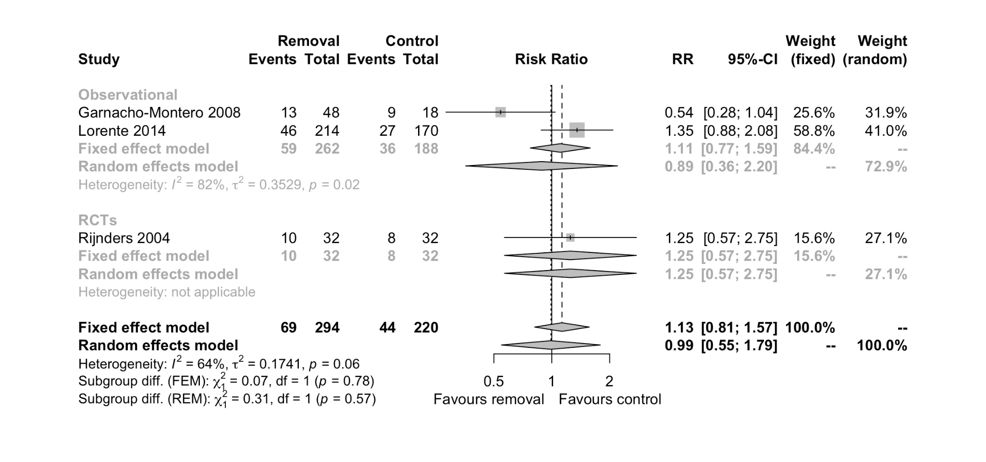

EtD. Summary of Judgments

 | Judgement
Problem | No | Probably no | Probably yes | Yes |  | Varies | Don't know
Desirable Effects | Trivial | Small | Moderate | Large |  | Varies | Don't know
Undesirable Effects | Large | Moderate | Small | Trivial |  | Varies | Don't know
Certainty of evidence | Very low | Low | Moderate | High |  |  | No included studies
Values | Important uncertainty or variability | Possibly important uncertainty or variability | Probably no important uncertainty or variability | No important uncertainty or variability
Balance of effects | Favors the comparison | Probably favors the comparison | Does not favor either the intervention or the comparison | Probably favors the intervention | Favors the intervention | Varies | Don't know
Resources required | Large costs | Moderate costs | Negligible costs and savings | Moderate savings | Large savings | Varies | Don't know
Certainty of evidence of required resources | Very low | Low | Moderate | High |  |  | No included studies
Cost effectiveness | Favors the comparison | Probably favors the comparison | Does not favor either the intervention or the comparison | Probably favors the intervention | Favors the intervention | Varies | No included studies
Equity | Reduced | Probably reduced | Probably no impact | Probably increased | Increased | Varies | Don't know
Acceptability | No | Probably no | Probably yes | Yes |  | Varies | Don't know
Feasibility | No | Probably no | Probably yes | Yes |  | Varies | Don't know

