International Guidelines for Management of Sepsis and Septic Shock

Surviving Sepsis Campaign: International Guidelines for Management of Sepsis and Septic Shock: 2021

Appendix 5. Additional Therapies

Laura Evans1, Andrew Rhodes2, Waleed Alhazzani3, Massimo Antonelli4, Craig M Coopersmith5, Craig French6, Flávia R. Machado7, Lauralyn Mcintyre8, Marlies Ostermann9, Hallie C. Prescott10, Christa Schorr11, Steven Simpson12, W Joost Wiersinga13, Fayez Alshamsi14, Derek C. Angus15, Yaseen Arabi16, Luciano Azevedo17, Richard Beale18, Gregory Beilman19, Emilie Belley-Cote20, Lisa Burry21,  Maurizio Cecconi22, John Centofanti23, Angel Coz Yataco24, Jan De Waele25, R. Phillip Dellinger26, Kent Doi27, Bin Du28, Elisa Estenssoro29, Ricard Ferrer30, Charles Gomersall31, Carol Hodgson32, Morten Hylander Møller33, Theodore Iwashyna34, Shevin Jacob35, Ruth Kleinpell36, Michael Klompas37, Younsuck Koh38, Anand Kumar39, Arthur Kwizera40, Suzana Lobo41, Henry Masur42, Steven McGloughlin43, Sangeeta Mehta44, Yatin Mehta45, Mervyn Mer46, Mark Nunnally47, Simon Oczkowski48, Tiffany Osborn49, Elizabeth Papathanassoglou50, Anders Perner51, Michael Puskarich52, Jason Roberts53, William Schweickert54, Maureen Seckel55, Jonathan Sevransky56, Charles L Sprung57, Tobias Welte58, Janice Zimmerman59, Mitchell Levy60.

Affiliations

Division of Pulmonary, Critical Care and Sleep Medicine, University of Washington, USA

Adult Critical Care, St George’s University Hospitals NHS Foundation Trust & St George’s University of London, London, UK

Department of Health Research Methods, Evidence, and Impact, McMaster University, Canada & Department of Medicine, McMaster University, Hamilton, Canada

Dipartimento di Scienze dell’ Emergenza  Anestesiologiche e della Rianimazione, Policlinico Universitario A. Gemelli IRCCS  Rome, Italy

Emory University School of Medicine, USA

Western Health, Melbourne, Australia

Federal University of Sao Paulo, Sao Paulo, Brazil

Ottawa Hospital, Ottawa, ON, Canada

Guy’s & St Thomas’ Hospital, London, England, UK

University of Michigan and VA Center for Clinical Management Research, USA

Cooper Health System, Camden, NJ, USA

University of Kansas Medical Center, Kansas City, KS, USA

1. Division of Infectious Diseases, Amsterdam UMC, University of Amsterdam, Amsterdam

Department of Internal Medicine, College of Medicine and Health Sciences, United Arab Emirates University, PO Box 17666, Al Ain, United Arab Emirates

University of Pittsburgh Critical Care Medicine CRISMA Laboratory, Pittsburgh, PA, USA

Intensive Care Department, Ministry of National Guard Health Affairs, King Saud Bin Abdulaziz University for Health Sciences, King Abdullah International Medical Research Center, Riyadh, Kingdom of Saudi Arabia

University of Sao Paulo, School of Medicine, Brazil

Guy’s & St Thomas’ Hospital, London, England, UK

University of Minnesota

Population Health Research Institute, Hamilton, Canada

Mount Sinai Hospital & University of Toronto (Leslie Dan Faculty of Pharmacy), Ontario Canada

Department of Anesthesia and Intensive care, Humanitas Clinical and Research Center, Rozzano, Milan, Italy.

Department of Anesthesia, McMaster University, Hamilton, Canada

Lexington Veterans Affairs Medical Center / University of Kentucky College of Medicine

Ghent University Hospital, Ghent, Belgium

Cooper Health System, Camden, NJ, USA

The University of Tokyo, Japan

Medical ICU, Peking Union Medical College Hospital, 1 Shuai Fu Yuan, Beijing 100730

Hospital Interzonal de Agudos San Martin de La Plata, Buenos Aires, Argentina

Intensive Care Department, Vall d'Hebron University Hospital, Vall d’Hebron Institut de Recerca. Barcelona, Spain.

Prince of Wales Hospital, Hong Kong, China

Australian and New Zealand Intensive Care Research Centre, Monash University, Australia

Copenhagen University Hospital Rigshospitalet, Department of Intensive Care 4131, Copenhagen, Denmark

University of Michigan Health System, USA

Liverpool School of Tropical Medicine, UK

Vanderbilt University Nashville TN, USA

Department of Medicine, Brigham and Women's Hospital, Boston MA; Department of Population Medicine, Harvard Medical School, and Harvard Pilgrim Health Care Institute, Boston MA, USA

ASAN Medical Center, University of Ulsan College of Medicine, Seoul, South Korea

University of Manitoba, Winnipeg, MB, Canada

Makerere University College of Health Sciences, Uganda

Intensive Care Division. Faculdade de Medicina de São José do Rio Preto, São Paulo- Brazil

Critical Care Medicine department, NIH Clinical Center, Bethedsa, MD, USA

Alfred Health, Australia

Medanta The Medicity, Gurugram, Haryana, India

Mount Sinai Hospital, Toronto, ON, Canada

Charlotte Maxeke Johannesburg Academic Hospital and Faculty of Health Sciences, University of the Witwatersrand, Johannesburg, South Africa

New York University School of Medicine, New York, NY, USA

Department of Medicine, McMaster University, Hamilton, Canada

Washington University School of Medicine, St. Louis, MO, USA

Faculty of Nursing, University of Alberta, Edmonton AB, Canada

Rigshospitalet, Copenhagen, Denmark

University of Minnesota / Hennepin County Medical Center

University of Queensland, Australia

University of Pennsylvania, USA

ChristianaCare, Newark, DE, USA

Emory University School of Medicine, USA

Faculty of Medicine, Hebrew University of Jerusalem, Israel and Department of Anesthesiology, Critical Care and Pain Medicine, Hadassah Medical Center, Jerusalem, Israel

Medizinische Hochschule Hannover and German Center of Lung Research (DZL), Germany

Houston Methodist Hospital, Houston, TX, USA

1. Warren Alpert School of Medicine at Brown University, Providence, Rhode Island & Rhode Island Hospital, Providence, Rhode Island.

Table of Contents

58. In adults with septic shock, should we use intravenous corticosteroids (versus not)? 5

Forest plot for Mortality (day 90 or less) 5

Evidence profile: Intravenous corticosteroids compared to not for patients with septic shock 6

EtD: Summary of Judgements for the Systemic Corticosteroids Recommendation 9

Type of Recommendation 10

59. In adults with sepsis, should we use a hemoperfusion therapy? 11

Forest plot for mortality, polymyxin 11

Forest plot for mortality, other therapies 12

Evidence profile: Hemoperfusion therapy compared to no hemoperfusion for patients with sepsis 13

EtD: Summary of Judgements Hemoperfusion in Sepsis Recommendation 15

Type of Recommendation 16

60. In adults with sepsis, should we use a restrictive transfusion strategy versus liberal transfusion? 17

Forest plot for 28-30 day mortality: 17

Forest plot for 90 day mortality: 17

Forest plot for 28-30 day mortality, excluding Bergamin: 17

Forest plot for 90 day mortality, excluding Bergamin: 18

Evidence profile : A restrictive transfusion strategy (defined as a hemoglobin concentration trigger for transfusion of 70-80 g/L) compared to liberal transfusion for patients with sepsis 19

EtD: Summary of Judgements for Restrictive Transfusion Recommendation 21

Type of Recommendation 22

61. In adults with sepsis or septic shock, should we use intravenous immunoglobulins (versus not)? 23

Forest plot for mortality (all immunoglobulins): 23

Forest plot for mortality (Polyclonal IVIG): 24

Forest plot for mortality, IgM-enriched IVIG: 24

Forest plot for mortality, low risk of bias studies: 25

Evidence profile: Intravenous immunoglobulins compared to not for adult patients with sepsis or septic shock 26

EtD: Summary of Judgments Immunoglobulins in sepsis 28

Type of Recommendation 29

EtD: Summary of Judgements on The Stress Ulcer Prophylaxis 32

Type of Recommendation 33

63. In adults with sepsis or septic shock, should we use pharmacologic VTE prophylaxis (UFH or LMWH)? 34

Forest plot for critical outcomes 34

Evidence profile: Pharmacologic venous thromboembolism prophylaxis (unfractionated heparin or low-molecular weight heparin) compared to no prophylaxis for critically ill patients with sepsis or septic shock 35

EtD: Summary of Judgements VTE Prophylaxis 37

Type of Recommendation 38

64. In adults with sepsis or septic shock, should we use LMWH (versus UFH) for VTE prophylaxis? 39

Forest plot for key outcomes 39

Evidence profile: Low-molecular weight heparin compared to unfractionated heparin for venous thromboembolism prophylaxis in critically ill patients with sepsis or septic shock 40

EtD: Summary of Judgements for Pharmacologic Prophylaxis 42

Type of Recommendation 43

65. In adults with sepsis or septic shock, should we use mechanical venous thromboembolism prophylaxis? 44

Evidence profile: Mechanical venous thromboembolism prophylaxis compared to no prophylaxis for critically ill patients with sepsis or septic shock 44

EtD: Summary of Judgements for Mechanical Prophylaxis Recommendation 46

Type of Recommendation 47

67. In adults with sepsis and indication for hemodialysis, should we use CRRT versus intermittent hemodialysis? 48

Forest plot for mortality 48

Evidence profile: Continuous renal replacement therapy compared to intermittent hemodialysis for patients with sepsis and indication for hemodialysis 49

ETD: Summary of Judgements CRRT versus IHD in Sepsis 51

Type of Recommendation 52

68. In adults with sepsis and AKI with no indication for hemodialysis, should we use renal replacement therapy versus not? 53

Forest plot for mortality 53

Forest plot for Renal recovery 53

Forest plot for central venous access device infection 54

Evidence profile: Renal replacement therapy compared to not for patients with sepsis and acute kidney injury and no indication for hemodialysis 55

EtD: Summary of Judgements for RRT in sepsis Recommendation 57

Type of Recommendation 58

69. In adults with sepsis or septic shock what should the trigger level of glucose be for starting an insulin infusion (> 180 or 150 mg/dL)? 59

Forest plot for mortality 59

Forest plot for hypoglycemia 60

Evidence profile: Commencing an insulin infusion at a blood glucose level of > 150 mg/dl compared to > 180 mg/dl for patients with sepsis or septic shock 61

ETD: Summary of Judgements for Glucose targets in sepsis 63

Type of recommendation 64

70. In adults with sepsis or septic shock should we use intravenous vitamin C? 65

Forest plot for mortality 65

Forest plot for vasopressor use (168 hours) 65

Evidence profile: Intravenous vitamin C compared to not for patients with sepsis or septic shock 66

71. In adults with sepsis and lactic acidosis should we use intravenous bicarbonate therapy? 67

Evidence profile: Intravenous bicarbonate therapy compared to not for patients with sepsis and lactic acidosis 67

72. In adults with sepsis or septic shock without contraindication to enteral feeding, should we use early enteral feeding (full or trophic) versus no initial enteral feeding? 69

Forest plot for mortality 69

Forest plot for pneumonia 69

Evidence profile: Early enteral feeding (full or trophic) compared to no initial enteral feeding for critically ill patients with sepsis or septic shock without contraindication to enteral feeding 70

# 58. In adults with septic shock, should we use intravenous corticosteroids (versus not)?

## Forest plot for Mortality (day 90 or less)

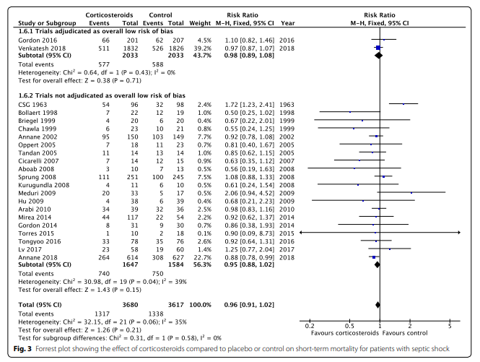

## Evidence profile: Intravenous corticosteroids compared to not for patients with septic shock

Setting: critically ill patients

Bibliography: Rygard SL, Butler E, Granholm A, et.al. Low-dose cortiosteroids for adult patient with septic shock: a systematic review with meta-analysis and trial sequantial analysis. Intensive Care Med 2018;44:1003-16 (mortality, short-term & and long-term follow up, time to resolution of shock, superinfections, gastrointestinal hemorrhage) Rochwerg B, Oczkowski SJ, Siemieniuk RAC, et. al. Corticosteroids in sepsis: an updated systematic review and meta-analysis. Crit Care Med 2018;46(9):1411 (organ failure, neuromuscular weakness) Fang F, Zhang Y, Tang J, et. al. Association of corticosteroid treatment with outcomes in adult patients with sepsis. A systematic review and meta-analysis. JAMA Internal Med 2019;179(2):213-23 (Vasopressor-free days)

|  |  |  |  |  |  |  |  |  |  |  |  |  |
| --- | --- | --- | --- | --- | --- | --- | --- | --- | --- | --- | --- | --- |
| Quality assessment | | | | | | | № of patients | | Effect | | Quality | Importance |
| № of studies | Study design | Risk of bias | Inconsistency | Indirectness | Imprecision | Other considerations | Intravenous corticosteroids | not | Relative (95% CI) | Absolute (95% CI) |
| Mortality, short term (follow up: 90 days or less) | | | | | | | | | | | | |
| 22 | randomised trials | not serious a | not serious b | not serious | not serious | none | 1317/3680 (35.8%) | 1338/3617 (37.0%) | RR 0.96 (0.91 to 1.02) | 15 fewer per 1,000 (from 33 fewer to 7 more) | ⨁⨁⨁⨁ HIGH | CRITICAL |
| Mortality, long-term (follow up: 180 days-12 months) | | | | | | | | | | | | |
| 5 | randomised trials | not serious c | not serious | not serious | serious d | none | 1100/2835 (38.8%) | 1147/2832 (40.5%) | RR 0.96 (0.90 to 1.02) | 16 fewer per 1,000 (from 41 fewer to 8 more) | ⨁⨁⨁◯ MODERATE | CRITICAL |
| Organ failure (follow up: 1 weeks) | | | | | | | | | | | | |
| 9 | randomised trials | not serious | not serious | not serious e | not serious | none |  |  | - | SMD 1.39 SD lower (1.88 lower to 0.89 lower) | ⨁⨁⨁⨁ HIGH | CRITICAL |
| Time to resolution of shock (assessed with: 4302 participants) | | | | | | | | | | | | |
| 7 | randomised trials | not serious | serious f | not serious | not serious | none |  |  | - | mean 1.52 days fewer (1.71 fewer to 1.32 fewer) | ⨁⨁⨁◯ MODERATE | IMPORTANT |
| Neuromuscular weakness | | | | | | | | | | | | |
| 7 | randomised trials | not serious | not serious | serious g | serious h | none |  |  | RR 1.21 (1.01 to 1.45) | 53 more per 1,000 (from 3 more to 130 more) i | ⨁⨁◯◯ LOW | IMPORTANT |
| Vasopressor-free days (1342 participants) | | | | | | | | | | | | |
| 3 | randomised trials | not serious | not serious | not serious | serious j | none |  |  | - | MD 1.95 days higher (0.8 higher to 3.11 higher) | ⨁⨁⨁◯ MODERATE | IMPORTANT |
| Superinfections | | | | | | | | | | | | |
| 11 | randomised trials | not serious | not serious | serious k | serious h | none |  |  | RR 1.05 (0.95 to 1.16) | 3 more per 1,000 (from 18 fewer to 29 more) i | ⨁⨁◯◯ LOW | IMPORTANT |
| Gastrointestinal hemorrhage | | | | | | | | | | | | |
| 12 | randomised trials | serious l | not serious | not serious | serious h | none |  |  | RR 1.09 (0.80 to 1.46) | 3 more per 1,000 (from 5 fewer to 13 more) i | ⨁⨁◯◯ LOW | IMPORTANT |

CI: Confidence interval; RR: Risk ratio; SMD: Standardised mean difference; MD: Mean difference

#### Explanations

a. Subgroup analysis showed similar estimate in trials at low risk of bias and those that were not.

b. I-squared 35%.

c. Authors cite concerns for risk of bias and results change when assessing trials at low risk (RR 1.66 [1.03,2.70]). This was the risk of any adverse event not the risk for mortality

d. Downgraded by Rochberg et al

e. Not specific to septic shock patients. Not downGRADEd.

f. Authors state downGRADE for inconsistency.

g. Variable timing, magnitude and tool of assessment.

h. 95% confidence interval includes no difference.

i. Quoting effect from source meta-analysis.

j. Imprecision around effect size suggests fragility.

k. downgraded by Rochberg

l. Authors cite that majority of weight attributed to trials with more than low risk of bias.

## EtD: Summary of Judgements for the Systemic Corticosteroids Recommendation

|  | Judgement | | | | | | |
| --- | --- | --- | --- | --- | --- | --- | --- |
| Problem | No | Probably no | Probably yes | Yes |  | Varies | Don't know |
| Desirable Effects | Trivial | Small | Moderate | Large |  | Varies | Don't know |
| Undesirable Effects | Large | Moderate | Small | Trivial |  | Varies | Don't know |
| Quality of evidence | Very low | Low | Moderate | High |  |  | No included studies |
| Values | Important uncertainty or variability | Possibly important uncertainty or variability | Probably no important uncertainty or variability | No important uncertainty or variability |  |  |  |
| Balance of effects | Favors the comparison | Probably favors the comparison | Does not favor either the intervention or the comparison | Probably favors the intervention | Favors the intervention | Varies | Don't know |
| Resources required | Large costs | Moderate costs | Negligible costs and savings | Moderate savings | Large savings | Varies | Don't know |
| Quality of evidence of required resources | Very low | Low | Moderate | High |  |  | No included studies |
| Cost effectiveness | Favors the comparison | Probably favors the comparison | Does not favor either the intervention or the comparison | Probably favors the intervention | Favors the intervention | Varies | No included studies |
| Equity | Reduced | Probably reduced | Probably no impact | Probably increased | Increased | Varies | Don't know |
| Acceptability | No | Probably no | Probably yes | Yes |  | Varies | Don't know |
| Feasibility | No | Probably no | Probably yes | Yes |  | Varies | Don't know |

## Type of Recommendation

|  |  |  |  |  |
| --- | --- | --- | --- | --- |
| Strong recommendation against the intervention | Conditional recommendation against the intervention | Conditional recommendation for either the intervention or the comparison | Conditional recommendation for the intervention | Strong recommendation for the intervention |
| ○ | ○ | ○ | ● | ○ |

# 59. In adults with sepsis, should we use a hemoperfusion therapy?

## Forest plot for mortality, polymyxin

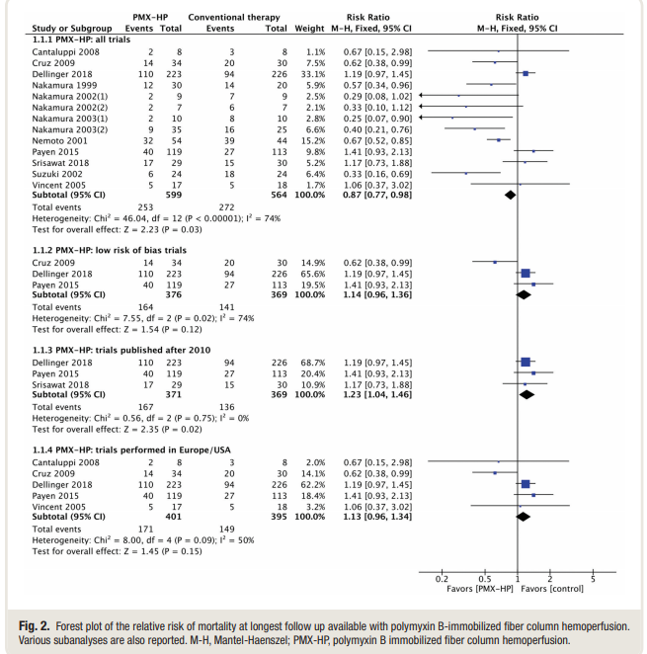

## Forest plot for mortality, other therapies

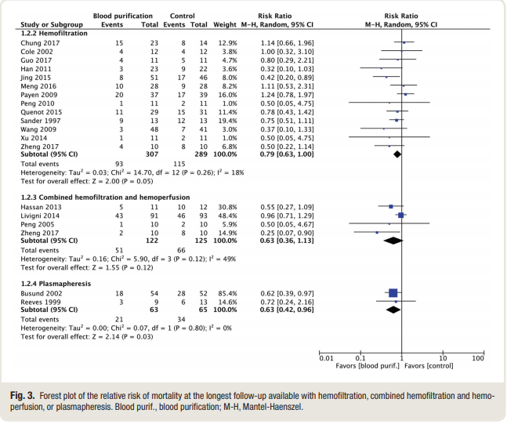

## Evidence profile: Hemoperfusion therapy compared to no hemoperfusion for patients with sepsis

Setting: hospitalized patients

Bibliography: Putzu A, Schorer R, Lopez-Delgado JC, et al. Blood purification and mortality in sepsis and septic shock: a systematic review and meta-analysis of randomized trials. Anesthesiology 2019;131:580-93 (mortality) Fuji T, Ganeko R, Kataoka Y, et. al. Polymyxin-B-immobilized hemoperfusion and mortality in critically ill adult patients with sepsis/septic shock: a systematic review with meta-analysis and trial sequential analysis. Intensive Care med 2018;44:167-78 (organ dysfunction, vasopressor-free days)

|  |  |  |  |  |  |  |  |  |  |  |  |  |
| --- | --- | --- | --- | --- | --- | --- | --- | --- | --- | --- | --- | --- |
| Quality assessment | | | | | | | № of patients | | Effect | | Quality | Importance |
| № of studies | Study design | Risk of bias | Inconsistency | Indirectness | Imprecision | Other considerations | hemoperfusion therapy | no hemoperfusion | Relative (95% CI) | Absolute (95% CI) |
| Mortality (follow up: longest) | | | | | | | | | | | | |
| 13 | randomised trials | serious a | serious b | serious c | not serious | publication bias strongly suspected d | 319/798 (40.0%) | 347/772 (44.9%) | RR 0.87 (0.78 to 0.98) | 58 fewer per 1,000 (from 99 fewer to 9 fewer) | ⨁◯◯◯ VERY LOW | CRITICAL |
| Mortality, low risk of bias studies (follow up: longest) | | | | | | | | | | | | |
| 3 | randomised trials | not serious | serious b | not serious | serious e | none | 164/376 (43.6%) | 141/369 (38.2%) | RR 1.14 (0.96 to 1.36) | 53 more per 1,000 (from 15 fewer to 138 more) | ⨁⨁◯◯ LOW |  |
| Organ failure (assessed with: SOFA & MODS scores) | | | | | | | | | | | | |
| 5 | randomised trials | serious f | not serious | not serious | serious e | none |  |  | - | SMD 0.26 SD lower (0.64 lower to 0.12 higher) | ⨁⨁◯◯ LOW | IMPORTANT |
| Vasopressor-free days (n=283 participants) | | | | | | | | | | | | |
| 3 | randomised trials | serious f | not serious | not serious | very serious e | none |  |  | - | MD 1.1 days lower (4.05 lower to 1.85 higher) | ⨁◯◯◯ VERY LOW | IMPORTANT |

CI: Confidence interval; RR: Risk ratio; SMD: Standardised mean difference; MD: Mean difference

#### Explanations

a. Authors cited high risk of bias using Cochrane criteria.

b. I-squared 74%.

c. Previously published abstract: results mainly "Influenced by polymyxin B hemoperfusion trials from Asia." Authors downGRADE in full publication for indirectness.

d. Authors pointed to publication bias.

e. 95 % confidence interval embraces harm and benefit.

f. DownGRADE for risk of bias by Fuji, et al.

## EtD: Summary of Judgements Hemoperfusion in Sepsis Recommendation

|  | Judgement | | | | | | |
| --- | --- | --- | --- | --- | --- | --- | --- |
| Problem | No | Probably no | Probably yes | Yes |  | Varies | Don't know |
| Desirable Effects | Trivial | Small | Moderate | Large |  | Varies | Don't know |
| Undesirable Effects | Large | Moderate | Small | Trivial |  | Varies | Don't know |
| Qualityof evidence | Very low | Low | Moderate | High |  |  | No included studies |
| Values | Important uncertainty or variability | Possibly important uncertainty or variability | Probably no important uncertainty or variability | No important uncertainty or variability |  |  |  |
| Balance of effects | Favors the comparison | Probably favors the comparison | Does not favor either the intervention or the comparison | Probably favors the intervention | Favors the intervention | Varies | Don't know |
| Resources required | Large costs | Moderate costs | Negligible costs and savings | Moderate savings | Large savings | Varies | Don't know |
| Qualityof evidence of required resources | Very low | Low | Moderate | High |  |  | No included studies |
| Cost effectiveness | Favors the comparison | Probably favors the comparison | Does not favor either the intervention or the comparison | Probably favors the intervention | Favors the intervention | Varies | No included studies |
| Equity | Reduced | Probably reduced | Probably no impact | Probably increased | Increased | Varies | Don't know |
| Acceptability | No | Probably no | Probably yes | Yes |  | Varies | Don't know |
| Feasibility | No | Probably no | Probably yes | Yes |  | Varies | Don't know |

## Type of Recommendation

|  |  |  |  |  |
| --- | --- | --- | --- | --- |
| Strong recommendation against the intervention | Conditional recommendation against the intervention | Conditional recommendation for either the intervention or the comparison | Conditional recommendation for the intervention | Strong recommendation for the intervention |
| ○ | ● | ○ | ○ | ○ |

# 60. In adults with sepsis, should we use a restrictive transfusion strategy versus liberal transfusion?

## Forest plot for 28-30 day mortality:

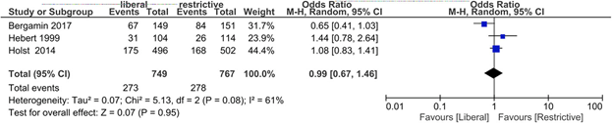

## Forest plot for 90 day mortality:

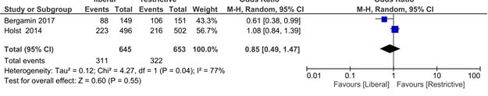

## Forest plot for 28-30 day mortality, excluding Bergamin:

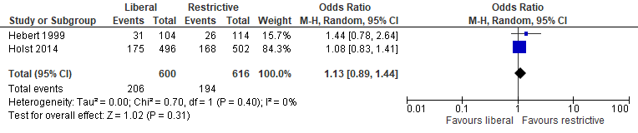

## Forest plot for 90 day mortality, excluding Bergamin:

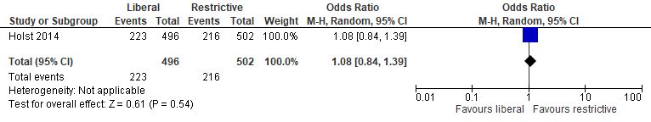

## Evidence profile : A restrictive transfusion strategy (defined as a hemoglobin concentration trigger for transfusion of 70-80 g/L) compared to liberal transfusion for patients with sepsis

Setting: hospitalized patients

Bibliography: Hirano y, Miyoshi Y, Okamoto, et. al. Liberal versus restrictive red blood cell transfusion strategy in sepsis or septic shock: a systematic review and meta-analysis of randomized trials. Critical Care 2019;23:262 (mortality, patients transfused)

|  |  |  |  |  |  |  |  |  |  |  |  |  |
| --- | --- | --- | --- | --- | --- | --- | --- | --- | --- | --- | --- | --- |
| Quality assessment | | | | | | | № of patients | | Effect | | Quality | Importance |
| № of studies | Study design | Risk of bias | Inconsistency | Indirectness | Imprecision | Other considerations | a restrictive transfusion strategy (defined as a hemoglobin concentration trigger for transfusion of 70-80 g/L) | liberal transfusion | Relative (95% CI) | Absolute (95% CI) |
| Mortality (follow up: mean 30 days) | | | | | | | | | | | | |
| 3 | randomised trials | not serious a | not serious b | not serious | serious c | none | 278/767 (36.2%) | 273/749 (36.4%) | RR 0.99 (0.67 to 1.46) | 4 fewer per 1,000 (from 120 fewer to 168 more) | ⨁⨁⨁◯ MODERATE | CRITICAL |
| Mortality (follow up: 90 days) | | | | | | | | | | | | |
| 2 | randomised trials | not serious a | serious d | not serious | serious c | none | 322/653 (49.3%) | 311/645 (48.2%) | RR 0.85 (0.49 to 1.47) | 72 fewer per 1,000 (from 246 fewer to 227 more) | ⨁⨁◯◯ LOW | CRITICAL |
| Number of patients transfused (PRBCs) (1277 participants) | | | | | | | | | | | | |
| 2 | randomised trials | not serious a | not serious e | serious f | serious g | none |  |  | OR 9.94 (0.39 to 250.88) | 10 fewer per 1,000 (from 251 fewer to 0 fewer) | ⨁⨁◯◯ LOW | IMPORTANT |

CI: Confidence interval; RR: Risk ratio; OR: Odds ratio

#### Explanations

a. Partial blinding. Not downGRADEd.

b. I-squared 63%. One trial (Bergamin 2017) was a single-center study of cancer sepsis patients with a high control group mortality, many of whom were not anemic. 40% of the patients in the liberal group were not transfused. Excluding this study maintains no effect (RR 1.13[0.89,1.44]) and eliminates heterogeneity. Not downGRADEd.

c. 95% confidence interval embraces benefit and modest harm.

d. I-squared 77%.

e. I-squared 98%.

f. Authors of Hirano meta-analysis downGRADEd by 1 for indirectness for different populations in studies.

g. 95% confidence interval broad, but not downGRADEd as already low quality.

## EtD: Summary of Judgements for Restrictive Transfusion Recommendation

|  | Judgement | | | | | | |
| --- | --- | --- | --- | --- | --- | --- | --- |
| Problem | No | Probably no | Probably yes | Yes |  | Varies | Don't know |
| Desirable Effects | Trivial | Small | Moderate | Large |  | Varies | Don't know |
| Undesirable Effects | Large | Moderate | Small | Trivial |  | Varies | Don't know |
| Qualityof evidence | Very low | Low | Moderate | High |  |  | No included studies |
| Values | Important uncertainty or variability | Possibly important uncertainty or variability | Probably no important uncertainty or variability | No important uncertainty or variability |  |  |  |
| Balance of effects | Favors the comparison | Probably favors the comparison | Does not favor either the intervention or the comparison | Probably favors the intervention | Favors the intervention | Varies | Don't know |
| Resources required | Large costs | Moderate costs | Negligible costs and savings | Moderate savings | Large savings | Varies | Don't know |
| Qualityof evidence of required resources | Very low | Low | Moderate | High |  |  | No included studies |
| Cost effectiveness | Favors the comparison | Probably favors the comparison | Does not favor either the intervention or the comparison | Probably favors the intervention | Favors the intervention | Varies | No included studies |
| Equity | Reduced | Probably reduced | Probably no impact | Probably increased | Increased | Varies | Don't know |
| Acceptability | No | Probably no | Probably yes | Yes |  | Varies | Don't know |
| Feasibility | No | Probably no | Probably yes | Yes |  | Varies | Don't know |

## Type of Recommendation

|  |  |  |  |  |
| --- | --- | --- | --- | --- |
| Strong recommendation against the intervention | Conditional recommendation against the intervention | Conditional recommendation for either the intervention or the comparison | Conditional recommendation for the intervention | Strong recommendation for the intervention |
| ○ | ○ | ○ | ● | ○ |

# 61. In adults with sepsis or septic shock, should we use intravenous immunoglobulins (versus not)?

## Forest plot for mortality (all immunoglobulins):

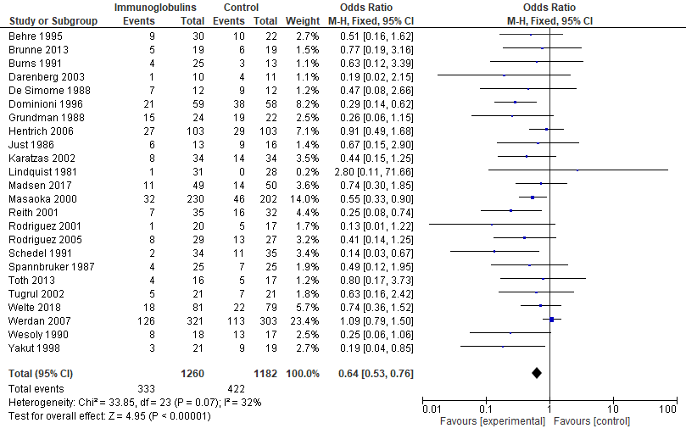

## Forest plot for mortality (Polyclonal IVIG):

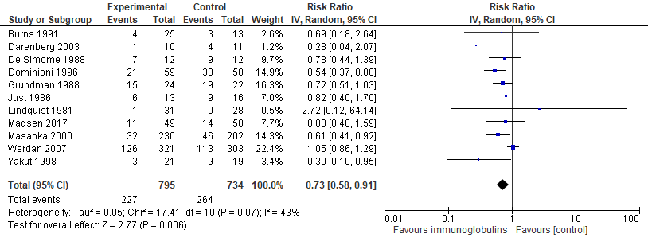

## Forest plot for mortality, IgM-enriched IVIG:

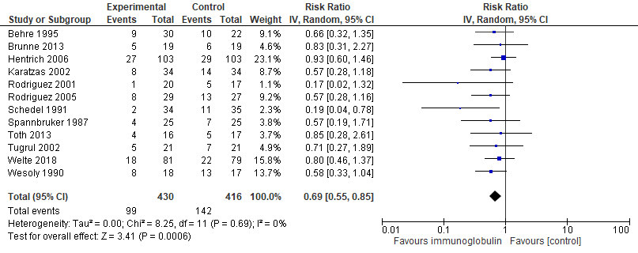

## Forest plot for mortality, low risk of bias studies:

Standard IVIG:

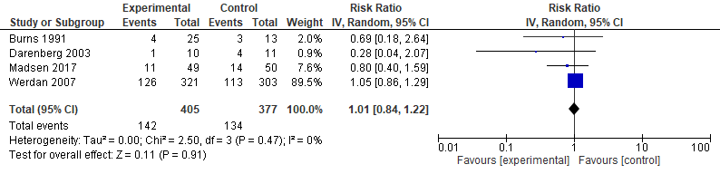

IgM-enriched IVIG:

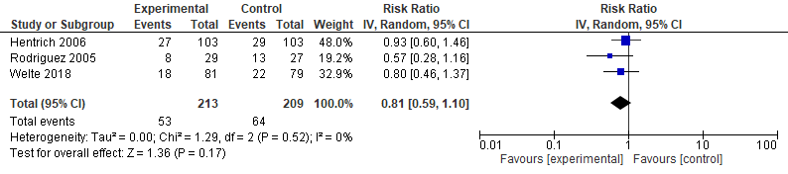

## Evidence profile: Intravenous immunoglobulins compared to not for adult patients with sepsis or septic shock

Setting: hospitalized patients

Bibliography: Alejandria MM, Lansang MAD, Mantaring III JB. Intravenous immunoglobulin for treating sepsis, severe sepsis and septic shock (review). Cochrane Database of Systematic Reviews 2013;9: CD001090 Busani S, Damiani E, Cavazzuti I, et al. Intravenous immunoglobulin in septic shock: review of the mechanisms of action and meta-analysis of the clinical effectiveness. Minerva Anestesiologica 2016;8(5):559-72 Madsen MB, Hjortrup PB, Hansen MB, et al. Immunoglobulin G for patients with nectrotising soft tissue infection (INSTINCT): a randomised, blinded, placebo-controlled trial. Intensive Care med 2017;43:1585-93 Welte T, Dellinger RP, Ebelt H, et. al. Efficacy and safety of trimodulin, a novel polyclonal antibody preparation, in patients with severe community-acquired pneumonia: a randomized, placebo-controlled, double-blind, multicenter, phase II trial (CIGMA study). Intesive Care med 2018;44:438-448

|  |  |  |  |  |  |  |  |  |  |  |  |  |
| --- | --- | --- | --- | --- | --- | --- | --- | --- | --- | --- | --- | --- |
| Quality assessment | | | | | | | № of patients | | Effect | | Quality | Importance |
| № of studies | Study design | Risk of bias | Inconsistency | Indirectness | Imprecision | Other considerations | intravenous immunoglobulins | not | Relative (95% CI) | Absolute (95% CI) |
| Mortality (all immunoglobulins) | | | | | | | | | | | | |
| 24 | randomised trials | not serious a | serious b | not serious c | not serious | publication bias strongly suspected d | 333/1260 (26.4%) | 422/1182 (35.7%) | RR 0.64 (0.53 to 0.76) | 129 fewer per 1,000 (from 168 fewer to 86 fewer) | ⨁⨁◯◯ LOW | CRITICAL |
| Mortality - IVIG | | | | | | | | | | | | |
| 11 | randomised trials | not serious a | serious e | not serious | not serious | publication bias strongly suspected d | 227/795 (28.6%) | 264/734 (36.0%) | RR 0.73 (0.58 to 0.91) | 97 fewer per 1,000 (from 151 fewer to 32 fewer) | ⨁⨁◯◯ LOW | CRITICAL |
| Mortality - IGM-enriched IVIG | | | | | | | | | | | | |
| 12 | randomised trials | not serious | not serious | not serious | not serious | publication bias strongly suspected d | 99/430 (23.0%) | 142/416 (34.1%) | RR 0.69 (0.55 to 0.85) | 106 fewer per 1,000 (from 154 fewer to 51 fewer) | ⨁⨁⨁◯ MODERATE | CRITICAL |
| Organ failure | | | | | | | | | | | | |
| 1 | randomised trials | not serious | not serious | not serious | serious f | none | 81 | 79 | - | median 0 points  (0 to 3 more) | ⨁⨁⨁◯ MODERATE | IMPORTANT |

CI: Confidence interval; RR: Risk ratio

#### Explanations

a. Risk may be important. From Busani et al: 4 studies Jadad score of 5, 7 studies 3, 7 studies </=2. Cochrane analysis of low risk of bias studies (RR: 0.94[0.74,1.18], I-squared 12%.

b. I-squared 32%. Authors note heterogeneity in type, dose and control across studies.

c. IgM-enriched antibodies, basic therapy and albumin as comparators.

d. Funnel plot asymmetry in Cochrane analysis. Single-center trials, those with unclear allocation concealment and industry sponsorship showed a greater reduction in mortality in Busani study.

e. I-squared 43%. Authors note heterogeneity in type, dose and control across studies.

f. 95% confidence interval embraces benefit and harm.

## EtD: Summary of Judgments Immunoglobulins in sepsis

|  | Judgement | | | | | | |
| --- | --- | --- | --- | --- | --- | --- | --- |
| Problem | No | Probably no | Probably yes | Yes |  | Varies | Don't know |
| Desirable Effects | Trivial | Small | Moderate | Large |  | Varies | Don't know |
| Undesirable Effects | Large | Moderate | Small | Trivial |  | Varies | Don't know |
| Quality of evidence | Very low | Low | Moderate | High |  |  | No included studies |
| Values | Important uncertainty or variability | Possibly important uncertainty or variability | Probably no important uncertainty or variability | No important uncertainty or variability |  |  |  |
| Balance of effects | Favors the comparison | Probably favors the comparison | Does not favor either the intervention or the comparison | Probably favors the intervention | Favors the intervention | Varies | Don't know |
| Resources required | Large costs | Moderate costs | Negligible costs and savings | Moderate savings | Large savings | Varies | Don't know |
| Qualityof evidence of required resources | Very low | Low | Moderate | High |  |  | No included studies |
| Cost effectiveness | Favors the comparison | Probably favors the comparison | Does not favor either the intervention or the comparison | Probably favors the intervention | Favors the intervention | Varies | No included studies |
| Equity | Reduced | Probably reduced | Probably no impact | Probably increased | Increased | Varies | Don't know |
| Acceptability | No | Probably no | Probably yes | Yes |  | Varies | Don't know |
| Feasibility | No | Probably no | Probably yes | Yes |  | Varies | Don't know |

## Type of Recommendation

|  |  |  |  |  |
| --- | --- | --- | --- | --- |
| Strong recommendation against the intervention | Conditional recommendation against the intervention | Conditional recommendation for either the intervention or the comparison | Conditional recommendation for the intervention | Strong recommendation for the intervention |
| ○ | ● | ○ | ○ | ○ |

62. In adults with sepsis or septic shock, should we use stress ulcer prophylaxis?

Mortality, all trials:

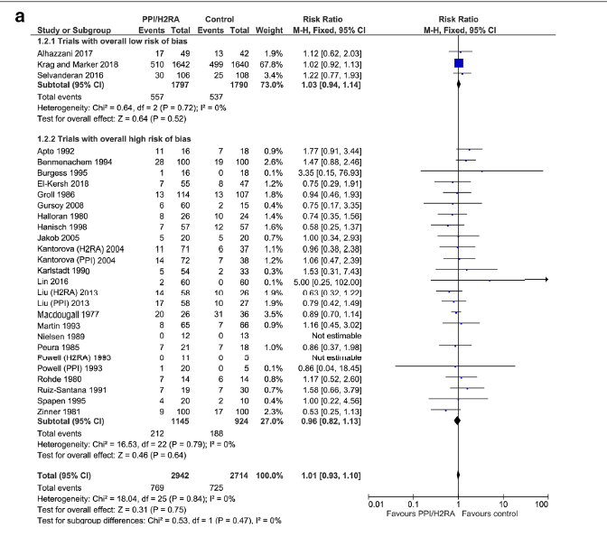

Author(s): Mark E. Nunnally, Craig French

Question: Stress ulcer prophylaxis compared to no prophylaxis for critically ill septic patients

Setting: hospitalized patients

Bibliography: Barbatesekovic M, Marker S, Granholm A, et a;. Stress ulcer prophylaxis with proton pump inhibitors or histamin-2 receptor antagonists in adult intensive care patients: a systematic review with meta-analysis and trial sequential analysis. Intensive Care med 2019;45:143-58

|  |  |  |  |  |  |  |  |  |  |  |  |  |
| --- | --- | --- | --- | --- | --- | --- | --- | --- | --- | --- | --- | --- |
| Quality assessment | | | | | | | № of patients | | Effect | | Quality | Importance |
| № of studies | Study design | Risk of bias | Inconsistency | Indirectness | Imprecision | Other considerations | stress ulcer prophylaxis | no prophylaxis | Relative (95% CI) | Absolute (95% CI) |
| Mortality (5656 participants) | | | | | | | | | | | | |
| 28 | randomised trials | not serious a | not serious | not serious | not serious | none | 769/2942 (26.1%) | 725/2714 (26.7%) | RR 1.01 (0.93 to 1.10) | 3 more per 1,000 (from 19 fewer to 27 more) | ⨁⨁⨁⨁ HIGH | CRITICAL |
| Gastrointestinal hemorrhage (6627 participants) | | | | | | | | | | | | |
| 39 | randomised trials | not serious a,b | serious c | not serious | not serious | none | 395/3223 (12.3%) | 218/3404 (6.4%) | RR 0.52 (0.45 to 0.61) | 31 fewer per 1,000 (from 35 fewer to 25 fewer) | ⨁⨁⨁◯ MODERATE | IMPORTANT |
| Clostridiodes difficile colitis | | | | | | | | | | | | |
| 3 | randomised trials | not serious d | not serious | not serious e | very serious f | none | 22/1799 (1.2%) | 26/1797 (1.4%) | RR 0.84 (0.48 to 1.47) | 2 fewer per 1,000 (from 8 fewer to 7 more) | ⨁⨁◯◯ LOW | IMPORTANT |
| Pneumonia (4951 participants) | | | | | | | | | | | | |
| 16 | randomised trials | serious g | not serious | not serious | serious h | none | 400/2250 (17.8%) | 358/2401 (14.9%) | RR 1.07 (0.94 to 1.21) | 10 more per 1,000 (from 9 fewer to 31 more) | ⨁⨁◯◯ LOW | IMPORTANT |

CI: Confidence interval; RR: Risk ratio

#### Explanations

a. Sensitivity analysis of low risk of bias trials gave nearly the same estimate of effect (RR 0.60 [0.47,0.77]).

b. 36 of 39 trials judged to have high risk of bias by authors.

c. I-squared 43%. Excluding high risk trials reduces I-square to 0% with not real change in effect.

d. Low risk of bias trials (3 of 4) used, as some might consider the effect difference significant (all trials: RR 0.78 [0.46,1.34]).

e. All trials PPI versus placebo.

f. 95% confidence interval embrace benefit and harm. 48 total events. TSA not possible according to authors.

g. Many trials at high risk of bias.

h. 95% confidence interval embraces harm and benefit.

# EtD: Summary of Judgements on The Stress Ulcer Prophylaxis

|  | Judgement | | | | | | |
| --- | --- | --- | --- | --- | --- | --- | --- |
| Problem | No | Probably no | Probably yes | Yes |  | Varies | Don't know |
| Desirable Effects | Trivial | Small | Moderate | Large |  | Varies | Don't know |
| Undesirable Effects | Large | Moderate | Small | Trivial |  | Varies | Don't know |
| Qualityof evidence | Very low | Low | Moderate | High |  |  | No included studies |
| Values | Important uncertainty or variability | Possibly important uncertainty or variability | Probably no important uncertainty or variability | No important uncertainty or variability |  |  |  |
| Balance of effects | Favors the comparison | Probably favors the comparison | Does not favor either the intervention or the comparison | Probably favors the intervention | Favors the intervention | Varies | Don't know |
| Resources required | Large costs | Moderate costs | Negligible costs and savings | Moderate savings | Large savings | Varies | Don't know |
| Qualityof evidence of required resources | Very low | Low | Moderate | High |  |  | No included studies |
| Cost effectiveness | Favors the comparison | Probably favors the comparison | Does not favor either the intervention or the comparison | Probably favors the intervention | Favors the intervention | Varies | No included studies |
| Equity | Reduced | Probably reduced | Probably no impact | Probably increased | Increased | Varies | Don't know |
| Acceptability | No | Probably no | Probably yes | Yes |  | Varies | Don't know |
| Feasibility | No | Probably no | Probably yes | Yes |  | Varies | Don't know |

# Type of Recommendation

|  |  |  |  |  |
| --- | --- | --- | --- | --- |
| Strong recommendation against the intervention | Conditional recommendation against the intervention | Conditional recommendation for either the intervention or the comparison | Conditional recommendation for the intervention | Strong recommendation for the intervention |
| ○ | ○ | ○ | ● | ○ |

# 63. In adults with sepsis or septic shock, should we use pharmacologic VTE prophylaxis (UFH or LMWH)?

## Forest plot for critical outcomes

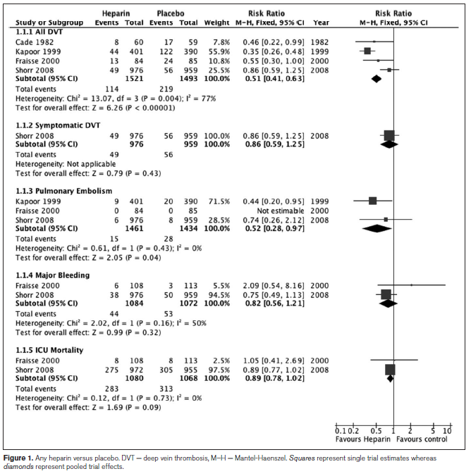

## Evidence profile: Pharmacologic venous thromboembolism prophylaxis (unfractionated heparin or low-molecular weight heparin) compared to no prophylaxis for critically ill patients with sepsis or septic shock

Setting: hospitalized patients

Bibliography: Alhazzani W, Lim W, Jaeshke R, et al. Heparin thromboprophylaxis in medical-surgical critically ill patients: a systematic review and meta-analysis of randomized trials. Crit Care Med 2013;41(9):2088-98

|  |  |  |  |  |  |  |  |  |  |  |  |  |
| --- | --- | --- | --- | --- | --- | --- | --- | --- | --- | --- | --- | --- |
| Quality assessment | | | | | | | № of patients | | Effect | | Quality | Importance |
| № of studies | Study design | Risk of bias | Inconsistency | Indirectness | Imprecision | Other considerations | pharmacologic venous thromboembolism prophylaxis (unfractionated heparin or low-molecular weight heparin) | no prophylaxis | Relative (95% CI) | Absolute (95% CI) |
| ICU Mortality | | | | | | | | | | | | |
| 2 | randomised trials | not serious | not serious | not serious | serious a | none | 283/1080 (26.2%) | 313/1068 (29.3%) | RR 0.89 (0.78 to 1.02) | 32 fewer per 1,000 (from 64 fewer to 6 more) | ⨁⨁⨁◯ MODERATE | CRITICAL |
| Pulmonary embolism | | | | | | | | | | | | |
| 3 | randomised trials | not serious | not serious | not serious | serious b | none | 15/1461 (1.0%) | 28/1434 (2.0%) | RR 0.52 (0.28 to 0.97) | 9 fewer per 1,000 (from 14 fewer to 1 fewer) | ⨁⨁⨁◯ MODERATE | CRITICAL |
| Deep venous thrombosis | | | | | | | | | | | | |
| 4 | randomised trials | not serious | serious c | serious d | not serious | none | 114/1521 (7.5%) | 219/1493 (14.7%) | RR 0.52 (0.41 to 0.63) | 70 fewer per 1,000 (from 87 fewer to 54 fewer) | ⨁⨁◯◯ LOW | CRITICAL |
| Bleeding | | | | | | | | | | | | |
| 2 | randomised trials | not serious | serious e | not serious | serious f | none | 44/1084 (4.1%) | 53/1072 (4.9%) | RR 0.82 (0.56 to 1.21) | 9 fewer per 1,000 (from 22 fewer to 10 more) | ⨁⨁◯◯ LOW | CRITICAL |

CI: Confidence interval; RR: Risk ratio

#### Explanations

a. 95% confidence interval includes no effect.

b. 43 total events.

c. I-squared 77%.

d. One trial assessed symptomatic DVT only (1935 participants). Authors downGRADEd for inconsistency.

e. I-squared 50%.

f. 95% confidence interval includes harm and benefit.

## EtD: Summary of Judgements VTE Prophylaxis

|  | Judgement | | | | | | |
| --- | --- | --- | --- | --- | --- | --- | --- |
| Problem | No | Probably no | Probably yes | Yes |  | Varies | Don't know |
| Desirable Effects | Trivial | Small | Moderate | Large |  | Varies | Don't know |
| Undesirable Effects | Large | Moderate | Small | Trivial |  | Varies | Don't know |
| Qualityof evidence | Very low | Low | Moderate | High |  |  | No included studies |
| Values | Important uncertainty or variability | Possibly important uncertainty or variability | Probably no important uncertainty or variability | No important uncertainty or variability |  |  |  |
| Balance of effects | Favors the comparison | Probably favors the comparison | Does not favor either the intervention or the comparison | Probably favors the intervention | Favors the intervention | Varies | Don't know |
| Resources required | Large costs | Moderate costs | Negligible costs and savings | Moderate savings | Large savings | Varies | Don't know |
| Qualityof evidence of required resources | Very low | Low | Moderate | High |  |  | No included studies |
| Cost effectiveness | Favors the comparison | Probably favors the comparison | Does not favor either the intervention or the comparison | Probably favors the intervention | Favors the intervention | Varies | No included studies |
| Equity | Reduced | Probably reduced | Probably no impact | Probably increased | Increased | Varies | Don't know |
| Acceptability | No | Probably no | Probably yes | Yes |  | Varies | Don't know |
| Feasibility | No | Probably no | Probably yes | Yes |  | Varies | Don't know |

## Type of Recommendation

|  |  |  |  |  |
| --- | --- | --- | --- | --- |
| Strong recommendation against the intervention | Conditional recommendation against the intervention | Conditional recommendation for either the intervention or the comparison | Conditional recommendation for the intervention | Strong recommendation for the intervention |
| ○ | ○ | ○ | ○ | ● |

# 64. In adults with sepsis or septic shock, should we use LMWH (versus UFH) for VTE prophylaxis?

## Forest plot for key outcomes

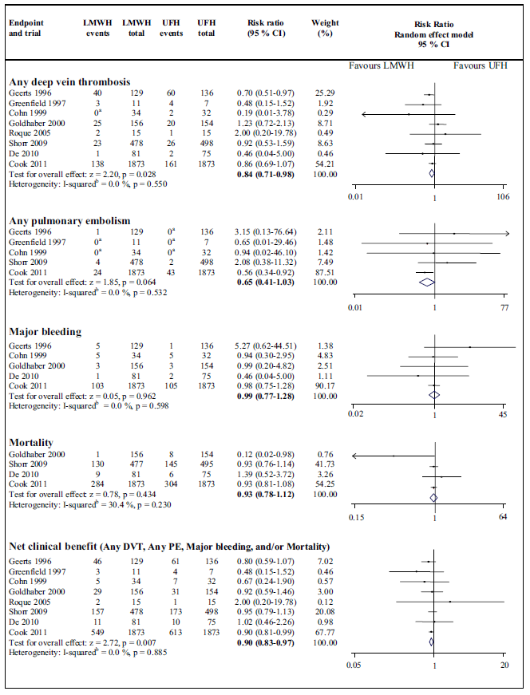

## Evidence profile: Low-molecular weight heparin compared to unfractionated heparin for venous thromboembolism prophylaxis in critically ill patients with sepsis or septic shock

Setting: hospitalized patients

Bibliography: Beitland S, Sandven I, Kjaervik, wt. al. Thromboprophylaxis with low molecular weight heparin versus unfractionated heparin in intensive care patients: a systematic review with meta-analysis and trial sequential analysis. Intensive Care Med 2015;41:1209-19

|  |  |  |  |  |  |  |  |  |  |  |  |  |
| --- | --- | --- | --- | --- | --- | --- | --- | --- | --- | --- | --- | --- |
| Quality assessment | | | | | | | № of patients | | Effect | | Quality | Importance |
| № of studies | Study design | Risk of bias | Inconsistency | Indirectness | Imprecision | Other considerations | low-molecular weight heparin | unfractionated heparin | Relative (95% CI) | Absolute (95% CI) |
| Mortality | | | | | | | | | | | | |
| 4 | randomised trials | not serious | not serious a | not serious b | serious c | none | 424/2587 (16.4%) | 463/2597 (17.8%) | RR 0.93 (0.78 to 1.12) | 12 fewer per 1,000 (from 39 fewer to 21 more) | ⨁⨁⨁◯ MODERATE | CRITICAL |
| Pulmonary embolism | | | | | | | | | | | | |
| 5 | randomised trials | not serious | not serious | not serious b | serious d | none | 29/2525 (1.1%) | 45/2546 (1.8%) | RR 0.65 (0.41 to 1.03) | 6 fewer per 1,000 (from 10 fewer to 1 more) | ⨁⨁⨁◯ MODERATE | CRITICAL |
| Deep venous thrombosis | | | | | | | | | | | | |
| 8 | randomised trials | not serious | not serious | not serious b | serious e | none | 232/2777 (8.4%) | 276/2790 (9.9%) | RR 0.84 (0.71 to 0.98) | 16 fewer per 1,000 (from 29 fewer to 2 fewer) | ⨁⨁⨁◯ MODERATE | CRITICAL |
| Bleeding | | | | | | | | | | | | |
| 5 | randomised trials | not serious | not serious | not serious b | serious f | none | 117/2273 (5.1%) | 116/2270 (5.1%) | RR 0.99 (0.77 to 1.28) | 1 fewer per 1,000 (from 12 fewer to 14 more) | ⨁⨁⨁◯ MODERATE | CRITICAL |

CI: Confidence interval; RR: Risk ratio

#### Explanations

a. I-squared 30.4%.

b. Study of all ICU patients, not sepsis-specific.

c. 95% confidence interval embraces harm and benefit.

d. 74 total events, 95% confidence interval includes no difference.

e. 95% confidence interval includes differences that are likely not clinically significant.

f. 95% confidence interval includes significant harm and benefit.

## EtD: Summary of Judgements for Pharmacologic Prophylaxis

|  | Judgement | | | | | | |
| --- | --- | --- | --- | --- | --- | --- | --- |
| Problem | No | Probably no | Probably yes | Yes |  | Varies | Don't know |
| Desirable Effects | Trivial | Small | Moderate | Large |  | Varies | Don't know |
| Undesirable Effects | Large | Moderate | Small | Trivial |  | Varies | Don't know |
| Qualityof evidence | Very low | Low | Moderate | High |  |  | No included studies |
| Values | Important uncertainty or variability | Possibly important uncertainty or variability | Probably no important uncertainty or variability | No important uncertainty or variability |  |  |  |
| Balance of effects | Favors the comparison | Probably favors the comparison | Does not favor either the intervention or the comparison | Probably favors the intervention | Favors the intervention | Varies | Don't know |
| Resources required | Large costs | Moderate costs | Negligible costs and savings | Moderate savings | Large savings | Varies | Don't know |
| Qualityof evidence of required resources | Very low | Low | Moderate | High |  |  | No included studies |
| Cost effectiveness | Favors the comparison | Probably favors the comparison | Does not favor either the intervention or the comparison | Probably favors the intervention | Favors the intervention | Varies | No included studies |
| Equity | Reduced | Probably reduced | Probably no impact | Probably increased | Increased | Varies | Don't know |
| Acceptability | No | Probably no | Probably yes | Yes |  | Varies | Don't know |
| Feasibility | No | Probably no | Probably yes | Yes |  | Varies | Don't know |

## Type of Recommendation

|  |  |  |  |  |
| --- | --- | --- | --- | --- |
| Strong recommendation against the intervention | Conditional recommendation against the intervention | Conditional recommendation for either the intervention or the comparison | Conditional recommendation for the intervention | Strong recommendation for the intervention |
| ○ | ○ | ○ | ○ | ● |

# 65. In adults with sepsis or septic shock, should we use mechanical venous thromboembolism prophylaxis?

## Evidence profile: Mechanical venous thromboembolism prophylaxis compared to no prophylaxis for critically ill patients with sepsis or septic shock

Setting: hospitalized patients

Bibliography: Arabi YM, Al-Hameed F, Burns KEA, et al. Adjunctive intermittent pneumatic compression for venous thromboprophylaxis. New Eng J Med 2019;380(14):1305-15

|  |  |  |  |  |  |  |  |  |  |  |  |  |
| --- | --- | --- | --- | --- | --- | --- | --- | --- | --- | --- | --- | --- |
| Quality assessment | | | | | | | № of patients | | Effect | | Quality | Importance |
| № of studies | Study design | Risk of bias | Inconsistency | Indirectness | Imprecision | Other considerations | mechanical venous thrombolembolism prophylaxis | no prophylaxis | Relative (95% CI) | Absolute (95% CI) |
| Pulmonary embolism | | | | | | | | | | | | |
| 1 | randomised trials | not serious a | not serious | not serious b | very serious c | none | 8/991 (0.8%) | 10/1012 (1.0%) | RR 0.82 (0.32 to 2.06) | 2 fewer per 1,000 (from 7 fewer to 10 more) | ⨁⨁◯◯ LOW | CRITICAL |
| Mortality (follow up: 90 days) | | | | | | | | | | | | |
| 1 | randomised trials | not serious a | not serious | not serious b | serious d | none | 258/990 (26.1%) | 270/1011 (26.7%) | RR 0.98 (0.84 to 1.13) | 5 fewer per 1,000 (from 43 fewer to 35 more) | ⨁⨁⨁◯ MODERATE | CRITICAL |
| Deep venous thrombosis | | | | | | | | | | | | |
| 1 | randomised trials | not serious a | not serious | not serious b | serious d | none | 37/957 (3.9%) | 41/985 (4.2%) | RR 0.93 (0.60 to 1.44) | 3 fewer per 1,000 (from 17 fewer to 18 more) | ⨁⨁⨁◯ MODERATE | CRITICAL |
| Extremity ischemia (all toes, foot and leg summed) | | | | | | | | | | | | |
| 1 | randomised trials | not serious a | not serious | not serious b | very serious e | none | 8/991 (0.8%) | 14/1012 (1.4%) | RR 0.63 (0.26 to 1.51) | 5 fewer per 1,000 (from 10 fewer to 7 more) f | ⨁⨁◯◯ LOW | IMPORTANT |

CI: Confidence interval; RR: Risk ratio

#### Explanations

a. Unblinded for treating clinicians and ultrasonographers. Not GRADEd down.

b. All ICU patients, not sepsis-specific. About 78% of patients medical.

c. 18 total events. Wide 95% confidence intervals include substantial harm and benefit.

d. 95% confidence interval embraces benefit and harm.

e. 22 total events. 95% confidence interval includes substantial harm and benefits.

f. RR and confidence interval calculated from RevMan.

## EtD: Summary of Judgements for Mechanical Prophylaxis Recommendation

|  | Judgement | | | | | | |
| --- | --- | --- | --- | --- | --- | --- | --- |
| Problem | No | Probably no | Probably yes | Yes |  | Varies | Don't know |
| Desirable Effects | Trivial | Small | Moderate | Large |  | Varies | Don't know |
| Undesirable Effects | Large | Moderate | Small | Trivial |  | Varies | Don't know |
| Qualityof evidence | Very low | Low | Moderate | High |  |  | No included studies |
| Values | Important uncertainty or variability | Possibly important uncertainty or variability | Probably no important uncertainty or variability | No important uncertainty or variability |  |  |  |
| Balance of effects | Favors the comparison | Probably favors the comparison | Does not favor either the intervention or the comparison | Probably favors the intervention | Favors the intervention | Varies | Don't know |
| Resources required | Large costs | Moderate costs | Negligible costs and savings | Moderate savings | Large savings | Varies | Don't know |
| Qualityof evidence of required resources | Very low | Low | Moderate | High |  |  | No included studies |
| Cost effectiveness | Favors the comparison | Probably favors the comparison | Does not favor either the intervention or the comparison | Probably favors the intervention | Favors the intervention | Varies | No included studies |
| Equity | Reduced | Probably reduced | Probably no impact | Probably increased | Increased | Varies | Don't know |
| Acceptability | No | Probably no | Probably yes | Yes |  | Varies | Don't know |
| Feasibility | No | Probably no | Probably yes | Yes |  | Varies | Don't know |

## Type of Recommendation

|  |  |  |  |  |
| --- | --- | --- | --- | --- |
| Strong recommendation against the intervention | Conditional recommendation against the intervention | Conditional recommendation for either the intervention or the comparison | Conditional recommendation for the intervention | Strong recommendation for the intervention |
| ○ | ● | ○ | ○ | ○ |

# 67. In adults with sepsis and indication for hemodialysis, should we use CRRT versus intermittent hemodialysis?

## Forest plot for mortality

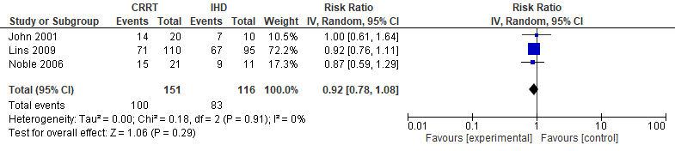

## Evidence profile: Continuous renal replacement therapy compared to intermittent hemodialysis for patients with sepsis and indication for hemodialysis

Setting: hospitalized patients

Bibliography: 1. John S, Griesbach D, Baumgartel M, et.al. Effects of continuous haemofiltration vs, intermittent haemodialysis on systemic haemodynamics and splanchnic regional perfusion in septic shock patients: a prospective, randomized clinical trial. Nephrology Dialysis Transplantation 2001;16:320-27 (mortality, vasopressor dose) 2. Lins R, Elseviers MM, Van der Niepan P, et. al. Intermittent versus continuous renal replacement therapy for acute kidney injury patients admitted to the intensive care unit: results of a randomized clinical trial. Nephrology Dialysis Transplantation 2009;24:512-18 (mortality, renal recovery) 3. Noble JSC, Simpson K, Allison MEM. Long-term quality of life and hospital mortality in patients treated with intermittent or continuous hemodialysis for acute renal and respiratory failure. Renal Failure 2006;28(4):323-30 (mortality)

|  |  |  |  |  |  |  |  |  |  |  |  |  |
| --- | --- | --- | --- | --- | --- | --- | --- | --- | --- | --- | --- | --- |
| Quality assessment | | | | | | | № of patients | | Effect | | Quality | Importance |
| № of studies | Study design | Risk of bias | Inconsistency | Indirectness | Imprecision | Other considerations | continuous renal replacement therapy | intermittent haemodialysis | Relative (95% CI) | Absolute (95% CI) |
| Overall Mortality | | | | | | | | | | | | |
| 3 | randomised trials | serious a | not serious | not serious b | serious c | none | 100/151 (66.2%) | 83/116 (71.6%) | RR 0.92 (0.78 to 1.08) | 57 fewer per 1,000 (from 157 fewer to 57 more) | ⨁⨁◯◯ LOW | CRITICAL |
| Renal recovery (GFR >/= 60 mL/min) | | | | | | | | | | | | |
| 1 | randomised trials | not serious | not serious | serious d | serious e | none | 49/172 (28.5%) | 43/144 (29.9%) | RR 0.95 (0.68 to 1.35) | 15 fewer per 1,000 (from 96 fewer to 105 more) | ⨁⨁◯◯ LOW | CRITICAL |
| Vasopressor dose (norepinephrine dose at 24 hours) | | | | | | | | | | | | |
| 1 | randomised trials | not serious | not serious | not serious | very serious e | none | 2.18 | 1.98 | - | mean 0.2 mg/hr higher (1.1 lower to 1.5 higher) | ⨁⨁◯◯ LOW | IMPORTANT |

CI: Confidence interval; RR: Risk ratio

#### Explanations

a. One study (Noble 2006) only partially randomized, conducted over 15 years.

b. Data are subgroups from the original trials with sepsis

c. 95% confidence interval includes modest harm and benefit.

d. From Lins trial which has a significant number of non-septic patients.

e. 95% confidence interval includes benefit and harm.

## ETD: Summary of Judgements CRRT versus IHD in Sepsis

|  | Judgement | | | | | | |
| --- | --- | --- | --- | --- | --- | --- | --- |
| Problem | No | Probably no | Probably yes | Yes |  | Varies | Don't know |
| Desirable Effects | Trivial | Small | Moderate | Large |  | Varies | Don't know |
| Undesirable Effects | Large | Moderate | Small | Trivial |  | Varies | Don't know |
| Qualityof evidence | Very low | Low | Moderate | High |  |  | No included studies |
| Values | Important uncertainty or variability | Possibly important uncertainty or variability | Probably no important uncertainty or variability | No important uncertainty or variability |  |  |  |
| Balance of effects | Favors the comparison | Probably favors the comparison | Does not favor either the intervention or the comparison | Probably favors the intervention | Favors the intervention | Varies | Don't know |
| Resources required | Large costs | Moderate costs | Negligible costs and savings | Moderate savings | Large savings | Varies | Don't know |
| Qualityof evidence of required resources | Very low | Low | Moderate | High |  |  | No included studies |
| Cost effectiveness | Favors the comparison | Probably favors the comparison | Does not favor either the intervention or the comparison | Probably favors the intervention | Favors the intervention | Varies | No included studies |
| Equity | Reduced | Probably reduced | Probably no impact | Probably increased | Increased | Varies | Don't know |
| Acceptability | No | Probably no | Probably yes | Yes |  | Varies | Don't know |
| Feasibility | No | Probably no | Probably yes | Yes |  | Varies | Don't know |

## Type of Recommendation

|  |  |  |  |  |
| --- | --- | --- | --- | --- |
| Strong recommendation against the intervention | Conditional recommendation against the intervention | Conditional recommendation for either the intervention or the comparison | Conditional recommendation for the intervention | Strong recommendation for the intervention |
| ○ | ○ | ● | ○ | ○ |

# 68. In adults with sepsis and AKI with no indication for hemodialysis, should we use renal replacement therapy versus not?

## Forest plot for mortality

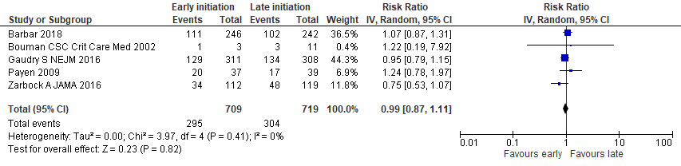

## Forest plot for Renal recovery

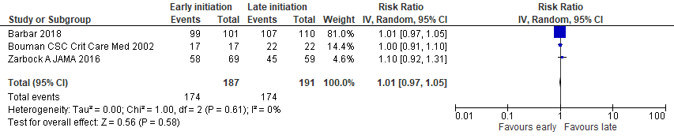

## Forest plot for central venous access device infection

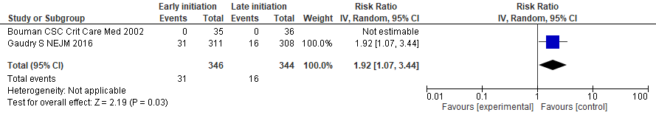

## Evidence profile: Renal replacement therapy compared to not for patients with sepsis and acute kidney injury and no indication for hemodialysis

Setting: hospitalized patients

Bibliography: 1. Bouman CSC, Oudemans-van Straaten HM, Tijssen JG, et. al. Effects of early high-volume continuous venovenous hemofiltration on survival and recovery of renal function in intensive care patients with acute renal failure: A prospective, randomized trial. Crit Care Med 2002;30(10):2205-11 (mortality, renal recovery, central line infections) 2. Payen D, Mateo J, Cavaillon JM, et.al. Impact of continuous venovenous hemofiltration on organ failure during the early phase of severe sepsis: A randomized controlled trial. Crit Care Med 2009;37(3):803-10 (mortality, organ failure) 3. Gaudry S, Hajage D, Schorten F, et. al. Initiation strategies for renal-replacement therapy in the intensive care unit. N Eng J Med 2016;375(2):122-33 (mortality, organ failure, central line infections) 4. Zarbock A, Kellum JA, Schmidt C, et.al. Effect of early vs delayed initiation of renal replacement therapy on mortality in critically ill patients with acute kidney injury. The ELAIN randomized clinical trial. JAMA 2016;315(20):2190-9 (mortality, recovery of renal function, organ dysfunction) 5. Barbar SD, Clere-Jehl R, Bourredjem A, et. al. Timing of renal-replacement therapy inpatients with acute kidney injury and sepsis. N Eng J Med 2018;379(15):1431-42 (mortality, renal recovery, organ failure, vasopressor-free days)

|  |  |  |  |  |  |  |  |  |  |  |  |  |  |  |
| --- | --- | --- | --- | --- | --- | --- | --- | --- | --- | --- | --- | --- | --- | --- |
| Quality assessment | | | | | | | № of patients | | Effect | | | Quality | | Importance |
| № of studies | Study design | Risk of bias | Inconsistency | Indirectness | Imprecision | Other considerations | renal replacement therapy | not | Relative (95% CI) | Absolute (95% CI) |  | |  | |
| Mortality | | | | | | | | | | | | | | |
| 5 | randomised trials | not serious | not serious | not serious a | serious b | none | 295/709 (41.6%) | 304/719 (42.3%) | RR 0.99 (0.87 to 1.11) | 4 fewer per 1,000 (from 55 fewer to 47 more) | ⨁⨁⨁◯ MODERATE | | CRITICAL | |
| Renal recovery | | | | | | | | | | | | | | |
| 3 | randomised trials | not serious c | not serious d | not serious e | not serious | none | 174/187 (93.0%) | 174/191 (91.1%) | RR 1.01 (0.97 to 1.05) | 9 more per 1,000 (from 27 fewer to 46 more) | ⨁⨁⨁⨁ HIGH | | CRITICAL | |
| Organ failure (SOFA scores without renal component) (follow up: 7 days) | | | | | | | | | | | | | | |
| 2 f | randomised trials | not serious | not serious g | not serious | not serious | none | 557 | 550 | - | MD 0.16 SOFA points lower (0.59 lower to 0.27 higher) | ⨁⨁⨁⨁ HIGH | | IMPORTANT | |
| Organ failure | | | | | | | | | | | | | | |
| 1 | randomised trials | not serious | not serious | serious h | very serious i | none | 107/119 (89.9%) | 118/119 (99.2%) | HR 0.18 (0.02 to 1.58) | 415 fewer per 1,000 (from 900 fewer to 8 more) | ⨁◯◯◯ VERY LOW | | IMPORTANT | |
| Vasopressor-free days | | | | | | | | | | | | | | |
| 1 | randomised trials | not serious | not serious | not serious | serious j | none | 246 | 242 | - | MD 1 days higher (4.28 lower to 2.28 higher) | ⨁⨁⨁◯ MODERATE | | IMPORTANT | |
| Central venous line infections | | | | | | | | | | | | | | |
| 2 | randomised trials | not serious | not serious | not serious | not serious | none | 31/346 (9.0%) | 16/344 (4.7%) | RR 1.92 (1.07 to 3.44) | 43 more per 1,000 (from 3 more to 113 more) | ⨁⨁⨁⨁ HIGH | | IMPORTANT | |

CI: Confidence interval; RR: Risk ratio; MD: Mean difference; HR: Hazard Ratio

#### Explanations

a. Only Barbar and Payen exclusively septic patients. 80% of Gaudry subjects had sepsis. Bouman data are subgroup with sepsis. Not downGRADEd.

b. 95% confidence interval includes modest benefit and harm.

c. Outcome assessed in survivors only, but not downGRADEd.

d. Data collected for longest follow up among survivors.

e. Only Barbar study specific to septic patients. It is the largest study and has the most precision around the estimate. Not downGRADEd.

f. Data from day 7, but total number of survivors not available. Total n used to weigh trials. Absolute values calculated on RevMan.

g. Payen (study of sepsis patients, n of 76 patients) analyzed time to SOFA worsening that showed worsening in the earlier group, but data unavailable (p < 0.01)

h. Data from Zarbock trial, which likely had a low incidence of sepsis.

i. 95% confidence interval includes modest harm.

j. 95% CI embraces less and more days. SD = IQR/1.35. Effect calculated in RevMan.

## EtD: Summary of Judgements for RRT in sepsis Recommendation

|  | Judgement | | | | | | |
| --- | --- | --- | --- | --- | --- | --- | --- |
| Problem | No | Probably no | Probably yes | Yes |  | Varies | Don't know |
| Desirable Effects | Trivial | Small | Moderate | Large |  | Varies | Don't know |
| Undesirable Effects | Large | Moderate | Small | Trivial |  | Varies | Don't know |
| Qualityof evidence | Very low | Low | Moderate | High |  |  | No included studies |
| Values | Important uncertainty or variability | Possibly important uncertainty or variability | Probably no important uncertainty or variability | No important uncertainty or variability |  |  |  |
| Balance of effects | Favors the comparison | Probably favors the comparison | Does not favor either the intervention or the comparison | Probably favors the intervention | Favors the intervention | Varies | Don't know |
| Resources required | Large costs | Moderate costs | Negligible costs and savings | Moderate savings | Large savings | Varies | Don't know |
| Qualityof evidence of required resources | Very low | Low | Moderate | High |  |  | No included studies |
| Cost effectiveness | Favors the comparison | Probably favors the comparison | Does not favor either the intervention or the comparison | Probably favors the intervention | Favors the intervention | Varies | No included studies |
| Equity | Reduced | Probably reduced | Probably no impact | Probably increased | Increased | Varies | Don't know |
| Acceptability | No | Probably no | Probably yes | Yes |  | Varies | Don't know |
| Feasibility | No | Probably no | Probably yes | Yes |  | Varies | Don't know |

## Type of Recommendation

|  |  |  |  |  |
| --- | --- | --- | --- | --- |
| Strong recommendation against the intervention | Conditional recommendation against the intervention | Conditional recommendation for either the intervention or the comparison | Conditional recommendation for the intervention | Strong recommendation for the intervention |
| ○ | ● | ○ | ○ | ○ |

# 69. In adults with sepsis or septic shock what should the trigger level of glucose be for starting an insulin infusion (> 180 or 150 mg/dL)?

## Forest plot for mortality

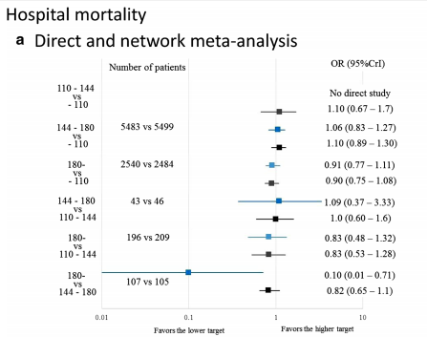

## Forest plot for hypoglycemia

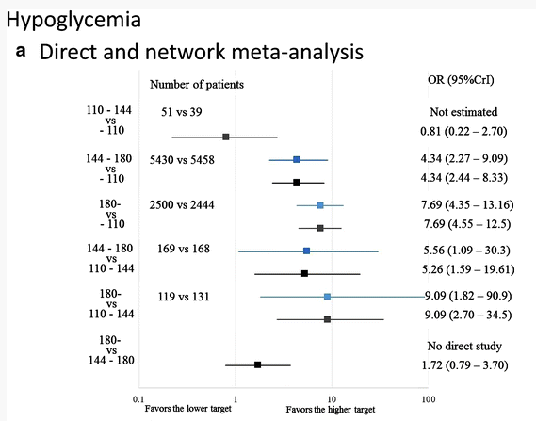

## Evidence profile: Commencing an insulin infusion at a blood glucose level of > 150 mg/dl compared to > 180 mg/dl for patients with sepsis or septic shock

Setting: hospitalized patients

Bibliography: Yatabe T, Inoue S, Sakaguchi M, Egi M. The optimal target for acute glycemic control in critically ill patients: a network meta-analysis. Intensive Care Med 2017;43:16-28

|  |  |  |  |  |  |  |  |  |  |  |  |  |
| --- | --- | --- | --- | --- | --- | --- | --- | --- | --- | --- | --- | --- |
| Quality assessment | | | | | | | № of patients | | Effect | | Quality | Importance |
| № of studies | Study design | Risk of bias | Inconsistency | Indirectness | Imprecision | Other considerations | commencing an insulin infusion at a blood glucose level of > 150 mg/dl | > 180 mg/dl | Relative (95% CI) | Absolute (95% CI) |
| Mortality (network meta analysis): 110-144 mg/dL vs 144-180 mg/dL | | | | | | | | | | | | |
| 35 | randomised trials | not serious a | not serious b | serious c | serious d | none |  | 40.0% | OR 1.0 (0.6 to 1.6) | 0 fewer per 1,000 (from 114 fewer to 116 more) | ⨁⨁◯◯ LOW | CRITICAL |
| Mortality (network meta-analysis): 144-180 mg/dL vs ≥ 180 mg/dL | | | | | | | | | | | | |
| 35 | randomised trials | not serious a | not serious b | serious e | serious f | none |  | 40.0% | OR 0.82 (0.65 to 1.10) | 47 fewer per 1,000 (from 98 fewer to 23 more) | ⨁⨁◯◯ LOW | CRITICAL |
| Hypoglycemia (network meta analysis): 110-144 mg/dL vs 144-180 mg/dL | | | | | | | | | | | | |
| 35 | randomised trials | not serious a | not serious b | serious c | not serious | none |  | 0.5% | OR 5.26 (1.59 to 19.61) | 21 more per 1,000 (from 3 more to 85 more) | ⨁⨁⨁◯ MODERATE | CRITICAL |
| Hypoglycemia (network meta analysis): 144-180 mg/dL vs ≥ 180 mg/dL | | | | | | | | | | | | |
| 35 g | randomised trials | not serious a | not serious b | serious e | serious d | none |  | 0.5% | OR 1.72 (0.79 to 3.70) | 4 more per 1,000 (from 1 fewer to 13 more) | ⨁⨁◯◯ LOW | CRITICAL |
| Hypoglycemia (network meta analysis): 110-144 mg/dL vs ≥ 180 mg/dL | | | | | | | | | | | | |
| 35 | randomised trials | not serious | not serious | serious e | not serious | none |  | 0.5% | OR 9.09 (2.70 to 34.50) | 39 more per 1,000 (from 8 more to 143 more) | ⨁⨁⨁◯ MODERATE | IMPORTANT |

CI: Confidence interval; OR: Odds ratio

#### Explanations

a. No blinding of participants and personnel, but overall low risk of bias across studies.

b. Heterogeneity statistic not mentioned.

c. Comparisons were between glycemic bands, not triggers.

d. 95% confidence interval includes harm and benefit.

e. Comparisons were between target glycemic bands 144-180 mg/dL, and > 180 mg/dL.

f. 95% confidence interval includes modest harm.

g. Results from network meta-analysis. No direct comparison.

## ETD: Summary of Judgements for Glucose targets in sepsis

|  | Judgement | | | | | | |
| --- | --- | --- | --- | --- | --- | --- | --- |
| Problem | No | Probably no | Probably yes | Yes |  | Varies | Don't know |
| Desirable Effects | Trivial | Small | Moderate | Large |  | Varies | Don't know |
| Undesirable Effects | Large | Moderate | Small | Trivial |  | Varies | Don't know |
| Qualityof evidence | Very low | Low | Moderate | High |  |  | No included studies |
| Values | Important uncertainty or variability | Possibly important uncertainty or variability | Probably no important uncertainty or variability | No important uncertainty or variability |  |  |  |
| Balance of effects | Favors the comparison | Probably favors the comparison | Does not favor either the intervention or the comparison | Probably favors the intervention | Favors the intervention | Varies | Don't know |
| Resources required | Large costs | Moderate costs | Negligible costs and savings | Moderate savings | Large savings | Varies | Don't know |
| Qualityof evidence of required resources | Very low | Low | Moderate | High |  |  | No included studies |
| Cost effectiveness | Favors the comparison | Probably favors the comparison | Does not favor either the intervention or the comparison | Probably favors the intervention | Favors the intervention | Varies | No included studies |
| Equity | Reduced | Probably reduced | Probably no impact | Probably increased | Increased | Varies | Don't know |
| Acceptability | No | Probably no | Probably yes | Yes |  | Varies | Don't know |
| Feasibility | No | Probably no | Probably yes | Yes |  | Varies | Don't know |

## Type of recommendation

|  |  |  |  |  |
| --- | --- | --- | --- | --- |
| Strong recommendation against the intervention | Conditional recommendation against the intervention | Conditional recommendation for either the intervention or the comparison | Conditional recommendation for the intervention | Strong recommendation for the intervention |
| ● | ○ | ○ | ○ | ○ |

# 70. In adults with sepsis or septic shock should we use intravenous vitamin C?

## Forest plot for mortality

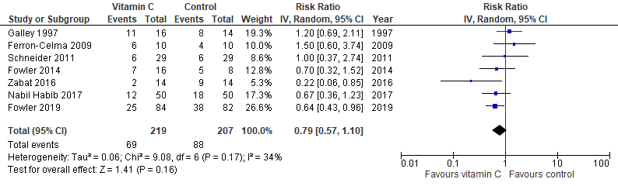

## Forest plot for vasopressor use (168 hours)

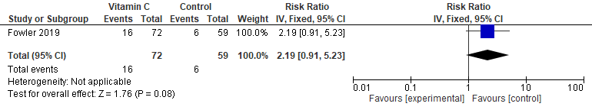

## Evidence profile: Intravenous vitamin C compared to not for patients with sepsis or septic shock

Setting: hospitalized patients

Bibliography: 1. Putzu A, Daems A, Lopez-Delgado JC, et.al. The effect of vitamin C on clinical outcome in criticaly ill patients: a systematic review with meta-analysis of randomized controlled trials. Crit Care med 2019;47:774-83. (mortality) 2. Fowler A, Truwit JD, Hite D, et.al. Effect of vitamin C infusion on organ failure and biomarkers of inflammation and vascular injury in patients with sepsis and severe acute respiratory failure. The CITRIS-ALI randomized clinical trial. JAMA 2019;322(13):1261-70. (mortality, vasopressor use, organ failure)

|  |  |  |  |  |  |  |  |  |  |  |  |  |
| --- | --- | --- | --- | --- | --- | --- | --- | --- | --- | --- | --- | --- |
| Quality assessment | | | | | | | № of patients | | Effect | | Quality | Importance |
| № of studies | Study design | Risk of bias | Inconsistency | Indirectness | Imprecision | Other considerations | intravenous vitamin C | not | Relative (95% CI) | Absolute (95% CI) |
| Mortality | | | | | | | | | | | | |
| 7 | randomised trials | not serious | serious a | not serious | serious b | none | 69/219 (31.5%) | 88/207 (42.5%) | RR 0.79 (0.57 to 1.10) | 89 fewer per 1,000 (from 183 fewer to 43 more) | ⨁⨁◯◯ LOW | CRITICAL |
| Organ failure (follow up: 96 hours) | | | | | | | | | | | | |
| 1 | randomised trials | not serious | not serious | not serious | serious b | none | 83 | 84 | - | SMD 0.1 SD lower (1.23 lower to 1.03 higher) | ⨁⨁⨁◯ MODERATE | CRITICAL |
| Vasopressor use (follow up: 168 hours) | | | | | | | | | | | | |
| 1 c | randomised trials | not serious | not serious | not serious | very serious d | none | 16/72 (22.2%) | 6/59 (10.2%) | RR 2.19 (0.91 to 5.23) | 121 more per 1,000 (from 9 fewer to 430 more) | ⨁⨁◯◯ LOW | IMPORTANT |

CI: Confidence interval; RR: Risk ratio; SMD: Standardised mean difference

#### Explanations

a. I-squared 34%.

b. 95% confidence interval embraces benefit and harm.

c. Vasopressor free days not available. Same importance attributed to this outcome.

d. 22 total events.

# 71. In adults with sepsis and lactic acidosis should we use intravenous bicarbonate therapy?

## Evidence profile: Intravenous bicarbonate therapy compared to not for patients with sepsis and lactic acidosis

Setting: hospitalized patients

Bibliography: Jaber S, Paugam C, Futier E, et. al. Sodium bicarbonate therapy for patients with severe metabolic acidaemia in the intensive care unit (BICAR-ICU): a multicentre, open-label, randomised controlled, phase 3 trial. Lancet 2018;392:31-40

|  |  |  |  |  |  |  |  |  |  |  |  |  |  |  |  |
| --- | --- | --- | --- | --- | --- | --- | --- | --- | --- | --- | --- | --- | --- | --- | --- |
| Quality assessment | | | | | | | № of patients | | | Effect | | | Quality | | Importance |
| № of studies | Study design | Risk of bias | Inconsistency | Indirectness | Imprecision | Other considerations | intravenous bicarbonate therapy | not | Relative (95% CI) | | Absolute (95% CI) |  | |  | |
| Mortality (follow up: 28 days) | | | | | | | | | | | | | | | |
| 1 a | randomised trials | not serious b | not serious | not serious | serious c | none | 57/123 (46.3%) | 65/115 (56.5%) | OR 0.66 (0.40 to 1.11) | | 103 fewer per 1,000 (from 223 fewer to 25 more) | ⨁⨁⨁◯ MODERATE | | CRITICAL | |
| Mortality (patients with AKIN scores of 2-3) | | | | | | | | | | | | | | | |
| 1 a | randomised trials | not serious b | not serious | serious d | not serious | none | 42/92 (45.7%) | 57/90 (63.3%) | OR 0.49 (0.27 to 0.88) | | 175 fewer per 1,000 (from 315 fewer to 30 fewer) | ⨁⨁⨁◯ MODERATE | | CRITICAL | |
| Vasopressor-free days (in survivors) | | | | | | | | | | | | | | | |
| 1 | randomised trials | not serious b | not serious | serious e | serious f | none | 108 | 90 | - | | MD 0 days  (1 lower to 0 ) | ⨁⨁◯◯ LOW | | CRITICAL | |
| Organ failure (at least one) (assessed with: SOFA score) | | | | | | | | | | | | | | | |
| 1 a | randomised trials | not serious b | not serious | serious e | serious c | none | 121/195 (62.1%) | 134/194 (69.1%) | OR 0.73 (0.48 to 1.11) | | 71 fewer per 1,000 (from 173 fewer to 22 more) | ⨁⨁◯◯ LOW | | CRITICAL | |
| Organ failure (at least one, patients with AKIN scores of 2-3) (assessed with: SOFA score) | | | | | | | | | | | | | | | |
| 1 a | randomised trials | not serious b | not serious | serious d | not serious | none | 61/92 (66.3%) | 74/90 (82.2%) | OR 0.43 (0.21 to 0.85) | | 157 fewer per 1,000 (from 330 fewer to 25 fewer) | ⨁⨁⨁◯ MODERATE | | CRITICAL | |
| Hypernatremia | | | | | | | | | | | | | | | |
| 1 a | randomised trials | not serious b | not serious | serious e | not serious | none | 96/195 (49.2%) | 57/194 (29.4%) | OR 2.35 (1.55 to 3.58) | | 201 more per 1,000 (from 98 more to 304 more) | ⨁⨁⨁◯ MODERATE | | IMPORTANT | |
| Hypocalcemia | | | | | | | | | | | | | | | |
| 1 a | randomised trials | not serious b | not serious | serious e | not serious | none | 48/195 (24.6%) | 29/194 (14.9%) | OR 1.86 (1.11 to 3.10) | | 97 more per 1,000 (from 14 more to 203 more) | ⨁⨁⨁◯ MODERATE | | IMPORTANT | |

CI: Confidence interval; OR: Odds ratio; MD: Mean difference

#### Explanations

a. OR calculated using Revman.

b. Not blinded. Not downGRADEd.

c. 95% confidence interval includes modest harm.

d. Subgroup not specific to sepsis patients.

e. Only 61% of population had sepsis.

f. Benefit or no benefit possible.

# 72. In adults with sepsis or septic shock without contraindication to enteral feeding, should we use early enteral feeding (full or trophic) versus no initial enteral feeding?

## Forest plot for mortality

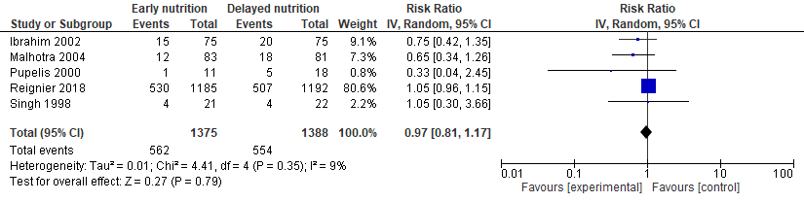

## Forest plot for pneumonia

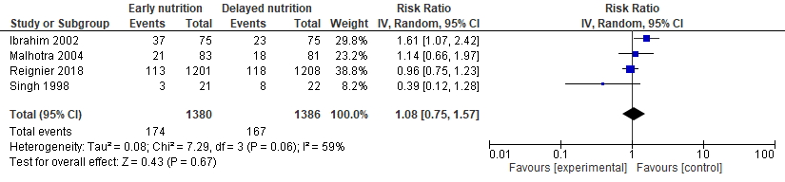

## Evidence profile: Early enteral feeding (full or trophic) compared to no initial enteral feeding for critically ill patients with sepsis or septic shock without contraindication to enteral feeding

Setting: hospitalized patients

Bibliography: 1. Ibrahim EH, Mehringer L, Prentice D et al (2002) Early versus late enteral feeding of mechanically ventilated patients: results of a clinical trial. JPEN J Parenter Enteral Nutr 26(3):174–181 2. Malhotra A, Mathur AK, Gupta S (2004) Early enteral nutrition after surgical treatment of gut perforations: a prospective randomised study. J Postgrad Med 50(2):102–106 3. Pupelis G, Austrums E, Jansone A, Sprucs R, Wehbi H (2000) Randomised trial of safety and efficacy of postoperative enteral feeding in patients with severe pancreatitis: preliminary report. Eur J Surg 166(5):383–387 4. Reignier J, Boisrame-Helms J, Bisard L, et al. Enteral versus parenteral early nutrition in ventilated adults with shock: a randomized, controlled, multicenter, open-label, parallel-group study (NUTRIREA-2). Lancet 2018;391(10116):133-43 5. Singh G, Ram P, Khanna SK. Early postoperative enteral feeding in patients with nontraumatic intestinal peroration and peritonitis. JACS 1998;187(2):142-6

|  |  |  |  |  |  |  |  |  |  |  |  |  |  |  |
| --- | --- | --- | --- | --- | --- | --- | --- | --- | --- | --- | --- | --- | --- | --- |
| Quality assessment | | | | | | | № of patients | | Effect | | | Quality | | Importance |
| № of studies | Study design | Risk of bias | Inconsistency | Indirectness | Imprecision | Other considerations | early enteral feeding (full or trophic) | no initial enteral feeding | Relative (95% CI) | Absolute (95% CI) |  | |  | |
| Mortality | | | | | | | | | | | | | | |
| 5 | randomised trials | not serious a | serious b | not serious c | serious d | none | 562/1375 (40.9%) | 554/1388 (39.9%) | RR 0.97 (0.81 to 1.17) | 12 fewer per 1,000 (from 76 fewer to 68 more) | ⨁⨁◯◯ LOW | | CRITICAL | |
| Ventilator-free days | | | | | | | | | | | | | | |
| 1 | randomised trials | not serious | not serious | not serious c | very serious d | none | 1201 | 1208 | - | MD 1 days lower (17.27 lower to 15.27 higher) | ⨁⨁◯◯ LOW | | CRITICAL | |
| Pneumonia | | | | | | | | | | | | | | |
| 4 | randomised trials | serious a | serious e | not serious c | serious d | none | 174/1380 (12.6%) | 167/1386 (12.0%) | RR 1.08 (0.75 to 1.57) | 10 more per 1,000 (from 30 fewer to 69 more) | ⨁◯◯◯ VERY LOW | | IMPORTANT | |
| Gastrointestinal hemorrhage | | | | | | | | | | | | | | |
| 1 | randomised trials | not serious f | not serious | not serious | very serious g | none | 0/21 (0.0%) | 1/22 (4.5%) | RR 0.35 (0.01 to 8.11) | 30 fewer per 1,000 (from 45 fewer to 323 more) | ⨁⨁◯◯ LOW | | IMPORTANT | |
| Gastrointestinal complications (NUTRIREA 2) | | | | | | | | | | | | | | |
| 1 | randomised trials | not serious | serious h | not serious | not serious | none | 868/1202 (72.2%) | 647/1208 (53.6%) | RR 1.35 (1.27 to 1.44) | 187 more per 1,000 (from 145 more to 236 more) | ⨁⨁⨁◯ MODERATE | | IMPORTANT | |

CI: Confidence interval; RR: Risk ratio; MD: Mean difference

#### Explanations

a. Pupelis 2000, Malhotra 2004, Singh 1998 at unclear risk of bias. Ibrahim 2002 not truly randomized (even and odd numbered days) and unblinded.

b. I-squared 9%. Largest study used parenteral nutrition in the control group.

c. Reignier compared early enteral versus parenteral early nutrition.

d. 95% confidence interval embraces benefit and harm.

e. I-squared = 59%.

f. Unclear risk of bias for Singh 1998.

g. 1 total outcome.

h. Aggregate of vomiting, diarrhea, bowel ischemia and acute colonic pseudo-obstruction, all of which were increased in the early enteric nutrition group.