International Guidelines for Management of Sepsis and Septic Shock

Surviving Sepsis Campaign: International Guidelines for Management of Sepsis and Septic Shock: 2021

Appendix 6. Goals and Long-Term Outcomes

Laura Evans1, Andrew Rhodes2, Waleed Alhazzani3, Massimo Antonelli4, Craig M Coopersmith5, Craig French6, Flávia R. Machado7, Lauralyn Mcintyre8, Marlies Ostermann9, Hallie C. Prescott1⁰, Christa Schorr1¹, Steven Simpson1², W Joost Wiersinga1³, Fayez Alshamsi1⁴, Derek C. Angus1⁵, Yaseen Arabi1⁶, Luciano Azevedo1⁷, Richard Beale1⁸, Gregory Beilman1⁹, Emilie Belley-Cote2⁰, Lisa Burry2¹, Maurizio Cecconi2², John Centofanti2³, Angel Coz Yataco2⁴, Jan De Waele2⁵, R. Phillip Dellinger2⁶, Kent Doi2⁷, Bin Du2⁸, Elisa Estenssoro2⁹, Ricard Ferrer3⁰, Charles Gomersall3¹, Carol Hodgson3², Morten Hylander Møller³³, Theodore Iwashyna3⁴, Shevin Jacob3⁵, Ruth Kleinpell3⁶, Michael Klompas3⁷, Younsuck Koh3⁸, Anand Kumar3⁹, Arthur Kwizera4⁰, Suzana Lobo4¹, Henry Masur4², Steven McGloughlin4³, Sangeeta Mehta4⁴, Yatin Mehta4⁵, Mervyn Mer⁴⁶, Mark Nunnally4⁷, Simon Oczkowski4⁸, Tiffany Osborn4⁹, Elizabeth Papathanassoglou5⁰, Anders Perner5¹, Michael Puskarich⁵², Jason Roberts⁵³, William Schweickert5⁴, Maureen Seckel5⁵, Jonathan Sevransky5⁶, Charles L Sprung57, Tobias Welte5⁸, Janice Zimmerman5⁹, Mitchell Levy6⁰.

Affiliations
- Division of Pulmonary, Critical Care and Sleep Medicine, University of Washington, USA
- Adult Critical Care, St George’s University Hospitals NHS Foundation Trust & St George’s University of London, London, UK
- Department of Health Research Methods, Evidence, and Impact, McMaster University, Canada & Department of Medicine, McMaster University, Hamilton, Canada
- Dipartimento di Scienze dell’ Emergenza Anestesiologiche e della Rianimazione, Policlinico Universitario A. Gemelli IRCCS Rome, Italy
- Emory University School of Medicine, USA
- Western Health, Melbourne, Australia
- Federal University of Sao Paulo, Sao Paulo, Brazil
- Ottawa Hospital, Ottawa, ON, Canada
- Guy’s & St Thomas’ Hospital, London, England, UK
- University of Michigan and VA Center for Clinical Management Research, USA
- Cooper Health System, Camden, NJ, USA
- University of Kansas Medical Center, Kansas City, KS, USA
- Division of Infectious Diseases, Amsterdam UMC, University of Amsterdam, Amsterdam
- Department of Internal Medicine, College of Medicine and Health Sciences, United Arab Emirates University, PO Box 17666, Al Ain, United Arab Emirates
- University of Pittsburgh Critical Care Medicine CRISMA Laboratory, Pittsburgh, PA, USA
- Intensive Care Department, Ministry of National Guard Health Affairs, King Saud Bin Abdulaziz University for Health Sciences, King Abdullah International Medical Research Center, Riyadh, Kingdom of Saudi Arabia
- University of Sao Paulo, School of Medicine, Brazil
- Guy’s & St Thomas’ Hospital, London, England, UK
- University of Minnesota
- Population Health Research Institute, Hamilton, Canada
- Mount Sinai Hospital & University of Toronto (Leslie Dan Faculty of Pharmacy), Ontario Canada
- Department of Anesthesia and Intensive care, Humanitas Clinical and Research Center, Rozzano, Milan, Italy.
- Department of Anesthesia, McMaster University, Hamilton, Canada
- Lexington Veterans Affairs Medical Center / University of Kentucky College of Medicine
- Ghent University Hospital, Ghent, Belgium
- Cooper Health System, Camden, NJ, USA
- The University of Tokyo, Japan
- Medical ICU, Peking Union Medical College Hospital, 1 Shuai Fu Yuan, Beijing 100730
- Hospital Interzonal de Agudos San Martin de La Plata, Buenos Aires, Argentina
- Intensive Care Department, Vall d'Hebron University Hospital, Vall d’Hebron Institut de Recerca. Barcelona, Spain.
- Prince of Wales Hospital, Hong Kong, China
- Australian and New Zealand Intensive Care Research Centre, Monash University, Australia
- Copenhagen University Hospital Rigshospitalet, Department of Intensive Care 4131, Copenhagen, Denmark
- University of Michigan Health System, USA
- Liverpool School of Tropical Medicine, UK
- Vanderbilt University Nashville TN, USA
- Department of Medicine, Brigham and Women's Hospital, Boston MA; Department of Population Medicine, Harvard Medical School, and Harvard Pilgrim Health Care Institute, Boston MA, USA
- ASAN Medical Center, University of Ulsan College of Medicine, Seoul, South Korea
- University of Manitoba, Winnipeg, MB, Canada
- Makerere University College of Health Sciences, Uganda
- Intensive Care Division. Faculdade de Medicina de São José do Rio Preto, São Paulo- Brazil
- Critical Care Medicine department, NIH Clinical Center, Bethedsa, MD, USA
- Alfred Health, Australia
- Medanta The Medicity, Gurugram, Haryana, India
- Mount Sinai Hospital, Toronto, ON, Canada
- Charlotte Maxeke Johannesburg Academic Hospital and Faculty of Health Sciences, University of the Witwatersrand, Johannesburg, South Africa
- New York University School of Medicine, New York, NY, USA
- Department of Medicine, McMaster University, Hamilton, Canada
- Washington University School of Medicine, St. Louis, MO, USA
- Faculty of Nursing, University of Alberta, Edmonton AB, Canada
- Rigshospitalet, Copenhagen, Denmark
- University of Minnesota / Hennepin County Medical Center
- University of Queensland, Australia
- University of Pennsylvania, USA
- ChristianaCare, Newark, DE, USA
- Emory University School of Medicine, USA
- Faculty of Medicine, Hebrew University of Jerusalem, Israel and Department of Anesthesiology, Critical Care and Pain Medicine, Hadassah Medical Center, Jerusalem, Israel
- Medizinische Hochschule Hannover and German Center of Lung Research (DZL), Germany
- Houston Methodist Hospital, Houston, TX, USA
- Warren Alpert School of Medicine at Brown University, Providence, Rhode Island & Rhode Island Hospital, Providence, Rhode Island.

Table of Contents
77. In patients with sepsis or septic shock, should we recommend discussions of goals of care and prognosis with family? 6
Narrative evidence summary: goals of care discussions and sharing of prognosis 6
78. In patients with sepsis or septic shock, should we recommend addressing goals of care early (within 72 hours) during ICU stay? 7
Narrative evidence summary: early goals of care discussions 7
EtD: Summary of Judgements for Goals of Care and Long-term Outcomes 8
Type of Recommendation 8
79. In patients with sepsis or septic shock. should we using standardized criteria (eg. prognostic scores) to identify patients for goals of care discussions? 10
Forest plot, goals of care discussion: early vs. control and duration of ICU stay vs. control; psychological symptoms in family- anxiety and depression (3 to 6 months) 10
Forest plot, goals of care discussions: early vs. control and duration of ICU stay vs. control; psychological symptoms in family- post traumatic stress symptoms (3 to 6 months) 10
Forest plot, goals of care discussions: early discussion vs. control and duration of ICU stay vs. control; satisfaction with care (3 to 6 months) 11
Forest plot, mortality at longest follow up by goals of care trigger: early discussion vs. control, duration of ICU stay vs. control, conflicts over treatment vs. control, early warning score trigger vs. control 11
Summary of Judgements for standardized criteria for goals of care discussions 12
80, 81. In patients with sepsis or septic shock, should we recommend incorporating palliative and end of life care? 13
Forest plot for psychological outcomes in family - anxiety and depression (3 months, measured with hospital anxiety and depression scale, higher is worse): 13
Forest plot for psychological outcomes in family - post-traumatic stress (3 months, measured with Impact of Events scale, higher is worse): 13
Forest plot for satisfaction with care 13
Forest plot for hospital mortality 13
Evidence profile: routine palliative care consultation 15
EtD: Summary of Judgments for routine palliative care consultation 16
Type of Recommendation 16
82. Does referral to peer support groups (varied models) compared to no referral to peer support, enhance functional and psychological recovery, reduce stress, anxiety and depression in patients and family members? 17
Forest plot, referral to peer support: family anxiety 17
Forest plot, referral to peer support: patient anxiety 17
Forest plot, referral to peer support: quality of life 17
Forest plot, referral to peer support: physical functional recovery 17
Evidence summary: referral to peer support groups 18
ETD: referral to peer support groups 19
Type of recommendation 19
83,84. Does a structured handoff across the continuum of care (ED to ICU, ICU to ward, ward to rehab, ward to home etc.) reduce mortality, ICU readmissions, medical errors, and patient and family satisfaction? 21
Narrative evidence summary: 21
EtD: Summary of judgements for structured handoff 25
Type of Recommendation 25
85. Does routine screening of patients and families for economic and social support (eg. housing, nutritional, finances), compared to no such screening, improve long-term physical, psychological, and financial outcomes? 27
Narrative evidence summary: screening for economic and social supports 27
Summary of judgements for routine screening for economic and social supports 30
86. In adult sepsis survivors and family members, does providing focused sepsis education (eg. booklets, apps, websites) during the hospitalization and at hospital discharge, compared to no such education, increase satisfaction, knowledge, improve psychological outcomes, and reduce ICU and hospital readmission? 31
Forest plot, patient symptoms of anxiety (measured with HADS-A and PTSS; range 1 month to 1 year) 31
Evidence profile: Sepsis education for patients and families 33
EtD: Summary of Judgements for Sepsis Education for patients and families 35
Type of Recommendation 35
87. Does family engagement in shared decision making and post-ICU and/or hospital discharge planning, compared to usual care improve patient quality of life, increase family satisfaction, and decrease length of stay, readmissions and discharge to long-term care? 37
Narrative evidence summary: 37
Summary of judgements for shared-decision making in discharge planning 39
88, 89, 90. Does a structured handoff across the continuum of care (ED to ICU, ICU to ward, ward to rehab, ward to home etc.) reduce mortality, ICU readmissions, medical errors, and patient and family satisfaction? 40
Forest plot, ICU readmission, post-ICU transition program 40
Forest plot, mortality, post-ICU transition program 40
Forest plot, psychological symptoms of patients— structured discharge plan (measured with STAI or HADS-A, higher is worse) 41
Forest plot, psychological symptoms of families— structured discharge plan (measured with STAI or HADS-A, higher is worse) 41
Evidence profile: comprehensive, standard discharge plan 42
EtD: Summary of Judgements for structured discharge plan 45
Type of Recommendation 45
91, 92. Does early (within 7-14 days) follow-up with a provider (eg. primary care, post-ICU clinic), improve quality of life, patient satisfaction, and reduce ICU and hospital readmission? 47
Narrative evidence summary: early post-discharge follow-up 47
Evidence profile: routine early follow-up after hospital discharge for sepsis survivors 48
Summary of Judgements for early post-discharge follow-up 51
93. Does early (within-ICU) cognitive therapy, as opposed to no cognitive therapy, reduce long-term cognitive dysfunction, discharge to long-term care, and increase quality of life, increase patient and family satisfaction? 52
Forest plot, cognitive functional recovery 52
Forest plot, quality of life 52
Forest plot, delirium 52
Forest plot, physical functional recovery 52
Evidence profile: Early cognitive therapy in patients with sepsis and septic shock 53
ETD: Summary of judgements for early cognitive therapy 55
Type of recommendation 55
94, 95, 96 Does a multidisciplinary recovery program (rehab, post-ICU clinic, primary care w/referrals), compared to no follow-up/recovery program increase physical function and cognitive recovery, improve psychological symptoms and QOL, and reduce hospital readmissions? 56
Forest plot, quality of life - 3 to 12 months (measured with SF-36 mental component score, range 0-100, higher is better; EQ-5D, higher is worse; SF-8 mental component, higher is better) 56
Forest plot, cognitive functional recovery - 3-12 months (measured with change in TICS-M, range 0-50, higher is better; or Tower Test, range 1-19 higher is better) 56
Forest plot, physical functional recovery- 3-12 months (measured using Extra Short Musculoskeletal Function Assessment, range 0-100, higher is worse; measured using 6 minute or 3 minute walk test, higher is better; Rivermeade Mobility Index, range 0-15, higher is better; Timed up and go, higher is worse) 57
Forest plot, psychological symptoms of patients - depression, 6 to 12 months (measured with change in MDI, range 0-50, higher is worse; measured with HADS-D, range 0-21, higher is worse; measured with BDI, range 0-63, higher is worse) 57
Forest plot, psychological symptoms of patients - post-traumatic stress,, 6-12 months (measured with change in PTSS, range 10-70, higher is worse; measured with Davidson Trauma Score, range 17-85 higher is worse) 57
Forest plot, mortality 3-12 months 58
Forest plot, hospital readmission, 30 days to 12 months 58
Evidence profile: Post-ICU follow-up programs 59
Evidence profile: Post-ICU rehabilitation program 62
ETD: Summary of judgements, post-ICU follow-up program 64
Type of recommendation 64
ETD: Summary of judgements, post-ICU rehabilitation program 66
Type of recommendation 66

77. In patients with sepsis or septic shock, should we recommend discussions of goals of care and prognosis with family?

Narrative evidence summary: goals of care discussions and sharing of prognosis
We did not identify any studies comparing goals of care & prognosis discussions to not having discussions; the existing literature on goals of care discussions for acutely ill patients is focused primarily on the timing/triggers for such discussions, and the ways in which it is done (eg. specialist clinicians).
There is a substantial body of literature evaluating advance care planning (ACP) in outpatients which suggests that ACP reduces the use of life-sustaining therapies, increases use of hospice and palliative care, and increase concordance between treatment and patient values and preferences, however these demonstrate inconsistent effects due to the complex and variable nature of the populations interventions, comparisons, and outcomes measured; the relevance of ACP interventions (planning for future health) to goals of care setting is unclear.
The study which most closely addressed this question is the 1995 SUPPORT trial which included patients with multi organ failure due to sepsis (<50%), and randomized patients to complex intervention, with treating clinicians receiving prognostic estimates as well patient and surrogate reports of goals of care obtained by interviews at week 1-2 of the study; this intervention did not impact agreement between patient preferences for CPR and documented code status; mortality; patient pain, ICU length of stay, or resource use— however patients/families in both arms participated in goals of care discussions at clinician discretion.
Despite lack of evidence, the panel recognized that discussion of prognosis and exploration of goals of care with patients and/or family is a necessary precondition to determine patient treatment preferences and providing value-concordant care. Thus, the panel made a best practice recommendation to discuss goals of care and prognosis with patients and families.
For adults with sepsis or septic shock, we recommend discussing goals of care and prognosis with patients and families over no such discussion. (Best practice statement)

References
Brinkman-Stoppelenburg A, Rietjens JA, Van der Heide A. The effects of advance care planning on end-of-life care: a systematic review. Palliative medicine. 2014 Sep;28(8):1000-25.
Connors AF, Dawson NV, Desbiens NA, Fulkerson WJ, Goldman L, Knaus WA, Lynn J, Oye RK, Bergner M, Damiano A, Hakim R. A controlled trial to improve care for seriously iII hospitalized patients: The study to understand prognoses and preferences for outcomes and risks of treatments (SUPPORT). JAMA. 1995 Nov 22;274(20):1591-8.

78. In patients with sepsis or septic shock, should we recommend addressing goals of care early (within 72 hours) during ICU stay?

Narrative evidence summary: early goals of care discussions
We did not directly identify any studies directly comparing early (within 72 hours) goals of care discussions vs. later goals of care discussions, and therefore relied upon indirect evidence.
White et al conducted a stepped-wedge cluster RCT including 1420 patients in 5 ICUs, comparing a multicomponent family-support intervention including a specially-trained support nurse; pre-arranged meetings (including relevant discussion of goals of care) at 48 hours post-ICU admission and every 5-7 days thereafter, and implementation support including a quality improvement specialist to incorporate the family support pathway; during non-intervention phases of the trial, patients received usual, non-protocolized care (26% of patients with sepsis); the support intervention did not affect family psychological outcomes but did improve perceived quality of communication, patient perception of patient-centredness, and a reduction in ICU length of stay (8.1 +/-8.6 days vs. 8.8 +/- 8.8 days, p=0.045), due to increased in-hospital patient mortality in the intervention group; there were no differences in number of patients discharged home, or functional status.
The certainty of evidence for all outcomes was low.
References
1. White DB, Angus DC, Shields AM, Buddadhumaruk P, Pidro C, Paner C, Chaitin E, Chang CC, Pike F, Weissfeld L, Kahn JM. A randomized trial of a family-support intervention in intensive care units. New England Journal of Medicine. 2018 Jun 21;378(25):2365-75.

EtD: Summary of Judgements for Goals of Care and Long-term Outcomes
 | JUDGEMENT
PROBLEM | No | Probably no | Probably yes | Yes |  | Varies | Don't know
DESIRABLE EFFECTS | Trivial | Small | Moderate | Large |  | Varies | Don't know
UNDESIRABLE EFFECTS | Large | Moderate | Small | Trivial |  | Varies | Don't know
CERTAINTY OF EVIDENCE | Very low | Low | Moderate | High |  |  | No included studies
VALUES | Important uncertainty or variability | Possibly important uncertainty or variability | Probably no important uncertainty or variability | No important uncertainty or variability
BALANCE OF EFFECTS | Favors the comparison | Probably favors the comparison | Does not favor either the intervention or the comparison | Probably favors the intervention | Favors the intervention | Varies | Don't know
RESOURCES REQUIRED | Large costs | Moderate costs | Negligible costs and savings | Moderate savings | Large savings | Varies | Don't know
CERTAINTY OF EVIDENCE OF REQUIRED RESOURCES | Very low | Low | Moderate | High |  |  | No included studies
COST EFFECTIVENESS | Favors the comparison | Probably favors the comparison | Does not favor either the intervention or the comparison | Probably favors the intervention | Favors the intervention | Varies | No included studies
EQUITY | Reduced | Probably reduced | Probably no impact | Probably increased | Increased | Varies | Don't know
ACCEPTABILITY | No | Probably no | Probably yes | Yes |  | Varies | Don't know
FEASIBILITY | No | Probably no | Probably yes | Yes |  | Varies | Don't know

Type of Recommendation
Strong recommendation against the intervention | Conditional recommendation against the intervention | Conditional recommendation for either the intervention or the comparison | Conditional recommendation for the intervention | Strong recommendation for the intervention
○ | ○ | ○ | ○ | ○

For adults with sepsis or septic shock, we suggest addressing goals of care early (within 72 hours) over late (72 hours or later). (weak recommendation, low quality evidence)

79. In patients with sepsis or septic shock. should we using standardized criteria (eg. prognostic scores) to identify patients for goals of care discussions?

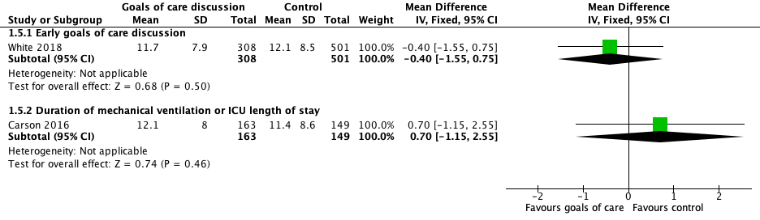
Forest plot, goals of care discussion: early vs. control and duration of ICU stay vs. control; psychological symptoms in family- anxiety and depression (3 to 6 months)

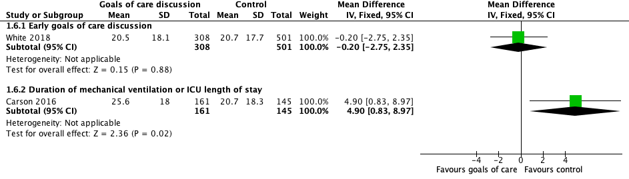
Forest plot, goals of care discussions: early vs. control and duration of ICU stay vs. control; psychological symptoms in family- post traumatic stress symptoms (3 to 6 months)

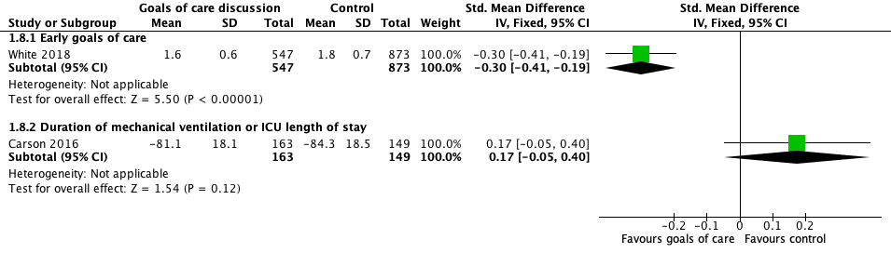
Forest plot, goals of care discussions: early discussion vs. control and duration of ICU stay vs. control; satisfaction with care (3 to 6 months)

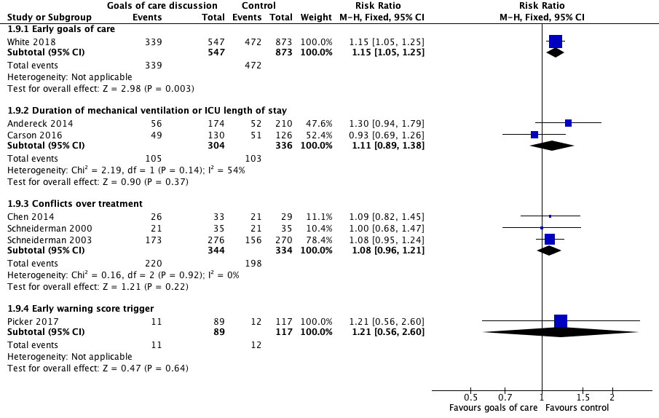
Forest plot, mortality at longest follow up by goals of care trigger: early discussion vs. control, duration of ICU stay vs. control, conflicts over treatment vs. control, early warning score trigger vs. control

Summary of Judgements for standardized criteria for goals of care discussions

Given the variety of triggers used in these studies and the lack of superiority of any single trigger, the panel chose to make no recommendation can be made for specific criteria to initiate a goals of care discussion. The timing of and triggers for such discussions should take into account the current condition of the patient, premorbid health and QoL, prognosis, response to treatment, interventions under consideration, anticipated QoL following treatment, availability of resources, and readiness and ability of the patient or family to engage in the discussion.
There is insufficient evidence to make a recommendation for any specific standardized criterion to trigger goals of care discussion.

80, 81. In patients with sepsis or septic shock, should we recommend incorporating palliative and end of life care?

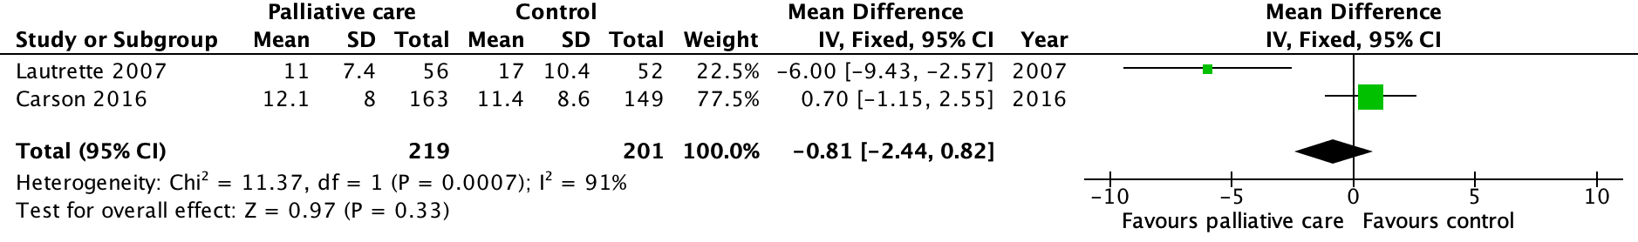
Forest plot for psychological outcomes in family - anxiety and depression (3 months, measured with hospital anxiety and depression scale, higher is worse):

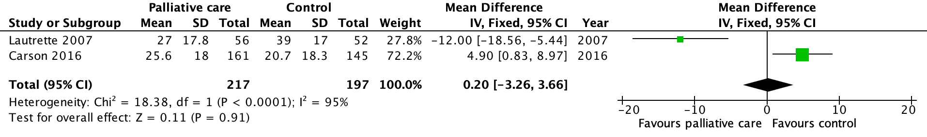
Forest plot for psychological outcomes in family - post-traumatic stress (3 months, measured with Impact of Events scale, higher is worse):

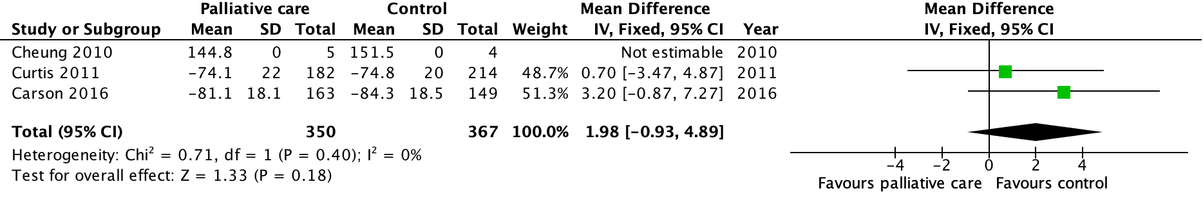
Forest plot for satisfaction with care

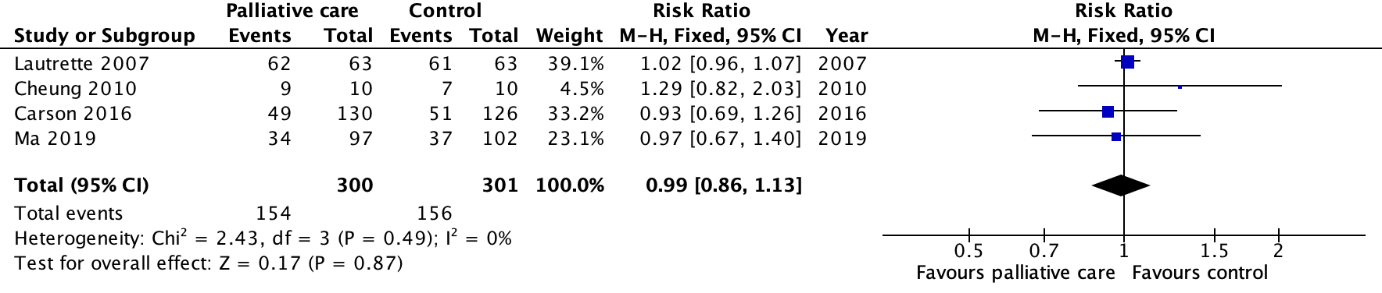
Forest plot for hospital mortality

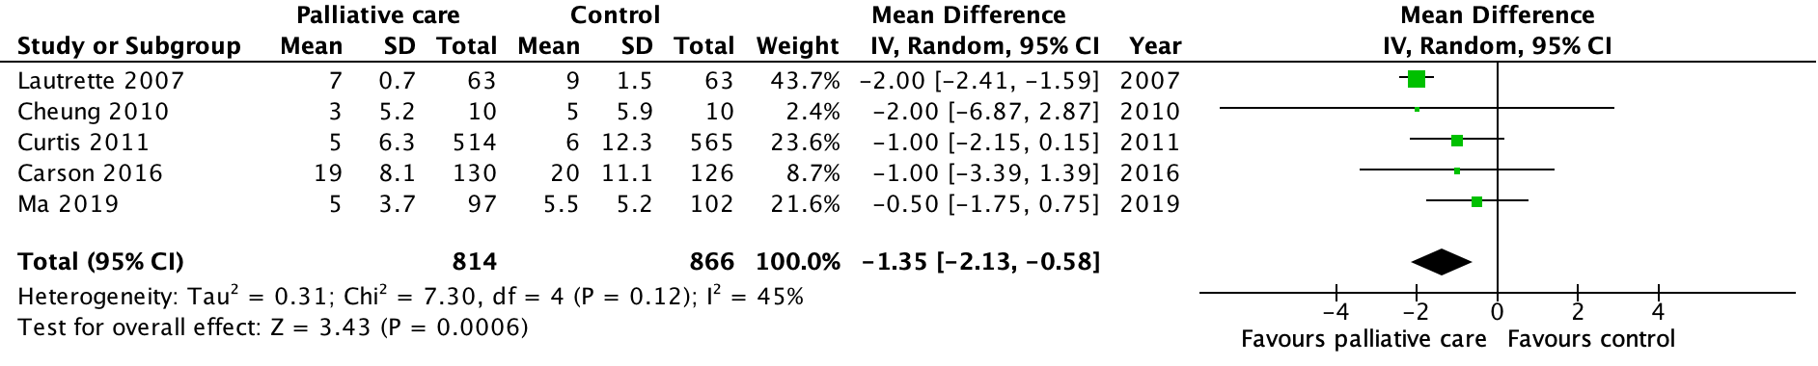
Forest plot for ICU length of stay:
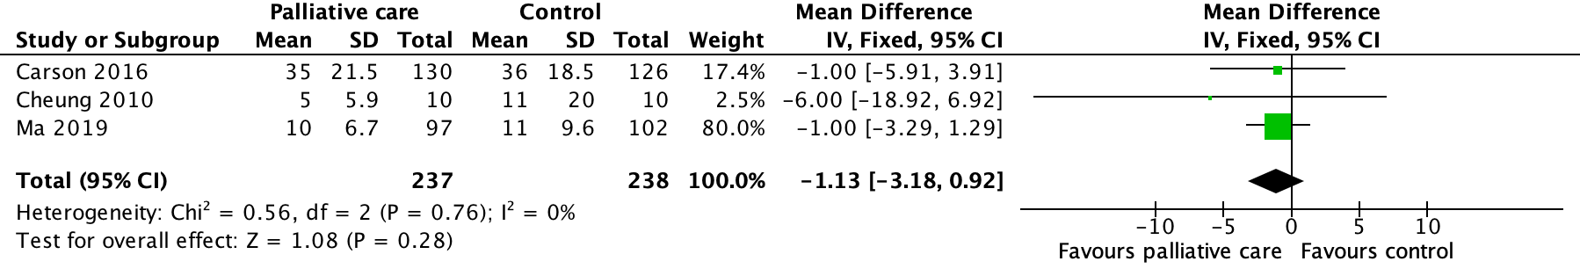
Forest plot for hospital length of stay:

Evidence profile: routine palliative care consultation
Certainty assessment |  |  |  |  |  | № of patients |  | Effect |  | Certainty | Importance
№ of studies | Risk of bias | Inconsistency | Indirectness | Imprecision | Other considerations | Palliative care | Control | Relative  (95% CI) | Absolute  (95% CI)
Psychological outcomes in family anxiety and depression
2 RCTs | serious ª | very serious ^{b} | not serious | not serious ^{c} | none | 219 | 201 | - | MD 0.81 lower  (2.44 lower to 0.82 higher) | ⨁◯◯◯  VERY LOW | CRITICAL
Psychological outcomes in family PTSD symptoms
2 RCTs | serious ª | very serious ^{b} | not serious | not serious ^{c} | none | 217 | 197 | - | MD 0.2 higher  (3.26 lower to 3.66 higher) | ⨁◯◯◯  VERY LOW | CRITICAL
Satisfaction with care
3 RCTs | serious ª | not serious | not serious | serious ^{d} | none | 350 | 367 | - | MD 1.98 higher  (0.93 lower to 4.89 higher) | ⨁⨁◯◯  LOW | CRITICAL
Mortality
4 RCTs | not serious | not serious | not serious | serious ^{d} | none | 154/300 (51.3%) | 156/301 (51.8%) | RR 0.99  (0.86 to 1.13) | 5 fewer per 1,000  (from 73 fewer to 67 more) | ⨁⨁⨁◯  MODERATE | IMPORTANT
ICU length of stay
5 RCTs | not serious | not serious | not serious | serious ^{e} | none | 814 | 866 | - | MD 1.35 days lower  (2.13 lower to 0.58 lower) | ⨁⨁⨁◯  MODERATE | IMPORTANT
Hospital length of stay
3 RCTs | not serious | not serious | not serious | serious ^{d} | none | 237 | 238 | - | MD 1.13 days lower  (3.18 lower to 0.92 higher) | ⨁⨁⨁◯  MODERATE | IMPORTANT
CI: Confidence interval; MD: Mean difference; RR: Risk ratio
Explanations
a. Family members were not blinded to the intervention received, increasing the risk of response bias.
b. Very significant statistical heterogeneity (I2 >90%) possibly due to differences in patient population and interventions studied.
c. Although the 95% confidence interval does not exclude potentially clinically significant differences, this is primarily due to inconsistency, which we already rated down twice.
d. Wide 95% CIs which do not rule out potentially significant benefit or harm.
e. Although statistically significant, we rated down as the optimal information size was not met.

EtD: Summary of Judgments for routine palliative care consultation
 | JUDGEMENT
PROBLEM | No | Probably no | Probably yes | Yes |  | Varies | Don't know
DESIRABLE EFFECTS | Trivial | Small | Moderate | Large |  | Varies | Don't know
UNDESIRABLE EFFECTS | Large | Moderate | Small | Trivial |  | Varies | Don't know
CERTAINTY OF EVIDENCE | Very low | Low | Moderate | High |  |  | No included studies
VALUES | Important uncertainty or variability | Possibly important uncertainty or variability | Probably no important uncertainty or variability | No important uncertainty or variability
BALANCE OF EFFECTS | Favors the comparison | Probably favors the comparison | Does not favor either the intervention or the comparison | Probably favors the intervention | Favors the intervention | Varies | Don't know
RESOURCES REQUIRED | Large costs | Moderate costs | Negligible costs and savings | Moderate savings | Large savings | Varies | Don't know
CERTAINTY OF EVIDENCE OF REQUIRED RESOURCES | Very low | Low | Moderate | High |  |  | No included studies
COST EFFECTIVENESS | Favors the comparison | Probably favors the comparison | Does not favor either the intervention or the comparison | Probably favors the intervention | Favors the intervention | Varies | No included studies
EQUITY | Reduced | Probably reduced | Probably no impact | Probably increased | Increased | Varies | Don't know
ACCEPTABILITY | No | Probably no | Probably yes | Yes |  | Varies | Don't know
FEASIBILITY | No | Probably no | Probably yes | Yes |  | Varies | Don't know

Type of Recommendation
Strong recommendation against the intervention | Conditional recommendation against the intervention | Conditional recommendation for either the intervention or the comparison | Conditional recommendation for the intervention | Strong recommendation for the intervention
○ | ○ | ● | ○ | ○

82. Does referral to peer support groups (varied models) compared to no referral to peer support, enhance functional and psychological recovery, reduce stress, anxiety and depression in patients and family members?

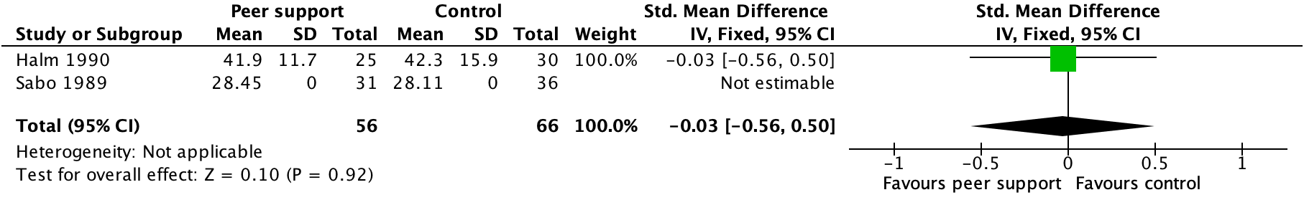
Forest plot, referral to peer support: family anxiety

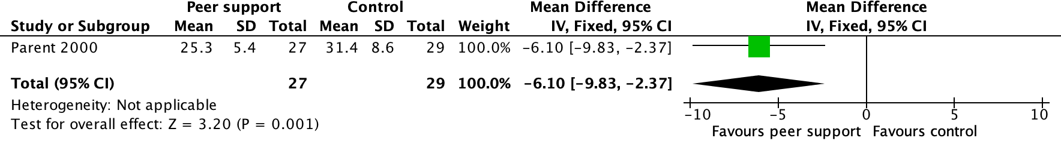
Forest plot, referral to peer support: patient anxiety

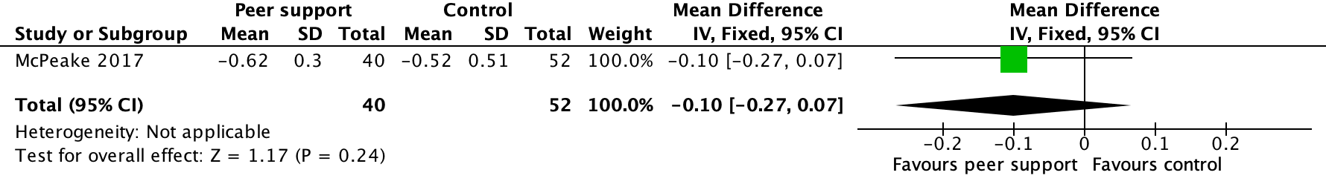
Forest plot, referral to peer support: quality of life

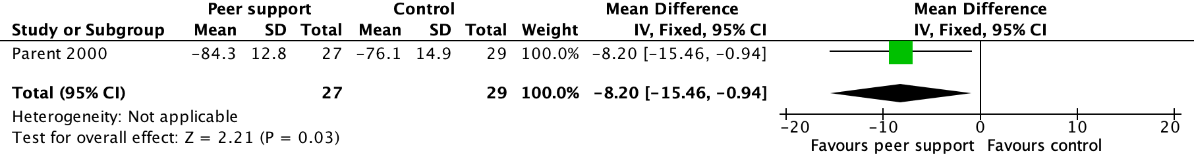
Forest plot, referral to peer support: physical functional recovery

Evidence summary: referral to peer support groups
Certainty assessment |  |  |  |  |  | № of patients |  | Effect |  | Certainty | Importance
№ of studies | Risk of bias | Inconsistency | Indirectness | Imprecision | Other considerations | Peer support | Usual care | Relative  (95% CI) | Absolute  (95% CI)
Family anxiety (assessed with: State-Trait Anxiety Inventory or stress score)
2 cohort studies | serious ª | not serious | not serious | serious ^{b} | none | 56 | 66 | - | SMD 0.03 lower  (0.56 lower to 0.5 higher) | ⨁◯◯◯  VERY LOW | CRITICAL
Patient anxiety (follow up: 4 weeks; assessed with: State-Trait Anxiety Inventory; Scale from: 20 to 80)
1 RCT | serious ^{c} | not serious | serious ^{d} | serious ^{e} | none | 27 | 29 | - | MD 6.1 lower  (9.83 lower to 2.37 lower) | ⨁◯◯◯  VERY LOW | CRITICAL
Quality of life (follow up: 1 years; assessed with: EQ-5D; Scale from: 0 to 1)
1 cohort study | serious ª | not serious | not serious | serious ^{b} | none | 40 | 52 | - | MD 0.1 lower  (0.27 lower to 0.07 higher) | ⨁◯◯◯  VERY LOW | CRITICAL
Physical function (follow up: 4 weeks; assessed with: patient self-report; Scale from: 0 to 100)
1 RCT | serious ^{c} | not serious | serious ^{d} | serious ^{e} | none | 27 | 29 | - | MD 8.2 lower  (15.46 lower to 0.94 lower) | ⨁◯◯◯  VERY LOW | IMPORTANT

CI: Confidence interval; SMD: Standardised mean difference; MD: Mean difference

Explanations
a. Studies did not rigorously adjust for likely confounders.
b. Very small number of patients and likely underpowered.
c. Single RCT at high risk of bias due to lack of allocation concealment, blinding, and high rates of loss to follow-up.
d. RCT evaluated patients undergoing elective cardiac surgery; peer support was initiated before patient had undergone surgery. This is of questionable directness to a patient with sepsis.
e. Small number of participants and events; optimal information size not met.

ETD: referral to peer support groups
 | JUDGEMENT
PROBLEM | No | Probably no | Probably yes | Yes |  | Varies | Don't know
DESIRABLE EFFECTS | Trivial | Small | Moderate | Large |  | Varies | Don't know
UNDESIRABLE EFFECTS | Large | Moderate | Small | Trivial |  | Varies | Don't know
CERTAINTY OF EVIDENCE | Very low | Low | Moderate | High |  |  | No included studies
VALUES | Important uncertainty or variability | Possibly important uncertainty or variability | Probably no important uncertainty or variability | No important uncertainty or variability
BALANCE OF EFFECTS | Favors the comparison | Probably favors the comparison | Does not favor either the intervention or the comparison | Probably favors the intervention | Favors the intervention | Varies | Don't know
RESOURCES REQUIRED | Large costs | Moderate costs | Negligible costs and savings | Moderate savings | Large savings | Varies | Don't know
CERTAINTY OF EVIDENCE OF REQUIRED RESOURCES | Very low | Low | Moderate | High |  |  | No included studies
COST EFFECTIVENESS | Favors the comparison | Probably favors the comparison | Does not favor either the intervention or the comparison | Probably favors the intervention | Favors the intervention | Varies | No included studies
EQUITY | Reduced | Probably reduced | Probably no impact | Probably increased | Increased | Varies | Don't know
ACCEPTABILITY | No | Probably no | Probably yes | Yes |  | Varies | Don't know
FEASIBILITY | No | Probably no | Probably yes | Yes |  | Varies | Don't know

Type of recommendation
Strong recommendation against the intervention | Conditional recommendation against the intervention | Conditional recommendation for either the intervention or the comparison | Conditional recommendation for the intervention | Strong recommendation for the intervention
○ | ○ | ○ | ● | ○

a. For adults with sepsis or septic shock, we recommend integrating principles of palliative care (which may include palliative care consultation based on clinician judgement) into the treatment plan, when appropriate, to address patient and family symptoms and suffering. (Best practice statement)
b. For adults with sepsis or septic shock, we suggest against routine formal palliative care consultation for all patients over palliative care consultation based on clinician judgement.

83,84. Does a structured handoff across the continuum of care (ED to ICU, ICU to ward, ward to rehab, ward to home etc.) reduce mortality, ICU readmissions, medical errors, and patient and family satisfaction?

Narrative evidence summary:
Structured handoff interventions have been evaluated at many transitions of patient care, OR to ICU, ICU to ward, and hospital to home; the vast majority observational pre/post studies, none were specifically for patients with sepsis. Many studies evaluated process (eg. frequency and completeness of information), and very few reported clinical outcomes; there were insufficient studies available for meta-analysis. Studies evaluating discharge summaries were excluded as these are a separate large and heterogenous group of trials (see Unnewehr et al. Postgraduate medicine. 2015 Nov 2;127(6):630-9)

OR to ICU
-Yang and Zhang evaluated a postoperative handover protocol checklist and protocol at a tertiary care hospital; in their pre/post observational study, the standardized process increased handover attendance, teamwork rating, and reduced the duration of mechanical ventilation [1]
-Mukhopadhyay conducted a pre/post observational study including observation of 62 patient handoffs within a surgical ICU, with or without a protocolled handover script and checklists, finding increased presence of key caregivers, procedural details from the surgical and anesthesia teams, without any major differences in time until patient was set up on monitor and ventilation equipment, or duration of handover (39 seconds)[2]
-Krimminger et al conducted a pre/post observational study including observation son 76 cardiac surgery handovers before and after implementation of a standardized handover process and communication template, finding an decrease in interruptions, fewer handover process errors, fewer information sharing errors, and a slight increase in handover time (1.4 minutes, not statistically significant); clinical outcomes were not reported [3]
-Hall et al conducted an observational pre/post study evaluating the use of a comprehensive handover process, including script, formal transfer of care, EMR integration, and evaluated the effect upon patient outcomes using database data; 550 handovers before and 577 after the intervention, finding no reduction in overall complications using standardized handover (mean 0.3, SD 0.84 vs. mean 0.23, SD 0.75) but a significant reduction in the number preventable complications (11/577 vs. 29/550), no difference in ICU LOS (5.78 SD 6.1 vs 5.86 SD 7.47) [4]
-Caruso et al conducted a pre/post observational study including 57 handover events (28 pre 29 post), evaluating the use of a standardized handoff presented using the IPASS format, finding increase in face-to-face handoffs, frequency of patient readiness, mean anesthesiologist satisfaction, without an increaspae in turnover times between cases [5]
-Segall et al conducted a pre/post observational study of 98 handover events (49 pre and 49 post) evaluating a structured handover process, finding an increase in desired handover behaviours, reduction in workload, and increased satisfaction without changes in presence of all team members present [6]
-Salzwedel et al conducted a single centre RCT evaluating a handover checklist from the transition from OR to ICU, finding that in 121 observed handover events, a greater proportion of critical information items were handed over (median 87.1%, [77.1, 90.0] vs. median 75 [66.7, 88.6]) using a checklist; no clinical outcomes were reported [7]
-Dixon et al conducted a observational pre-post study of 60 handover (30 pre-checklist, 30 post-checkist) in a cardiac intensive care unit, observing an increase in team members present, improvement in surgical and anesthesiologist information delivered, reduction of interruptions, and discussion of postoperative care plans; clinical outcomes were not addressed [8]
-Petrovic et al conducted an observational pre-post study of 60 patients, finding increased team presence, reduction in missed information at surgery (but not anesthesia) repots, and increase in satisfaction with an increased time of 1 minute [9]
-Catchpole et al observed 50 handovers (23 before 27 after) evaluating a structured handover protocol based upon models used in Formula 1 racing, finding a reduction in technical errors 3.15 (0.71) vs. 5.42 (1.24), mean number of handover omissions 1.07 (0.55) vs. 2.09 (1.14), and duration of handover 9.4 (1.29) vs. 10.8 (1.6) minutes [10}

References
Yang JG, Zhang J. Improving the postoperative handover process in the intensive care unit of a tertiary teaching hospital. Journal of clinical nursing. 2016 Apr;25(7-8):1062-72.
Mukhopadhyay D, Wiggins-Dohlvik KC, MrDutt MM, Hamaker JS, Machen GL, Davis ML, Regner JL, Smith RW, Ciceri DP, Shake JG. Implementation of a standardized handoff protocol for post-operative admissions to the surgical intensive care unit. The American Journal of Surgery. 2018 Jan 1;215(1):28-36.
Krimminger D, Sona C, Thomas-Horton E, Schallom M. A Multidisciplinary QI Initiative to Improve OR–ICU Handovers. AJN The American Journal of Nursing. 2018 Feb 1;118(2):48-59.
Hall M, Robertson J, Merkel M, Aziz M, Hutchens M. A structured transfer of care process reduces perioperative complications in cardiac surgery patients. Anesthesia & Analgesia. 2017 Aug 1;125(2):477-82.
Caruso TJ, Marquez JL, Gipp MS, Kelleher SP, Sharek PJ. Standardized ICU to OR handoff increases communication without delaying surgery. International journal of health care quality assurance. 2017 May 8;30(4):304-11
Segall N, Bonifacio AS, Barbeito A, Schroeder RA, Perfect SR, Wright MC, Emery JD, Atkins BZ, Taekman JM, Mark JB. Operating room-to-ICU patient handovers: a multidisciplinary human-centered design approach. The Joint Commission Journal on Quality and Patient Safety. 2016 Sep 1;42(9):400-AP5.
Salzwedel C, Mai V, Punke MA, Kluge S, Reuter DA. The effect of a checklist on the quality of patient handover from the operating room to the intensive care unit: a randomized controlled trial. Journal of critical care. 2016 Apr 1;32:170-4.
Dixon JL, Stagg HW, Wehbe-Janek H, Jo C, Culp Jr WC, Shake JG. A standard handoff improves cardiac surgical patient transfer: operating room to intensive care unit. The Journal for Healthcare Quality (JHQ). 2015 Jan 1;37(1):22-32.
Petrovic MA, Aboumatar H, Baumgartner WA, Ulatowski JA, Moyer J, Chang TY, Camp MS, Kowalski J, Senger CM, Martinez EA. Pilot implementation of a perioperative protocol to guide operating room–to–intensive care unit patient handoffs. Journal of cardiothoracic and vascular anesthesia. 2012 Feb 1;26(1):11-6.
Catchpole KR, De Leval MR, McEwan A, Pigott N, Elliott MJ, McQuillan A, Macdonald C, Goldman AJ. Patient handover from surgery to intensive care: using Formula 1 pit‐stop and aviation models to improve safety and quality. Pediatric Anesthesia. 2007 May;17(5):470-8.

Within ICU
-Parent et al conducted a cluster randomized stepped-wedge trial at 8 medical-surgical ICU to evaluate the impact of a standardized handoff curriculum (UW-IPASS) on clinican communication and patient outcomes within the ICU; they observed 343 handoffs, and did not find a change in ICU length of stay 7.3 days (2.2) vs. 7.5 (4.8), duration of mechanical ventilation 3.5 (0.92) vs. 4.3 (0.56) or duration of handover; it was perceived to improve preparedness and workflow [1]
-Nanchal et al conducted a pre/post observational study at single medical ICU evaluating at the use of a standardized structured handoff; pre vs. post intervention surveys, residents noted that unexpected events were less common (13/69 vs 23/63), including the need for fewer unanticipated interventions and procedures (11/69 vs. 23/61); clinical events were not recorded [2]

References
Parent B, LaGrone LN, Albirair MT, Serina PT, Keller JM, Cuschieri J, Addison EJ, Choe L, Delossantos GB, Gaskill CE, Moon SD. Effect of standardized handoff curriculum on improved clinician preparedness in the intensive care unit: a stepped-wedge cluster randomized clinical trial. JAMA surgery. 2018 May 1;153(5):464-70.
Nanchal R, Aebly B, Graves G, Truwit J, Kumar G, Taneja A, Dagar G, Graf J, Hubertz E, Ramalingam V, Fletcher KE. (1). BMJ Qual Saf. 2017 Dec 1;26(12):987-92.

ICU to ward
-Hoffmann et al conducted an observational pre/post study (335 patients pre, 171 patients post) evaluating a structured handover program in a surgical ICU; readmission rate was 8/171 vs. 20/335 [1]
-Graan et al conducted a pre/post study of a standardized handover tool from ICU to cardiac ward, and found that use of the tool increased consist occurrence of handover, checks of patient identity, and communication of complete information [2]
-Chaboyer et al. conducted a pre/post study of 1787 ICU discharge events (1001 before, 786 after) to evaluate a multifaceted ICU discharge process, including a patient handover sheet and ICU daily discharge worksheet; they found a reduction in average patient discharge delay time from ICU, no difference in ICU LOS 25(39) vs. 32(56) or hospital LOS 245 (347) vs. 259 (311) or mortality [3]
-Medlock et al conducted a pre/post study (1872 pre, 4951 post) at a 30 bed ICU, evaluating the use of a written transfer of accountability letter for hospital discharge; they found that the majority of clinicians completed the letters, but no difference in mortality (17.81% vs 17.47) [4]
-Hess et al conducted a pre/post evaluation (151 pre, 211 post) evaluating the use of a verbal report by a physician, nurse, NP, or RT in addition to a discharge handoff; they found a reduced chance of readmission OR 0.42 (95% CI 0.17-1.04), and lower costs ($111,723 vs $148,574) [5]
-Mitchell and Courtney evaluated an intervention where ICU nurses conducted a case conference with patients and families, providing information about transfer, ongoing issues; this was perceived to be a valuable intervention for patients and families; clinical outcomes were not collected [6]
-Bokinski conducted a pre/post observational study of 31 family members of patients in a neuroscience intensive care unit (9 pre, 13 post), finding a reduction in State-trait anxiety index in families who participated in a family conference prior to ICU discharge (35.45 (11.02) vs 38.67(12.85) trait; 40.54 (15.11) vs. 40.56 (12.37) [7]

References
Hoffman RL, Saucier J, Dasani S, Collins T, Holena DN, Fitzpatrick M, Tsypenyuk B, Martin ND. Development and implementation of a risk identification tool to facilitate critical care transitions for high-risk surgical patients. International Journal for Quality in Health Care. 2017 Mar 22;29(3):412-9.
Graan SM, Botti M, Wood B, Redley B. Nursing handover from ICU to cardiac ward: Standardised tools to reduce safety risks. Australian Critical Care. 2016 Aug 1;29(3):165-71.
Chaboyer W, Lin F, Foster M, Retallick L, Panuwatwanich K, Richards B. Redesigning the ICU nursing discharge process: a quality improvement study. Worldviews on Evidence‐Based Nursing. 2012 Feb;9(1):40-8.
Medlock S, Eslami S, Askari M, van Lieshout EJ, Dongelmans DA, Abu-Hanna A. Improved communication in post-ICU care by improving writing of ICU discharge letters: a longitudinal before‐after study. BMJ Qual Saf. 2011 Nov 1;20(11):967-73.
Hess DR, Tokarczyk A, O'Malley M, Gavaghan S, Sullivan J, Schmidt U. The value of adding a verbal report to written handoffs on early readmission following prolonged respiratory failure. Chest. 2010 Dec 1;138(6):1475-9.
Mitchell M, Courtney M. An intervention study to improve the transfer of ICU patients to the ward-evaluation by ICU nurses. Australian Critical Care. 2005 Aug 1;18(3):123-8.
Bokinskie JC. Family conferences: a method to diminish transfer anxiety. The Journal of neuroscience nursing: journal of the American Association of Neuroscience Nurses. 1992 Jun;24(3):129-33.

Hospital to home
-Ellis et all conducted an observational pre/post study (202 pre, 100 post) evaluating an intervention to increase communication between ICU clinicians and primary care providers at 3 ICUs; they found the frequency of documented communication were higher (72/100 vs. 5/202) but that rehospitalization at 30 days was similar (16/88 vs. 41/202)
References
Ellis KA, Connolly A, Hosseinnezhad A, Lilly CM. Standardizing communication from acute care providers to primary care providers on critically ill adults. American Journal of Critical Care. 2015 Nov 1;24(6):496-500.
Chaboyer W, Lin F, Foster M, Retallick L, Panuwatwanich K, Richards B. Redesigning the ICU nursing discharge process: a quality improvement study. Worldviews Evid Based Nurs. 2012;9(1):40-8.

EtD: Summary of judgements for structured handoff
 | JUDGEMENT
PROBLEM | No | Probably no | Probably yes | Yes |  | Varies | Don't know
DESIRABLE EFFECTS | Trivial | Small | Moderate | Large |  | Varies | Don't know
UNDESIRABLE EFFECTS | Large | Moderate | Small | Trivial |  | Varies | Don't know
CERTAINTY OF EVIDENCE | Very low | Low | Moderate | High |  |  | No included studies
VALUES | Important uncertainty or variability | Possibly important uncertainty or variability | Probably no important uncertainty or variability | No important uncertainty or variability
BALANCE OF EFFECTS | Favors the comparison | Probably favors the comparison | Does not favor either the intervention or the comparison | Probably favors the intervention | Favors the intervention | Varies | Don't know
RESOURCES REQUIRED | Large costs | Moderate costs | Negligible costs and savings | Moderate savings | Large savings | Varies | Don't know
CERTAINTY OF EVIDENCE OF REQUIRED RESOURCES | Very low | Low | Moderate | High |  |  | No included studies
COST EFFECTIVENESS | Favors the comparison | Probably favors the comparison | Does not favor either the intervention or the comparison | Probably favors the intervention | Favors the intervention | Varies | No included studies
EQUITY | Reduced | Probably reduced | Probably no impact | Probably increased | Increased | Varies | Don't know
ACCEPTABILITY | No | Probably no | Probably yes | Yes |  | Varies | Don't know
FEASIBILITY | No | Probably no | Probably yes | Yes |  | Varies | Don't know

Type of Recommendation
Strong recommendation against the intervention | Conditional recommendation against the intervention | Conditional recommendation for either the intervention or the comparison | Conditional recommendation for the intervention | Strong recommendation for the intervention
○ | ○ | ○ | ● | ○

a. For adults with sepsis or septic shock, we suggest using a handoff process of critically important information at transitions of care over no such handoff process. (Weak recommendation, very low quality evidence)

b. For adults with sepsis or septic shock, we make no recommendation for the use of any specific structured handoff tool over usual handoff processes. (No recommendation, very low quality evidence)

85. Does routine screening of patients and families for economic and social support (eg. housing, nutritional, finances), compared to no such screening, improve long-term physical, psychological, and financial outcomes?

Narrative evidence summary: screening for economic and social supports
We did not identify any studies comparing screening vs. no screening for economic and social supports (including housing, nutritional, financial, spiritual supports). There is a robust observational literature describing the relationships between various socioeconomic supports and patient outcomes suggesting that low socioeconomic stats (SES), substance abuse, and poor nutritional status lead to poor outcomes, and that critical illness itself results in lower SES post-illness.

Overal socioeconomic status
-the most relevant study overall was a 2 year cohort study of septic patients admitted to the ICU, which associated lower SES, an increase in mortality at 30 and 180 days; low education and low income were associated with earlier readmission [1]
-Donnelly et al conducted a large prospective observational study, which demonstrated that after adjusting for major confounders, patients living in the lowest SES quartile vs. highest SES quartile neighbourhoods had an increased risk of sepsis and hospitalization for sepsis [2], similar to finings from a Danish case-control study in which low SES was associate with a greater risk of community-acquired bacteremia [3] and death from bacteremia [4]; and an Australian study linking low SES with worse outcomes [5]
-this is consistent with data from Goodwin et al. that racial disparities in sepsis [6] are at least partially explained by living in medically underserved neighbourhoods [7]
-In a national database in Denmark, low socioeconomic status was linked with higher rates of S.Aureus bacteria, but not higher rates of infective endocarditis [8]
-homelessness is associated with longer length of stay, but not increased mortality compared to non-homeless patients in the US thought outcomes were not significantly worse [9,10], this was consistent with data from a French ICU, where mortality was similar between homeless and non-homeless patients, though length of stay was longer [11,12];contrasts with data from Canada where homelessness was associated both with longer duration of ICU stay and life support, and higher mortality [13]

Substance use disorders
-alcohol use is the best studied substance use disorder, but is inconsistency
-in retrospective studies, alcohol dependence and is linked to higher rates of sepsis, septic shock, and mortality,[14] though reasons for this are unclear
-in general ICU population, intoxicated patients have higher resource use and healthcare costs [15] as well as an increased risk of ARDS [16] and death [17]
-admission blood alcohol level was associated with reduced mortality and fewer episodes of bloodstream infection and sepsis, possibly through reduction of ischemia-reperfusion injuries [18]
-smoking appears to have a dose-related relationship to increased mortality in critically ill patients, even after adjusting fro confounders [19]

Nutritional screening
-there are many studies comparing varying methods of screening for nutritional status, linking poorer nutritional status with worse outcomes [20-22]

References
- Schnegelsberg A, Mackenhauer J, Nibro HL, Dreyer P, Koch K, Kirkegaard H. Impact of socioeconomic status on mortality and unplanned readmission in septic intensive care unit patients. Acta Anaesthesiologica Scandinavica. 2016 Apr;60(4):465-75.
- Donnelly JP, Lakkur S, Judd SE, Levitan EB, Griffin R, Howard G, Safford MM, Wang HE. Association of neighborhood socioeconomic status with risk of infection and sepsis. Clinical Infectious Diseases. 2018 Feb 12;66(12):1940-7.
- Koch K, Søgaard M, Nørgaard M, Thomsen RW, Schønheyder HC, Danish Collaborative Bacteremia Network. Socioeconomic inequalities in risk of hospitalization for community-acquired bacteremia: a Danish population-based case-control study. American journal of epidemiology. 2014 Mar 28;179(9):1096-106.
- Koch K, Nørgaard M, Schønheyder HC, Thomsen RW, Søgaard M. Effect of socioeconomic status on mortality after bacteremia in working-age patients. A Danish population-based cohort study. PLoS One. 2013 Jul 25;8(7):e70082.
- Ho KM, Dobb GJ, Knuiman M, Finn J, Webb SA. The effect of socioeconomic status on outcomes for seriously ill patients: a linked data cohort study. Med J Aust. 2008 Jul 7;189(1):26-30.
- Ogundipe F, Kodadhala V, Ogundipe T, Mehari A, Gillum R. Disparities in Sepsis Mortality by Region, Urbanization, and Race in the USA: a Multiple Cause of Death Analysis. Journal of racial and ethnic health disparities. 2019 Jun 15;6(3):546-51.
- Goodwin AJ, Nadig NR, McElligott JT, Simpson KN, Ford DW. Where you live matters: the impact of place of residence on severe sepsis incidence and mortality. Chest. 2016 Oct 1;150(4):829-36.
- Oestergaard LB, Schmiegelow MD, Bruun NE, Skov RL, Petersen A, Andersen PS, Torp-Pedersen C. The associations between socioeconomic status and risk of Staphylococcus aureus bacteremia and subsequent endocarditis–a Danish nationwide cohort study. BMC infectious diseases. 2017 Dec;17(1):589.
- Oud L. Epidemiology, Characteristics, and Outcomes of ICU-Managed Homeless Patients: A Population-Based Study. BioMed research international. 2018;2018.
- Nathanson BH, Higgins TL, Stefan M, Lagu T, Lindenauer PK, Steingrub JS. An analysis of homeless patients in the United States requiring ICU admission. Journal of critical care. 2019 Feb 1;49:118-23.
- Bigé N, Hejblum G, Baudel JL, Carron A, Chevalier S, Pichereau C, Maury E, Guidet B. Homeless patients in the ICU: an observational propensity-matched cohort study. Critical care medicine. 2015 Jun 1;43(6):1246-54.
- Bein T, Hackner K, Zou T, Schultes S, Bösch T, Schlitt HJ, Graf BM, Olden M, Leitzmann M. Socioeconomic status, severity of disease and level of family members' care in adult surgical intensive care patients: the prospective ECSSTASI study. Intensive Care Med. 2012 Apr;38(4):612-9.
- Smith OM, Chant C, Burns KE, Kaur M, Ashraf S, DosSantos CC, Hwang SW, Friedrich JO. Characteristics, clinical course, and outcomes of homeless and non-homeless patients admitted to ICU: A retrospective cohort study. PloS one. 2017 Jun 12;12(6):e0179207.
- O’Brien JM, Lu B, Ali NA, Martin GS, Aberegg SK, Marsh CB, Lemeshow S, Douglas IS. Alcohol dependence is independently associated with sepsis, septic shock, and hospital mortality among adult intensive care unit patients. Critical care medicine. 2007 Feb 1;35(2):345-50.
- van Beusekom I, Bakhshi-Raiez F, De Keizer NF, de Lange DW. The healthcare costs of intoxicated patients who survive ICU admission are higher than non-intoxicated ICU patients: a retrospective study combining healthcare insurance data and data from a Dutch national quality registry. BMC emergency medicine. 2019 Dec;19(1):6.
- Moss M, Bucher B, Moore FA, Moore EE, Parsons PE. The role of chronic alcohol abuse in the development of acute respiratory distress syndrome in adults. Jama. 1996 Jan 3;275(1):50-4.
- Gacouin A, Tadie JM, Uhel F, Sauvadet E, Fillâtre P, Letheulle J, Bouju P, Le Tulzo Y. At-risk drinking is independently associated with ICU and one-year mortality in critically ill nontrauma patients*. Crit Care Med. 2014 Apr;42(4):860-7.
- Stehman CR, Moromizato T, McKane CK, Mogensen KM, Gibbons FK, Christopher KB. Association between blood alcohol concentration and mortality in critical illness. Journal of critical care. 2015 Dec 1;30(6):1382-9.
- Ho KM, Hart G, Austin D, Hunter M, Botha J, Chavan S. Dose-related effect of smoking on mortality in critically ill patients: a multicentre cohort study. Intensive care medicine. 2011 Jun 1;37(6):981-9.
- Heyland DK, Dhaliwal R, Jiang X, Day AG. Identifying critically ill patients who benefit the most from nutrition therapy: the development and initial validation of a novel risk assessment tool. Crit Care. 2011;15(6):R268.
- Gonzalez MC, Bielemann RM, Kruschardt PP, Orlandi SP. Complementarity of NUTRIC score and Subjective Global Assessment for predicting 28-day mortality in critically ill patients. Clin Nutr. 2018 Dec 18.
- Atalay BG, Yagmur C, Nursal TZ, Atalay H, Noyan T. Use of subjective global assessment and clinical outcomes in critically ill geriatric patients receiving nutrition support. JPEN J Parenter Enteral Nutr. 2008 Jul-Aug;32(4):454-9.

Summary of judgements for routine screening for economic and social supports

For adults with sepsis or septic shock and their families, we recommend screening for economic and social support (including housing, nutritional, financial, and spiritual support), and make referrals where available to meet these needs. (Best practice statement)
The panel suggests a best practice statement. Below, we justify each the criteria for this decision [1]:

- Is the statement clear and actionable?
Socioeconomic screening may be done differently in different settings; however it is a standard part of most medical, nursing, and social worker assessments.
Health care workers in most settings would generally understand what is included in screening for socioeconomic supports such as housing, nutritional, financial, spiritual supports) and could do so for many if not most patients under their care.

- Is the message really necessary in regard to actual health care practice?
Although socioeconomic screening is considered a part of standard clinical practice, it may not be routinely done by all clinicians in many settings, especially in critical care where many patients are not able to communicate and the social determinants of health may be viewed as secondary to the acute resuscitation required for survival. Reinforcing the need to identify socioeconomic supports in acutely ill patients may change some health care workers’ practice.

- After consideration of all relevant outcomes and potential downstream consequences, will implementing the good practice statement result in large net positive consequences.
While the relationships between low socioeconomic status and poorer health outcomes are only associations, they are fairly consistent and have face validity. Hospitalization represents an opportunity to identify areas where socioeconomic support is lacking, and refer patients to locally-available services to meet these needs. While these services require resources, in general addressing the social determinants of health is likely cost-effective and can have a positive impact upon a patient’s health, but also their general quality of life. The negative effects of routine socioeconomic screening are likely minimal, as long as some level of social support referral exists.

- Is collecting and summarizing the evidence a poor use of a guideline panel’s limited time and energy (opportunity cost is large)?
We conducted a systematic review and there were no RCTs or observational studies comparing a screening strategy to no screening strategy. It is unlikely that many such studies would be conducted, as locally available social needs and supports likely vary. There is unlikely to be widely-generalizable evidence for this topic suitable for formal GRADE review.
- Is there a well-documented clear and explicit rationale connecting the indirect evidence?
There is clear evidence that social determinants of health are major contributor to health and disease in humans, furthermore critically ill patients have a decline in socio-economic status after their illness.[2] Some instruments, such as the Blaylock Risk Assessment Screening Score (BRASS) can identify patients at risk of complex discharge needs.[3]

References
- Guyatt GH, Alonso-Coello P, Schünemann HJ, Djulbegovic B, Nothacker M, Lange S, Murad MH, Akl EA. Guideline panels should seldom make good practice statements: guidance from the GRADE Working Group. J Clin Epidemiol. 2016 Dec;80:3-7.
- Griffiths J, Hatch RA, Bishop J, Morgan K, Jenkinson C, Cuthbertson BH, Brett SJ. An exploration of social and economic outcome and associated health-related quality of life after critical illness in general intensive care unit survivors: a 12-month follow-up study. Crit Care. 2013 May 28;17(3):R100.
- Chaboyer W, Kendall E, Foster M. Use of the 'BRASS' to identify ICU patients who may have complex hospital discharge planning needs. Nurs Crit Care. 2002 Jul-Aug;7(4):171-5.

86. In adult sepsis survivors and family members, does providing focused sepsis education (eg. booklets, apps, websites) during the hospitalization and at hospital discharge, compared to no such education, increase satisfaction, knowledge, improve psychological outcomes, and reduce ICU and hospital readmission?

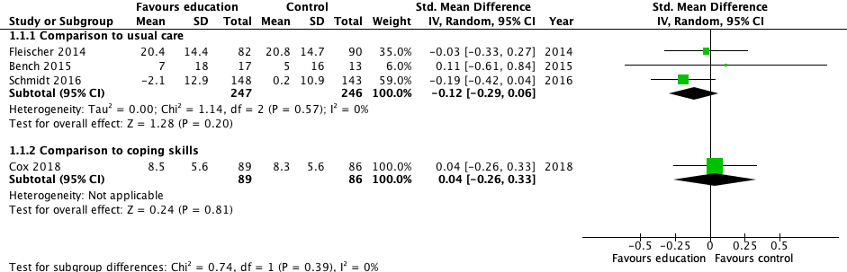
Forest plot, patient symptoms of anxiety (measured with HADS-A and PTSS; range 1 month to 1 year)

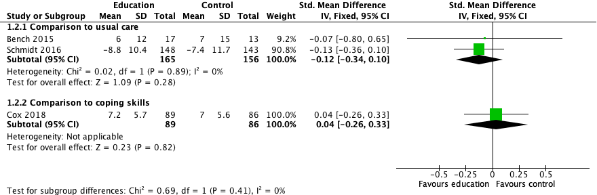
Forest plot, patient symptoms of depression (measured with HADS-D, MDI; range 1 week to 1 year)

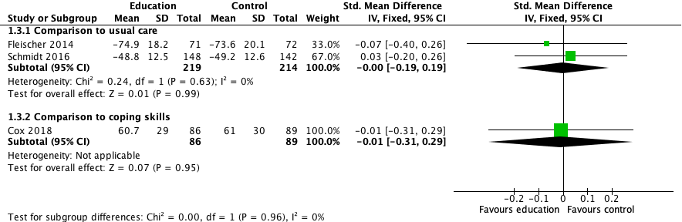
Forest plot, quality of life (Measured with EQ-5D, SF-36 MCS, range 3 months to 1 year)

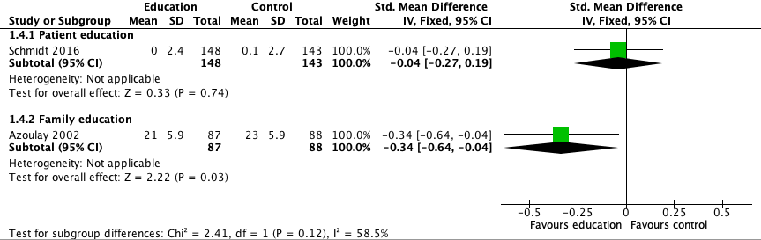
Forest plot, satisfaction with care (measured with Critical Care Family Needs Inventory and Patient Assessment of Chronic Illness Care Questionnaire; range 5 days to 1 year)

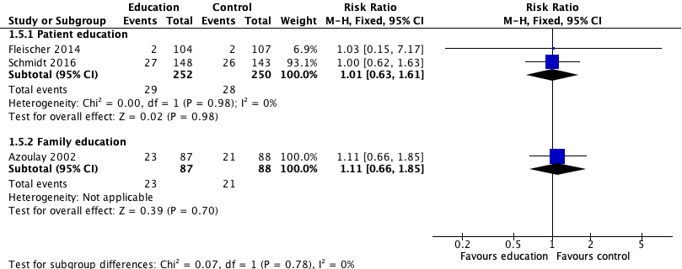
Forest plot, mortality (range: hospital mortality to 1 year)

Evidence profile: Sepsis education for patients and families
Certainty assessment |  |  |  |  |  | № of patients |  | Effect |  | Certainty | Importance
№ of studies | Risk of bias | Inconsistency | Indirectness | Imprecision | Other considerations | Sepsis education | Usual care | Relative  (95% CI) | Absolute  (95% CI)
Patient symptoms of anxiety
3 RCTs | serious ª | not serious | serious ^{b} | serious ^{c} | none | 247 | 246 | - | SMD 0 SD  (0.19 lower to 0.19 higher) | ⨁◯◯◯  VERY LOW | CRITICAL
Patient symptoms of depression
2 RCTs | serious ª | not serious | serious ^{b} | serious ^{c} | none | 165 | 156 | - | SMD 0.12 SD lower  (0.34 lower to 0.1 higher) | ⨁◯◯◯  VERY LOW | CRITICAL
Quality of life
2 RCTs | serious ª | not serious | serious ^{b} | serious ^{c} | none | 219 | 214 | - | SMD 0 SD  (0.19 lower to 0.19 higher) | ⨁◯◯◯  VERY LOW | CRITICAL
Satisfaction
1 RCT | serious ª | not serious | serious ^{b} | serious ^{c} | none | 148 | 143 | - | SMD 0.04 SD lower  (0.27 lower to 0.19 higher) | ⨁◯◯◯  VERY LOW | IMPORTANT
Mortality
2 RCTs | not serious | not serious | serious ^{b} | serious ^{c} | none | 29/252 (11.5%) | 28/250 (11.2%) | RR 1.01  (0.63 to 1.61) | 1 more per 1,000  (from 41 fewer to 68 more) | ⨁⨁◯◯  LOW | IMPORTANT
ICU length of stay
2 RCTs | not serious | not serious | serious ^{b} | serious ^{c} | none | 133 | 149 | - | MD 0.59 days lower  (2.09 lower to 0.9 higher) | ⨁⨁◯◯  LOW | IMPORTANT
Hospital length of stay
2 RCTs | not serious | not serious | serious ^{b} | serious ^{c} | none | 151 | 159 | - | MD 1.08 days lower  (4.78 lower to 2.63 higher) | ⨁⨁◯◯  LOW | IMPORTANT

CI: Confidence interval; SMD: Standardised mean difference; RR: Risk ratio; MD: Mean difference

Explanations
a. Only one trial (Cox 2018) specifically had blinded outcome assessment; others were unblinded or had inconsistent blinding, resulting in possible detection bias. In addition, there was significant loss to follow-up across all trials, leading to possible attrition bias.
b. Only one trial (Schmidt 2016) specifically provided sepsis-related education; in addition, control arms not identical between groups (eg. coping skills, usual care, etc.)
c. Wide 95% confidence intervals which do not exclude the possibility of significant benefit or harm.

EtD: Summary of Judgements for Sepsis Education for patients and families

 | JUDGEMENT
PROBLEM | No | Probably no | Probably yes | Yes |  | Varies | Don't know
DESIRABLE EFFECTS | Trivial | Small | Moderate | Large |  | Varies | Don't know
UNDESIRABLE EFFECTS | Large | Moderate | Small | Trivial |  | Varies | Don't know
CERTAINTY OF EVIDENCE | Very low | Low | Moderate | High |  |  | No included studies
VALUES | Important uncertainty or variability | Possibly important uncertainty or variability | Probably no important uncertainty or variability | No important uncertainty or variability
BALANCE OF EFFECTS | Favors the comparison | Probably favors the comparison | Does not favor either the intervention or the comparison | Probably favors the intervention | Favors the intervention | Varies | Don't know
RESOURCES REQUIRED | Large costs | Moderate costs | Negligible costs and savings | Moderate savings | Large savings | Varies | Don't know
CERTAINTY OF EVIDENCE OF REQUIRED RESOURCES | Very low | Low | Moderate | High |  |  | No included studies
COST EFFECTIVENESS | Favors the comparison | Probably favors the comparison | Does not favor either the intervention or the comparison | Probably favors the intervention | Favors the intervention | Varies | No included studies
EQUITY | Reduced | Probably reduced | Probably no impact | Probably increased | Increased | Varies | Don't know
ACCEPTABILITY | No | Probably no | Probably yes | Yes |  | Varies | Don't know
FEASIBILITY | No | Probably no | Probably yes | Yes |  | Varies | Don't know

Type of Recommendation
Strong recommendation against the intervention | Conditional recommendation against the intervention | Conditional recommendation for either the intervention or the comparison | Conditional recommendation for the intervention | Strong recommendation for the intervention
○ | ○ | ○ | ● | ○

For adults with sepsis or septic shock and their families, we suggest offering written and verbal sepsis education (diagnosis, treatment, and post-ICU/post-sepsis syndrome) prior to hospital discharge and in the follow-up setting. (weak recommendation, very low certainty of evidence)

87. Does family engagement in shared decision making and post-ICU and/or hospital discharge planning, compared to usual care improve patient quality of life, increase family satisfaction, and decrease length of stay, readmissions and discharge to long-term care?

Narrative evidence summary:
We were unable to identify any studies comparing shared decision-making (SDM) to another form of discharge planning. A large body of literature exists consisting of decision-aids to assist patient and families, particularly with decisions around treatment decisions and end of life care; these generally compared the use of a decision aid to usual care, though families in the “usual care” arm studies were also engaged in a shared decision-making process.[1]
In a small observational study of 50 relatives of patients in a large ICU, family members expressed a range of preferences for their role in decision-making, with 25% preferring an active role, 58% preferring a shared role with the physician, and 17% preferring a passive role; family members preferring a passive role were more likely to have symptoms of anxiety and depression; this highlights that there may be significant variability in the extent to which family members are willing and capable of participating in shared decision-making at discharge [2]
Two studies which compared the use of a structured family conference at time of ICU discharge; the extent to which families were actually involved in decision-making (as opposed to simply receiving information and having questions answered) is unclear [3,4]
Mitchell and Courtney evaluated an intervention where ICU nurses conducted a case conference with patients and families, providing information about transfer, ongoing issues; this was perceived to be a valuable intervention for patients and families; clinical outcomes were not collected [3]
Bokinski conducted a pre/post observational study of 31 family members of patients in a neuroscience intensive care unit (9 pre, 13 post), finding a reduction in State-trait anxiety index in the group participating in a family conference at time of discharge (35.45 (11.02) vs 38.67(12.85) trait; 40.54 (15.11) vs. 40.56 (12.37) [4]
Qualitative evidence suggests that family members value participating in care of the patient, want support from the ICU team in their role [5]; are both relived by recovery of loved ones to discharge but need information and skills to help manage patient care needs after transition [6]; and identify clear communication as fundamental to a shared decision-making role [7]
Specific strategies to assist in effective shared decision-making include focused training for families [8] and involvement of primary care physicians who have had a long-term relationship with the patient and family.[9]

References
Austin CA, Mohottige D, Sudore RL, Smith AK, Hanson LC. Tools to promote shared decision making in serious illness: a systematic review. JAMA internal medicine. 2015 Jul 1;175(7):1213-21.
Anderson WG, Arnold RM, Angus DC, Bryce CL. Passive decision-making preference is associated with anxiety and depression in relatives of patients in the intensive care unit. Journal of critical care. 2009 Jun 1;24(2):249-54.
Mitchell M, Courtney M. An intervention study to improve the transfer of ICU patients to the ward-evaluation by ICU nurses. Australian Critical Care. 2005 Aug 1;18(3):123-8.
Bokinskie JC. Family conferences: a method to diminish transfer anxiety. The Journal of neuroscience nursing: journal of the American Association of Neuroscience Nurses. 1992 Jun;24(3):129-33.
Blom H, Gustavsson C, Sundler AJ. Participation and support in intensive care as experienced by close relatives of patients—A phenomenological study. Intensive and Critical Care Nursing. 2013 Feb 1;29(1):1-8.
Choi J, Lingler JH, Donahoe MP, Happ MB, Hoffman LA, Tate JA. Home discharge following critical illness: A qualitative analysis of family caregiver experience. Heart & Lung. 2018 Jul 1;47(4):401-7.
Moss KO, Douglas SL, Baum E, Daly B. Family Surrogate Decision-making in Chronic Critical Illness: A Qualitative Analysis. Critical care nurse. 2019 Jun 1;39(3):e18-26.
Turnbull AE, Chessare CM, Coffin RK, Needham DM. A brief intervention for preparing ICU families to be proxies: A phase I study. PloS one. 2017 Oct 2;12(10):e0185483.
Huang KB, Weber U, Johnson J, Anderson N, Knies AK, Nhundu B, Bautista C, Poskus K, Sheth KN, Hwang DY. Primary care physician involvement in shared decision making for critically ill patients and family satisfaction with care. The Journal of the American Board of Family Medicine. 2018 Jan 1;31(1):64-72.

Summary of judgements for shared-decision making in discharge planning
For adults with sepsis or septic shock and their families, we recommend the clinical team provide the opportunity to participate in shared decision making in post-ICU and hospital discharge planning to ensure discharge plans are acceptable and feasible. (Best practice statement)
The panel chose to make a best practice statement, as per the GRADE criteria below:
(i) Is the statement clear and actionable?
The statement provides direction for a particular group (clinicians) to commit to a specific course of action (shared decision-making in post-ICU and hospital discharge planning).
(ii) Is the message really necessary in regard to actual health care practice?
While shared decision-making is considered standard of care in many health care settings, some clinicians and health care organizations may not routinely engage patients and families in the discharge process. By making a good practice statement, the panel emphasizes that this should done proactively.
(iii) After consideration of all relevant outcomes and potential downstream consequences, will implementing the good practice statement result in large net positive consequences?
Shared decision-making is more likely (though not certain) to result in decisions consistent with the values and preferences of patients and families. Furthermore, routinely providing an opportunity to all patients and families to participate in decision-making will reduce inequality by allowing less proactive families to engage. Lastly, recognizing that there may be variations in patient and family interest, willingness, and ability to engage in decision-making,

(iv) Is collecting and summarizing the evidence a poor use of a guideline panel’s limited time and energy (opportunity cost is large)?
The literature review we conducted did not identify any robust evidence comparing shared-decision making to no shared decision-making in discharge planning. Such evidence is unlikely to be forthcoming, as shared decision-making is increasingly recognized as a patient right, based upon the principle of autonomy. However, we anticipate that studies comparing different methods of engaging in shared decision-making (analogous to the literature in end-of-life decision-making) may be forthcoming.

(v) Is there a well-documented clear and explicit rationale connecting the indirect evidence?
There is indirect evidence that shared decision-making is helpful in other settings, that patients and families perceive shared decision-making to be beneficial and desirable.

88, 89, 90. Does a structured handoff across the continuum of care (ED to ICU, ICU to ward, ward to rehab, ward to home etc.) reduce mortality, ICU readmissions, medical errors, and patient and family satisfaction?

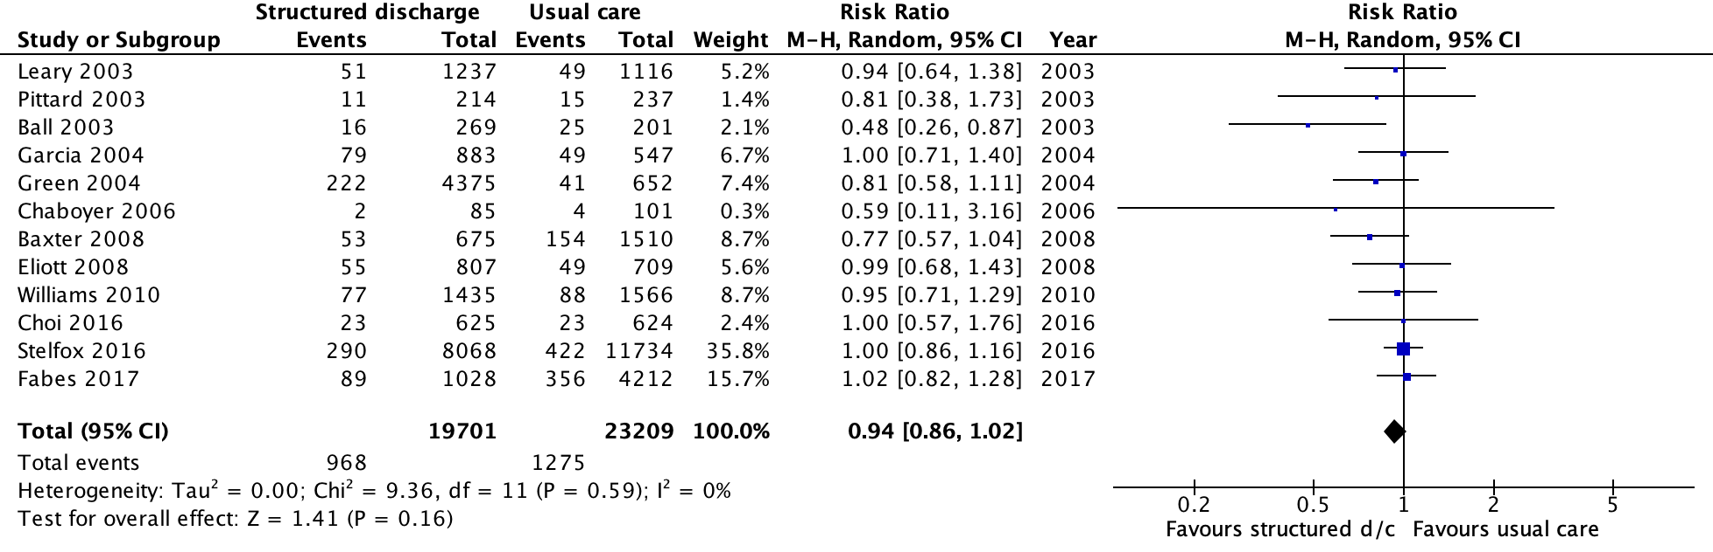
Forest plot, ICU readmission, post-ICU transition program

Forest plot, mortality, post-ICU transition program
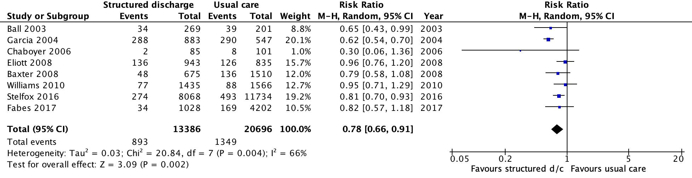

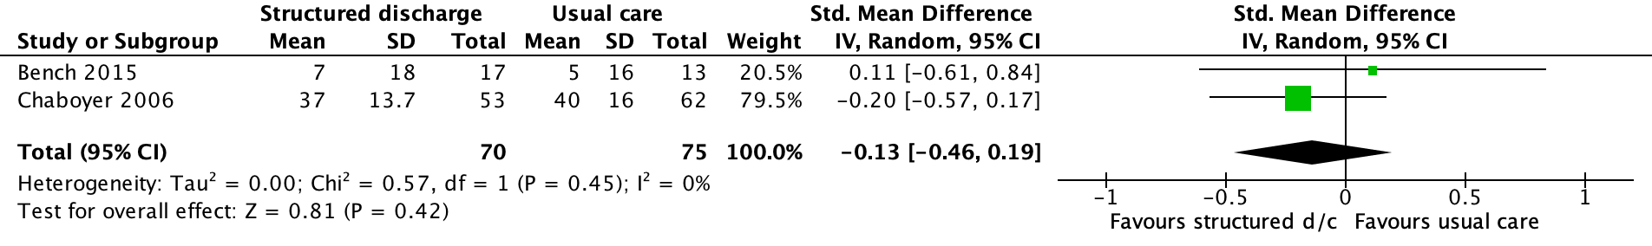
Forest plot, psychological symptoms of patients— structured discharge plan (measured with STAI or HADS-A, higher is worse)

Forest plot, psychological symptoms of families— structured discharge plan (measured with STAI or HADS-A, higher is worse)
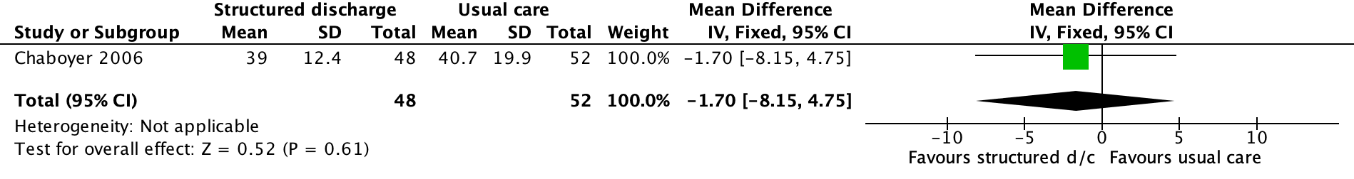

Evidence profile: comprehensive, standard discharge plan

Certainty assessment |  |  |  |  |  | № of patients |  | Effect |  | Certainty | Importance
№ of studies | Risk of bias | Inconsistency | Indirectness | Imprecision | Other considerations | Discharge plan | Usual care | Relative  (95% CI) | Absolute  (95% CI)
Quality of life
1 RCT | serious ª | not serious | not serious | very serious ^{b} | none | 47 | 53 | - | MD 0.1 points lower  (5.07 lower to 4.87 higher) | ⨁◯◯◯  VERY LOW | CRITICAL
ICU readmission
12 Before-after | serious ^{c} | not serious | not serious | serious ^{d} | none | 968/19701 (4.9%) | 1275/23209 (5.5%) | RR 0.94  (0.86 to 1.02) | 3 fewer per 1,000  (from 8 fewer to 1 more) | ⨁◯◯◯  VERY LOW | CRITICAL
Mortality
12 Before-after | serious ^{c} | not serious ^{e} | not serious | not serious | none | 893/13386 (6.7%) | 1349/20696 (6.5%) | RR 0.78  (0.66 to 0.91) | 14 fewer per 1,000  (from 22 fewer to 6 fewer) | ⨁◯◯◯  VERY LOW | CRITICAL
Patient anxiety
1 RCT | serious ^{f} | not serious | not serious | very serious ^{b} | none | 70 | 75 | - | SMD 0.13 lower  (0.46 lower to 0.19 higher) | ⨁◯◯◯  VERY LOW | CRITICAL
Family anxiety
1 RCT | serious ^{f} | not serious | not serious | very serious ^{b} | none | 48 | 52 | - | MD 1.7 lower  (8.15 lower to 4.75 higher) | ⨁◯◯◯  VERY LOW | CRITICAL
ICU length of stay
2 RCTs | serious ^{g} | not serious | not serious | very serious ^{b} | none | 3186 | 3238 | - | MD 0.01 days lower  (1.88 lower to 1.9 higher) | ⨁◯◯◯  VERY LOW | IMPORTANT
Hospital length of stay
3 Before-after | serious ^{c} | not serious | not serious | not serious | none | 9143 | 12723 | - | MD 0 days  (0.4 lower to 0.39 higher) | ⨁◯◯◯  VERY LOW | IMPORTANT

CI: Confidence interval; MD: Mean difference; RR: Risk ratio; SMD: Standardised mean difference

Explanations
a. Lack of blinding of patients, clinicians, and data collectors may have resulted in bias.
b. Very wide 95% confidence intervals resulting with very significant imprecision which does not exclude potentially significant benefit or harm.
c. Risk of selection bias across all studies; inconsistent methods used to adjust for baseline differences; inconsistent adjustment for relevant prognostic factors within included studies.
d. Though the 95% confidence interval is very narrow, it does not exclude the possibility of a small benefit.
e. Though the value of I-squared is very high (66%) the point estimates of every study are on the side of benefit, with none demonstrating a signal for potential harm.
f. Use of quasi-randomization (cluster randomized by date of ICU discharge) in single trial may have resulted in bias.
g. Lack of blinding of patients and clinicians in one study (Kleinell 2004) and use of quasi-randomization in the other (cluster-randomized by date of ICU discharge) result in possible high risk of bias.

EtD: Summary of Judgements for structured discharge plan
 | JUDGEMENT
PROBLEM | No | Probably no | Probably yes | Yes |  | Varies | Don't know
DESIRABLE EFFECTS | Trivial | Small | Moderate | Large |  | Varies | Don't know
UNDESIRABLE EFFECTS | Large | Moderate | Small | Trivial |  | Varies | Don't know
CERTAINTY OF EVIDENCE | Very low | Low | Moderate | High |  |  | No included studies
VALUES | Important uncertainty or variability | Possibly important uncertainty or variability | Probably no important uncertainty or variability | No important uncertainty or variability
BALANCE OF EFFECTS | Favors the comparison | Probably favors the comparison | Does not favor either the intervention or the comparison | Probably favors the intervention | Favors the intervention | Varies | Don't know
RESOURCES REQUIRED | Large costs | Moderate costs | Negligible costs and savings | Moderate savings | Large savings | Varies | Don't know
CERTAINTY OF EVIDENCE OF REQUIRED RESOURCES | Very low | Low | Moderate | High |  |  | No included studies
COST EFFECTIVENESS | Favors the comparison | Probably favors the comparison | Does not favor either the intervention or the comparison | Probably favors the intervention | Favors the intervention | Varies | No included studies
EQUITY | Reduced | Probably reduced | Probably no impact | Probably increased | Increased | Varies | Don't know
ACCEPTABILITY | No | Probably no | Probably yes | Yes |  | Varies | Don't know
FEASIBILITY | No | Probably no | Probably yes | Yes |  | Varies | Don't know

Type of Recommendation
Strong recommendation against the intervention | Conditional recommendation against the intervention | Conditional recommendation for either the intervention or the comparison | Conditional recommendation for the intervention | Strong recommendation for the intervention
○ | ○ | ○ | ● | ○

a. For adults with sepsis and septic shock and their families, we suggest using a critical care transition program, compared to usual care, upon transfer to the floor. (Weak recommendation, very low quality evidence)
b. For adults with sepsis and septic shock, we recommend reconciling medications at both ICU and hospital discharge. (Best Practice Statement)
c. For adult survivors of sepsis and septic shock and their families, we recommend including information about the ICU stay, sepsis and related diagnoses, treatments, and post-ICU/post-sepsis syndrome in the written and verbal hospital discharge summary. (Best Practice Statement)

91, 92. Does early (within 7-14 days) follow-up with a provider (eg. primary care, post-ICU clinic), improve quality of life, patient satisfaction, and reduce ICU and hospital readmission?

Narrative evidence summary: early post-discharge follow-up
We found only 3 studies which evaluated early post-hospital follow-up in patients with critical illness, one RCT [1] and two observational studies.[2,3]
None of the studies evaluated a “pure” sepsis population or reported the proportion of patients included in the study which had sepsis as the reason for hospitalization. A large number of studies evaluated late post-discharge follow-up strategies such as ICU clinics or rehabilitation programs, usually at 1-3 months post hospital discharge; these studies will be included in PICO 7 (post-hospitalization multidisciplinary sepsis recovery program). A number of studies also evaluated within-hospital, post-ICU follow-up strategies (these are addressed in questions 88-90)
Douglas at el. used a complex interaction, involving an advances practice nurse liaison prior to hospital discharge, then follow-up within first week of discharge, weekly for the next 3 weeks, then every other week for a total of 8 visits; the APN provided patient assessment, medication review, case coordination, arrangement of follow-up and consultations, and emotional support for patients and families; outcomes: mortality at 2 months; costs were similar between groups (numbers not reported); the same investigators reported the impact upon caregivers/family members at 2 months
Jónasdóttir et al. conducted a prospective observational comparing ICU survivors at two different ICUs within a single hospital; patients in one ICU received nurse follow-up on ward, a follow-up phone call and assessment within one week of hospital discharge, and follow-up clinic at 3 months post discharge; outcomes: patient mental health outcomes (IES, HADS); patient quality of life (SF-36);
Kansagara et al. conducted a prospective observational study in 10 hospitals with 7 hospitals assigned to post-discharge telephone follow-up within 7 days of hospital discharge and the 3 remaining hospitals functioning as control hospitals; patients were eligible of they were age>35 and had a significant com orbit condition; reason for the index hospitalization was not specified; primary outcome was re-admission to hospital

References
1. Douglas SL, Daly BJ, Kelley CG, O’Toole E, Montenegro H. Chronically critically ill patients: health-related quality of life and resource use after a disease management intervention. American Journal of Critical Care. 2007 Sep 1;16(5):447-57.
2. Jónasdóttir RJ, Jónsdóttir H, Gudmundsdottir B, Sigurdsson GH. Psychological recovery after intensive care: Outcomes of a long-term quasi-experimental study of structured nurse-led follow-up. Intensive and Critical Care Nursing. 2018 Feb 1;44:59-66.
3. Kansagara D, Ramsay RS, Labby D, Saha S. Post‐discharge intervention in vulnerable, chronically ill patients. Journal of hospital medicine. 2012 Feb;7(2):124-30.

Evidence profile: routine early follow-up after hospital discharge for sepsis survivors

Certainty assessment |  |  |  |  |  | № of patients |  | Effect |  | Certainty | Importance
№ of studies | Risk of bias | Inconsistency | Indirectness | Imprecision | Other considerations | Early follow-up | Usual care | Relative  (95% CI) | Absolute  (95% CI)
Patient physical recovery (follow up: 12 months; assessed with: SF-36v2 Physical function component; Scale from: 0 to 100)
1 obs. study | serious ª | not serious | not serious | serious ^{b} | none | 56 | 63 | - | MD 2.4 lower  (12.51 lower to 7.71 higher) | ⨁◯◯◯  VERY LOW | CRITICAL
Patient symptoms of anxiety (follow up: 12 months; assessed with: Hospital anxiety and depression scale, anxiety subscale; Scale from: 0 to 21)
1 obs. study | serious ª | not serious | not serious | serious ^{c} | none | 54 | 56 | - | MD 1.5 higher  (0.37 higher to 2.63 higher) | ⨁◯◯◯  VERY LOW | CRITICAL
Patient symptoms of depression (follow up: 12 months; assessed with: Hospital anxiety and depression scale, depression subscale; Scale from: 0 to 21)
1 obs. study | serious ª | not serious | not serious | serious ^{b} | none | 55 | 57 | - | MD 0.1 higher  (1.11 lower to 1.31 higher) | ⨁◯◯◯  VERY LOW | CRITICAL
Patient symptoms of PTSD (follow up: 12 months; assessed with: Impact of Events Scale; Scale from: 0 to 88)
1 obs. study | serious ª | not serious | not serious | serious ^{b} | none | 53 | 49 | - | MD 6 higher  (0.21 lower to 12.21 higher) | ⨁◯◯◯  VERY LOW | CRITICAL
Patient pain (follow up: 12 months; assessed with: Sf-36v2 Pain component; Scale from: 0 to 100)
1 obs. study | serious ª | not serious | not serious | serious ^{c} | none | 56 | 63 | - | MD 14.5 higher  (3.89 higher to 25.11 higher) | ⨁◯◯◯  VERY LOW | IMPORTANT
Family symptoms of depression (follow up: 2 months; assessed with: Center for Epidemiologic Studies depression scale; Scale from: 0 to 60)
1 RCT | serious ^{d} | not serious | not serious | serious ^{b} | none | 163 | 48 | - | MD 0.1 higher  (3.58 lower to 3.78 higher) | ⨁⨁◯◯  LOW | CRITICAL
Family financial concerns (follow up: 2 months; assessed with: Likert scale; Scale from: 1 to 5)
1 RCT | serious ^{d} | not serious | not serious | serious ^{b} | none | 163 | 48 | - | MD 0.1 higher  (0.21 lower to 0.41 higher) | ⨁⨁◯◯  LOW | IMPORTANT
Hospital re-admission (follow up: 60 days)
1 obs. study | serious ª | not serious | not serious | serious ^{b} | none | 23/97 (23.7%) | 38/130 (29.2%) | RR 0.81  (0.50 to 1.24) | 56 fewer per 1,000  (from 146 fewer to 70 more) | ⨁◯◯◯  VERY LOW | CRITICAL
Mortality (follow up: 2 months)
1 RCT | serious ^{d} | not serious | not serious | serious ^{b} | none | 43/231 (18.6%) | 20/103 (19.4%) | RR 0.96  (0.60 to 1.50) | 8 fewer per 1,000  (from 78 fewer to 97 more) | ⨁⨁◯◯  LOW | IMPORTANT

CI: Confidence interval; MD: Mean difference; RR: Risk ratio

Explanations
a. Serious baseline differences between the groups, not adjusted for in analysis with likely residual confounding; and significant loss to follow-up during study period, with risk of serious attrition bias.
b. Serious imprecision which does not exclude significant benefit or harm.
c. Although statistically significant, very small number of participants with wide standard deviations in each population; optimal information size not met.
d. Serious loss to follow-up in both arms with risk of attrition bias

Summary of Judgements for early post-discharge follow-up
Despite the limitations of the evidence , the panel recommends follow-up with a provider after hospital discharge to manage new impairments associated with sepsis as a best practice statement, recognizing the increasingly well-described long-term challenges to recovery faced by sepsis survivors, many of which are likely to require assistance for recovery and adaption.
Due to the low quality and lack of evidence specific to sepsis, we are unable to make a recommendation for early (7-14 days) provider follow-up versus routine follow-up upon hospital discharge. Timely, coordinated resources and provider follow-up may lead to improved QoL for sepsis survivors, however further research on the impact of post-discharge follow-up is needed.

For adults with sepsis or septic shock who developed new impairments, we recommend hospital discharge plans include follow-up with clinicians able to support and manage new and long-term sequelae. (Best practice statement)

There is insufficient evidence to make a recommendation on early post-hospital discharge follow-up compared to routine post-hospital discharge follow-up.

93. Does early (within-ICU) cognitive therapy, as opposed to no cognitive therapy, reduce long-term cognitive dysfunction, discharge to long-term care, and increase quality of life, increase patient and family satisfaction?

Forest plot, cognitive functional recovery

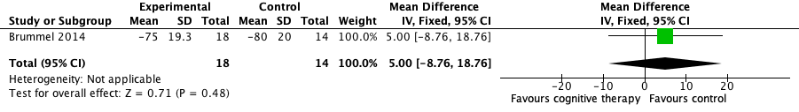
Forest plot, quality of life

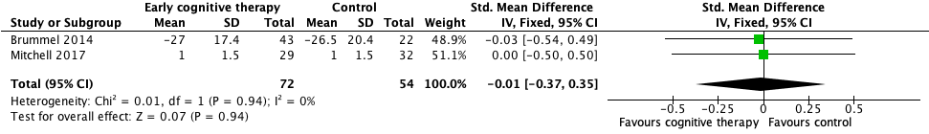
Forest plot, delirium

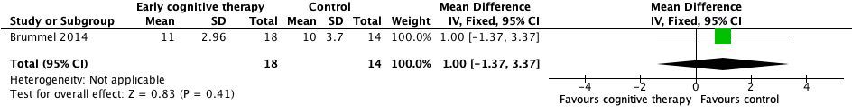
Forest plot, physical functional recovery

Evidence profile: Early cognitive therapy in patients with sepsis and septic shock

Certainty assessment |  |  |  |  |  | № of patients |  | Effect |  | Certainty | Importance
№ of studies | Risk of bias | Inconsistency | Indirectness | Imprecision | Other considerations | Early cognitive therapy | Usual care | Relative  (95% CI) | Absolute  (95% CI)
Cognitive functional recovery (follow up: 3 months; assessed with: Mini-mental status examination (MMSE); Scale from: 0 to 30)
2 RCTs | serious ª | serious ^{b} | not serious | serious ^{c} | none | 18 | 14 | - | SMD 0.67 SD  (0.35 higher to 0.99 higher) | ⨁◯◯◯  VERY LOW | IMPORTANT
Quality of life (follow up: 3 months; assessed with: EQ-5D; Scale from: 0 to 100)
1 RCT | serious ª | not serious | not serious | very serious ^{d} | none | 18 | 14 | - | MD 5 units higher  (8.76 lower to 18.76 higher) | ⨁◯◯◯  VERY LOW | IMPORTANT
Delirium (follow up: 3 months; assessed with: Delirium-free days or total duration of delirium)
2 RCTs | serious ª | not serious | not serious | very serious ^{d} | none | 72 | 54 | - | SMD 0.01 SD lower  (0.37 lower to 0.35 higher) | ⨁◯◯◯  VERY LOW | IMPORTANT
Physical functional recovery (follow up: 3 months; assessed with: Timed up and go)
1 RCT | serious ª | not serious | not serious | very serious ^{d} | none | 18 | 14 | - | MD 1 seconds higher  (1.37 lower to 3.37 higher) | ⨁◯◯◯  VERY LOW | IMPORTANT
Return to activities (follow up: 3 months; assessed with: FAQ instrumental activities of daily living; Scale from: 0 to 30)
1 RCT | serious ª | not serious | not serious | very serious ^{d} | none | 18 | 14 | - | MD 1 unit lower  (3.29 lower to 1.29 higher) | ⨁◯◯◯  VERY LOW | IMPORTANT
Mortality (follow up: 3 months)
1 RCT | serious ª | not serious | not serious | very serious ^{d} | none | 11/43 (25.6%) | 6/22 (27.3%) | RR 0.94  (0.40 to 2.20) | 16 fewer per 1,000  (from 164 fewer to 327 more) | ⨁◯◯◯  VERY LOW | IMPORTANT
ICU length of stay
1 RCT | serious ª | not serious | not serious | serious ^{c} | none | 43 | 22 | - | MD 0.14 days higher  (0.51 lower to 0.79 higher) | ⨁⨁◯◯  LOW | IMPORTANT
Hospital length of stay
1 RCT | serious ª | not serious | not serious | very serious ^{d} | none | 43 | 22 | - | MD 0.9 days higher  (2.52 lower to 4.32 higher) | ⨁◯◯◯  VERY LOW | IMPORTANT
Ventilator-free days
1 RCT | serious ª | not serious | not serious | very serious ^{d} | none | 44 | 22 | - | MD 1.8 VFDs higher  (8.68 lower to 12.28 higher) | ⨁◯◯◯  VERY LOW | IMPORTANT

CI: Confidence interval; MD: Mean difference; SMD: Standardised mean difference; RR: Risk ratio

Explanations
a. Lack of blinding of participants in all trials with risk of performance bias; one trial lacked blinded outcome adjudication with risk of detection bias (Mitchell et al.); one trial (Brummel et al.) had significant loss to follow-up with risk of attrition bias. Overall the trials were small with few events, making detection of bias difficult.
b. Significant heterogeneity between the two trials (I2=78%), with one trial showing no effect (Brummel 2014) and the other (Jingjing 2019) showing a moderate effect
c. Two small trials, resulting in serious imprecision with optimal information size not met.
d. Very small pilot trials with few events, resulting in very serious imprecision.

ETD: Summary of judgements for early cognitive therapy
 | JUDGEMENT
PROBLEM | No | Probably no | Probably yes | Yes |  | Varies | Don't know
DESIRABLE EFFECTS | Trivial | Small | Moderate | Large |  | Varies | Don't know
UNDESIRABLE EFFECTS | Large | Moderate | Small | Trivial |  | Varies | Don't know
CERTAINTY OF EVIDENCE | Very low | Low | Moderate | High |  |  | No included studies
VALUES | Important uncertainty or variability | Possibly important uncertainty or variability | Probably no important uncertainty or variability | No important uncertainty or variability
BALANCE OF EFFECTS | Favors the comparison | Probably favors the comparison | Does not favor either the intervention or the comparison | Probably favors the intervention | Favors the intervention | Varies | Don't know
RESOURCES REQUIRED | Large costs | Moderate costs | Negligible costs and savings | Moderate savings | Large savings | Varies | Don't know
CERTAINTY OF EVIDENCE OF REQUIRED RESOURCES | Very low | Low | Moderate | High |  |  | No included studies
COST EFFECTIVENESS | Favors the comparison | Probably favors the comparison | Does not favor either the intervention or the comparison | Probably favors the intervention | Favors the intervention | Varies | No included studies
EQUITY | Reduced | Probably reduced | Probably no impact | Probably increased | Increased | Varies | Don't know
ACCEPTABILITY | No | Probably no | Probably yes | Yes |  | Varies | Don't know
FEASIBILITY | No | Probably no | Probably yes | Yes |  | Varies | Don't know

Type of recommendation
Strong recommendation against the intervention | Conditional recommendation against the intervention | Conditional recommendation for either the intervention or the comparison | Conditional recommendation for the intervention | Strong recommendation for the intervention
○ | ○ | ● | ○ | ○

There is insufficient evidence to make a recommendation on early cognitive therapy for adult survivors of sepsis or septic shock.

94, 95, 96 Does a multidisciplinary recovery program (rehab, post-ICU clinic, primary care w/referrals), compared to no follow-up/recovery program increase physical function and cognitive recovery, improve psychological symptoms and QOL, and reduce hospital readmissions?

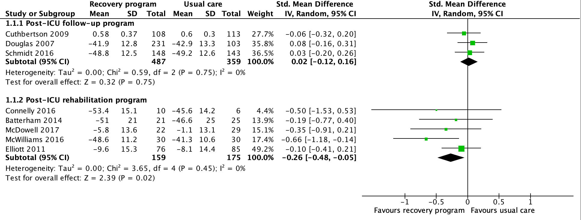
Forest plot, quality of life - 3 to 12 months (measured with SF-36 mental component score, range 0-100, higher is better; EQ-5D, higher is worse; SF-8 mental component, higher is better)

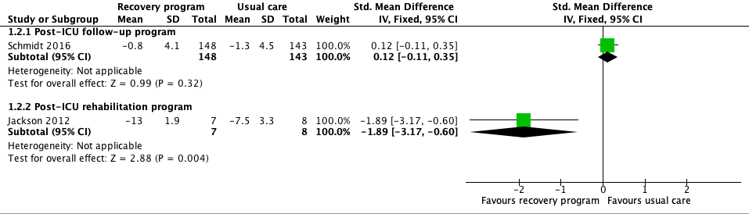
Forest plot, cognitive functional recovery - 3-12 months (measured with change in TICS-M, range 0-50, higher is better; or Tower Test, range 1-19 higher is better)

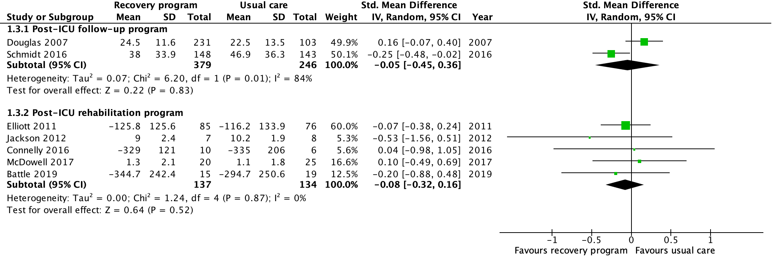
Forest plot, physical functional recovery- 3-12 months (measured using Extra Short Musculoskeletal Function Assessment, range 0-100, higher is worse; measured using 6 minute or 3 minute walk test, higher is better; Rivermeade Mobility Index, range 0-15, higher is better; Timed up and go, higher is worse)

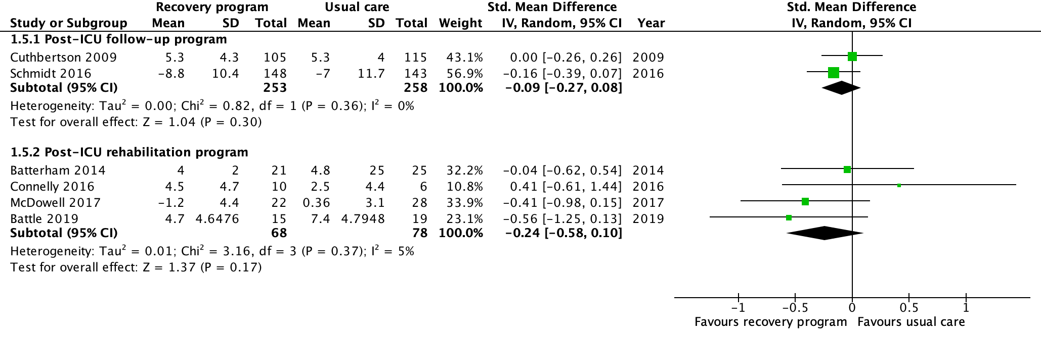
Forest plot, psychological symptoms of patients - depression, 6 to 12 months (measured with change in MDI, range 0-50, higher is worse; measured with HADS-D, range 0-21, higher is worse; measured with BDI, range 0-63, higher is worse)

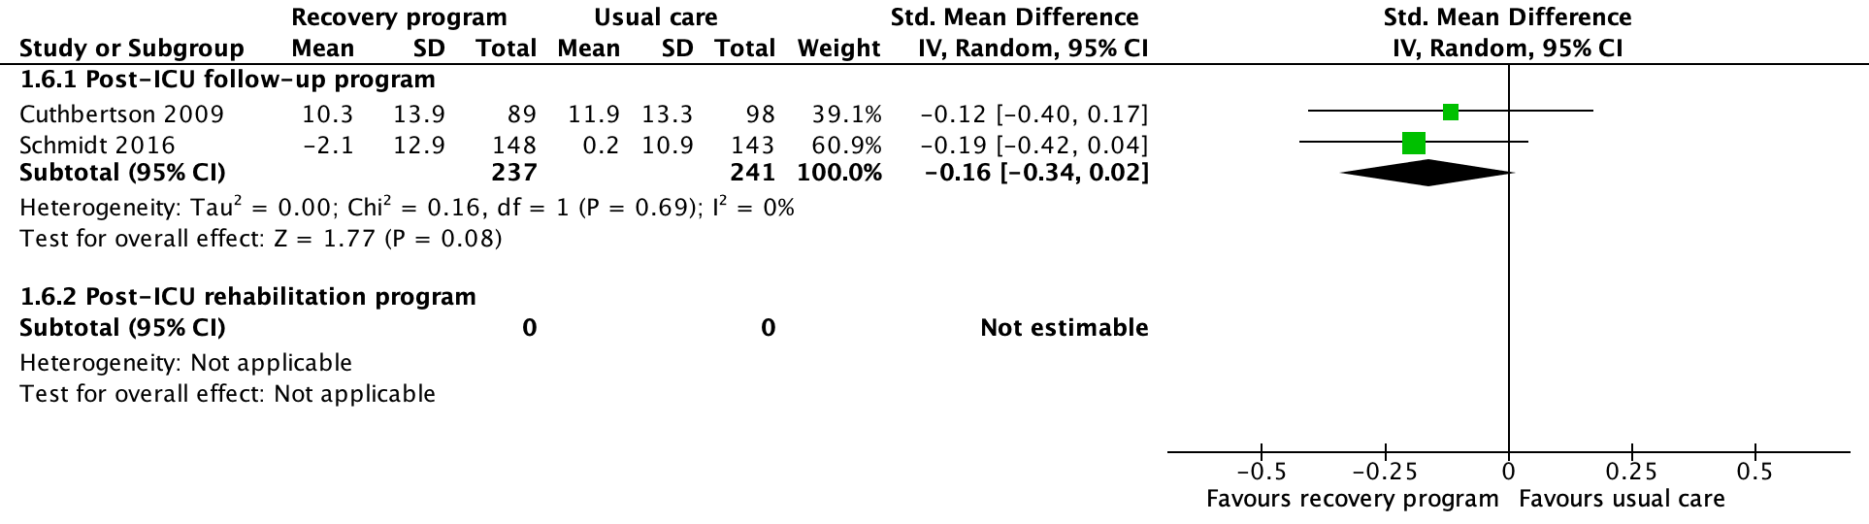
Forest plot, psychological symptoms of patients - post-traumatic stress,, 6-12 months (measured with change in PTSS, range 10-70, higher is worse; measured with Davidson Trauma Score, range 17-85 higher is worse)

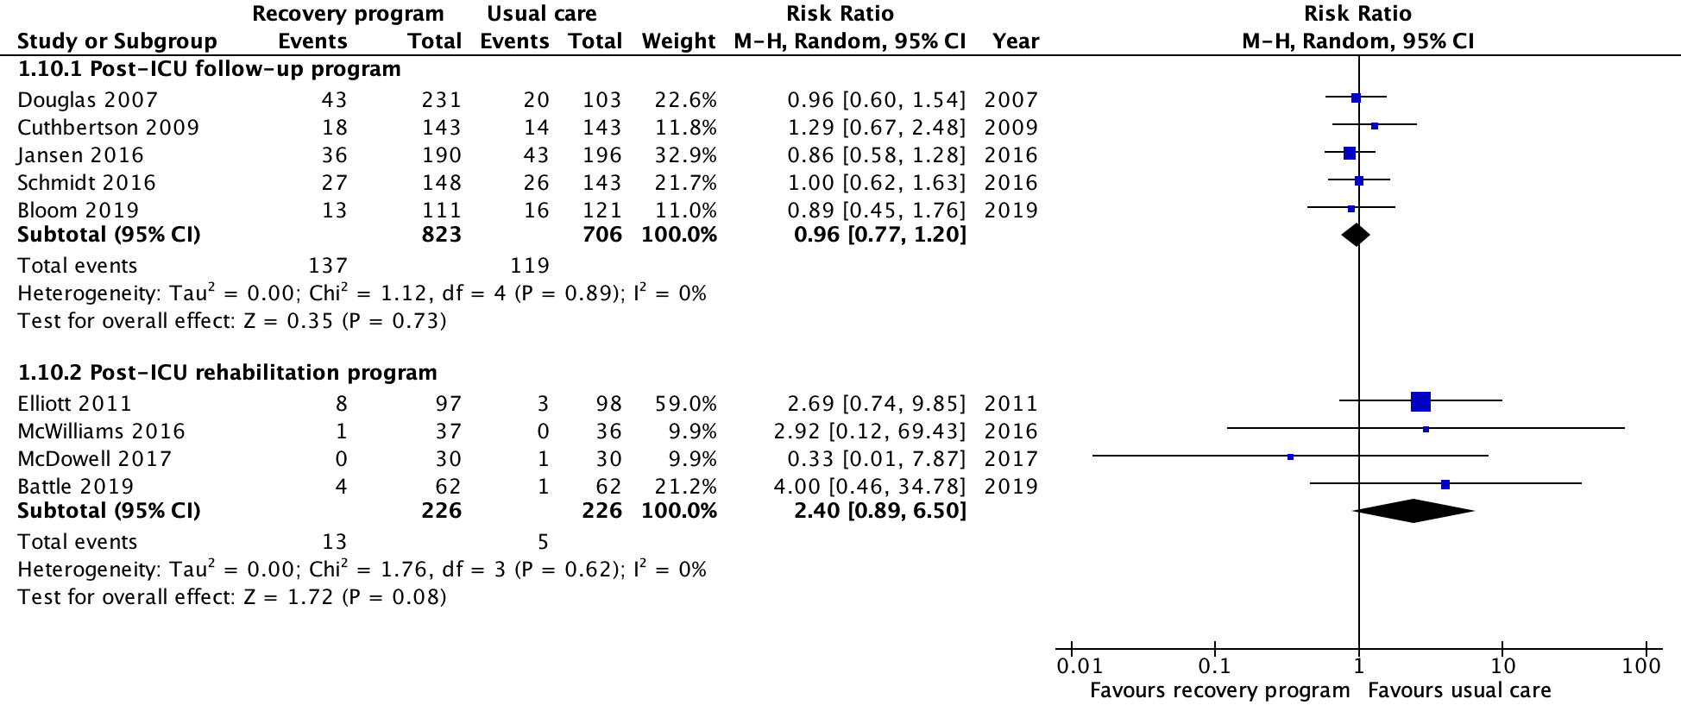
Forest plot, mortality 3-12 months

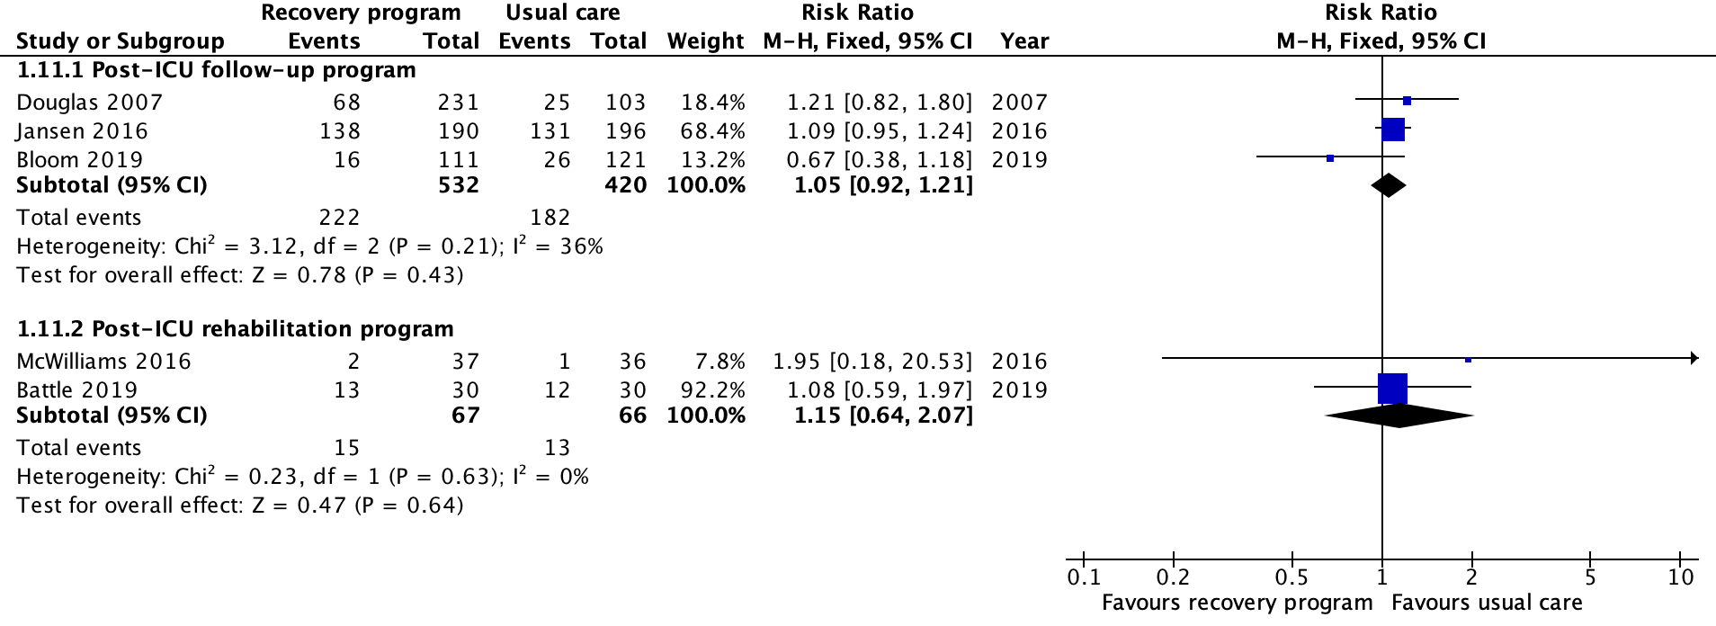
Forest plot, hospital readmission, 30 days to 12 months

Evidence profile: Post-ICU follow-up programs

Certainty assessment |  |  |  |  |  | № of patients |  | Effect |  | Certainty | Importance
№ of studies | Risk of bias | Inconsistency | Indirectness | Imprecision | Other considerations | Follow-up program | Usual care | Relative  (95% CI) | Absolute  (95% CI)
Quality of life - Post-ICU follow-up program
3 RCTs | serious ª | not serious | not serious | serious ^{b} | none | 487 | 359 | - | SMD 0.02 higher  (0.12 lower to 0.16 higher) | ⨁⨁◯◯  LOW | CRITICAL
Cognitive functional recovery - Post-ICU follow-up program
1 RCT | serious ª | not serious | not serious | serious ^{b} | none | 148 | 143 | - | SMD 0.12 higher  (0.11 lower to 0.35 higher) | ⨁⨁◯◯  LOW | CRITICAL
Physical functional recovery - Post-ICU follow-up program
2 RCTs | serious ª | serious ^{c} | not serious | serious ^{b} | none | 379 | 246 | - | SMD 0.05 lower  (0.45 lower to 0.36 higher) | ⨁◯◯◯  VERY LOW | CRITICAL
Patient symptoms of anxiety - Post-ICU follow-up program
1 RCT | serious ª | not serious | not serious | serious ^{b} | none | 92 | 100 | - | MD 0.9 units lower  (2.18 lower to 0.38 higher) | ⨁⨁◯◯  LOW | CRITICAL
Patient symptoms of depression - Post-ICU follow-up program
2 RCTs | serious ª | not serious | not serious | serious ^{b} | none | 253 | 258 | - | SMD 0.09 lower  (0.27 lower to 0.08 higher) | ⨁⨁◯◯  LOW | CRITICAL
Patient symptoms of post-traumatic stress - Post-ICU follow-up program
2 RCTs | serious ª | not serious | not serious | serious ^{b} | none | 237 | 241 | - | SMD 0.16 lower  (0.34 lower to 0.02 higher) | ⨁⨁◯◯  LOW | CRITICAL
Family symptoms of depression - Post-ICU follow-up program
2 RCTs | serious ª | not serious | not serious | serious ^{b} | none | 228 | 129 | - | MD 0.69 higher  (0.46 lower to 1.83 higher) | ⨁⨁◯◯  LOW | CRITICAL
Satisfaction with Care - Post-ICU follow-up program
1 RCT | serious ª | not serious | not serious | serious ^{b} | none | 148 | 143 | - | MD 0.1 lower  (0.69 lower to 0.49 higher) | ⨁⨁◯◯  LOW | CRITICAL
Mortality - Post-ICU follow-up program
5 RCTs | serious ª | not serious | not serious | serious ^{b} | none | 137/823 (16.6%) | 119/706 (16.9%) | RR 0.96  (0.77 to 1.20) | 7 fewer per 1,000  (from 39 fewer to 34 more) | ⨁⨁◯◯  LOW | IMPORTANT
Financial outcomes of survivors and families - Post-ICU follow-up program
1 RCT | serious ª | not serious | not serious | serious ^{b} | none | 163 | 48 | - | MD 0.1 higher  (0.21 lower to 0.41 higher) | ⨁⨁◯◯  LOW | IMPORTANT
Readmission - Post-ICU follow-up program
3 RCTs | serious ª | serious ^{d} | not serious | serious ^{b} | none | 222/532 (41.7%) | 182/420 (43.3%) | RR 1.05  (0.92 to 1.21) | 22 more per 1,000  (from 35 fewer to 91 more) | ⨁◯◯◯  VERY LOW | IMPORTANT

CI: Confidence interval; SMD: Standardised mean difference; MD: Mean difference; RR: Risk ratio

Explanations
a. Significant loss to follow-up in virtually all included studies, as well as inconsistent blinding of patients, clinicians, outcome assessors across studies.
b. Wide 95% CI does not exclude potential benefit or harm.
c. Significant statistical heterogeneity between the two included studies (I-squared = 84%); neither of the two included studies explicitly included a physiotherapy/rehabilitation component in the follow-up program.
d. Inconsistent effects between Bloom 2019 and other studies without clear reason.

Evidence profile: Post-ICU rehabilitation program
Certainty assessment |  |  |  |  |  | № of patients |  | Effect |  | Certainty | Importance
№ of studies | Risk of bias | Inconsistency | Indirectness | Imprecision | Other considerations | Rehab program | Usual care | Relative  (95% CI) | Absolute  (95% CI)
Quality of life - Post-ICU rehabilitation program
5 RCTs | serious ª | not serious | not serious | not serious | none | 260 | 271 | - | SMD 0.26 SD lower  (0.48 lower to 0.05 lower) | ⨁⨁⨁◯  MODERATE | CRITICAL
Cognitive functional recovery - Post-ICU rehabilitation program
1 RCT | serious ª | not serious | serious ^{b} | serious ^{c} | none | 7 | 8 | - | SMD 1.89 lower  (3.17 lower to 0.6 lower) | ⨁◯◯◯  VERY LOW | CRITICAL
Physical functional recovery - Post-ICU rehabilitation program
5 RCTs | serious ª | not serious | not serious | serious ^{d} | none | 276 | 287 | - | SMD 0.08 SD lower  (0.32 lower to 0.16 higher) | ⨁⨁◯◯  LOW | CRITICAL
Patient symptoms of anxiety - Post-ICU rehabilitation program
4 RCTs | serious ª | not serious ^{e} | not serious | serious ^{d} | none | 190 | 194 | - | SMD 0.32 SD lower  (0.77 lower to 0.13 higher) | ⨁⨁◯◯  LOW | CRITICAL
Patient symptoms of depression - Post-ICU rehabilitation program
4 RCTs | serious ª | not serious | not serious | serious ^{d} | none | 190 | 194 | - | SMD 0.24 SD lower  (0.58 lower to 0.1 higher) | ⨁⨁◯◯  LOW | CRITICAL
Mortality - Post-ICU rehabilitation program
4 RCTs | serious ª | not serious | not serious | very serious ^{f} | none | 13/226 (5.8%) | 5/226 (2.2%) | RR 2.40  (0.89 to 6.50) | 31 more per 1,000  (from 2 fewer to 12.2 more) | ⨁◯◯◯  VERY LOW | IMPORTANT

CI: Confidence interval; SMD: Standardised mean difference; RR: Risk ratio

Explanations
a. Significant loss to follow-up in virtually all trials.
b. Cognitive function measured using the Tower Test demonstrated a benefit to the intervention; Mini-Mental Status Exam did not demonstrate a benefit; it is unclear which test of cognitive function is best to evaluate this intervention.
c. Though statistically significant, single trial included 15 patients in final outcome assessment and optimal information size not met.
d. Wide 95% CI does not exclude significant benefit nor harm; v
e. Though statistical inconsistency (I-squared 40%), point estimate for all trials is neutral or on side of benefit.
f. Wide 95% CI and very small number of events resulting in very serious imprecision.

ETD: Summary of judgements, post-ICU follow-up program
 | JUDGEMENT
PROBLEM | No | Probably no | Probably yes | Yes |  | Varies | Don't know
DESIRABLE EFFECTS | Trivial | Small | Moderate | Large |  | Varies | Don't know
UNDESIRABLE EFFECTS | Large | Moderate | Small | Trivial |  | Varies | Don't know
CERTAINTY OF EVIDENCE | Very low | Low | Moderate | High |  |  | No included studies
VALUES | Important uncertainty or variability | Possibly important uncertainty or variability | Probably no important uncertainty or variability | No important uncertainty or variability
BALANCE OF EFFECTS | Favors the comparison | Probably favors the comparison | Does not favor either the intervention or the comparison | Probably favors the intervention | Favors the intervention | Varies | Don't know
RESOURCES REQUIRED | Large costs | Moderate costs | Negligible costs and savings | Moderate savings | Large savings | Varies | Don't know
CERTAINTY OF EVIDENCE OF REQUIRED RESOURCES | Very low | Low | Moderate | High |  |  | No included studies
COST EFFECTIVENESS | Favors the comparison | Probably favors the comparison | Does not favor either the intervention or the comparison | Probably favors the intervention | Favors the intervention | Varies | No included studies
EQUITY | Reduced | Probably reduced | Probably no impact | Probably increased | Increased | Varies | Don't know
ACCEPTABILITY | No | Probably no | Probably yes | Yes |  | Varies | Don't know
FEASIBILITY | No | Probably no | Probably yes | Yes |  | Varies | Don't know

Type of recommendation
Strong recommendation against the intervention | Conditional recommendation against the intervention | Conditional recommendation for either the intervention or the comparison | Conditional recommendation for the intervention | Strong recommendation for the intervention
○ | ○ | ○ | ● | ○

a. For adult survivors of sepsis or septic shock, we recommend assessment and follow-up for physical, cognitive, and emotional problems after hospital discharge. (Best practice statement)

b. For adult survivors of sepsis or septic shock, we suggest referral to a post-critical illness follow-up program if available. (weak recommendation, very low-quality evidence)

ETD: Summary of judgements, post-ICU rehabilitation program
 | JUDGEMENT
PROBLEM | No | Probably no | Probably yes | Yes |  | Varies | Don't know
DESIRABLE EFFECTS | Trivial | Small | Moderate | Large |  | Varies | Don't know
UNDESIRABLE EFFECTS | Large | Moderate | Small | Trivial |  | Varies | Don't know
CERTAINTY OF EVIDENCE | Very low | Low | Moderate | High |  |  | No included studies
VALUES | Important uncertainty or variability | Possibly important uncertainty or variability | Probably no important uncertainty or variability | No important uncertainty or variability
BALANCE OF EFFECTS | Favors the comparison | Probably favors the comparison | Does not favor either the intervention or the comparison | Probably favors the intervention | Favors the intervention | Varies | Don't know
RESOURCES REQUIRED | Large costs | Moderate costs | Negligible costs and savings | Moderate savings | Large savings | Varies | Don't know
CERTAINTY OF EVIDENCE OF REQUIRED RESOURCES | Very low | Low | Moderate | High |  |  | No included studies
COST EFFECTIVENESS | Favors the comparison | Probably favors the comparison | Does not favor either the intervention or the comparison | Probably favors the intervention | Favors the intervention | Varies | No included studies
EQUITY | Reduced | Probably reduced | Probably no impact | Probably increased | Increased | Varies | Don't know
ACCEPTABILITY | No | Probably no | Probably yes | Yes |  | Varies | Don't know
FEASIBILITY | No | Probably no | Probably yes | Yes |  | Varies | Don't know

Type of recommendation
Strong recommendation against the intervention | Conditional recommendation against the intervention | Conditional recommendation for either the intervention or the comparison | Conditional recommendation for the intervention | Strong recommendation for the intervention
○ | ○ | ○ | ● | ○

For adult survivors of sepsis or septic shock receiving mechanical ventilation for >48hours or an ICU stay of >72 hours, we suggest referral to a post-hospital rehabilitation program. (Weak recommendation, very low-quality evidence)

