Effects of prone position on lung recruitment and ventilation-perfusion matching in patients with COVID-19 acute respiratory distress syndrome.

A combined CT-scan/Electrical Impedance Tomography study
Fossali et al.

Online supplement

Methods

Gas exchange data computation
Partial alveolar pressure of O₂ (P_{A}O₂) was calculated by the simplified Riley and Cournand equation: [FiO₂ * (PB-PH₂O)] – (PaCO₂/RER) [E1]. We assumed standard values for barometric pressure (PB) and partial pressure of H₂O (PH₂O) and respiratory exchange ratio (RER) of 760 torr, 47 torr and 0.8, respectively. PaCO₂ is the measured arterial partial pressure of CO₂. Alveolo-arterial difference in O₂ (D(A-a)O₂) was obtained as P_{A}O2 minus arterial pressure in O₂ (PaO₂). Venous admixture (Q_{VA}/Q_{T}) was calculated as previously described by using central venous and arterial blood gas analyses [E2]. Corrected minute ventilation (VMcorr) was computed as (minute ventilation * PaCO₂)/40, and Ventilatory Ratio (VR) as (minute ventilation * PaCO₂)/(PBW*37.5*100) [E3].

Respiratory mechanics data computation
Respiratory mechanics were measured by tele-inspiratory and tele-expiratory occlusions of 2-3 seconds. Driving pressure was measured as plateau pressure (Pplat) minus total PEEP (PEEPtot). Respiratory system compliance (C_{RS}) was calculated as the ratio between tidal volume and driving pressure and standardized respiratory system elastance (E_{RS}) as the ratio between driving pressure and tidal volume per kilograms of PBW [E4].

CT-scan analysis
CT-scans were performed by an experienced team, using a 64-MDCT Lightspeed system (GE Medical Systems, Milwaukee, WI, USA). All CT-scan acquisitions were centralized, manually contoured by 2 independent researchers and analyzed offline, using standard software (Maluna v3.7, Mannheim, Germany).
Quantitative analysis allowed computation of global lung weight, and the proportions of hyperinflated, normally-, poorly- and non-aerated lung weight, as previously described [E5]. This analysis was performed also at the regional level for ventral and dorsal lung, by splitting each CT slices in two equal regions of interest.
Recruitment (or de-recruitment) between supine and prone position at global and regional level was computed as the decrease (or increase, respectively) in non-aerated weight, divided by the global lung weight in the supine position [E5].
Lung gas volume was measured at the global and regional levels, as previously described [E5]. We also computed the mean Hounsfield Units (HU) intensity, defined by the sum of HU*density (for each HU range), divided by the total density. This mean number was calculated both for ventral and dorsal regions, and for each CT compartment (total, hyperinflated, normally, poorly and non-aerated) [E6].

EIT data management and computation
EIT data were stored for offline analysis performed at the global and regional level, by splitting the EIT functional image in 2 same-size ventral and dorsal regions of interest [E7]. Regional distribution of ventilation was measured as previously described.
To assess ventilation-perfusion matching, the pulmonary perfusion map was obtained from the slope of the impedance deflection following a 10 ml bolus of a NaCl 5% solution injected during a tele-inspiratory occlusion, after the removal of the heart and large vessels components [E8]. A filter of 10% of the maximal impedance variation was then applied for recognition of ventilated and/or perfused pixels. Overlap of these two images allowed the detection of ventilated and non-perfused units (only ventilated, indicating dead space) and vice versa (only perfused, indicating shunt). The ratio between these two measures was computed as the dead-space/shunt ratio [E9].

Time-impedance curve concavity index
The authors measured a time-impedance curve concavity index, based on a similar concept than the stress index [E9]. The slope of the global and regional time-impedance curves was fitted with a power equation y = a*Δt^{b} + c, as previously described [E10]. We assumed that, everything being equal in a mode with constant pressure, this curve was an acceptable surrogate for the pressure-volume curve (Figure E1), and we hypothesized that higher “b coefficient” (i.e., more pronounced concavity of the time-impedance curve during insufflation) may indicate larger amount of units opening during inspiration leading to higher risk of atelectrauma (Figure E1).

References
- RILEY RL, COURNAND A. Ideal alveolar air and the analysis of ventilation-perfusion relationships in the lungs. J Appl Physiol. 1949 Jun;1(12):825-47.
- Tahvanainen J, Meretoja O, Nikki P. Can central venous blood replace mixed venous blood samples? Crit Care Med. 1982 Nov;10(11):758-61.
- Sinha P, Calfee CS, Beitler JR, Soni N, Ho K, Matthay MA, Kallet RH. Physiologic Analysis and Clinical Performance of the Ventilatory Ratio in Acute Respiratory Distress Syndrome. Am J Respir Crit Care Med. 2019 Feb 1;199(3):333-341.
- Goligher EC, Costa ELV, Yarnell CJ, et al. Effect of Lowering Tidal Volume on Mortality in ARDS Varies with Respiratory System Elastance. Am J Respir Crit Care Med. 2021 Jan 13.
- Gattinoni L, Caironi P, Cressoni M, et al. Lung recruitment in patients with the acute respiratory distress syndrome. N Engl J Med. 2006 Apr 27;354(17):1775-86.
- Vieira SR, Puybasset L, Richecoeur J, et al. A lung computed tomographic assessment of positive end-expiratory pressure-induced lung overdistension. Am J Respir Crit Care Med. 1998 Nov;158(5 Pt 1):1571-7.
- Mauri T, Eronia N, Turrini C, Battistini M, Grasselli G, Rona R, Volta CA, Bellani G, Pesenti A. Bedside assessment of the effects of positive end-expiratory pressure on lung inflation and recruitment by the helium dilution technique and electrical impedance tomography. Intensive Care Med. 2016 Oct;42(10):1576-1587.
- Bluth T, Kiss T, Kircher M, et al. Measurement of relative lung perfusion with electrical impedance and positron emission tomography: an experimental comparative study in pigs. Br J Anaesth. 2019 Aug;123(2):246-254.
- Grasso S, Terragni P, Mascia L, et al. Airway pressure-time curve profile (stress index) detects tidal recruitment/hyperinflation in experimental acute lung injury. Crit Care Med. 2004 Apr;32(4):1018-27.
- Mauri T, Spinelli E, Scotti E, et al. Potential for Lung Recruitment and Ventilation-Perfusion Mismatch in Patients With the Acute Respiratory Distress Syndrome From Coronavirus Disease 2019. Crit Care Med. 2020 Aug;48(8):1129-1134.
- Wrigge H, Zinserling J, Muders T, et al. Electrical impedance tomography compared with thoracic computed tomography during a slow inflation maneuver in experimental models of lung injury. Crit Care Med. 2008 Mar;36(3):903-9.

Additional Table

Variable | Supine  n = 21 | Prone  n = 21 | p value
CT-scan global analysis
Total lung weight, g | 1466 (±378) | 1394 (±381) | .007
Hyperinflated lung weight, g | 14 (±12) | 12 (±9) | .008
Normally aerated lung weight, g | 356 (±132) | 400 (±164) | .004
Poorly aerated lung weight, g | 525 (±192) | 505 (±173) | .335
Non-aerated lung weight, g | 571 (±294) | 477 (±249) | .001
Lung volume, mL | 1402 (±599) | 1462 (±612) | .117
CT-scan ventral regions analysis
Total lung weight, g | 531 (±133) | 632 (±189) | <.001
Hyperinflated lung weight, g | 10 (±9) | 4 (±4) | <.001
Normally aerated lung weight, g | 187 (±69) | 148 (±66) | <.001
Poorly aerated lung weight, g | 183 (±74) | 222 (±93) | .019
Non-aerated lung weight, g | 152 (±84) | 257 (±140) | <.001
Lung volume, mL | 785 (±351) | 541 (±265) | <.001
CT-scan dorsal regions analysis
Total lung weight, g | 965 (±264) | 803 (±252) | <.001
Hyperinflated lung weight, g | 4 (±4) | 8 (±6) | <.001
Normally aerated lung weight, g | 177 (±75) | 260 (±115) | <.001
Poorly aerated lung weight, g | 353 (±142) | 295 (±118) | .015
Non-aerated lung weight, g | 431 (±238) | 239 (±149) | <.001
Lung volume, mL | 641 (±271) | 930 (±350) | <.001

Table E1. Regional quantitative CT-scan analysis between the supine and prone positions.

Variable | Supine  n = 21 | Prone  n = 21 | p value
Ventral regions
Mean HU global | -623 [-662 - -444] | -458 [-562 - -333] | <.001
Mean HU hyperinflated | -939 [-941 - -939] | - 939 [-941 – 938] | .224
Mean HU normally aerated | -729 [-770 - -705] | -707 [-735 - -685] | <.001
Mean HU poorly aerated | -328 [-340 - -310] | -309 [-320 - -285] | <.001
Mean HU non-aerated | 18 [11-27] | 11 [4-16] | <.001
Dorsal regions
Mean HU global | -421 [-493 - -296] | -540 [-603 - -481] | <.001
Mean HU hyperinflated | -940 [-941 - -939] | -940 [-941 - -938] | .426
Mean HU normally aerated | -696 [-723 - -670] | -707 [-746 - -697] | <.001
Mean HU poorly aerated | -304 [-319 - -282] | -332 [-347 - -317] | <.001
Mean HU non-aerated | 16 [7-21] | 24 [17-31] | <.001

Table E2. Mean CT numbers distribution, expressed in Hounsfield Units (HU), according to each CT-scan based lung compartment.

Additional Figures

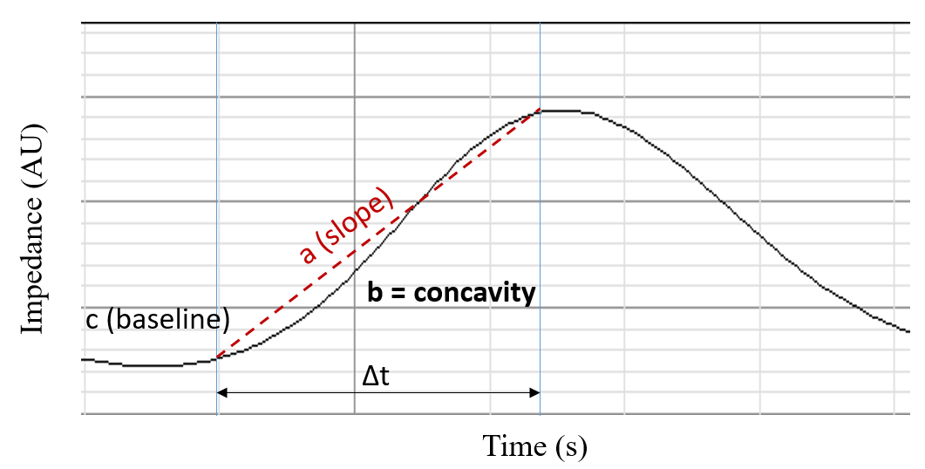
Figure E1. Determinants of the power equation to compute the time-impedance curve index for a given tidal breathe. The inspiratory part of the curve is fitted with the following equation: z = a*Δt^{b} + c. a represents the slope of the curve, b its concavity (this is, the measured index), and c the baseline value at the beginning of the cycle. The higher b is, the more concave the curve is, which could be related to atelectrauma.

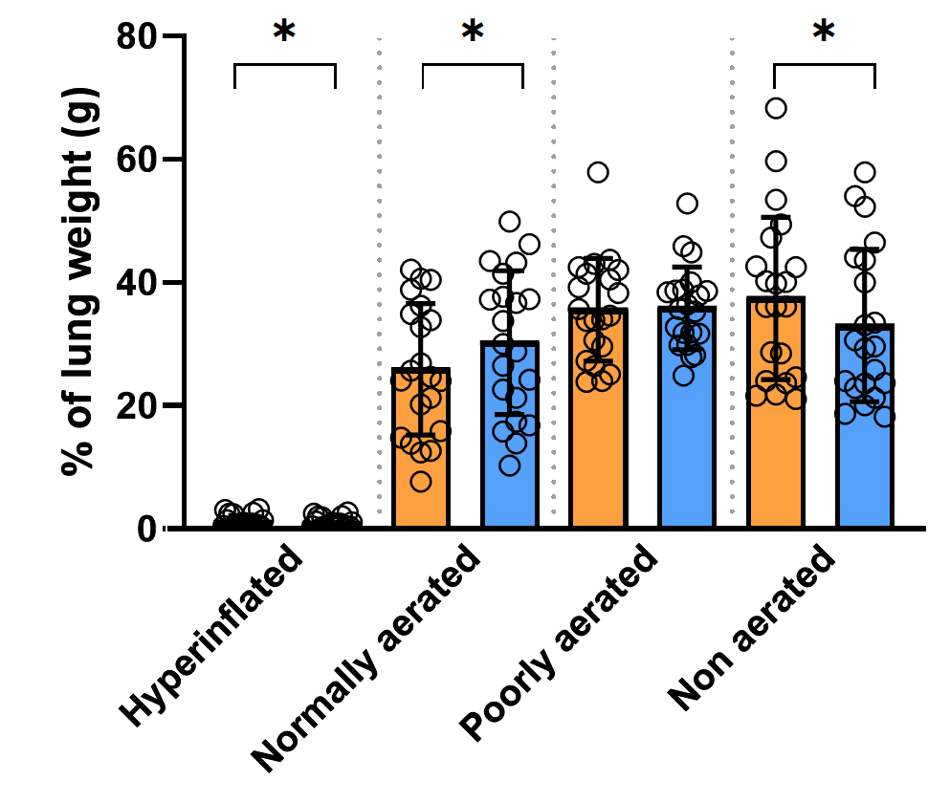
Figure E2. Distribution of the global weight among lung components between supine (orange bars) and prone (blue bars) position. *p<0.05

Figure E3. Variation of the amount of only ventilated (blue boxes) and only perfused (red boxes) lung units between the supine and prone positions. *p<0.05, box plots in Tukey representation.

Figure E4. Individual values and box plots (mean with Tukey representation) of respiratory system compliance (A, C_{RS}), PaO₂/FiO₂ ratio (B) and PaCO₂ (C). *p<0.05

Figure E5. Association between global and regional (de)recruitment, and change in PaO₂/FiO₂ ratio. Note the absence of correlation (rho=0.091, p=0.703 for the global lungs; rho=0.317, p=0.173 for the ventral regions, and rho=0.184, p=0.436 for the dorsal ones).

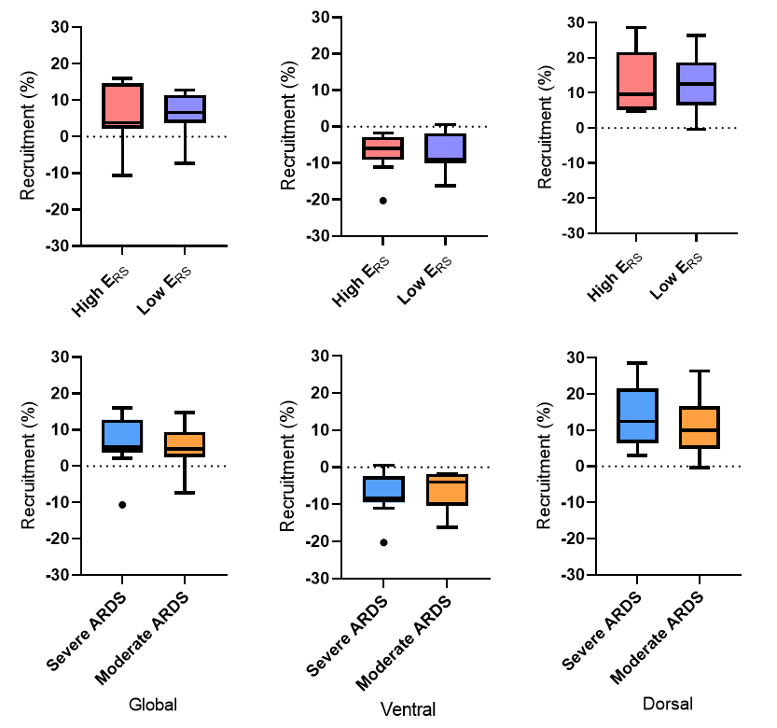
Figure E6. Effect of prone positioning on recruitment among subgroups, in global and regional lung regions. E_{RS}: respiratory system elastance.

