Supplemental digital content 1. Flow Chart
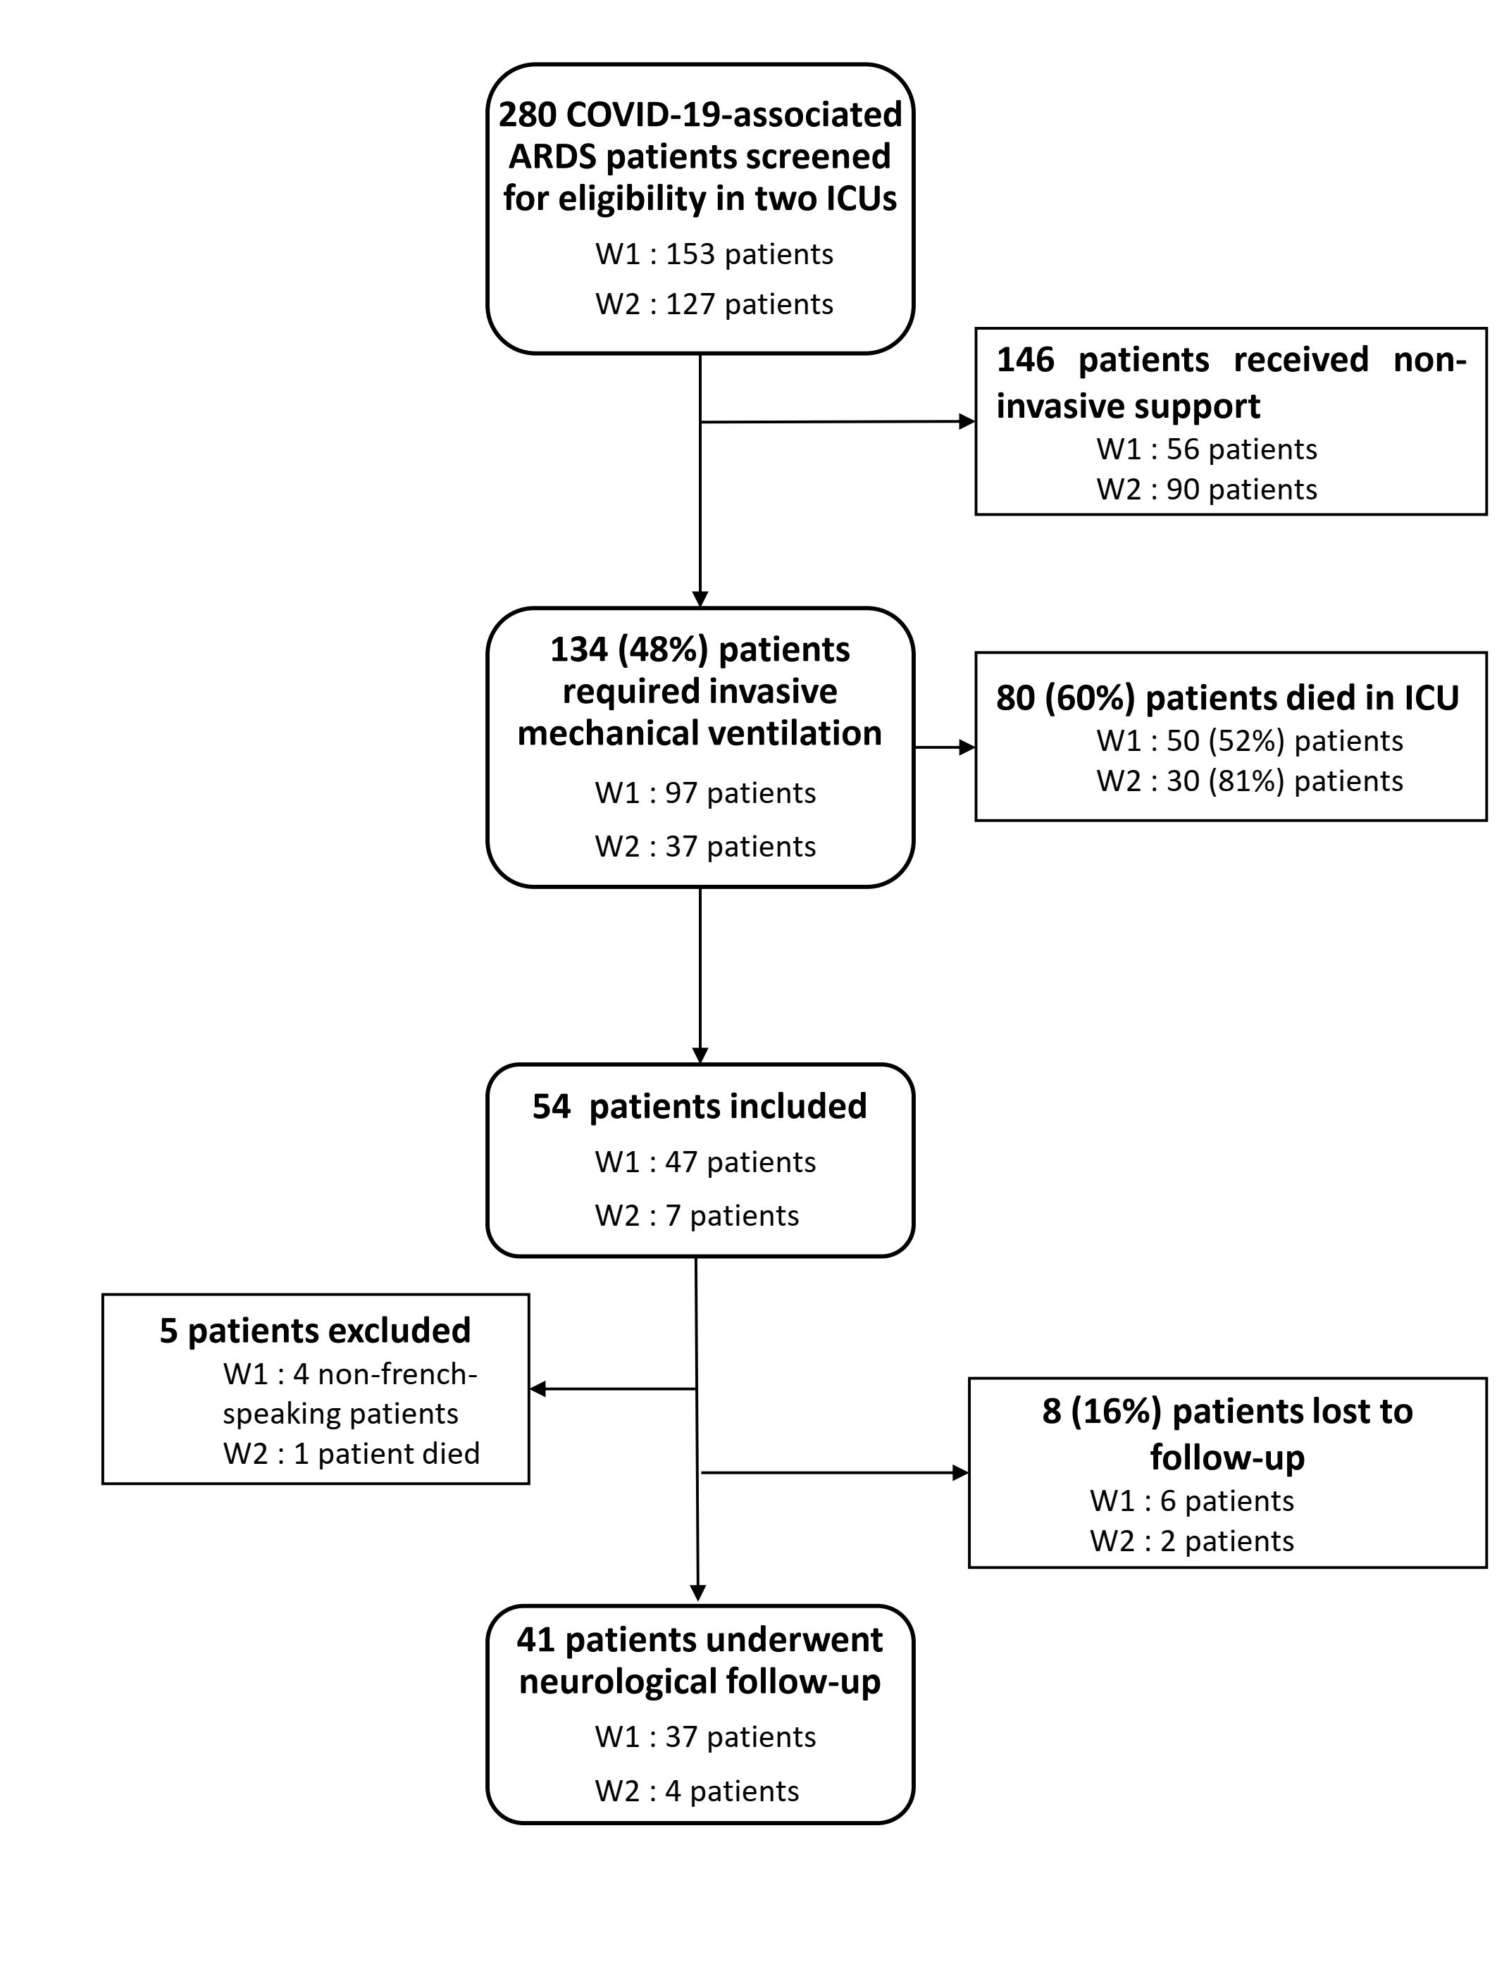
ICU = Intensive Care Unit, ARDS = Acute Respiratory Distress Syndrome. W1 = first wave of COVID-19 pandemic (March to May 2020), W2 = second wave of COVID-19 pandemic (September to December 2020).

