Supplemental material of manuscript “Functional recovery groups in critically ill COVID-19 patients and their associated factors: From ICU to hospital discharge”

Page 2 – Supplemental Figure 1. Flowchart of the early mobilization protocol at Hospital Sírio-Libanês based on studies by Gosselink et al., 2008 and Murakami et al.,2015.

Page 3- Supplemental Table 1. Physical and functional characteristics of COVID-19 patients at ICU discharge and hospital discharge

Page 4- Supplemental Figure 2. Percentages of patients who reached the maximum possible score in each of the BI-specific activities at ICU discharge and at hospital discharge.

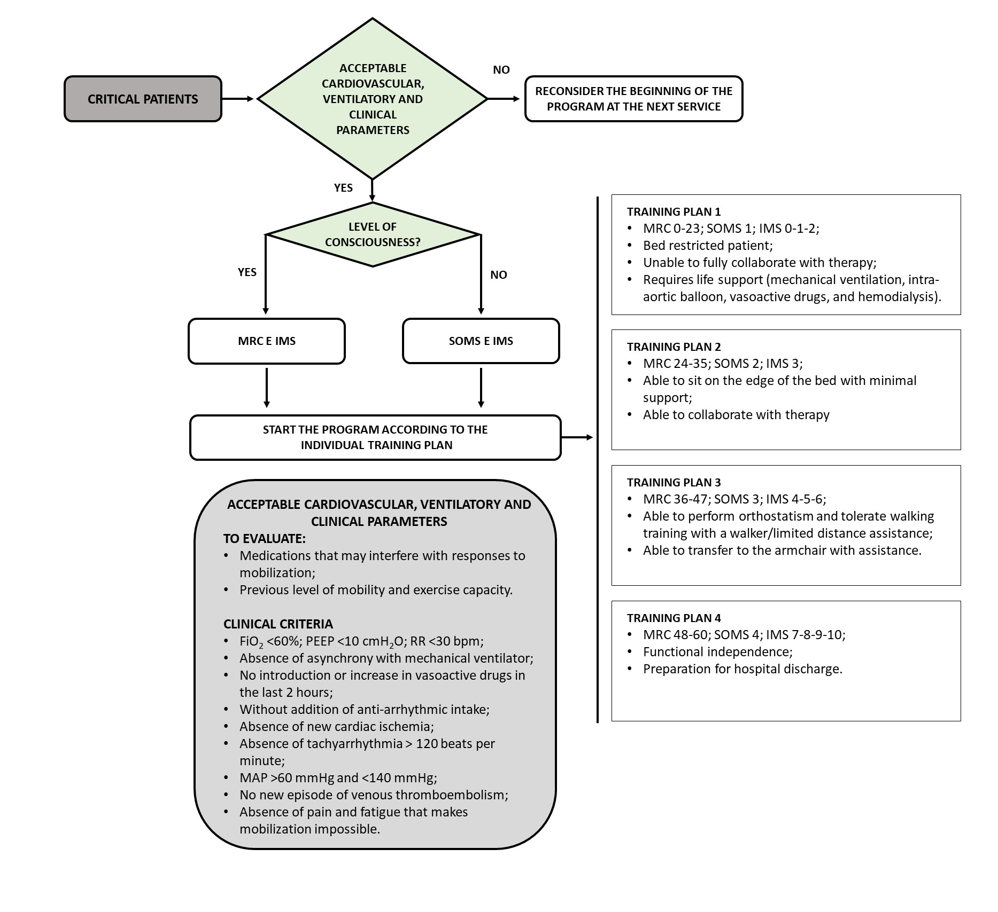
Supplemental Figure 1. Flowchart of the early mobilization protocol at Hospital Sírio-Libanês based on studies by Gosselink et al., 2008 and Murakami et al.,2015.

Supplemental Table 1. Physical and functional characteristics of COVID-19 patients at ICU discharge and hospital discharge
Variables | ICU discharge  n=339 |  | Hospital discharge  n=328
IMS scale, score | 7 | ±2 | NA | NA
Barthel Index, score | 73 | ±24 | 85 | ±19
Functional dependence (BI<85), n (%) | 188 | 55.5% | 109 | 33%
Delta Barthel Index, score | 26 | ±24.6 | 12 | ±9
MRC, score | 50.0 | ±9.4 | 52 | ±8
Handgrip, kgf | 19.3 | ±12.4 | 21.2 | ±11.8
ICU acquired muscle weakness, n (%) | 105 | 31.0% | 33 | 9.7%
Maximal inspiratory pressure, cmH₂O | 67 | ±28 | 76 | ±30.9
Maximal expiratory pressure, cmH₂O | 72 | ±28 | 79 | ±29.9
Step test, number | 15 | ±25 | 24 | ±32
Data described in mean ± SD, median (25–95%), n=absolute number (%). ICU=intensive care unit; IMS=ICU Mobility Scale; MRC=Medical Research Council, NA: not assessed.

Supplemental Figure 2. Percentages of patients who reached the maximum possible score in each of the BI-specific activities at ICU discharge and at hospital discharge.

