Supplementary online content

Bose S, Groat D, Dinglas VD et al. Association between unmet non-medication needs after hospital discharge and readmission or death among acute respiratory failure survivors: a multicenter prospective cohort study
Supplementary tables
eTable S1: Frequency of prescription for durable medical equipment (DME) and status at follow-up. eTable S2: Reasons for unfilled durable medical equipment (DME) needs (n=118)
eTable S3: Frequency and unfilled rate of home health services at follow-up. (n = 134)
eTable S4: Reasons for unmet home health services (HHS) needs. (n=134)
eTable S5: Frequency of unmet follow-up appointments (FUA) by medical specialty and status at follow-up. (n = 189)
eTable S6: Estimates of top four variables identified from random forest model predictive of unmet discharge needs. Variables were included in a Poisson multivariate regression model for unmet discharge need

Supplementary figures
eFigure S1: Covariate balancing for unmet non-medication discharge needs.
eFigure S2: Timing of follow-up and constituents of primary outcome. Outcomes on the left of the follow-up occurred before the follow-up assessment of discharge needs. There were 18% (35/195) of outcomes that occurred before 28 days, of which 12% (23/195) occurred before the follow-up assessment.
eFigure S3: Variable importance from random forest model predicting proportion of unmet needs.

eTable S1: Frequency of prescription for durable medical equipment (DME) and status at follow-up. (n=118)

Durable Medical Equipment | Frequency | DME Status at Follow-up
 |  | *Unmet % | *Used %
Oxygen | 40 | 12 | 85
Walker | 31 | 23 | 74
Non-invasive ventilation | 16 | 31 | 69
Glucometer | 14 | 14 | 79
Nebulizer | 13 | 8 | 85
Commode | 12 | 50 | 33
Shower chair | 12 | 42 | 42
Wound care | 11 | 0 | 100
Infusion pump: nutrition | 10 | 0 | 100
Infusion pump: medications | 8 | 12 | 88
Cane | 7 | 57 | 0
Wheelchair | 4 | 25 | 75
Hospital bed | 3 | 33 | 67
Wound VAC (Vacuum Assisted Closure) device | 3 | 33 | 67
Shower bar | 2 | 0 | 100
Chairlift | 2 | 50 | 50
Foley catheter | 2 | 0 | 100
Crutches | 1 | 0 | 100
Ramp for house | 1 | 0 | 100
* Unmet were never delivered or not in process for delivery. Used if the patient reported using the equipment.

eTable S2: Reasons for unfilled durable medical equipment (DME) needs (n=118)

DME | Frequency | Reason DME was Unmet
 |  | Can’t Afford  % | Not Delivered % | Patient  Declined  % | Physician Cancelled  % | Other  %
Oxygen | 40 | 0 | 2 | 0 | 8 | 8
Walker | 31 | 0 | 3 | 10 | 0 | 16
Non-invasive ventilation | 16 | 0 | 19 | 0 | 0 | 12
Glucometer | 14 | 0 | 0 | 0 | 0 | 21
Nebulizer | 13 | 0 | 0 | 0 | 0 | 15
Commode | 12 | 0 | 8 | 25 | 0 | 17
Shower chair | 12 | 0 | 0 | 17 | 8 | 25
Wound care | 11 | 0 | 0 | 0 | 0 | 0
Infusion pump: nutrition | 10 | 0 | 0 | 0 | 0 | 0
Infusion pump: medications | 8 | 0 | 0 | 0 | 0 | 12
Cane | 7 | 0 | 14 | 0 | 0 | 57
Wheelchair | 4 | 0 | 0 | 25 | 0 | 0
Hospital bed | 3 | 0 | 0 | 0 | 0 | 0
Wound Vac | 3 | 0 | 33 | 0 | 0 | 0
Shower bar | 2 | 0 | 0 | 0 | 0 | 0
Chairlift | 2 | 50 | 0 | 0 | 0 | 0
Foley catheter | 2 | 0 | 0 | 0 | 0 | 0
Crutches | 1 | 0 | 0 | 0 | 0 | 0
Ramp for house | 1 | 0 | 0 | 0 | 0 | 0

eTable S3: Frequency and unfilled rate of home health services at follow-up. (n = 134)

Home Health Service | Frequency | Home Health Service Status at Follow-up
 |  | *Unmet % | Not Scheduled %
Nurse | 96 | 21 | 6
Physical therapy | 84 | 45 | 21
Occupational therapy | 63 | 49 | 25
Wound care | 14 | 21 | 7
Speech-language pathology | 13 | 54 | 38
Oxygen | 12 | 25 | 8
Infusion care | 10 | 20 | 20
Evaluation | 7 | 57 | 14
Education | 7 | 43 | 14
Home health aide | 5 | 20 | 20
Remote patient monitoring | 4 | 25 | 0
Enteral Feeding | 4 | 25 | 25
Social work | 3 | 100 | 33
Respiratory therapy | 2 | 100 | 50
Private nurse | 1 | 0 | 0
* Unmet were missed or not scheduled.

eTable S4: Reasons for unmet home health services (HHS) needs. (n=134)

Home Health Service | Frequency | Reason HHS Appointments were Unmet*
 |  | Can’t  Afford  % | Pt  Refused  % | MD  Cancelled  % | Has  COVID  % | Other  %
Nurse | 96 | 0.0 | 2 | 0 | 7 | 86
Physical therapy | 84 | 0.0 | 4 | 4 | 19 | 70
Occupational therapy | 63 | 0.0 | 3 | 11 | 21 | 65
Wound care | 14 | 0.0 | 7 | 0 | 0 | 93
Speech-language pathology | 13 | 0.0 | 8 | 0 | 31 | 54
Oxygen | 12 | 0.0 | 0 | 8 | 0 | 92
Infusion care | 10 | 0.0 | 0 | 0 | 10 | 80
Evaluation | 7 | 0.0 | 0 | 0 | 29 | 71
Education | 7 | 0.0 | 0 | 0 | 14 | 71
Home health aid | 5 | 0.0 | 0 | 0 | 0 | 80
Remote patient monitoring | 4 | 0.0 | 0 | 0 | 0 | 100
Enteral Feeding | 4 | 0.0 | 0 | 0 | 0 | 0
Social worker consult | 3 | 0.0 | 0 | 0 | 67 | 33
Respiratory therapy | 2 | 0.0 | 0 | 0 | 100 | 0
Private nurse | 1 | 0.0 | 0 | 0 | 0 | 100
* No HHS were unfilled because of patients’ decision to not follow through to avoid getting COVID
eTable S5: Frequency of unmet follow-up medical appointments (FUA) by medical specialty and status at follow-up. (n = 189)

Follow-up Medical Appointment | Frequency | Status of FUA at Follow-up
 |  | *Unmet  % | Scheduled  before  discharge % | Scheduled  after  discharge % | One or  More  Visits %
Physician
Primary Care Provider | 138 | 13 | 42 | 46 | 57
Cardiologist | 67 | 9 | 76 | 15 | 39
Pulmonologist | 51 | 7 | 73 | 20 | 31
Heme/Oncologist | 33 | 15 | 58 | 27 | 36
Nephrologist | 17 | 12 | 47 | 41 | 24
General Surgery | 14 | 7 | 64 | 29 | 21
Cardiothoracic Surgeon | 13 | 0 | 85 | 15 | 38
Infectious Disease | 13 | 7 | 85 | 8 | 31
Sleep Medicine | 13 | 31 | 54 | 15 | 8
Urologist | 11 | 9 | 82 | 9 | 36
Hepatologist | 10 | 20 | 80 | 0 | 30
Gastroenterologist | 9 | 11 | 67 | 22 | 22
Internal/Family Medicine | 9 | 11 | 56 | 33 | 33
Psychiatrist | 5 | 0 | 80 | 20 | 40
Vascular Surgery | 4 | 0 | 100 | 0 | 0
Endocrinologist | 4 | 0 | 75 | 25 | 0
Orthopedic Surgeon | 4 | 0 | 75 | 25 | 25
Neurologist | 4 | 50 | 50 | 0 | 0
Ear, Nose, Throat | 4 | 50 | 25 | 25 | 0
Plastic Surgery | 3 | 33 | 67 | 0 | 0
Radiology | 3 | 0 | 67 | 33 | 0
Dermatologist | 2 | 0 | 100 | 0 | 50
Rheumatologist | 2 | 0 | 100 | 0 | 50
Thoracic Surgeon | 2 | 0 | 100 | 0 | 0
Addiction Medicine | 2 | 50 | 50 | 0 | 50
Electrophysiologist | 2 | 50 | 50 | 0 | 50
Psychiatrist | 2 | 0 | 50 | 50 | 100
OB/GYN | 1 | 0 | 100 | 0 | 0
Neurosurgery | 1 | 100 | 0 | 0 | 0
Laboratory/Imaging/Dialysis
Laboratory | 46 | 21 | 46 | 33 | 52
Imaging | 25 | 24 | 52 | 24 | 20
Anticoagulation Clinic | 7 | 14 | 57 | 29 | 71
Dialysis | 1 | 0 | 100 | 0 | 100
Rehabilitation and Support Services
Physical Therapy | 9 | 22 | 22 | 56 | 22
Cardiac Registered Nurse | 8 | 0 | 88 | 12 | 12
Cardiac Rehabilitation | 7 | 43 | 43 | 14 | 0
COVID-19 Related | 7 | 14 | 43 | 43 | 43
Physical Medicine/Rehab | 7 | 0 | 100 | 0 | 0
Speech-Language Pathology | 7 | 57 | 14 | 29 | 29
After Care Clinic | 6 | 0 | 83 | 17 | 50
Drug Use | 6 | 67 | 33 | 0 | 17
Occupational Therapy | 5 | 80 | 0 | 20 | 20
Nutrition | 3 | 33 | 67 | 0 | 0
Pulmonology Rehab | 3 | 67 | 33 | 0 | 33
Registered Nurse | 2 | 0 | 100 | 0 | 50
Alcohol Use | 2 | 50 | 0 | 50 | 0
Tobacco Use | 2 | 100 | 0 | 0 | 0
Social Worker | 1 | 0 | 100 | 0 | 0
Psychologist | 1 | 100 | 0 | 0 | 0
Therapist | 1 | 100 | 0 | 0 | 0

* Unmet FUA needs: Appointments were never scheduled, hence no visit occurred.

eTable S6: Estimates of top four variables identified from random forest model predictive of unmet discharge needs. Variables were included in a Poisson multivariate regression model for unmet discharge needs.
Variable | Odds Ratio | 95% CI | p-value
Hospital Length of Stay | 1.015 | 1.006 to 1.025 | 0.002
APACHE II Severity of Illness Score | 0.983 | 0.959 to 1.009 | 0.200
Multidimensional Scale Perceived Social Support Score | 1.000 | 0.986 to 1.015 | 0.998
Age | 1.016 | 1.002 to 1.030 | 0.022

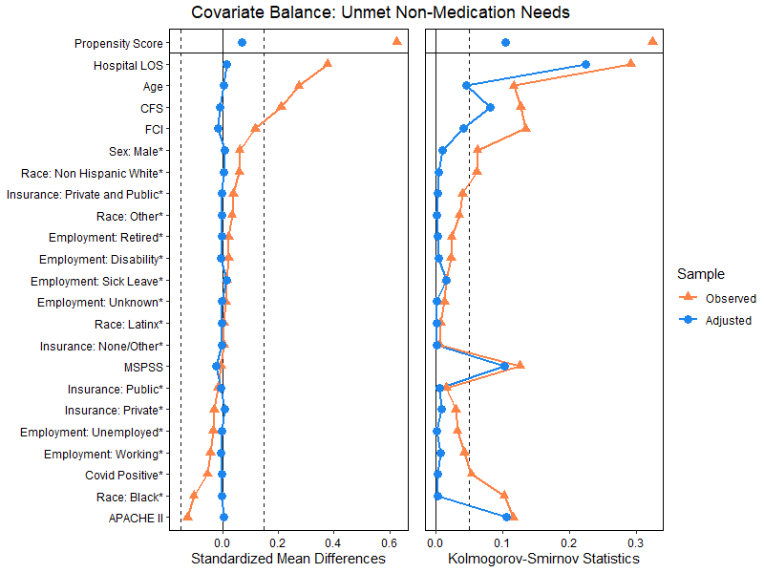

eFigure S1: Covariate balancing for unmet non-medication discharge needs.

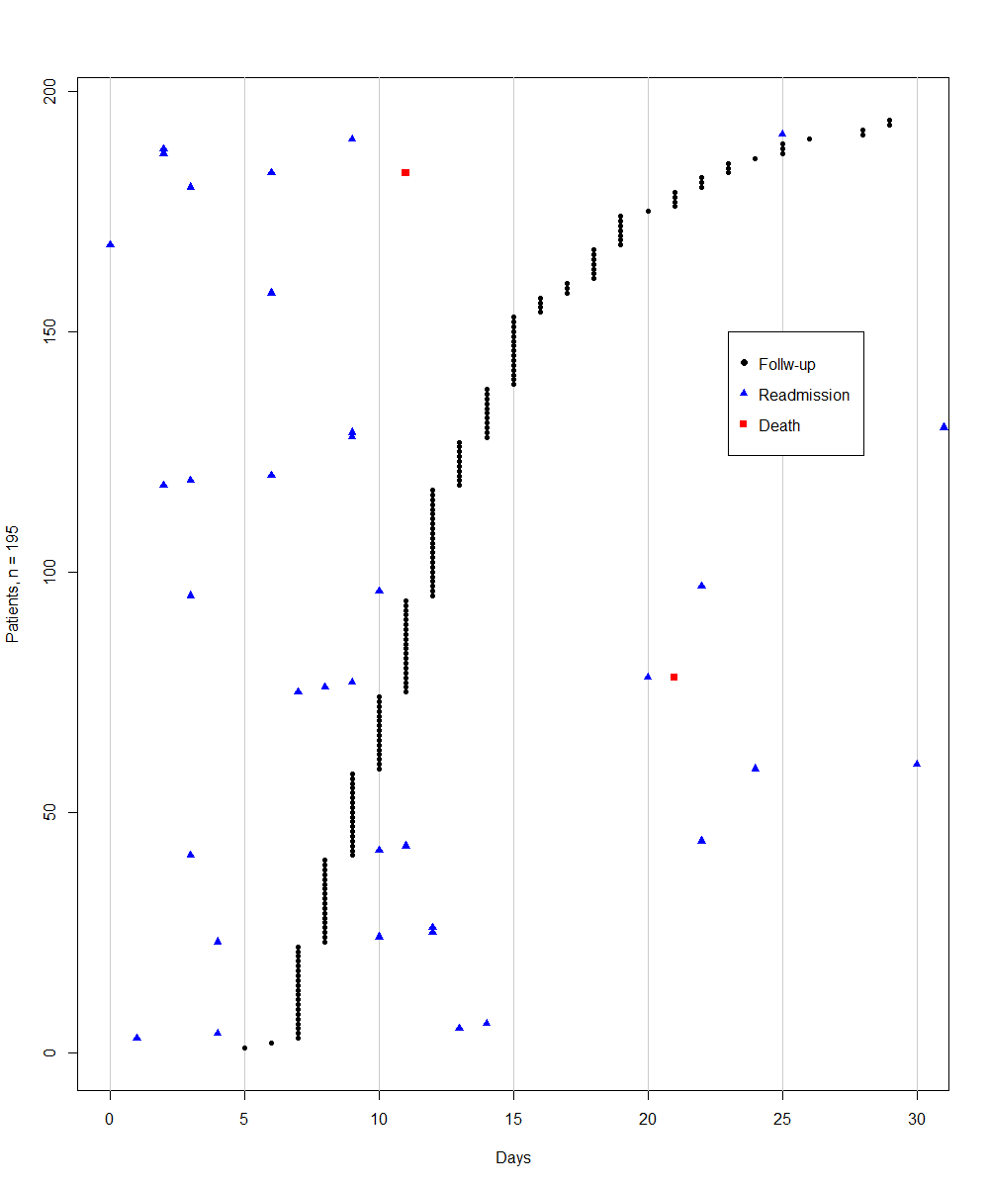

eFigure S2: Timing of follow-up and constituents of primary outcome. Outcomes on the left of the follow-up occurred before the follow-up assessment of discharge needs. There were 18% (35/195) of outcomes that occurred before 28 days, of which 12% (23/195) occurred before the follow-up assessment.

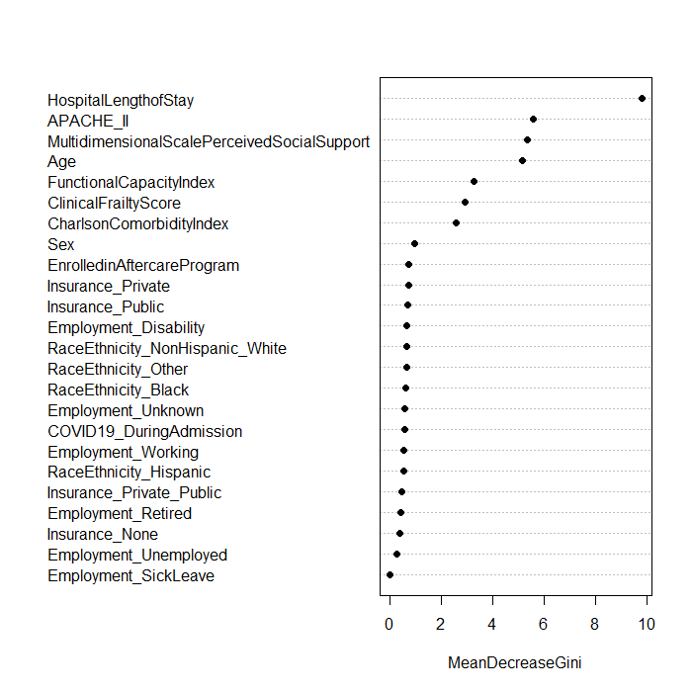

eFigure S3: Variable importance from random forest model predicting proportion of unmet needs.

