Table of Contents
Supplement Table 1. EMBASE search strategy 3
Supplement Table 2. OVID search strategy 5
Supplement Table 3. Cochrane Library search strategy 9
Supplement Table 4. ClinicalTrials.gov search strategy 11
Supplement Table 5. Updated Cochrane Library search strategy 14
Supplement Table 6. Clinical Effect Sizes of Interest for the Trial Sequential Analyses 16
Supplement Table 7. Summary of TSA Adjusted Effect Estimates 16
Supplement Figure 1. TSA Mortality at longest follow-up 17
Supplement Figure 2. TSA Mortality at 28 days 18
Supplement Figure 3. TSA Risk of undergoing renal replacement therapy 18
Supplement Figure 4. TSA ICU length of stay 19
Supplement Figure 5. TSA Hospital length of stay 19
Supplement Figure 6. TSA Duration of vasopressor therapy 20
Supplement Table 8. Hypothesized directions of effect 21
Supplement Table 9. Excluded studies from full review with justification 21
Supplement Table 10. ROB2 Assessment mortality 25
Supplement Table 11. ROB2 Assessment duration of vasopressor therapy 28
Supplement Table 12. ROB2 risk of undergoing renal replacement therapy 30
Supplement Table 13. ROB2 Incidence of digital ischemia/necrosis 32
Supplement Table 14. ROB2 Incidence of mesenteric ischemia 34
Supplement Table 15. ROB2 Incidence of cardiac arrhythmias 36
Supplement Table 16. ROB2 Total fluid administered 38
Supplement Table 17. ROB2 ICU length of stay 40
Supplement Table 18. ROB2 Hospital length of stay 42
Supplement Table 19. GRADE Evidence Profile 44
Supplement Figure 7. Forest plot showing mortality at longest follow-up subgroup analysis by control MAP target ≤65mmHg versus >65mmHg 46
Supplement Figure 8. Forest plot showing mortality at longest follow-up subgroup analysis by shock type 47
Supplement Figure 9. Forest plot showing mortality at 28-30 days 47
Supplement Figure 10. Forest plot showing mortality at 28 days subgroup analysis by control MAP target ≤65mmHg versus >65mmHg 48
Supplement Figure 11. Forest plot showing risk of undergoing renal replacement therapy subgroup analysis by control MAP target ≤65mmHg versus >65mmHg 48
Supplement Figure 12. Forest plot showing risk of undergoing renal replacement therapy subgroup analysis by history of chronic hypertension versus no chronic hypertension 49
Supplement Figure 13. Forest plot showing risk of undergoing renal replacement therapy subgroup analysis by shock type 49
Supplement Figure 14. Forest plot showing ICU length of stay subgroup analysis by control MAP target ≤65mmHg versus >65mmHg 50
Supplement Figure 15. Forest plot showing ICU length of stay subgroup analysis by shock type 50
Supplement Figure 16. Forest plot showing hospital length of stay subgroup analysis by shock type 50
Supplement Figure 17. Forest plot showing duration of vasopressor therapy subgroup analysis by control MAP target ≤65mmHg versus >65mmHg 51
Supplement Figure 18. Forest plot showing duration of vasopressor therapy subgroup analysis by shock type 51
Supplement Figure 19. Forest plot showing total fluid administered 52
Supplement Figure 20. Forest plot showing total fluid administered subgroup analysis by shock type 52
Supplement Figure 21. Forest plot showing risk of digital ischemia/necrosis subgroup analysis by control MAP target ≤65mmHg versus >65mmHg 53
Supplement Figure 22. Forest plot showing risk of mesenteric ischemia subgroup analysis by control MAP target ≤65mmHg versus >65mmHg 53
Supplement Figure 23. Forest plot showing incidence cardiac arrhythmias subgroup analysis by shock type 54
Supplement Table 20. Sensitivity analyses excluding MAP target 50mmHg 54
Supplement Table 21. Sensitivity analyses excluding MAP target <65mmHg 54

Supplement Table 1. EMBASE search strategy
Concept #1: Pts Diagnosed with Shock [Critically Ill/Intensive Care Unit (ICU)]
exp Shock/
shock*.tw,kf,kw.
(bacter?emi* OR (blood* ADJ (infect* OR poison*)) OR fungemia OR py?emia* OR pyohemia* OR sepsis OR sept#c?emia* OR septic OR tox?emi*).tw,kf,kw.
((multiple ADJ organ? ADJ2 (dysfuction* OR failure*)) OR MODS).tw,kf,kw.
(((sepsis* OR septic*) ADJ syndrome?) OR (systemic inflammatory adj3 response adj3 syndrome?) OR SIRS).tw,kf,kw.

exp *Intensive Care Units/ use ppez
exp *Intensive Care Unit/ use oemezd
exp *Critical Care/ use ppez
exp *Intensive Care/ use oemezd
*Critical Illness/
(((acute* OR critical*) ADJ2 (ill* OR injur* OR wound*)) OR trauma*).ti,kf,kw.
((intensive* OR critical* OR neurointensive* OR neuro-intensive* OR neurocritical* OR neuro-critical*) ADJ (care OR therap* OR treatment*)).ti,kf,kw.
(ICU OR MICU OR CICU OR CVICU OR CCU OR SICU OR POCCU OR ITU OR HDU).ti.
(high dependency OR coronary care unit*).ti.

Concept #2: Vasoactive Medications [Blood Pressure OR Hypotension OR Resuscitation]
exp Vasoconstrictor Agents/ use ppez
exp Vasoconstrictor Agent/ use oemezd
exp Cardiotonic Agents/ use ppez
exp Cardiotonic Agent/ use oemezd
((agonist? ADJ (vasoactive OR vaso-active)) OR (blood ADJ vessel? ADJ constrict*) OR cardiotonic? OR inotrop* OR vasoconstrictive* OR vaso-constrictive* OR vasoconstrictor? OR vaso-constrictor?).tw,kf,kw.
exp Vasopressins/ use ppez
exp Vasopressin Derivative/ use oemezd
(vasopressin? OR vaso-pressin? OR vasopressor? OR vaso-pressor?).tw,kf,kw.
(argipressin OR arg-vasopressin OR argipressin tannate).tw,kf,kw.
(desmopressin OR Adiuretin OR Apo-Desmopressin OR DDAVP OR Octostim OR Desmotabs OR Octim OR desmopressine ferring OR Desmospray OR Nocutil OR Minirin OR Minurin OR Desmogalen).tw,kf,kw.
(lyoressub OR Lys-Vasopressin OR Diapid OR Postacton).tw,kf,kw.
(felypressin OR Octopressin OR Phelypressin OR PLV-2 OR Octapressin).tw,kf,kw.
(terlipressin OR Glycylpressin OR TGLVP OR Terlypressin OR Triglycylvasopressin OR Glipressin OR Glypressin OR Gly-Gly-Gly-8-Lys-vasopressin OR tri-Gly-8-Lys-Vasopressin OR Remestyp).tw,kf,kw.
(ornipressin OR Orpressin OR Ornithine-8-Vasopressin OR POR-8).tw,kf,kw.
pitressin.mp.
exp Catecholamines/
(catecholamine? OR sympathin?).tw,kf,kw.
Dihydroxyphenylalanine/
(3-hydroxy-dl-tyrosine OR dihydroxyphenylalanine OR dopa OR beta-hydroxytyrosine).tw,kf,kw.
Cysteinyldopa/
(5-s-cysteinyldopa OR cysteinyldopa).tw,kf,kw.
Levodopa/
(3-hydroxy-l-tyrosine OR 46627o600j OR dopaflex OR dopar OR l-dopa OR larodopa OR levodopa OR levopa).tw,kf,kw.
Methyldopa/
(aldomet OR alphamethyldopa OR apo-methyldopa OR dopamet OR dopegit OR dopegyt OR dopergit OR hydopa OR meldopa OR methyldopa OR methyldopate OR nu-medopa OR sembrina OR alpha-methyl-l-dopa OR alpha-methyldopa).tw,kf,kw.
Carbidopa/
(carbidopa OR lodosin OR lodosyn OR mk-485 OR mk-486 OR mk485 OR mk486 OR methyldopahydrazine).tw,kf,kw.
Dobutamine/
(cp0yc140t9 OR dobucor OR dobuject OR dobutamin* OR dobutrex OR lilly 81929 OR oxiken OR posiject).tw,kf,kw.
exp Dopamine Agents/ OR exp Dopamine Agonists/
Dopamine/
(dopamine? OR hydroxytyramine OR intropin).tw,kf,kw.
Deoxyepinephrine/
(deoxyadrenaline OR deoxyepinephrine OR desoxyadrenaline OR desoxyepinephrine OR epinine? OR methyldopamine).tw,kf,kw.
Hydroxydopamines/
hydroxydopamine?.tw,kf,kw.
Oxidopamine/
(6-hydroxydopamine OR 6-ohda OR 8hw4ybz748 OR oxidopamine?).tw,kf,kw.
Epinephrine/
(epinephrine? OR adrenaline? OR epifrin? OR epitrate OR lyophrin OR m1njx34rvj OR medihaler-epi OR wbb047oo38 OR ykh834o4bh).tw,kf,kw.
Metanephrine/
(metadrenaline? OR metanephrine?).tw,kf,kw.
Racepinephrine/
(gr0l9s3j0f OR micronefrin? OR micronephrine? OR racepinephrine? OR vaponefrin?).tw,kf,kw.
Isoproterenol/
(925fx3x776 OR dia2a74855 OR euspiran OR isoproterenol OR isadrin? OR isoprenaline OR isopropyl noradrenaline OR isopropylarterenol OR isopropylnoradrenaline OR isopropylnorepinephrine OR isuprel OR izadrin OR l628tt009w OR norisodrine OR novodrin).tw,kf,kw.
Metaproterenol/
(53qog569e0 OR alotec OR alupent OR astmopent OR gj20h50yf0 OR metaprel OR metaproterenol OR orciprenaline).tw,kf,kw.
Fenoterol/
(22m9p70oq9 OR berotec OR berotek OR fenoterol OR partusisten OR phenoterol OR rli45z99rb OR th-1165a OR th1165a OR p-hydroxyphenyl-orciprenaline OR p-hydroxyphenylorciprenaline).tw,kf,kw.
Norepinephrine/
(arterenol OR ify5pe3zrw OR levarterenol OR levonor OR levonorepinephrine OR levophed OR noradrenaline OR norepinephrine).tw,kf,kw.
Droxidopa/
(droxidopa OR j7a92w69l7 OR threo-dops).tw,kf,kw.
Nordefrin/
(cobefrine OR corbadrine OR nordefrin OR levonordefrin OR methylnorepinephrine OR ngo8k841zv OR neo-cobefrin OR neocobefrin OR norephrine OR r81x549e70 OR v008l6478d OR alpha-methylnoradrenaline OR alpha-methylnorepinephrine).tw,kf,kw.
Normetanephrine/
(0j45de6b88 OR 3-methoxynoradrenaline OR normetadrenaline OR normetanephrine).tw,kf,kw.
exp Ephedrine/
(ephedrine OR gn83c131xs OR nlj6390p1z OR sal-phedrine OR salphedrine).tw,kf,kw.
exp Phenylephrine/
(phenylephrine OR du5ato7hyp OR metaoxedrin OR metasympatol OR mezaton OR neo-synephrine OR neosynephrine).tw,kf,kw.
Etilefrine/
(adrenam OR bioflutin OR cardanat OR circupon OR effortil OR efortil OR ethyl-adrianol OR ethyladrianol OR ethylnorphenylephrine OR ethylphenylephrine OR eti-puren OR etilefrin? OR etilefrin-al OR fetanol OR phetanol OR thomasin OR zb6f8my53v OR zbi6q5fh3s OR etil-von-ct).tw,kf,kw.
Synephrine/
(oxedrine OR peg5dp7434 OR sympaethamin OR synephrin?).tw,kf,kw.

exp *Blood Pressure/
(blood pressure? OR diastolic pressure? OR pulse pressure? OR systolic pressure?).ti,kf,kw.

exp *Hypotension/
(hypotens* OR hypo-tens*).ti,kf,kw.

*Resuscitation/
resuscitat*.ti,kf,kw.

RCT Filter
(Randomized Controlled Trial OR Controlled Clinical Trial OR Pragmatic Clinical Trial OR Adaptive Clinical Trial OR Equivalence Trial OR Clinical Trial, Phase III OR Clinical Trial, Phase IV).pt.
Randomized Controlled Trial/
exp Randomized Controlled Trials as Topic/
"Randomized Controlled Trial (topic)"/
Controlled Clinical Trial/
exp Controlled Clinical Trials as Topic/
"Controlled Clinical Trial (topic)"/
(random* OR sham OR placebo*).tw,kf,kw.
((singl* OR doubl*) ADJ (blind* OR dumm* OR mask*)).tw,kf,kw.
((tripl* OR trebl*) ADJ (blind* OR dumm* OR mask*)).tw,kf,kw.
((adaptive OR control* OR equivalence) ADJ3 (study OR studies OR trial* OR group*)).tw,kf,kw.
(quasi-random* OR quasirandom*).tw,kf,kw.
"allocated to".tw.
((open label OR open-label) ADJ5 (study OR studies OR trial*)).tw,kf,kw.
((equivalence OR superiority OR non-inferiority OR noninferiority) ADJ3 (study OR studies OR trial*)).tw,kf,kw.
(pragmatic study OR pragmatic studies).tw,kf,kw.
((pragmatic OR practical) ADJ3 trial*).tw,kf,kw.
((quasiexperimental OR quasi-experimental) ADJ3 (study OR studies OR trial*)).tw,kf,kw.
trial.ti,kf,kw.
((phase adj3 (III OR "3" OR IV OR "4")) ADJ3 (study OR studies OR trial*)).tw,kf,kw.
or/
exp animals/
exp animal experimentation/ OR exp animal experiment/
exp models animal/
nonhuman/
exp vertebrate/ OR exp vertebrates/
or/
exp humans/
exp human experimentation/ OR exp human experiment/
or/
6 not 9
RCTs not animals]

Supplement Table 2. OVID search strategy
Database(s): Embase 1974 to 2020 October 12, OVID Medline Epub Ahead of Print, In-Process & Other Non-Indexed Citations, Ovid MEDLINE(R) Daily and Ovid MEDLINE(R) 1946 to Present
Search Strategy:
# | Searches | Results
1 | exp Shock/ | 208660
2 | shock*.tw,kf,kw. | 455944
3 | (bacter?emi* or (blood* adj (infect* or poison*)) or fungemia or py?emia* or pyohemia* or sepsis or sept#c?emia* or septic or tox?emi*).tw,kf,kw. | 478882
4 | ((multiple adj organ? adj2 (dysfuction* or failure*)) or MODS).tw,kf,kw. | 24254
5 | (((sepsis* or septic*) adj syndrome?) or (systemic inflammatory adj3 response adj3 syndrome?) or SIRS).tw,kf,kw. | 24843
6 | exp *Intensive Care Units/ use ppez | 38909
7 | exp *Intensive Care Unit/ use oemezd | 45976
8 | exp *Critical Care/ use ppez | 35502
9 | exp *Intensive Care/ use oemezd | 260939
10 | *Critical Illness/ | 27922
11 | (((acute* or critical*) adj2 (ill* or injur* or wound*)) or trauma*).ti,kf,kw. | 528110
12 | ((intensive* or critical* or neurointensive* or neuro-intensive* or neurocritical* or neuro-critical*) adj (care or therap* or treatment*)).ti,kf,kw. | 171889
13 | (ICU or MICU or CICU or CVICU or CCU or SICU or POCCU or ITU or HDU).ti. | 29524
14 | (high dependency or coronary care unit*).ti. | 2720
15 | or/1-14 | 1802695
16 | exp Vasoconstrictor Agents/ use ppez | 258964
17 | exp Vasoconstrictor Agent/ use oemezd | 161865
18 | exp Cardiotonic Agents/ use ppez | 206950
19 | exp Cardiotonic Agent/ use oemezd | 190310
20 | ((agonist? adj (vasoactive or vaso-active)) or (blood adj vessel? adj constrict*) or cardiotonic? or inotrop* or vasoconstrictive* or vaso-constrictive* or vasoconstrictor? or vaso-constrictor?).tw,kf,kw. | 111851
21 | exp Vasopressins/ use ppez | 35940
22 | exp Vasopressin Derivative/ use oemezd | 63212
23 | (vasopressin? or vaso-pressin? or vasopressor? or vaso-pressor?).tw,kf,kw. | 97855
24 | (argipressin or arg-vasopressin or argipressin tannate).tw,kf,kw. | 376
25 | (desmopressin or Adiuretin or Apo-Desmopressin or DDAVP or Octostim or Desmotabs or Octim or desmopressine ferring or Desmospray or Nocutil or Minirin or Minurin or Desmogalen).tw,kf,kw. | 12746
26 | (lyoressub or Lys-Vasopressin or Diapid or Postacton).tw,kf,kw. | 141
27 | (felypressin or Octopressin or Phelypressin or PLV-2 or Octapressin).tw,kf,kw. | 461
28 | (terlipressin or Glycylpressin or TGLVP or Terlypressin or Triglycylvasopressin or Glipressin or Glypressin or Gly-Gly-Gly-8-Lys-vasopressin or tri-Gly-8-Lys-Vasopressin or Remestyp).tw,kf,kw. | 2675
29 | (ornipressin or Orpressin or Ornithine-8-Vasopressin or POR-8).tw,kf,kw. | 356
30 | pitressin.mp. | 1837
31 | exp Catecholamines/ | 584029
32 | (catecholamine? or sympathin?).tw,kf,kw. | 123550
33 | Dihydroxyphenylalanine/ | 14619
34 | (3-hydroxy-dl-tyrosine or dihydroxyphenylalanine or dopa or beta-hydroxytyrosine).tw,kf,kw. | 45524
35 | Cysteinyldopa/ | 636
36 | (5-s-cysteinyldopa or cysteinyldopa).tw,kf,kw. | 611
37 | Levodopa/ | 65787
38 | (3-hydroxy-l-tyrosine or 46627o600j or dopaflex or dopar or l-dopa or larodopa or levodopa or levopa).tw,kf,kw. | 56279
39 | Methyldopa/ | 18355
40 | (aldomet or alphamethyldopa or apo-methyldopa or dopamet or dopegit or dopegyt or dopergit or hydopa or meldopa or methyldopa or methyldopate or nu-medopa or sembrina or alpha-methyl-l-dopa or alpha-methyldopa).tw,kf,kw. | 7701
41 | Carbidopa/ | 8978
42 | (carbidopa or lodosin or lodosyn or mk-485 or mk-486 or mk485 or mk486 or methyldopahydrazine).tw,kf,kw. | 6969
43 | Dobutamine/ | 31060
44 | (cp0yc140t9 or dobucor or dobuject or dobutamin* or dobutrex or lilly 81929 or oxiken or posiject).tw,kf,kw. | 22557
45 | exp Dopamine Agents/ or exp Dopamine Agonists/ | 441520
46 | Dopamine/ | 184761
47 | (dopamine? or hydroxytyramine or intropin).tw,kf,kw. | 295530
48 | Deoxyepinephrine/ | 928
49 | (deoxyadrenaline or deoxyepinephrine or desoxyadrenaline or desoxyepinephrine or epinine? or methyldopamine).tw,kf,kw. | 835
50 | Hydroxydopamines/ | 5979
51 | hydroxydopamine?.tw,kf,kw. | 23993
52 | Oxidopamine/ | 24036
53 | (6-hydroxydopamine or 6-ohda or 8hw4ybz748 or oxidopamine?).tw,kf,kw. | 27377
54 | Epinephrine/ | 69001
55 | (epinephrine? or adrenaline? or epifrin? or epitrate or lyophrin or m1njx34rvj or medihaler-epi or wbb047oo38 or ykh834o4bh).tw,kf,kw. | 120948
56 | Metanephrine/ | 4000
57 | (metadrenaline? or metanephrine?).tw,kf,kw. | 4422
58 | Racepinephrine/ | 253
59 | (gr0l9s3j0f or micronefrin? or micronephrine? or racepinephrine? or vaponefrin?).tw,kf,kw. | 78
60 | Isoproterenol/ | 86736
61 | (925fx3x776 or dia2a74855 or euspiran or isoproterenol or isadrin? or isoprenaline or isopropyl noradrenaline or isopropylarterenol or isopropylnoradrenaline or isopropylnorepinephrine or isuprel or izadrin or l628tt009w or norisodrine or novodrin).tw,kf,kw. | 68388
62 | Metaproterenol/ | 5882
63 | (53qog569e0 or alotec or alupent or astmopent or gj20h50yf0 or metaprel or metaproterenol or orciprenaline).tw,kf,kw. | 2964
64 | Fenoterol/ | 7640
65 | (22m9p70oq9 or berotec or berotek or fenoterol or partusisten or phenoterol or rli45z99rb or th-1165a or th1165a or p-hydroxyphenyl-orciprenaline or p-hydroxyphenylorciprenaline).tw,kf,kw. | 4985
66 | Norepinephrine/ | 203424
67 | (arterenol or ify5pe3zrw or levarterenol or levonor or levonorepinephrine or levophed or noradrenaline or norepinephrine).tw,kf,kw. | 204890
68 | Droxidopa/ | 804
69 | (droxidopa or j7a92w69l7 or threo-dops).tw,kf,kw. | 727
70 | Nordefrin/ | 959
71 | (cobefrine or corbadrine or nordefrin or levonordefrin or methylnorepinephrine or ngo8k841zv or neo-cobefrin or neocobefrin or norephrine or r81x549e70 or v008l6478d or alpha-methylnoradrenaline or alpha-methylnorepinephrine).tw,kf,kw. | 702
72 | Normetanephrine/ | 3992
73 | (0j45de6b88 or 3-methoxynoradrenaline or normetadrenaline or normetanephrine).tw,kf,kw. | 2965
74 | exp Ephedrine/ | 17648
75 | (ephedrine or gn83c131xs or nlj6390p1z or sal-phedrine or salphedrine).tw,kf,kw. | 9749
76 | exp Phenylephrine/ | 48129
77 | (phenylephrine or du5ato7hyp or metaoxedrin or metasympatol or mezaton or neo-synephrine or neosynephrine).tw,kf,kw. | 43838
78 | Etilefrine/ | 1377
79 | (adrenam or bioflutin or cardanat or circupon or effortil or efortil or ethyl-adrianol or ethyladrianol or ethylnorphenylephrine or ethylphenylephrine or eti-puren or etilefrin? or etilefrin-al or fetanol or phetanol or thomasin or zb6f8my53v or zbi6q5fh3s or etil-von-ct).tw,kf,kw. | 875
80 | Synephrine/ | 1075
81 | (oxedrine or peg5dp7434 or sympaethamin or synephrin?).tw,kf,kw. | 1156
82 | exp *Blood Pressure/ | 209371
83 | (blood pressure? or diastolic pressure? or pulse pressure? or systolic pressure?).ti,kf,kw. | 194133
84 | exp *Hypotension/ | 44472
85 | (hypotens* or hypo-tens*).ti,kf,kw. | 43757
86 | *Resuscitation/ | 70634
87 | resuscitat*.ti,kf,kw. | 71373
88 | or/16-87 | 2072029
89 | 15 and 88 | 163115
90 | (Randomized Controlled Trial or Controlled Clinical Trial or Pragmatic Clinical Trial or Adaptive Clinical Trial or Equivalence Trial or Clinical Trial, Phase III or Clinical Trial, Phase IV).pt. | 608471
91 | Randomized Controlled Trial/ | 1140498
92 | exp Randomized Controlled Trials as Topic/ | 328658
93 | "Randomized Controlled Trial (topic)"/ | 188395
94 | Controlled Clinical Trial/ | 559051
95 | exp Controlled Clinical Trials as Topic/ | 341596
96 | "Controlled Clinical Trial (topic)"/ | 11101
97 | (random* or sham or placebo*).tw,kf,kw. | 3171222
98 | ((singl* or doubl*) adj (blind* or dumm* or mask*)).tw,kf,kw. | 423933
99 | ((tripl* or trebl*) adj (blind* or dumm* or mask*)).tw,kf,kw. | 2594
100 | ((adaptive or control* or equivalence) adj3 (study or studies or trial* or group*)).tw,kf,kw. | 2483131
101 | (quasi-random* or quasirandom*).tw,kf,kw. | 10804
102 | "allocated to".tw. | 159749
103 | ((open label or open-label) adj5 (study or studies or trial*)).tw,kf,kw. | 103037
104 | ((equivalence or superiority or non-inferiority or noninferiority) adj3 (study or studies or trial*)).tw,kf,kw. | 21316
105 | (pragmatic study or pragmatic studies).tw,kf,kw. | 1073
106 | ((pragmatic or practical) adj3 trial*).tw,kf,kw. | 9884
107 | ((quasiexperimental or quasi-experimental) adj3 (study or studies or trial*)).tw,kf,kw. | 19556
108 | trial.ti,kf,kw. | 595513
109 | (phase adj3 (III or "3" or IV or "4") adj3 (study or studies or trial*)).tw,kf,kw. | 133031
110 | or/90-109 | 5361447
111 | exp animals/ | 49693198
112 | exp animal experimentation/ or exp animal experiment/ | 2620889
113 | exp models animal/ | 1995815
114 | nonhuman/ | 6339945
115 | exp vertebrate/ or exp vertebrates/ | 48358873
116 | or/111-115 | 51564945
117 | exp humans/ | 40248282
118 | exp human experimentation/ or exp human experiment/ | 532244
119 | or/117-118 | 40250687
120 | 116 not 119 | 11315911
121 | 110 not 120 | 4594984
122 | 89 and 121 | 19434
123 | conference abstract.pt. | 3876112
124 | 122 not 123 | 13388
125 | limit 124 to yr="1860 - 2010" | 5574
126 | remove duplicates from 125 | 4528
127 | limit 124 to yr="2011 - 2018" | 5818
128 | remove duplicates from 127 | 4386
129 | limit 124 to yr="2019 -Current" | 1969
130 | remove duplicates from 129 | 1450
131 | 126 or 128 or 130 | 10364

Supplement Table 3. Cochrane Library search strategy
Search Line | Term | Results
#1 | MeSH descriptor: [Shock] explode all trees | 2263
#2 | (shock*):ti,ab,kw | 11174
#3 | #1 OR #2 | 11821
#4 | MeSH descriptor: [Intensive Care Units] explode all trees | 3573
#5 | MeSH descriptor: [Critical Care] explode all trees | 2059
#6 | MeSH descriptor: [Critical Illness] this term only | 2250
#7 | ((((acute* OR critical*) NEAR/2 (ill* OR injur* OR wound*)) OR trauma*)):ti OR (((intensive* OR critical* OR neurointensive* OR neuro-intensive* OR neurocritical* OR neuro-critical*) NEXT (care OR therap* OR treatment*))):ti OR ((ICU OR MICU OR CICU OR CVICU OR CCU OR SICU OR POCCU OR ITU OR HDU)):ti OR ((high dependency OR coronary care unit*)):ti | 19008
#8 | #4 OR #5 OR #6 OR #7 | 22424
#9 | #3 OR #8 | 33095
#10 | MeSH descriptor: [Vasoconstrictor Agents] explode all trees | 1798
#11 | MeSH descriptor: [Cardiotonic Agents] explode all trees | 1122
#12 | ((agonist? NEXT (vasoactive OR vaso-active)) OR (blood NEXT vessel? NEXT constrict*) OR cardiotonic? OR inotrop* OR vasoconstrictive* OR vaso-constrictive* OR vasoconstrictor? OR vaso-constrictor?):ti,ab,kw
#13 | MeSH descriptor: [Vasopressins] explode all trees | 1382
#14 | ((vasopressin? OR vaso-pressin? OR vasopressor? OR vaso-pressor?)):ti,ab,kw OR ((argipressin OR arg-vasopressin OR argipressin tannate)):ti,ab,kw OR ((desmopressin OR Adiuretin OR Apo-Desmopressin OR DDAVP OR Octostim OR Desmotabs OR Octim OR desmopressine ferring OR Desmospray OR Nocutil OR Minirin OR Minurin OR Desmogalen)):ti,ab,kw OR ((lyoressub OR Lys-Vasopressin OR Diapid OR Postacton)):ti,ab,kw OR ((felypressin OR Octopressin OR Phelypressin OR PLV-2 OR Octapressin)):ti,ab,kw
#15 | ((terlipressin OR Glycylpressin OR TGLVP OR Terlypressin OR Triglycylvasopressin OR Glipressin OR Glypressin OR Remestyp)):ti,ab,kw OR ((ornipressin OR Orpressin OR POR-8)):ti,ab,kw OR (Pitressin)
#16 | MeSH descriptor: [Catecholamines] explode all trees | 10387
#17 | ((catecholamine? OR sympathin?)):ti,ab,kw | 3909
#18 | MeSH descriptor: [Dihydroxyphenylalanine] explode all trees | 1950
#19 | ((dihydroxyphenylalanine OR dopa OR beta-hydroxytyrosine)):ti,ab,kw
#20 | MeSH descriptor: [Cysteinyldopa] explode all trees | 2
#21 | (cysteinyldopa):ti,ab,kw | 2
#22 | MeSH descriptor: [Levodopa] explode all trees | 1421
#23 | (46627o600j OR dopaflex OR dopar OR l-dopa OR larodopa OR levodopa OR levopa):ti,ab,kw | 3650
#24 | MeSH descriptor: [Methyldopa] explode all trees | 771
#25 | ((aldomet OR alphamethyldopa OR apo-methyldopa OR dopamet OR dopegit OR dopegyt OR dopergit OR hydopa OR meldopa OR methyldopa OR methyldopate OR nu-medopa OR sembrina OR alpha-methyl-l-dopa OR alpha-methyldopa)):ti,ab,kw
#26 | MeSH descriptor: [Carbidopa] explode all trees | 444
#27 | ((carbidopa OR lodosin OR lodosyn OR mk-485 OR mk-486 OR mk485 OR mk486 OR methyldopahydrazine)):ti,ab,kw | 966
#28 | MeSH descriptor: [Dobutamine] explode all trees | 532
#29 | (cp0yc140t9 OR dobucor OR dobuject OR dobutamin* OR dobutrex OR lilly 81929 OR oxiken OR posiject):ti,ab,kw | 1362
#30 | MeSH descriptor: [Dopamine Agents] explode all trees | 1735
#31 | MeSH descriptor: [Dopamine Agonists] explode all trees | 619
#32 | MeSH descriptor: [Dopamine] explode all trees | 1281
#33 | (dopamine? OR hydroxytyramine OR intropin):ti,ab,kw | 7783
#34 | MeSH descriptor: [Deoxyepinephrine] explode all trees | 80
#35 | (deoxyadrenaline OR deoxyepinephrine OR desoxyadrenaline OR desoxyepinephrine OR epinine? OR methyldopamine):ti,ab,kw | 97
#36 | MeSH descriptor: [Hydroxydopamines] explode all trees | 0
#37 | (hydroxydopamine?):ti,ab,kw | 2
#38 | MeSH descriptor: [Oxidopamine] explode all trees | 0
#39 | (oxidopamine?):ti,ab,kw | 2
#40 | MeSH descriptor: [Epinephrine] explode all trees | 3655
#41 | (epinephrine? OR adrenaline? OR epifrin? OR epitrate OR lyophrin OR m1njx34rvj OR medihaler-epi OR wbb047oo38 OR ykh834o4bh):ti,ab,kw | 9570
#42 | MeSH descriptor: [Metanephrine] explode all trees | 17
#43 | (metadrenaline? OR metanephrine?):ti,ab,kw | 71
#44 | MeSH descriptor: [Racepinephrine] explode all trees | 472
#45 | (gr0l9s3j0f OR micronefrin? OR micronephrine? OR racepinephrine? OR vaponefrin?):ti,ab,kw | 473
#46 | MeSH descriptor: [Isoproterenol] explode all trees | 591
#47 | (925fx3x776 OR dia2a74855 OR euspiran OR isoproterenol OR isadrin? OR isoprenaline OR isopropyl noradrenaline OR isopropylarterenol OR isopropylnoradrenaline OR isopropylnorepinephrine OR isuprel OR izadrin OR l628tt009w OR norisodrine OR novodrin):ti,ab,kw | 1160
#48 | MeSH descriptor: [Metaproterenol] explode all trees | 673
#49 | (53qog569e0 OR alotec OR alupent OR astmopent OR gj20h50yf0 OR metaprel OR metaproterenol OR orciprenaline):ti,ab,kw | 369
#50 | MeSH descriptor: [Fenoterol] explode all trees | 431
#51 | (berotec OR berotek OR fenoterol OR partusisten OR phenoterol):ti,ab,kw | 871
#52 | MeSH descriptor: [Norepinephrine] explode all trees | 2790
#53 | (arterenol OR ify5pe3zrw OR levarterenol OR levonor OR levonorepinephrine OR levophed OR noradrenaline OR norepinephrine):ti,ab,kw | 7658
#54 | MeSH descriptor: [Droxidopa] explode all trees | 56
#55 | (droxidopa OR j7a92w69l7 OR threo-dops):ti,ab,kw
#56 | MeSH descriptor: [Nordefrin] explode all trees | 16
#57 | (cobefrine OR corbadrine OR nordefrin OR levonordefrin OR methylnorepinephrine OR neo-cobefrin OR neocobefrin OR norephrine OR alpha-methylnoradrenaline OR alpha-methylnorepinephrine):ti,ab,kw
#58 | MeSH descriptor: [Normetanephrine] explode all trees | 26
#59 | (normetadrenaline OR normetanephrine):ti,ab,kw | 61
#60 | MeSH descriptor: [Ephedrine] explode all trees | 737
#61 | (ephedrine OR sal-phedrine OR salphedrine):ti,ab,kw | 2111
#62 | MeSH descriptor: [Phenylephrine] explode all trees | 810
#63 | (phenylephrine OR du5ato7hyp OR metaoxedrin OR metasympatol OR mezaton OR neo-synephrine OR neosynephrine):ti,ab,kw | 2025
#64 | MeSH descriptor: [Etilefrine] explode all trees | 34
#65 | (adrenam OR bioflutin OR cardanat OR circupon OR effortil OR efortil OR ethyl-adrianol OR ethyladrianol OR ethylnorphenylephrine OR ethylphenylephrine OR eti-puren OR etilefrin? OR etilefrin-al OR fetanol OR phetanol OR thomasin):ti,ab,kw | 100
#66 | MeSH descriptor: [Synephrine] explode all trees | 19
#67 | (oxedrine OR peg5dp7434 OR sympaethamin OR synephrin?):ti,ab,kw | 35
#68 | MeSH descriptor: [Blood Pressure] this term only | 26501
#69 | MeSH descriptor: [Hypotension] explode all trees | 2195
#70 | MeSH descriptor: [Resuscitation] this term only | 592
#71 | (blood pressure? OR diastolic pressure? OR pulse pressure? OR systolic pressure?):ti OR (hypotens* OR hypo-tens*):ti OR (resuscitat*):ti
#72 | #10 OR #11 OR #13 OR #16 OR #17 OR #18 OR #20 OR #21 OR #22 OR #23 OR #24 OR #26 OR #27 OR #28 OR #29 OR #30 OR #31 OR #32 OR #33 OR #34 OR #35 OR #36 OR #37 OR #38 OR #39 OR #40 OR #41 OR #42 OR #43 OR #44 OR #45 OR #46 OR #47 OR #48 OR #49 OR #50 OR #51 OR #52 OR #53 OR #54 OR #56 OR #58 OR #59 OR #60 OR #61 OR #62 OR #63 OR #64 OR #65 OR #66 OR #67 OR #68 OR #69 OR #70 | 59504
#73 | #9 AND #72 [in Trials] | 2097

Supplement Table 4. ClinicalTrials.gov search strategy
(https://clinicaltrials.gov)
=197 results found

shock OR intensive care OR critical care OR critical* ill* :disease/condition

vasoconstrictor* OR vasoconstrictive* OR vasopressin* OR vasopressor* OR blood pressure OR hypotension OR resuscitat* :intervention

Updated Search Strategy (May 2021)
Database(s): Embase 1974 to 2021 May 11 , OVID Medline Epub Ahead of Print, In-Process & Other Non-Indexed Citations, Ovid MEDLINE(R) Daily and Ovid MEDLINE(R) 1946 to Present
Search Strategy:
# Searches Results
1 exp Shock/ 218989
2 shock*.tw,kf,kw. 464781
3 (bacter?emi* or (blood* adj (infect* or poison*)) or fungemia or py?emia* or pyohemia* or sepsis or sept#c?emia* or septic or tox?emi*).tw,kf,kw. 490134
4 ((multiple adj organ? adj2 (dysfuction* or failure*)) or MODS).tw,kf,kw. 24976
5 (((sepsis* or septic*) adj syndrome?) or (systemic inflammatory adj3 response adj3 syndrome?) or SIRS).tw,kf,kw. 25332
6 exp *Intensive Care Units/ use ppez 40283
7 exp *Intensive Care Unit/ use oemezd 49587
8 exp *Critical Care/ use ppez 36417
9 exp *Intensive Care/ use oemezd 258320
10 *Critical Illness/ 29385
11 (((acute* or critical*) adj2 (ill* or injur* or wound*)) or trauma*).ti,kf,kw. 541127
12 ((intensive* or critical* or neurointensive* or neuro-intensive* or neurocritical* or neuro-critical*) adj (care or therap* or treatment*)).ti,kf,kw. 178192
13 (ICU or MICU or CICU or CVICU or CCU or SICU or POCCU or ITU or HDU).ti. 31049
14 (high dependency or coronary care unit*).ti. 2743
15 or/1-14 1839067
16 exp Vasoconstrictor Agents/ use ppez 260819
17 exp Vasoconstrictor Agent/ use oemezd 174996
18 exp Cardiotonic Agents/ use ppez 208603
19 exp Cardiotonic Agent/ use oemezd 196916
20 ((agonist? adj (vasoactive or vaso-active)) or (blood adj vessel? adj constrict*) or cardiotonic? or inotrop* or vasoconstrictive* or vaso-constrictive* or vasoconstrictor? or vaso-constrictor?).tw,kf,kw. 113749
21 exp Vasopressins/ use ppez 36134
22 exp Vasopressin Derivative/ use oemezd 65791
23 (vasopressin? or vaso-pressin? or vasopressor? or vaso-pressor?).tw,kf,kw. 100531
24 (argipressin or arg-vasopressin or argipressin tannate).tw,kf,kw. 382
25 (desmopressin or Adiuretin or Apo-Desmopressin or DDAVP or Octostim or Desmotabs or Octim or desmopressine ferring or Desmospray or Nocutil or Minirin or Minurin or Desmogalen).tw,kf,kw. 13094
26 (lyoressub or Lys-Vasopressin or Diapid or Postacton).tw,kf,kw. 144
27 (felypressin or Octopressin or Phelypressin or PLV-2 or Octapressin).tw,kf,kw. 461
28 (terlipressin or Glycylpressin or TGLVP or Terlypressin or Triglycylvasopressin or Glipressin or Glypressin or Gly-Gly-Gly-8-Lys-vasopressin or tri-Gly-8-Lys-Vasopressin or Remestyp).tw,kf,kw. 2705
29 (ornipressin or Orpressin or Ornithine-8-Vasopressin or POR-8).tw,kf,kw. 360
30 pitressin.mp. 1897
31 exp Catecholamines/ 596796
32 (catecholamine? or sympathin?).tw,kf,kw. 124580
33 Dihydroxyphenylalanine/ 14748
34 (3-hydroxy-dl-tyrosine or dihydroxyphenylalanine or dopa or beta-hydroxytyrosine).tw,kf,kw. 45902
35 Cysteinyldopa/ 642
36 (5-s-cysteinyldopa or cysteinyldopa).tw,kf,kw. 619
37 Levodopa/ 67811
38 (3-hydroxy-l-tyrosine or 46627o600j or dopaflex or dopar or l-dopa or larodopa or levodopa or levopa).tw,kf,kw. 57068
39 Methyldopa/ 18671
40 (aldomet or alphamethyldopa or apo-methyldopa or dopamet or dopegit or dopegyt or dopergit or hydopa or meldopa or methyldopa or methyldopate or nu-medopa or sembrina or alpha-methyl-l-dopa or alpha-methyldopa).tw,kf,kw. 7755
41 Carbidopa/ 9159
42 (carbidopa or lodosin or lodosyn or mk-485 or mk-486 or mk485 or mk486 or methyldopahydrazine).tw,kf,kw. 7106
43 Dobutamine/ 32000
44 (cp0yc140t9 or dobucor or dobuject or dobutamin* or dobutrex or lilly 81929 or oxiken or posiject).tw,kf,kw. 22847
45 exp Dopamine Agents/ or exp Dopamine Agonists/ 450227
46 Dopamine/ 188769
47 (dopamine? or hydroxytyramine or intropin).tw,kf,kw. 298385
48 Deoxyepinephrine/ 931
49 (deoxyadrenaline or deoxyepinephrine or desoxyadrenaline or desoxyepinephrine or epinine? or methyldopamine).tw,kf,kw. 835
50 Hydroxydopamines/ 6025
51 hydroxydopamine?.tw,kf,kw. 24163
52 Oxidopamine/ 24447
53 (6-hydroxydopamine or 6-ohda or 8hw4ybz748 or oxidopamine?).tw,kf,kw. 27579
54 Epinephrine/ 71993
55 (epinephrine? or adrenaline? or epifrin? or epitrate or lyophrin or m1njx34rvj or medihaler-epi or wbb047oo38 or ykh834o4bh).tw,kf,kw. 122838
56 Metanephrine/ 4209
57 (metadrenaline? or metanephrine?).tw,kf,kw. 4517
58 Racepinephrine/ 257
59 (gr0l9s3j0f or micronefrin? or micronephrine? or racepinephrine? or vaponefrin?).tw,kf,kw. 78
60 Isoproterenol/ 88025
61 (925fx3x776 or dia2a74855 or euspiran or isoproterenol or isadrin? or isoprenaline or isopropyl noradrenaline or isopropylarterenol or isopropylnoradrenaline or isopropylnorepinephrine or isuprel or izadrin or l628tt009w or norisodrine or novodrin).tw,kf,kw. 69178
62 Metaproterenol/ 5958
63 (53qog569e0 or alotec or alupent or astmopent or gj20h50yf0 or metaprel or metaproterenol or orciprenaline).tw,kf,kw. 2985
64 Fenoterol/ 7753
65 (22m9p70oq9 or berotec or berotek or fenoterol or partusisten or phenoterol or rli45z99rb or th-1165a or th1165a or p-hydroxyphenyl-orciprenaline or p-hydroxyphenylorciprenaline).tw,kf,kw. 5035
66 Norepinephrine/ 207343
67 (arterenol or ify5pe3zrw or levarterenol or levonor or levonorepinephrine or levophed or noradrenaline or norepinephrine).tw,kf,kw. 207196
68 Droxidopa/ 852
69 (droxidopa or j7a92w69l7 or threo-dops).tw,kf,kw. 729
70 Nordefrin/ 961
71 (cobefrine or corbadrine or nordefrin or levonordefrin or methylnorepinephrine or ngo8k841zv or neo-cobefrin or neocobefrin or norephrine or r81x549e70 or v008l6478d or alpha-methylnoradrenaline or alpha-methylnorepinephrine).tw,kf,kw. 699
72 Normetanephrine/ 4112
73 (0j45de6b88 or 3-methoxynoradrenaline or normetadrenaline or normetanephrine).tw,kf,kw. 3002
74 exp Ephedrine/ 18081
75 (ephedrine or gn83c131xs or nlj6390p1z or sal-phedrine or salphedrine).tw,kf,kw. 9802
76 exp Phenylephrine/ 49364
77 (phenylephrine or du5ato7hyp or metaoxedrin or metasympatol or mezaton or neo-synephrine or neosynephrine).tw,kf,kw. 44398
78 Etilefrine/ 1394
79 (adrenam or bioflutin or cardanat or circupon or effortil or efortil or ethyl-adrianol or ethyladrianol or ethylnorphenylephrine or ethylphenylephrine or eti-puren or etilefrin? or etilefrin-al or fetanol or phetanol or thomasin or zb6f8my53v or zbi6q5fh3s or etil-von-ct).tw,kf,kw. 880
80 Synephrine/ 1104
81 (oxedrine or peg5dp7434 or sympaethamin or synephrin?).tw,kf,kw. 1183
82 exp *Blood Pressure/ 216597
83 (blood pressure? or diastolic pressure? or pulse pressure? or systolic pressure?).ti,kf,kw. 198412
84 exp *Hypotension/ 45601
85 (hypotens* or hypo-tens*).ti,kf,kw. 44374
86 *Resuscitation/ 72190
87 resuscitat*.ti,kf,kw. 72924
88 or/16-87 2117671
89 15 and 88 168121
90 (Randomized Controlled Trial or Controlled Clinical Trial or Pragmatic Clinical Trial or Adaptive Clinical Trial or Equivalence Trial or Clinical Trial, Phase III or Clinical Trial, Phase IV).pt. 623698
91 Randomized Controlled Trial/ 1194545
92 exp Randomized Controlled Trials as Topic/ 351367
93 "Randomized Controlled Trial (topic)"/ 204624
94 Controlled Clinical Trial/ 566052
95 exp Controlled Clinical Trials as Topic/ 364961
96 "Controlled Clinical Trial (topic)"/ 11717
97 (random* or sham or placebo*).tw,kf,kw. 3257754
98 ((singl* or doubl*) adj (blind* or dumm* or mask*)).tw,kf,kw. 432394
99 ((tripl* or trebl*) adj (blind* or dumm* or mask*)).tw,kf,kw. 2705
100 ((adaptive or control* or equivalence) adj3 (study or studies or trial* or group*)).tw,kf,kw. 2548216
101 (quasi-random* or quasirandom*).tw,kf,kw. 10987
102 "allocated to".tw. 164132
103 ((open label or open-label) adj5 (study or studies or trial*)).tw,kf,kw. 107686
104 ((equivalence or superiority or non-inferiority or noninferiority) adj3 (study or studies or trial*)).tw,kf,kw. 22746
105 (pragmatic study or pragmatic studies).tw,kf,kw. 1150
106 ((pragmatic or practical) adj3 trial*).tw,kf,kw. 10575
107 ((quasiexperimental or quasi-experimental) adj3 (study or studies or trial*)).tw,kf,kw. 20541
108 trial.ti,kf,kw. 619811
109 (phase adj3 (III or "3" or IV or "4") adj3 (study or studies or trial*)).tw,kf,kw. 138893
110 or/90-109 5499583
111 exp animals/ 51418335
112 exp animal experimentation/ or exp animal experiment/ 2739218
113 exp models animal/ 2090965
114 nonhuman/ 6633107
115 exp vertebrate/ or exp vertebrates/ 50050034
116 or/111-115 53353594
117 exp humans/ 41757886
118 exp human experimentation/ or exp human experiment/ 565156
119 or/117-118 41760472
120 116 not 119 11594841
121 110 not 120 4702988
122 89 and 121 19959
123 conference abstract.pt. 4086795
124 122 not 123 13739
125 (2020* or 2021*).ed,em. 5660079
126 124 and 125 1934
127 limit 124 to yr="2020 -Current" 1597
128 126 or 127 2250
129 remove duplicates from 128 1862

Supplement Table 5. Updated Cochrane Library search strategy
ID Search Hits
#1 MeSH descriptor: [Shock] explode all trees 2345
#2 (shock*):ti,ab,kw 11884
#3 #1 OR #2 12546
#4 MeSH descriptor: [Intensive Care Units] explode all trees 3719
#5 MeSH descriptor: [Critical Care] explode all trees 2104
#6 MeSH descriptor: [Critical Illness] this term only 2354
#7 ((((acute* OR critical*) NEAR/2 (ill* OR injur* OR wound*)) OR trauma*)):ti OR (((intensive* OR critical* OR neurointensive* OR neuro intensive* OR neurocritical* OR neuro critical*) NEXT (care OR therap* OR treatment*))):ti OR (ICU OR MICU OR CICU OR CVICU OR CCU OR SICU OR POCCU OR ITU OR HDU OR high dependency OR coronary care unit*):ti,ab,kw 33146
#8 #4 OR #5 OR #6 OR #7 35735
#9 #3 OR #8 46147
#10 MeSH descriptor: [Vasoconstrictor Agents] explode all trees 1837
#11 MeSH descriptor: [Cardiotonic Agents] explode all trees 1135
#12 ((agonist? NEXT (vasoactive OR vaso active)) OR (blood NEXT vessel? NEXT constrict*) OR cardiotonic? OR inotrop* OR vasoconstrictive* OR vaso constrictive* OR vasoconstrictor? OR vaso constrictor?):ti,ab,kw 6798
#13 MeSH descriptor: [Vasopressins] explode all trees 1396
#14 (vasopressin? OR vaso pressin? OR vasopressor? OR vaso pressor?):ti,ab,kw OR (argipressin OR arg vasopressin OR argipressin tannate):ti,ab,kw OR (desmopressin OR Adiuretin OR Apo Desmopressin OR DDAVP OR Octostim OR Desmotabs OR Octim OR desmopressine ferring OR Desmospray OR Nocutil OR Minirin OR Minurin OR Desmogalen):ti,ab,kw OR (lyoressub OR Lys Vasopressin OR Diapid OR Postacton):ti,ab,kw OR (felypressin OR Octopressin OR Phelypressin OR PLV 2 OR Octapressin):ti,ab,kw 5303
#15 (terlipressin OR Glycylpressin OR TGLVP OR Terlypressin OR Triglycylvasopressin OR Glipressin OR Glypressin OR Remestyp):ti,ab,kw OR (ornipressin OR Orpressin OR POR 8 OR Pitressin):ti,ab,kw 3750
#16 MeSH descriptor: [Catecholamines] explode all trees 10505
#17 ((catecholamine? OR sympathin?)):ti,ab,kw 3971
#18 MeSH descriptor: [Dihydroxyphenylalanine] explode all trees 1971
#19 (dihydroxyphenylalanine OR dopa OR beta hydroxytyrosine):ti,ab,kw 1299
#20 MeSH descriptor: [Cysteinyldopa] explode all trees 2
#21 (cysteinyldopa):ti,ab,kw 2
#22 MeSH descriptor: [Levodopa] explode all trees 1437
#23 (46627o600j OR dopaflex OR dopar OR l-dopa OR larodopa OR levodopa OR levopa):ti,ab,kw 3760
#24 MeSH descriptor: [Methyldopa] explode all trees 785
#25 (aldomet OR alphamethyldopa OR apo methyldopa OR dopamet OR dopegit OR dopegyt OR dopergit OR hydopa OR meldopa OR methyldopa OR methyldopate OR nu medopa OR sembrina OR alpha methyl l dopa OR alpha methyldopa):ti,ab,kw 686
#26 MeSH descriptor: [Carbidopa] explode all trees 454
#27 ((carbidopa OR lodosin OR lodosyn OR mk-485 OR mk-486 OR mk485 OR mk486 OR methyldopahydrazine)):ti,ab,kw 1004
#28 MeSH descriptor: [Dobutamine] explode all trees 534
#29 (cp0yc140t9 OR dobucor OR dobuject OR dobutamin* OR dobutrex OR lilly 81929 OR oxiken OR posiject):ti,ab,kw 1396
#30 MeSH descriptor: [Dopamine Agents] explode all trees 1754
#31 MeSH descriptor: [Dopamine Agonists] explode all trees 622
#32 MeSH descriptor: [Dopamine] explode all trees 1294
#33 (dopamine? OR hydroxytyramine OR intropin):ti,ab,kw 8008
#34 MeSH descriptor: [Deoxyepinephrine] explode all trees 80
#35 (deoxyadrenaline OR deoxyepinephrine OR desoxyadrenaline OR desoxyepinephrine OR epinine? OR methyldopamine):ti,ab,kw 97
#36 MeSH descriptor: [Hydroxydopamines] explode all trees 0
#37 (hydroxydopamine?):ti,ab,kw 2
#38 MeSH descriptor: [Oxidopamine] explode all trees 0
#39 (oxidopamine?):ti,ab,kw 2
#40 MeSH descriptor: [Epinephrine] explode all trees 3711
#41 (epinephrine? OR adrenaline? OR epifrin? OR epitrate OR lyophrin OR m1njx34rvj OR medihaler-epi OR wbb047oo38 OR ykh834o4bh):ti,ab,kw 9943
#42 MeSH descriptor: [Metanephrine] explode all trees 18
#43 (metadrenaline? OR metanephrine?):ti,ab,kw 74
#44 MeSH descriptor: [Racepinephrine] explode all trees 484
#45 (gr0l9s3j0f OR micronefrin? OR micronephrine? OR racepinephrine? OR vaponefrin?):ti,ab,kw 485
#46 MeSH descriptor: [Isoproterenol] explode all trees 591
#47 (925fx3x776 OR dia2a74855 OR euspiran OR isoproterenol OR isadrin? OR isoprenaline OR isopropyl noradrenaline OR isopropylarterenol OR isopropylnoradrenaline OR isopropylnorepinephrine OR isuprel OR izadrin OR l628tt009w OR norisodrine OR novodrin):ti,ab,kw 1167
#48 MeSH descriptor: [Metaproterenol] explode all trees 673
#49 (53qog569e0 OR alotec OR alupent OR astmopent OR gj20h50yf0 OR metaprel OR metaproterenol OR orciprenaline):ti,ab,kw 371
#50 MeSH descriptor: [Fenoterol] explode all trees 431
#51 (berotec OR berotek OR fenoterol OR partusisten OR phenoterol):ti,ab,kw 872
#52 MeSH descriptor: [Norepinephrine] explode all trees 2821
#53 (arterenol OR ify5pe3zrw OR levarterenol OR levonor OR levonorepinephrine OR levophed OR noradrenaline OR norepinephrine):ti,ab,kw 7895
#54 MeSH descriptor: [Droxidopa] explode all trees 56
#55 (droxidopa OR j7a92w69l7 OR threo dops):ti,ab,kw 112
#56 MeSH descriptor: [Nordefrin] explode all trees 17
#57 (cobefrine OR corbadrine OR nordefrin OR levonordefrin OR methylnorepinephrine OR neo cobefrin OR neocobefrin OR norephrine OR alpha methylnoradrenaline OR alpha methylnorepinephrine):ti,ab,kw 32
#58 MeSH descriptor: [Normetanephrine] explode all trees 27
#59 (normetadrenaline OR normetanephrine):ti,ab,kw 63
#60 MeSH descriptor: [Ephedrine] explode all trees 743
#61 (ephedrine OR sal-phedrine OR salphedrine):ti,ab,kw 2173
#62 MeSH descriptor: [Phenylephrine] explode all trees 831
#63 (phenylephrine OR du5ato7hyp OR metaoxedrin OR metasympatol OR mezaton OR neo-synephrine OR neosynephrine):ti,ab,kw 2105
#64 MeSH descriptor: [Etilefrine] explode all trees 35
#65 (adrenam OR bioflutin OR cardanat OR circupon OR effortil OR efortil OR ethyl-adrianol OR ethyladrianol OR ethylnorphenylephrine OR ethylphenylephrine OR eti-puren OR etilefrin? OR etilefrin-al OR fetanol OR phetanol OR thomasin):ti,ab,kw 102
#66 MeSH descriptor: [Synephrine] explode all trees 19
#67 (oxedrine OR peg5dp7434 OR sympaethamin OR synephrin?):ti,ab,kw 37
#68 MeSH descriptor: [Blood Pressure] this term only 26829
#69 MeSH descriptor: [Hypotension] explode all trees 2258
#70 MeSH descriptor: [Resuscitation] this term only 608
#71 (blood pressure? OR diastolic pressure? OR pulse pressure? OR systolic pressure? OR hypotens* OR hypo tens* OR resuscitat*):ti 19594
#72 #10 OR #11 OR #13 OR #16 OR #17 OR #18 OR #20 OR #21 OR #22 OR #23 OR #24 OR #26 OR #27 OR #28 OR #29 OR #30 OR #31 OR #32 OR #33 OR #34 OR #35 OR #36 OR #37 OR #38 OR #39 OR #40 OR #41 OR #42 OR #43 OR #44 OR #45 OR #46 OR #47 OR #48 OR #49 OR #50 OR #51 OR #52 OR #53 OR #54 OR #56 OR #58 OR #59 OR #60 OR #61 OR #62 OR #63 OR #64 OR #65 OR #66 OR #67 OR #68 OR #69 OR #70 60868
#73 #9 AND #72 with Publication Year from 2020 to 2021, in Trials 181

ClinicalTrials.gov (https://clinicaltrials.gov)
=2020 Oct-current, 1 result found

shock OR intensive care OR critical care OR critical* ill* :disease/condition

vasoconstrictor* OR vasoconstrictive* OR vasopressin* OR vasopressor* OR blood pressure OR hypotension OR resuscitat* :intervention

Supplement Table 6. Clinical Effect Sizes of Interest for the Trial Sequential Analyses
Outcomes | Effect Size
Mortality | 10% RRR
Risk of undergoing renal replacement therapy, cardiac arrhythmias | 10% RRR
Digital ischemia/necrosis, mesenteric ischemia | 20% RRR
Duration vasopressor therapy | MD 12 hours
ICU LOS | MD 24 hours
Hospital LOS | MD 24 hours
Volume fluid administered | MD 2 litres
NB. Effect sizes of interest were not predefined in the protocol but were established post hoc based on clinical reasoning and expert opinion. ICU=Intensive Care Unit; LOS=Length of stay; MD=Mean difference; RRR=Relative risk reduction

Supplement Table 7. Summary of TSA Adjusted Effect Estimates
Outcomes | TSA Adjusted Effect Estimate
Mortality at longest follow-up | RR 1.06 (0.93 to 1.22)
Mortality at 28 days | RR 1.06 (0.51 to 2.22)
Risk of undergoing renal replacement therapy | RR 0.95 (0.80 to 1.11)
Duration vasopressor therapy | MD 11.91 hours (-0.93 to 24.75)
ICU LOS | MD 0.20 days (-0.19 to 0.59)
Hospital LOS | MD -0.83 days (-5.14 to 3.48)
ICU=Intensive Care Unit; LOS=Length of stay; MD=Mean difference; RR=Relative risk

Supplement Figure 1. TSA Mortality at longest follow-up
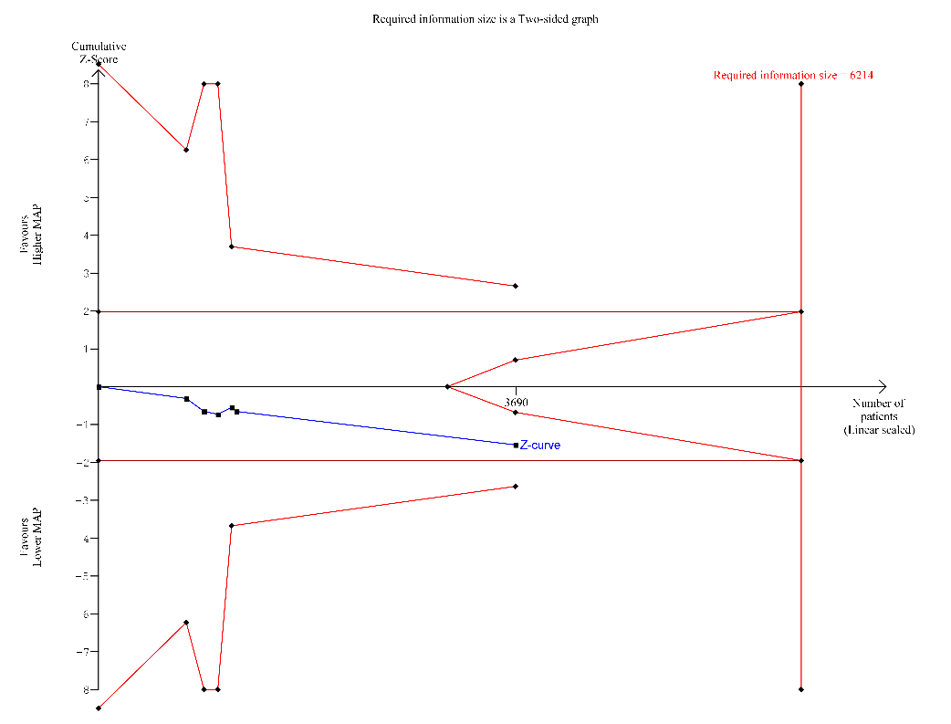
TSA results: D2 = 0.00%. Accrued information size (AIS) / required information size (RIS) 3690 / 6214 (59.4%)
TSA-adjusted CI: RR 1.06 (0.96 to 1.18) Conclusion: the AIS is smaller than the RIS and no TSA boundaries are crossed; the TSA is inconclusive (as is the conventional MA).

Supplement Figure 2. TSA Mortality at 28 days
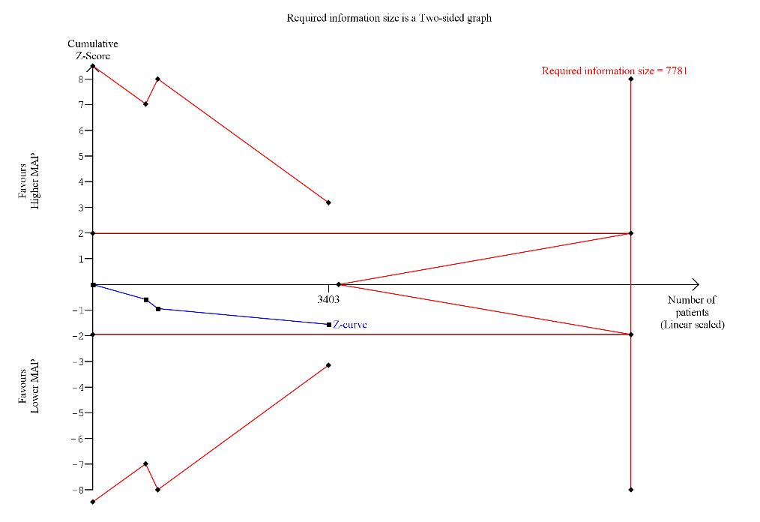
TSA results: D2 = 0.00%. Accrued information size (AIS) / required information size (RIS) 3403 / 7781 (43.7%)
TSA-adjusted CI: RR 1.07 (0.93 to 1.24) Conclusion: the AIS is smaller than the RIS and no TSA boundaries are crossed; the TSA is inconclusive (as is the conventional MA).

Supplement Figure 3. TSA Risk of undergoing renal replacement therapy
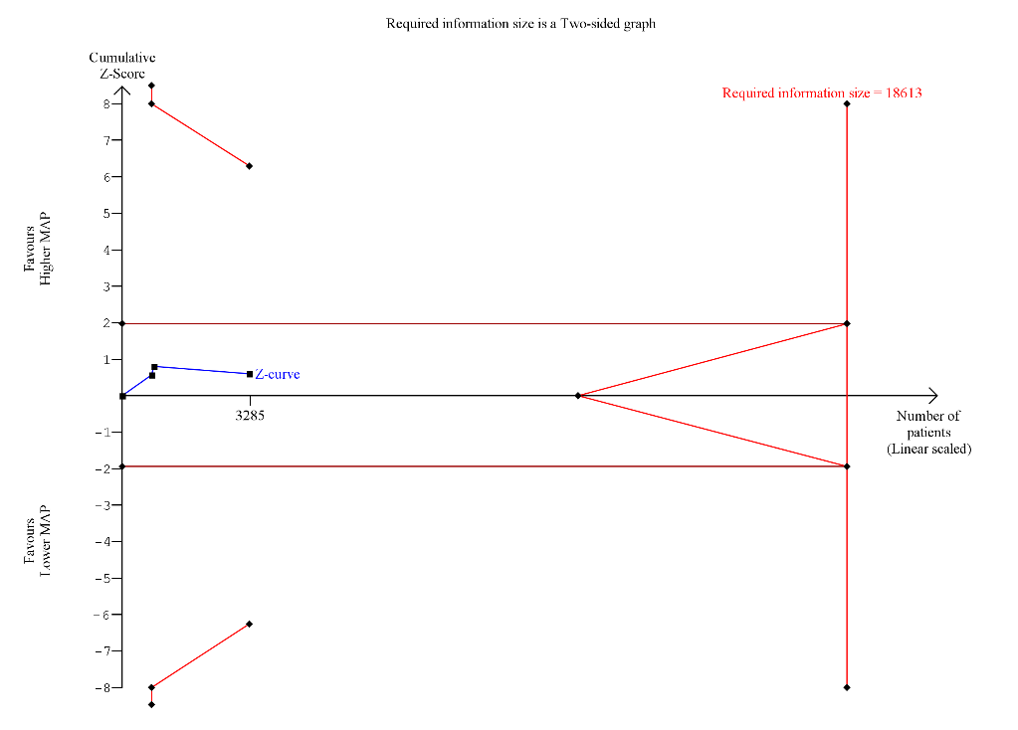
TSA results: D2 = 42.37%. Accrued information size (AIS) / required information size (RIS) 3285 / 18613 (17.6%)
TSA-adjusted CI: RR 0.96 (0.62 to 1.48) Conclusion: the AIS is smaller than the RIS and no TSA boundaries are crossed; the TSA is inconclusive (as is the conventional MA).

Supplement Figure 4. TSA ICU length of stay
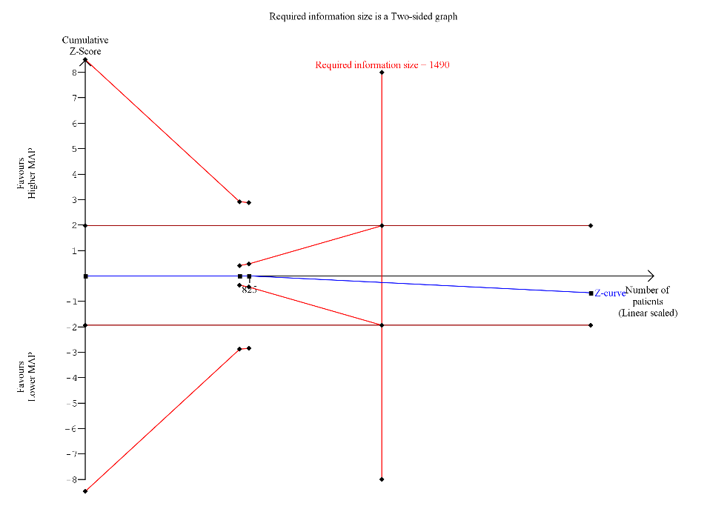
TSA results: D2 = 0.00%. Accrued information size (AIS) / required information size (RIS) 2540 / 1490 (170.5%)
TSA-adjusted CI: MD 0.17 (-0.30 to 0.63) Conclusion: the AIS is larger than the RIS; the TSA is conclusive the conventional and TSA-adjusted CIs are identical and a 1-day difference can be rejected.

Supplement Figure 5. TSA Hospital length of stay
TSA results: D2 = 66.36%. Accrued information size (AIS) / required information size (RIS) 1502 / 40698 (3.7%)
TSA-adjusted CI: MD -0.83 (-5.14 to 3.48) Conclusion: TSA cannot be conducted due to an extremely low event count. This indicates substantial uncertainty/imprecision.

Supplement Figure 6. TSA Duration of vasopressor therapy
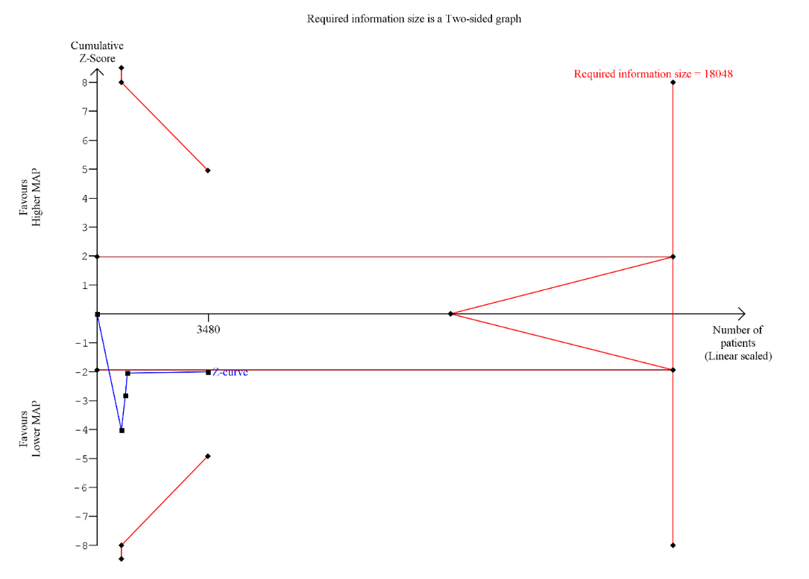
TSA results: D2 = 97.73%. Accrued information size (AIS) / required information size (RIS) 3480 / 18048 (19.3%)
TSA-adjusted CI: MD 17.12 (-21.78 to 56.01) Conclusion: the AIS is smaller than the RIS and no TSA boundaries are crossed; the TSA is inconclusive.

Supplement Figure 7. TSA Risk of undergoing renal replacement therapy subgroup of patients with chronic hypertension
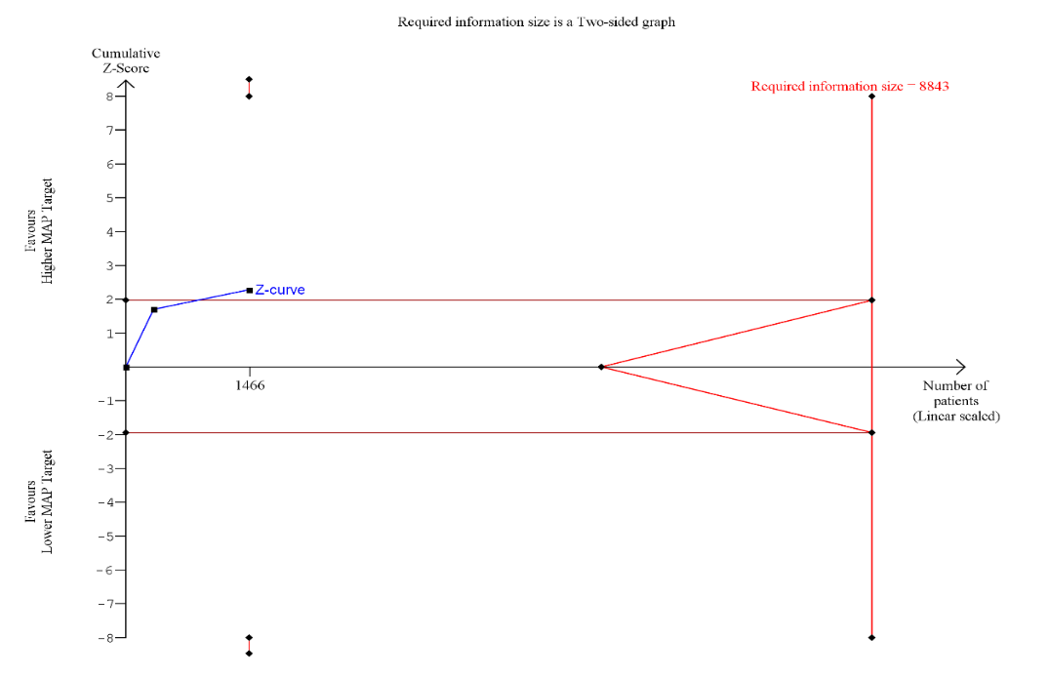
TSA results: D2 = 0.00%. Accrued information size (AIS) / required information size (RIS) 1466 / 8843 (16.6%)
TSA-adjusted CI: RR 0.83 (0.43 to 1.60) Conclusion: the AIS is smaller than the RIS and no TSA boundaries are crossed; the TSA is inconclusive (as is the conventional MA).

Supplement Table 8. Hypothesized directions of effect
1. History of chronic hypertension - we anticipate that targeting higher MAP would reduce mortality, need for renal replacement therapy, ICU and hospital length of stay, and complications.
2. Cause of shock - we anticipate no difference in mortality, need for renal replacement therapy, ICU length of stay, hospital length of stay, health related quality of life scores in patients admitted with distributive shock and a shorter duration of vasopressor therapy in those randomized to the lower MAP.
3. Type of vasopressor - we anticipate an increased mortality rate when vasopressors other than norepinephrine, vasopressin, phenylephrine, and epinephrine are used in the higher MAP target group. We anticipate a higher risk of arrhythmias in all vasopressors except for vasopressin in the group randomized to the higher MAP. We anticipate more digital or gut ischemia with the use of vasopressin in the group randomized to the higher MAP.
4. Age - we anticipate no difference in mortality in older patients treated with a lower MAP target, however, an increased need for renal replacement therapy in patients treated to a lower MAP target, higher rate of digital/gut ischemia and longer length of stay in the higher MAP group.

Supplement Table 9. Excluded studies from full review with justification

# | Screening number from Covidence | Full Citation | Reason for exclusion
1 | 5236 | Redfors, B., Bragadottir, G., Sellgren, J. et al. Effects of norepinephrine on renal perfusion, filtration and oxygenation in vasodilatory shock and acute kidney injury. Intensive Care Med. 2011; 37, 60–67. | Wrong Outcomes
2 | 7882 | Meyer, A.S.P., Ostrowski, S.R., Kjaergaard, J. et al. Endothelial Dysfunction in Resuscitated Cardiac Arrest (ENDO-RCA): safety and efficacy of low-dose prostacyclin administration and blood pressure target in addition to standard therapy, as compared to standard therapy alone, in post-cardiac arrest syndrome patients: study protocol for a randomized controlled trial. Trials 17, 378 (2016). | Wrong intervention
3 | 8263 | Carrick MM, Morrison CA, Tapia NM, Leonard J, Suliburk JW, Norman MA, Welsh FJ, Scott BG, Liscum KR, Raty SR, Wall MJ Jr, Mattox KL. Intraoperative hypotensive resuscitation for patients undergoing laparotomy or thoracotomy for trauma: Early termination of a randomized prospective clinical trial. J Trauma Acute Care Surg. 2016 Jun;80(6):886-96. | Wrong outcomes
4 | 9874 | Jakkula P, Pettilä V, Skrifvars MB, Hästbacka J, Loisa P, Tiainen M, Wilkman E, Toppila J, Koskue T, Bendel S, Birkelund T, Laru-Sompa R, Valkonen M, Reinikainen M; COMACARE study group. Targeting low-normal or high-normal mean arterial pressure after cardiac arrest and resuscitation: a randomised pilot trial. Intensive Care Med. 2018 Dec;44(12):2091-2101. | Wrong study type
5 | 7882 | Meyer AS, Ostrowski SR, Kjaergaard J, Johansson PI, Hassager C. Endothelial Dysfunction in Resuscitated Cardiac Arrest (ENDO-RCA): safety and efficacy of low-dose prostacyclin administration and blood pressure target in addition to standard therapy, as compared to standard therapy alone, in post-cardiac arrest syndrome patients: study protocol for a randomized controlled trial. Trials. 2016 Aug 2;17:378. | Wrong outcomes
6 | 10443 | https://clinicaltrials.gov/ct2/show/NCT04136080 | Incomplete study
7 | 10067 | https://clinicaltrials.gov/show/NCT04136080 | Incomplete study
8 | 5171 | https://ClinicalTrials.gov/show/NCT01443494 | Wrong outcomes
9 | 11461 | He HW, Liu WL, Zhou X, Long Y, Liu DW. Effect of mean arterial pressure change by norepinephrine on peripheral perfusion index in septic shock patients after early resuscitation. Chin Med J (Engl). 2020 Sep 20;133(18):2146-2152. | Wrong outcomes
10 | 8730 | https://clinicaltrials.gov/show/NCT03145168 | Incomplete study
11 | 10097 | Mölström S, Nielsen TH, Nordström CH, Hassager C, Møller JE, Kjærgaard J, Möller S, Schmidt H, Toft P. Design paper of the "Blood pressure targets in post-resuscitation care and bedside monitoring of cerebral energy state: a randomized clinical trial". Trials. 2019 Jun 10;20(1):344. | Incomplete study
12 | 7164 | https://clinicaltrials.gov/show/NCT02453425 | Incomplete study
13 | 5303 | https://clinicaltrials.gov/show/NCT01473498 | Incomplete study
14 | 5220 | https://ClinicalTrials.gov/show/NCT02453425 | Incomplete study
15 | 3841 | Nygren A, Thorén A, Ricksten SE. Norepinephrine and intestinal mucosal perfusion in vasodilatory shock after cardiac surgery. Shock. 2007 Nov;28(5):536-43. | Wrong outcomes
16 | 3369 | Bourgoin A, Leone M, Delmas A, Garnier F, Albanèse J, Martin C. Increasing mean arterial pressure in patients with septic shock: effects on oxygen variables and renal function. Crit Care Med. 2005 Apr;33(4):780-6 | Wrong outcomes
17 | 6653 | https://clinicaltrials.gov/show/NCT02085291 | Incomplete study
18 | 3313 | Russell JA, Walley KR, Singer J, Gordon AC, Hébert PC, Cooper DJ, Holmes CL, Mehta S, Granton JT, Storms MM, Cook DJ, Presneill JJ, Ayers D; VASST Investigators. Vasopressin versus norepinephrine infusion in patients with septic shock. N Engl J Med. 2008 Feb 28;358(9):877-87. | Wrong intervention
19 | 7343 | Xu JY, Ma SQ, Pan C, He HL, Cai SX, Hu SL, Liu AR, Liu L, Huang YZ, Guo FM, Yang Y, Qiu HB. A high mean arterial pressure target is associated with improved microcirculation in septic shock patients with previous hypertension: a prospective open label study. Crit Care. 2015 Mar 30;19(1):130. | Wrong outcomes
20 | 3583 | https://ClinicalTrials.gov/show/NCT00459160 | Incomplete Study
21 | 3286 | Suk, Pavel; Leverve, Xavier; Hruda, Jan; Sramek, Vladimir EARLY RESUSCITATION OF SEPTIC SHOCK TO DIFFERENT LEVEL OF ARTERIAL PRESSURE, Shock: October 2006 - Volume 26 - Issue 4 - p 38 | Incomplete Study
22 | 3287 | Suk, Pavel; Leverve, Xavier; Hruda, Jan; Sramek, Vladimir EARLY RESUSCITATION OF SEPTIC SHOCK TO DIFFERENT LEVEL OF ARTERIAL PRESSURE, Shock: October 2006 - Volume 26 - Issue 4 - p 38 | Incomplete Study
23 | 9448 | https://ClinicalTrials.gov/show/NCT03145168 | Incomplete Study
24 | 10786 | Russell JA, Gordon AC, Williams MD, Boyd JH, Walley KR, Kissoon N. Vasopressor Therapy in the Intensive Care Unit. Semin Respir Crit Care Med. 2021 Feb;42(1):59-77. | Wrong Study Design
25 | 7789 | Gjonbrataj J, Kim HJ, Jung HI, Choi WI. Does the Mean Arterial Pressure Influence Mortality Rate in Patients with Acute Hypoxemic Respiratory Failure under Mechanical Ventilation? Tuberc Respir Dis (Seoul). 2015 Apr;78(2):85-91. | Wrong Study Design
26 | 9338 | Nishida O, Ogura H, Egi M, Fujishima S, Hayashi Y, Iba T, Imaizumi H, Inoue S, Kakihana Y, Kotani J, Kushimoto S, Masuda Y, Matsuda N, Matsushima A, Nakada TA, Nakagawa S, Nunomiya S, Sadahiro T, Shime N, Yatabe T, Hara Y, Hayashida K, Kondo Y, Sumi Y, Yasuda H, Aoyama K, Azuhata T, Doi K, Doi M, Fujimura N, Fuke R, Fukuda T, Goto K, Hasegawa R, Hashimoto S, Hatakeyama J, Hayakawa M, Hifumi T, Higashibeppu N, Hirai K, Hirose T, Ide K, Kaizuka Y, Kan'o T, Kawasaki T, Kuroda H, Matsuda A, Matsumoto S, Nagae M, Onodera M, Ohnuma T, Oshima K, Saito N, Sakamoto S, Sakuraya M, Sasano M, Sato N, Sawamura A, Shimizu K, Shirai K, Takei T, Takeuchi M, Takimoto K, Taniguchi T, Tatsumi H, Tsuruta R, Yama N, Yamakawa K, Yamashita C, Yamashita K, Yoshida T, Tanaka H, Oda S. The Japanese Clinical Practice Guidelines for Management of Sepsis and Septic Shock 2016 (J-SSCG 2016). Acute Med Surg. 2018 Feb 5;5(1):3-89. | Wrong Study Design
27 | 9753 | Aggarwal R, Mirzan H, Chiu N, Steinkamp J. Heart failure and the discrepancy between trials of intensive blood pressure management: an analysis of individual patient data. Clin Res Cardiol. 2018 Jul;107(7):565-569. | Wrong Patient Population
28 | 3116 | Wilson SJ, Mehta SS, Bellamy MC. The safety and efficacy of the use of vasopressin in sepsis and septic shock. Expert Opin Drug Saf. 2005 Nov;4(6):1027-39. | Wrong Study Design
29 | 1002 | Bersten AD, Holt AW. Vasoactive drugs and the importance of renal perfusion pressure. New Horiz. 1995 Nov;3(4):650-61. | Wrong Study Design
30 | 4436 | https://ClinicalTrials.gov/show/NCT01149278 | Duplicate
31 | 9965 | Favory R, Durand A, Howsam M, Preau S. Arterial pressure targets in patients with septic shock and prior hypertension: should we throw SEPSISPAM findings out with the bathwater? Intensive Care Med. 2018 May;44(5):692-693. | Wrong Study Design
32 | 7675 | Leone M, Asfar P, Radermacher P, Vincent JL, Martin C. Optimizing mean arterial pressure in septic shock: a critical reappraisal of the literature. Crit Care. 2015 Mar 10;19(1):101. | Wrong Study Design
33 | 8633 | Rochwerg B, Hylands M, Møller MH, Asfar P, Cohen D, Khadaroo RG, Laake JH, Perner A, Tanguay T, Widder S, Vandvik P, Kristiansen A, Lamontagne F. CCCS-SSAI WikiRecs clinical practice guideline: vasopressor blood pressure targets in critically ill adults with hypotension and vasopressor use in early traumatic shock. Intensive Care Med. 2017 Jul;43(7):1062-1064. | Wrong Study Design
34 | 9863 | Jha AK. Letter by Jha Regarding Article, "High-Target Versus Low-Target Blood Pressure Management During Cardiopulmonary Bypass to Prevent Cerebral Injury in Cardiac Surgery Patients: A Randomized Controlled Trial". Circulation. 2018 Nov 20;138(21):2443-2444. | Wrong Study Design
35 | 10378 | Kjeldsen SE, Os I, Westheim A. Could adverse events offset the benefit of intensive blood pressure lowering treatment in the Systolic Blood Pressure Intervention Trial? J Hypertens. 2019 May;37(5):902-904. | Wrong Study Design
36 | 9483 | Lamontagne F, Day AG, Meade MO, Cook DJ, Guyatt GH, Hylands M, Radermacher P, Chrétien JM, Beaudoin N, Hébert P, D'Aragon F, Meziani F, Asfar P. Pooled analysis of higher versus lower blood pressure targets for vasopressor therapy septic and vasodilatory shock. Intensive Care Med. 2018 Jan;44(1):12-21. | Wrong Study Design
37 | 6083 | https://clinicaltrials.gov/show/NCT01800877 | Duplicate
38 | 9593 | Rocco MV, Sink KM, Lovato LC, Wolfgram DF, Wiegmann TB, Wall BM, Umanath K, Rahbari-Oskoui F, Porter AC, Pisoni R, Lewis CE, Lewis JB, Lash JP, Katz LA, Hawfield AT, Haley WE, Freedman BI, Dwyer JP, Drawz PE, Dobre M, Cheung AK, Campbell RC, Bhatt U, Beddhu S, Kimmel PL, Reboussin DM, Chertow GM; SPRINT Research Group. Effects of Intensive Blood Pressure Treatment on Acute Kidney Injury Events in the Systolic Blood Pressure Intervention Trial (SPRINT). Am J Kidney Dis. 2018 Mar;71(3):352-361. | Wrong Patient Population
39 | 7460 | D'Aragon F, Belley-Cote EP, Meade MO, Lauzier F, Adhikari NK, Briel M, Lalu M, Kanji S, Asfar P, Turgeon AF, Fox-Robichaud A, Marshall JC, Lamontagne F; Canadian Critical Care Trials Group. Blood pressure targets for vasopressor therapy: a systematic review. Shock. 2015 Jun;43(6):530-9 | Wrong Study Design
40 | 11332 | https://ClinicalTrials.gov/show/NCT04257136 | Wrong Intervention
41 | 7906 | Mao DRH, Ong MEH. High-rise residential resuscitation: scaling the challenge. CMAJ. 2016 Apr 5;188(6):399-400. | Wrong Study Design
42 | 7350 | SPRINT Research Group, Wright JT Jr, Williamson JD, Whelton PK, Snyder JK, Sink KM, Rocco MV, Reboussin DM, Rahman M, Oparil S, Lewis CE, Kimmel PL, Johnson KC, Goff DC Jr, Fine LJ, Cutler JA, Cushman WC, Cheung AK, Ambrosius WT. A Randomized Trial of Intensive versus Standard Blood-Pressure Control. N Engl J Med. 2015 Nov 26;373(22):2103-16. | Wrong Patient Population
43 | 10476 | Guyette FX, Martin-Gill C, Galli G, McQuaid N, Elmer J. Bolus Dose Epinephrine Improves Blood Pressure but is Associated with Increased Mortality in Critical Care Transport. Prehosp Emerg Care. 2019 Nov-Dec;23(6):764-771. | Wrong Study Design
44 | 8805 | Kudo, D., Yoshida, Y. & Kushimoto, S. Permissive hypotension/hypotensive resuscitation and restricted/controlled resuscitation in patients with severe trauma. j intensive care 5, 11 (2017). | Wrong Study Design
45 | 10227 | Varajic B, Cavallazzi R, Mann J, Furmanek S, Guardiola J, Saad M. High versus low mean arterial pressures in hepatorenal syndrome: A randomized controlled pilot trial. J Crit Care. 2019 Aug;52:186-192. doi: 10.1016/j.jcrc.2019.04.006. Epub 2019 Apr 15. | Wrong patient population
46 | 8938 | Futier E, Lefrant J, Guinot P, et al. Effect of Individualized vs Standard Blood Pressure Management Strategies on Postoperative Organ Dysfunction Among High-Risk Patients Undergoing Major Surgery: A Randomized Clinical Trial. JAMA. 2017;318(14):1346–1357. | Wrong Patient Populaion
47 | 10309 | Shao Z, Du Z, Wang R, Wang Z, He X, Wang H, Li Y, Qiu Z, Li L, Zheng C, Cheng F. [Effects of different target blood pressure resuscitation on peripheral blood inflammatory factors and hemodynamics in patients with traumatic hemorrhagic shock]. Zhonghua Wei Zhong Bing Ji Jiu Yi Xue. 2019 Apr;31(4):428-433. | Wrong Intervention
48 | 9100 | Ameloot K, De Deyne C, Ferdinande B, Dupont M, Palmers PJ, Petit T, Eertmans W, Moonen C, Belmans A, Lemmens R, Dens J, Janssens S. Mean arterial pressure of 65 mm Hg versus 85-100 mm Hg in comatose survivors after cardiac arrest: Rationale and study design of the Neuroprotect post-cardiac arrest trial. Am Heart J. 2017 Sep;191:91-98. | Wrong Study Design
49 | 8388 | Wu X, Jiang Z, Ying J, Han Y, Chen Z. Optimal blood pressure decreases acute kidney injury after gastrointestinal surgery in elderly hypertensive patients: A randomized study: Optimal blood pressure reduces acute kidney injury. J Clin Anesth. 2017 Dec;43:77-83. | Wrong Patient Population
50 | 10471 | Ham KR, Boldt DW, McCurdy MT, Busse LW, Favory R, Gong MN, Khanna AK, Chock SN, Zeng F, Chawla LS, Tidmarsh GF, Ostermann M. Sensitivity to angiotensin II dose in patients with vasodilatory shock: a prespecified analysis of the ATHOS-3 trial. Ann Intensive Care. 2019 Jun 3;9(1):63. | Wrong Comparator
51 | 10330 | Schleien C, Pryce P. A New Age in Cardiopulmonary Resuscitation. Pediatr Crit Care Med. 2019 Jul;20(7):691-692. | Wrong Patient Population
52 | 9820 | Richards-Belle A, Mouncey PR, Grieve RD, et al. Evaluating the clinical and cost-effectiveness of permissive hypotension in critically ill patients aged 65 years or over with vasodilatory hypotension: Protocol for the 65 randomised clinical trial. Journal of the Intensive Care Society. September 2019. | Wrong Study Design
53 | 9370 | https://clinicaltrials.gov/show/NCT03629418 | Wrong Patient population
54 | 6048 | https://ClinicalTrials.gov/show/NCT02519699 | Wrong Outcomes
55 | 6975 | McLaughlin D, English W. High versus Low Blood Pressure Target in Patients with Septic Shock. Journal of the Intensive Care Society. 2014;15(3):258-259. | Letter to Editor
56 | 9873 | Jakkula, P., Reinikainen, M., Hästbacka, J. et al. Targeting two different levels of both arterial carbon dioxide and arterial oxygen after cardiac arrest and resuscitation: a randomised pilot trial. Intensive Care Med 44, 2112–2121 (2018). | Wrong Intervention
57 | 5390 | https://ClinicalTrials.gov/show/NCT01411852 | Wrong Intervention
58 | 10441 | https://ClinicalTrials.gov/show/NCT03827369 | Wrong Study Design
59 | 6973 | Schreiber, Martin A. MD; Meier, Eric N. MS; Tisherman, Samuel A. MD; Kerby, Jeffrey D. MD, PhD; Newgard, Craig D. MD, MPH; Brasel, Karen MD; Egan, Debra MSc, MPH; Witham, William MD; Williams, Carolyn RN; Daya, Mohamud MD; Beeson, Jeff DO; McCully, Belinda H. PhD; Wheeler, Stephen MD; Kannas, Delores RN, MS, MHA; May, Susanne PhD; McKnight, Barbara PhD; Hoyt, David B. MD the ROC Investigators A controlled resuscitation strategy is feasible and safe in hypotensive trauma patients, Journal of Trauma and Acute Care Surgery: April 2015 - Volume 78 - Issue 4 - p 687-697 | Wrong Intervention
60 | 6053 | https://ClinicalTrials.gov/show/NCT01473498 | Duplicate – Incomplete Study
61 | 10516 | 39th International Symposium on Intensive Care and Emergency Medicine. Crit Care 23, 72 (2019). | Wrong Intervention
62 | 10006 | Perner, A., Hjortrup, P.B. & Arabi, Y. Focus on blood pressure targets and vasopressors in critically ill patients. Intensive Care Med 45, 1295–1297 (2019). | Wrong study design – Letter to Editor
63 | 6211 | Matthias S. Goepfert, Hans Peter Richter, Christine zu Eulenburg, Janna Gruetzmacher, Erik Rafflenbeul, Katharina Roeher, Alexandra von Sandersleben, Stefan Diedrichs, Herrmann Reichenspurner, Alwin E. Goetz, Daniel A. Reuter; Individually Optimized Hemodynamic Therapy Reduces Complications and Length of Stay in the Intensive Care Unit: A Prospective, Randomized Controlled Trial. Anesthesiology 2013; 119:824–836 | Wrong Comparator
64 | 7295 | Alvarez RA, Barbash IJ, Rose JJ. Bosentan for sarcoidosis-associated pulmonary hypertension, age-adjusted D-dimer levels in pulmonary embolism, and mean arterial blood pressure targets in septic shock. Am J Respir Crit Care Med. 2014 Oct 15;190(8):948-9. | Wrong Study Design – Letter to Editor
65 | 8188 | Pettilä, V., Merz, T., Wilkman, E. et al. Targeted tissue perfusion versus macrocirculation-guided standard care in patients with septic shock (TARTARE-2S): study protocol and statistical analysis plan for a randomized controlled trial. Trials 17, 384 (2016). | Wrong Intervention
66 | 5123 | Bangalore S, Qin J, Sloan S, Murphy SA, Cannon CP; PROVE IT-TIMI 22 Trial Investigators. What is the optimal blood pressure in patients after acute coronary syndromes?: Relationship of blood pressure and cardiovascular events in the PRavastatin OR atorVastatin Evaluation and Infection Therapy-Thrombolysis In Myocardial Infarction (PROVE IT-TIMI) 22 trial. Circulation. 2010 Nov 23;122(21):2142-51. | Wrong Patient population
67 | 10704 | Thomas K, Patel A, Sadique MZ, et al. Evaluating the clinical and cost-effectiveness of permissive hypotension in critically ill patients aged 65 years or over with vasodilatory hypotension: Statistical and health economic analysis plan for the 65 trial in article. Journal of the Intensive Care Society. 2020;21(3):230-231. | Wrong Outcomes
68 | 3670 | Goepfert MS, Reuter DA, Akyol D, Lamm P, Kilger E, Goetz AE. Goal-directed fluid management reduces vasopressor and catecholamine use in cardiac surgery patients. Intensive Care Med. 2007 Jan;33(1):96-103. | Wrong Intervention
69 | 4656 | Dünser, M.W., Ruokonen, E., Pettilä, V. et al. Association of arterial blood pressure and vasopressor load with septic shock mortality: a post hoc analysis of a multicenter trial. Crit Care 13, R181 (2009). | Wrong Study Design
70 | 5300 | https://clinicaltrials.gov/show/NCT01296789 | Wrong Intervention
71 | 10023 | https://ClinicalTrials.gov/show/NCT03991052 | Wrong Intervention
72 | 1 | https://ClinicalTrials.gov/show/NCT02069288 | Wrong Intervention
73 | 9051 | Berlowitz DR, Foy CG, Kazis LE, Bolin LP, Conroy MB, Fitzpatrick P, Gure TR, Kimmel PL, Kirchner K, Morisky DE, Newman J, Olney C, Oparil S, Pajewski NM, Powell J, Ramsey T, Simmons DL, Snyder J, Supiano MA, Weiner DE, Whittle J; SPRINT Research Group. Effect of Intensive Blood-Pressure Treatment on Patient-Reported Outcomes. N Engl J Med. 2017 Aug 24;377(8):733-744. | Wrong Patient Population
74 | 858 | Tuchschmidt J, Fried J, Astiz M, Rackow E. Elevation of cardiac output and oxygen delivery improves outcome in septic shock. Chest. 1992 Jul;102(1):216-20. | Wrong Intervention
75 | 4916 | Duveau, A., Augusto, J.F., Gilet, C. et l. SEPSISPAM : évaluation de l’effet de deux niveaux de pression artérielle sur la survie des patients en choc eptique. Réanimation 20, 98–104 (2011). | Duplicate-Wrong study design
76 | 10262 | Thomas K, Patel A, Sadique MZ, et al. Evaluating the clinical and cost-effectiveness of permissive hypotension in critically ill patients aged 65 years or over with vasodilatory hypotension: Statistical and Health Economic Analysis Plan for the 65 trial. Journal of the Intensive Care Society. July 2019. | Wrong Outcomes
77 | 5508 | Polito, A., Parisini, E., Ricci, Z. et al. Vasopressin for treatment of vasodilatory shock: an ESICM systematic review and meta-analysis. Intensive Care Med 38, 9–19 (2012). | Wrong Study Design
78 | 6432 | Lampard JG, Lang E. Vasopressors for hypotensive shock. Ann Emerg Med. 2013 Mar;61(3):351-2. | Wrong Study Design
79 | 10007 | Permpikul C, Tongyoo S, Viarasilpa T, Trainarongsakul T, Chakorn T, Udompanturak S. Early Use of Norepinephrine in Septic Shock Resuscitation (CENSER). A Randomized Trial. Am J Respir Crit Care Med. 2019 May 1;199(9):1097-1105. | Wrong Comparator
80 | 7956 | Laurikkala J, Wilkman E, Pettilä V, Kurola J, Reinikainen M, Hoppu S, Ala-Kokko T, Tallgren M, Tiainen M, Vaahersalo J, Varpula T, Skrifvars MB; FINNRESUSCI Study Group. Mean arterial pressure and vasopressor load after out-of-hospital cardiac arrest: Associations with one-year neurologic outcome. Resuscitation. 2016 Aug;105:116-22. | Wrong Intervention
81 | 10739 | Skrifvars, Markus B.a; Åneman, Andersb,c,d; Ameloot, Koene,f,g Individualized blood pressure targets during postcardiac arrest intensive care, Current Opinion in Critical Care: June 2020 - Volume 26 - Issue 3 - p 259-266 | Wrong Study Design
82 | 9222 | Tran, Alexandre MD; Yates, Jeffrey MD; Lau, Aaron MD; Lampron, Jacinthe MD; Matar, Maher MD Permissive hypotension versus conventional resuscitation strategies in adult trauma patients with hemorrhagic shock: A systematic review and meta-analysis of randomized controlled trials, Journal of Trauma and Acute Care Surgery: May 2018 - Volume 84 - Issue 5 - p 802-808 | Wrong Study Design
83 | 8305 | Beloncle F, Radermacher P, Guerin C, Asfar P. Mean arterial pressure target in patients with septic shock. Minerva Anestesiol. 2016 Jul;82(7):777-84. | Wrong Study Design
84 | 8634 | Rochwerg, B., Hylands, M., Møller, M. et al. CCCS-SSAI WikiRecs Clinical Practice Guideline: vasopressor blood pressure targets in critically ill adults with hypotension. Can J Anesth/J Can Anesth 64, 763–765 (2017). | Wrong Study Design

Supplement Table 10. ROB2 Assessment mortality
Mortality at Longest Follow-Up
 |  | Asfar 2014 | Lamontange 2016 | Lamontagne 2020 | Carrick 2016 | Grand 2020 | Ameloot 2020
ROB from randomization | 1.1 | Y - Computer generated | Y - Computer generated | Y - Computer generated | PY - “third party randomization” | Y - Web based | Y - Computer generated
 | 1.2 | Y - All blinded to randomization | Y - Web based system | Y - Web based system | Y - blinded | Y | Y - Central coordinating center
 | 1.3 | N | N | N | N | N | N
 | Judgement | LOW RISK | LOW RISK | LOW RISK | LOW RISK | LOW RISK | LOW RISK
ROB due to deviation from intended intervention  *assignment intervention | 2.1 | N - Patients blinded | Y - Open label | Y - Open label | PN - On arrival to OR | N - Double blind | Y - Open label
 | 2.2 | Y - unable to blind care team | Y - Open label | Y - Open label | Y - Open label | N - Double blind | Y - Open label
 | 2.3 | N | N | N | N | N/A | N
 | 2.4 | N/A | N/A | N/A | N/A | N/A | N/A
 | 2.5 | N/A | N/A | N/A | N/A | N/A | N/A
 | 2.6 | Y - ITT analysis | Y | Y - ITT analysis | PY | Y - Modified ITT | Y - ITT
 | 2.7 | N/A | N/A | N/A | N/A | N/A | N/A
 | Judgement | LOW RISK | LOW RISK | LOW RISK | LOW RISK | LOW RISK | LOW RISK
ROB due to missing outcome data | 3.1 | Y - None lost to follow up | Y | Y | Y | Y | Y - All followed at 180 days
 | 3.2 | N/A | N/A | N/A | N/A | N/A | N/A
 | 3.3 | N/A | N/A | N/A | N/A | N/A | N/A
 | 3.4 | N/A | N/A | N/A | N/A | N/A | N/A
 | Judgement | LOW RISK | LOW RISK | LOW RISK | LOW RISK | LOW RISK | LOW RISK
Bias in measurement of outcome | 4.1 | N | N | N | N | N | N
 | 4.2 | N - mortality | N - mortality | N - mortality | N - mortality | N | N
 | 4.3 | PY - not specified but clinicians unblinded | Y - open label | PY - open label | PY - open label | PN - blinded | N - study personnel blinded
 | 4.4 | N - mortality | N - mortality | N - mortality | N - mortality | N/A | N/A
 | 4.5 | N/A | N/A | N/A | N/A | N/A | N/A
 | Judgement | LOW RISK | LOW RISK | LOW RISK | LOW RISK | LOW RISK | LOW RISK
ROB in reported results | 5.1 | Y - prespecified | Y - prespecified | Y - prespecified | Y | Y - protocol published | Y - prespecified
 | 5.2 | N - mortality | N | N | N | N | N
 | 5.3 | N | N | N | N | N | N
 | Judgement | LOW RISK | LOW RISK | LOW RISK | LOW RISK | LOW RISK | LOW RISK
Overall ROB |  | LOW RISK | LOW RISK | LOW RISK | LOW RISK | LOW RISK | LOW RISK

Summary table
Study | ROB for randomization | ROB due to deviation from intended intervention  *assignment intervention | ROB due to missing outcome data | Bias in measurement of outcome | ROB in selection of reported results
Asfar
Lamontagne 2016
Lamontagne 2020
Carrick
Grand
Ameloot

Supplement Table 11. ROB2 Assessment duration of vasopressor therapy
Duration of Vasopressor Therapy
 |  | Asfar 2014 | Lamontange 2016 | Lamontagne 2020 | Grand 2020
ROB from randomization | 1.1 | Y - Computer generated | Y - Computer generated | Y - Computer generated | Y - Web based
 | 1.2 | Y - All blinded to randomization | Y - Web based system | Y - Web based system | Y
 | 1.3 | N | N | N | N
 | Judgement | LOW RISK | LOW RISK | LOW RISK | LOW RISK
ROB due to deviation from intended intervention  *assignment intervention | 2.1 | N - Patients blinded | Y - Open label | Y - Open label | N - Double blind
 | 2.2 | Y - unable to blind care team | Y - Open label | Y - Open label | N - Double blind
 | 2.3 | N | N | N | N/A
 | 2.4 | N/A | N/A | N/A | N/A
 | 2.5 | N/A | N/A | N/A | N/A
 | 2.6 | Y - ITT analysis | Y | Y - ITT analysis | Y - Modified ITT
 | 2.7 | N/A | N/A | N/A | N/A
 | Judgement | LOW RISK | LOW RISK | LOW RISK | LOW RISK
ROB due to missing outcome data | 3.1 | Y - None lost to follow up | Y | Y | Y
 | 3.2 | N/A | N/A | N/A | N/A
 | 3.3 | N/A | N/A | N/A | N/A
 | 3.4 | N/A | N/A | N/A | N/A
 | Judgement | LOW RISK | LOW RISK | LOW RISK | LOW RISK
Bias in measurement of outcome | 4.1 | N | N | N | N
 | 4.2 | N | N | N | N
 | 4.3 | PY - not specified but clinicians unblinded | Y - open label | PY - open label | PN - blinded
 | 4.4 | N | N | N | N/A
 | 4.5 | N/A | N/A | N/A | N/A
 | Judgement | LOW RISK | LOW RISK | LOW RISK | LOW RISK
ROB in reported results | 5.1 | Y - prespecified | Y - prespecified | Y - prespecified | Y - protocol published
 | 5.2 | N | N | N | N
 | 5.3 | N | N | N | N
 | Judgement | LOW RISK | LOW RISK | LOW RISK | LOW RISK
Overall ROB |  | LOW RISK | LOW RISK | LOW RISK | LOW RISK

Summary table
Study | ROB for randomization | ROB due to deviation from intended intervention  *assignment intervention | ROB due to missing outcome data | Bias in measurement of outcome | ROB in selection of reported results
Asfar
Lamontagne 2016
Lamontagne 2020
Grand

Supplement Table 12. ROB2 risk of undergoing renal replacement therapy
Renal Replacement Therapy
 |  | Asfar 2014 | Lamontange 2016 | Lamontagne 2020 | Carrick 2016 | Grand 2020
ROB from randomization | 1.1 | Y - Computer generated | Y - Computer generated | Y - Computer generated | PY - “third party randomization” | Y - Web based
 | 1.2 | Y - All blinded to randomization | Y - Web based system | Y - Web based system | Y - blinded | Y
 | 1.3 | N | N | N | N | N
 | Judgement | LOW RISK | LOW RISK | LOW RISK | LOW RISK | LOW RISK
ROB due to deviation from intended intervention  *assignment intervention | 2.1 | N - Patients blinded | Y - Open label | Y - Open label | PN - On arrival to OR | N - Double blind
 | 2.2 | Y - unable to blind care team | Y - Open label | Y - Open label | Y - Open label | N - Double blind
 | 2.3 | N | N | N | N | N/A
 | 2.4 | N/A | N/A | N/A | N/A | N/A
 | 2.5 | N/A | N/A | N/A | N/A | N/A
 | 2.6 | Y - ITT analysis | Y | Y - ITT analysis | PY | Y - Modified ITT
 | 2.7 | N/A | N/A | N/A | N/A | N/A
 | Judgement | LOW RISK | LOW RISK | LOW RISK | LOW RISK | LOW RISK
ROB due to missing outcome data | 3.1 | Y - None lost to follow up | Y | Y | Y | Y
 | 3.2 | N/A | N/A | N/A | N/A | N/A
 | 3.3 | N/A | N/A | N/A | N/A | N/A
 | 3.4 | N/A | N/A | N/A | N/A | N/A
 | Judgement | LOW RISK | LOW RISK | LOW RISK | LOW RISK | LOW RISK
Bias in measurement of outcome | 4.1 | N | N | N | N | N
 | 4.2 | N | N | N | N | N
 | 4.3 | PY - not specified but clinicians unblinded | Y - open label | PY - open label | PY - open label | PN - blinded
 | 4.4 | N | N | N | N | N/A
 | 4.5 | N/A | N/A | N/A | N/A | N/A
 | Judgement | LOW RISK | LOW RISK | LOW RISK | LOW RISK | LOW RISK
ROB in reported results | 5.1 | Y - prespecified | Y - prespecified | Y - prespecified | Y | Y - protocol published
 | 5.2 | N | N | N | N | N
 | 5.3 | N | N | N | N | N
 | Judgement | LOW RISK | LOW RISK | LOW RISK | LOW RISK | LOW RISK
Overall ROB |  | LOW RISK | LOW RISK | LOW RISK | LOW RISK | LOW RISK

Study | ROB for randomization | ROB due to deviation from intended intervention  *assignment intervention | ROB due to missing outcome data | Bias in measurement of outcome | ROB in selection of reported results
Asfar
Lamontagne 2016
Lamontagne 2020
Carrick
Grand

Supplement Table 13. ROB2 Incidence of digital ischemia/necrosis
Incidence digital ischemia/necrosis
 |  | Asfar 2014 | Lamontange 2016 | Lamontagne 2020
ROB from randomization | 1.1 | Y - Computer generated | Y - Computer generated | Y - Computer generated
 | 1.2 | Y - All blinded to randomization | Y - Web based system | Y - Web based system
 | 1.3 | N | N | N
 | Judgement | LOW RISK | LOW RISK | LOW RISK
ROB due to deviation from intended intervention  *assignment intervention | 2.1 | N - Patients blinded | Y - Open label | Y - Open label
 | 2.2 | Y - unable to blind care team | Y - Open label | Y - Open label
 | 2.3 | N | N | N
 | 2.4 | N/A | N/A | N/A
 | 2.5 | N/A | N/A | N/A
 | 2.6 | Y - ITT analysis | Y | Y - ITT analysis
 | 2.7 | N/A | N/A | N/A
 | Judgement | LOW RISK | LOW RISK | LOW RISK
ROB due to missing outcome data | 3.1 | Y - None lost to follow up | Y | Y
 | 3.2 | N/A | N/A | N/A
 | 3.3 | N/A | N/A | N/A
 | 3.4 | N/A | N/A | N/A
 | Judgement | LOW RISK | LOW RISK | LOW RISK
Bias in measurement of outcome | 4.1 | N | N | N
 | 4.2 | N | N | N
 | 4.3 | PY - not specified but clinicians unblinded | Y - open label | PY - open label
 | 4.4 | N | N | N
 | 4.5 | N/A | N/A | N/A
 | Judgement | LOW RISK | LOW RISK | LOW RISK
ROB in reported results | 5.1 | Y - prespecified | Y - prespecified | Y - prespecified
 | 5.2 | N | N | N
 | 5.3 | N | N | N
 | Judgement | LOW RISK | LOW RISK | LOW RISK
Overall ROB |  | LOW RISK | LOW RISK | LOW RISK

Study | ROB for randomization | ROB due to deviation from intended intervention  *assignment intervention | ROB due to missing outcome data | Bias in measurement of outcome | ROB in selection of reported results
Asfar
Lamontagne 2016
Lamontagne 2020

Supplement Table 14. ROB2 Incidence of mesenteric ischemia
Incidence Mesenteric Ischemia
 |  | Asfar 2014 | Lamontange 2016 | Lamontagne 2020
ROB from randomization | 1.1 | Y - Computer generated | Y - Computer generated | Y - Computer generated
 | 1.2 | Y - All blinded to randomization | Y - Web based system | Y - Web based system
 | 1.3 | N | N | N
 | Judgement | LOW RISK | LOW RISK | LOW RISK
ROB due to deviation from intended intervention  *assignment intervention | 2.1 | N - Patients blinded | Y - Open label | Y - Open label
 | 2.2 | Y - unable to blind care team | Y - Open label | Y - Open label
 | 2.3 | N | N | N
 | 2.4 | N/A | N/A | N/A
 | 2.5 | N/A | N/A | N/A
 | 2.6 | Y - ITT analysis | Y | Y - ITT analysis
 | 2.7 | N/A | N/A | N/A
 | Judgement | LOW RISK | LOW RISK | LOW RISK
ROB due to missing outcome data | 3.1 | Y - None lost to follow up | Y | Y
 | 3.2 | N/A | N/A | N/A
 | 3.3 | N/A | N/A | N/A
 | 3.4 | N/A | N/A | N/A
 | Judgement | LOW RISK | LOW RISK | LOW RISK
Bias in measurement of outcome | 4.1 | N | N | N
 | 4.2 | N | N | N
 | 4.3 | PY - not specified but clinicians unblinded | Y - open label | PY - open label
 | 4.4 | N | N | N
 | 4.5 | N/A | N/A | N/A
 | Judgement | LOW RISK | LOW RISK | LOW RISK
ROB in reported results | 5.1 | Y - prespecified | Y - prespecified | Y - prespecified
 | 5.2 | N | N | N
 | 5.3 | N | N | N
 | Judgement | LOW RISK | LOW RISK | LOW RISK
Overall ROB |  | LOW RISK | LOW RISK | LOW RISK

Study | ROB for randomization | ROB due to deviation from intended intervention  *assignment intervention | ROB due to missing outcome data | Bias in measurement of outcome | ROB in selection of reported results
Asfar
Lamontagne 2016
Lamontagne 2020

Supplement Table 15. ROB2 Incidence of cardiac arrhythmias
Incidence Cardiac Arrhythmias
 |  | Lamontange 2016 | Lamontagne 2020 | Ameloot 2019
ROB from randomization | 1.1 | Y - Computer generated | Y - Computer generated | Y - Computer generated
 | 1.2 | Y - Web based system | Y - Web based system | Y - Central coordinating center
 | 1.3 | N | N | N
 | Judgement | LOW RISK | LOW RISK | LOW RISK
ROB due to deviation from intended intervention  *assignment intervention | 2.1 | Y - Open label | Y - Open label | Y - Open label
 | 2.2 | Y - Open label | Y - Open label | Y - Open label
 | 2.3 | N | N | N
 | 2.4 | N/A | N/A | N/A
 | 2.5 | N/A | N/A | N/A
 | 2.6 | Y | Y - ITT analysis | Y - ITT
 | 2.7 | N/A | N/A | N/A
 | Judgement | LOW RISK | LOW RISK | LOW RISK
ROB due to missing outcome data | 3.1 | Y | Y | Y
 | 3.2 | N/A | N/A | N/A
 | 3.3 | N/A | N/A | N/A
 | 3.4 | N/A | N/A | N/A
 | Judgement | LOW RISK | LOW RISK | LOW RISK
Bias in measurement of outcome | 4.1 | N | N | N
 | 4.2 | N | N | N
 | 4.3 | Y - open label | PY - open label | N - study personnel blinded
 | 4.4 | N | N | N/A
 | 4.5 | N/A | N/A | N/A
 | Judgement | LOW RISK | LOW RISK | LOW RISK
ROB in reported results | 5.1 | Y - prespecified | Y - prespecified | Y - prespecified
 | 5.2 | N | N | N
 | 5.3 | N | N | N
 | Judgement | LOW RISK | LOW RISK | LOW RISK
Overall ROB |  | LOW RISK | LOW RISK | LOW RISK

Study | ROB for randomization | ROB due to deviation from intended intervention  *assignment intervention | ROB due to missing outcome data | Bias in measurement of outcome | ROB in selection of reported results
Lamontagne 2016
Lamontagne 2020
Ameloot

Supplement Table 16. ROB2 Total fluid administered
Total Fluid Administered
 |  | Asfar 2014 | Carrick 2016
ROB from randomization | 1.1 | Y - Computer generated | PY - “third party randomization”
 | 1.2 | Y - All blinded to randomization | Y - blinded
 | 1.3 | N | N
 | Judgement | LOW RISK | LOW RISK
ROB due to deviation from intended intervention  *assignment intervention | 2.1 | N - Patients blinded | PN - On arrival to OR
 | 2.2 | Y - unable to blind care team | Y - Open label
 | 2.3 | N | N
 | 2.4 | N/A | N/A
 | 2.5 | N/A | N/A
 | 2.6 | Y - ITT analysis | PY
 | 2.7 | N/A | N/A
 | Judgement | LOW RISK | LOW RISK
ROB due to missing outcome data | 3.1 | Y - None lost to follow up | Y
 | 3.2 | N/A | N/A
 | 3.3 | N/A | N/A
 | 3.4 | N/A | N/A
 | Judgement | LOW RISK | LOW RISK
Bias in measurement of outcome | 4.1 | N | N
 | 4.2 | N | N
 | 4.3 | PY - not specified but clinicians unblinded | PY - open label
 | 4.4 | N | N
 | 4.5 | N/A | N/A
 | Judgement | LOW RISK | LOW RISK
ROB in reported results | 5.1 | Y - prespecified | Y
 | 5.2 | N | N
 | 5.3 | N | N
 | Judgement | LOW RISK | LOW RISK
Overall ROB |  | LOW RISK | LOW RISK

Study | ROB for randomization | ROB due to deviation from intended intervention  *assignment intervention | ROB due to missing outcome data | Bias in measurement of outcome | ROB in selection of reported results
Asfar
Carrick

Supplement Table 17. ROB2 ICU length of stay
ICU Length of Stay
 |  | Asfar 2014 | Lamontagne 2020 | Grand 2020
ROB from randomization | 1.1 | Y - Computer generated | Y - Computer generated | Y - Web based
 | 1.2 | Y - All blinded to randomization | Y - Web based system | Y
 | 1.3 | N | N | N
 | Judgement | LOW RISK | LOW RISK | LOW RISK
ROB due to deviation from intended intervention  *assignment intervention | 2.1 | N - Patients blinded | Y - Open label | N - Double blind
 | 2.2 | Y - unable to blind care team | Y - Open label | N - Double blind
 | 2.3 | N | N | N/A
 | 2.4 | N/A | N/A | N/A
 | 2.5 | N/A | N/A | N/A
 | 2.6 | Y - ITT analysis | Y - ITT analysis | Y - Modified ITT
 | 2.7 | N/A | N/A | N/A
 | Judgement | LOW RISK | LOW RISK | LOW RISK
ROB due to missing outcome data | 3.1 | Y - None lost to follow up | Y | Y
 | 3.2 | N/A | N/A | N/A
 | 3.3 | N/A | N/A | N/A
 | 3.4 | N/A | N/A | N/A
 | Judgement | LOW RISK | LOW RISK | LOW RISK
Bias in measurement of outcome | 4.1 | N | N | N
 | 4.2 | N | N | N
 | 4.3 | PY - not specified but clinicians unblinded | PY - open label | PN - blinded
 | 4.4 | N | N | N/A
 | 4.5 | N/A | N/A | N/A
 | Judgement | LOW RISK | LOW RISK | LOW RISK
ROB in reported results | 5.1 | Y - prespecified | Y - prespecified | Y - protocol published
 | 5.2 | N | N | N
 | 5.3 | N | N | N
 | Judgement | LOW RISK | LOW RISK | LOW RISK
Overall ROB |  | LOW RISK | LOW RISK | LOW RISK

Study | ROB for randomization | ROB due to deviation from intended intervention  *assignment intervention | ROB due to missing outcome data | Bias in measurement of outcome | ROB in selection of reported results
Asfar
Lamontagne 2020
Grand
Jakkula

Supplement Table 18. ROB2 Hospital length of stay
Hospital Length of Stay
 |  | Lamontagne 2020 | Grand 2020
ROB from randomization | 1.1 | Y - Computer generated | Y - Web based
 | 1.2 | Y - Web based system | Y
 | 1.3 | N | N
 | Judgement | LOW RISK | LOW RISK
ROB due to deviation from intended intervention  *assignment intervention | 2.1 | Y - Open label | N - Double blind
 | 2.2 | Y - Open label | N - Double blind
 | 2.3 | N | N/A
 | 2.4 | N/A | N/A
 | 2.5 | N/A | N/A
 | 2.6 | Y - ITT analysis | Y - Modified ITT
 | 2.7 | N/A | N/A
 | Judgement | LOW RISK | LOW RISK
ROB due to missing outcome data | 3.1 | Y | Y
 | 3.2 | N/A | N/A
 | 3.3 | N/A | N/A
 | 3.4 | N/A | N/A
 | Judgement | LOW RISK | LOW RISK
Bias in measurement of outcome | 4.1 | N | N
 | 4.2 | N | N
 | 4.3 | PY - open label | PN - blinded
 | 4.4 | N | N/A
 | 4.5 | N/A | N/A
 | Judgement | LOW RISK | LOW RISK
ROB in reported results | 5.1 | Y - prespecified | Y - protocol published
 | 5.2 | N | N
 | 5.3 | N | N
 | Judgement | LOW RISK | LOW RISK
Overall ROB |  | LOW RISK | LOW RISK

Study | ROB for randomization | ROB due to deviation from intended intervention | ROB due to missing outcome data | Bias in measurement of outcome | ROB in selection of reported results
Lamontagne 2020
Grand

Supplement Table 19. GRADE Evidence Profile
Certainty assessment |  |  |  |  |  |  | № of patients |  | Effect |  | Certainty
№ of studies | Study design | Risk of bias | Inconsistency | Indirectness | Imprecision | Other considerations | Higher MAP | Lower MAP | Relative  (95% CI) | Absolute  (95% CI)
Mortality at Longest Follow-Up
6 | randomised trials | not serious | not serious | not serious | seriousª | none | 790/1853 (42.6%) | 730/1837 (39.7%) | RR 1.07  (0.99 to 1.16) | 3 more per 100  (from 0 fewer to 6 more) | ⨁⨁⨁◯  Moderate
28 Day Mortality
3 | randomised trials | not serious | not serious | not serious | serious^{b} | none | 635/1710 (37.1%) | 584/1693 (34.5%) | RR 1.07  (0.98 to 1.18) | 2 more per 100  (from 1 fewer to 6 more) | ⨁⨁⨁◯  Moderate
Need for RRT
3 | randomised trials | not serious | not serious | not serious | serious^{c} | none | 439/1653 (26.6%) | 449/1632 (27.5%) | RR 0.96  (0.83 to 1.11) | 1 fewer per 100  (from 5 fewer to 3 more) | ⨁⨁⨁◯  Moderate
ICU Length of Stay
3 | randomised trials | not serious | not serious | not serious | not serious^{d} | none | 1276 | 1264 | - | MD 0.17 higher  (0.3 lower to 0.63 higher) | ⨁⨁⨁⨁  High
Hospital Length of Stay
2 | randomised trials | not serious | not serious | not serious | serious^{e} | none | 744 | 758 | - | MD 0.81 lower  (3.96 lower to 2.34 higher) | ⨁⨁⨁◯  Moderate
Duration of Vasopressor Therapy
4 | randomised trials | not serious | serious^{f} | not serious | serious^{g} | none | 1745 | 1735 | - | MD 17.12 higher  (0.6 higher to 33.63 higher) | ⨁⨁◯◯  Low
Total Fluid Administered
3 | randomised trials | not serious | not serious | not serious | not serious^{h} | none | 511 | 534 | - | MD 0.01 lower  (0.42 lower to 0.4 higher) | ⨁⨁⨁⨁  High
Incidence Digital Ischemia/Necrosis
3 | randomised trials | not serious | not serious | not serious | serious^{i} | none | 14/1746 (0.8%) | 16/1730 (0.9%) | RR 0.89  (0.43 to 1.84) | 0 fewer per 100  (from 1 fewer to 1 more) | ⨁⨁⨁◯  Moderate
Incidence Mesenteric Ischemia
3 | randomised trials | not serious | not serious | not serious | serious^{j} | none | 23/1746 (1.3%) | 21/1730 (1.2%) | RR 1.09  (0.60 to 1.98) | 0 fewer per 100  (from 0 fewer to 1 more) | ⨁⨁⨁◯  Moderate
Incidence Cardiac Arrhythmias
4 | randomised trials | not serious | serious^{k} | not serious | serious^{l} | none | 91/1804 (5.0%) | 66/1792 (3.7%) | RR 1.34  (0.83 to 2.19) | 1 more per 100  (from 1 fewer to 4 more) | ⨁⨁◯◯  Low
CI: confidence interval; MD: mean difference; RR: risk ratio

Explanations
a. We elected to rate down as Accrued information size (AIS) / required information size (RIS) 3690 / 6214 (59.4%); TSA-adjusted CI: RR 1.06 (0.96 to 1.18) Conclusion: the AIS is smaller than the RIS and no TSA boundaries are crossed; the TSA is inconclusive.
b. We elected to rate down as AIS/RIS = 3403 / 7781 (43.7%); TSA-adjusted CI: RR 1.07 (0.93 to 1.24). No TSA boundaries are crossed; the TSA is inconclusive.
c. We elected to rate down as AIS/RIS = 3285 / 18613 (17.6%); TSA-adjusted CI: RR 0.96 (0.62 to 1.48). No TSA boundaries are crossed; the TSA is inconclusive.
d. AIS/RIS = 2540 / 1490 (170.5%); TSA-adjusted CI: MD 0.17 (-0.30 to 0.63). The TSA is conclusive the conventional and TSA-adjusted CIs are identical and a 1 day difference can be rejected.
e. We elected to rate down as AIS/RIS = 1502 / 40698 (3.7%); TSA cannot be conducted due to an extremely low event count. Despite the substantial imprecision for the relative effect size of interest, we elected to only rate down once as this would most likely translate to a very low absolute difference.
f. We rated down for I-squared 85%, and confidence intervals and point estimates do not overlap.
g. We elected to rate down as AIS/RIS = 3480 / 18048 (19.3%); TSA-adjusted CI: MD 17.12 (-21.78 to 56.01). No TSA boundaries are crossed; the TSA is inconclusive.
h. AIS/RIS = 1045 / 119 (878.2%); TSA-adjusted CI: MD -0.01 (-0.42 to 0.40). The TSA is conclusive the conventional and TSA-adjusted CIs are identical and a 2 L difference can be rejected.
i. AIS/RIS = 3476 / 104224 (3.34%); TSA-adjusted CI: RR 0.89 (? to ?). TSA cannot be conducted due to an extremely low event count. Despite the substantial imprecision for the relative effect size of interest, we elected to only rate down once as this would most likely translate to a very low absolute difference due to the low baseline event rate.
j. AIS/RIS = 3476 / 77955 (4.46%); TSA-adjusted CI: RR 1.09 (? to ?). TSA cannot be conducted due to an extremely low event count. Despite the substantial imprecision for the relative effect size of interest, we elected to only rate down once as this would most likely translate to a very low absolute difference due to the low baseline event rate.
k. We rated down for I-squared 54%, and P=0.09 despite overlap in point estimates.
l. AIS/RIS = 3596 / 266399 (1.35%); TSA-adjusted CI: RR 1.34 (? to ?). TSA cannot be conducted due to an extremely low event count. This indicates substantial uncertainty/imprecision.

Supplement Figure 7. Forest plot showing mortality at longest follow-up subgroup analysis by control MAP target ≤65mmHg versus >65mmHg
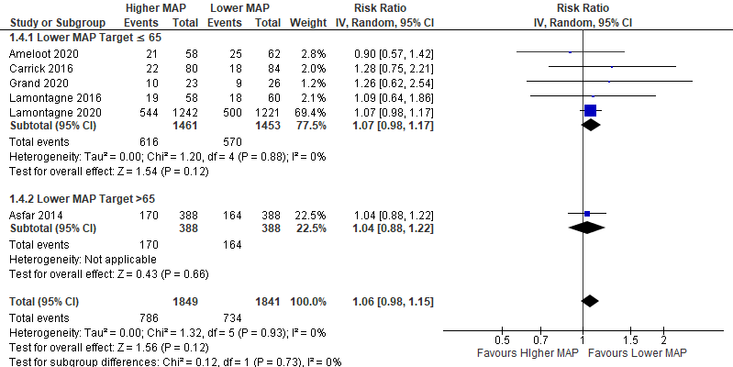
IV = inverse variance; df = degrees of freedom, MAP = mean arterial pressure

Supplement Figure 8. Forest plot showing mortality at longest follow-up subgroup analysis by shock type
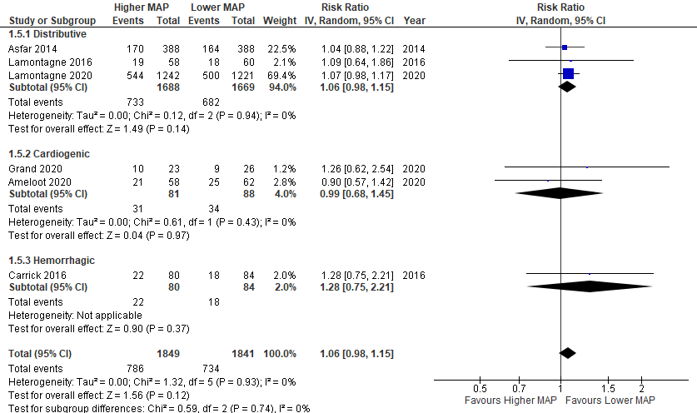
IV = inverse variance; df = degrees of freedom, MAP = mean arterial pressure

Supplement Figure 9. Forest plot showing mortality at 28-30 days
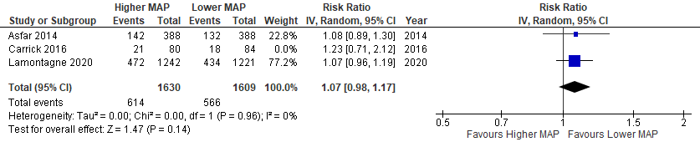
IV = inverse variance; df = degrees of freedom, MAP = mean arterial pressure

Supplement Figure 10. Forest plot showing mortality at 28 days subgroup analysis by control MAP target ≤65mmHg versus >65mmHg
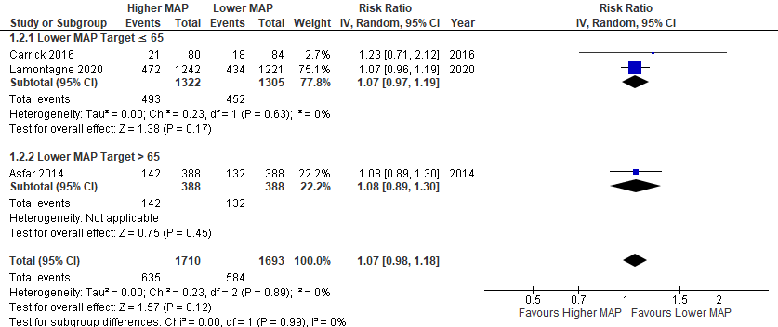
IV = inverse variance; df = degrees of freedom; MAP = mean arterial pressure

Supplement Figure 11. Forest plot showing risk of undergoing renal replacement therapy subgroup analysis by control MAP target ≤65mmHg versus >65mmHg
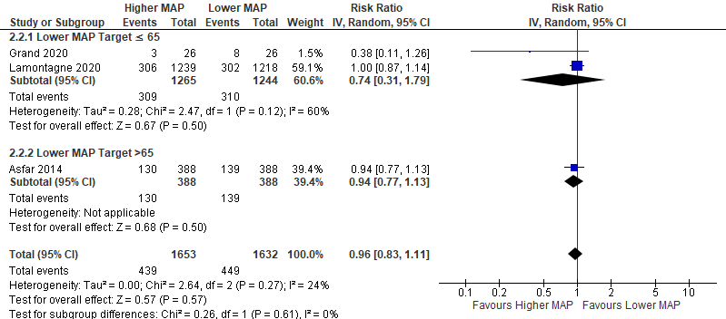
IV = inverse variance; df = degrees of freedom, MAP = mean arterial pressure

Supplement Figure 12. Forest plot showing risk of undergoing renal replacement therapy subgroup analysis by history of chronic hypertension versus no chronic hypertension
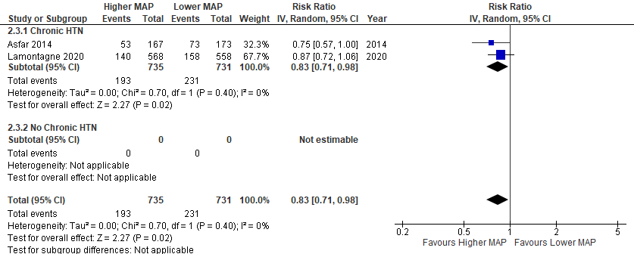
IV = inverse variance; df = degrees of freedom, MAP = mean arterial pressure

Supplement Figure 13. Forest plot showing risk of undergoing renal replacement therapy subgroup analysis by shock type
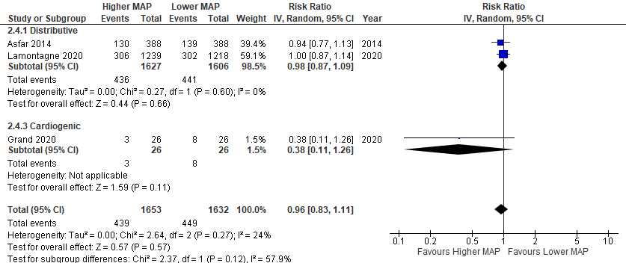
IV = inverse variance; df = degrees of freedom, MAP = mean arterial pressure

Supplement Figure 14. Forest plot showing ICU length of stay subgroup analysis by control MAP target ≤65mmHg versus >65mmHg
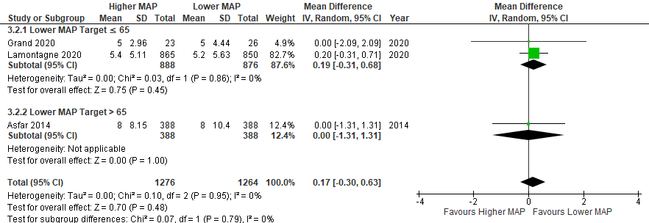
IV = inverse variance; df = degrees of freedom, MAP = mean arterial pressure

Supplement Figure 15. Forest plot showing ICU length of stay subgroup analysis by shock type
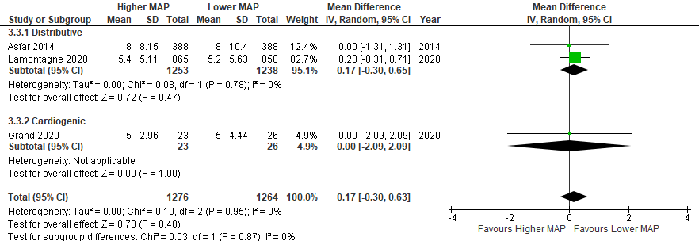
IV = inverse variance; df = degrees of freedom, MAP = mean arterial pressure

Supplement Figure 16. Forest plot showing hospital length of stay subgroup analysis by shock type
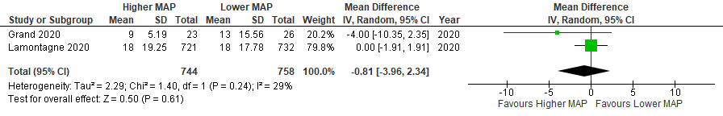
IV = inverse variance; df = degrees of freedom, MAP = mean arterial pressure

Supplement Figure 17. Forest plot showing duration of vasopressor therapy subgroup analysis by control MAP target ≤65mmHg versus >65mmHg
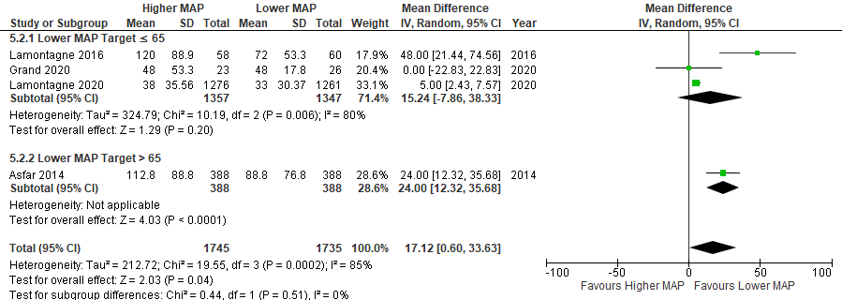
IV = inverse variance; df = degrees of freedom, MAP = mean arterial pressure

Supplement Figure 18. Forest plot showing duration of vasopressor therapy subgroup analysis by shock type
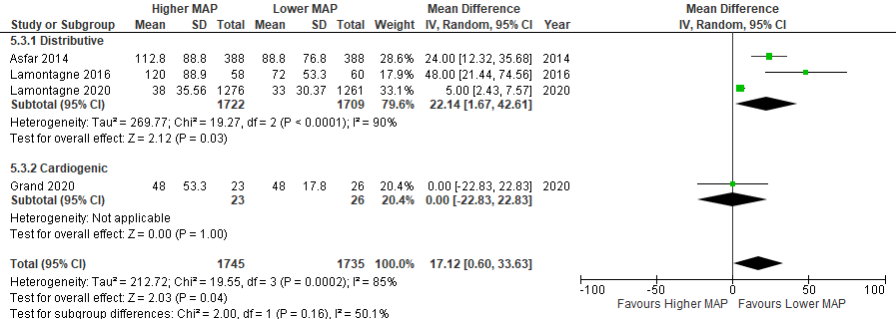
IV = inverse variance; df = degrees of freedom, MAP = mean arterial pressure

Supplement Figure 19. Forest plot showing total fluid administered
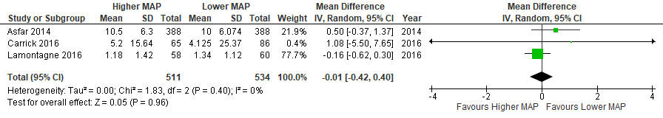
IV = inverse variance; df = degrees of freedom, MAP = mean arterial pressure

Supplement Figure 20. Forest plot showing total fluid administered subgroup analysis by shock type
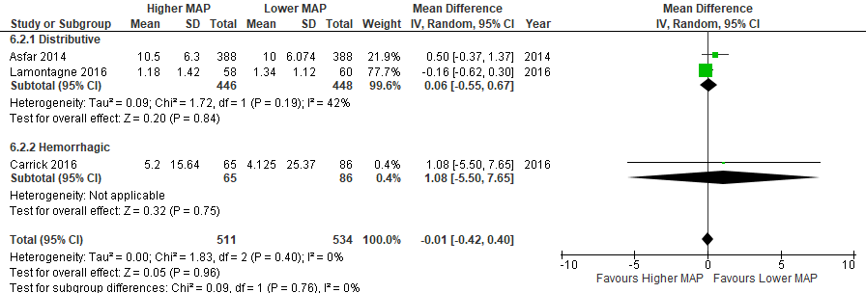
IV = inverse variance; df = degrees of freedom, MAP = mean arterial pressure

Supplement Figure 21. Forest plot showing risk of digital ischemia/necrosis subgroup analysis by control MAP target ≤65mmHg versus >65mmHg
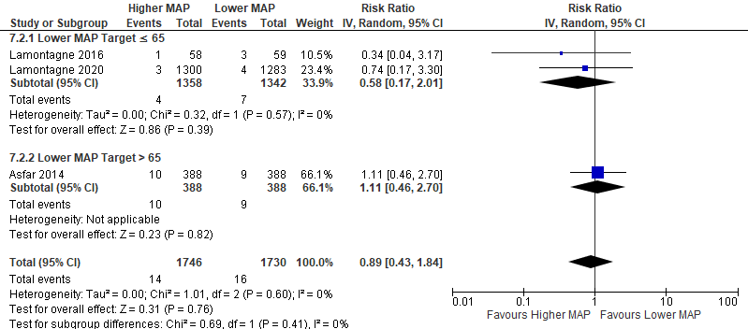
IV = inverse variance; df = degrees of freedom, MAP = mean arterial pressure

Supplement Figure 22. Forest plot showing risk of mesenteric ischemia subgroup analysis by control MAP target ≤65mmHg versus >65mmHg
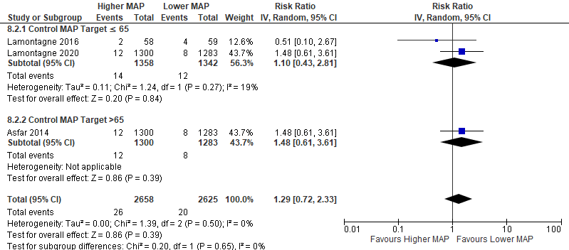
IV = inverse variance; df = degrees of freedom, MAP = mean arterial pressure

Supplement Figure 23. Forest plot showing incidence cardiac arrhythmias subgroup analysis by shock type
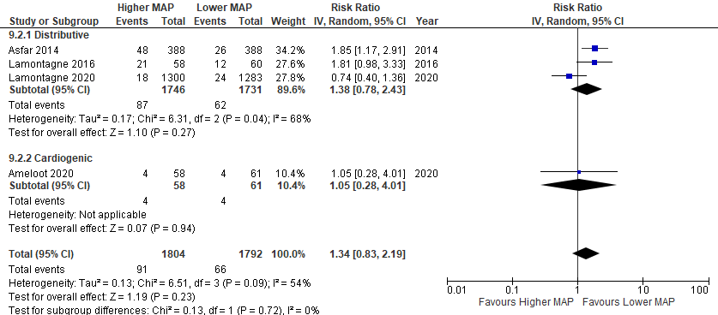
IV = inverse variance; df = degrees of freedom, MAP = mean arterial pressure

Supplement Table 20. Sensitivity analyses excluding MAP target 50mmHg
Outcome | RR | 95% CI
Mortality at longest follow-up | 1.07 | 0.99 to 1.15
28 Day Mortality | 1.07 | 0.98 to 1.17
Total Fluid Administered | 0.06L | -0.55 to 0.67

Supplement Table 21. Sensitivity analyses excluding MAP target <65mmHg
Outcome | RR or MD | 95% CI
Mortality at longest follow-up | 1.06 | 0.91 to 1.22
Need for RRT | 0.73 | 0.33 to 1.62
ICU length of stay | MD 0.00 days | -1.11 to 1.11
Duration of vasopressor therapy | MD 23.22 hours | 1.16 to 45.28
Incidence digital ischemia/necrosis | 0.94 | 0.41 to 2.16
Incidence mesenteric ischemia | 0.85 | 0.38 to 1.90
Incidence cardiac arrhythmias | 1.85 | 1.01 to 3.41

