Association between socioeconomic status and outcomes in critical care:
a systematic review and meta-analysis

Supplementary Digital Material

Table of Contents
Page(s)
2 Search Strategy for MEDLINE, Embase & CINAHL
3 Supplementary Figure 1. PRISMA flow chart of article selection and retrieval.
4-5 Supplementary Table 1. Table of study characteristics ordered by year(s) of recruitment. Showing study type, country, year(s) of recruitment, participant numbers for socioeconomic analysis (n), Newcastle-Ottawa Score converted to Agency for Healthcare Research and Quality Standard, and Deprivation Exposure.
6 Supplementary Table 2. Study characteristics of number of critical care units involved in cohort and the critical care population assessed.
7-9 Supplementary Table 3. Table of study mortality outcomes ordered by year(s) of recruitment. Showing mortality outcomes, socioeconomic groups assessed, and mortality associations (95% confidence intervals) by specified time points.
10-12 Supplementary Table 4. PRISMA 2020 Checklist
13-14 Supplementary Table 5. Table of studies included in meta-analysis, demonstrating adjustments for potentially confounding variables present in each study
15 Supplementary Figure 2. Subgroup meta-analysis and pooled effect sizes of the association between socioeconomic status and mortality up to 30 days following admission to critical care, including only studies reporting adjusted effect size
16 Supplementary Table 6. Multiple meta-regression of studies included in meta-analysis with year of publication, and population size as continuous variables, and continent of study, type of socioeconomic indicator (area- or individual-level), adjustment for confounders, and measure of effect (HR or OR) as categorical variables.
17 Supplementary Figure 3. Leave-one-out sensitivity analysis, sorted by I², of studies included in meta-analysis of the association between socioeconomic status and mortality up to 30 days following admission to critical care.
18 Supplementary Figure 4. Contour-enhanced funnel plot of the association between socioeconomic status and mortality up to 30 days following admission to critical care units.
19 Supplementary Figure 5. Contour-enhanced funnel plot & Egger’s test of the association between socioeconomic status and ICU length of stay.

Search Terms for MEDLINE, Embase & CINAHL

Ovid MEDLINE(R) <1996 to August Week 1 2022>
Embase <1996 to 2022 Week 31>

1 critical care/ or critical illness/ or critical care outcomes/ or intensive care units.mp. [mp=ti, bt, ab, ot, nm, hw, fx, kf, ox, px, rx, ui, sy, tn, dm, mf, dv, dq] 288553
2 ((intensive adj care) or (intensive adj care adj unit*) or (critical adj care) or (critical adj illness) or (critically adj ill) or (postintensive adj care adj syndrome) or (post-intensive adj care adj syndrome) or PICS or (critical adj care adj outcome*) or (intensive adj care adj outcome*)).mp. [mp=ti, bt, ab, ot, nm, hw, fx, kf, ox, px, rx, ui, sy, tn, dm, mf, dv, dq] 678631
3 socioeconomic factors/ or social class.mp. [mp=ti, bt, ab, ot, nm, hw, fx, kf, ox, px, rx, ui, sy, tn, dm, mf, dv, dq] 287634
4 ((social adj disadvantag*) or (socioeconomic adj disadvantage*) or (socio-economic adj disadvantage) or (socioeconomic adj status) or (socio-economic adj status) or (social adj deprivation) or deprivation or (socioeconomic adj deprivation) or (socio-economic adj deprivation) or (relative adj deprivation) or (socioeconomic adj position) or (socio-economic adj position) or (socioeconomic adj factor*) or (socio-economic adj factor*) or (area* adj deprivation) or (socioeconomic adj index) or (socioeconomic adj indexes) or (socioeconomic adj indices) or (socio-economic adj index) or (socio-economic adj indexes) or (socio-economic adj indices) or (deprivation adj index) or (deprivation adj indexes) or (deprivation adj indices) or (social adj class)).mp. [mp=ti, bt, ab, ot, nm, hw, fx, kf, ox, px, rx, ui, sy, tn, dm, mf, dv, dq] 464407
5 neonat$.mp. 536211
6 paediat$/ or child$.mp. [mp=ti, bt, ab, ot, nm, hw, fx, kf, ox, px, rx, ui, sy, tn, dm, mf, dv, dq] 3940115
7 ((1 or 2) and (3 or 4)) not 5 not 6 3001
8 remove duplicates from 7 2313

CINAHL

("Critical Care" OR "Intensive Care") AND ("Social Class" OR "Socioeconomic Status" OR "Socioeconomic Factors" OR "Deprivation")

Limits - Age Groups: All Adult

Supplementary Figure 1 - PRISMA flow chart of article selection and retrieval.

Supplementary Table 1. Table of study characteristics ordered by year(s) of recruitment. Showing study type, country, year(s) of recruitment, participant numbers for socioeconomic analysis (n), Newcastle-Ottawa Score converted to Agency for Healthcare Research and Quality Standard, and Deprivation Exposure.
Study | Study Type | Country/Region | Recruitment Year(s) | n = | Agency for Healthcare Research and Quality Standard | Socioeconomic Status Level | Socioeconomic Status Measure
Latour et al. 1991 (38) | Retrospective Cohort | Spain | Unspecified | 824 | Good | Individual | Occupation
Shippee et al. 2011 (42) | Retrospective Cohort | USA | 1971-1992 | 4229 | Good | Individual | Income, Education assessed independently
Ho et al. 2008 (46) | Retrospective Cohort | Australia | 1987-2002 | 15619 | Good | Area | Index of Relative Socioeconomic Disadvantage 1986, 1991, 1996, 2001
Findlay et al. 2000 (44) | Retrospective Cohort | Scotland | 1993-1994 | 716 | Good | Area | Carstairs Score
Hutchings et al. 2004 (4) | Retrospective Cohort | England & Wales | 1995-2000 | 51572 | Good | Area | Carstairs Score
Zager et al. 2011 (22) | Retrospective Cohort | USA | 1997-2007 | 38917 | Good | Area | Federal Poverty Rate 1990
Mendu et al. 2012 (21) | Retrospective Cohort | USA | 1997-2007 | 14597 | Good | Area | Federal Poverty Rate 1990
Falvey et al. 2022 (28) | Prospective Cohort | USA | 1998-1999 | 239 | Good | Area | Area Deprivation Index
Norena et al. 2006 (48) | Retrospective Cohort | Canada | 1998-2003 | 1603 | Good | Area | Area average Income, Education, Employment assessed independently
Garland et al. 2015 (45) | Retrospective Cohort | Manitoba, Canada | 1999-2008 | 38862 | Good | Area | Average area household income
Welch et al. 2010 (6) | Retrospective Cohort | England & Wales | 2000-2002 | 71710 | Good | Area | Index of Multiple Deprivation 2004
Puxty et al. 2015 (33) | Retrospective Cohort | Scotland | 2000-2009 | 6040 | Good | Area | Scottish Index of Multiple Deprivation 2012
Bigé et al. 2015 (30) | Case-Control | France | 2000-2012 | 421 | Good | Individual | Living place, finances, insurance, isolation
Fletcher et al. 2014 (47) | Retrospective Cohort | England | 2003-2010 | 6937 | Good | Area | Index of Multiple Deprivation 2007
Haddad et al. 2020 (26) | Prospective Cohort | USA | 2006-2010 | 489 | Good | Area | Agency for Healthcare Research and Quality Socioeconomic Status Index 2008
Mullany et al. 2021 (7) | Retrospective Cohort | Queensland, Australia | 2006-2015 | 218462 | Good | Area | Index of Relative Socioeconomic Disadvantage 2006, 2011
Gabriel et al. 2016 (23) | Retrospective Cohort | Victoria, Australia | 2007-2012 | 33306 | Good | Area | Index of Relative Socioeconomic Disadvantage 2011
Docherty et al. 2022 (24) | Retrospective Cohort | Victoria, Australia | 2007-2018 | 130775 | Good | Area | Index of Relative Socioeconomic Disadvantage 2016
Ventre et al. 2018 (35) | Retrospective Cohort | Scotland | 2008-2010 | 1464 | Good | Area | Scottish Index of Multiple Deprivation 2012
Docking et al. 2014 (43) | Retrospective Cohort | Scotland | 2008-2010 | 1017 | Poorª | Area | Scottish Index of Multiple Deprivation 2009
Schnegelsberg et al. 2016 (32) | Retrospective Cohort | Denmark | 2008-2010 | 387 | Good | Individual | Income, Education, Cohabitation assessed independently
Hua et al. 2015 (49) | Retrospective Cohort | USA | 2008-2010 | 492653 | Good | Area | Median area income
Bein et al. 2012 (36) | Retrospective Cohort | Germany | 2009-2010 | 1006 | Good | Individual | Composite index of Education, Occupation, Income
Griffith et al. 2018 (25) | Prospective Cohort | United Kingdom | 2010-2013 | 240 | Good | Area | Scottish Index of Multiple Deprivation 2012
Gayat et al. 2018 (19) | Retrospective Cohort | France & Belgium | 2011-2013 | 1570 | Poorª | Area | French Deprivation Index (FDep)
Bastian et al. 2018 (20) | Retrospective Cohort | France | 2011-2013 | 1834 | Good | Area | French Deprivation Index (FDep)
Barwise et al. 2021 (3) | Retrospective Cohort | USA | 2011-2014 | 3378 | Good | Individual | HOUsing-based index of socioeconomic status (HOUSES)
Vasquez et al. 2015 (41) | Retrospective Cohort | Argentina | 2012 | 362 | Good | Individual | Education
McPeake et al. 2015 (27) | Prospective Cohort | Scotland | 2012-2013 | 580 | Good | Area | Scottish Index of Multiple Deprivation 2012
Oh et al. 2018 (39) | Retrospective Cohort | S Korea | 2012-2016 | 6008 | Good | Individual | Education, Occupation, Marital, Religion, Insurance assessed independently
Quenot et al. 2020 (40) | Retrospective Cohort | France | 2013-2016 | 1294 | Good | Individual | Evaluation de la Précarité et des Inégalités de santé dans les Centres d'Examens de Santé (EPICES) score of social conditions, leisure activities & family/social support
Oh et al. 2020 (34) | Retrospective Cohort | S Korea, Nationwide | 2013-2017 | 14600 | Good | Individual | Income at month of admission
Liisanantti et al. 2017 (50) | Retrospective Cohort | Finland | 2013-2015 | 735 | Poorª | Area | Area-level median income
Benaïs et al. 2018 (37)  *Letter | Retrospective Cohort | France | 2017 | 234 | Good | Individual | Social environment, language, education, housing, finance, insurance assessed independently
Lone et al. 2021 (18) | Retrospective Cohort | Scotland | 2020 | 688 | Good | Area | Scottish Index of Multiple Deprivation 2020
Ferrando-Vivas et al. 2021 (31) | Retrospective Cohort | England, Wales & Northern Ireland | 2020 | 9267 | Good | Area | Index of Multiple Deprivation 2020
Soulsby et al. 2020 (17)  *Letter | Retrospective Cohort | Scotland | 2020 | 62 | Good | Area | Scottish Index of Multiple Deprivation 2020
Nordberg et al. 2022 (29) | Mixed Case-Control and Retrospective Cohort | Sweden | 2020-2021 | 4921 | Good | Individual | Education, Income
ª In relation to adjustment for outcomes based on SES exposure

Supplementary Table 2. Study characteristics of number of critical care units involved in cohort and the critical care population assessed.
Study | Number of Units | Critical Care Population
Latour et al. 1991 (38) | 3 | All
Shippee et al. 2011 (42) | Unspecified | Cardiac ICU
Ho et al. 2008 (46) | 1 | All
Findlay et al. 2000 (44) | 1 | All
Hutchings et al. 2004 (4) | 99 | All
Zager et al. 2011 (22) | 2 | All
Mendu et al. 2012 (21) | 2 | Septicaemia
Falvey et al. 2022 (28) | State | Age ≥70, independent with activities of daily living, and non-frail
Norena et al. 2006 (48) | 1 | All
Garland et al. 2015 (45) | 12 | All
Welch et al. 2010 (6) | 138 | All
Puxty et al. 2015 (33) | National | Cancer
Bigé et al. 2015 (30) | 1 | All
Fletcher et al. 2014 (47) | 1 | All
Haddad et al. 2020 (26) | 5 | All
Mullany et al. 2021 (7) | 35 | All
Gabriel et al. 2016 (23) | 5 | All
Docherty et al. 2022 (24) | 23 | All
Ventre et al. 2018 (35) | National | Acute Pancreatitis
Docking et al. 2014 (43) | 1 | All
Schnegelsberg et al. 2016 (32) | 1 | Sepsis
Hua et al. 2015 (49) | State | All
Bein et al. 2012 (36) | 1 | Surgical
Griffith et al. 2018 (25) | 2 | All
Gayat et al. 2018 (19) | 21 | All
Bastian et al. 2018 (20) | 20 | All
Barwise et al. 2021 (3) | 7 | All
Vasquez et al. 2015 (41) | National | Maternal
McPeake et al. 2015 (27) | 1 | All
Oh et al. 2018 (39) | 4 | All
Quenot et al. 2020 (40) | 8 | All
Oh et al. 2020 (34) | National | ARDS
Liisanantti et al. 2017 (50) | 1 | Non-trauma, emergency admissions
Benaïs et al. 2018 (37)  *Letter | 1 | All
Lone et al. 2021 (18) | National | COVID-19
Ferrando-Vivas et al. 2021 (31) | 258 | COVID-19
Soulsby et al. 2020 (17) *Letter | 1 | COVID-19
Nordberg et al. 2022 (29) | National | Severe COVID-19 requiring mechanical ventilation

Supplementary Table 3. Table of study mortality outcomes ordered by year(s) of recruitment. Showing mortality outcomes, socioeconomic groups assessed, and mortality associations (95% confidence intervals) by specified time points.
Study | Mortality Outcome(s) | Socioeconomic Groups Assessed | ICU Mortality | Hospital Mortality |  | 30d Mortality | Longer Term
Latour et al. 1991 (38) | ICU | Dichotomised low and high socioeconomic status | Unadjusted OR 1.61 (1.07-2.42)ª  Adjusted Mantel-Haenszel chi-square p=0.1776
Shippee et al. 2011 (42) | Long Term up to 20 year follow-up | Individually grouped for each socioeconomic factor  Education – 7 categories  Income – 12 categories |  |  |  |  | Education Measure  HR 1.019 (0.962-1.079)^{c}  Income Measure  HR 1.038 (0.99-1.089)^{c}
Ho et al. 2008 (46) | In-Hospital & Long Term | Most to least deprived sextile |  | Adjusted OR 1.16 (0.85-1.59) |  |  | Adjusted HR 1.21 (1.04-1.41)
Findlay et al. 2000 (44) | In-Hospital | 2 most deprived septiles to 5 least deprived septiles |  | Adjusted OR 1.3 (0.9-1.8)
Hutchings et al. 2004 (4) | In-Hospital | Most to least deprived quintile |  | Adjusted OR 1.04 (1.01-1.19)
Zager et al. 2011 (22) | In-Hospital, & 30, 90 & 365 Day | Federal poverty rate >40% to <5% |  | No significant difference in adjusted model^{b} |  | Adjusted OR 1.2 (0.9-1.6) | 90 Day  No significant difference in adjusted model^{b}  365 Day  No significant difference in adjusted model^{b}
Mendu et al. 2012 (21) | In-Hospital, & 30, 90 & 365 Day | Federal poverty rate >40% to <5% |  | Adjusted OR 0.85 (0.58-1.24) |  | Adjusted OR 0.80 (0.55-1.15) | 90 Day  Adjusted OR 0.77 (0.54-1.09)  365 Day  Adjusted OR 0.83 (0.60-1.15)
Norena et al. 2006 (48) | In-Hospital | Groups at the limits of interquartile range for each measure |  | Education Measure (% Postsecondary Education)  Adjusted with Charleston Comorbidity Index OR 0.854 (0.759-0.976)^{c}  Employment Measure (% Unemployed)  Adjusted with Charleston Comorbidity Index OR 1.0378 (0.874-1.2079)  Income Measure (per $1000 Median Income)  Adjusted with Charleston Comorbidity Index OR 0.8928 (0.6583-1.1273)
Garland et al. 2015 (45) | In-Hospital | Test-of-trend across quintiles |  | Adjusted Fisher exact p<0.0001  Declining mortality with rising socioeconomic status for urban residents^{b}
Welch et al. 2010 (6) | In-Hospital | Most to least deprived quintile |  | Adjusted OR 1.19 (1.1-1.28)
Puxty et al. 2015 (33) | In-Hospital | Most to least deprived quintile |  | Adjusted OR 2.7 (1.52-4.76)^{c}
Bigé et al. 2015 (30) | In-Hospital & ICU | Homeless to non-homeless | Adjusted OR 1.20 (0.84-1.69) | Adjusted OR 1.07 (0.77-1.49)
Fletcher et al. 2014 (47) | In-Hospital | Average of most deprived to average of least deprived quintile |  | Calculated adjusted HR 1.18 (1.06-1.30)
Mullany et al. 2021 (7) | In-Hospital | Most to least disadvantaged decile |  | Adjusted OR 0.94 (0.82-1.08)^{c}
Gabriel et al. 2016 (23) | In-Hospital | Most to least disadvantaged decile |  | Adjusted OR 1.19 (0.98- 1.42)^{c}
Docherty et al. 2022 (24) | Long Term (median follow-up to 3.6 years) | Most to least deprived quartile |  |  |  |  | Adjusted HR 1.09 (1.05-1.12)
Ventre et al. 2018 (35) | Long Term (median follow-up to 4.4 years) | Most to least deprived quintile |  |  |  |  | Mantel-Cox chi-square p = 0.50
Docking et al. 2014 (43) | In-Hospital & ICU (within 30 days) | Most to least deprived decile | Unadjusted OR 1.22 (0.48-3.13)^{c} | Unadjusted OR 1.32 (0.55-3.23)^{c}
Schnegelsberg et al. 2016 (32) | 30 & 180 Day | Each group reported |  |  |  | Income Measure  Adjusted HR 1.99 (1.24-3.21)  Education Measure  Adjusted HR 1.49 (0.84-2.65)  Cohabitation Measure Adjusted HR 0.57 (0.38-0.83) | 180 Day  Income Measure  Adjusted HR 1.72 (0.86-3.45)  Education Measure  Adjusted HR 1.39 (0.62-3.1)  Cohabitation Measure Adjusted HR 1.29 (0.73-2.29)
Gayat et al. 2018 (19) | 1 Year | Continuous |  |  |  |  | 1 Year  Unadjusted Wilcoxon rank-sum test p = 0.44
Bastian et al. 2018 (20) | In-Hospital & ICU, 28 Day & 1 Year | Dichotomised deprived to not deprived | Chi-square p=0.704  Calculated unadjusted OR 1.1 (0.87-1.4) | Chi-square p = 0.364 Calculated unadjusted OR 1.07 (0.86-1.33) |  | 28 Day of ICU survivors  Chi-square p = 0.172 Calculated unadjusted OR 1.09 (0.73-1.62) | 1 year of ICU survivors  Chi-square p=0.304.  Calculated unadjusted OR 1.08 (0.82-1.43)
Barwise et al. 2021 (3) | In-Hospital | Q2-4 compared to most deprived quartile |  | Adjusted HR 1.23 (0.96-1.59)  Subgroup >50 years adjusted HR 1.39 (1.07-1.79)^{c}
Vasquez et al. 2015 (41) | Maternal-foetal-neonatal mortality |  |  | Adjusted OR 1.12 (1.02-1.25)^{c}
McPeake et al. 2015 (27) | 6 Month | Most deprived quintile to quintiles 2-5 |  |  |  |  | 6 Month of ICU survivor  Adjusted HR 1.11 (0.84-1.45)
Oh et al. 2018 (39) | 30 Day & 1 Year | Individually grouped for each socioeconomic factor |  |  |  | Education Measure (<High School to ≥College)  Adjusted HR 1.14 (0.88-1.47)^{c}  Employment Measure (Unemployed to Office Worker)  Adjusted HR 1.4 (0.89-2.18) | 1 year  Education Measure (<High School to ≥College)  Adjusted HR 1.04 (0.89-1.22)^{c}  Employment Measure (Unemployed to Office Worker)  Adjusted HR 1.83 (1.37-2.43)
Quenot et al. 2020 (40) | In-Hospital & ICU, 3, 6 & 12 Month | Dichotomised deprived to not deprived | Chi-square p = 0.557  Calculated unadjusted OR 1.11 (0.84-1.47) | For ICU survivors  Chi-square p = 0.987  Calculated unadjusted OR 1.26 (0.80-2.00) |  |  | 3 Month of ICU survivors  Adjusted OR 1.04(0.79-1.37)  6 Month of ICU survivors  Adjusted OR 0.97 (0.75-1.27)  12 Month of ICU survivors  Adjusted OR 1.06 (0.82-1.37)
Oh et al. 2020 (34) | 30 Day & 1 Year | Least income quartile to most income quartile |  |  |  | Adjusted HR 1.02 (0.95-1.10)^{c} | 1 year  Adjusted HR 1.04 (0.98-1.10)^{c}
Liisanantti et al. 2017 (50) | In-Hospital and ICU | Low, middle and high area-level median income | Calculated unadjusted OR 0.56 (0.29-1.17) |  | Calculated unadjusted OR 0.72 (0.44-1.19)
Benaïs et al. 2018 (37) | ICU | Dichotomised low and high socioeconomic status for each variable assessed | Social Measure  Adjusted HR 1.73 (0.62-4.83)  Language Measure  Adjusted HR 1.3 (0.29-5.79)  Education Measure  Adjusted HR 1.15 (0.46-2.98)  Housing Measure  Adjusted HR 1.77 (0.53-5.86)  Finance Measure  Adjusted HR 0.26 (0.06-1.17)  Health Insurance Measure  Adjusted HR 1.29 (0.29-5.79)
Lone et al. 2021 (18) | 30 Day | Most to least deprived quintile |  |  |  | Adjusted OR 1.78 (1.01-3.15)
Ferrando-Vivas et al. 2021 (31) | 30 Day | Most to least deprived quintile |  |  |  | Adjusted HR 1.14 (1.01-1.28)
Soulsby et al. 2020 (17) | 30 Day | Most to least deprived quintile |  |  |  | Adjusted HR 2.9 (1.3-6.5)
Nordberg et al. 2022 (29) | 90 Day | Individually groups for each socioeconomic factor |  |  |  |  | 90 day  Education Measure (Primary to >Secondary)  Adjusted HR 1.00 (0.87-1.16)^{c}  Income Measure (Quartile 1 to Quartile 5)  Adjusted HR 1.16 (0.97-1.39)
ªUnadjusted effect utilised for meta-analysis as adjusted effect size not presented
^{b}Further data or analysis not presented.
^{c} Transformed to maintain relationship of most deprived group to reference of least deprived group.

PRISMA 2020 Checklist

Section and Topic | Item # | Checklist item | Location where item is reported
TITLE
Title | 1 | Identify the report as a systematic review. | Introduction
ABSTRACT
Abstract | 2 | See the PRISMA 2020 for Abstracts checklist. | Abstract
INTRODUCTION
Rationale | 3 | Describe the rationale for the review in the context of existing knowledge. | Introduction
Objectives | 4 | Provide an explicit statement of the objective(s) or question(s) the review addresses. | Introduction
METHODS
Eligibility criteria | 5 | Specify the inclusion and exclusion criteria for the review and how studies were grouped for the syntheses. | Methods
Information sources | 6 | Specify all databases, registers, websites, organisations, reference lists and other sources searched or consulted to identify studies. Specify the date when each source was last searched or consulted. | Methods
Search strategy | 7 | Present the full search strategies for all databases, registers and websites, including any filters and limits used. | Supplementary Material
Selection process | 8 | Specify the methods used to decide whether a study met the inclusion criteria of the review, including how many reviewers screened each record and each report retrieved, whether they worked independently, and if applicable, details of automation tools used in the process. | Methods
Data collection process | 9 | Specify the methods used to collect data from reports, including how many reviewers collected data from each report, whether they worked independently, any processes for obtaining or confirming data from study investigators, and if applicable, details of automation tools used in the process. | Methods
Data items | 10a | List and define all outcomes for which data were sought. Specify whether all results that were compatible with each outcome domain in each study were sought (e.g. for all measures, time points, analyses), and if not, the methods used to decide which results to collect. | Methods
 | 10b | List and define all other variables for which data were sought (e.g. participant and intervention characteristics, funding sources). Describe any assumptions made about any missing or unclear information. | Methods
Study risk of bias assessment | 11 | Specify the methods used to assess risk of bias in the included studies, including details of the tool(s) used, how many reviewers assessed each study and whether they worked independently, and if applicable, details of automation tools used in the process. | Methods
Effect measures | 12 | Specify for each outcome the effect measure(s) (e.g. risk ratio, mean difference) used in the synthesis or presentation of results. | Methods
Synthesis methods | 13a | Describe the processes used to decide which studies were eligible for each synthesis (e.g. tabulating the study intervention characteristics and comparing against the planned groups for each synthesis (item #5)). | Methods
 | 13b | Describe any methods required to prepare the data for presentation or synthesis, such as handling of missing summary statistics, or data conversions. | Methods
 | 13c | Describe any methods used to tabulate or visually display results of individual studies and syntheses. | Methods
 | 13d | Describe any methods used to synthesize results and provide a rationale for the choice(s). If meta-analysis was performed, describe the model(s), method(s) to identify the presence and extent of statistical heterogeneity, and software package(s) used. | Methods
 | 13e | Describe any methods used to explore possible causes of heterogeneity among study results (e.g. subgroup analysis, meta-regression). | Methods
 | 13f | Describe any sensitivity analyses conducted to assess robustness of the synthesized results. | Methods
Reporting bias assessment | 14 | Describe any methods used to assess risk of bias due to missing results in a synthesis (arising from reporting biases). | Methods
Certainty assessment | 15 | Describe any methods used to assess certainty (or confidence) in the body of evidence for an outcome. | Methods
RESULTS
Study selection | 16a | Describe the results of the search and selection process, from the number of records identified in the search to the number of studies included in the review, ideally using a flow diagram. | Results & Supplementary Material
 | 16b | Cite studies that might appear to meet the inclusion criteria, but which were excluded, and explain why they were excluded. | Supplementary Material
Study characteristics | 17 | Cite each included study and present its characteristics. | Results & Supplementary Material
Risk of bias in studies | 18 | Present assessments of risk of bias for each included study. | Supplementary Material
Results of individual studies | 19 | For all outcomes, present, for each study: (a) summary statistics for each group (where appropriate) and (b) an effect estimate and its precision (e.g. confidence/credible interval), ideally using structured tables or plots. | Table 2 & Supplementary Material
Results of syntheses | 20a | For each synthesis, briefly summarise the characteristics and risk of bias among contributing studies. | Results
 | 20b | Present results of all statistical syntheses conducted. If meta-analysis was done, present for each the summary estimate and its precision (e.g. confidence/credible interval) and measures of statistical heterogeneity. If comparing groups, describe the direction of the effect. | Results & Supplementary Material
 | 20c | Present results of all investigations of possible causes of heterogeneity among study results. | Results & Supplementary Material
 | 20d | Present results of all sensitivity analyses conducted to assess the robustness of the synthesized results. | Results & Supplementary Material
Reporting biases | 21 | Present assessments of risk of bias due to missing results (arising from reporting biases) for each synthesis assessed. | N/A
Certainty of evidence | 22 | Present assessments of certainty (or confidence) in the body of evidence for each outcome assessed. | Results
DISCUSSION
Discussion | 23a | Provide a general interpretation of the results in the context of other evidence. | Discussion
 | 23b | Discuss any limitations of the evidence included in the review. | Discussion
 | 23c | Discuss any limitations of the review processes used. | Discussion
 | 23d | Discuss implications of the results for practice, policy, and future research. | Discussion
OTHER INFORMATION
Registration and protocol | 24a | Provide registration information for the review, including register name and registration number, or state that the review was not registered. | N/A
 | 24b | Indicate where the review protocol can be accessed, or state that a protocol was not prepared. | N/A
 | 24c | Describe and explain any amendments to information provided at registration or in the protocol. | N/A
Support | 25 | Describe sources of financial or non-financial support for the review, and the role of the funders or sponsors in the review. | Other Information
Competing interests | 26 | Declare any competing interests of review authors. | Other Information
Availability of data, code and other materials | 27 | Report which of the following are publicly available and where they can be found: template data collection forms; data extracted from included studies; data used for all analyses; analytic code; any other materials used in the review. | Other Information

From: Page MJ, McKenzie JE, Bossuyt PM, Boutron I, Hoffmann TC, Mulrow CD, et al. The PRISMA 2020 statement: an updated guideline for reporting systematic reviews. BMJ 2021;372:n71. doi: 10.1136/bmj.n71
For more information, visit: http://www.prisma-statement.org/

Supplementary Table 4. Table of studies included in meta-analysis of mortality, demonstrating adjustments for potentially confounding variables present in each study (where studies have presented multiple models with varying levels of adjustment, the model with adjustment for the greatest number of confounding variables is presented).
Study | Adjustment Present | Age | Sex/Gender | Race/  Ethnicity | Charlson Comorbidity Index | SAPS/SAPSII | APACHE/APACHE II/APACHE III | Source of Admission | Admitting Diagnosis | Year of Admission | Laboratory Values | Other SES Variables | ICU of Admission | Other
Latour et al. 1991 (38) | Yesª | X |  |  |  | X |  |  |  |  |  |  | X | Therapeutic Intervention Scoring System
Ho et al. 2008 (46) | Yes | X |  | X | X |  | X |  |  |  |  |  |  | Accessibility/Remoteness Index of Australia
Findlay et al. 2000 (44) | Yes | X |  |  |  |  | X | X | X |  |  |  |  | IWRisk Score calculated from APACHE II & admitting diagnosis^{b}
Hutchings et al. 2004 (4) | Yes | X |  |  | X |  | X | X | X | X |  |  | X | Severe medical history^{b}
Zager et al.  2011 (22) | Yes | X | X | X | X |  |  | X | X^{b} | X | X^{b} |  |  | Distance from Hospital
Norena et al. 2006 (48) | Yes | X | X |  | X |  | X | X | X |  |  | X^{b}
Welch et al. 2010 (6) | Yes | X | X |  | X |  |  |  |  |  |  |  | X | ICNARC Physiology Score  Severe medical history^{b}
Puxty et al. 2015 (33) | Yes | X | X |  |  |  |  | X | X^{b} | X |  |  | X^{b} | Organ Support^{b}
Bigé et al. 2015 (30) | Yes | X | X |  |  | X
Fletcher et al. 2014 (47) | Yes | X |  |  |  |  |  |  |  |  |  |  |  | ICNARC Model^{b}
Mullany et al. 2021 (7) | Yes |  | X |  |  |  | X | X | X^{b} | X |  |  |  | Hospital Type^{b}  Comorbidities^{b}
Gabriel et al. 2016 (23) | Yes | X |  |  |  |  | X | X | X | X |  | X^{b}
Docking et al. 2014 (43) | No
Schnegelsberg et al. 2016 (32) | Yes |  | X |  | X | X
Bastian et al. 2018 (20) | Yesª | X | X |  | X | X |  |  |  |  |  | X |  | SOFA  Lifestyle Factors^{b}  Comorbidities^{b}
Barwise et al. 2021 (3) | Yes | X | X | X |  |  | X
Oh et al. 2018 (39) | Yes | X | X |  | X |  | X | X |  | X |  |  |  | BMI  Comorbidities^{b}
Quenot et al. 2020 (40) | Yes | X |  |  | X | X |  |  |  |  |  |  | X | Activities of Daily Living Score^{b}
Oh et al. 2020 (34) | Yes | X | X |  |  |  |  |  |  | X |  |  |  | ECMO Use  Area of Residence^{b}  Comorbidities^{b}
Liisanantti et al. 2017 (50) | No
Benaïs et al. 2018 (37)  *Letter | Yes |  | X |  |  | X |  |  |  |  |  |  |  | BMI
Lone et al. 2021 (18) | Yes | X | X | X | X |  | X^{c} |  |  |  |  |  |  | Emergency Hospital Admission in past year
Ferrando-Vivas et al. 2021 (31) | Yes | X | X | X |  |  |  |  |  |  | X^{b} |  |  | BMI  Comorbidities^{b}  Dependency prior  Initial sedation  Physiological variables^{b}  Mechanical Ventilation
ªUnadjusted effect utilised for meta-analysis as adjusted effect size not presented
^{b}Further defined in the study publication
^{c}Acute Physiology Score component

Supplementary Figure 2. Subgroup meta-analysis and pooled effect sizes of the association between socioeconomic status and mortality up to 30 days following admission to critical care, including only studies reporting adjusted effect size.
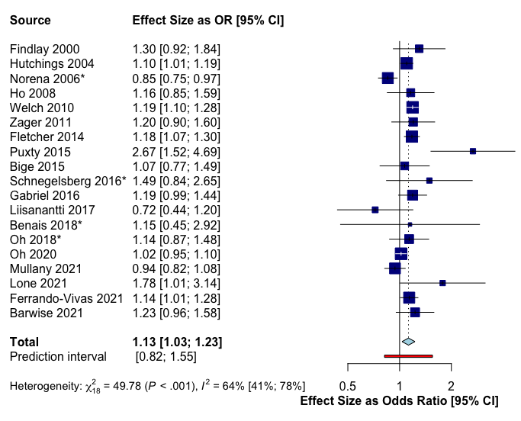
*Using educational attainment socioeconomic status measure

Supplementary Table 5. Multiple meta-regression of studies included in meta-analysis with year of publication, and population size as continuous variables, and continent of study, type of socioeconomic indicator (area- or individual-level), adjustment for confounders, and measure of effect (HR or OR) as categorical variables.

Mixed-Effects Model (k = 23; tau² estimator: DL)

Tau² (estimated amount of residual heterogeneity): 0.0174 (SE = 0.0155)
tau (square root of estimated tau² value): 0.1318
I² (residual heterogeneity / unaccounted variability): 59.44%
H² (unaccounted variability / sampling variability): 2.47
R² (amount of heterogeneity accounted for): 0.00%

Test for Residual Heterogeneity:
QE(df = 12) = 29.5837, p-val = 0.0032

Test of Moderators (coefficients 2:11):
F(df1 = 10, df2 = 12) = 0.4524, p-val = 0.8910

 | Estimate | Standard Error | t value | p value | 95% Confidence Intervals
Intercept | 12.6098 | 18.8312 | 0.6696 | 0.5158 | -28.4199-53.6394
Type of Indicator: Individual | 0.1232 | 0.1623 | 0.7596 | 0.4622 | -0.0266-0.4768
Study Year | -0.0063 | 0.0093 | -0.6711 | 0.5149 | -0.0266-0.0141
Population Size | -0.0000 | 0.0000 | -0.5896 | 0.5664 | -0.0000-0.0000
Adjustment: Unadjusted | -0.0235 | 0.1904 | -0.1234 | 0.9038 | -0.4384-0.3914
Effect Measure: OR | -0.0183 | 0.1543 | -0.1543 | 0.9075 | -0.3545-0.3179
Continent: Australia | 0.3484 | 0.2953 | 1.1797 | 0.2610 | -0.3545-0.9918
Continent: Europe | 0.3212 | 0.2322 | 1.3835 | 0.1917 | -0.1847-0.8271
Continent: North America | 0.1425 | 0.2327 | 0.6123 | 0.5517 | -0.3645-0.6495
Mortality Time Point: In-Hospital | -0.1521 | 0.1523 | -0.9989 | 0.3376 | -0.4838-0.1797
Mortality Time Point: ICU | -0.1495 | 0.2782 | -0.5373 | 0.6009 | -0.7555-0.4566

Supplementary Figure 3. Leave-one-out sensitivity analysis, sorted by I², of studies included in meta-analysis of the association between socioeconomic status and mortality up to 30 days following admission to critical care.
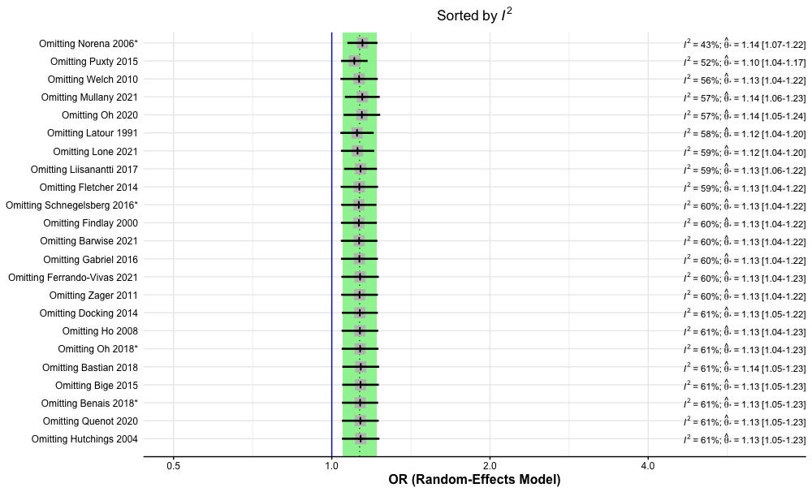

Supplementary Figure 4. Contour-enhanced funnel plot of the association between socioeconomic status and mortality up to 30 days following admission to critical care units.

Supplementary Figure 5. Contour-enhanced funnel plot & Egger’s test of the association between socioeconomic status and ICU length of stay.

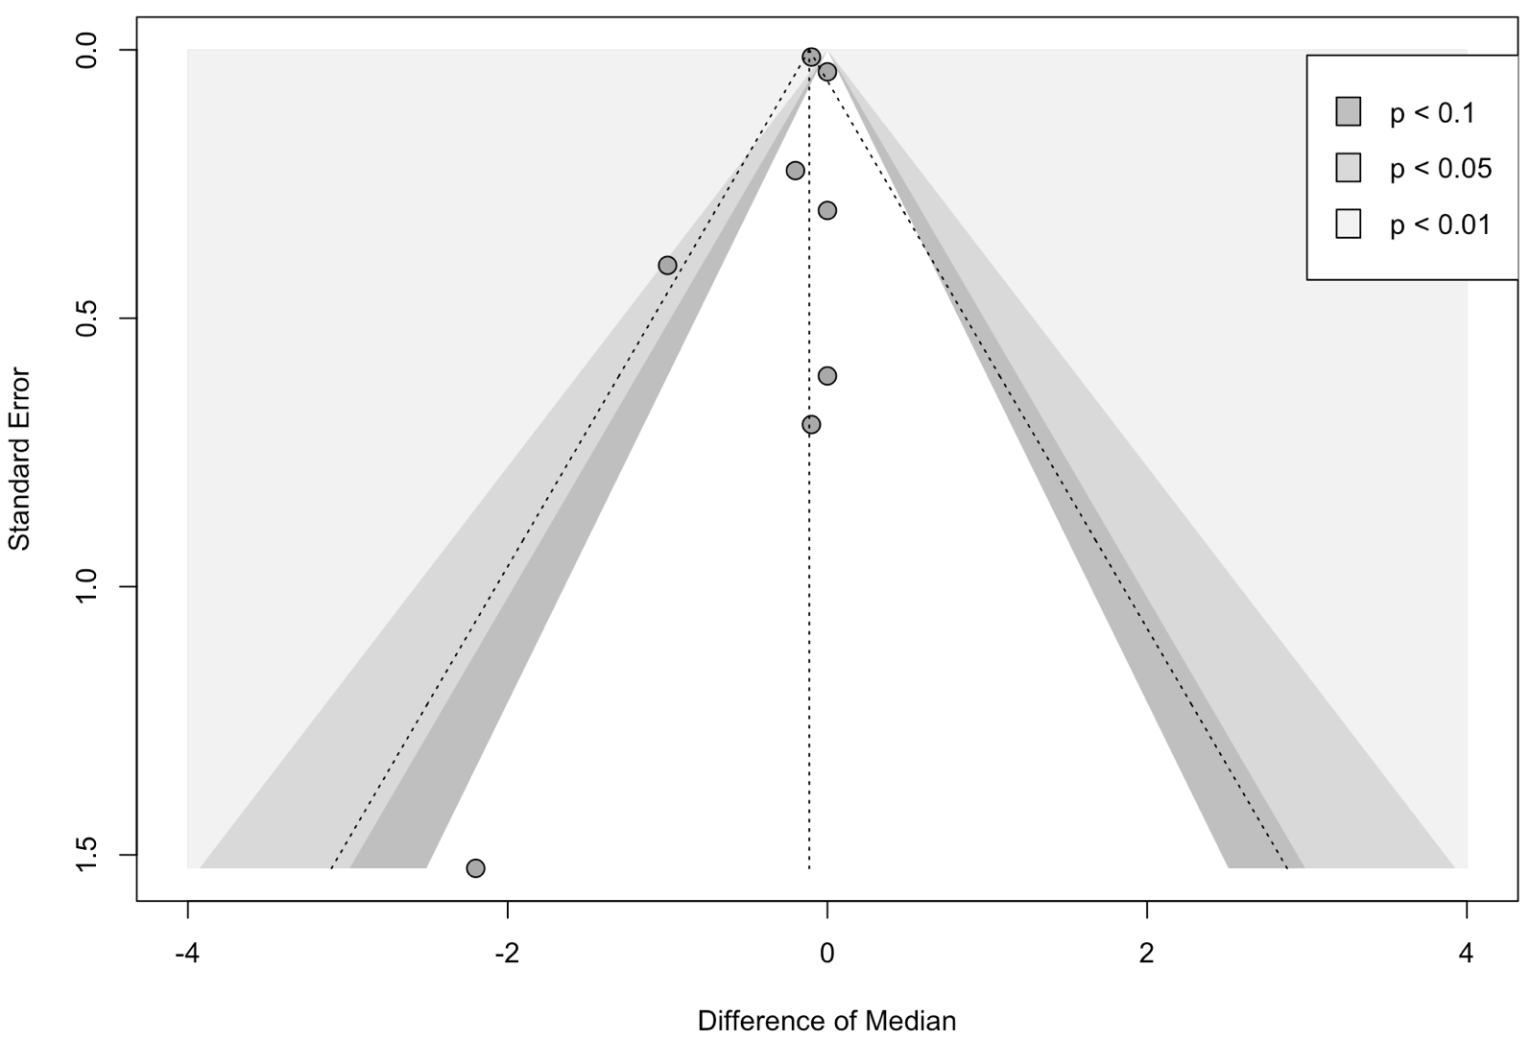

Egger’s test intercept = -0.347 (95% CI -1.49-0.79, t = -0.598, p 0.57)

