Supplementary Material

Additional text regarding data cleaning:

Some CLs either did not have a removal date in our dataset or had a line removal date that occurred prior to a documented access to that line. For such lines, we imputed the removal date to be the earliest discharge date from the hospital that (1) followed the date of line insertion and such that (2) no line accesses were documented following the date. Similarly, there were some lines that either had no insertion date in our dataset or had an insertion date that occurred after a documented access to that line. For such lines, we imputed the insertion date to be the latest hospital admission date that occurred before any documented accesses of the line. Lines with no placement or removal times were excluded from the analysis.

Supplementary Figure 1: Several examples illustrating methodology regarding central line device day inclusion and outcome definition. Each rectangle represents a separate day for a given patient; these line-days were treated as separate observations. Patient A had a line inserted on day 4 of their stay, and removed on day 9. Patient B had a line inserted on day 4, and a CLABSI was identified on day 9, so days 6, 7, and 8 were considered positive observations. Patient C had a central line inserted in a previous medical encounter; therefore, the first two hospital days did not count as central line days. Patient D had a central line inserted after they contracted a CLABSI, but no line days were assessed for patients after they contracted a CLABSI. Patient E had a line inserted on day 4, and a CLABSI was identified on day 5, so only day 4 was considered an eligible observation (and classified as a positive observation, since it was within 3 days of a CLABSI).
Abbreviations: CLI - central line inserted; CLR - central line removed
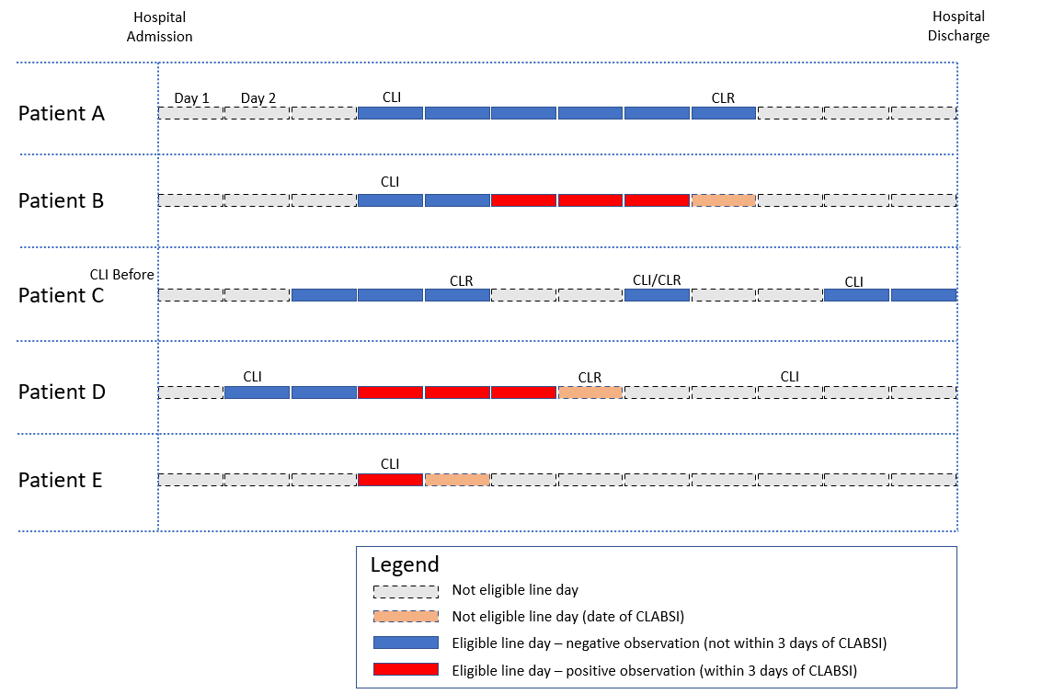

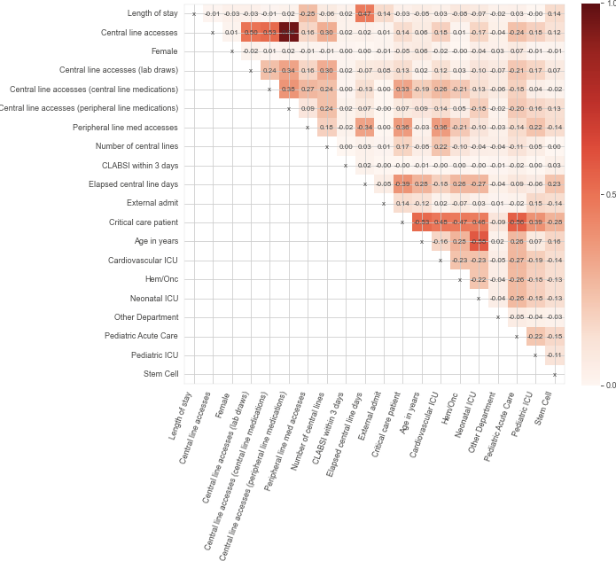
Supplementary Figure 2: Pairwise Spearman correlation between each variable, including the outcome variable, considered in the study. Due to the fact that the number of elapsed CL device days and the number of hospital days since admission would be highly correlated for all patients with multiple consecutive CL device days, the number of days since admission was excluded from the multivariate analysis.

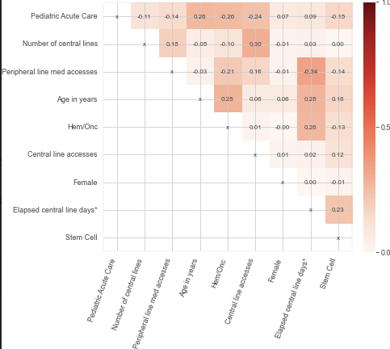
Supplementary Figure 3: Pairwise Spearman correlation between each variable considered in the multivariate logistic regression analysis.
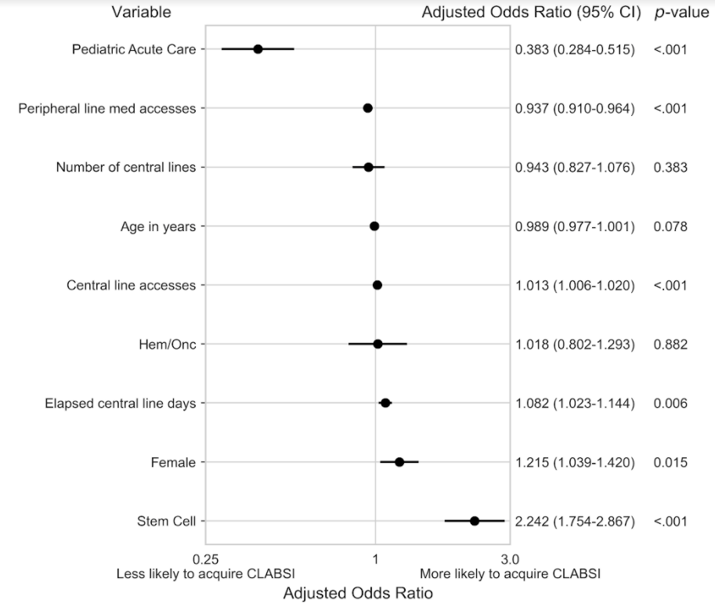
Supplementary Figure 4: Results of the multivariate logistic regression analysis without modeling each patient as a random effect. Shown are adjusted odds ratios, 95% confidence intervals, and p values for each variable when regressing on the outcome of confirmed CLABSI in the next 3 days. The use of mixed-effects modelling for this analysis enabled us to model each patient separately. However, the substantial computational resources required for training this model is a barrier to similar research. We found that a relatively simple logistic regression-based approach recapitulated many of the same results as the more intensive mixed effects model. Therefore, logistic regression-based models are useful for exploratory analyses at other institutions that wish to pursue similar analyses. Many of the same conclusions can be drawn from the results of this model as can be drawn from the results of the mixed-effects model (pediatric acute care and peripheral line accesses are associated with lower risk; central line accesses, elapsed central line days, female gender, and stem cell are associated with higher risk).
Abbreviations: CI - confidence interval; Hem/Onc - Hematology/Oncology; CLABSI - central line-associated bloodstream infection

Medication | Min. Concentration | Route administration details
dextrose | 15% | Central line only
dobutamine |  | Central line only
dopamine |  | Central line only
epinephrine |  | Central line only
norepinephrine |  | Central line only
potassium chloride | 0.4 meq/mL | Central line only
TPN |  | Central line only
acyclovir |  | Central line preferred
alprostadil |  | Central line preferred
amiodarone | 6 mg/mL | Central line only
amphotericin | 0.25 mg/mL | Central line only
anti-thymocyte globulin (lymphocyte) |  | Central line only
anti-thymocyte globulin (rabbit) |  | Central line only
arginine |  | Central line preferred
calcium gluconate | 100 mg/mL | Central line only
calcium chloride | 50 mg/mL | Central line only
chlorothiazide |  | Central line preferred
ciprofloxacin |  | Central line preferred
cyclophosphamide |  | Central line preferred
dantrolene |  | Central line preferred
diltiazem | 1 mg/mL | Central line preferred
doxycycline |  | Central line preferred
esmolol |  | Central line preferred
indomethacin |  | Central line preferred
isoproterenol | 20 mcg/mL | Central line only
magnesium sulfate | 500 mg/mL | Central line only
mannitol |  | Central line preferred
melphalan |  | Central line only
nafcillin | 20 mg/mL | Central line preferred
nicardipine |  | Central line only
nitroprusside |  | Central line only
pentobarbital |  | Central line preferred
phenylephrine | 0.02 mg/mL | Central line only
phenytoin |  | Central line preferred
promethazine |  | Central line preferred
propofol |  | Central line preferred
vancomycin | 5 mg/mL | Central line preferred

Supplementary Table 1: List of medications which were classified as "central line (CL) medications" based on the preferred route of access as defined by our pharmacy formulary, which is consistent with the medications’ manufacturer’s directive. All other medications were classified as "peripheral line (PL) medications". For medications with a value in the minimum concentration column, any medication with a concentration lower than the minimum was classified as a PL medication.

Variable | Pediatric Acute Care | Pediatric ICU | Cardiovascular ICU | Stem Cell | Neonatal ICU | Hem/Onc | Other Department | Total
N Patients | 1,487 | 945 | 1,875 | 214 | 1,835 | 788 | 127 | 7,271
N Patient Hospitalizations | 2,817 | 1,051 | 2,177 | 364 | 1,862 | 3,529 | 142 | 11,942
N CL days | 31,587 | 16,879 | 27,012 | 10,328 | 26,144 | 25,221 | 1,240 | 138,411
Age on admission, in years | 9.97 ± 6.66 | 8.08 ± 6.65 | 7.96 ± 11.47 | 11.09 ± 7.25 | 0.04 ± 0.78 | 10.83 ± 6.17 | 16.81 ± 14.58 | 8.26 ± 8.25
Female (N, %) | 1,451 (52) | 485 (46) | 998 (46) | 155 (43) | 764 (41) | 1,421 (40) | 94 (66) | 5,368 (45)
CLABSI (N, rate per 1000 CL days) | 17 (0.538) | 26 (1.54) | 37 (1.37) | 41 (3.97) | 47 (1.8) | 49 (1.94) | 0 (0) | 217 (1.57)
Length of stay in days, median (IQR) | 8.8 (5-15) | 13 (7.3-26) | 9.3 (5.2-20) | 28 (6.8-47) | 22 (10-46) | 4.9 (3.5-8.7) | 9.4 (4-15) | 8.8 (4.5-20)
CL days per patient, median (IQR) | 19 (6.1-160) | 8.5 (4.3-26) | 3.3 (0.66-8.6) | 91 (38-170) | 6.4 (4-11) | 92 (31-180) | 7.6 (2.3-17) | 14 (4.6-93)
Number of CLs | 1.18 ± 0.44 | 1.24 ± 0.48 | 1.43 ± 0.54 | 1.27 ± 0.58 | 1.26 ± 0.40 | 1.19 ± 0.47 | 1.07 ± 0.27 | 1.25 ± 0.48
Average daily CL accesses | 6.33 ± 4.15 | 12.54 ± 8.96 | 10.56 ± 7.26 | 10.55 ± 6.74 | 6.77 ± 5.58 | 8.60 ± 4.52 | 5.65 ± 5.01 | 8.51 ± 6.11
Average daily CL accesses (lab draws) | 0.76 ± 0.84 | 2.16 ± 2.44 | 1.04 ± 1.39 | 1.40 ± 1.34 | 1.26 ± 1.53 | 1.13 ± 1.02 | 0.48 ± 0.66 | 1.14 ± 1.38
Average daily CL accesses (CL medications) | 0.60 ± 0.97 | 0.98 ± 1.16 | 1.70 ± 1.36 | 0.61 ± 0.74 | 0.99 ± 0.82 | 0.27 ± 0.69 | 0.18 ± 0.54 | 0.79 ± 1.10
Average daily CL accesses (PL medications) | 4.97 ± 3.69 | 9.40 ± 7.63 | 7.82 ± 5.72 | 8.54 ± 5.66 | 4.51 ± 4.20 | 7.21 ± 4.14 | 4.99 ± 4.72 | 6.58 ± 5.09
Average daily PL medication accesses | 1.03 ± 2.01 | 5.34 ± 5.78 | 7.94 ± 5.51 | 0.35 ± 1.23 | 1.02 ± 1.79 | 0.19 ± 0.85 | 0.61 ± 1.40 | 2.39 ± 4.35

Unless otherwise noted, values are presented as [mean] ± [standard deviation]
Abbreviations: N - number; ICU - intensive care unit; Hem/Onc - Hematology/Oncology; CL - central line; PL - peripheral line; CLABSI - central line-associated bloodstream infection; IQR - interquartile range
Supplementary Table 2: Patient-daily characteristics averaged over individual hospitalizations and broken down by unit.

Cardiovascular ICU |  | Hem/Onc |  | Pediatric ICU |  | Stem Cell
Medication name | N | Medication name | N | Medication name | N | Medication name | N
morphine* | 31,384 | porcine* | 21,105 | lorazepam (ativan)* | 26,231 | porcine* | 17,125
lorazepam (ativan)* | 22,908 | ondansetron (zofran)* | 12,483 | fentanyl* | 18,384 | lorazepam (ativan)* | 11,087
potassium chloride | 20,217 | cefepime (maxipime)* | 11,177 | porcine* | 16,933 | ondansetron (zofran)* | 10,778
sodium chloride* | 17,362 | dextrose* | 11,019 | sodium chloride* | 15,488 | sodium chloride* | 10,490
furosemide (lasix)* | 16,547 | lorazepam (ativan)* | 8,979 | midazolam* | 12,919 | cefepime (maxipime)* | 8,434
acetaminophen (ofirmev)* | 13,198 | sodium chloride* | 7,394 | morphine* | 10,465 | acyclovir (zovirax)* | 8,403
fat emulsion* | 12,926 | piperacillin-tazobactam (zosyn)* | 5,414 | furosemide (lasix)* | 8,447 | dextrose* | 7,154
chlorothiazide (diuril)* | 10,006 | vancomycin (vancocin) | 5,190 | hydromorphone* | 7,925 | vancomycin (vancocin) | 6,167
midazolam (pf)* | 9,824 | diphenhydramine (benadryl)* | 4,246 | acetaminophen (ofirmev)* | 6,560 | diphenhydramine (benadryl)* | 5,510
tpn rate | 9,486 | meropenem (merrem)* | 3,697 | vancomycin (vancocin) | 6,331 | cyclosporine (sandimmune)* | 4,071
midazolam (lpch)* | 8,869 | granisetron pf* | 2,798 | piperacillin-tazobactam (zosyn)* | 6,303 | tpn rate | 3,555
milrinone (primacor)* | 8,054 | acetaminophen (ofirmev)* | 2,749 | fat emulsion* | 5,648 | meropenem (merrem)* | 3,549
piperacillin-tazobactam (zosyn)* | 7,994 | caspofungin (cancidas)* | 1,811 | tpn rate | 5,524 | granisetron pf* | 3,427
hydrocortisone sod* | 7,487 | dexamethasone (decadron)* | 1,549 | meropenem (merrem)* | 5,189 | fat emulsion* | 3,107
vancomycin (vancocin) | 7,297 | dexamethasone (decadron)* | 1,340 | dextrose* | 5,157 | mycophenolate (cellcept)* | 2,852
dopamine | 6,748 | pantoprazole (protonix)* | 1,299 | hydromorphone (dilaudid)* | 5,150 | voriconazole (vfend)* | 2,689
vecuronium (norcuron)* | 6,450 | tpn rate | 1,250 | potassium chloride | 4,735 | furosemide (lasix)* | 2,583
fentanyl* | 6,377 | furosemide (lasix)* | 1,150 | midazolam (lpch)* | 4,300 | ceftazidime (fortaz)* | 2,454
dextrose* | 6,324 | hydromorphone (dilaudid)* | 1,147 | aminophylline* | 3,749 | acetaminophen (ofirmev)* | 2,401
sodium bicarbonate* | 5,703 | fat emulsion* | 1,108 | pantoprazole (protonix)* | 3,742 | piperacillin-tazobactam (zosyn)* | 2,345
Neonatal ICU |  | Pediatric Acute Care |  | Other Department |  | Total
Medication name | N | Medication name | N | Medication name | N | Medication name | N
tpn rate | 16,655 | porcine* | 56,126 | porcine* | 2,982 | porcine* | 119,728
lorazepam (ativan)* | 15,855 | piperacillin-tazobactam (zosyn)* | 10,650 | sodium chloride* | 2,322 | lorazepam (ativan)* | 93,470
fat emulsion* | 15,089 | sodium chloride* | 10,143 | ampicillin* | 2,226 | sodium chloride* | 68,330
ampicillin* | 11,674 | tpn rate | 8,015 | ondansetron (zofran)* | 2,039 | morphine* | 53,955
furosemide (lasix)* | 9,386 | fat emulsion* | 7,627 | dextrose* | 1,431 | fat emulsion* | 46,286
morphine* | 8,659 | lorazepam (ativan)* | 7,062 | lorazepam (ativan)* | 1,348 | tpn rate | 45,378
hydrocortisone sod* | 6,237 | acetaminophen (ofirmev)* | 6,138 | tpn rate | 893 | dextrose* | 41,715
caffeine citrated* | 5,993 | dextrose* | 5,679 | dexamethasone (decadron)* | 825 | furosemide (lasix)* | 41,357
sodium chloride* | 5,131 | vancomycin (vancocin) | 5,175 | fat emulsion* | 781 | acetaminophen (ofirmev)* | 33,943
dextrose* | 4,951 | cefepime (maxipime)* | 4,662 | ranitidine (zantac)* | 779 | piperacillin-tazobactam (zosyn)* | 33,805
vancomycin (vancocin) | 3,185 | nafcillin | 4,431 | dexamethasone (decadron)* | 648 | vancomycin (vancocin) | 33,520
ceftazidime (fortaz)* | 3,132 | ondansetron (zofran)* | 4,204 | mesna (mesnex)* | 511 | cefepime (maxipime)* | 33,323
cefotaxime (claforan)* | 2,928 | furosemide (lasix)* | 3,202 | cefotaxime (claforan)* | 494 | ondansetron (zofran)* | 33,084
hydromorphone* | 2,793 | cefazolin (ancef)* | 3,191 | meropenem (merrem)* | 427 | fentanyl* | 29,158
acetaminophen (ofirmev)* | 2,721 | diphenhydramine (benadryl)* | 3,107 | ceftazidime (fortaz)* | 399 | potassium chloride | 28,860
gentamicin* | 2,669 | meropenem (merrem)* | 3,105 | diphenhydramine (benadryl)* | 342 | meropenem (merrem)* | 20,746
fentanyl* | 2,115 | pantoprazole (protonix)* | 2,954 | ceftriaxone (rocephin)* | 297 | hydrocortisone sod* | 19,512
aminophylline* | 2,038 | hydromorphone (dilaudid)* | 2,620 | cefazolin (ancef)* | 232 | ampicillin* | 17,759
chlorothiazide (diuril)* | 1,943 | milrinone (primacor)* | 2,610 | penicillin g* | 220 | diphenhydramine (benadryl)* | 16,225
fluconazole in* | 1,898 | morphine* | 1,893 | granisetron pf* | 214 | chlorothiazide (diuril)* | 15,665
Legend
Neurosedatives/Analgesics
Antimicrobials
Dextrose/Electrolytes
Diuretics
Parenteral Nutrition
Miscellaneous
Anticoagulation/Line maintenance
* = peripheral preferred

Supplementary Table 3: Total number of central line accesses attributed to individual medications, for each unit and in total. Colors denote the type of medication.
* = medication which can safely be administered through a peripheral line (i.e., peripheral line medication)

Line Name | N | %
LPCH LDA CENTRAL/MIDLINE CATHETER SINGLE LUMEN | 6571 | 38.64%
LPCH LDA CENTRAL/MIDLINE CATHETER DOUBLE LUMEN | 7850 | 46.16%
LPCH LDA CENTRAL/MIDLINE CATHETER TRIPLE LUMEN | 1257 | 7.39%
LPCH LDA CENTRAL/MIDLINE CATHETER QUADRUPLE LUMEN | 8 | 0.05%
LDA HEMODIALYSIS CATH | 220 | 1.29%
LDA PORT A CATH | 30 | 0.18%
LDA UMBILICAL ARTERY CATH | 847 | 4.98%
LPCH G LDA CRRT CIRCUIT | 17 | 0.10%
LPCH G LDA ECMO CIRCUIT | 206 | 1.21%

Supplementary Table 4: Total number of central lines of each type considered in the analysis.

