Additional Files

Tables of Contents

Detailed methods 2
Additional Figure 1 4
Additional figure 2 5
Additional table 1 6
Additional table 2 10
Additional table 3 11
Additional table 4 12
Additional table 5 13

Detailed methods

Data retrospectively collected from the electronic health record include: patient characteristics (i.e., age, sex, ICU mortality, 30-day mortality), vital signs (i.e., mean arterial pressure), and scoring (i.e., Simplified Acute Physiology Score (SAPS) II score), current medical issue and comorbidities (i.e., acute bleeding, kidney failure, diabetes, liver cirrhosis, malnutrition, nephrotic syndrome), interventions (i.e., renal replacement therapy (RRT), red blood cell (RBC) transfusion) as well as type of surgery (e.g., heart, neuro, thoracic, trauma, visceral surgery), and laboratory values (e.g., serum albumin, creatinine, glucose, hemoglobin, estimated glomerular filtration rate (eGFR), lactate). The collected data were monitored for correctness by a medical professional by sampling random data points and checking for errors, controlling extreme high and low outputs and examining clinically conspicuous values.
The acquisition of data was facilitated through the clinical data warehouse of the University Hospital of Basel, and the statistical analyses were performed using the program R (version 4.1.3).
The study was concluded in adherence with the STROBE checklist.
For analysis of the intravascular volume expansion within patients of the albumin group, baseline Hb values were defined either as the closest Hb measurement before each albumin administration (case) or at least 12 hours before or after an albumin administration. The latter were used to set up the self-matched control group to analyze the course of Hb values over time when no albumin was given. Hence, a patient could have multiple baseline Hb values that were separated by > 12 hours to be used for the self-matched control. For each baseline Hb, multiple follow-up Hb values measured within 12 hours after the baseline were identified. If a transfusion or bleeding occurred between the baseline and the follow-up Hb measurement, the follow-up Hb value was discarded. For some of the cases, no follow-up Hb value that fulfilled the criteria could be found, hence the number of cases in the self-matched control group (n=1959) is slightly lower compared to the number of cases in the albumin group (n=2128).
In addition to the self-matched control group, a second control group, the so-called matched control group, was formed. For each patient in the albumin group (case), a patient of the non-albumin group was identified who was admitted to the ICU within ± 30 days of the case admission date and whose length of ICU stay was the same or longer. For matched control group patients, a baseline Hb value was determined, which was at a similar time point relative to the admission time to the ICU as the baseline Hb value of the case. A patient from the non-albumin group could be matched only once. For the 9% of the cases that could not be matched, the matching criteria were loosened by being less restrictive concerning admission date and length of ICU stay. Thereafter, follow-up Hb values were identified by applying the same rules as for the cases. For some patients, no follow-up Hb values could be identified (due to missing or discarded Hb measurement or occurrence of transfusion or bleeding). Hence, the number of cases in the matched control group was slightly lower compared to the number of cases (n=1886 vs. n=2006, respectively). Illustrations for both control groups can be found in the supplement (see figures below).

Additional Figure 1 Methods used for self-matched control group
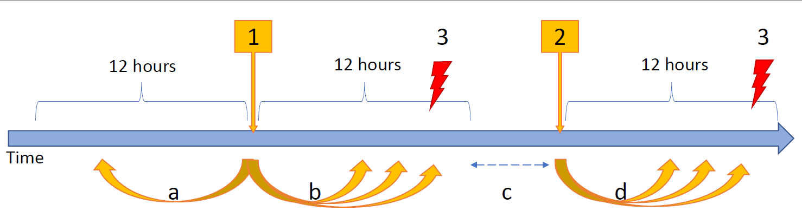
1. Time of albumin administration with a. collection of baseline Hb (no more than 12 hours prior to albumin administration) and b. collection of follow-up Hb (within 12 hours after albumin administration)
2. Baseline Hb for self-matched control c. at least 12 hours after albumin administration and within same ICU stay and d. collection of follow-up Hb (within 12 hours after baseline Hb)
3. Event of albumin administration, hemolysis, blood transfusion or bleeding leads to discarding of further follow-up Hb

Additional figure 2 Methods used for matched control group.
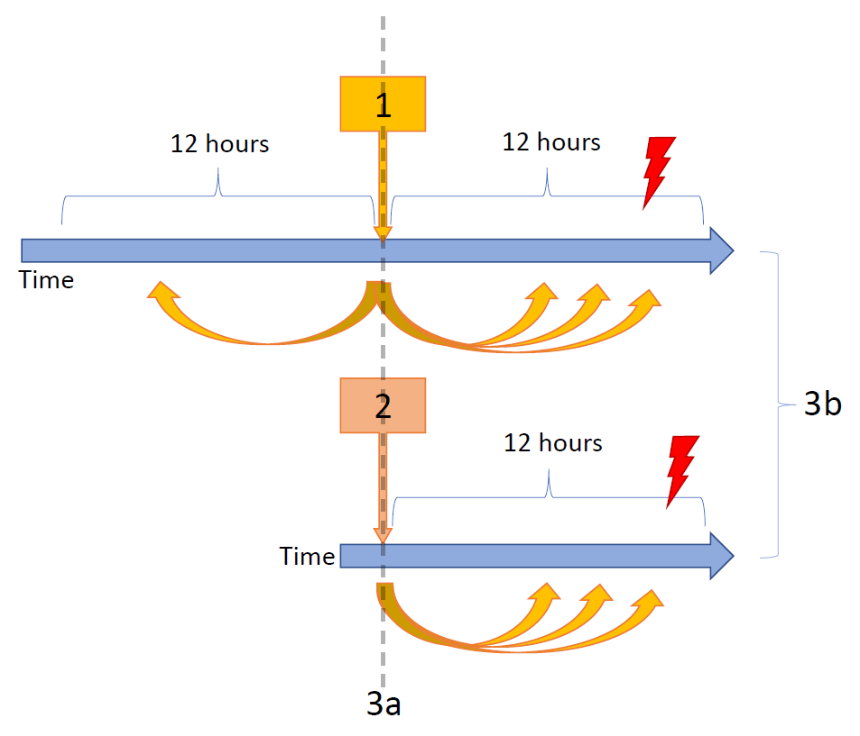
1. Time of albumin administration with collection of baseline and follow-up Hb equal to Fig. 1
2. Baseline Hb for matched control with collection of follow-up Hb equal to Fig. 1
3. Both cases are a. taking place on the identical day of both patient’s ICU stay and b. are no more than 30 days apart in 91% of all cases (in the remaining 9% the matching criteria was loosened)

Additional table 1 All baseline data, diseases, comorbidities, and interventions from 2013 and 2021 with all patient characteristics (n = 20’927 cases)

Year of admission | 2013 | 2014 | 2015 | 2016 | 2017 | 2018 | 2019 | 2020 | 2021 | Total
ICU admission
Cases (n, %)
albumin | 132 (5.1%) | 235 (9.5%) | 324 (13.1%) | 446 (18.5%) | 408 (16.8%) | 451 (19.7%) | 549 (23.7%) | 574 (28.8%) | 629 (32.5%) | 3748 (17.9%)
hyperoncotic albumin | 89 (3.4%) | 185 (7.5%) | 138 (5.6%) | 171 (7.1%) | 137 (5.6%) | 105 (4.6%) | 146 (6.3%) | 182 (9.1%) | 189 (9.8%) | 1342 (6.4%)
no albumin | 2476 (94.9%) | 2228 (90.5%) | 2143 (86.9%) | 1958 (81.1%) | 2027 (83.2%) | 1840 (80.3%) | 1772 (76.3%) | 1419 (71.2%) | 1306 (67.5%) | 17,179 (82.1%)
all | 2608 (100%) | 2463 (100%) | 2467 (100%) | 2414 (100%) | 2435 (100%) | 2291 (100%) | 2321 (100%) | 1993 (100%) | 1935 (100%) | 20,927 (100%)
Patients (n)
albumin | 130 | 232 | 323 | 440 | 404 | 444 | 539 | 568 | 620 | 3613
no albumin | 2386 | 2139 | 2072 | 1885 | 1951 | 1774 | 1696 | 1377 | 1273 | 15,588
all | 2505 | 2352 | 2364 | 2299 | 2325 | 2185 | 2199 | 1921 | 1860 | 18,645
Length of ICU stay (median (h), IQR)
albumin | 121 (44, 322) | 162 (60, 380) | 101 (54, 216) | 95 (47, 210) | 91 (46, 234) | 91 (45, 212) | 90 (48, 203) | 93 (47, 236) | 97 (48, 235) | 96 (47, 237)
no albumin | 47 (37, 85) | 48 (37, 86) | 46 (36, 73) | 47 (36, 81) | 46 (36, 77) | 45 (34, 76) | 45 (34, 73) | 46 (35, 86) | 46 (35, 80) | 46 (36, 80)
all | 48 (37, 90) | 50 (38, 94) | 48 (38, 86) | 49 (38, 95) | 49 (38, 91) | 48 (36, 94) | 49 (37, 94) | 53 (38, 117) | 52 (38, 116) | 49 (38, 95)
Demographics
Males (n, %)
albumin | 68 (51.5%) | 147 (62.6%) | 203 (62.7%) | 259 (58.1%) | 273 (66.9%) | 286 (63.4%) | 352 (64.1%) | 385 (67.1%) | 432 (68.7%) | 2405 (64.2%)
no albumin | 1582 (63.9%) | 1460 (65.5%) | 1391 (64.9%) | 1250 (63.5%) | 1304 (64.3%) | 1198 (65.1%) | 1144 (64.6%) | 943 (66.5%) | 887 (67.9%) | 11,159 (65.0%)
all | 1650 (63.3%) | 1607 (65.2%) | 1594 (64.6%) | 1509 (62.5%) | 1577 (64.8%) | 1484 (64.8%) | 1496 (64.5%) | 1328 (66.6%) | 1319 (68.2%) | 13,564 (64.8%)
Age (median (y), IQR)
albumin | 67 (56, 75) | 66 (56, 75) | 67 (58, 76) | 69 (61, 78) | 68 (58, 75) | 68 (58, 75) | 68 (58, 75) | 68 (59, 75) | 67 (58, 75) | 68 (58, 75)
no albumin | 69 (57, 77) | 68 (57, 77) | 69 (57, 78) | 69 (56, 78) | 68 (57, 77) | 67 (56, 77) | 68 (56, 78) | 67 (55, 77) | 66 (55, 76) | 68 (56, 77)
all | 68 (57, 77) | 68 (56, 77) | 68 (57, 78) | 69 (57, 78) | 68 (57, 77) | 68 (56, 76) | 68 (57, 77) | 67 (56, 76) | 67 (56, 76) | 68 (57, 77)
Mortality
ICU (n, %)
albumin | 17 (12.8%) | 41 (17.4%) | 44 (13.6%) | 42 (9.4%) | 36 (8.8%) | 34 (7.5%) | 50 (9.1%) | 63 (11.0%) | 62 (9.9%) | 389 (10.4%)
no albumin | 81 (3.3%) | 63 (2.8%) | 71 (3.3%) | 59 (3.0%) | 53 (2.6%) | 55 (3.0%) | 32 (1.8%) | 37 (2.6%) | 47 (3.6%) | 498 (2.9%)
all | 98 (3.8%) | 104 (4.2%) | 115 (4.7%) | 101 (4.2%) | 89 (3.7%) | 89 (3.9%) | 82 (3.5%) | 100 (5.0%) | 109 (5.6%) | 887 (4.2%)
30-day (%, 95% CI)
albumin | 18.2 (11.3, 24.5) | 28.1 (22.1, 33.6) | 25.6 (20.7, 30.2) | 17.9 (14.3, 21.4) | 18.6 (14.8, 22.3) | 14.4 (11.1, 17.6) | 19.3 (15.9, 22.5) | 25.3 (21.6, 28.7) | 22.7 (19.4, 25.9) | 21.0 (19.7, 22.3)
no albumin | 9.5 (8.3, 10.6) | 9.1 (7.9, 10.3) | 10.0 (8.8, 11.3) | 10.3 (8.9, 11.6) | 9.9 (8.6, 11.2) | 10.4 (9.0, 11.8) | 9.7 (8.3, 11.1) | 9.3 (7.8, 10.8) | 11.5 (9.7, 13.2) | 9.9 (9.5, 10.3)
all | 9.9 (8.7, 11.0) | 10.9 (9.7, 12.1) | 12.1 (10.8, 13.4) | 11.7 (10.4, 13.0) | 11.3 (10.1, 12.6) | 11.2 (9.9, 12.5) | 12.0 (10.7, 13.3) | 13.9 (12.4, 15.4) | 15.1 (13.5, 16.7) | 11.9 (11.5, 12.3)
Admission scores
SAPS II (median, 95% CI)
albumin | 41 (22, 58) | 47 (33, 66) | 44 (31, 60) | 45 (31, 64) | 45 (31, 62) | 38 (30, 51) | 44 (33, 60) | 44 (33, 60) | 43 (32, 57) | 44 (31, 60)
no albumin | 34 (25, 46) | 35 (27, 48) | 36 (27, 49) | 37 (27, 51) | 34 (26, 48) | 34 (25, 48) | 36 (27, 49) | 34 (25, 44) | 34 (25, 46) | 35 (26, 48)
all | 35 (25, 47) | 37 (27, 50) | 37 (28, 50) | 38 (28, 54) | 36 (26, 51) | 35 (26, 49) | 38 (28, 52) | 36 (27, 49) | 37 (27, 50) | 36 (27, 50)
Comorbidities & diseases
Diabetes (n, %)
albumin | 40 (30.3%) | 62 (26.4%) | 88 (27.2%) | 114 (25.6%) | 114 (27.9%) | 113 (25.1%) | 160 (29.1%) | 183 (31.9%) | 189 (30.0%) | 1063 (28.4%)
no albumin | 573 (23.1%) | 579 (26.0%) | 511 (23.8%) | 472 (24.0%) | 535 (26.4%) | 452 (24.6%) | 512 (28.9%) | 420 (29.6%) | 371 (28.4%) | 4425 (25.8%)
all | 613 (23.5%) | 641 (26.0%) | 599 (24.3%) | 586 (24.3%) | 649 (26.7%) | 565 (24.7%) | 672 (29.0%) | 603 (30.3%) | 560 (28.9%) | 5488 (26.2%)
Septic shock (n, %)
albumin | 18 (13.6%) | 63 (26.8%) | 53 (16.4%) | 54 (12.1%) | 67 (16.4%) | 66 (14.6%) | 78 (14.2%) | 75 (13.1%) | 95 (15.1%) | 569 (15.2%)
no albumin | 70 (2.8%) | 65 (2.9%) | 53 (2.5%) | 56 (2.8%) | 36 (1.8%) | 42 (2.3%) | 48 (2.7%) | 25 (1.8%) | 20 (1.5%) | 415 (2.4%)
all | 88 (3.4%) | 128 (5.2%) | 106 (4.3%) | 110 (4.6%) | 103 (4.2%) | 108 (4.7%) | 126 (5.4%) | 100 (5.0%) | 115 (5.9%) | 984 (4.7%)
Liver cirrhosis (n, %)
albumin | 18 (13.6%) | 35 (14.9%) | 22 (6.8%) | 20 (4.5%) | 23 (5.6%) | 23 (5.1%) | 35 (6.4%) | 37 (6.4%) | 50 (7.9%) | 263 (7.0%)
no albumin | 25 (1.0%) | 41 (1.8%) | 37 (1.7%) | 48 (2.4%) | 38 (1.9%) | 43 (2.3%) | 43 (2.4%) | 37 (2.6%) | 38 (2.9%) | 350 (2.0%)
all | 43 (1.6%) | 76 (3.1%) | 59 (2.4%) | 68 (2.8%) | 61 (2.5%) | 66 (2.9%) | 78 (3.4%) | 74 (3.7%) | 88 (4.5%) | 613 (2.9%)
Nephrotic syndrome (n, %)
albumin | 0 (0%) | 1 (0.4%) | 0 (0%) | 1 (0.2%) | 0 (0%) | 1 (0.2%) | 2 (0.4%) | 0 (0%) | 0 (0%) | 5 (0.1%)
no albumin | 7 (0.3%) | 0 (0%) | 0 (0%) | 1 (0.1%) | 0 (0%) | 4 (0.2%) | 1 (0.1%) | 0 (0%) | 1 (0.1%) | 14 (0.1%)
all | 7 (0.3%) | 1 (0.0%) | 0 (0%) | 2 (0.1%) | 0 (0%) | 5 (0.2%) | 3 (0.1%) | 0 (0%) | 1 (0.1%) | 19 (0.1%)
Malnutrition (n, %)
albumin | 5 (3.8%) | 6 (2.6%) | 9 (2.8%) | 6 (1.3%) | 13 (3.2%) | 25 (5.5%) | 18 (3.3%) | 27 (4.7%) | 18 (2.9%) | 127 (3.4%)
no albumin | 15 (0.6%) | 17 (0.8%) | 14 (0.7%) | 22 (1.1%) | 23 (1.1%) | 36 (2.0%) | 28 (1.6%) | 21 (1.5%) | 19 (1.5%) | 195 (1.1%)
all | 20 (0.8%) | 23 (0.9%) | 23 (0.9%) | 28 (1.2%) | 36 (1.5%) | 61 (2.7%) | 46 (2.0%) | 48 (2.4%) | 37 (1.9%) | 322 (1.5%)
Acute bleeding (n, %)
albumin | 21 (15.9%) | 53 (22.6%) | 68 (21.0%) | 97 (21.7%) | 86 (21.1%) | 79 (17.5%) | 130 (23.7%) | 139 (24.2%) | 153 (24.3%) | 826 (22.0%)
no albumin | 334 (13.5%) | 294 (13.2%) | 314 (14.7%) | 249 (12.7%) | 292 (14.4%) | 289 (15.7%) | 265 (15.0%) | 218 (15.4%) | 203 (15.5%) | 2458 (14.3%)
all | 355 (13.6%) | 347 (14.1%) | 382 (15.5%) | 346 (14.3%) | 378 (15.5%) | 368 (16.1%) | 395 (17.0%) | 357 (17.9%) | 356 (18.4%) | 3284 (15.7%)
Kidney disease (n, %)
albumin | 90 (68.2%) | 153 (65.1%) | 190 (58.6%) | 221 (49.6%) | 248 (60.8%) | 229 (50.8%) | 285 (51.9%) | 293 (51.0%) | 303 (48.2%) | 2012 (53.7%)
no albumin | 601 (24.3%) | 555 (24.9%) | 566 (26.4%) | 582 (29.6%) | 626 (30.9%) | 503 (27.3%) | 527 (29.7%) | 396 (27.9%) | 344 (26.3%) | 4700 (27.4%)
all | 691 (26.5%) | 708 (28.7%) | 756 (30.6%) | 803 (33.2%) | 874 (35.9%) | 732 (32.0%) | 812 (35.0%) | 689 (34.6%) | 647 (33.4%) | 6712 (32.1%)
Hypoalbuminemia HA (n, %)
albumin | 57 (43.2%) | 103 (43.8%) | 139 (42.9%) | 185 (41.5%) | 169 (41.4%) | 160 (35.5%) | 208 (37.9%) | 237 (41.3%) | 287 (45.6%) | 1545 (41.2%)
no albumin | 430 (17.4%) | 464 (20.8%) | 428 (20.0%) | 529 (26.9%) | 529 (26.1%) | 408 (22.2%) | 449 (25.3%) | 311 (21.9%) | 341 (26.1%) | 3889 (22.6%)
all | 487 (18.7%) | 567 (23.0%) | 567 (23.0%) | 714 (29.6%) | 698 (28.7%) | 568 (24.8%) | 657 (28.3%) | 548 (27.5%) | 628 (32.5%) | 5434 (26.0%)
Hypoalbuminemia ICU (n, %)
albumin | 97 (73.5%) | 189 (80.4%) | 264 (81.5%) | 377 (84.5%) | 317 (77.7%) | 332 (73.6%) | 393 (71.6%) | 393 (68.5%) | 464 (73.8%) | 2826 (75.4%)
no albumin | 1382 (55.8%) | 1272 (57.1%) | 1103 (51.5%) | 1165 (59.2%) | 1120 (55.3%) | 891 (48.4%) | 881 (49.7%) | 649 (45.7%) | 667 (51.1%) | 9130 (53.2%)
all | 1479 (56.7%) | 1461 (59.3%) | 1367 (55.4%) | 1542 (63.9%) | 1437 (59.0%) | 1223 (53.4%) | 1274 (54.9%) | 1042 (52.3%) | 1131 (58.5%) | 11956 (57.1%)
Anemia ICU (n, %)
albumin | 69 (52.3%) | 119 (50.6%) | 189 (58.3%) | 244 (54.7%) | 235 (57.6%) | 208 (46.1%) | 212 (38.6%) | 211 (36.8%) | 209 (33.2%) | 1696 (45.3%)
no albumin | 647 (26.1%) | 567 (25.5%) | 532 (24.8%) | 472 (24.0%) | 465 (22.9%) | 349 (19%) | 313 (17.7%) | 241 (17.0%) | 197 (15.1%) | 3783 (22.0%)
all | 716 (27.5%) | 686 (27.9%) | 721 (29.2%) | 716 (29.7%) | 700 (28.8%) | 557 (24.3%) | 525 (22.6%) | 452 (22.7%) | 406 (21.0%) | 5479 (26.2%)
Laboratory values
Hemoglobin (median [g/L], IQR)
albumin | 98 (85, 110) | 99 (86, 115) | 96 (87, 109) | 97 (87, 111) | 97 (86, 109) | 101 (88, 117) | 105 (91, 120) | 108 (94, 126) | 109 (95, 125) | 102 (89, 118)
no albumin | 116 (98, 133) | 117 (99, 133) | 117 (100, 133) | 117 (100, 132) | 118 (101, 134) | 122 (104, 137) | 124 (106, 140) | 126 (108, 140) | 128 (111, 142) | 120 (102, 136)
all | 115 (98, 132) | 115 (97, 132) | 114 (96, 131) | 113 (96, 130) | 114 (97, 131) | 118 (100, 134) | 119 (101, 137) | 121 (102, 138) | 122 (103, 138) | 116 (99, 133)
Interventions
All surgeries (n, %)
albumin | 44 (33.3%) | 79 (33.6%) | 161 (49.7%) | 261 (58.5%) | 210 (51.5%) | 251 (55.7%) | 352 (64.1%) | 331 (57.7%) | 339 (53.9%) | 2028 (54.1%)
no albumin | 896 (36.2%) | 781 (35.1%) | 591 (27.6%) | 523 (26.6%) | 547 (27.0%) | 500 (27.2%) | 446 (25.2%) | 405 (28.5%) | 379 (29.0%) | 5068 (29.5%)
all | 940 (36.0%) | 860 (34.9%) | 752 (30.5%) | 784 (32.5%) | 757 (31.1%) | 751 (32.8%) | 798 (34.4%) | 736 (36.9%) | 718 (37.1%) | 7096 (33.9%)
Cardiac surgery (n, %)
albumin | 23 (17.4%) | 55 (23.4%) | 107 (33.0%) | 178 (39.9%) | 134 (32.8%) | 174 (38.6%) | 209 (38.1%) | 177 (30.8%) | 237 (37.8%) | 1294 (34.5%)
no albumin | 532 (21.5%) | 523 (23.5%) | 446 (20.8%) | 369 (18.8%) | 391 (19.3%) | 364 (19.8%) | 353 (19.9%) | 238 (16.8%) | 210 (16.1%) | 3426 (19.9%)
all | 555 (21.3%) | 578 (23.5%) | 553 (22.4%) | 547 (22.7%) | 525 (21.6%) | 538 (23.5%) | 562 (24.2%) | 415 (20.8%) | 447 (23.1%) | 4720 (22.6%)
Visceral surgery (n, %)
albumin | 37 (28.0%) | 66 (28.1%) | 75 (23.1%) | 86 (19.3%) | 76 (18.6%) | 92 (20.4%) | 108 (19.7%) | 106 (18.5%) | 113 (18.0%) | 759 (20.3%)
no albumin | 130 (5.3%) | 104 (4.7%) | 55 (2.6%) | 50 (2.5%) | 61 (3.0%) | 60 (3.3%) | 56 (3.2%) | 55 (3.9%) | 46 (3.5%) | 617 (3.6%)
all | 167 (6.4%) | 170 (6.9%) | 130 (5.3%) | 136 (5.6%) | 137 (5.6%) | 152 (6.6%) | 164 (7.1%) | 161 (8.1%) | 159 (8.2%) | 1376 (6.6%)
Neurosurgery (n, %)
albumin | 1 (0.8%) | 2 (0.9%) | 8 (2.5%) | 18 (4.0%) | 16 (3.9%) | 12 (2.7%) | 14 (2.6%) | 14 (2.4%) | 14 (2.2%) | 99 (2.6%)
no albumin | 94 (3.8%) | 98 (4.4%) | 98 (4.6%) | 109 (5.5%) | 102 (5.0%) | 102 (5.5%) | 92 (5.2%) | 106 (7.5%) | 110 (8.4%) | 911 (5.3%)
all | 95 (3.6%) | 100 (4.1%) | 106 (4.3%) | 127 (5.3%) | 118 (4.8%) | 114 (5.0%) | 106 (4.6%) | 120 (6.0%) | 124 (6.4%) | 1010 (4.8%)
Thoracic surgery (n, %)
albumin | 19 (14.4%) | 36 (15.3%) | 51 (15.7%) | 78 (17.5%) | 48 (11.8%) | 76 (16.9%) | 62 (11.3%) | 59 (10.3%) | 50 (7.9%) | 479 (12.8%)
no albumin | 132 (5.3%) | 127 (5.7%) | 87 (4.1%) | 59 (3.0%) | 57 (2.8%) | 46 (2.5%) | 49 (2.8%) | 41 (2.9%) | 41 (3.1%) | 639 (3.7%)
all | 151 (5.8%) | 163 (6.6%) | 138 (5.6%) | 137 (5.7%) | 105 (4.3%) | 122 (5.3%) | 111 (4.8%) | 100 (5.0%) | 91 (4.7%) | 1118 (5.3%)
Trauma/orthopedic surgery (n, %)
albumin | 19 (13.6%) | 28 (11.9%) | 46 (14.2%) | 85 (19.1%) | 67 (16.4%) | 55 (12.2%) | 68 (12.4%) | 70 (12.2%) | 57 (9.1%) | 494 (13.2%)
no albumin | 132 (7.3%) | 156 (7.0%) | 121 (5.6%) | 121 (6.1%) | 107 (5.3%) | 98 (5.3%) | 93 (5.2%) | 83 (5.8%) | 59 (4.5%) | 1019 (5.9%)
all | 151 (7.6%) | 184 (7.5%) | 167 (6.8%) | 206 (8.5%) | 174 (7.1%) | 153 (6.7%) | 161 (6.9%) | 153 (7.7%) | 116 (6.0%) | 1513 (7.2%)
Transfusion (n, %)
albumin | 89 (67.4%) | 168 (71.5%) | 225 (69.4%) | 286 (64.1%) | 271 (66.4%) | 267 (59.2%) | 313 (57.0%) | 318 (55.4%) | 368 (58.5%) | 2305 (61.5%)
no albumin | 561 (22.7%) | 481 (21.6%) | 352 (16.4%) | 305 (15.5%) | 285 (14.1%) | 266 (14.5%) | 207 (11.7%) | 168 (11.8%) | 139 (10.6%) | 2764 (16.1%)
all | 650 (24.9%) | 649 (26.3%) | 577 (23.4%) | 591 (24.5%) | 556 (22.8%) | 533 (23.3%) | 520 (22.4%) | 486 (24.4%) | 507 (26.2%) | 5069 (24.2%)
Renal replacement therapy (n, %)
albumin | 29 (22.0%) | 52 (22.1%) | 59 (18.2%) | 49 (11.0%) | 76 (18.6%) | 60 (13.3%) | 84 (15.3%) | 90 (15.7%) | 88 (14.0%) | 587 (15.7%)
no albumin | 85 (3.4%) | 63 (2.8%) | 65 (3.0%) | 38 (1.9%) | 49 (2.4%) | 47 (2.6%) | 43 (2.4%) | 31 (2.2%) | 28 (2.1%) | 449 (2.6%)
all | 114 (4.4%) | 115 (4.7%) | 124 (5.0%) | 87 (3.6%) | 125 (5.1%) | 107 (4.7%) | 127 (5.5%) | 121 (6.1%) | 116 (6.0%) | 1036 (5.0%)
CI confidence interval, HA hospital admission, ICU Intensive Care Unit, IQR interquartile range, RRT Renal replacement therapy, SAPS Simplified Acute Physiology

Additional table 2 Course of the Hb level relative to the baseline over a period of 12 hours estimated with a linear mixed model

 | Estimated Hb change | 95% CI | P value
Intercept | -0.781 | -1.031, -0.521 | < 0.0001
Albumin 20 g (20% in 100 mL) | -3.004. | -3.328, -2.680 | < 0.0001
Albumin 12.5 g (5% in 250 mL) | -4.776 | -5.116, -4.435 | < 0.0001
Albumin 25 g (5% in 500 mL) | -7.732 | -8.143, -7.322 | < 0.0001
Albumin administration and follow-up Hb (hourly change) | 0.166 | 0.114, 0.219 | < 0.0001
Baseline Hb and follow-up Hb (hourly change) | -0.148 | -0.178, -0.119 | < 0.0001
Hb hemoglobin, CI confidence interval

Additional table 3 Prediction of Hb decrease 6 and 12 hours after albumin administration

Amount of Albumin (g), (% in mL) | Hb decrease after 6 hours [g/L], (CI 95%) | Hb decrease after 12 hours [g/L], (CI 95%)
20 (20% in 100 mL) | 3.8 (3.5, 4.0) | 3.7 (3.2, 4.0)
12.5 (5% in 250 mL) | 5.5 (5.3, 5.8) | 5.4 (5.0, 5.8)
25 (5% in 500 mL) | 8.5 (8.1, 8.8) | 8.4 (7.9, 8.9)
Hb hemoglobin, CI confidence interval

Additional table 4 Level relative to the baseline over 12 hours estimated with a linear mixed model extended by the covariate septic shock

 | Estimated Hb change | 95% CI | P value
Intercept | -0.437 | -1.090, 0.216 | 0.19
Albumin 20 g (20% in 100 mL) | -3.310 | -3.970, -2.650 | < 0.0001
Albumin 12.5 g (5% in 250 mL) | -5.492 | -6.274, -4.711 | < 0.0001
Albumin 25 g (5% in 500 mL) | -6.714 | -7.569, -5.859 | < 0.0001
Albumin administration and follow-up Hb (hourly change) | 0.0029 | 0.0010, 0.0049 | 0.003
Baseline Hb and Follow-up Hb (hourly change) | -0.0012 | -0.0024, 0.0001 | 0.07
CI confidence interval, Hb hemoglobin

Additional table 5 Prediction of Hb decrease 6 and 12 hours after albumin administration in patients with septic shock
Amount of albumin | Hb decrease after 6 h [g/L]  (95% CI) | Hb decrease after 12 h [g/L]  (95% CI)
20 g (20% in 100 mL) | 3.0 (2.5, 3.5) | 2.9 (2.3, 3.5)
12.5 g (5% in 250 mL) | 4.8 (4.3, 5.3) | 4.7 (4.1, 5.3)
25 g (5% in 500 mL) | 7.7 (7.2, 8.3) | 7.6 (7.0, 8.3)
CI confidence interval, Hb hemoglobin

