Supplemental Digital Content

- Supplementary figures Page 2-10

- Supplementary tables Page 11-13

Supplementary figures
Supplementary Figure 1: The i-II-X microfluidic test description
Panel A and B are representative Autocad renderings of example microfluidic device designs. A is a top view of a circular microfluidic clotting device. The dotted circle in the center indicates a general field of view encompassing all of the ‘clotting areas’ for each input channel. B is a magnified view of panel A. The channel geometry of the microfluidic device was optimized to localize the start of the cross-linked fibrin clot formation so that the “time-to-clot” (TtC) could be reliably determined. Channel architecture was optimized to permit simultaneous imaging of multiple channels at high magnification. Examples of various channel geometeries tested for this assay are included within the field of view, with the final geometry used depicted in Panel C. Panel C shows a brightfield image of the clotting imaging area on the left and a fluorescence image on the right with examples of green fluorescent cross-linked fibrin clots at various stages of formation. The coagulation cascade depicted in panel D explains the logic of the i-II-X testing approach, utilizing an upstream-downstream principle with Agonist A testing upstream and Agonist B testing downstream of the inhibitor. The basic work-flow of the i-II-X microfluidic test is shown in the flow diagram (E). A blood sample is collected, then fluorescent fibrinogen, calcium, and agonist are added to the sample; and lastly, the sample mixture is loaded into the microfluidic device, which is imaged by time-lapse fluorescence microscopy ever 15 seconds for 10 minutes.

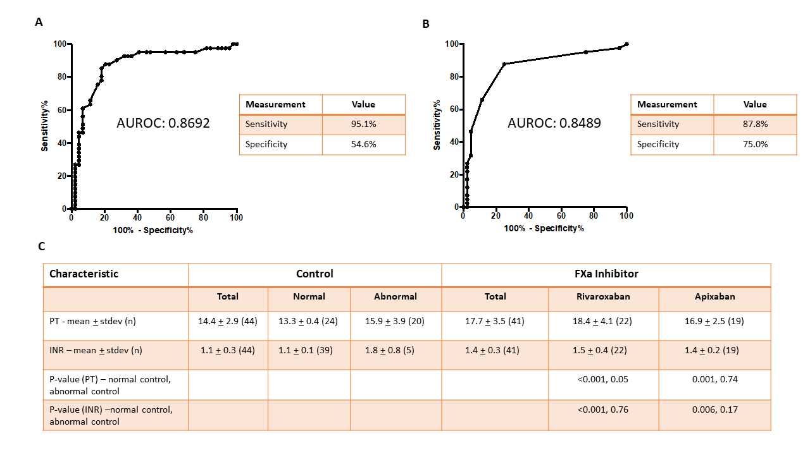
Supplementary Figure 2: PT and INR are sensitive but not specific for FXa-I-inducedanticoagulation
Both PT and INR were compared between control patients and patients with a documented history of Fxa-I use. Abnormal PT was defined as >14 seconds and abnormal INR was defined as >1.2 seconds. (A and B) ROC curves comparing PT and INR of total controls to patients on FXa-I. (C) Descriptive statistics of patients with PT and INR results evaluated. One-way ANOVA was used to compare normal and abnormal controls with both rivaroxaban and apixaban. Significance was defined as p < 0.05. Results show that, when compared to abnormal controls, there is no significance compared to the FXa-I patients, with the exception of PT and rivaroxaban.

Supplementary Figure 3: Comparative Clotting Curves
Clotting times were compared at various agonist concentrations for all the patient groups to construct clotting curves. (A-D) Scatter plots demonstrating the mean and standard error bars of the clotting times at various agonist concentrations with respect to patients in different groups confirm multiple agonist concentrations at which there is statistically significant clotting times between the patients on FXa-I therapy and the controls. (E and F). Clotting curves showing the mean and standard error of control subgroups (patients with either normal or abnormal PT or INR), demonstrates similar results for each subgroup using the i-II-X method. Statistical significance is defined as p < 0.05 (*).

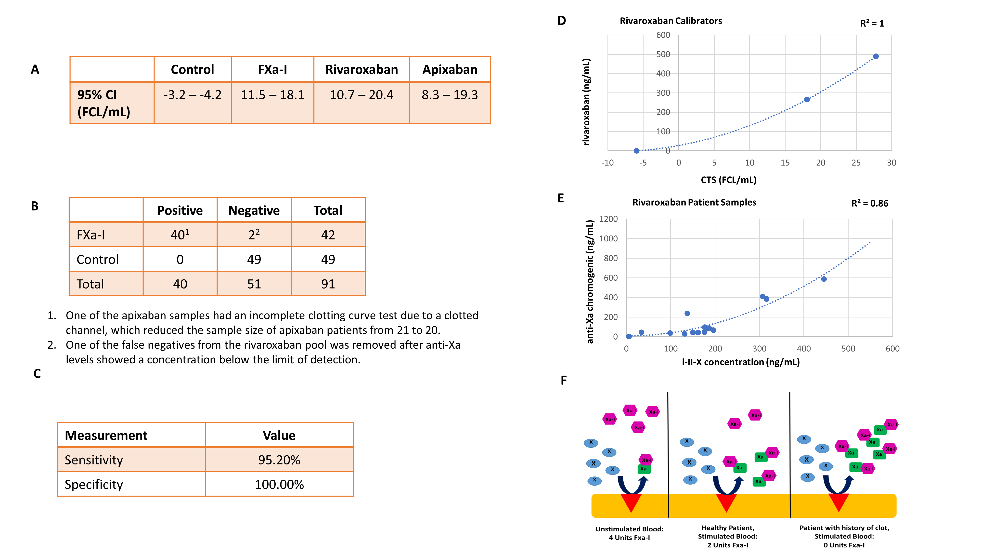
Supplemental Figure 4: Clotting Time Score (CTS) analysis
Evaluation of CTS utilization for the detection of FXa-I in patient samples. (A) Descriptive statistics of the CTS for different patient groups. (B and C) Evaluation of the CTS for determining the accuracy of FXa-I detection. (D) Utilizing the CTS score calculated for each of the controlled spiked rivaroxaban samples, a best-fit line was plotted for an equation that converted CTS into drug concentration (D). This calibrator best-fit equation was then applied to the CTS values for each patient sample in order to calculate a functional concentration for each patient sample. Calculated concentrations were directly compared to sample rivaroxaban concentrations that were derived using the anti-Xa chromogenic assay (E) Calculated sample concentrations demonstrated good correlation (R² = 0.83) between anti-Xa and i-II-X values. (F) A depiction of how a single concentration of a FXa inhibitor can yield varying anticoagulant effects in different patients based on baseline levels of FX and/or FX-to-FXa conversion rates. In the panel on the left, the blood is not stimulated to clot and there is free drug in the circulation. In the middle panel, the blood is stimulated to clot and there is complete anticoagulation with exogenous blood in the plasma. In the panel on the right, there is stimulation to clot but all of the drug is used up and any further clotting activation will not be inhibited by the FXa inhibitor. Note: Hemolyzed samples were not included in the anti-Xa chromogenic assay and CTS direct due to possible exogenous effects on the anti-Xa chromogenic assay accuracy.

Supplemental Figure 5: Clotting Time Scores for FXa and FIIa inhibitors
(A-D) Clotting Time Scores (CTS) are plotted for various concentration of various direct FXa inhibitors in response to the FXa test, including rivaroxaban, apixaban, edoxaban, and betrixaban. (E-F) CTS values are positively correlated with the concentration of FXa inhibitor present. As betrixaban calibrator samples are not yet commercially-available, these samples were created in the lab; therefore, variation is likely due to human error in the dissolving and creating of the spiked samples. (E-F) CTS values are plotted for each concentration of dabigatran. Panel E shows the CTS curve for the FXa test, while panel F shows the CTS curve for the FIIa test. As expected, both curves are positively correlated with the concentration of FIIa inhibitor present.

Supplementary Figure 6: Detection of factor Xa-inhibitor reversal
Edoxaban at 500 ng/mL was used as a control. FEIBA (4-factor aPCC) was added at a concentration of 1.3 U/mL to the edoxaban sample. This is equivalent to 100 U/kg - active bleeding treatment. The addition of FEIBA to the sample reduced the clotting time to resemble edoxaban at 250 ng/mL (B). This demonstrates the ability of the i-II-X test to detect and confirm reversal of direct FXa inhibition with the administration of FEIBA.

Supplementary Figure 7: Warfarin detection with FIIa- and FXa-inhibition testing
This set of curves demonstrates the results of testing warfarin plasma samples with the i-II-X test. Panels A and B show clotting curves for both the FIIa inhibition test (agonist B) and the FXa inhibition test (agonist A) with control plasma (no anticoagulant) and two plasma samples from patient on warfarin (INR 1.9 and 3.2). Panels C and D show the clotting curves from Panel A and B with representative curves from both a factor II-inhibitor (dabigatran, 250 and 500 ng/mL) (panel C) and a factor Xa-inhibitor (apixaban, 250 and 500 ng/mL) (panel D), demonstrating how the clotting curves are starkly different between the IIa- and Xa-inhibitor samples and the warfarin samples. These results suggest that there is a lack of cross-reactivity between the anticoagulant types. The FXa Clotting Time Scores (CTS) for the 1.9 and 3.2 INR samples were -2.5 and -2.0, respectively.

Supplementary Tables

Supplementary Table 1: Patient Descriptive Statistics
Characteristic | Control |  |  | Factor Xa-Inhibitor
 | Total  (N=48) | Normalª  (N=28) | Abnormal^{b}  (N=20) | Total  (N=44) | Rivaroxaban  (N=23) | Apixaban  (N=20)
Male sex – no. (%) | 18 (37.5) | 11 (39.3) | 7 (35.0) | 26 (60) | 14 (67) | 12 (60)
Age – yr (mean + stdev) | 71 + 15 | 72 + 12 | 68 + 17 | 69 + 18 | 69 + 19 | 70 + 17
Platelet inhibitor – no. (%) | 22 (45.8) | 15 (53.6) | 6 (30.0) | 18 (41) | 6 (26) | 12 (60)
Bleed – no. (%) | 1 (2.1) | 0 (0) | 1 (5.0) | 1 (2.3) | 1 (4.3)^{c} | 0 (0)
Clot – no. (%) | 2 (4.2) | 2 (7.1)^{d} | 0 (0)^{e} | 1 (2.3) | 1 (4.3)^{f} | 0 (0)
Cardiac disease^{g} – no. (%) |  |  |  | 36 (82) | 17 (73) | 19 (95)
Other^{h} – no. (%) |  |  |  |  | 6 (26) - History of PE/DVT^{i}, cancer (lung, breast, hepatic), COPD^{i} | 1 (5) – History of PE/DVT, cancer (lung), COPD
a. Patients not on anticoagulants with normal PT, INR, aPTT, or DDimer
b. Patients not on an anticoagulant with abnormal PT, INR, aPTT, or DDimer
c. Cause of hospitalization during blood draw was due to bleeding event. Patient presented for vaginal bleeding (history of uterine cancer).
d. Cause of hospitalization during blood draw was due to bleeding event. Patient presented for a rectal bleed.
e, Cause of hospitalization during blood draw was due to a bleeding event. One patient was diagnosed with a PE and one patient was diagnosed with a DVT.
f. Cause of hospitalization during blood draw was due to Clotting event. Patient was diagnosed with a PE (history of PE and DVT).
g. FXa treatment initiated due to cardiac conditions, including A Fib, SSS, CHF
h. FXa treatment initiated due to non-primary cardiac conditions
i. PE, Pulmonary Embolism; DVT, Deep Vein Thrombosis; COPD, Chronic Obstructive Pulmonary Disease.

Supplementary Table 2: ROC Curve Statistics

Test | Cut-off | Sensitivity (%) | 95% CI | Specificity (%) | 95% CI | Likelihood ratio
PT | > 14 | 95.12 | 83.47% to 99.4% | 54.55 | 38.85% to 69.61% | 2.09
INR | > 1.150 | 87.80 | 73.80% to 95.92% | 75.00 | 59.66% to 86.81% | 3.51
CTS¹ | > -0.1255 | 93.02 | 81.39% to 97.60% | 97.92 | 89.10% to 99.89% | 44.65
CTS¹ | > 0.8374 | 93.02 | 81.39% to 97.60% | 100.00 | 92.59% to 100.0% | NA
CTS² | > -0.1255 | 95.24 | 84.21% to 99.15% | 97.92 | 89.10% to 99.89% | 45.71
CTS² | > 0.8374 | 95.24 | 84.21% to 99.15% | 100.00 | 92.59% to 100.0% | NA

1. Includes all 44 Fxa-I patients
2. Includes 43 Fxa-I patients (rivaroxaban false negative patient removed)

