Supplemental Digital Content 1: Materials and Methods, Study Population
Thromboembolism and major bleeding events in the subgroup of 4953 patients with missing or unknown creatinine levels were analyzed. Thromboembolic events occurred in 344 patients (6.9%), and the crude incidence rate was 2.5/100 person-years. While 109 patients (2.2%) experienced a major bleeding event during the follow-up and the crude incidence rate was 0.76/100 person-years. The crude incidence rates of patients with available creatinine levels were similar to patients with missing or unknown creatinine levels.
Besides, we have analyzed the major events in the subgroup of 8909 patients who underwent catheter ablation. After multivariate analysis, mild CKD was not an independent risk factor for thromboembolism and major bleeding [Supplemental Figure 1]. The results were consistent with patients who didn’t undergo catheter ablation.

Supplementary Figure 1: Cumulative incidence rates of thromboembolism (A) and major bleeding (B) according to estimated glomerular filtration rate (eGFR) in patients undergoing catheter ablation at baseline.
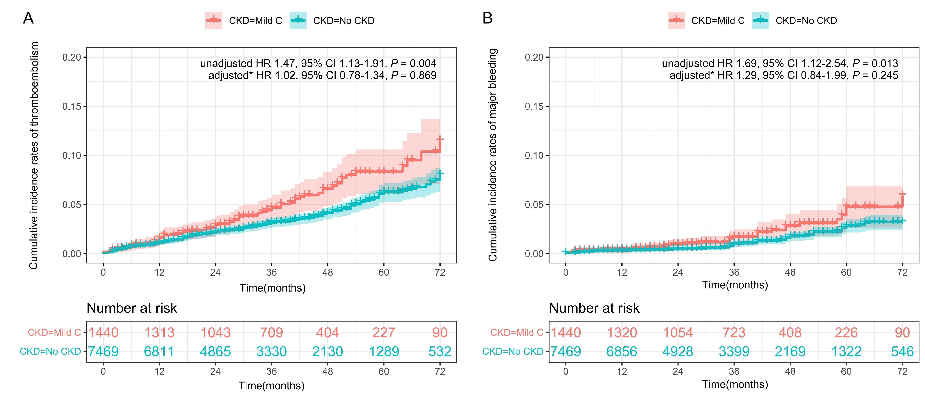
CKD: Chronic kidney disease.
*COX regression model adjusted for variables with P < 0.2 in univariate analysis.

